Supplementary Material, Spectra

Prospects for the use of 3-R-benzo[f][1,2,4]triazino[2,3-d][1,4]diazepine-2,7(6H,8H)-diones as agonists and antagonists of GABA_{A} receptors
Anton Bershak¹, Lyudmyla Antypenko^{1*}, Svitlana Koptieva¹, Natalia Bohdan², Igor Belenichev³, Nina Bukhtiyarova⁴, Sergiy Okovytyy¹, Serhii Kovalenko¹

¹Institute of Chemistry and Geology, Oles Honchar Dnipro National University, 72 Nauky Ave., 49010, Dnipro, Ukraine
²Institute of Organic Chemistry of the National Academy of Sciences of Ukraine, 5 Akademika Kukhara Str., 02094, Kyiv, Ukraine;
³Department of Pharmacology and Medical Formulation with a course in Normal Physiology, Zaporizhzhia State Medical and Pharmaceutical University, 26 Maria Prymachenko Blvd., 69035, Zaporizhzhia, Ukraine
⁴ Department of Clinical Laboratory Diagnostics and Biochemestry, Zaporizhzhia State Medical and Pharmaceutical University, 26 Maria Prymachenko Blvd., 69035, Zaporizhzhia, Ukraine

* Correspondence: antypenkol@gmail.com

Content

LC-MS, ¹H NMR and ¹³C NMR-spectra of compound 1.1 2-4
LC-MS, ¹H NMR and ¹³C NMR-spectra of compound 1.2 5-7
LC-MS, ¹H NMR and ¹³C NMR-spectra of compound 1.3 8-10
LC-MS, ¹H NMR and ¹³C NMR-spectra of compound 1.5 11-13
LC-MS, ¹H NMR and ¹³C NMR-spectra of compound 1.6 14-16
LC-MS, ¹H NMR and ¹³C NMR-spectra of compound 1.7 17-19

LC-MS spectra of compound 1.1

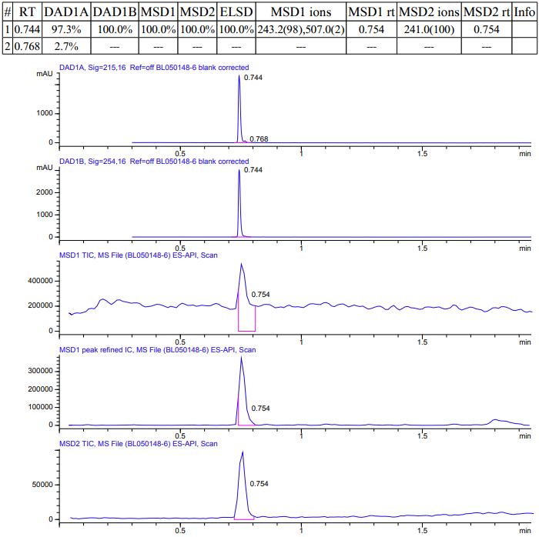
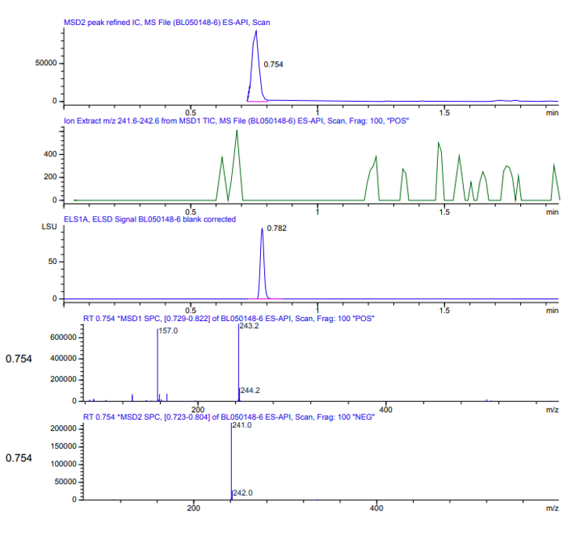

¹H NMR spectra of compound 1.1

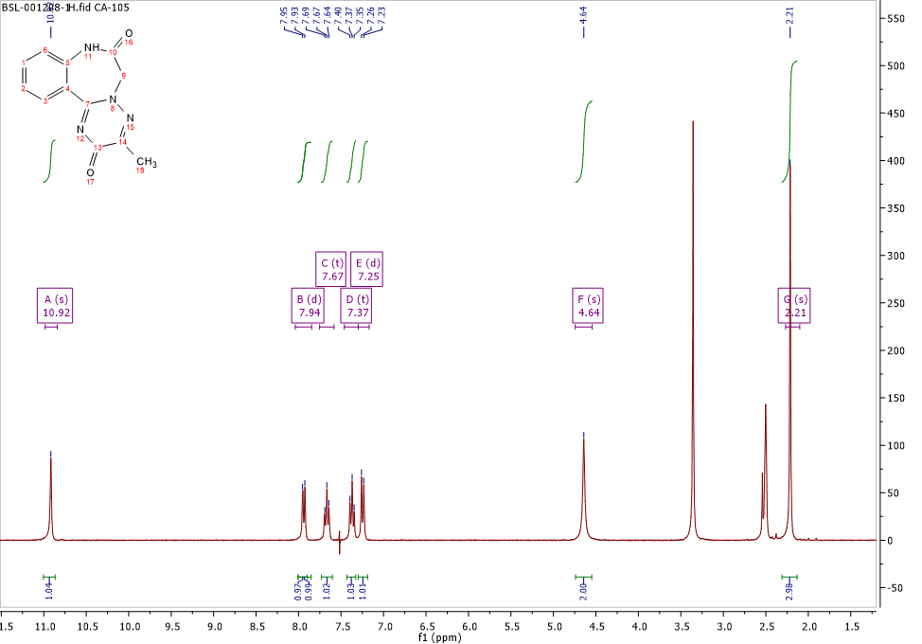
¹³C NMR spectra of compound 1.1
LC-MS spectra of compound 1.2
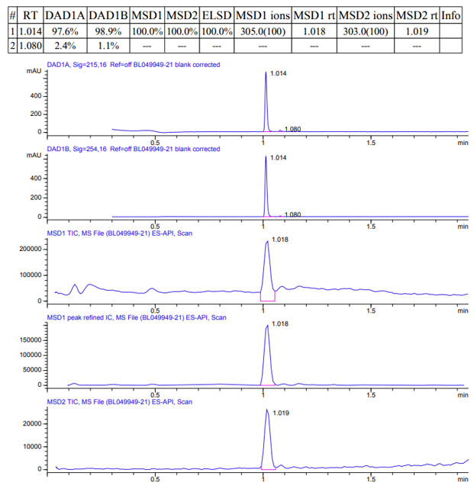
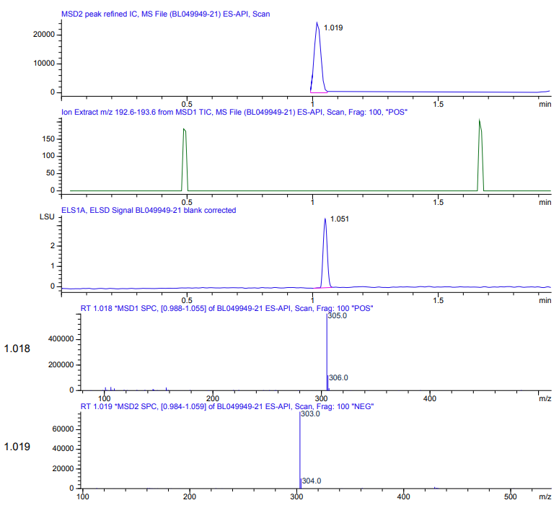

¹H NMR spectra of compound 1.2
¹³C NMR spectra of compound 1.2
LC-MS spectra of compound 1.3
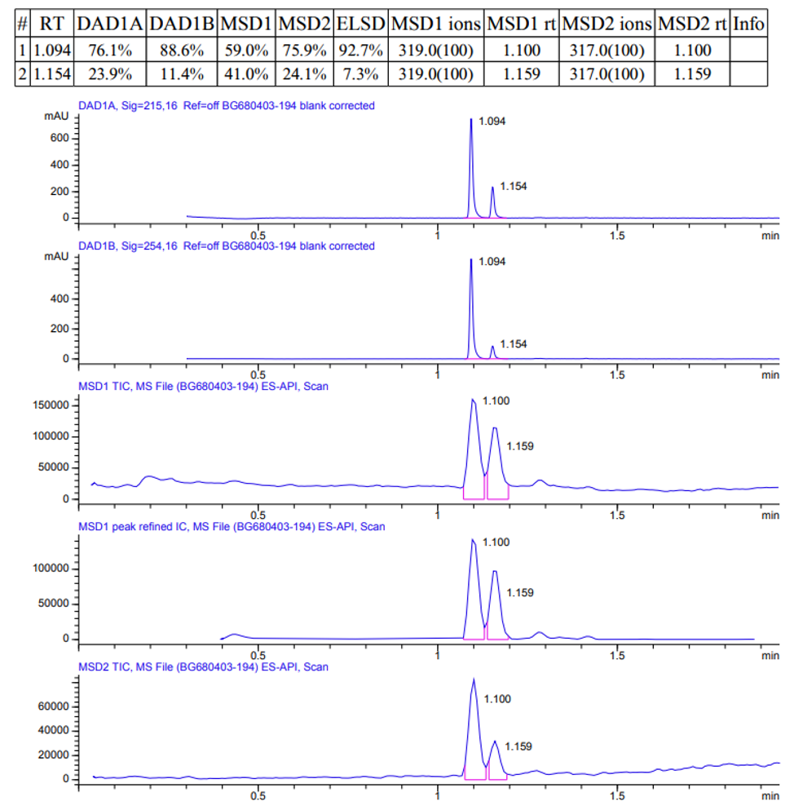
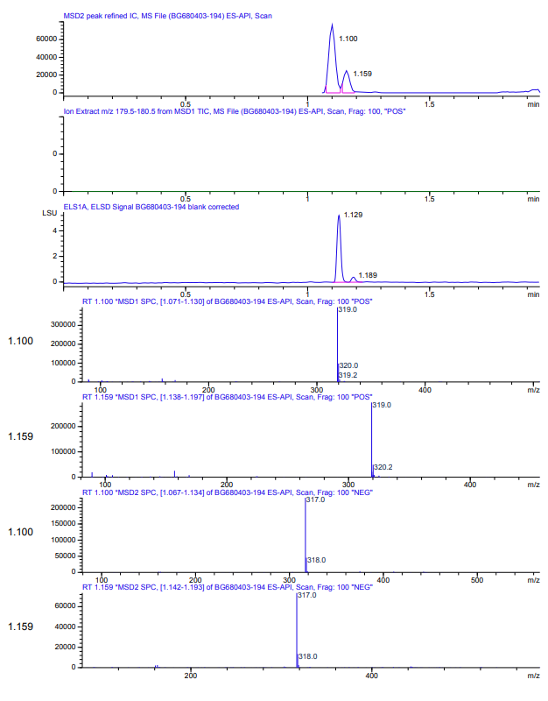

¹H NMR spectra of compound 1.3
¹³C NMR spectra of compound 1.3
LC-MS spectra of compound 1.5
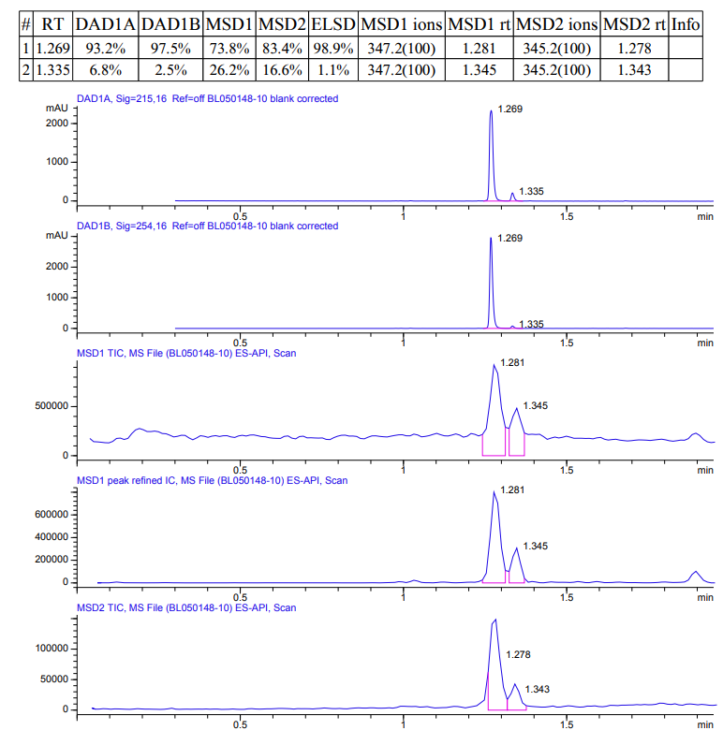
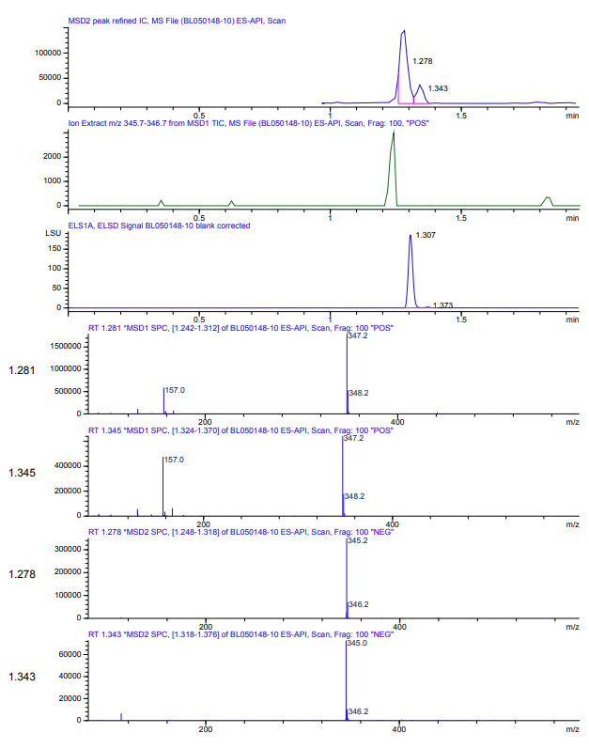

¹H NMR spectra of compound 1.5
¹³C NMR spectra of compound 1.5
LC-MS spectra of compound 1.6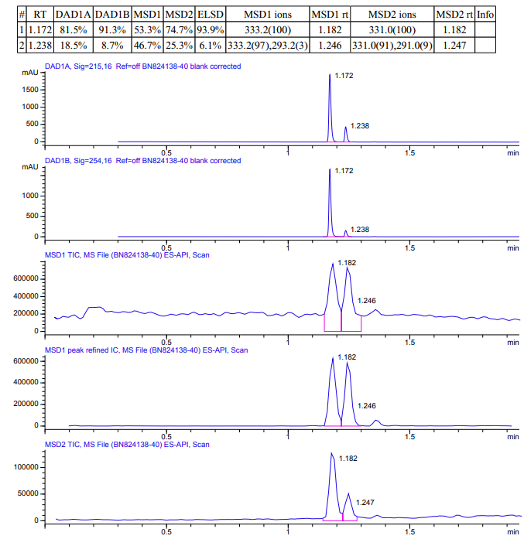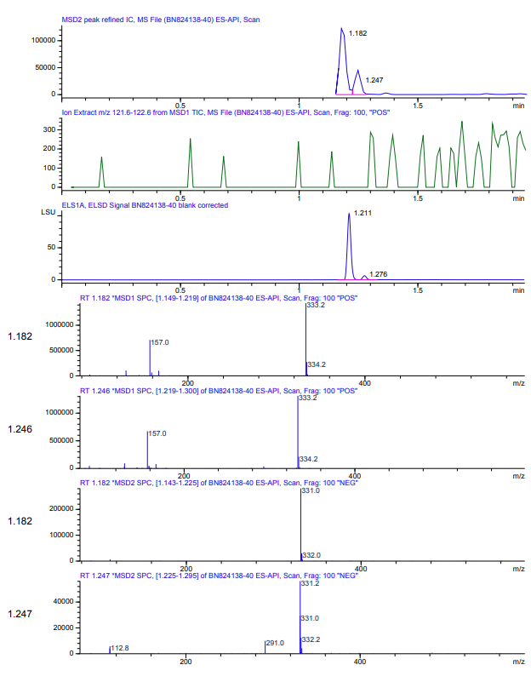

¹H NMR spectra of compound 1.6
¹³C NMR spectra of compound 1.6
LC-MS spectra of compound 1.7
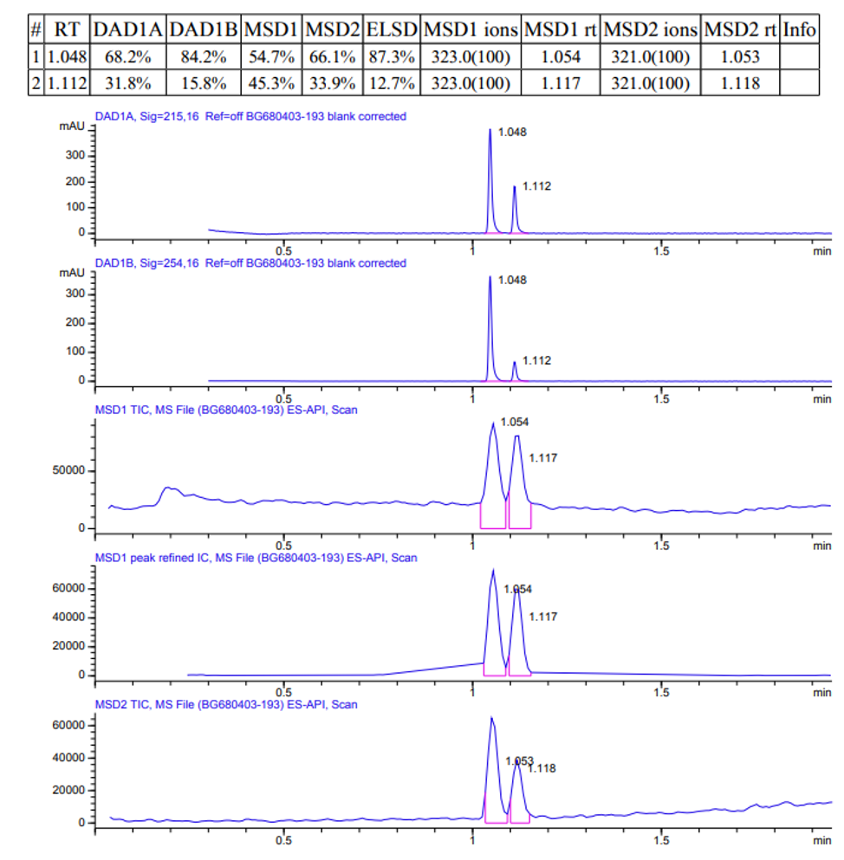
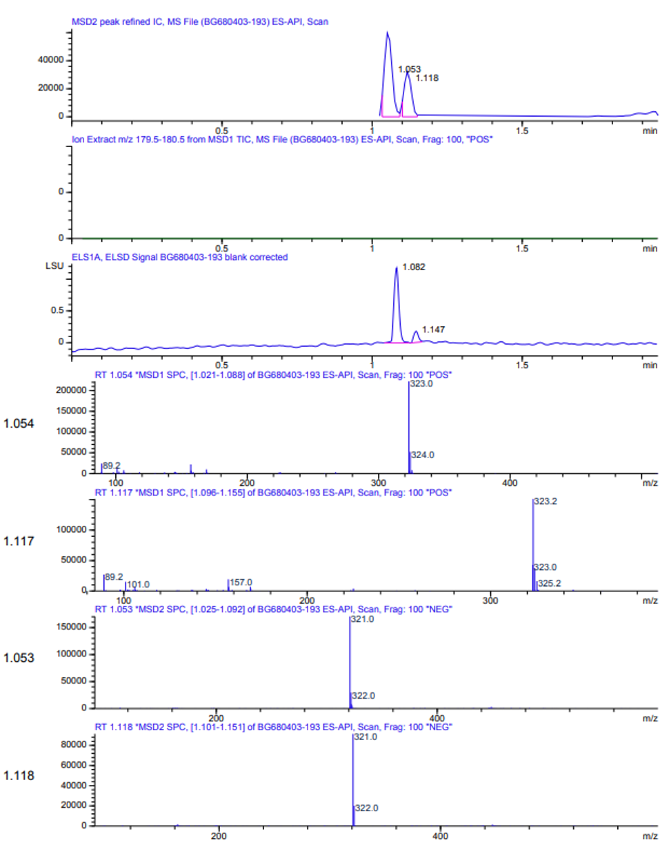

¹H NMR spectra of compound 1.7
¹³C NMR spectra of compound 1.7

