Supplementary material
Fatigue is associated with stimulus-related theta and alpha power and distinguishes subjective from objective cognition in a post-viral cohort: A cross-sectional study
Christian Neumannª, Lara Godbersen^{b}, Lily Schmeer^{b}, Janka Marlene Hauffe^{b}, Katharina Helzel^{b}, Johanna Geritzª, Gesine Hermannª, Lina Stagnethª, Lara Egerer^{b}, Louis Fuglsangª, Marc Buschung^{b}, Lennart Reinke^{c}, Susanne Poick^{c}, Wolfgang Lieb^{d}, Katrin Franzpoetter^{d}, Anne-Kathrin Ruß^{e,f,g}, Sina Pütz^{h}, Shimita Raquib^{i}, Lena Schmidbauer^{j,k}, J. Janne Vehreschild^{i}, Bettina Lorenz-Depiereux^{l}, Stefan Schreiber^{c}, Michael Krawczak^{g}, Thomas Bahmer^{c,m}, Jan Heyckendorf^{c,m}, Walter Maetzlerª, Julian Keil^{n,o}, Julius Welzel^{a,p}

a Neurology Department, University Medical Center Schleswig-Holstein, Campus Kiel, Arnold-Heller-Straße 3, 24105 Kiel, Germany
b Department of General Psychology I and Biological Psychology, Christian-Albrechts-University Kiel, Neufeldstraße 4a, 24118 Kiel, Germany
c Internal Medicine Department I, University Hospital Schleswig-Holstein, Campus Kiel, Arnold-Heller-Straße 3, 24105 Kiel, Germany
d Institute for Epidemiology, Christian-Albrechts-University Kiel, Niemannsweg 11, 24105 Kiel, Germany
e Institute of Clinical Studies and Digitalization, Medical Statistics, Health and Medical University Erfurt, Dalbergsweg 5, 99084 Erfurt, Germany
f Department of Human Medicine, Health and Medical University Erfurt, Dalbergsweg 5, 99084 Erfurt, Germany
g Institute of Medical Statistics, Kiel University, University Medical Center Schleswig-Holstein, Campus Kiel, Brunswiker Straße 10, 24105 Kiel, Germany
h Department I of Internal Medicine, Division of Infectious Diseases, University of Cologne, Faculty of Medicine, University Hospital Cologne, Kerpener Straße 62, 50937 Cologne, Germany
i Institute for Digital Medicine and Clinical Data Science, Goethe University Frankfurt, Faculty of Medicine, Marienburgstraße 6, 60528 Frankfurt am Main, Germany
j Institute of Clinical Epidemiology and Biometry, University of Würzburg, Josef-Schneider-Straße 2, 97080 Würzburg, Germany
k Institute for Medical Data Science, University Hospital Würzburg, Josef-Schneider-Straße 2, 97080 Würzburg, Germany
l Institute of Epidemiology, Helmholtz Zentrum München, Ingolstädter Landstraße 1, 85764 Neuherberg, Germany
m Institute of Medical Informatics and Artificial Intelligence, Kiel University, University Medical Center Schleswig-Holstein, Campus Kiel, Kaistraße 101, 24114 Kiel, Germany
n Airway Research Center North (ARCN), German Center for Lung Research (DZL), Wöhrendamm 80, 22927 Großhansdorf, Germany
o Department of Psychology, University of Potsdam, Karl-Liebknecht-Straße 24 - 25, 14476 Potsdam, Germany
p Department of Psychiatry and Psychotherapy, Clinical Neurotechnology Laboratory, Charité - Universitätsmedizin Berlin, Charitéplatz 1, 10117 Berlin, Germany
q Department of Psychology, Neuropsychology Lab, Carl-von-Ossietzky University Oldenburg, Ammerländer Heerstraße 114 - 118, 26129 Oldenburg, Germany

Supplementary methods

EEG preprocessing
All filters were implemented as onepass-zerophase, Hamming-windowed sinc finite impulse response (FIR) filters.
For artifact identification, low-pass filtering was performed with an order of 332, cutoff frequency (−6 dB) at 40 Hz, transition width of 10 Hz, passband 0–35 Hz, and stopband 45–500 Hz. High-pass filtering was performed with an order of 1652, cutoff frequency (−6 dB) at 1 Hz, transition width of 2 Hz, and passband 2–500 Hz.
Channels were rejected if channel variance exceeded the median channel variance by at least one median absolute deviation or exceeded an absolute variance threshold of 1500. One-second segments with z-scores >2 or <-2 were excluded.
Independent components were classified as artifacts using ICLabel and pop_icflag if classified as muscle (≥30% confidence), eye (≥80%), heart (≥40%), line noise (≥30%), channel noise (≥30%), or other artifact (≥35%).
For spectral power analysis, low-pass filtering was performed with an order of 148, cutoff frequency (−6 dB) at 90 Hz, transition width of 22.5 Hz, passband 0–78.8 Hz, and stopband 101.2–500 Hz. A band-stop filter (49–51 Hz) was applied with an order of 1652 and a transition width of 2 Hz.
Trials were rejected using pop_jointprob with thresholds of 3 SD for both single-channel and global joint probability.
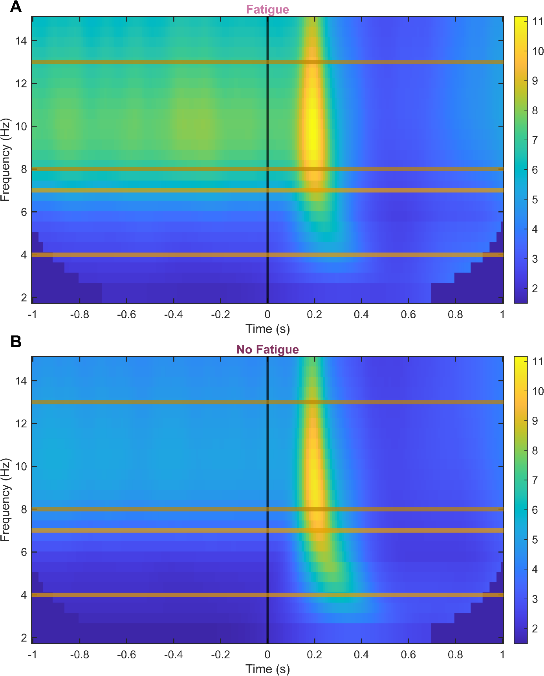
Supplementary Figure S1. Time-frequency plots show the power over all channels (in µV²) of frequencies from 2 to 15 over time, averaged across all PVT trials and all participants separately for the groups (A) with and (B) without clinically significant fatigue. Pre- or post-stimulus periods are separated by a black vertical line; colored horizontal lines highlight the alpha (8 - 12 Hz) and theta (4 - 7 Hz) area. Yellow areas show an increase in activity. PVT, Psychomotor Vigilance Task.

