SUPPLEMENTARY MATERIAL

Optimization of kombucha production using organic green tea (Camellia sinensis) and specialty coffee (Coffea arabica): Production optimization, physicochemical composition, microbial viability, and sensory evaluation

Radharani de Melo Serafim Ferreira, Ana Camile Assis de Jesus, Jaqueline dos Santos de Jesus, Beatriz Fernandes Vieira, Wallysson Wagner Vilela Santos, Manuela Barreto Nascimento, Paulo Roberto Ribeiro de Mesquita, Bruno Nicolau Paulino, Cosme Damião Barbosa, Maria Eugênia de Oliveira Mamede

Table S1 Matrix of Central Composite Rotatable Design (CCDR) with experimental and predicted yield (Y1 = pH; Y2 = Volatile acidity; Y3 = Total Titratable Acidity)
Run | $x$₁ | $x$₂ | $x$₃ | $Y$₁ |  |  | $Y$₂ |  |  |  |  | $Y$₃
 |  |  |  | Experimental | Predicted | Resids | Experimental | Predicted | Resids | Experimental | Predicted |  | Resids
1 | -1 | -1 | -1 | 3.21 | 3.22 | -0.011550 | 22.25 | 18.68 | 3.56748 | 53.60 | 55.29 |  | -1.69149
2 | +1 | -1 | -1 | 3.29 | 3.28 | 0.011491 | 18.46 | 20.78 | -2.31547 | 54.61 | 60.60 |  | -5.99209
3 | -1 | +1 | -1 | 3.21 | 3.21 | 0.001415 | 38.68 | 41.97 | -3.28567 | 88.99 | 91.99 |  | -3.00422
4 | +1 | +1 | -1 | 3.23 | 3.26 | -0.025544 | 37.17 | 35.84 | 1.32639 | 88.99 | 89.71 |  | -0.72481
5 | -1 | -1 | +1 | 3.25 | 3.23 | 0.024477 | 17.70 | 19.54 | -1.84469 | 41.46 | 45.12 |  | -3.66077
6 | +1 | -1 | +1 | 3.23 | 3.20 | -0.002482 | 24.52 | 21.75 | 2.76736 | 51.58 | 52.96 |  | -1.38136
7 | -1 | +1 | +1 | 3.19 | 3.20 | -0.012557 | 48.04 | 46.24 | 1.79717 | 106.19 | 104.58 |  | 1.60651
8 | +1 | +1 | +1 | 3.21 | 3.20 | 0.010483 | 36.15 | 40.24 | -4.08578 | 102.14 | 104.83 |  | -2.69409
9 | -1.68 | 0 | 0 | 3.19 | 3.19 | -0.001576 | 30.09 | 30.48 | -0.38918 | 76.86 | 74.96 |  | 1.89927
10 | +1.68 | 0 | 0 | 3.24 | 3.24 | 0.003084 | 28.31 | 27.19 | 1.12218 | 83.94 | 79.63 |  | 4.30288
11 | 0 | -1.68 | 0 | 3.26 | 3.27 | -0.013557 | 12.89 | 14.43 | -1.54294 | 46.52 | 41.06 |  | 5.45246
12 | 0 | +1.68 | 0 | 3.25 | 3.23 | 0.015066 | 51.83 | 49.55 | 2.27594 | 116.30 | 115.55 |  | 0.74968
13 | 0 | 0 | -1.68 | 3.25 | 3.24 | 0.013868 | 29.07 | 28.90 | 0.17067 | 73.82 | 69.14 |  | 4.67169
14 | 0 | 0 | +1.68 | 3.18 | 3.19 | -0.012359 | 33.88 | 33.32 | 0.56232 | 74.84 | 73.30 |  | 1.53046
15 | 0 | 0 | 0 | 3.23 | 3.22 | 0.009914 | 28.32 | 30.89 | -2.56859 | 66.75 | 75.19 |  | -8.44137
16 | 0 | 0 | 0 | 3.22 | 3.22 | -0.000086 | 29.58 | 30.89 | -1.30859 | 71.80 | 75.19 |  | -3.39137
17 | 0 | 0 | 0 | 3.21 | 3.22 | -0.010086 | 34.64 | 30.89 | 3.75141 | 85.96 | 75.19 |  | 10.76863

Table S2 Effects estimates for independent variables (Y1 = pH; Y2 = Volatile acidity; Y3 = Total Titratable Acidity)
Source | Effect | Std.Err. | t(2) | p
(a) $Y$₁
Mean/Interc. | 3.220086 | 0.005762 | 558,8288 |  | 0.000003*
$x$₁ | 0.026959 | 0.005412 | 4.9814 |  | 0.038016*
$x$₂ | -0.022965 | 0.005412 | -4.2435 |  | 0.051298
$x$₃ | -0.026027 | 0.005412 | -4.8092 |  | 0.040620*
$x$₁ $x$₂ | -0.005000 | 0.007071 | -0.7071 |  | 0.552786
$x$₁ $x$₃ | -0.025000 | 0.007071 | -3.5355 |  | 0.071523
$x$₂ $x$₃ | -0.005000 | 0.007071 | -0.7071 |  | 0.552786
$$x_{1}^{2}$$ | -0.004130 | 0.005957 | -0.6933 |  | 0.559792
$$x_{2}^{2}$$ | 0.024154 | 0.005957 | 4.0550 |  | 0.055776
$$x_{3}^{2}$$ | -0.004130 | 0.005957 | -0.6933 |  | 0.559792
(b) $Y$₂
Mean/Interc. | 30.88859 | 1.927450 | 16.02562 |  | 0.003871*
$x$₁ | -1.95705 | 1.810294 | -1.08107 |  | 0.392688
$x$₂ | 20.88314 | 1.810294 | 11.53578 |  | 0.007431*
$x$₃ | 2.62717 | 1.810294 | 1.45124 |  | 0.283816
$x$₁ $x$₂ | -4.10750 | 2.365262 | -1.73659 |  | 0.224593
$x$₁ $x$₃ | 0.05750 | 2.365262 | 0.02431 |  | 0.982813
$x$₂ $x$₃ | 1,70750 | 2.365262 | 0.72191 |  | 0.545345
$$x_{1}^{2}$$ | -1.45316 | 1.992492 | -0.72932 |  | 0.541653
$$x_{2}^{2}$$ | 0.78129 | 1.992492 | 0.39212 |  | 0.732811
$$x_{3}^{2}$$ | 0.15550 | 1.992492 | 0.07804 |  | 0.944898
(c) $Y$₃
Model | 75.19137 | 5.738301 | 13.10342 |  | 0.005774*
$x$₁ | 2.78060 | 5.389510 | 0.51593 |  | 0.657279
$x$₂ | 44.28773 | 5.389510 | 8.21739 |  | 0.014488*
$x$₃ | 2.47428 | 5.389510 | 0.45909 |  | 0.691235
$x$₁ $x$₂ | -3.79500 | 7.041734 | -0.53893 |  | 0.643900
$x$₁ $x$₃ | 1.26500 | 7.041734 | 0.17964 |  | 0.873986
$x$₂ $x$₃ | 11.38000 | 7.041734 | 1.61608 |  | 0.247457
$$x_{1}^{2}$$ | 1.49026 | 5.931942 | 0.25123 |  | 0.825094
$$x_{2}^{2}$$ | 2.20444 | 5.931942 | 0.37162 |  | 0.745851
$$x_{3}^{2}$$ | -2.80187 | 5.931942 | -0.47234 |  | 0.683210
x1 = Coffee; x2 = Tea; x3 = Sucrose. *Statistically significant at the p < 0.05 level by ANOVA.

Table S3 Regression coefficient estimates and statistical parameters for the CCDR model of pH (a, Y1), volatile acidity (mEq/L) (b, Y2), and total titratable acidity (mEq/L) (c, $Y$₃)
Source | Coeff. | Std.Err. | t(2) | p
(a) $Y$₁
Mean/Interc. | 3.220086 | 0.005762 | 558.8288 |  | 0.000003*
$x$₁ | 0.013480 | 0.002706 | 4.9814 |  | 0.038016*
$x$₂ | -0.014883 | 0.002706 | -4.2435 |  | 0.051298
$x$₃ | -0.013014 | 0.002706 | -4.8092 |  | 0.040620*
$x$₁ $x$₂ | -0.002500 | 0.003536 | -0.7071 |  | 0.552786
$x$₁ $x$₃ | -0.012500 | 0.003536 | -3.5355 |  | 0.071523
$x$₂ $x$₃ | -0.002500 | 0.003536 | -0.7071 |  | 0.552786
$$x_{1}^{2}$$ | -0.002065 | 0.002978 | -0.6933 |  | 0.559792
$$x_{2}^{2}$$ | 0.012077 | 0.002978 | 4.0550 |  | 0.055776
$$x_{3}^{2}$$ | -0.002065 | 0.002978 | -0.6933 |  | 0.559792
(b) $Y$₂
Mean/Interc. | 30.88859 | 1.927450 | 16.02562 |  | 0.003871*
$x$₁ | -0.97853 | 0.905147 | -1.08107 |  | 0.392688
$x$₂ | 10.44157 | 0.905147 | 11.53578 |  | 0.007431*
$x$₃ | 1.31358 | 0.905147 | 1.45124 |  | 0.283816
$x$₁ $x$₂ | -2.05375 | 1.182631 | -1.73659 |  | 0.224593
$x$₁ $x$₃ | 0.02875 | 1.182631 | 0.02431 |  | 0.982813
$x$₂ $x$₃ | 0.85375 | 1.182631 | 0.72191 |  | 0.545345
$$x_{1}^{2}$$ | -0.72658 | 0.996246 | -0.72932 |  | 0.541653
$$x_{2}^{2}$$ | 0.39065 | 0.996246 | 0.39212 |  | 0.732811
$$x_{3}^{2}$$ | 0.07775 | 0.996246 | 0.07804 |  | 0.944898
(c) $Y$₃
Mean/Interc. | 75.19137 | 5.738301 | 13.10342 |  | 0.005774*
$x$₁ | 1.39030 | 2.694755 | 0.51593 |  | 0.657279
$x$₂ | 22.14386 | 2.694755 | 8.21739 |  | 0.014488*
$x$₃ | 1.23714 | 2.694755 | 0.45909 |  | 0.691235
$x$₁ $x$₂ | -1.89750 | 3.520867 | -0.53893 |  | 0.643900
$x$₁ $x$₃ | 0.63250 | 3.520867 | 0.17964 |  | 0.873986
$x$₂ $x$₃ | 5.69000 | 3.520867 | 1.61608 |  | 0.247457
$$x_{1}^{2}$$ | 0.74513 | 2.965971 | 0.25123 |  | 0.825094
$$x_{2}^{2}$$ | 1.10222 | 2.965971 | 0.37162 |  | 0.745851
$$x_{3}^{2}$$ | -1.40094 | 2.965971 | -0.47234 |  | 0.683210
x1 = Coffee; x2 = Tea; x3 = Sucrose. *Statistically significant at the p < 0.05 level by ANOVA.

Table S4 Microbiological counts of yeasts and acetic acid bacteria in kombucha samples (Log₁₀ CFU/mL)
Samples | K3 | K4 | K7 | K8 | K12 | K14
Acetic acid bacteria | 5.77 | 5.49 | 6.09 | 6.33 | 6.18 | 5.94
Yeasts | 6.89 | 6.36 | 6.46 | 6.25 | 4.69 | 6.43

Fig. S1 Sum of relative peak areas of volatile organic compound classes identified in the kombucha samples (K3, K4, K7, K8, K12, and K14)
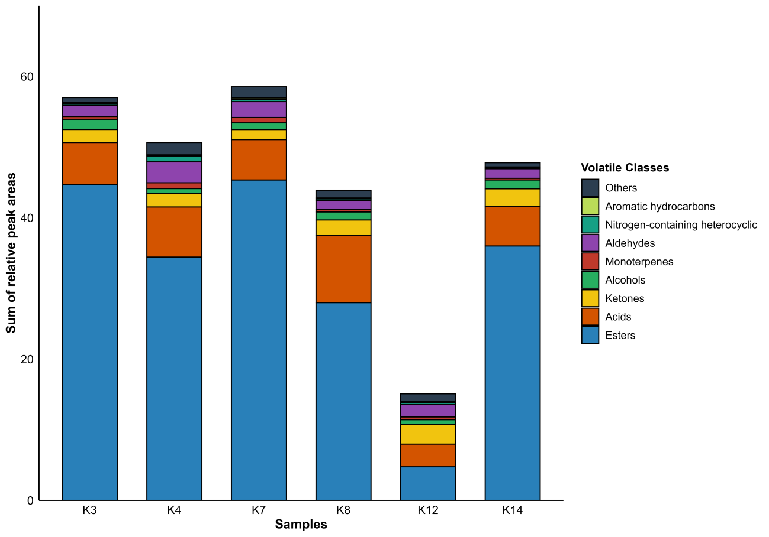
The values represent the sum of the relative chromatographic peak areas of all individual volatile compounds grouped within each chemical class.

Fig. S2 Sensory attributes (Global Acceptance, Aroma, Flavor, and Appearance) of the different kombucha formulations (K3, K4, K7, K8, K12, and K14) evaluated on a 9-point hedonic scale (n=60)

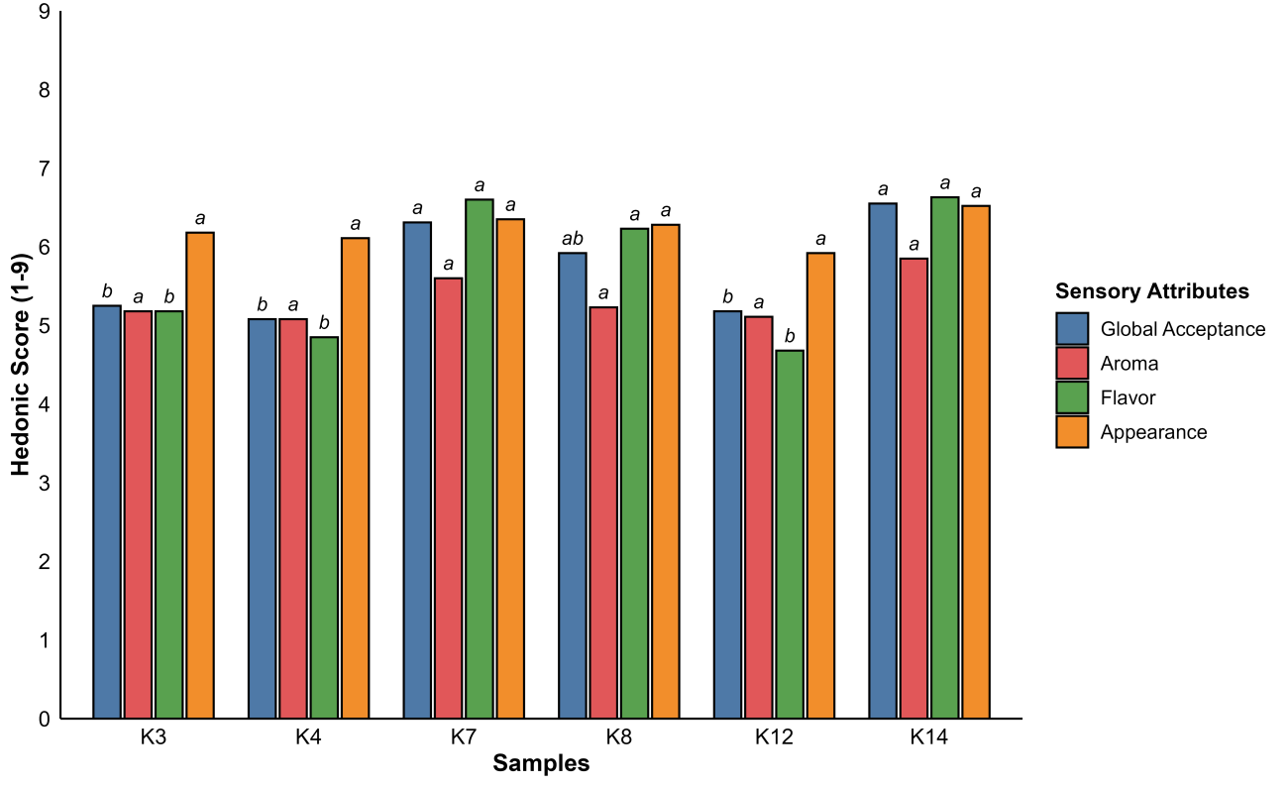
Values are expressed as mean. Different lowercase letters above the bars indicate significant differences between samples for the same attribute by Tukey's test.
Fig. S3 Purchase intent of the six kombucha formulations (K3, K4, K7, K8, K12, and K14) evaluated by a 5-point Likert scale (n = 60)
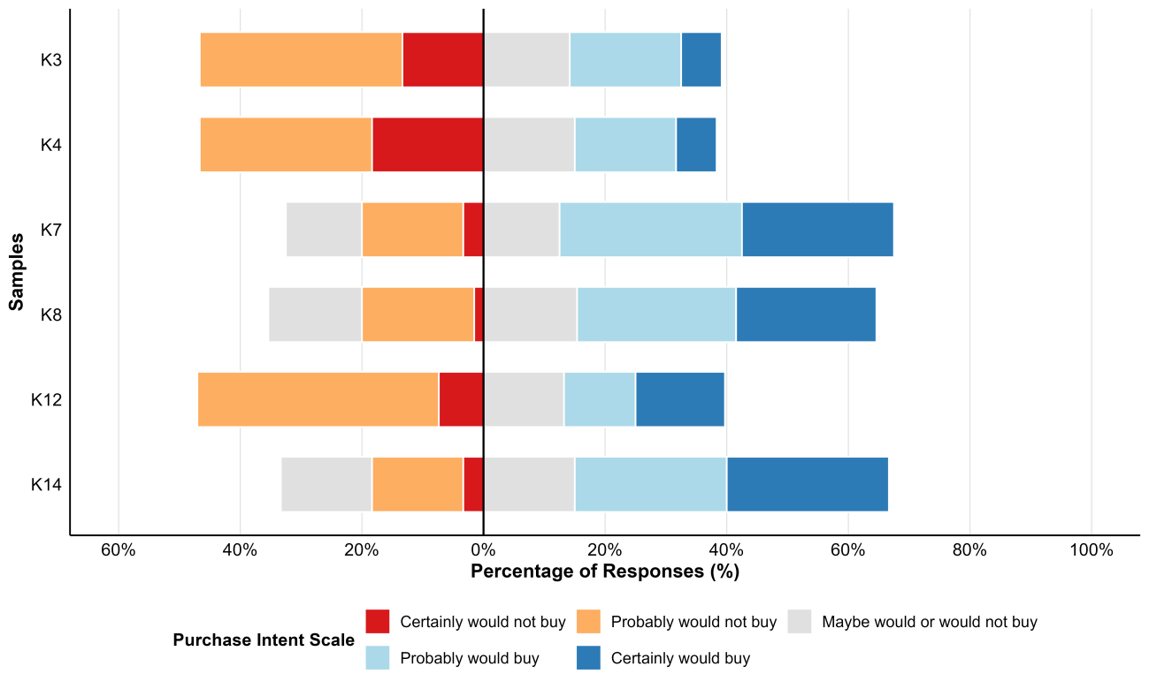
The vertical solid line represents the neutral threshold ("Maybe would or would not buy"), with rejection categories stacked to the left and acceptance categories stacked to the right.
Table S5 Preference ranking test results for the kombucha formulations selected based on their highest global acceptance score
Samples | Sum | Group*
K7 | 122 | a
K8 | 110 | a
K14 | 128 | a
*Identical letters within the column indicate no significant difference among the samples according to the Friedman/rank-sum test (n = 60, p < 0,05).

Table S6 Eigenvalues. coordinates. contribution of variables. and cosine square values of the active groups used in Multiple Factor Analysis (MFA)
MFA | Dim1 | Cont | Cos² | Dim2 | Cont | Cos² | Dim3 | Cont | Cos²
Eigenvalues | 2.34 | - | - | 1.91 | - | - | 1.16 | - | -
Percent of variance | 30.38 | - | - | 24.82 | - | - | 15.02 | - | -
Cumulative percent of variance | 30.38 | - | - | 55.21 | - | - | 70.23 | - | -
Active Groups
MV | 0.22 | 9.29 | 0.04 | 0.92 | 48.08 | 0.73 | 0.06 | 5.06 | 0.00
SEN | 0.88 | 37.58 | 0.77 | 0.04 | 1.97 | 0.00 | 0.08 | 7.03 | 0.01
PCC | 0.92 | 39.28 | 0.48 | 0.44 | 23.11 | 0.11 | 0.57 | 48.98 | 0.18
VOC | 0.32 | 13.85 | 0.07 | 0.51 | 26.84 | 0.17 | 0.45 | 38.93 | 0.13
(-) Not applicable; Dim – Dimension; Cont – Contribution (%); Cos² – Cosine squared; MV – Microbiological viability; PCC – Physicochemical and chemical; SEN – Sensory; VOC – Volatile Organic Compounds.

Fig. S4 Pearson correlation matrix for microbiological viability. physicochemical and chemical properties. sensory characteristics. and volatile compounds in kombucha made using coffee as a fermentation substrate
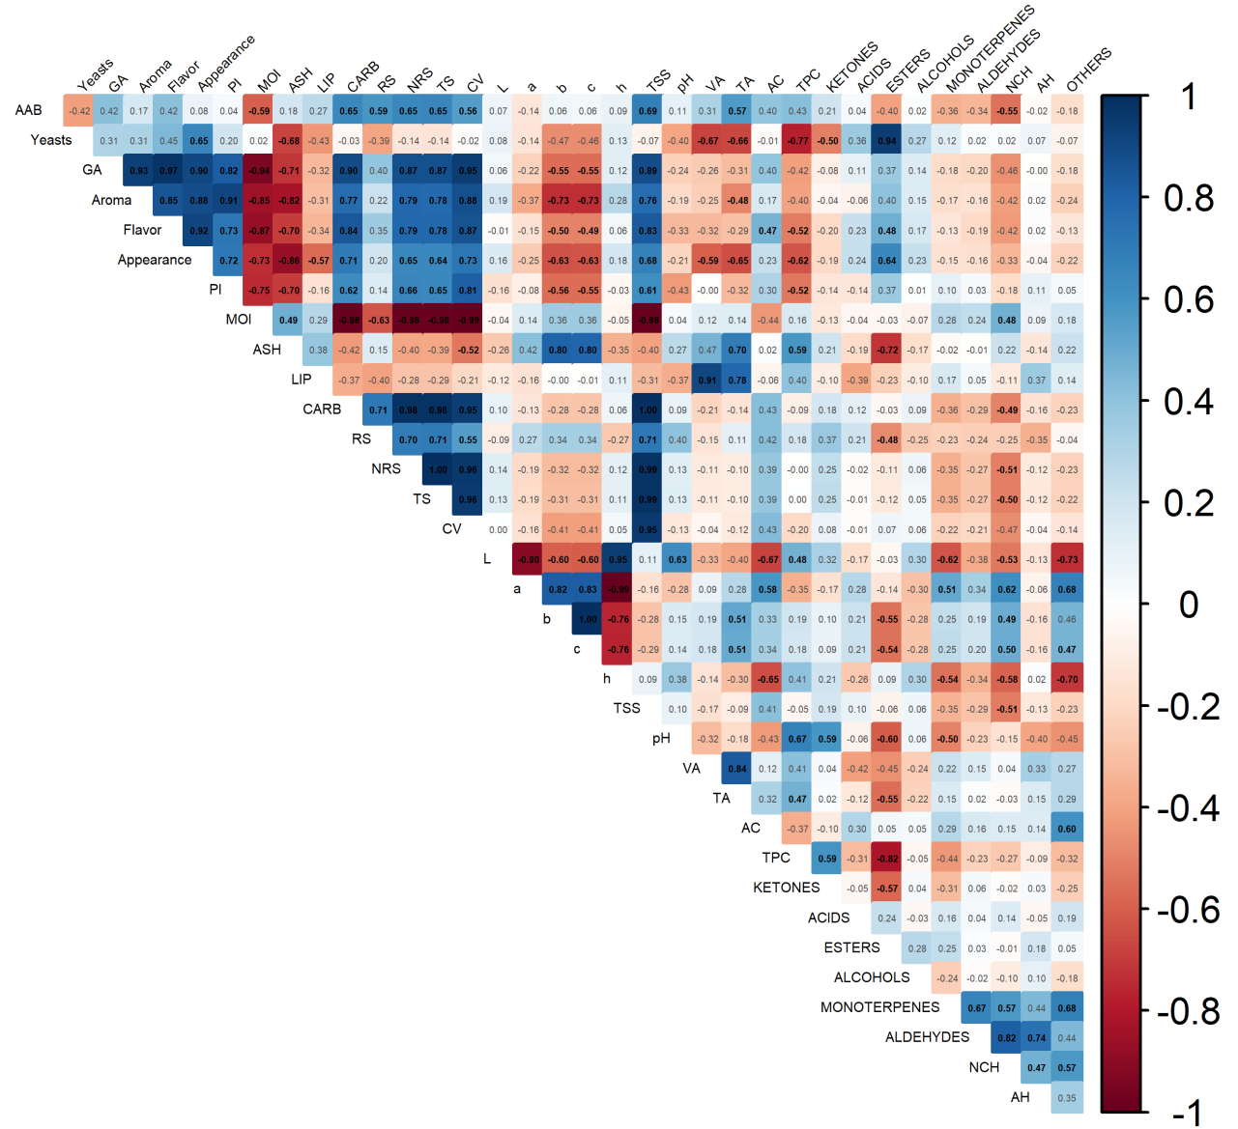
Highlighted values (black) indicate statistically significant correlations (p < 0.05). whereas faded/grayed-out values indicate non-significant correlations. AAB – acetic acid bacteria; GA – Global acceptance; PI – Purchase intent; MOI – Moisture; LIP – Lipids; CARB – Carbohydrates; RS – Reducing sugar; NRS – Non-reducing sugar; TS – Total sugar; CV – Caloric value; TSS – Total soluble solids; VA – Volatile acidity; TA – Total acidity; AC – Alcoholic content; TPC – Total phenolic compounds; NCH – Nitrogen-containing heterocyclic; AH – Aromatic hydrocarbons.

Fig. S5 Representative appearance of the six coffee kombucha formulations (K3, K4, K7, K8, K12, and K14) produced for physicochemical, microbiological, volatile, and sensory analyses
