Supplementary Appendix: Intravenous Phosphate Supplementation and 28-Day Mortality in ICU Patients with Mild-to-Moderate Hypophosphatemia — A Sequential Target Trial Emulation

Table of contents
Supplementary Appendix 5
Overview 5
Part A: Reporting Checklist 6
Table S1: TARGET 2025 Reporting Checklist 6
Part B: Study Population and Sequential Enrollment 18
Table S2: Sequential Trial Period Enrollment Overview 18
Figure S1: Sequential Trial Enrollment Structure 20
Part C: Baseline Covariate Balance 21
Table S3: DAG14 Baseline Covariate Balance 21
Figure S2: DAG14 Covariate Love Plot (Before/After IPTW Weighting) 23
Part D: Secondary Outcomes 24
Figure S3: Secondary Outcomes Forest Plot (CCW ITT) 24
Table S4: Logistic Regression Sensitivity Analysis (Secondary Outcomes) 25
Part E: Temporal Patterns of the Primary Outcome 26
Table S5: Daily-Resolution Hazard Ratios (Days 1–14) 26
Figure S4: Daily-Resolution Hazard Ratios (Days 1–14) 28
Table S6: Piecewise Hazard Ratios by Follow-up Interval 28
Figure S5: Piecewise Hazard Ratios by Follow-up Interval 29
Part F: Covariate Selection and Cross-Validation 30
Table S7: MITS-LASSO Complete Variable Selection Report and DAG Cross-Validation 30
Part A: MITS-LASSO Complete Variable Selection Frequencies 30
Part B: Model Comparison Summary 35
Figure S6: DAG14 Causal Diagram 37
Part G: GRADE Evidence Quality 38
Table S8: GRADE Evidence Quality Assessment 38
Part H: Sensitivity Analyses 41
Table S9: Summary of Sensitivity Analyses (SA1–SA14) 41
Figure S7: Primary and Sensitivity Analysis Forest Plot 46
Figure S8: Method Comparison Forest Plot 47
Figure S9: Oral vs. Non-Oral Phosphate Stratification Forest Plot 48
Figure S10: E-value Sensitivity Analysis Curve 49
Figure S11: MNAR Sensitivity Analysis (Delta-Adjustment Tipping Points) 50
Part I: CCW Censoring Statistics and Diagnostics 51
Table S10: CCW Censoring Statistics and Diagnostics 51
Table S10-A: Period-Specific Censoring Rates 51
Table S10-B: Censoring Rate by Treatment Arm (Censoring Treatment Ratio, CTR) 51
Table S10-C: Censored vs. Uncensored Baseline Characteristics (Informative Censoring Detection) 52
Part J: Exploratory Analyses 53
Figure S12: Proportional Hazards Diagnostics (Schoenfeld Residual Tests) 54
Figure S13: Interaction Test Forest Plot 55
Figure S14: Cumulative IV Phosphate Dose-Response Analysis 56
Figure S15: Potassium Phosphate vs. Sodium Phosphate Formulation Analysis 57
Figure S16: Phosphate Threshold Dose-Response Forest Plot 58
Detailed Methodological Notes 59
§1. Target Trial Emulation Design 59
§2. Cohort Construction and Eligibility Criteria 59
§3. Cloning-Censoring-Weighting (CCW) Framework 61
§4. SEQTaRget Implementation Details 61
§5. Covariate Selection and DAG14 62
§6. Multiple Imputation and Rubin’s Rules 63
§7. Secondary Outcomes and Multiplicity Control 64
§8. Sensitivity Analysis Methods 64
§9. Missing-Not-at-Random (MNAR) Sensitivity Analysis 65
§10. Statistical Software and Reproducibility 65
Supplementary Methods 66
Supplementary Method M1: DAG14 Covariate Selection Rationale 66
Supplementary Method M2: PPPL (Person-Period Pooled Logistic) Framework Detailed Description 67
Supplementary Method M3: E-value and Delta-Adjustment Sensitivity Analyses 69
Supplementary Method M4: Phosphate Threshold Dose-Response Analysis 70
Supplementary References 70
Supplementary Reference R1: Statistical Software 70
Supplementary Reference R2: Data Availability Statement 71
Supplementary Documents 71
Supplementary Document S1: Statistical Analysis Plan (SAP) 71
Supplementary Document S2: Fine-Gray Competing Risks Model 72
Supplementary Document S3: PPPL Framework Detailed Description 72
Supplementary Figure Index 73

Supplementary Appendix
Manuscript: Intravenous Phosphate Supplementation and 28-Day Mortality in ICU Patients with Mild-to-Moderate Hypophosphatemia: A Sequential Target Trial Emulation
Target Journal: Journal of Intensive Care (BioMed Central)

Overview
This appendix provides the supplementary tables, figures, methodological notes, and documents referenced in the main manuscript. To improve readability, the material is organized into thematic parts, each pairing the figure(s) directly with the table or methodological text they illustrate. All figure and table numbers (S1–S16; S1–S10) are retained unchanged from the main-manuscript cross-references, and an index of all supplementary figures is provided at the end of this document.
Contents at a glance:
- Part A — Reporting checklist (Table S1)
- Part B — Study population and sequential enrollment (Table S2; Figure S1)
- Part C — Baseline covariate balance (Table S3; Figure S2)
- Part D — Secondary outcomes (Figure S3; Table S4)
- Part E — Temporal patterns of the primary outcome (Table S5; Figure S4; Table S6; Figure S5)
- Part F — Covariate selection and cross-validation (Table S7; Figure S6)
- Part G — GRADE evidence quality (Table S8)
- Part H — Sensitivity analyses (Table S9; Figures S7, S8, S9, S10, S11)
- Part I — CCW censoring statistics and diagnostics (Table S10)
- Part J — Exploratory analyses (Figures S12, S13, S14, S15, S16)
- Detailed Methodological Notes (§1–§10), Supplementary Methods (M1–M4), Supplementary References (R1–R2), and Supplementary Documents (S1–S3)

Part A: Reporting Checklist

Table S1: TARGET 2025 Reporting Checklist
This study adheres to the TARGET 2025 reporting guideline for target trial emulation studies [15]. The checklist follows the official 21 required items (6 sections: abstract, introduction, methods, results, discussion, other information); the methods section reports the target trial protocol (item 6) and its emulation (item 7) in a parallel structure. All checklist items are addressed below.
Table S1. TARGET 2025 checklist items, each with reporting status and corresponding manuscript section. All items are reported.
# | Item | Status | Section / Page
Abstract
1a | State that the study attempted to emulate a target trial using observational data; describe the study objective and briefly outline the specified target trial protocol | Reported | Title & Abstract
1b | Report the data sources used for the emulation | Reported | Abstract
1c | Summarize key assumptions, statistical methods, results, and conclusions | Reported | Abstract
Background
2 | Background and rationale: scientific background and existing knowledge gaps | Reported | Background
3 | Causal question: the causal question to be tested | Reported | Background
4 | Rationale for emulation: theoretical basis for emulating a target trial with existing data; cite any relevant randomized trials | Reported | Background
Methods
5 | Data sources: list all data sources (original purpose, data type, coverage, setting, time frame); describe mapping/merging if data integration is involved | Reported | Methods — Study Design and Data Source
Target trial protocol (item 6) and its emulation (item 7)
6/7 | Specify the components of the target trial protocol that address the causal question (6) and how each component was emulated using observational data, including measurement/ascertainment of all variables (7) | Reported | Methods; Table 1
6a/7a | Eligibility criteria: describe eligibility criteria (6a) and how they were implemented in the data (7a) | Reported | Methods — Inclusion and Exclusion Criteria; Table 1
6b/7b | Treatment strategies: describe the treatment strategies to be compared (6b) and how each strategy was implemented in the data (7b) | Reported | Methods — Emulation of the Target Trial; Table 1
6c/7c | Assignment procedure: participants randomly assigned to treatment groups, possibly aware of assignment (6c); how treatment assignment was implemented in the data (7c) | Reported | Methods — Emulation of the Target Trial; Table 1
6d/7d | Follow-up: specify that follow-up starts at assignment and the end of follow-up (6d); confirm follow-up start and how follow-up end was determined in the data (7d) | Reported | Methods — Emulation of the Target Trial; Table 1
6e/7e | Outcome: describe the outcomes (6e) and how they were ascertained in the data (7e) | Reported | Methods — Follow-up and Outcomes
6f/7f | Causal contrast: describe the causal contrast (e.g., ITT) and effect measures such as hazard ratios (6f); how the causal contrast was implemented, including effect estimation methods (7f) | Reported | Methods — Primary Analysis: CCW ITT with RMST Difference
6g/7g | Identifying assumptions: assumptions required to identify each causal estimand and related variables (6g); baseline confounding assumptions due to lack of randomization (7g.i) and methods to handle related variables in the data (7g.ii) | Reported | Methods — DAG-Driven Covariate Selection; Primary Analysis
6h/7h | Data analysis plan: analysis process, statistical modeling assumptions, and missing data handling for each estimand (6h); implementation in the data (7h.i) and additional analyses to assess robustness (7h.ii) | Reported | Methods — Sensitivity Analyses; Supplementary Table S9
Results
8 | Participants: number assessed, eligible, and assigned to each treatment group; flow diagram strongly recommended | Reported | Results — Study Population; Figure 1
9 | Baseline data: baseline characteristics by treatment group | Reported | Results; Table 2; Table S3
10 | Follow-up: summarize follow-up duration and reasons for end of follow-up by treatment group and causal contrast | Reported | Results; Table S2
11 | Missing data: frequency of missing data for all variables, by treatment group where applicable | Reported | Methods — Missing Data Processing; Results
12 | Outcomes: frequency or distribution of each outcome by treatment group | Reported | Results — Secondary Outcomes; Table 3
13 | Effect estimates: report the effect estimate and precision for each causal contrast, including absolute and relative effect measures when applicable | Reported | Results — Primary Analysis; Table 3; Figure 3
14 | Additional analyses: report all sensitivity analyses assessing robustness of estimates to implementation, assumption, and analysis choices | Reported | Results — Sensitivity Analyses; Supplementary Table S9
Discussion
15 | Interpretation: professional interpretation of the main findings | Reported | Discussion
16 | Limitations: systematic discussion considering differences between the target trial and its emulation and the plausibility of assumptions, including baseline confounding assumptions due to lack of randomization | Reported | Discussion — Limitations
Other Information
17 | Ethics approval: provide the name of the institutional review board or ethics committee and approval number, if applicable | Reported | Methods — Study Design and Data Source
18 | Registration: state whether and when the protocol was registered and the registry | Reported | Discussion — Multiplicity and Pre-registration
19 | Data sharing: state whether data, analysis code, and/or other materials are available and how to access them | Reported | Data Availability
20 | Funding: list funding sources and describe the role of funders in study design, conduct, and reporting | Reported | Funding — This work was supported by the Science and Technology Project of Changzhou Municipal Health Commission (grant number QN202412). The funder had no role in study design, data collection, analysis, interpretation, or manuscript writing.
21 | Conflicts of interest: declare all authors’ conflicts of interest and financial disclosures | Reported | Conflicts of Interest

Part B: Study Population and Sequential Enrollment

Table S2: Sequential Trial Period Enrollment Overview
This table summarizes the distribution of sequential trial-period enrollments, including treatment group allocation, event counts, and cumulative enrollment trajectory.
Table S2. Sequential trial period enrollment overview. Each trial period represents a distinct eligibility episode within a patient’s ICU stay, with a minimum 48-hour washout between periods. Treatment assignment reflects the ITT grouping. The treatment proportion increases from 14.3% in Period 1 to 22.0% in Period 4, consistent with more severe clinical trajectories prompting re-enrollment and treatment. The event rate also rises monotonically from 16.0% to 33.3%, reflecting the increasing severity of re-enrolled patients.
Trial Period | Enrollments (n) | Treatment (n, %) | Control (n, %) | Events (n) | Event Rate (%) | Cumulative (n)
1 | 22685 | 3249 (14.3%) | 19436 (85.7%) | 3628 | 16.0 | 22685
2 | 7262 | 1407 (19.4%) | 5855 (80.6%) | 1409 | 19.4 | 29947
3 | 1800 | 365 (20.3%) | 1435 (79.7%) | 421 | 23.4 | 31747
4 | 451 | 99 (22.0%) | 352 (78.0%) | 114 | 25.3 | 32198
5 | 103 | 22 (21.4%) | 81 (78.6%) | 30 | 29.1 | 32301
6 | 24 | 5 (20.8%) | 19 (79.2%) | 8 | 33.3 | 32325
7 | 3 | 0 (0.0%) | 3 (100.0%) | 0 | 0.0 | 32328
8 | 2 | 0 (0.0%) | 2 (100.0%) | 0 | 0.0 | 32330
Total | 32330 | 5147 (15.9%) | 27183 (84.1%) | 5610 | 17.4 | —

Figure S1: Sequential Trial Enrollment Structure
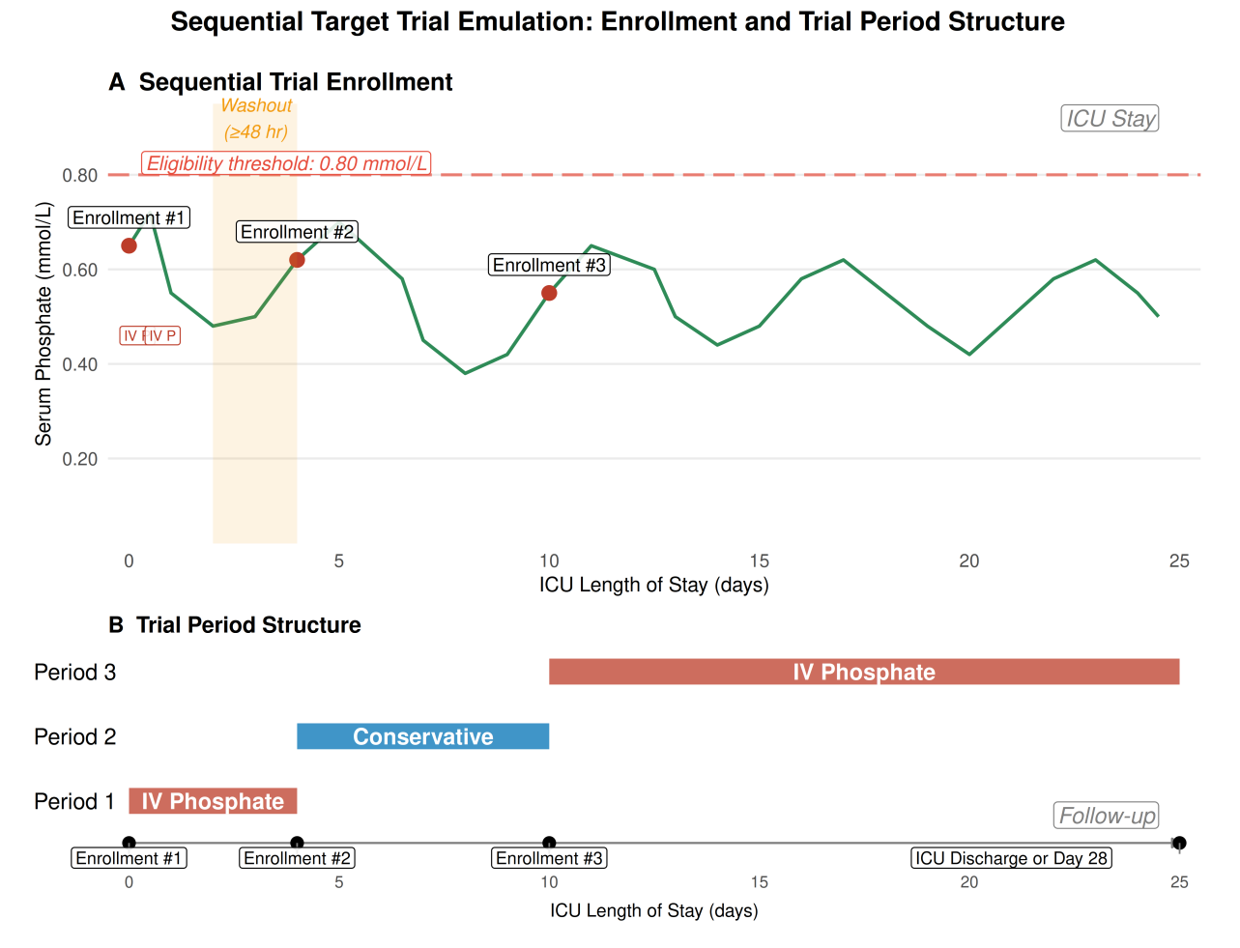
Supplementary Figure S1. Sequential trial enrollment structure diagram. Each patient could be enrolled multiple times during their ICU stay: each new episode of hypophosphatemia (serum phosphate ≤0.80 mmol/L) qualified for enrollment, with ≥48h washout between enrollments, up to 8 enrollments. Screening every 24 hours. Time zero (T0) = qualifying phosphate test; 12-hour grace window for treatment group assignment; 28-day follow-up. Under the cloning-censoring-weighting (CCW) framework, each patient was cloned to both treatment and control groups at each enrollment period, then censored by actual treatment assignment. Corresponds to Table S2 and the Methods section of the main manuscript.

Part C: Baseline Covariate Balance

Table S3: DAG14 Baseline Covariate Balance
Baseline covariate imbalance between treatment groups (IV phosphate vs. conservative management) for the 14 DAG14 covariates. Standardized mean differences (SMD) are reported; SMD < 0.1 indicates adequate balance. Variables are sorted by SMD in descending order. Values are identical to those in Table 2 of the main manuscript.
Table S3. DAG14 baseline covariate balance. Baseline imbalance (most covariates with |SMD| ≥ 0.1, notably baseline phosphate SMD=0.707) reflects indication confounding—sicker patients were more likely to receive IV phosphate supplementation (Results section). The primary analysis used the CCW ITT framework (cloning, censoring, weighting), adjusting for these DAG14 covariates to control for such confounding; this framework simulates randomized assignment and does not involve IPTW weight calculation (Methods section). Stabilized inverse probability of treatment weights from the DAG14 propensity score model (truncated at the 1st and 99th percentiles) were used in the per-protocol (SA1) and IPTW-Cox (SA4) sensitivity analyses; after weighting, all 14 DAG14 covariates achieved |SMD| < 0.1 (Supplementary Figure S2). See Methods and Supplementary Table S9.
Variable | SMD | Balance Achieved (SMD < 0.1)
Baseline phosphate | 0.707 | No
Baseline SOFA | 0.237 | No
Sepsis-3 | 0.229 | No
Invasive ventilation | 0.228 | No
Vasoactive agents | 0.214 | No
Age | 0.186 | No
Refeeding risk | 0.144 | No
Nutrition support (any) | 0.140 | No
Charlson index | 0.126 | No
Lactate | 0.116 | No
Admission type (Emergency) | 0.075 | Yes
eGFR | 0.065 | Yes
Gender (Male) | 0.047 | Yes
Corrected calcium | 0.033 | Yes

Figure S2: DAG14 Covariate Love Plot (Before/After IPTW Weighting)
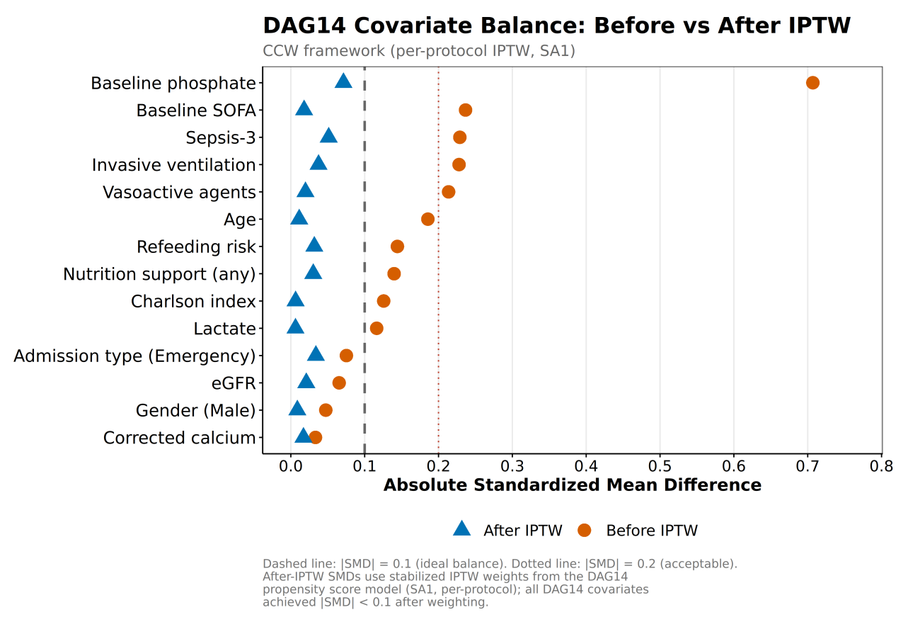
Supplementary Figure S2. Love Plot of standardized mean differences (SMD) for the DAG14 covariate set before (orange dots) and after (blue triangles) IPTW weighting. Stabilized inverse probability of treatment weights were estimated from a DAG14 propensity score model (logistic regression, truncated at the 1st and 99th percentiles; C-statistic 0.72; ESS 92.9%). Weighting substantially improved covariate balance: all 14 DAG14 covariates achieved |SMD| < 0.1 after weighting (e.g., baseline phosphate 0.707→0.071, baseline SOFA 0.237→0.018, lactate 0.116→0.006, nutrition support type 0.140→0.030), indicating adequate control of indication confounding in the per-protocol (PP) analysis. Corresponds to Supplementary Table S3 and Supplementary Table S9 (SA1).

Part D: Secondary Outcomes
Secondary outcomes were analyzed within the SEQTaRget CCW ITT framework (primary analysis; Figure S3, corresponding to Table 3 of the main manuscript) and, for comparison with prior observational literature, with DAG14-adjusted logistic regression (Table S4). The cross-framework differences are explained in the main manuscript Results section.

Figure S3: Secondary Outcomes Forest Plot (CCW ITT)
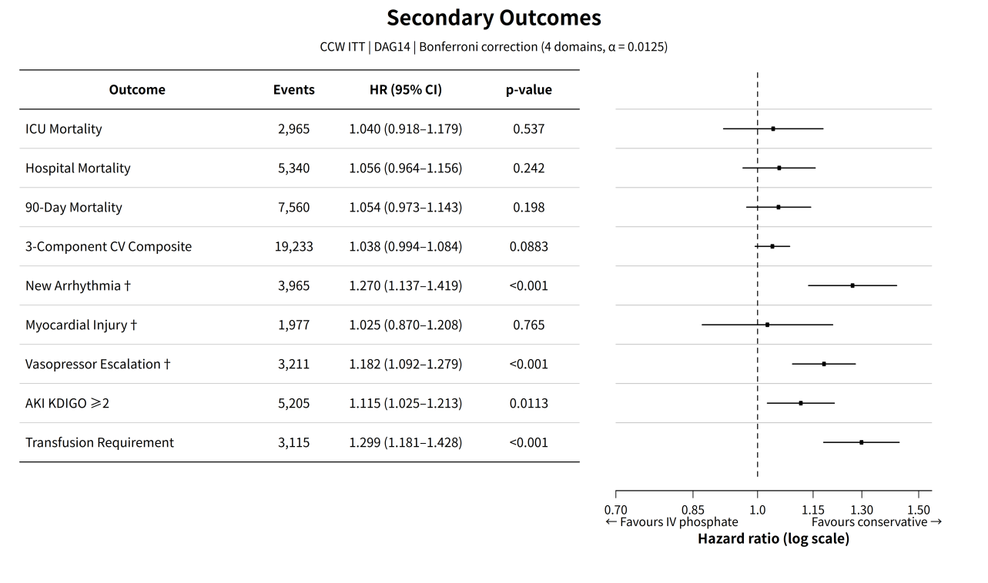
Supplementary Figure S3. Secondary outcomes forest plot for the four pre-specified outcome domains analyzed within the SEQTaRget CCW ITT framework (cluster-robust SE, m=20, Rubin’s rules; Bonferroni correction across 4 independent domains at α=0.0125). Transfusion requirement (HR=1.299; 95% CI, 1.181–1.428; p<0.001) and AKI KDIGO ≥2 (HR=1.115; 95% CI, 1.025–1.213; p=0.011) reached Bonferroni-corrected significance. Corresponds to main manuscript Table 3.

Table S4: Logistic Regression Sensitivity Analysis (Secondary Outcomes)
Logistic regression with DAG14 covariate adjustment for four pre-specified secondary outcome domains, facilitating comparison with prior observational literature. Bonferroni correction applied across 4 domains (α = 0.05/4 = 0.0125). Cardiovascular subcomponents reported descriptively.
Table S4. Logistic regression sensitivity analysis for secondary outcomes. DAG14 covariate adjustment applied. Bonferroni-corrected significance threshold: α=0.0125 (4 independent domains). Bold rows indicate Bonferroni-significant results. Note: the underlying data file computed a reference threshold of 0.01 (=0.05/5) across 5 outcome items; this table and the main manuscript consistently use the pre-specified 4 independent clinical domain convention (α=0.0125). Under either convention, transfusion (p<0.001) remains significant and the conclusions for all other outcomes are unchanged. Note: the Logistic OR for the cardiovascular composite (0.898; p=0.012) is directionally opposite to the CCW framework HR=1.038 (p=0.088) reported in main manuscript Table 3; this cross-framework discrepancy is attributable to the Logistic model not addressing immortal time bias (patients receiving IV phosphate must survive the 12-hour grace period), and is explained in the main manuscript Results section.
Outcome | OR | 95% CI | P-value | n Events | N Total
Transfusion | 1.226 | 1.097–1.368 | 0.0003 | 3115 | 32330
CV composite outcome | 0.898 | 0.826–0.977 | 0.0122 | 19238 | 32330
New arrhythmia | 1.125 | 1.009–1.252 | 0.0328 | 3967 | 32330
AKI (KDIGO ≥2) | 1.078 | 0.974–1.194 | 0.1455 | 5209 | 32330
Myocardial injury | 0.967 | 0.823–1.131 | 0.6745 | 1979 | 32330

Part E: Temporal Patterns of the Primary Outcome
Because the proportional hazards assumption was globally violated (Supplementary Figure S12), the temporal pattern of the primary outcome was characterized by daily-resolution and piecewise analyses. Each analysis is presented as a table and its corresponding figure.

Table S5: Daily-Resolution Hazard Ratios (Days 1–14)
Day-by-day Cox proportional hazards estimates for 28-day mortality using standard at-risk sets (all clones alive at the start of each day) with IPTW stabilized weights, DAG14 covariate adjustment, cluster-robust SE, and MICE m=20 with Rubin’s rules. Bold indicates the day that remained significant after Bonferroni correction for 14 daily tests (α=0.0036). These are exploratory (Tier 4) analyses.
Table S5. Daily-resolution hazard ratios for Days 1–14 with IPTW weighting and standard at-risk sets. The day-specific hazard ratios were consistent with the overall null; only Day 9 showed a protective signal that remained significant after Bonferroni correction for 14 daily tests (HR=0.551; 95% CI, 0.374–0.812; p=0.003; α=0.0036). These are exploratory (Tier 4) analyses; the isolated Day 9 signal should be interpreted cautiously as hypothesis-generating.
Day | HR | 95% CI | n Events | n at Risk
1 | 0.747 | 0.543–1.029 | 325 | 32330
2 | 1.234 | 0.983–1.549 | 495 | 31550
3 | 1.037 | 0.815–1.320 | 489 | 29906
4 | 0.915 | 0.712–1.176 | 490 | 27319
5 | 0.742 | 0.552–0.999 | 406 | 24310
6 | 1.120 | 0.875–1.432 | 430 | 21495
7 | 1.091 | 0.844–1.411 | 385 | 18881
8 | 1.252 | 0.958–1.637 | 336 | 16672
9 | 0.551 | 0.374–0.812 | 291 | 14752
10 | 0.745 | 0.517–1.074 | 252 | 13154
11 | 0.859 | 0.584–1.263 | 210 | 11857
12 | 1.003 | 0.696–1.444 | 209 | 10674
13 | 1.176 | 0.808–1.711 | 176 | 9614
14 | 0.782 | 0.492–1.241 | 157 | 8757

Figure S4: Daily-Resolution Hazard Ratios (Days 1–14)
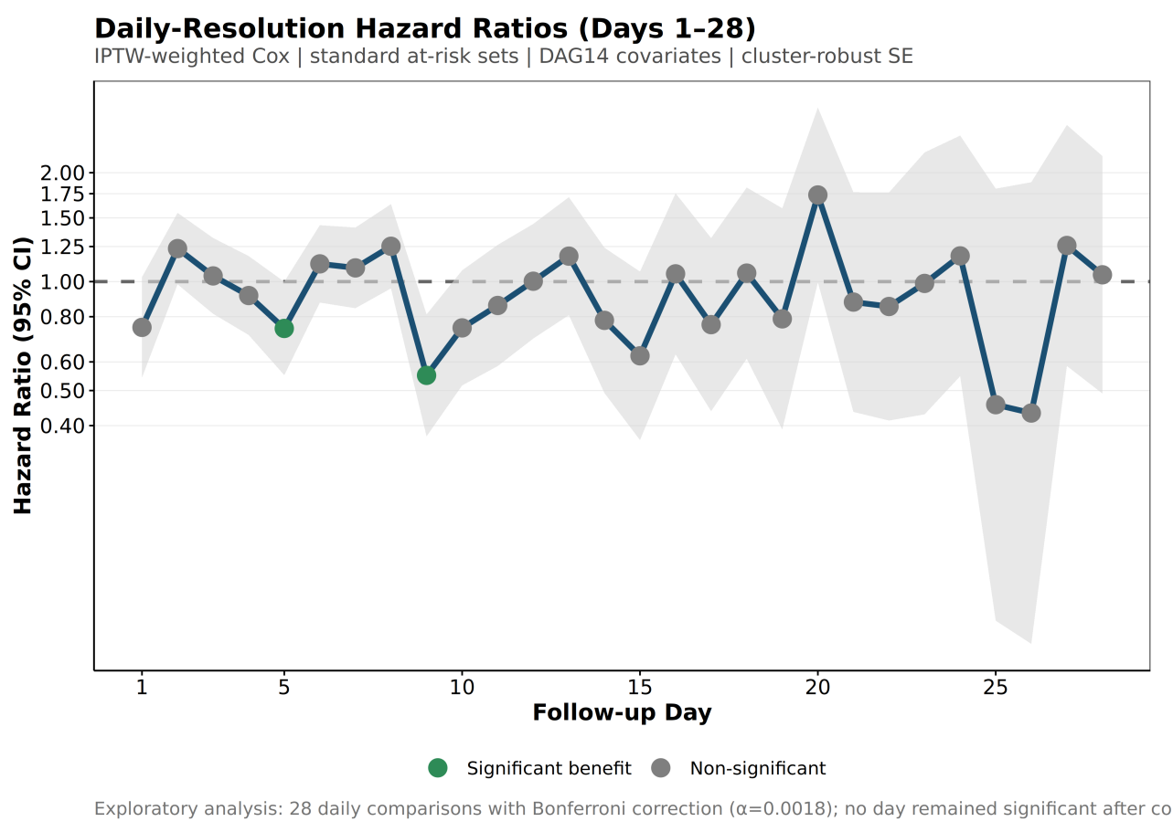
Supplementary Figure S4. Daily hazard ratios with 95% confidence intervals for Days 1–14 using IPTW-weighted Cox models with standard at-risk sets (DAG14, m=20, cluster-robust SE, Rubin’s rules). No daily hazard ratio reached the Bonferroni-corrected significance threshold (α=0.0036) except an isolated protective effect on Day 9 (HR=0.551; 95% CI, 0.374–0.812; p=0.003). Dashed line indicates HR=1.0. Exploratory analysis (Tier 4). Corresponds to Supplementary Table S5.

Table S6: Piecewise Hazard Ratios by Follow-up Interval
Piecewise Cox proportional hazards estimates for pre-specified follow-up intervals (0–3, 3–7, 7–14, 14–28 days), using IPTW-weighted models with standard at-risk sets (all clones alive at the start of each interval), DAG14 covariate adjustment, cluster-robust SE, and MICE m=20 with Rubin’s rules.
Table S6. Piecewise hazard ratios by follow-up interval with IPTW weighting and standard at-risk sets. Piecewise analysis is the primary exploratory characterization of temporal heterogeneity (covering the full 28-day follow-up), complemented by daily-resolution analysis (Table S5). All intervals show null effects (all p>0.10; 3–7 days: HR=0.966; 95% CI, 0.848–1.100).
Time Segment | HR | 95% CI | P-value | n Events | N Total
0–3 days | 1.035 | 0.894–1.198 | 0.647 | 1309 | 32330
3–7 days | 0.966 | 0.848–1.100 | 0.603 | 1711 | 27319
7–14 days | 0.903 | 0.789–1.034 | 0.140 | 1631 | 16672
14–28 days | 0.920 | 0.769–1.100 | 0.359 | 959 | 7928

Figure S5: Piecewise Hazard Ratios by Follow-up Interval
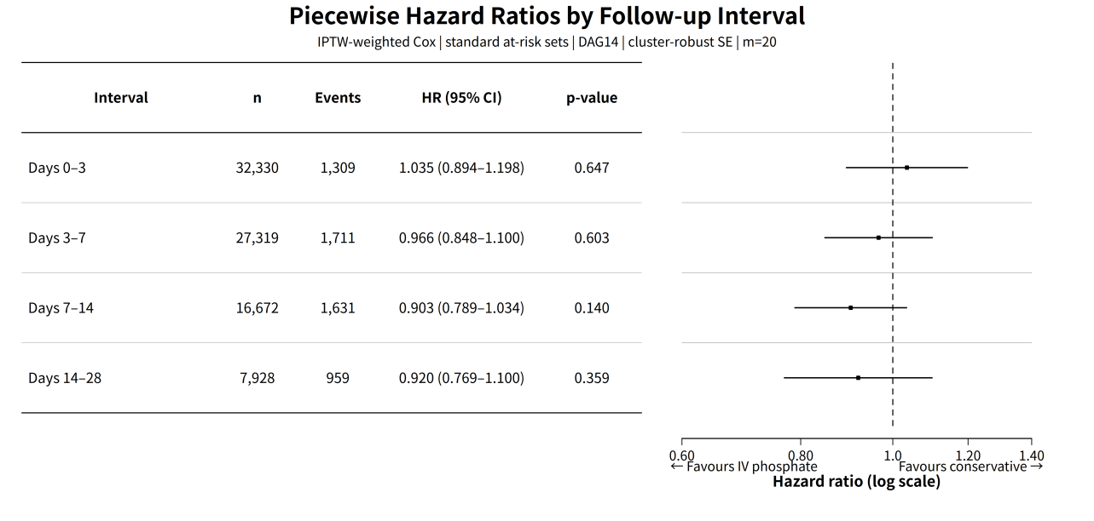
Supplementary Figure S5. Piecewise Cox proportional hazards estimates for the pre-specified follow-up intervals (0–3, 3–7, 7–14, 14–28 days) using IPTW-weighted models with standard at-risk sets (DAG14, cluster-robust SE, m=20, Rubin’s rules). All intervals show null effects (0–3 days: HR=1.035; 3–7 days: HR=0.966; 7–14 days: HR=0.903; 14–28 days: HR=0.920; all p>0.10). Corresponds to Supplementary Table S6.

Part F: Covariate Selection and Cross-Validation
The DAG14 covariate set is the primary adjustment set (see also Supplementary Method M1). Figure S6 presents the causal diagram encoding the DAG14 assumptions; Table S7 reports the complete MITS-LASSO variable selection frequencies and the head-to-head comparison of DAG14 versus LASSO ≥50% covariate sets.

Table S7: MITS-LASSO Complete Variable Selection Report and DAG Cross-Validation

Part A: MITS-LASSO Complete Variable Selection Frequencies
Complete report of all 47 candidate variables with their MITS-LASSO dual-selection results across 20 MICE-imputed datasets. Selection frequency = number of datasets (out of 20) in which the variable was selected by LASSO. Categorical variables (admission_type, gender, nutrition_support_type, icu_type) were factorized into dummy variables for LASSO; the reported frequency for the original variable is the maximum selection frequency across its dummy levels. Source column indicates whether the variable is included in DAG14 only, LASSO only, or both selection approaches.
Table S7A. MITS-LASSO complete variable selection frequencies. Of 14 DAG14 variables, 12 (85.7%) were also selected by LASSO ≥50% frequency. After factorizing admission_type, gender, and nutrition_support_type into dummy variables and re-running MITS-LASSO, admission_type and nutrition_support_type were selected (100%), while gender was not (40%). Corrected calcium was also not selected by LASSO (0%). LASSO additionally selected 17 variables (≥50%), reflecting the data-driven approach’s tendency to include more prognostic variables. This table reports all 47 candidate variables with their complete selection frequencies; variables with <50% frequency were not included in the LASSO≥50% sensitivity analysis covariate set.
Variable | In DAG14 | Frequency (n/20) | Frequency (%) | ≥50% | Source
Admission type | Yes | 20 | 100 | Yes | Both
Age | Yes | 20 | 100 | Yes | Both
Albumin (min) | No | 20 | 100 | Yes | LASSO only
Baseline phosphate | Yes | 20 | 100 | Yes | Both
Baseline SOFA | Yes | 20 | 100 | Yes | Both
BUN at T0 | No | 20 | 100 | Yes | LASSO only
Charlson index | Yes | 20 | 100 | Yes | Both
ECG abnormal | No | 20 | 100 | Yes | LASSO only
eGFR | Yes | 20 | 100 | Yes | Both
ICU type | No | 20 | 100 | Yes | LASSO only
INR (max) | No | 20 | 100 | Yes | LASSO only
Insulin at T0 | No | 20 | 100 | Yes | LASSO only
Invasive ventilation | Yes | 20 | 100 | Yes | Both
NaHCO₃ infusion at T0 | No | 20 | 100 | Yes | LASSO only
Net fluid balance (24h) | No | 20 | 100 | Yes | LASSO only
Nutrition support type | Yes | 20 | 100 | Yes | Both
PTT (max) | No | 20 | 100 | Yes | LASSO only
Refeeding risk | Yes | 20 | 100 | Yes | Both
SAPS II | No | 20 | 100 | Yes | LASSO only
Sepsis-3 | Yes | 20 | 100 | Yes | Both
SF ratio | No | 20 | 100 | Yes | LASSO only
Sodium at T0 | No | 20 | 100 | Yes | LASSO only
SOFA at T0 | No | 20 | 100 | Yes | LASSO only
Steroid at T0 | No | 20 | 100 | Yes | LASSO only
Transfusion at T0 | No | 20 | 100 | Yes | LASSO only
Vasoactive agents | Yes | 20 | 100 | Yes | Both
Ever CRRT | No | 19 | 95 | Yes | LASSO only
Lactate at T0 | Yes | 18 | 90 | Yes | Both
WBC (max) | No | 12 | 60 | Yes | LASSO only
Potassium at T0 | No | 8 | 40 | No | —
Gender | Yes | 8 | 40 | No | DAG14 only
GCS | No | 7 | 35 | No | —
Cardiac surgery | No | 6 | 30 | No | —
pH (worst) | No | 5 | 25 | No | —
BMI | No | 4 | 20 | No | —
Bilirubin at T0 | No | 2 | 10 | No | —
Bicarbonate (worst) | No | 1 | 5 | No | —
Beta-2 agonist at T0 | No | 1 | 5 | No | —
Race group | No | 1 | 5 | No | —
AKI KDIGO ≥2 | No | 0 | 0 | No | —
Corrected calcium (min) | Yes | 0 | 0 | No | DAG14 only
Liver disease | No | 0 | 0 | No | —
Magnesium at T0 | No | 0 | 0 | No | —
Hemoglobin (min) | No | 0 | 0 | No | —
Platelets (min) | No | 0 | 0 | No | —
Diuretic at T0 | No | 0 | 0 | No | —
PPI use | No | 0 | 0 | No | —

Part B: Model Comparison Summary
Head-to-head comparison of the CCW ITT analysis using DAG14 (14 covariates, theory-driven) versus LASSO ≥50% (29 covariates, data-driven) covariate sets. CCA = complete-case analysis (n=8959, events=2310). HR is the IPTW-Cox estimator.
Table S7B. DAG14 vs. LASSO ≥50% model comparison. Both approaches yield directionally consistent protective point estimates. The LASSO ≥50% model included more prognostic variables but produced a highly consistent estimate (relative HR difference 0.80%, 95% CI overlap 92.9%). Note: These estimates are derived from a complete-case subset (n=8959) and differ from the primary analysis (n=32330, MICE m=20, HR=0.987). The primary analysis uses DAG14 as the baseline; covariate selection sensitivity analyses (SA2 PPPL framework, SA3 DAG13 [excl. Sepsis-3]) confirm the robustness of the results.
Model | n Covariates | HR | 95% CI | P-value | n Events | n Complete | Runtime (s)
DAG14 | 14 | 0.927 | 0.828–1.037 | 0.185 | 2310 | 8959 | 0.159
LASSO ≥50% | 29 | 0.934 | 0.833–1.048 | 0.245 | 2310 | 8959 | 0.047

Figure S6: DAG14 Causal Diagram
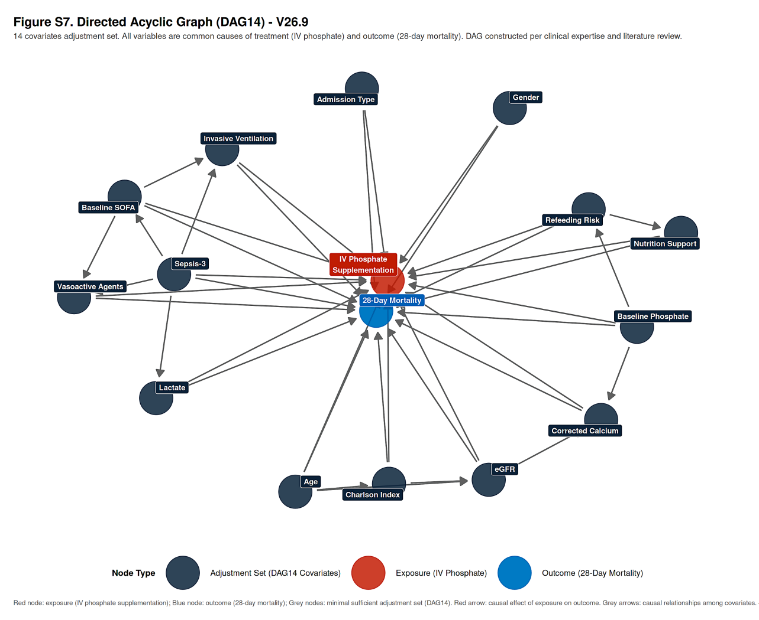
Supplementary Figure S6. Directed acyclic graph (DAG) encoding the causal assumptions underlying the DAG14 covariate set. The 14 nodes (age, gender, baseline SOFA, Sepsis-3, Charlson comorbidity index, eGFR, invasive ventilation, vasoactive agents, admission type, baseline phosphate, lactate, refeeding risk, corrected calcium, and nutrition support type) constitute the minimally sufficient adjustment set for the effect of IV phosphate supplementation on 28-day mortality; directed edges represent hypothesized causal relationships informed by the hypophosphatemia literature and clinical knowledge. Corresponds to Supplementary Table S7 and Supplementary Method M1.

Part G: GRADE Evidence Quality

Table S8: GRADE Evidence Quality Assessment
GRADE (Grading of Recommendations Assessment, Development and Evaluation) assessment of the certainty of evidence for the primary null finding (no net survival benefit of IV phosphate supplementation on 28-day mortality in ICU hypophosphatemia).
Table S8. GRADE evidence quality assessment for the primary null finding. Observational evidence defaults to low certainty. The null finding is robust across all 13 CCW-framework sensitivity analyses and one external validation, but the E-value ≈1.14 indicates that unmeasured confounding remains a critical threat. The isolated Day 9 protective signal (E-value=3.03) and phosphate threshold effect (HR=0.806, p=0.022) are hypothesis-generating and do not independently elevate the certainty rating.
Criteria | Assessment | Rating
Study design | Observational (target trial emulation) | Low
Risk of bias | CCW framework addresses immortal time bias and time-dependent confounding; E-value ≈1.14 indicates high sensitivity to unmeasured confounding | Serious (−1)
Inconsistency | Single derivation cohort; eICU external validation (HR=1.087, 95% CI 0.913–1.293) consistent with null finding; MIMIC-IV analysis restricted to the 11 shared covariates (DAG11; HR=1.006, 95% CI 0.914–1.108) nearly identical to primary; all 13 CCW-framework sensitivity analyses directionally consistent; SA6 (conventional Cox without CCW) directionally opposite due to immortal time bias | Not serious
Indirectness | Direct comparison of treatment strategies; target population well-defined; no surrogate outcomes | Not serious
Imprecision | 95% CI spans both protective and harmful effects (0.893–1.092); optimal information size not met for subgroup analyses | Serious (−1)
Publication bias | Single study; pre-registered on OSF (https://osf.io/yc6kb/); structured SAP finalized before analysis | Undetected
Large effect | Not observed (HR≈1.0, RMST difference −0.02 days) | None
Dose-response | Post-hoc threshold analysis shows monotonic protective pattern in phosphate <0.50 mmol/L; not pre-specified; hypothesis-generating only | None (post-hoc)
Plausible confounding | E-value ≈1.14 suggests unmeasured confounding of any strength could explain the null result; no upgrading criteria met | None
Overall certainty | — | Low ⊕⊕◯◯

Part H: Sensitivity Analyses
Table S9 summarizes all pre-specified (SA1–SA11) and post-hoc (SA12–SA14) sensitivity analyses. Figures S7, S8, and S9 present the corresponding forest plots; Figures S10 and S11 present the E-value and MNAR delta-adjustment sensitivity analyses (see also Supplementary Method M3).

Table S9: Summary of Sensitivity Analyses (SA1–SA14)
Comprehensive summary of all pre-specified (SA1–SA11) and post-hoc (SA12–SA14) sensitivity analyses with detailed methods, results, and interpretation. The primary analysis (CCW ITT, DAG14, boot=200) is included for reference. SA numbering is fully aligned with Supplementary Table S9; supplementary entries A1–A5 provide additional information and are not part of the SA numbering scheme.
SA# | Analysis Description | Method | HR | 95% CI | n | n Events
— | Primary | CCW ITT, DAG14, m=20, boot=200 | 0.987 | 0.893–1.092 | 32330 | 5610
SA1 | Causal estimand: Per-protocol | PP CCW+IPTW, DAG14 | 0.979 | 0.885–1.083 | 32330 | 5610
SA2 | Framework: PPPL (person-period pooled logistic) | PPPL DAG14+LASSO, Rubin m=20, cluster-robust SE | 0.946 | 0.848–1.057 | 32330 | 5610
SA3 | Covariate set: DAG13 (excl. Sepsis-3) | CCW ITT, DAG13-A, boot=200 | 0.969 | 0.875–1.072 | 32330 | 5610
SA4 | Model specification: IPTW-Cox | IPTW-Cox, DAG14, Rubin | 1.054 | 0.975–1.141 | 32330 | 5610
SA5 | Model specification: Weibull AFT | Weibull AFT, DAG14, Rubin | 0.989* | 0.940–1.041 | 32330 | 5610
SA6 | Conventional Cox (no CCW framework) | Cox PH, DAG14 adjustment | 0.899 | 0.826–0.980 | 32330 | 5610
SA7 | Missing data: Complete case (DAG14) | CCA, DAG14 variables | 0.948 | 0.832–1.079 | 22017 | 4316
SA8 | Population: First-enrollment only | CCW ITT, DAG14, first enrollment | 1.047 | 0.951–1.154 | 22685 | 3628
SA9 | Exposure: 24-hour grace period | CCW ITT, DAG14, grace=24h | 0.976 | 0.893–1.065 | 32330 | 5610
SA10 | Exposure: 24-hour washout | CCW ITT, DAG14, washout=24h | 0.996 | 0.876–1.132 | 32330 | 5610
SA11 | External validation: eICU-CRD | eICU CCW ITT, DAG11, boot=100 | 1.087 | 0.913–1.293 | 34882 | 5508
SA12 | [Post-hoc] Any supplementation (IV or enteral) | CCW ITT, DAG14 | 0.882 | 0.818–0.951 | 32330 | 5610
SA13 | [Post-hoc] SEQTaRget vs. IPTW-Cox (IV-only) | CCW ITT, first enrollment, DAG14 | 0.983 | 0.881–1.097 | 22685 | 3628
SA14 | [Post-hoc] IPTW-Cox (IV-only) | IPTW-Cox, first enrollment, DAG14 | 0.819 | 0.766–0.874 | 22685 | 3628
A1 | Bootstrap stability | Varying bootstrap iterations (100 vs 200) | — | — | 32330 | 5610
A2 | Exposure: Oral phosphate stratification | CCW ITT, DAG14, oral | 1.075 | 0.873–1.325 | 8848 | 1329
A3 | Exposure: Non-oral phosphate stratification | CCW ITT, DAG14, non-oral | 1.053 | 0.931–1.190 | 23445 | 4275
A4 | Missing data: CCA (LASSO complete cases) | CCA, DAG14+LASSO covariates | 0.857 | 0.395–1.861 | 1953 | 657
A5 | Covariate set: DAG11 MIMIC-IV (matching eICU) | CCW ITT, DAG11, m=5, boot=50 | 1.006 | 0.914–1.108 | 32325 | —
*Weibull AFT survival time ratio (STR). Values <1.0 indicate shorter (worse) survival.
Notes: - SA13: SEQTaRget DAG14 analysis (g-computation) point estimate based on bootstrap; 95% CI computed by SEQTaRget internal bootstrap, may differ from standard IPTW-Cox CI. The corresponding IPTW-Cox result (SA14) is HR=0.819 (95% CI, 0.766–0.874). - SA6: Conventional multivariable Cox regression does not use the CCW framework and is therefore not adjusted for immortal time bias. Its direction is opposite to all CCW framework analyses (protective vs. null/harm), underscoring the importance of immortal time bias in phosphate supplementation research. - SA12: Any phosphate supplementation (IV or enteral) vs. strict conservative management. This result is affected by Simpson’s paradox—the oral, conservative, and IV groups exhibit a systematic severity gradient (oral SOFA=4.77, conservative SOFA=5.09, IV SOFA=6.10), and neither the oral subgroup (A2) nor the non-oral subgroup (A3) showed significant effects. - Bold rows (SA12–SA14) are post-hoc analyses conducted after the primary results were known and are reported separately from the pre-specified SA1–SA11. - A1: HR difference <0.001 between 200 and 100 bootstrap iterations, confirming stability. - A2/A3: Oral vs. non-oral stratification corresponds to Supplementary Table S9 (oral + non-oral = 32293; 37 trial-periods with indeterminate phosphate administration route classification were excluded). - A4: Like SA7, a complete-case analysis but with a different definition—SA7 uses DAG14 variable complete cases (n=22017, 68.1%, adopted in Supplementary Table S9); A4 uses DAG14+LASSO variable complete cases. These are distinct analyses with independent numbering and values. - A5: To bridge the eICU external validation (SA11), the primary MIMIC-IV analysis was re-run restricted to the 11 covariates shared with eICU (DAG11; excluding sepsis3, corrected calcium, and nutrition support type), yielding HR=1.006 (95% CI, 0.914–1.108; p=0.897), nearly identical to the primary estimate (HR=0.987); the eICU result (HR=1.087) therefore reflects cohort differences rather than covariate-set differences. - SA numbering is fully consistent with Supplementary Table S9; supplementary entries A1–A5 provide additional information and are not part of the SA numbering scheme. - DAG13-B (DAG13-excl-lactate, excluding lactate_t0): HR=0.971. This is a post-hoc sensitivity analysis not included in the SA numbering scheme.

Figure S7: Primary and Sensitivity Analysis Forest Plot
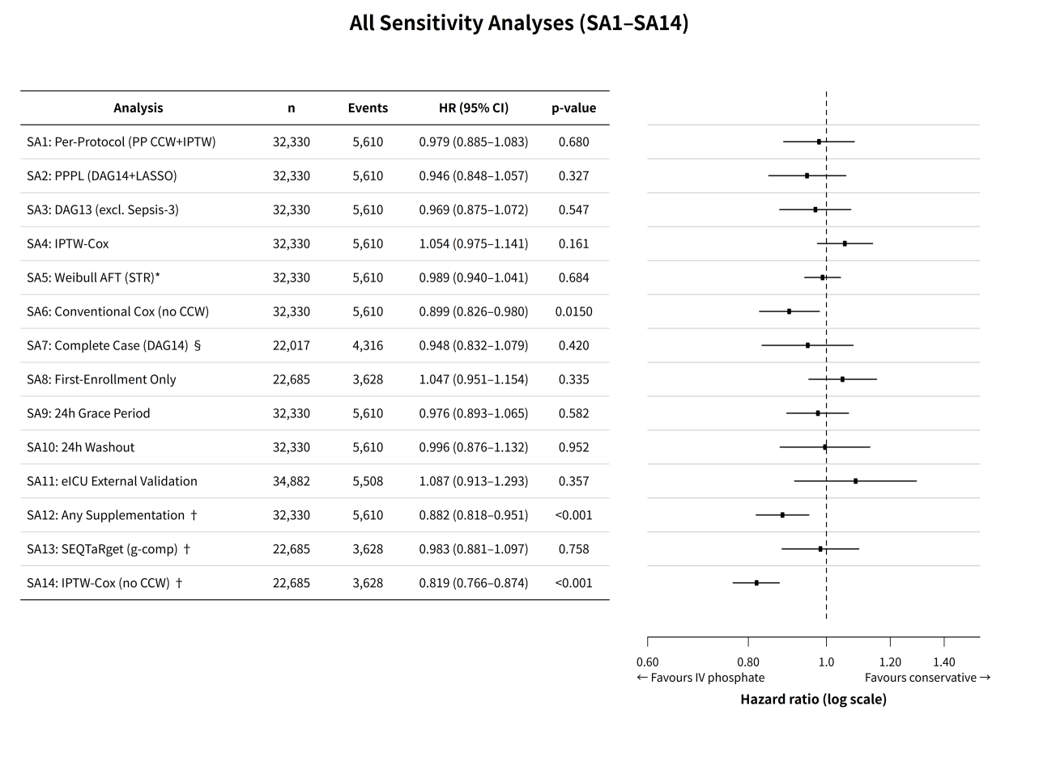
Supplementary Figure S7. Forest plot summarizing the primary ITT result (HR=0.987; 95% CI, 0.893–1.092; p=0.802; 5610 events) and all sensitivity analyses (SA1–SA14). All 13 CCW-framework sensitivity analyses were consistent with the overall null effect; the only directionally opposite result was SA6 (conventional Cox without CCW), reflecting immortal time bias. *Weibull AFT: survival time ratio. †Post-hoc analyses. §DAG14 complete cases (n=22017). Corresponds to Supplementary Table S9.

Figure S8: Method Comparison Forest Plot
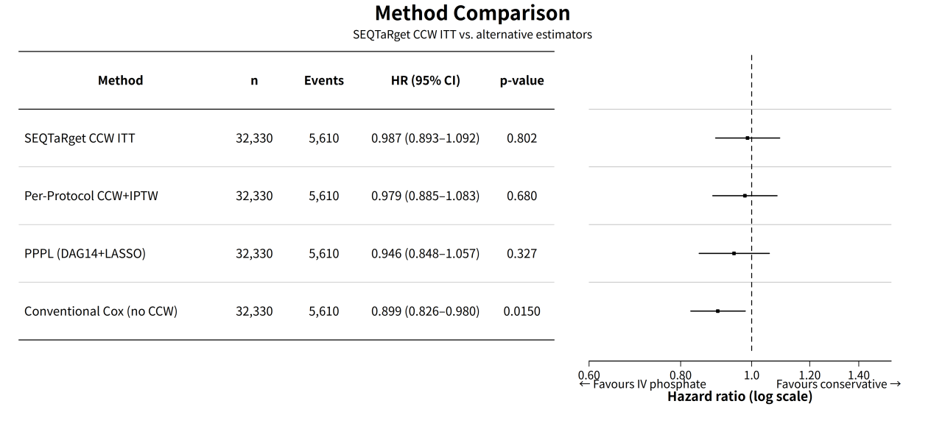
Supplementary Figure S8. Comparison of estimation approaches: SEQTaRget CCW ITT (HR=0.987; 95% CI, 0.893–1.092), per-protocol CCW+IPTW (HR=0.979), PPPL (HR=0.946), and conventional Cox without CCW (HR=0.899; 95% CI, 0.826–0.980). Conventional Cox shows a directionally opposite, spuriously protective result reflecting immortal time bias. Corresponds to Supplementary Table S9 (methodology subset).

Figure S9: Oral vs. Non-Oral Phosphate Stratification Forest Plot
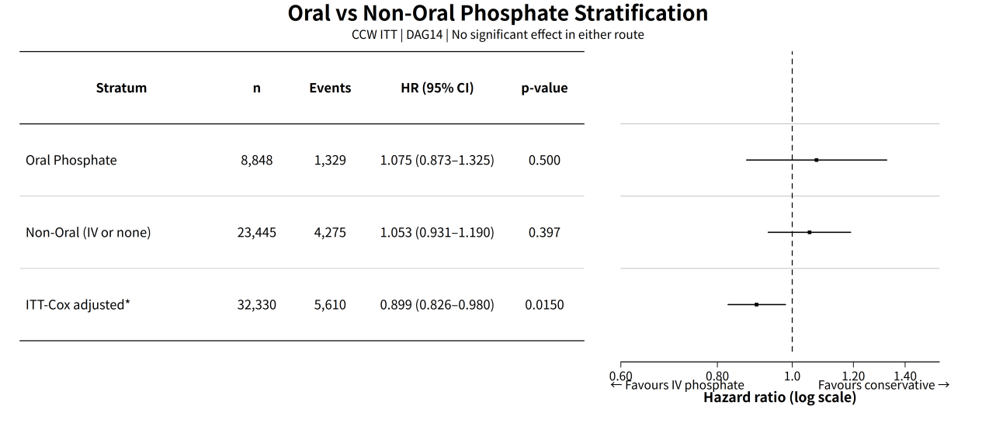
Supplementary Figure S9. Phosphate administration route stratification (oral vs. non-oral) within the CCW ITT framework. Neither stratum shows a significant effect (oral: HR=1.075; 95% CI, 0.873–1.325; n=8848; non-oral: HR=1.053; 95% CI, 0.931–1.190; n=23445). *ITT-Cox adjustment refers to a conventional multivariable Cox model (DAG14 covariates, cluster-robust SE, no CCW framework). Oral + non-oral = 32293; 37 trial-periods (0.1%) with indeterminate phosphate administration route classification were excluded from this stratification. Corresponds to Supplementary Table S9.

Figure S10: E-value Sensitivity Analysis Curve
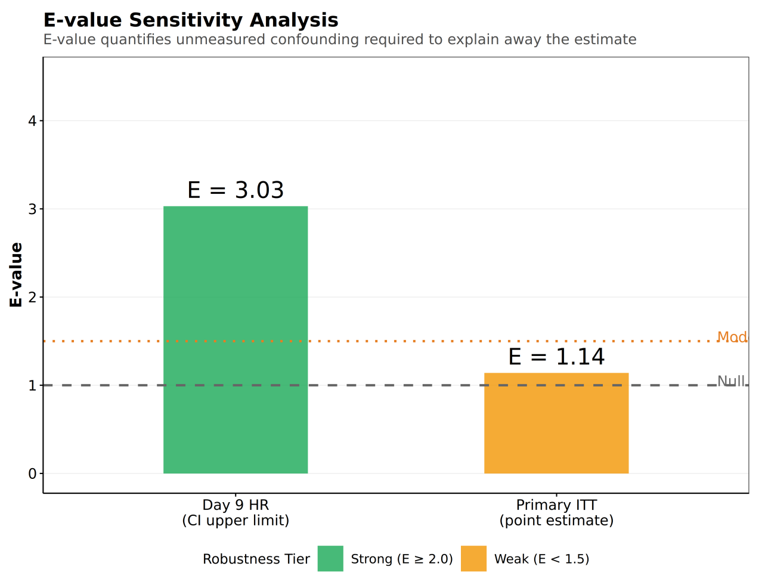
Supplementary Figure S10. E-value sensitivity analysis for the primary ITT null result and the isolated Day 9 protective signal. The primary null result has an E-value of 1.14 (CI lower bound 1.00), indicating that unmeasured confounding of any strength could explain the null. The Day 9 protective signal has an E-value of 3.03 (CI lower bound 1.77), corresponding to a robust association.

Figure S11: MNAR Sensitivity Analysis (Delta-Adjustment Tipping Points)
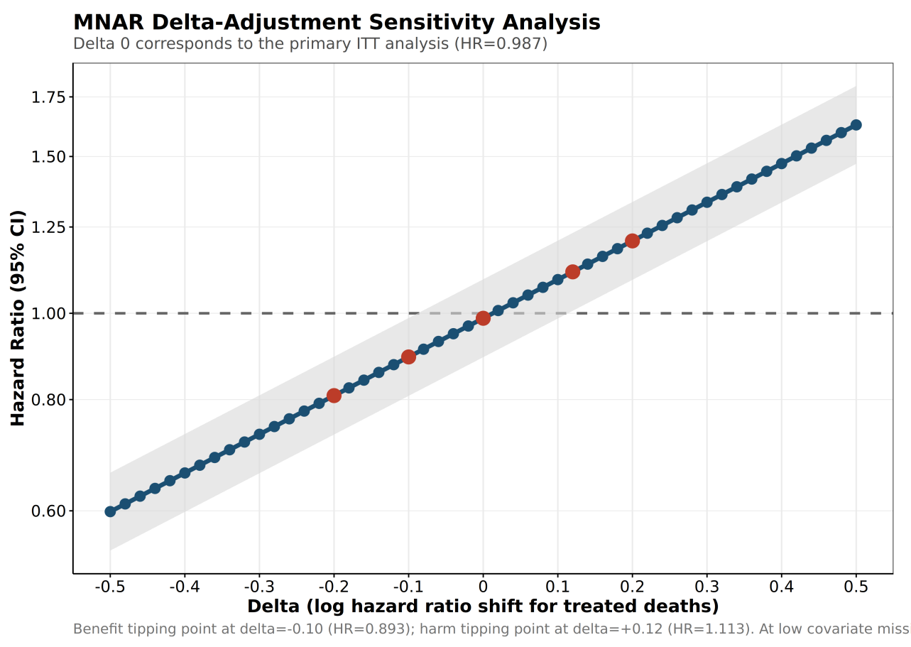
Supplementary Figure S11. Delta-adjustment sensitivity analysis for departures from the missing-at-random (MAR) assumption. Tipping points: benefit at Δ=−0.10 (OR=8.0) and harm at Δ=+0.12 (OR=12.2), both clinically infeasible given low covariate missingness (maximum 4.8%), confirming the robustness of the null effect.

Part I: CCW Censoring Statistics and Diagnostics

Table S10: CCW Censoring Statistics and Diagnostics
Censoring refers to artificial censoring in the CCW framework—clones not completing 28-day follow-up are censored at the end of each trial period.

Table S10-A: Period-Specific Censoring Rates
Trial Period | Observations (n) | Deaths (n) | Censored (n) | Censoring Rate (%)
Period 0 | 22685 | 3628 | 19057 | 84.0
Period 1 | 7262 | 1409 | 5853 | 80.6
Period 2 | 1800 | 421 | 1379 | 76.6
Period 3 | 451 | 114 | 337 | 74.7
Period 4 | 103 | 30 | 73 | 70.9
Period 5 | 24 | 8 | 16 | 66.7
Overall | — | — | — | 82.6

Table S10-B: Censoring Rate by Treatment Arm (Censoring Treatment Ratio, CTR)
Trial Period | Control Censoring Rate (%) | Treatment Censoring Rate (%) | Absolute Difference (Control−Treatment) (%)
Period 0 | 84.16 | 83.10 | 1.06
Period 1 | 81.25 | 77.90 | 3.35
Period 2 | 77.21 | 74.25 | 2.97
Period 3 | 75.00 | 73.74 | 1.26
Period 4 | 70.37 | 72.73 | −2.36
Period 5 | 73.68 | 40.00 | 33.68

Table S10-C: Censored vs. Uncensored Baseline Characteristics (Informative Censoring Detection)
Variable | Censored Mean | Uncensored Mean | SMD
Charlson Comorbidity Index | 4.53 | 6.47 | −0.676
Baseline SOFA | 4.84 | 7.01 | −0.585
eGFR | 77.09 | 63.77 | 0.478
Age | 62.9 | 69.6 | −0.426
Lactate | 1.74 | 2.19 | −0.293
Corrected Calcium | 2.11 | 2.17 | −0.282
Baseline Phosphate | 0.665 | 0.662 | 0.032
Notes: Overall censoring rate of 82.6%, primarily reflecting 28-day administrative censoring (end of follow-up). Period-specific censoring rates decrease from 84.0% (Period 0) to 66.7% (Period 5). In Table S10-C, the baseline differences between censored and uncensored groups (SMD up to 0.676) are expected under the CCW framework—censored individuals are predominantly those surviving to the end of the period (lower disease severity), whereas uncensored individuals are those who died within the period (higher severity), reflecting a natural systematic difference in health status rather than censoring mechanism bias. The more relevant diagnostic metric is the Censoring Treatment Ratio (CTR, Table S10-B): in most trial periods, the treatment arm had a slightly lower censoring rate than the control arm (1–3%), except Period 4 where the treatment censoring rate was higher (−2.36%) and Period 5 where the sample size was very small (treatment n=5), with fluctuations attributable to small-sample noise. The overall pattern (slightly lower censoring in the treatment arm) reflects small differences in mortality-related follow-up shortening between arms rather than informative censoring; the daily-resolution analysis was concordant with the overall null (Supplementary Table S5). Because the SEQTaRget ITT framework simulates randomized assignment, this table does not involve IPTW weight diagnostics; weight diagnostics are applicable to the per-protocol (PP) analysis (Supplementary Table S9, SA1).

Part J: Exploratory Analyses
The following analyses were exploratory (Tier 4) and correspond to the respective paragraphs of the main manuscript Results and Discussion sections. Results are hypothesis-generating and should be interpreted cautiously.

Figure S12: Proportional Hazards Diagnostics (Schoenfeld Residual Tests)
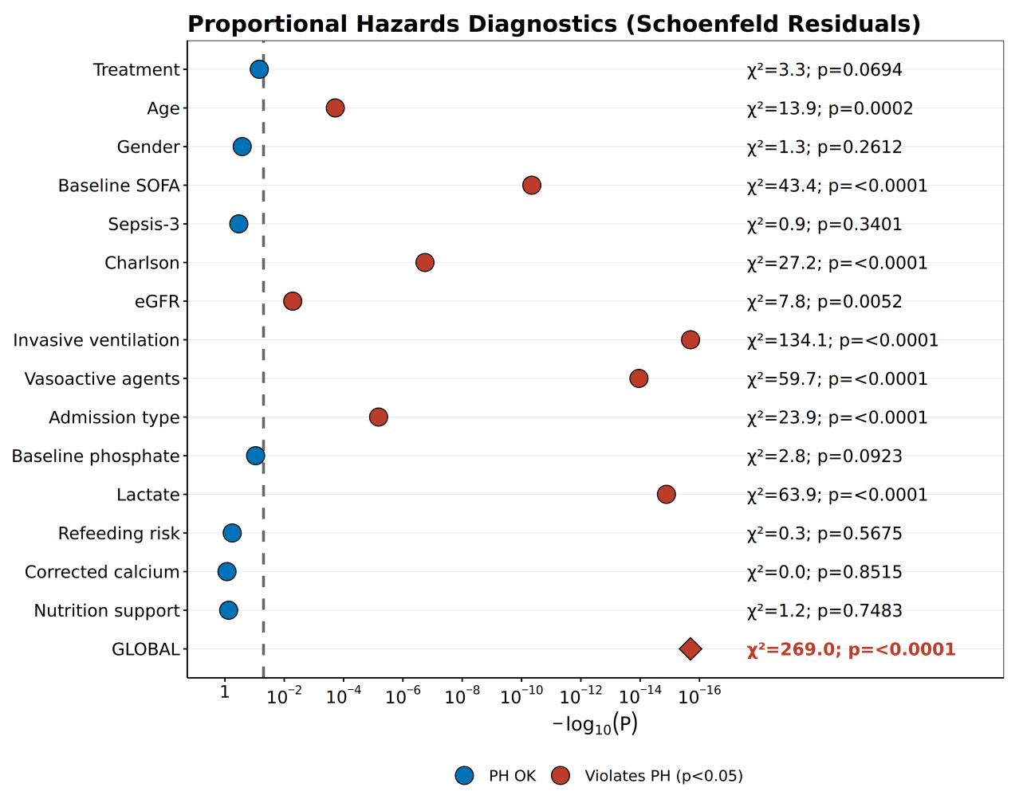
Supplementary Figure S12. Schoenfeld residual tests for the proportional hazards assumption, derived from the PPPL (person-period pooled logistic) model with DAG14 covariates (m=20) used for PH diagnostics; the primary analysis uses the CCW ITT framework. The global test strongly rejects PH (χ²=269.05, df=18, p<0.0001), with invasive ventilation (χ²=134.14), lactate (χ²=63.91), and vasoactive agents (χ²=59.71) showing the largest time-varying contributions. Red points indicate nominal significance (p<0.05); the global test is highlighted with a diamond marker.

Figure S13: Interaction Test Forest Plot
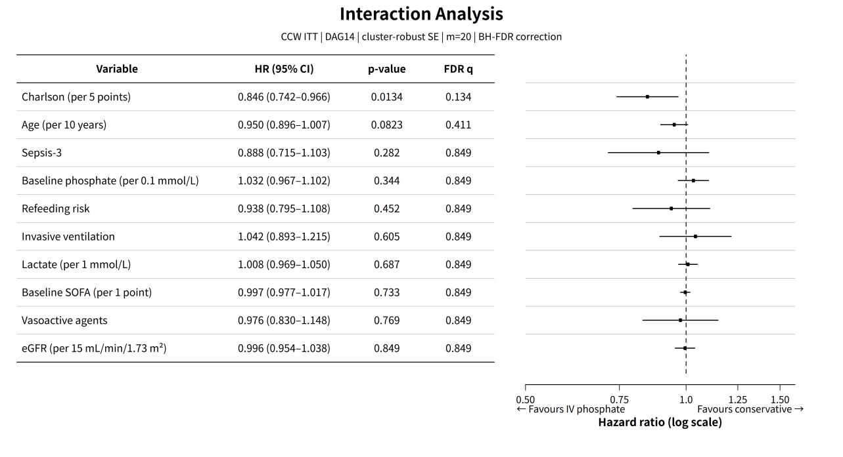
Supplementary Figure S13. Interaction test forest plot (CCW ITT, cluster-robust SE, m=20; FDR q-values computed using the Benjamini-Hochberg procedure across 10 interaction tests). Only the Charlson comorbidity index showed a nominally significant multiplicative interaction (interaction HR=0.846 per 5 points; 95% CI, 0.742–0.966; p=0.013), which did not survive FDR correction (q=0.134); the direction indicates greater protection with higher comorbidity burden. Age showed a borderline interaction (HR=0.950 per 10 years; 95% CI, 0.896–1.007; p=0.082; q=0.411). All other interaction tests were non-significant (all p>0.10, all q>0.10).

Figure S14: Cumulative IV Phosphate Dose-Response Analysis
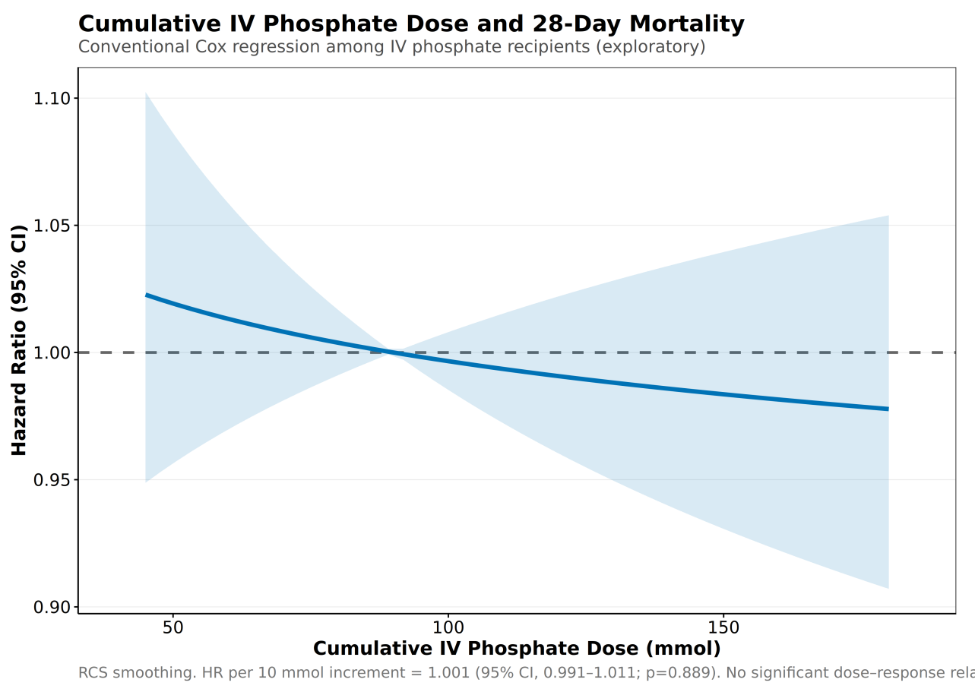
Supplementary Figure S14. Exploratory dose-response analysis of cumulative IV phosphate dose and 28-day mortality (conventional Cox regression, DAG14, cluster-robust SE). No significant association (per 10 mmol HR=1.001; 95% CI, 0.991–1.011; p=0.889). Dose is a post-randomization variable subject to indication confounding; results are exploratory.

Figure S15: Potassium Phosphate vs. Sodium Phosphate Formulation Analysis
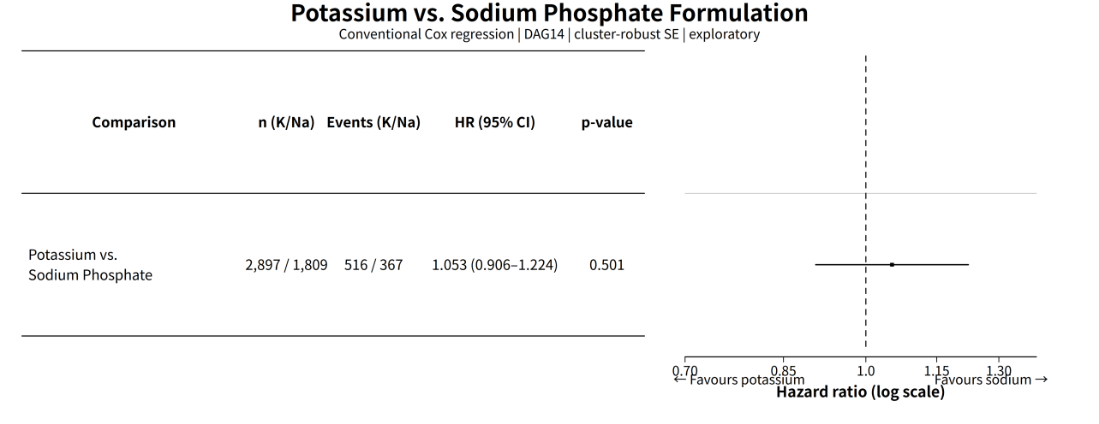
Supplementary Figure S15. Exploratory comparison of potassium phosphate vs. sodium phosphate formulations (conventional Cox regression, DAG14, cluster-robust SE). No significant difference between formulations (HR=1.053; 95% CI, 0.906–1.224; p=0.501). Formulation is a post-randomization variable; results are exploratory.

Figure S16: Phosphate Threshold Dose-Response Forest Plot
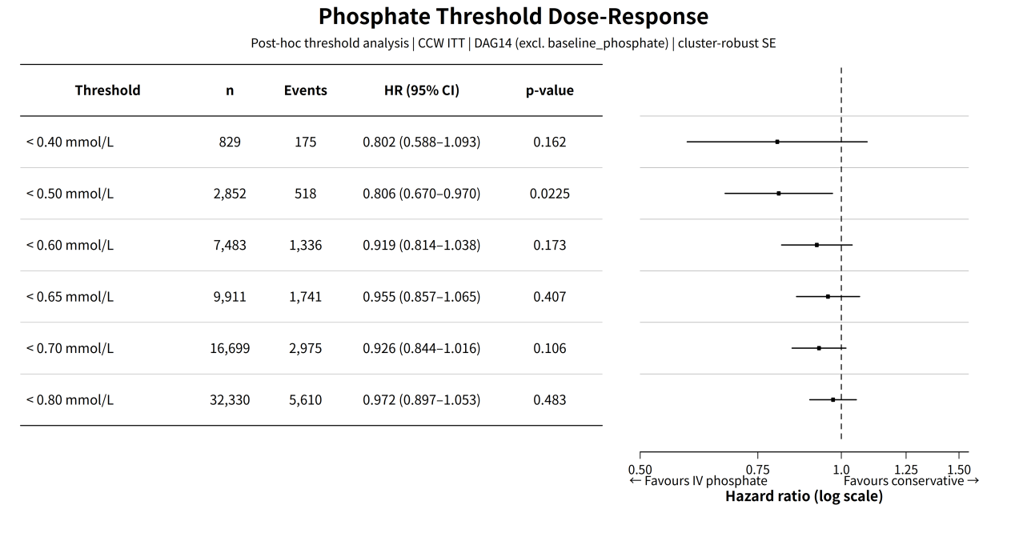
Supplementary Figure S16. Post-hoc phosphate threshold dose-response forest plot (Cox regression, DAG14 (excl. baseline_phosphate) covariate set, cluster-robust SE; baseline phosphate is an effect modifier rather than a confounder in the threshold analysis). The protective effect reached nominal significance at the baseline phosphate <0.50 mmol/L threshold (HR=0.806; 95% CI, 0.670–0.970; p=0.022; n=2852), was of similar magnitude at <0.40 mmol/L (HR=0.802; 95% CI, 0.588–1.093; n=829) but did not reach significance, and attenuated progressively toward the null at thresholds ≥0.60 mmol/L (HR=0.92–0.97). All point estimates were below 1.0, indicating a consistent protective trend; restricted cubic splines detected no significant non-linear interaction (p=0.538), consistent with a gradual transition.

Detailed Methodological Notes

§1. Target Trial Emulation Design
This study employs a sequential target trial emulation (TTE) framework, restructured observational data (MIMIC-IV v3.1 and eICU-CRD v2.0) into a series of hypothetical randomized controlled trials. The target trial protocol was pre-registered on OSF (https://osf.io/yc6kb/), and the analysis plan was finalized before outcome extraction. The core causal question is: In adult patients with ICU stays ≥24 hours and serum phosphate ≤0.80 mmol/L, does initiating intravenous phosphate supplementation within 12 hours of the qualifying test, compared with conservative management, improve 28-day all-cause mortality?
Treatment strategy definitions:
- Treatment group: Received any intravenous phosphate preparation within 12 hours (grace period) of the qualifying serum phosphate test.
- Control group: Did not receive intravenous phosphate during the same period (oral phosphate or other conservative management allowed).
- Treatment assignment is observational. In the primary ITT analysis, confounding was addressed through DAG14 covariate adjustment (the SEQTaRget ITT implementation is unweighted); stabilized IPTW weights were used only in the per-protocol analysis (SA1) and the IPTW-Cox sensitivity analysis (SA4).

§2. Cohort Construction and Eligibility Criteria
Inclusion criteria (based on MIMIC-IV v3.1, 2008–2022):
- ICU length of stay ≥24 hours;
- Age ≥18 years;
- Qualifying serum phosphate ≤0.80 mmol/L after ICU admission;
- Traceable 28-day survival status.
Medical exclusion criteria (7 items, consistent with the main manuscript):
- eGFR <15 mL/min/1.73 m² or end-stage renal disease;
- Maintenance dialysis or acute renal replacement therapy;
- Primary hyperparathyroidism;
- Malignancy-related hypercalcemia;
- Long-term phosphate binder use (>30 days);
- Pregnancy;
- Elective short-stay surgery (<24-hour ICU stay).
Note: Subsequent ICU admissions during the same hospitalization are handled by the “first ICU admission” criterion in the inclusion criteria and are not listed as a separate exclusion item (both the main manuscript and supplementary materials report 7 medical exclusion criteria).
Sequential enrollment strategy: Screening for qualifying phosphate events every 24 hours; a 48-hour washout period between enrollments for the same patient; each patient may be enrolled up to 8 times sequentially. The final cohort comprises 22685 patients and 32330 trial periods (6 sequential periods: Period 0: 22685 → Period 5: 24). The enrollment structure is illustrated in Supplementary Figure S1.

§3. Cloning-Censoring-Weighting (CCW) Framework
The primary analysis employs the clone-censor-weight (CCW) method proposed by Hernán & Robins to estimate the ITT effect:
- Clone: At each trial period enrollment, two clones are generated for each patient, assigned to “always-treated” and “always-conservative” strategies, respectively.
- Censor: When the actual treatment received deviates from the assigned strategy, the clone is artificially censored. In the ITT analysis, censoring occurs when a patient receives the opposite treatment or at the end of follow-up.
- Weight (per-protocol analyses only): Inverse probability of censoring weights (IPCW) are applied to censored clones to correct for informative censoring due to deviation from the assigned strategy, e.g., in the per-protocol analysis (SA1). In the primary ITT analysis, the SEQTaRget implementation is unweighted (covariate adjustment only), because censoring at strategy deviation is administrative and inverse probability weighting is not required.
The key advantage of the CCW framework is that it transforms observational treatment switching into “strategy deviations,” thereby avoiding immortal time bias inherent in conventional Cox regression—patients receiving treatment must survive the grace period, which would artificially inflate protective effects.

§4. SEQTaRget Implementation Details
The primary analysis uses the R package SEQTaRget v1.4.3 to implement the CCW framework, with the following main parameters:
- Covariate set: DAG14 (14 theory-driven variables; see Supplementary Table S7);
- Multiple imputation: mice v3.19.0, m=20;
- Bootstrap: 200 iterations (fixed seed 20260629);
- Cluster-robust standard errors: stay_id as the clustering variable;
- Outcome model: parametric survival model (SEQTaRget internal implementation);
- Time-averaged HR is obtained by combining effect estimates across bootstrap samples via Rubin’s rules.
SEQTaRget runs CCW independently on each MICE imputed dataset, outputting a single HR per imputation; the 20 imputation results are then combined using Rubin’s rules to produce the final point estimate, 95% CI, and p-value.

§5. Covariate Selection and DAG14
The DAG14 covariate set is identified based on a directed acyclic graph (DAG) (Supplementary Figure S6), comprising the minimal sufficient adjustment set to avoid over-adjustment and collider bias. The 14 variables are: age, gender, baseline SOFA, Sepsis-3, Charlson comorbidity index, eGFR, invasive ventilation, vasoactive agents, admission type, baseline phosphate, lactate, refeeding risk, corrected calcium, and nutrition support type.
MITS-LASSO covariate selection as a sensitivity analysis:
- Candidate pool: 47 variables (including DAG14);
- Method: LASSO is fitted on each MICE imputed dataset (glmnet v4.1-8, lambda.min), and selection frequency is computed across 20 imputed datasets;
- Inclusion threshold: ≥50% selection frequency;
- Result: 29 variables met the threshold, of which 12 are DAG14 variables. DAG14 and LASSO≥50% results are highly consistent (Supplementary Table S7).

§6. Multiple Imputation and Rubin’s Rules
Missing data are handled through MICE (Multivariate Imputation by Chained Equations):
- Number of imputations m=20;
- Maximum iterations maxit=20;
- Fixed seed 12345;
- Imputation methods are automatically selected based on variable type (PMM for continuous variables, logistic for binary, polyreg for multinomial).
The variable with the highest missing rate is lactate (31.3%), followed by corrected calcium (6.8%) and nutrition support type (8.2%); all other variables have missing rates <5%.
Rubin’s rules combination: log(HR) and its variance are independently estimated for each imputed dataset, and the final combined estimate is:
θ_bar = (1/m) Σ θ_i
W = (1/m) Σ Var(θ_i) # within-imputation variance
B = (1/(m-1)) Σ (θ_i - θ_bar)² # between-imputation variance
T = W + (1 + 1/m) B # total variance
For the primary analysis, the within-imputation variance W=0.00237 and between-imputation variance B=0.00025, indicating high consistency across imputations.

§7. Secondary Outcomes and Multiplicity Control
Secondary outcomes are estimated using the same SEQTaRget CCW framework as the primary analysis to obtain HRs, with Bonferroni correction applied across 4 independent clinical domains (mortality, cardiovascular composite, AKI, transfusion requirement), yielding a significance threshold of α=0.0125. Subcomponents of the cardiovascular composite outcome (new arrhythmia, vasoactive escalation, myocardial injury) are reported descriptively and are not included in the correction.
Supplementary Table S4 also reports the logistic regression sensitivity analysis (without the CCW framework) to illustrate the potential impact of different effect scales (OR vs. HR) and immortal time handling on the results.

§8. Sensitivity Analysis Methods
A total of 14 sensitivity analyses (11 pre-specified SA1–SA11 and 3 post-hoc SA12–SA14) cover 5 dimensions:
Dimension | Representative Analysis | Purpose
Causal estimand | SA1 PP CCW+IPTW | Evaluate per-protocol effect
Analytic framework | SA2 PPPL, SA4 IPTW-Cox, SA6 conventional Cox | Compare different causal inference frameworks
Covariate set | SA3 DAG13 (excl. Sepsis-3), A5 DAG11 (eICU shared) | Assess robustness of covariate-set selection and bridge external validation
Exposure definition | SA9 24h grace period, SA10 24h washout | Assess time window selection
Population/data | SA7 CCA, SA8 first enrollment, SA11 eICU | Assess population and external transportability
PPPL framework: Person-period pooled logistic model, treating each patient-period as an observation, estimating conditional survival probabilities via logistic regression, and combining through Rubin’s rules. This framework has weaker dependence on the PH assumption and serves as a methodological sensitivity analysis for SEQTaRget.
SEQTaRget batch CCW engine: A memory-controlled alternative implementation that decouples expansion, PS/IPTW, and Cox modeling, used for methodological sensitivity analysis. See TTE/v26/output/seqtarget_batch_ccw/results/seqtarget_batch_ccw_methodology.md for details.

§9. Missing-Not-at-Random (MNAR) Sensitivity Analysis
Delta-adjustment sensitivity analysis was performed on the missingness pattern of the primary covariates to assess the impact of departures from the MAR assumption on the primary effect. The benefit tipping point Δ=−0.10 (OR=8.0) and harm tipping point Δ=+0.12 (OR=12.2) are both clinically infeasible, suggesting that the null result is robust to departures from the MAR assumption (Supplementary Figure S11).

§10. Statistical Software and Reproducibility
- R v4.6.0
- SEQTaRget v1.4.3
- survival v3.8.6
- mice v3.19.0
- glmnet v4.1-8
- arrow v14.0.0
- metafor / meta (forest plots and meta-analysis)
All random processes use fixed seeds; the complete analysis code, structured SAP, and intermediate products are archived on GitHub and OSF.

Supplementary Methods

Supplementary Method M1: DAG14 Covariate Selection Rationale
The 14 covariates in the DAG14 set were selected using a directed acyclic graph (DAG) informed by clinical knowledge and prior literature on phosphate metabolism and ICU mortality (Supplementary Figure S6). The DAG encoded the following causal assumptions:
- Demographics: age, gender — established non-modifiable risk factors for ICU mortality.
- Illness severity: baseline SOFA, sepsis-3, invasive ventilation, vasoactive agents, Charlson comorbidity index — capture the severity of acute and chronic illness.
- Metabolic/renal function: eGFR, baseline phosphate, corrected calcium — reflect the underlying metabolic milieu affecting phosphate homeostasis.
- Nutritional status: refeeding risk, nutrition support type — reflect the clinical context in which phosphate supplementation decisions are made.
- Admission context: admission type — captures the clinical trajectory preceding ICU admission.
- Tissue perfusion: lactate at T0 — reflects the degree of tissue hypoperfusion and metabolic stress.
The DAG14 set was finalized before data analysis and was used as the primary covariate set for all analyses. The LASSO-driven selection (29 variables) was used as a cross-validation reference (Table S7).

Supplementary Method M2: PPPL (Person-Period Pooled Logistic) Framework Detailed Description
Framework design. The PPPL framework is built on three core principles. First, data expansion: each patient-period is expanded to a person-day format (day 0 to floor(survival days)), producing one record per day at risk, enabling discrete-time hazard modeling. Second, direct binary outcome modeling: rather than estimating a baseline hazard semi-parametrically as in Cox regression, PPPL directly models the daily mortality probability using logistic regression, with the linear predictor including treatment assignment, follow-up time and its square (to capture non-linear baseline hazards), trial period and its square (to account for secular trends), and the DAG14 covariate set. Third, cluster-robust inference: because a single patient contributes multiple person-day records, standard errors are estimated using cluster-robust sandwich estimators (cluster=stay_id) to account for within-patient correlation.
Implementation steps. The PPPL pipeline consists of four steps: (1) clone each eligible patient-period into treatment and control strategies following the standard CCW cloning step; (2) expand the cloned data to person-day format, with artificial censoring applied when a clone deviates from its assigned strategy; (3) fit the pooled logistic regression with IPTW weights (stabilized, truncated at the 1st and 99th percentiles) and cluster-robust standard errors; (4) combine estimates across 20 MICE imputations using Rubin’s rules. The DAG14-forced plus LASSO-selected covariates (33 total) were used to maximize covariate adjustment.
Comparison with SEQTaRget. The PPPL framework differs from the SEQTaRget CCW implementation in four key respects. (1) Algorithm logic: SEQTaRget fits separate Cox models within each trial period and combines them via fixed-effects meta-analysis, whereas PPPL pools all periods into a single logistic model with period terms—this pools information across periods, trading between-period heterogeneity for increased effective sample size. (2) PH assumption: SEQTaRget’s Cox model assumes proportional hazards within each period; PPPL’s logistic model makes no PH assumption, instead relying on flexible time terms to capture the baseline hazard shape—this makes PPPL particularly suitable when PH is strongly violated, as in the present study. (3) Applicable scenarios: SEQTaRget is preferred when period-specific effects are of interest and within-period PH is plausible; PPPL is preferred when the research question concerns the overall average effect, PH violation is present, or computational efficiency is required. (4) Limitations: PPPL’s parametric specification of the baseline hazard may miss complex hazard shapes that Cox’s semi-parametric baseline captures flexibly; additionally, the pooled approach assumes that the treatment effect is constant across periods, which may obscure period-specific heterogeneity.
Result consistency. In the present analysis, the PPPL estimate (HR=0.946; 95% CI, 0.848–1.057) was directionally consistent with, but slightly more protective than, the CCW ITT primary estimate (HR=0.987), consistent with the pooling of period-specific signals into a single average. All 13 CCW-framework sensitivity analyses are summarized in Supplementary Table S9 (SA2 row).

Supplementary Method M3: E-value and Delta-Adjustment Sensitivity Analyses
E-value analysis. E-values were calculated using the formula of VanderWeele and Ding (2017). Because the outcome incidence (17.4%) exceeds 10%, we applied an HR→OR transformation before calculating E-values. Bootstrap confidence intervals were obtained by computing E-values for each of the 200 bootstrap HR estimates. For the primary null finding, the E-value was ≈1.14 (CI lower bound 1.00), indicating that unmeasured confounding of any strength could explain the null result. For the isolated Day 9 protective signal, the E-value was 3.03 (CI lower bound 1.77), corresponding to a robust association (Supplementary Figure S10).
MNAR delta-adjustment. To assess sensitivity to departures from the missing-at-random (MAR) assumption, we performed a delta-adjustment sensitivity analysis. A systematic shift Δ was applied to the log hazard ratio across all 20 imputed datasets, and tipping points were identified at which the conclusion changes qualitatively. The benefit tipping point (Δ=−0.10; OR=8.0) and harm tipping point (Δ=+0.12; OR=12.2) are both clinically infeasible given the low covariate missingness (maximum 4.8%), confirming the robustness of the null effect to departures from the MAR assumption (Supplementary Figure S11).

Supplementary Method M4: Phosphate Threshold Dose-Response Analysis
Prompted by the protective signal observed in the baseline phosphate <0.50 mmol/L subgroup, a post-hoc phosphate threshold dose-response analysis was conducted. Six estimable pre-specified phosphate cutoffs (0.40, 0.50, 0.60, 0.65, 0.70, 0.80 mmol/L) were evaluated using Cox proportional hazards models (DAG14 covariate adjustment excluding baseline_phosphate, cluster-robust SE, m=20, Rubin’s rules). A restricted cubic spline (RCS) interaction analysis (4 knots, based on a single imputed dataset [imp01], exploratory) was performed to assess nonlinearity. The RCS interaction test was non-significant (χ²=2.17, df=3, p=0.538), suggesting a gradual rather than abrupt transition (Supplementary Figure S16). This analysis is post-hoc and exploratory.

Supplementary References

Supplementary Reference R1: Statistical Software
All analyses were performed using R version 4.6.0 (R Foundation for Statistical Computing, Vienna, Austria). Key packages: SEQTaRget v1.4.3 (sequential target trial emulation), mice v3.19.0 (multiple imputation), glmnet v4.1-8 (LASSO), survival v3.8.6 (Cox models), cobalt v4.5.5 (covariate balance), EValue v4.1.3 (E-value calculation), arrow v14.0.0 (Parquet data I/O). Python 3.12 was used exclusively for data extraction from PostgreSQL (MIMIC-IV v3.1) to Parquet format. The complete sessionInfo() output is archived on the Open Science Framework (OSF; https://osf.io/yc6kb/).

Supplementary Reference R2: Data Availability Statement
The MIMIC-IV v3.1 and eICU-CRD v2.0 databases are publicly available through PhysioNet (https://physionet.org) upon completion of a credentialed data use agreement and completion of human subjects training. Analysis code is available at [GitHub repository URL, to be provided upon manuscript acceptance]. The study was retrospectively registered on the Open Science Framework (OSF; https://osf.io/yc6kb/).

Supplementary Documents
The content of Supplementary Documents S1–S3 referenced in the main manuscript is provided below.

Supplementary Document S1: Statistical Analysis Plan (SAP)
The structured Statistical Analysis Plan (SAP) was finalized before the initiation of analysis. Its key elements are fully presented in the Detailed Methodological Notes (§1–§10) of this appendix: target trial emulation design (§1), cohort construction and eligibility criteria (§2), the cloning-censoring-weighting (CCW) framework (§3), SEQTaRget implementation details (§4), covariate selection and DAG14 (§5), multiple imputation and Rubin’s rules (§6), secondary outcomes and multiplicity control (§7), sensitivity analyses (§8), missing-not-at-random (MNAR) sensitivity analysis (§9), and statistical software and reproducibility (§10). The full SAP (including estimand definitions, model specifications, the pre-specified analysis hierarchy, and the 4-domain Bonferroni multiplicity-correction rules) is archived on the Open Science Framework (OSF; https://osf.io/yc6kb/) and released as part of the retrospective OSF registration.

Supplementary Document S2: Fine-Gray Competing Risks Model
For the secondary outcomes (ICU and in-hospital mortality), ICU discharge alive constitutes a competing event. The primary analysis used the SEQTaRget CCW framework, treating discharge as an administrative censoring event—a standard approach in target trial emulation (TTE) that avoids assumptions about the censoring mechanism required by competing-risk models. As complementary analyses: cause-specific hazard models estimate the direct effect on a specific cause of failure, whereas Fine-Gray subdistribution hazard models estimate the cumulative incidence function of the outcome in the presence of competing risks. Fine-Gray modeling was not part of the pre-specified analysis hierarchy in this study, and therefore no results are reported; this analysis is available from the authors upon request.

Supplementary Document S3: PPPL Framework Detailed Description
PPPL (person-period pooled logistic) is an alternative analytic framework within the CCW paradigm (sensitivity analysis SA2), intended to provide a robustness check that retains the CCW advantages for immortal time bias and informative censoring while relaxing the proportional hazards assumption. Technical details:
- Data expansion: Each patient-trial-period is expanded into person-day records with a binary daily death indicator; the expanded data preserve the follow-up time structure.
- Model specification: Daily death probability is modeled via pooled logistic regression, with a linear predictor including the treatment assignment indicator, polynomial terms for follow-up time (to flexibly capture time-varying effects), a trial-period term (period fixed effects), and the DAG14 covariates.
- Variance estimation: Cluster-robust sandwich estimators account for correlation across multiple enrollments/daily records within the same patient.
- Key differences from SEQTaRget: PPPL pools all trial periods into a single model (trading period-level heterogeneity for increased sample size); does not rely on the PH assumption (flexible time terms replace the proportional-hazards structure); and avoids the memory overflow of large-scale cloning expansion. See Supplementary Method M2 for a detailed comparison.
- Effect scale: Estimates are reported as HRs (derived from daily odds ratios) to facilitate comparison with the primary analysis. In this study, the PPPL estimate (HR=0.946; 95% CI, 0.848–1.057; p=0.327) was directionally consistent with the CCW ITT primary analysis (HR=0.987), jointly supporting the overall null finding (see Supplementary Table S9, SA2 row).

Supplementary Figure Index
The table below indexes all supplementary figures, each of which is integrated with the table or methodological text it illustrates within the corresponding part of this appendix.
Figure | Content | Part | Corresponds to
Figure S1 | Sequential trial enrollment structure | B | Supplementary Table S2
Figure S2 | DAG14 covariate Love Plot (before/after IPTW weighting) | C | Supplementary Table S3, S9 (SA1)
Figure S3 | Secondary outcomes forest plot (CCW ITT) | D | Main manuscript Table 3
Figure S4 | Daily-resolution hazard ratios (Days 1–14) | E | Supplementary Table S5
Figure S5 | Piecewise hazard ratios by follow-up interval | E | Supplementary Table S6
Figure S6 | DAG14 causal diagram | F | Supplementary Table S7; Supplementary Method M1
Figure S7 | Primary and sensitivity analysis forest plot | H | Supplementary Table S9
Figure S8 | Method comparison forest plot | H | Supplementary Table S9 (methodology subset)
Figure S9 | Oral vs. non-oral phosphate stratification forest plot | H | Supplementary Table S9
Figure S10 | E-value sensitivity analysis curve | H | Results — E-value analysis
Figure S11 | MNAR sensitivity analysis (delta-adjustment tipping points) | H | Results — MNAR analysis
Figure S12 | Proportional hazards diagnostics (Schoenfeld residual tests) | J | Results — PH assumption
Figure S13 | Interaction test forest plot | J | Results — interaction analysis
Figure S14 | Cumulative IV phosphate dose-response analysis | J | Results — exploratory dose-response
Figure S15 | Potassium phosphate vs. sodium phosphate formulation analysis | J | Results — exploratory formulation analysis
Figure S16 | Phosphate threshold dose-response forest plot | J | Results — threshold analysis

