Frailty as a predictor of outcome in non-invasive respiratory support for acute respiratory failure: a multicentre study

Additional file 1 — Supplementary material
Table S1. Observed outcome, frailty and the model's use of age, by quartile of age
Age quartile | n | Age, years | Observed NIRS failure rate | Clinical Frailty Scale | Mean SHAP contribution of age†
Q1 (youngest) | 89 | 50.9 ± 11.0 | 40.4% | 2.8 ± 1.8 | +0.106
Q2 | 89 | 66.6 ± 2.1 | 41.6% | 3.6 ± 1.8 | +0.019
Q3 | 100 | 74.5 ± 2.7 | 39.0% | 4.0 ± 1.6 | -0.057
Q4 (oldest) | 63 | 81.9 ± 3.1 | 39.7% | 5.1 ± 1.5 | -0.126
Values are mean ± standard deviation unless otherwise stated.
† SHAP contribution of the age feature in the TabPFN model including CFS, computed on held-out data within each cross-validation fold and averaged within the quartile. Positive values indicate that age pushed the prediction towards NIRS failure.
The observed failure rate is essentially constant across the age range, while mean CFS rises by more than two points from the youngest to the oldest quartile. Age and CFS were moderately correlated (Pearson r = 0.45). Within a model that already contains frailty, older age is associated with a lower predicted probability of failure; possible explanations are discussed in the main text.
Figure S1. Calibration of out-of-fold predicted probabilities
Predicted probability of NIRS failure against observed failure rate, by quintile of predicted risk, using pooled out-of-fold predictions from repeated stratified 10-fold cross-validation (N=341, 50 partitions). (A) TabPFN with and without CFS. (B) XGBoost with and without CFS. Points are the mean across the 50 partitions and error bars their standard deviation; the dotted line is perfect calibration. Adding CFS lowered the Brier score in both frameworks (TabPFN 0.189 to 0.174, p=0.011; XGBoost 0.204 to 0.185, p=0.026).
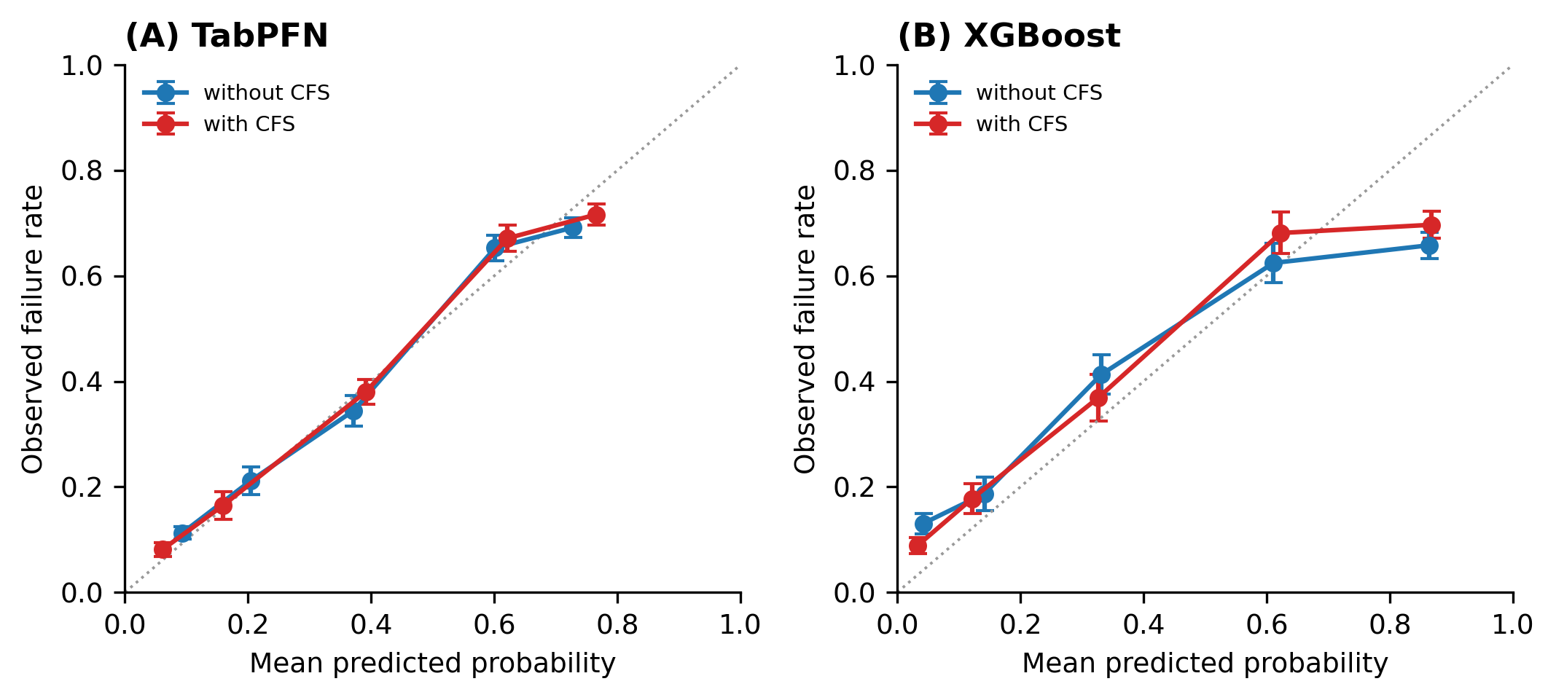

Figure S2. Performance metrics at a Youden-optimal classification threshold
All performance metrics for the five model configurations. Bars are means across all 500 cross-validation folds and error bars are standard deviations. Accuracy, balanced accuracy, sensitivity and specificity are computed at a Youden-optimal threshold selected on the pooled out-of-fold predictions of the other nine folds; AUC and Brier score are threshold-independent. Note the CFS-only model's specificity of 0.382 at the sensitivity required to flag a useful proportion of failures: a model using frailty alone cannot be operated at any clinically acceptable pair of values.
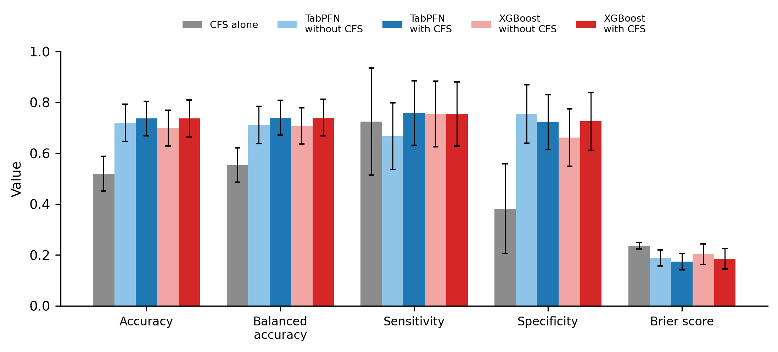

Supplementary methods note: model feature set
The models used eight features when CFS was included and seven when it was not: Age, Clinical_Frailty_Scale (excluded in the "without CFS" configuration), RR_T0, RR_T1, RR_Delta, FiO2_T0, FiO2_T1 and FiO2_Delta. Arterial blood gas variables (PaO₂, PaCO₂, PaO₂/FiO₂) were recorded for the Modena cohort but not for the North Midlands cohort, and were excluded from all models; they are reported in Table 1 for cohort description only.
Cross-validation used StratifiedKFold(n_splits=10, shuffle=True) repeated over 50 random seeds; within each partition the same fold assignment was applied to every model so that all comparisons are paired. TabPFN was used with 32 estimators and XGBoost with 100 trees, learning rate 0.1 and maximum depth 4; no hyperparameter tuning was performed.
All code, aggregate result tables and figure-generating scripts are available at https://github.com/LukaszRegulski03/frailty-nirs-outcome.

