Supplementary Information

Computational Characterization of Flavonoid Recognition of CAG-Repeat Mismatch Motifs Using Molecular Docking, Global Reactivity Descriptors, and Pharmacokinetic Profiling

Kiara Garcia Homs, Bijili Navine Nanjo, Nabanita Saikia
Chemistry Department, New Mexico Highlands University, Las Vegas 87701, USA
Email – nsaikia@nmhu.edu

Corresponding author:
*E-mail: nsaikia@nmhu.edu

ORCID
Nabanita Saikia: 0000-0002-0684-260X
Table S1. Solvent-induced change in dipole moment (Δμ) for NA and selected flavonoids calculated at the M06-2X/6-31+G(d,p) and CAM-B3LYP/6-31+G(d,p) levels of theory. Δμ was calculated as the difference between the aqueous implicit solvent and gas-phase dipole moments (Δμ = μ_{water} ​− μ_{gas​}). Positive Δμ values indicate an increase in molecular polarization upon solvation.

Compound | Subclass | Δμ M06-2X (D) | Δμ CAM-B3LYP (D)
NA | Reference | 3.933 | 3.697
EGCG | Flavanol | 2.194 | 2.802
Catechin | Flavanol | 1.220 | 0.900
Hesperetin | Flavanone | 2.630 | 2.838
Naringenin | Flavanone | 1.291 | 1.272
Myricetin | Flavonol | 0.798 | 0.865
Quercetin | Flavonol | 3.813 | 4.019
Kaempferol | Flavonol | 3.126 | 3.294
Fisetin | Flavonol | 3.250 | 3.266
Morin | Flavonol | 3.018 | 3.240
Luteolin | Flavone | 2.607 | 2.703
Baicalein | Flavone | 1.383 | 1.582
Nobiletin | Flavone | 3.623 | 3.778
7,8-DHF | Flavone | 3.304 | 3.485
Chrysin | Flavone | 3.267 | 3.470
Genistein | Isoflavone | 2.479 | 2.599

Table S2. The chemical potential (μ) and global softness (S) values for NA and flavonoids dataset calculated at the M06-2X/6-31+G(d,p) and CAM-B3LYP/6-31+G(d,p) levels of theory in presence of implicit solvent.

Compound | Subclass | μ (eV) |  | S (eV)
Compound | Subclass | M06-2X | CAM-B3LYP | M06-2X | CAM-B3LYP
NA | Reference | -3.827 | -3.824 | 0.355 | 0.322
EGCG | Flavanol | -3.963 | -3.834 | 0.288 | 0.273
Catechin | Flavanol | -3.544 | -3.362 | 0.263 | 0.244
Hesperetin | Flavanone | -4.117 | -4.027 | 0.305 | 0.291
Naringenin | Flavanone | -4.269 | -4.190 | 0.291 | 0.277
Myricetin | Flavonol | -4.109 | -4.018 | 0.343 | 0.325
Quercetin | Flavonol | -4.177 | -4.084 | 0.341 | 0.323
Kaempferol | Flavonol | -4.185 | -4.091 | 0.338 | 0.319
Fisetin | Flavonol | -4.225 | -4.116 | 0.327 | 0.307
Morin | Flavonol | -4.206 | -4.107 | 0.320 | 0.302
Luteolin | Flavone | -4.272 | -4.173 | 0.327 | 0.309
Baicalein | Flavone | -4.368 | -4.254 | 0.324 | 0.307
Nobiletin | Flavone | -4.485 | -4.350 | 0.317 | 0.299
7,8-DHF | Flavone | -4.445 | -4.340 | 0.315 | 0.299
Chrysin | Flavone | -4.473 | -4.363 | 0.312 | 0.297
Genistein | Isoflavone | -4.085 | -4.108 | 0.313 | 0.296

Table S3. The maximum charge transfer index (ΔN_{max}) for NA and flavonoids dataset calculated at the M06-2X/6-31+G(d,p) and CAM-B3LYP/6-31+G(d,p) levels of theory in presence of implicit solvent.

Compound | Subclass | ΔN_{max} M06-2X | ΔN_{max} CAM-B3LYP
NA | Reference | 1.358 | 1.232
EGCG | Flavanol | 1.412 | 1.047
Catechin | Flavanol | 0.933 | 0.819
Hesperetin | Flavanone | 1.256 | 1.171
Naringenin | Flavanone | 1.244 | 1.163
Myricetin | Flavonol | 1.410 | 1.306
Quercetin | Flavonol | 1.427 | 1.321
Kaempferol | Flavonol | 1.414 | 1.307
Fisetin | Flavonol | 1.380 | 1.265
Morin | Flavonol | 1.344 | 1.238
Luteolin | Flavone | 1.398 | 1.292
Baicalein | Flavone | 1.415 | 1.306
Nobiletin | Flavone | 1.424 | 1.302
7,8-DHF | Flavone | 1.399 | 1.299
Chrysin | Flavone | 1.397 | 1.294
Genistein | Isoflavone | 1.280 | 1.188

Table S4. Physicochemical properties of the flavonoids and NA molecule based on Swiss ADME. Molecules with a Log S (ESOL) of –6.0–0.0 may have favorable oral bioavailability. The SwissADME bioavailability score is a categorical probability estimate and should not be interpreted as the fraction or percentage of an administered dose reaching systemic circulation.

Compound | Subclass | Num. rotatable bonds | Log S (ESOL) | Bioavailability Score
NA | Reference | 11 | -2.95 | 0.55
EGCG | Flavanol | 4 | -3.56 | 0.17
Catechin | Flavanol | 1 | -2.22 | 0.55
Hesperetin | Flavanone | 2 | -3.62 | 0.55
Naringenin | Flavanone | 1 | -3.49 | 0.55
Myricetin | Flavonol | 1 | -3.01 | 0.55
Quercetin | Flavonol | 1 | -3.16 | 0.55
Kaempferol | Flavonol | 1 | -3.31 | 0.55
Fisetin | Flavonol | 1 | -2.99 | 0.55
Morin | Flavonol | 1 | -3.19 | 0.55
Luteolin | Flavone | 1 | -3.71 | 0.55
Baicalein | Flavone | 1 | -3.23 | 0.55
Nobiletin | Flavone | 7 | -3.68 | 0.55
7,8-DHF | Flavone | 1 | -4.03 | 0.55
Chrysin | Flavone | 1 | -4.19 | 0.55
Genistein | Isoflavone | 1 | -3.72 | 0.55

Table S5a. ProTox 3.0-predicted toxicity endpoints for the selected flavonoids and the reference ligand NA, including predicted LD50, toxicity class, and the probability of hepatotoxicity, carcinogenicity, neurotoxicity, and mutagenicity predictions. Probability corresponds to the confidence associated with the ProTox 3.0 Active/Inactive classification for each toxicity endpoint.

Compound | Mutagenicity | LD50  (mg/kg) | Toxicity class | Hepatotoxicity | Neurotoxicity | Carcinogenicity
NA | Active (.53) | 1190 | 4 | Inactive (.80) | Active (.72) | Inactive (.56)
EGCG | Inactive (.70) | 1000 | 4 | Inactive (.70) | Inactive (.88) | Inactive (.54)
Catechin | Inactive (.55) | 10,000 | 6 | Inactive (.72) | Inactive (.90) | Inactive (.51)
Hesperetin | Inactive (.87) | 2000 | 4 | Inactive (.70) | Inactive (.87) | Inactive (.70)
Naringenin | Inactive (.83) | 2000 | 4 | Inactive (.67) | Inactive (.84) | Inactive (.62)
Myricetin | Active (.51) | 159 | 3 | Inactive (.69) | Inactive (.89) | Active (.68)
Quercetin | Active (.51) | 159 | 3 | Inactive (.69) | Inactive (.89) | Active (.68)
Kaempferol | Inactive (.52) | 3919 | 5 | Inactive (.68) | Inactive (.89) | Inactive (.72)
Fisetin | Inactive (.53) | 159 | 3 | Inactive (.70) | Inactive (.88) | Active (.71)
Morin | Inactive (.52) | 3919 | 5 | Inactive (.68) | Inactive (.89) | Inactive (.72)
Luteolin | Active (.51) | 3919 | 5 | Inactive (.69) | Inactive (.89) | Active (.68)
Baicalein | Active (.51) | 3919 | 5 | Inactive (.69) | Inactive (.89) | Active (.68)
Nobiletin | Inactive (.69) | 5000 | 5 | Inactive (.69) | Inactive (.74) | Inactive (.53)
7,8-DHF | Inactive (.53) | 3919 | 5 | Inactive (.70) | Inactive (.88) | Active (.71)
Chrysin | Inactive (.57) | 3919 | 5 | Inactive (.68) | Inactive (.86) | Inactive (.62)
Genistein | Inactive (.74) | 2500 | 5 | Inactive (.69) | Inactive (.85) | Inactive (.69)

Table S5b. ProTox 3.0-predicted toxicity endpoints for the selected flavonoids and the reference ligand NA, including probability of CYP-related metabolism risks. Probability corresponds to the confidence associated with the ProTox 3.0 Active/Inactive classification for each toxicity endpoint.

Compound | CYP1A2 | CYP2C19 | CYP2C9 | CYP2D6 | CYP3A4 | CYP2E1
NA | Inactive  .88 | Inactive  .81 | Inactive  .66 | Inactive  .66 | Inactive  .78 | Inactive  .99
EGCG | Inactive  .78 | Inactive  .80 | Inactive  .54 | Inactive  .87 | Inactive  .98 | Inactive  1
Catechin | Inactive  .79 | Inactive  .91 | Inactive  .66 | Inactive  .88 | Inactive  .99 | Inactive  .99
Hesperetin | Active  .84 | Active  .98 | Active  .84 | Inactive  .72 | Inactive  .96 | Inactive  .99
Naringenin | Active  1 | Active  1 | Active  .87 | Inactive  .97 | Active  .80 | Inactive  .99
Myricetin | Active  1 | Active  .77 | Active  .99 | Inactive  .85 | Inactive  .79 | Inactive  1
Quercetin | Active  1 | Active  .77 | Active  .99 | Inactive  .85 | Inactive  .79 | Inactive  1
Kaempferol | Active  .93 | Active  .65 | Active  .66 | Active  .62 | Inactive  .65 | Inactive  1
Fisetin | Active  1 | Active  .65 | Active  .99 | Inactive  .93 | Inactive  .99 | Inactive  1
Morin | Active  .93 | Active  .65 | Active  .66 | Active  .62 | Inactive  .65 | Inactive  1
Luteolin | Active  1 | Active  .77 | Active  .99 | Inactive  .85 | Inactive  .79 | Inactive  1
Baicalein | Active  1 | Active  .77 | Active  .99 | Inactive  .85 | Inactive  .79 | Inactive  1
Nobiletin | Active  .84 | Active  .63 | Active  .62 | Inactive  .73 | Inactive  .50 | Inactive  .99
7,8-DHF | Active  1 | Active  .65 | Active  .99 | Inactive  .93 | Inactive  .99 | Inactive  1
Chrysin | Active  1 | Active  .99 | Active  .81 | Inactive  .89 | Active  .99 | Inactive  .98
Genistein | Active  .99 | Active  1 | Active  .94 | Active  .83 | Active  .89 | Inactive  1

(a)
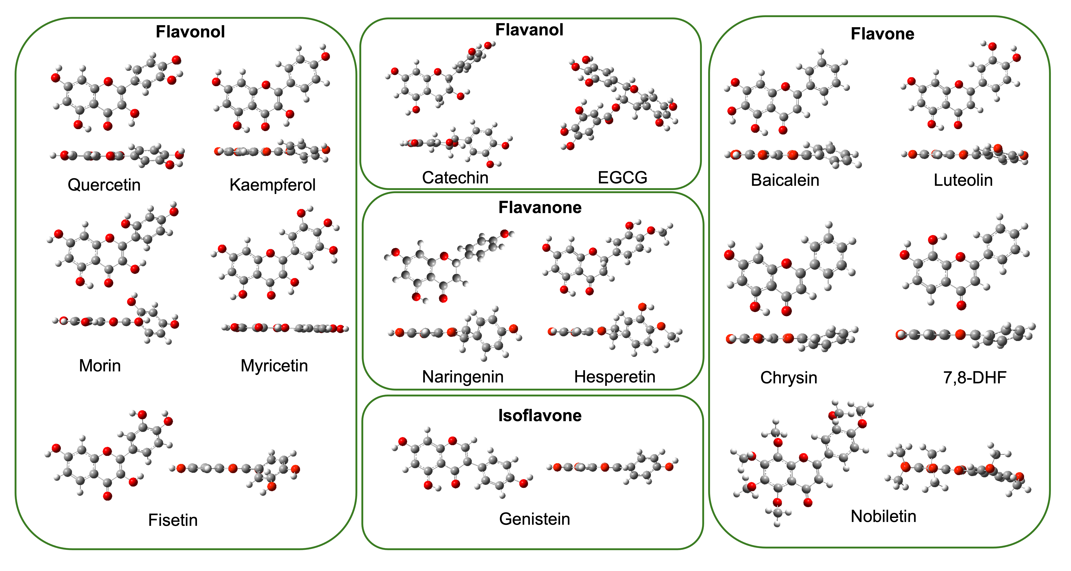

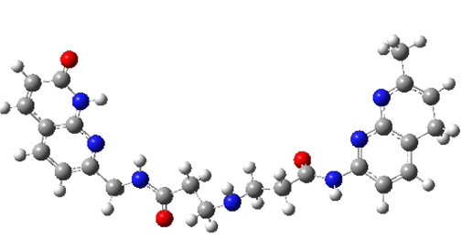
(b)

Figure S1. Optimized geometries of (a) selected flavonoids and (b) NA molecule in solvent phase at the M06-2X/6-31+G(d,p) level. SMD (Solvation Model based on Density) water model treats the solvent as a continuum dielectric medium and uses the solute's electron density, not partial atomic charges, to describe the solute-solvent interactions. NA: Naphthyridine-azaquinolone, is a novel repeat-structure-specific DNA ligand, specifically binding slipped-CAG DNA intermediates of expansion mutations. NA binds the G-A region of the mismatch, which causes significant changes in the structure of DNA.

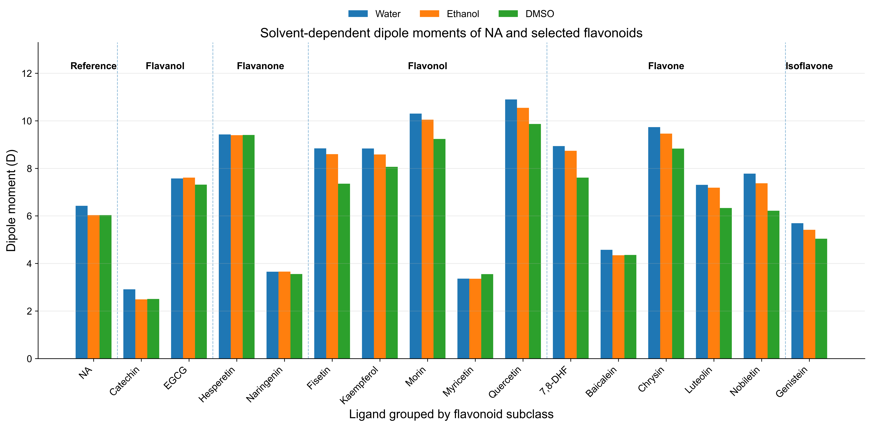

Figure S2. Solvent-dependent dipole moments of NA and selected flavonoids calculated at the M06-2X/6-31+G(d,p) level in implicit water, ethanol, and DMSO. Ligands are grouped according to flavonoid subclass, with NA included as the reference compound. The grouped bar chart shows that most ligands exhibit higher dipole moments in water than in ethanol or DMSO, consistent with stronger solvent-induced polarization in the aqueous implicit-solvent environment.

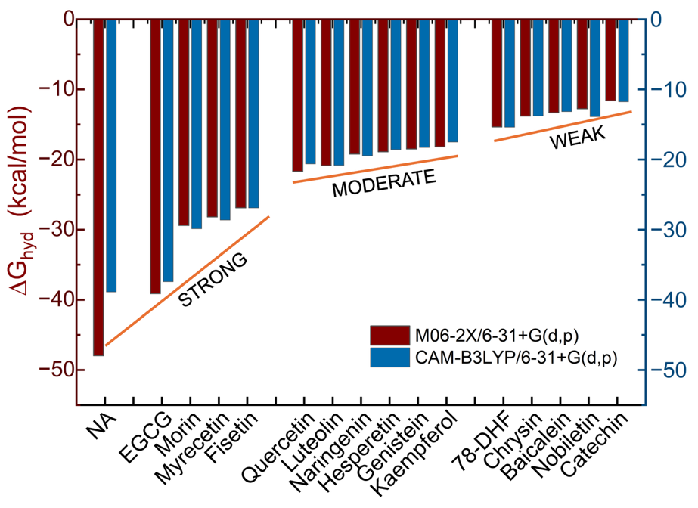

Figure S3. Hydration Free Energy (ΔG_{hyd}) of NA and the selected flavonoids calculated at the M06-2X/6-31+G(d,p) and CAM-B3LYP/6-31+G(d,p) levels of theory. More negative ΔG_{hyd} values indicate favorable hydration and stronger aqueous stabilization.

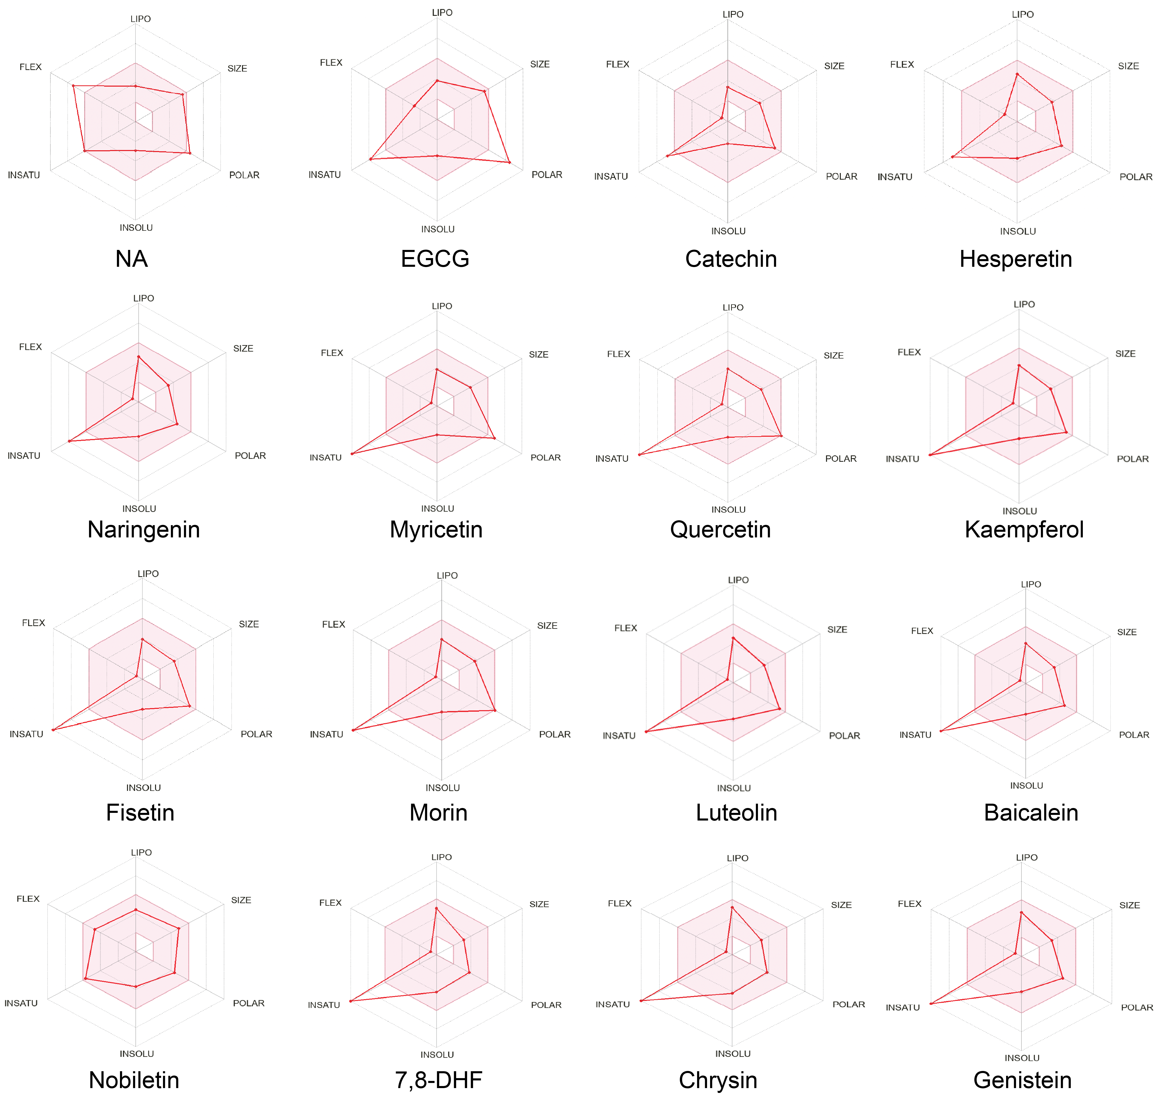

Figure S4. Radar map of the flavonoids and NA molecule computed using SwissADME. The pink region represents the optimal physicochemical space for predicted oral drug-likeness. The radar plots summarize lipophilicity, size, polarity, solubility, saturation, and flexibility. The radar plots show that most flavonoids occupy broadly acceptable drug-like space, whereas EGCG exhibits the strongest deviation, primarily due to high polarity and extensive hydrogen-bonding capacity. Nobiletin shows a comparatively balanced radar profile, consistent with its favorable physicochemical and drug-likeness properties. These plots support the consensus ADME analysis by showing that predicted pharmacokinetic suitability varies across the flavonoid scaffolds.

