Supplementary figures
Fig S1 – BLAST2GO E-Value distribution
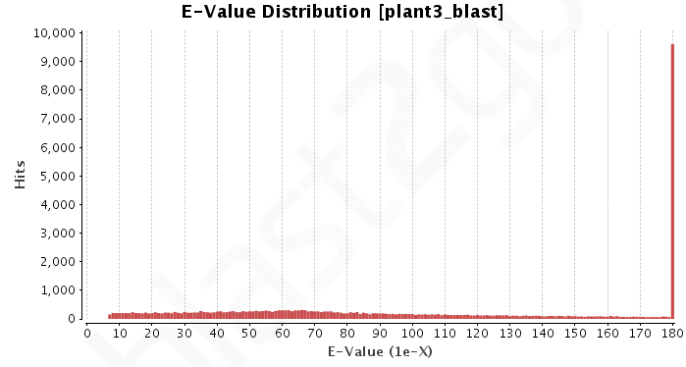Fig S2 – GO analysis and its distribution from the sugarcane during interaction with C. falcatum 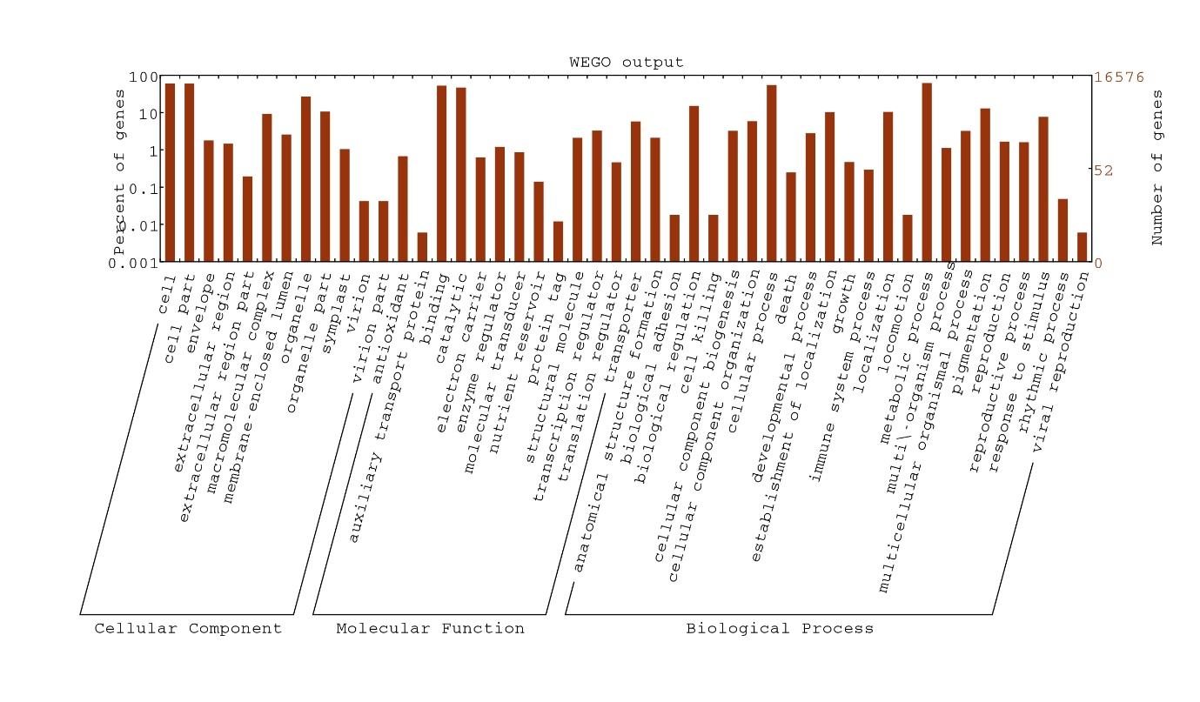

Fig S3 - GO analysis and its distribution from the fungal transcripts expressed during interaction with sugarcane.
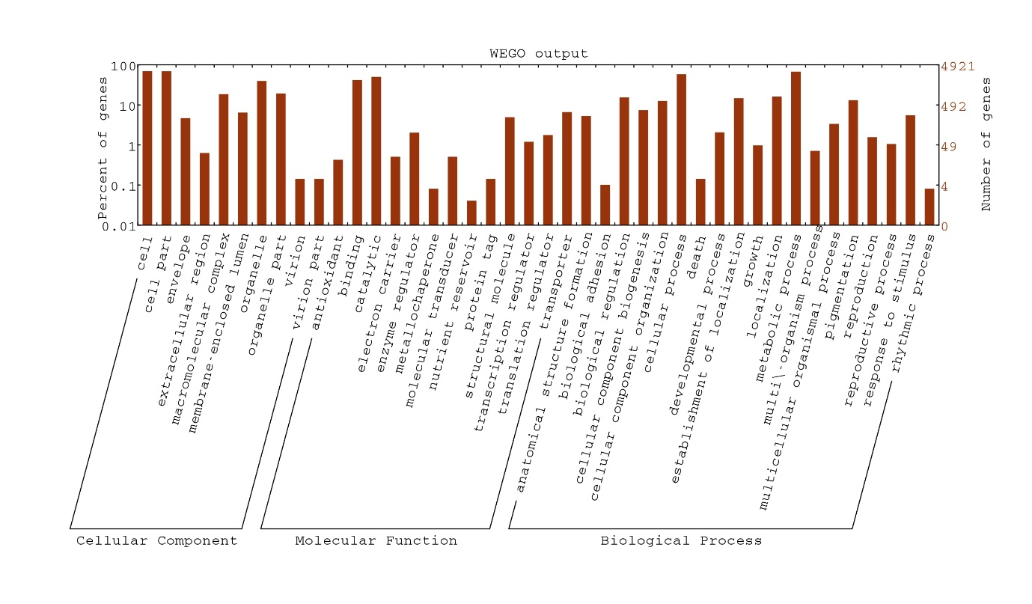

Tables
Table – S1 - List of Homologous sequences from DD RT-PCR Incompatible interaction of sugarcane with sugarcane transcriptome
S. No | Protein/Gene Description | Transcript ID | Platform used | Platform compared | Functional category | Class
1 | TPA: ubiquinol-cytochrome c reductase complex partial | TRINITY_DN21177_c0_g1_i1 | Illumina Hi-Seq 2000 | DD RT-PCR | Electron transport | Cell growth/metabolism
2 | UMP | CL15884Contig1 | Illumina Hi-Seq 2000 | DD RT-PCR | Proteome complex | Cell growth/metabolism
3 | CMP | CL15655Contig1 | Illumina Hi-Seq 2000 | DD RT-PCR | Proton transport | Cell growth/metabolism
4 | Myosin | TRINITY_DN66819_c0_g1_i1 | Illumina Hi-Seq 2000 | DD RT-PCR | Maintenance of cytoskeleton | Cell growth/metabolism
5 | NADPH | TRINITY_DN11592_c0_g1_i1 | Illumina Hi-Seq 2000 | DD RT-PCR | Calvin cycle | Cell growth/metabolism
6 | Tubulin alpha | TRINITY_DN28610_c0_g4_i6 | Illumina Hi-Seq 2000 | DD RT-PCR | Microtubule associated | Cell growth/metabolism
7 | RNA binding protein | CL8310Contig1 | Illumina Hi-Seq 2000 | DD RT-PCR | Cytoskeleton associated | Cell growth/metabolism
8 | Actin-polymerizing factor | TRINITY_DN26548_c0_g5_i3 | Illumina Hi-Seq 2000 | DD RT-PCR | Organisation of cytoskeleton | Cell growth/metabolism
9 | Nucleoside phosphatase | TRINITY_DN30805_c0_g1_i3 | Illumina Hi-Seq 2000 | DD RT-PCR | Cell wall Biogenesis | Cell growth/metabolism
10 | Ubiquinone oxidoreductase sub unit | TRINITY_DN27957_c0_g1_i1 | Illumina Hi-Seq 2000 | DD RT-PCR | Electron transfer | Cell growth/metabolism
11 | Phosphoenolpyruvate carboxylase kinase | TRINITY_DN25749_c0_g1_i2 | Illumina Hi-Seq 2000 | DD RT-PCR | Photosynthesis | Cell growth/metabolism
12 | ASF SF2-like pre-mRNA splicing factor SRP32 | CL8475Contig1 | Illumina Hi-Seq 2000 | DD RT-PCR | Transcription | Cell growth/metabolism
13 | Methionine-tRNA synthetase | CL12032Contig1 | Illumina Hi-Seq 2000 | DD RT-PCR | Nucleotide binding | Cell growth/metabolism
14 | Aldehyde dehydrogenase | TRINITY_DN29387_c1_g1_i1 | Illumina Hi-Seq 2000 | DD RT-PCR | Stress responsive | Defense, stress and signaling related
15 | Delta 1-pyrroline-5-carboxylate synthetase 2 | CL7965Contig1 | Illumina Hi-Seq 2000 | DD RT-PCR | Proline biosynthesis Stress responsive | Defense, stress and signaling related
16 | ADP-ribosylation factor 1 isoform X1 | CL3762Contig1 | Illumina Hi-Seq 2000 | DD RT-PCR | Intracellular traffic  and regulation of  stress and  hormonal  responses | Defense, stress and signaling related
17 | VIP1 protein | TRINITY_DN25122_c0_g1_i1 | Illumina Hi-Seq 2000 | DD RT-PCR | regulator of  osmosensory  signaling | Defense, stress and signaling related
18 | lipoxygenase | TRINITY_DN32699_c0_g2_i1 | Illumina Hi-Seq 2000 | DD RT-PCR | Senescence/response  to wounding | Defense, stress and signaling related
19 | Chitinase | CL1508Contig2, | Illumina Hi-Seq 2000 | DD RT-PCR | Pathogen resistance | Defense, stress and signaling related
20 | beta-glucosidase 20 isoform X2 | TRINITY_DN87243_c0_g1_i1 | Illumina Hi-Seq 2000 | DD RT-PCR | Plant defense | Defense, stress and signaling related
21 | F-box domain containing | CL16699Contig1 | Illumina Hi-Seq 2000 | DD RT-PCR | Signal transduction | Defense, stress and signaling related
22 | Leucine Rich Repeat family Protein | TRINITY_DN32310_c1_g1_i1 | Illumina Hi-Seq 2000 | DD RT-PCR | Signal transduction | Defense, stress and signaling related
23 | Heat shock protein | TRINITY_DN70086_c0_g1_i1 | Illumina Hi-Seq 2000 | DD RT-PCR | Stress tolerance | Defense, stress and signaling related
24 | WRKY51 - superfamily of TFs having WRKY and zinc finger domains | CL16298Contig1 | Illumina Hi-Seq 2000 | DD RT-PCR | Sequence specific DNA binding | Defense, stress and signalling related
25 | senescence-associated protein | CL37Contig2 | Illumina Hi-Seq 2000 | DD RT-PCR | integral component of membrane | Defense, stress and signalling related
26 | 14-3-3-like protein | CL464Contig2 | Illumina Hi-Seq 2000 | DD RT-PCR | Signal transduction | Defense, stress and signalling related
27 | Serine/threonine kinase | CL11516Contig1 | Illumina Hi-Seq 2000 | DD RT-PCR | Signal transduction | Defense, stress and signalling related
28 | Mitogen activated protein kinase | CL4125Contig1 | Illumina Hi-Seq 2000 | DD RT-PCR | Signal transduction | Defense, stress and signalling related
29 | chorismate mutase | TRINITY_DN26365_c0_g1_i1 | Illumina Hi-Seq 2000 | DD RT-PCR | Biosynthesis of tyrosine and phenylalanine | Defense, stress and signalling related
30 | Auxin efflux carrier protein | CL16509Contig1 | Illumina Hi-Seq 2000 | DD RT-PCR | Membrane transport | Cell transport
31 | Histidine biosynthesis | TRINITY_DN31326_c2_g1_i1 | Illumina Hi-Seq 2000 | DD RT-PCR | Membrane transport | Cell transport
32 | Glucose-6-phosphate phosphate-translocator Precursor | CL10471Contig1 | Illumina Hi-Seq 2000 | DD RT-PCR | Membrane transport | Cell transport

Table S2 List of Homologous sequences from 2D Proteome analysis of sugarcane with sugarcane transcriptome
S. No | Protein/Gene Description | Transcript ID | Platform used | Platform compared | Functional category | Class
1 | BAG domain-containing protein | TRINITY_DN53527_c0_g1_i1 | Illumina Hi-Seq | 2D, MALDI-TOF |  | Cell growth & development
2 | PAN1 | TRINITY_DN77384_c0_g1_i1 | Illumina Hi-Seq | 2D, MALDI-TOF
3 | bifunctional inhibitor LTP seed storage family | TRINITY_DN24437_c0_g1_i1 | Illumina Hi-Seq | 2D, MALDI-TOF | Lipid transport | Plant defense
4 | Polyphenol oxidase | TRINITY_DN11530_c0_g1_i1 | Illumina Hi-Seq | 2D, MALDI-TOF | pigment biosynthetic process | Secondary metabolism
5 | exostosin family domain-containing | TRINITY_DN25367_c0_g2_i1 | Illumina Hi-Seq | 2D, MALDI-TOF |  | Secondary metabolism
6 | calcium-dependent kinase family | CL11623Contig1 | Illumina Hi-Seq | 2D, MALDI-TOF | Nucleotide binding | signaling
7 | RNA-binding containing a PIN domain | TRINITY_DN8602_c0_g1_i1 | Illumina Hi-Seq | 2D, MALDI-TOF |  | Transcription
8 | Auxin response family protein | CL6445Contig1 | Illumina Hi-Seq | 2D, MALDI-TOF | Response to auxin | Cell growth & development
9 | ATPase like protein | CL584Contig1 | Illumina Hi-Seq | 2D, MALDI-TOF | Catalytic activity | Energy
10 | ribulose-1,5 bisphosphate carboxylase oxygenase large subunit N- chloroplastic isoform X1 | TRINITY_DN54381_c0_g1_i1 | Illumina Hi-Seq | 2D, MALDI-TOF |  | Primary metabolism
11 | photosystem I reaction center subunit IV A | CL12766Contig1 | Illumina Hi-Seq | 2D, MALDI-TOF | Photosynthesis | Primary metabolism
12 | ACC synthase 1 | CL2189Contig1 | Illumina Hi-Seq | 2D, MALDI-TOF | pyridoxal phosphate binding | signaling
13 | F-box domain containing protein | TRINITY_DN27160_c0_g2_i1 | Illumina Hi-Seq | 2D, MALDI-TOF | integral component of membrane | signaling
14 | spliceosome-associated protein | CL15089Contig1 | Illumina Hi-Seq | 2D, MALDI-TOF |  | Transcription
15 | pentatricopeptide repeat-containing | CL10294Contig1 | Illumina Hi-Seq | 2D, MALDI-TOF | Nucleotide binding | Transcription
 | Compatible interaction proteins
16 | callose synthase | TRINITY_DN25139_c0_g1_i1 | Illumina Hi-Seq | 2D, MALDI-TOF | Transferase activity | Defense
17 | Retroelement | TRINITY_DN50168_c0_g1_i1 | Illumina Hi-Seq | 2D, MALDI-TOF | Nucleic acid binding | DNA replication/repair
18 | glyceraldehyde-3-phosphate cytosolic | CL11919Contig1 | Illumina Hi-Seq | 2D, MALDI-TOF | NADP binding | Primary metabolism
19 | ribulose-1,5 bisphosphate carboxylase oxygenase large subunit N- chloroplastic isoform X1 | TRINITY_DN54381_c0_g1_i1 | Illumina Hi-Seq | 2D, MALDI-TOF | methionine biosynthetic process | Primary metabolism
20 | p-coumarate 3-hydroxylase 2 | TRINITY_DN26746_c1_g1_i3 | Illumina Hi-Seq | 2D, MALDI-TOF |  | Secondary metabolism
21 | transcription initiation factor IIB | CL5144Contig1 | Illumina Hi-Seq | 2D, MALDI-TOF | Zinc ion binding | Transcription
22 | R2R3-MYB transcription factor | TRINITY_DN14015_c0_g1_i1 | Illumina Hi-Seq | 2D, MALDI-TOF | DNA binding | Transcription
23 | CKX1 Cytokinin dehydrogenase 1 | TRINITY_DN14481_c0_g1_i1 | Illumina Hi-Seq | 2D, MALDI-TOF | cytokinin metabolic process | Defense

Table S3 – List of primers used for qRT-PCR validation
S. No | Gene | Primers | Annealing temp | Product size (bp)
1 | WRKY | 5’-ATACACCGTGTTGTGTGCGT-3’  5’-GTCGGTCCACCAATCTCGTC-3’ | 58°C | 145
2 | WRKY 26 | 5’-GTATCTGAGTGCGAAGGCGA-3’  5’- ACTCGCTCCTCTGCTAGTGA-3’ | 58.5°C | 143
3 | MYB | 5’-TTGCAACTCCGCATTGAAGC-3’  5’-ATGCATGCTGGAGGCATTCT-3’ | 57.5°C | 166
4 | MYB -2 | 5’-AGTGAGTAGTGACACGAGCC-3’  5’-GGCCAGCCGAATTCTTCTTC-3’ | 58.5°C | 161
5 | NAC 23 | 5’-TCTGGCACAGCACGTTTTTG-3’  5’-GGACTCTGGACCCGTTGTTT-3’ | 59°C | 154
6 | NAC 67 | 5’-CGATCCTGTTGTCGTCCGAG -3’  5’-GCTGAAATGGGACAGCTTCG -3’ | 59°C | 161
7 | bZIP | 5’-GCGAGCCGTCTCTGAATCTT-3’  5’-GAGGAGGTCAAGTTCGGCAA-3’ | 58°C | 152
8 | bZIP -2 | 5’-GTCCAGTGGATACGTCGGTG-3’  5’-CTCCCTCAAAGGGGTATGGC-3’ | 59°C | 99
9 | bHLH | 5’-TGCATGATGCCCATCTCGTT-3’  5’-ATGCATGTTACGGTTGCTGC-3’ | 58°C | 123
10 | bHLH -2 | 5’-AGCCGATAGGTGAGGGGATT-3’  5’-TAGAACCCGGTGGTAACCCA-3’ | 58.5°C | 133
11 | ACTIN | 5’-ATGTGCAAGGCCGGTTTCGC-3’  5’-TACGAGTCCTTCTGGCCCAT-3’ | 58°C | 150

