Supplementary Table 1: List of antibodies.
Antibody | Host animal | Manufacturer, cat. no. | Dilution
Anti-mouse IgG, HRP-linked Antibody | Horse | CST, #7076S | 1:2000^{b}
Anti-Mouse IgG (H+L) Secondary Antibody, Alexa Fluor 568 | Goat | Invitrogen, A11004 | 1:2000^{IF}
Anti-rabbit IgG, HRP-linked Antibody | Goat | CST, #7074S | 1:2000^{b}
Anti-Rabbit IgG (H+L) Secondary Antibody, Alexa Fluor 488 | Goat | Invitrogen, A11034 | 1:2000^{IF}
Anti-Rat IgG (H+L) Secondary Antibody, Alexa Fluor 647 | Donkey | Invitrogen, A48272 | 1:2000^{IF}
β-Actin | Mouse | CST, #3700S | 1:10000ª
BiP | Rabbit | CST, #3177S | 1:1000ª; 1:500^{IF}
CD3 | Rat | Biorad, MCA1477 | 1:500^{IF}
CD3ε | Rabbit | CST, #85061S | 1:1000ª
CD4 | Rabbit | Zeta, Z2420RL | 1:1000ª
CD8α | Rabbit | CST, #85336S | 1:1000ª
CHOP | Mouse | CST, #2895S | 1.500ª
CHOP | Mouse | Sony, 5343510 | 1:200^{IF}
DAPI | - | Merck, MBD0015 | 1:1000^{IF}
FoxP3 | Rabbit | CST, #12632S | 1:1000ª
IRE1α | Rabbit | CST, #3294S | 1:1000ª
PD-1 | Rabbit | CST, #86163S | 1:500ª
PD-L1 | Rabbit | CST, #13684S | 1:500ª
PERK | Rabbit | CST, #3192S | 1:1000ª
Phalloidin | - | Abcam, ab176761 | 1:2000^{IF}
TUSC3 | Rabbit | Abcam, ab230520 | 1:500ª
XBP1s | Rabbit | CST, #40435S | 1:500ª
Antibodies for Western Blot (WB); ª primary antibodies diluted in 5% BSA/PBS+0.1% Tween-20; ^{b} secondary antibodies diluted in 5% milk/PBS+0.1% Tween-20. Antibodies for Immunofluorescence staining (IF) diluted in 3% BSA/PBS.
Abbreviations: CST – Cell Signaling Technology

Supplementary Table 2: Composition of donor-derived buffy coats.
Buffy coat composition | Average | SD
White blood cells [10⁹/L] | 5.74 | 0.99
Coefficient of variation, platelet distribution width [%] | 12.45 | 0.73
Platelet distribution width [fL] | 10.96 | 1.55
Mean platelet volume [fL] | 9.83 | 0.78
Proportion of large platelets (>12 fL) | 0.24 | 0.06
Platelet hematocrit [%] | 0.22 | 0.04
Neutrophil count [10⁹/L] | 3.04 | 0.82
Lymphocyte count [10⁹/L] | 1.94 | 0.40
Monocyte count [10⁹/L] | 0.53 | 0.12
Eosinophil count [10⁹/L] | 0.19 | 0.11
Basophil count [10⁹/L] | 0.04 | 0.02
Red blood cells [10₁₂/L] | 5.01 | 0.39
Immature granulocytes, count [10⁹/L] | 0.01 | 0.01
Neutrophils [%] | 52.36 | 7.92
Lymphocytes [%] | 34.31 | 7.02
Monocytes [%] | 9.35 | 2.08
Eosinophils [%] | 3.28 | 1.85
Basophils [%] | 0.69 | 0.33
Immature granulocytes [%] | 0.17 | 0.14
Hemoglobin [g/L] | 149.80 | 9.37
Hematocrit [L/L] | 0.45 | 0.02
Mean Red Blood Cell Volume [fL] | 89.44 | 3.90
Hb Mass in Red Blood Cells [pg] | 29.98 | 1.31
Hb Concentration in Red Blood Cells [g/L] | 335.15 | 8.06
Platelets [10⁹/L] | 220.34 | 45.85

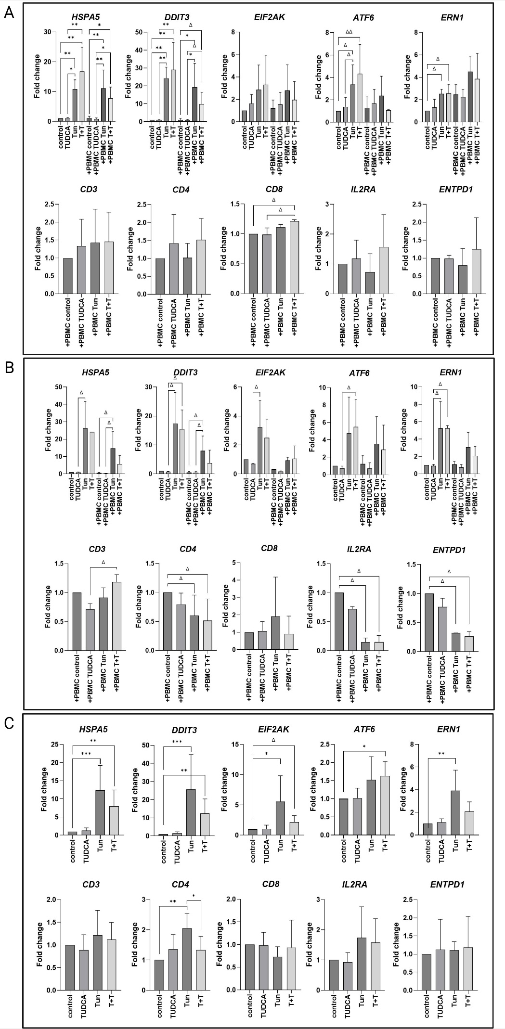
Supplementary Figure 1: Gene expression analysis of UPR and immune markers in TK-10, Caki-2, and PBMCs under ERS modulation in mono- and co-culture.
Gene expression was assessed by RT-qPCR and expressed as fold change relative to the untreated monoculture control. Data represent mean ± SD. Statistical comparisons were performed using Dunn's test; significance indicated as *p < 0.05, **p < 0.01, ***p < 0.001; Δ p < 0.05 without FDR correction.
(A) TK-10. Tun robustly induced HSPA5 and DDIT3 in both monoculture and co-culture conditions (p < 0.01–0.05), with T+T producing a partial attenuation of the Tun-induced signal. ATF6 and ERN1 showed modest, variably significant elevations under Tun and co-culture conditions (Δ). Among immune transcripts, CD8 was significantly elevated in PBMC co-culture under T+T treatment (Δ), while CD3, CD4, IL2RA, and ENTPD1 did not reach significance across conditions.
(B) Caki-2. HSPA5 and DDIT3 were significantly induced by Tun in monoculture (Δ), with attenuation observed under T+T and in co-culture conditions. EIF2AK, ATF6, and ERN1 showed high variability and no consistent significant differences. Immune transcripts CD3, CD4, IL2RA, and ENTPD1 were reduced under Tun and T+T co-culture conditions (Δ), while CD8 showed a trend toward elevation under co-culture that did not reach corrected significance.
(C) PBMCs. Tun significantly induced HSPA5 (p < 0.001–0.01), DDIT3 (p < 0.001–0.01), EIF2AK (p < 0.05), and ERN1 (p < 0.01) relative to untreated control, confirming UPR activation in the immune compartment under ERS modulation. ATF6 showed a non-significant trend toward elevation. Among immune transcripts, CD4 was significantly elevated under Tun treatment (p < 0.01–0.05), while CD3, CD8, IL2RA, and ENTPD1 did not differ significantly across conditions.
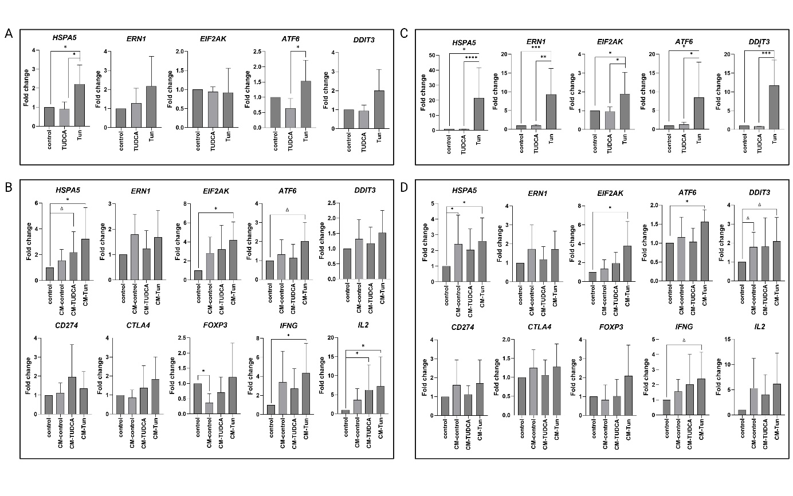
Supplementary Figure 2: Gene expression analysis of UPR and immune markers in RCC cells and CM-exposed PBMCs.
Gene expression was assessed by RT-qPCR and expressed as fold change relative to untreated control. Data represent mean ± SD. In all PBMC conditions (B, D), cells were exposed to conditioned media (CM) only; Tun and TUDCA were not added directly to PBMC cultures. CM was collected from donor RCC cells following drug treatment and complete media replacement to eliminate residual compounds. Statistical comparisons were performed using Dunn's test; significance indicated as *p < 0.05, **p < 0.01, ***p < 0.001, ****p < 0.0001; Δ p < 0.05 without FDR correction.
(A) Caki-2 — UPR gene expression following direct drug treatment. Tun significantly induced HSPA5 (p < 0.05) and ATF6 (p < 0.05) relative to untreated control, confirming pharmacological ERS activation in Caki-2 donor cells prior to CM collection. ERN1, EIF2AK, and DDIT3 showed trends toward elevation that did not reach corrected significance, consistent with the modest ERS sensitivity of Caki-2 relative to TK-10.
(B) PBMCs exposed to CM from Caki-2 — UPR and immune gene expression. CM from Tun-treated Caki-2 cells (CM-Tun) significantly induced HSPA5 (p < 0.05) and EIF2AK (p < 0.05) in naïve PBMCs relative to untreated control, with ATF6 showing a trend toward elevation (Δ). Among immune transcripts, FOXP3 was significantly elevated in PBMCs receiving CM-control relative to control (p < 0.05). IFNG was significantly elevated under CM-Tun (p < 0.05). IL2 showed the largest fold-change elevation under CM-control and CM-Tun conditions, with CM-control reaching significance versus control (p < 0.05). CD274 and CTLA4 did not reach significance across CM conditions.
(C) TK-10 — UPR gene expression following direct drug treatment. Tun robustly induced all five UPR transcripts: HSPA5 (p < 0.05), ERN1 (p < 0.001), EIF2AK (p < 0.05), ATF6 (p < 0.05), and DDIT3 (p < 0.001), confirming strong ERS activation in TK-10 donor cells. The magnitude of induction was substantially higher than in Caki-2, consistent with greater Tun sensitivity in this line (Figure 1C–D). TUDCA did not significantly alter UPR transcript levels relative to control in TK-10.
(D) PBMCs exposed to CM from TK-10 — UPR and immune gene expression.
CM from Tun-treated TK-10 cells significantly induced HSPA5 (p < 0.05), EIF2AK (p < 0.05), and ATF6 (p < 0.05) in naïve PBMCs. DDIT3 showed a trend toward elevation (Δ). Among immune transcripts, IFNG showed a trend toward elevation under CM-TUDCA (Δ). IL2, CD274, CTLA4, and FOXP3 did not reach significance across TK-10-derived CM conditions.

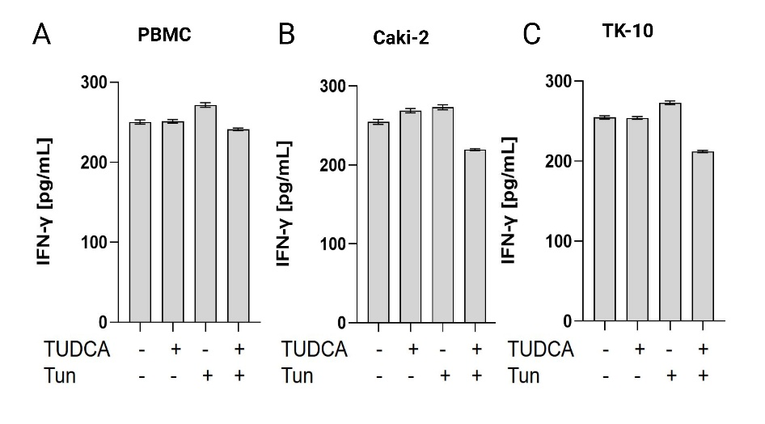
Supplementary Figure 3: IFN-γ production (ELISA). Changes in IFNγ production by PBMC were assessed upon ERS modulation both alone and in co-culture with RCC.
(A) Baseline IFN-γ production by PBMCs was ~250 pg/mL. Tun treatment induced slight increase in IFN-γ production to ~270 pg/mL.
(B) When co-cultured with Caki-2 cells baseline IFN-g production was ~250 pg/mL. Cells treated with T+T showed decreased IFN-γ production ~220 pg/mL.
(C) When co-cultured with TK-10 cells baseline IFN-g production was ~250 pg/mL. Cells treated with T+T showed decreased IFN-γ production ~220 pg/mL.

