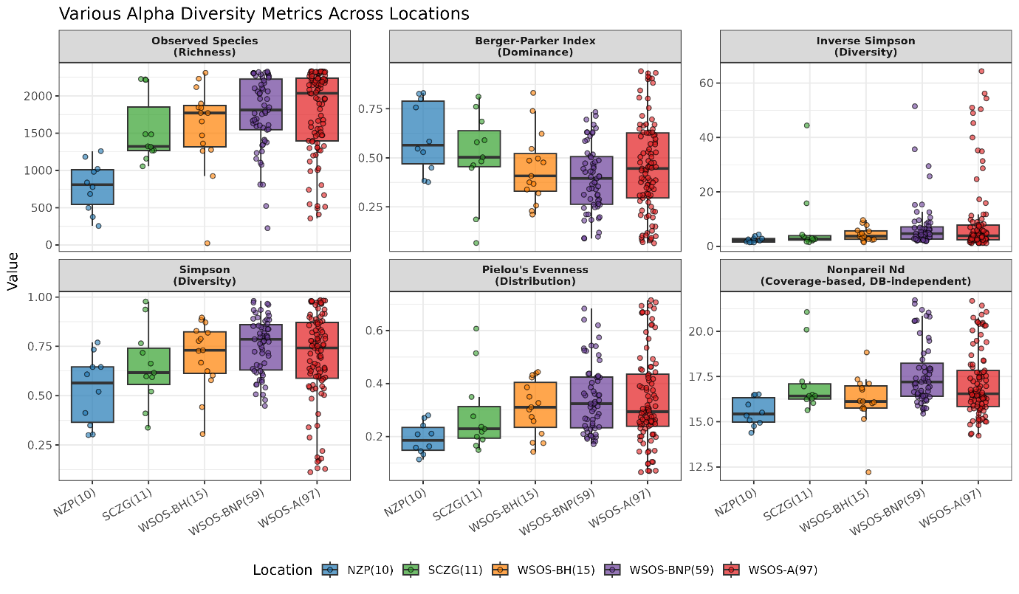

Figure S1 Various alpha diversity metrics across the 5 locations (Nehru Zoological Park, Hyderabad (n=10), Sri Chamarajendra Zoological Gardens, Mysuru (n=11), Wildlife SOS, Bhopal (n=15), Wildlife SOS, Bannerghatta (n=59), and Wildlife SOS, Agra (n=97)), along with the Nonpareil N_{d} value. Overall, all the metrics indicate towards the higher dominance and lesser evenness in these samples.

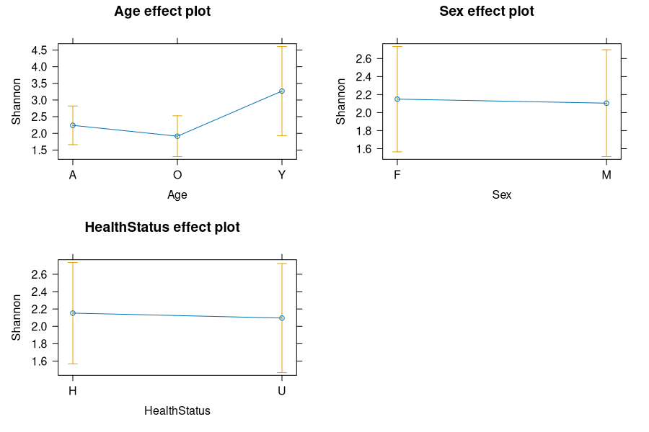
Figure S2 Linear mixed model (LMM) showing the effects of age, sex and health status of the animal on gut microbial alpha diversity in captive sloth bears. LMM_{Young} = 1.02945 and LMM_{Old} = -0.32526

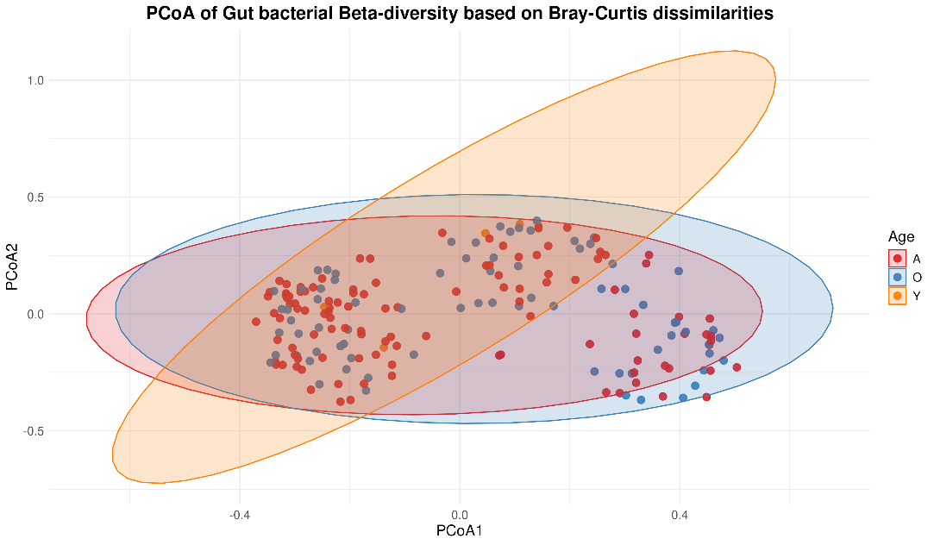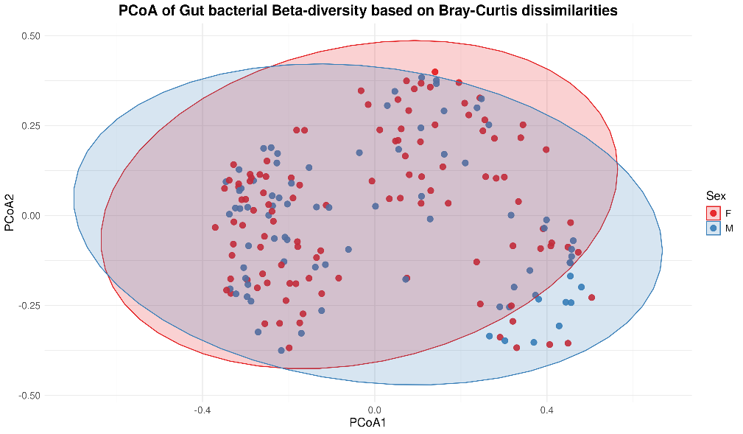
C
B
A
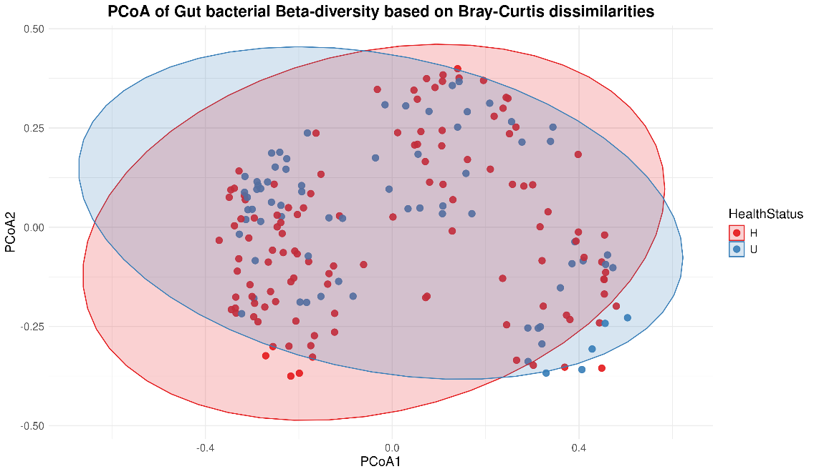
Figure S3 Beta diversity plot based on Bray-Curtis dissimilarity matrix for gut microbial diversity in captive sloth bear for A) Age, B) Sex and C) Health Status
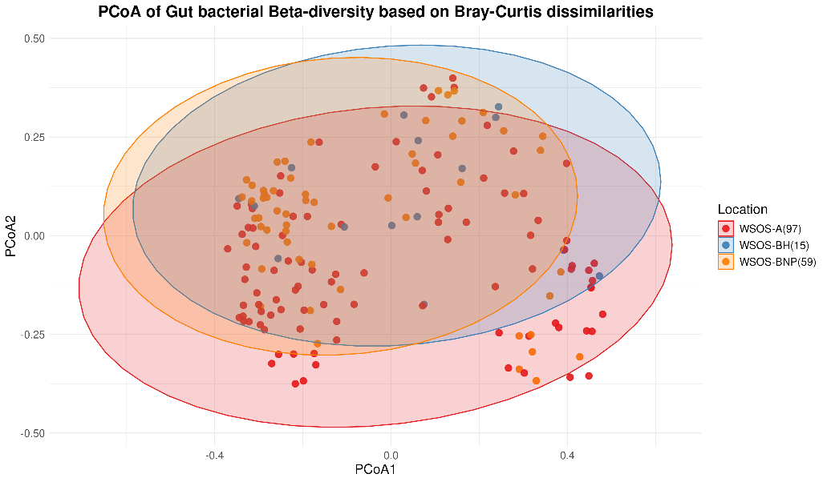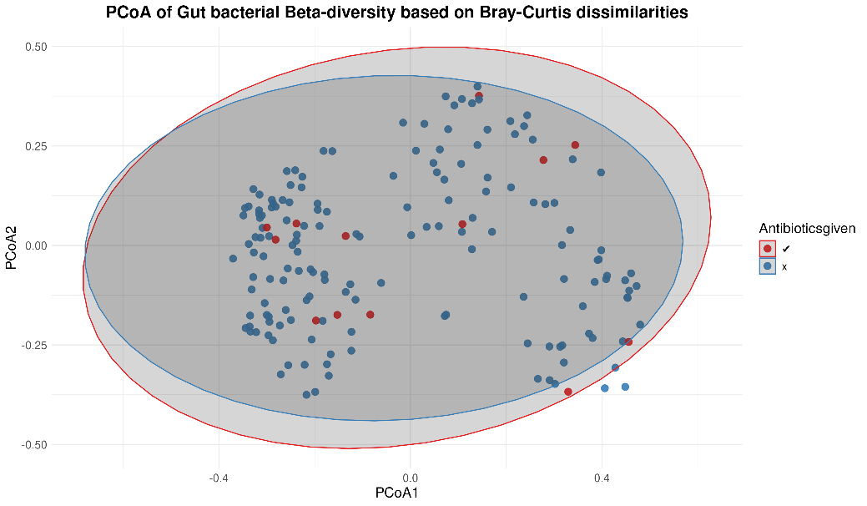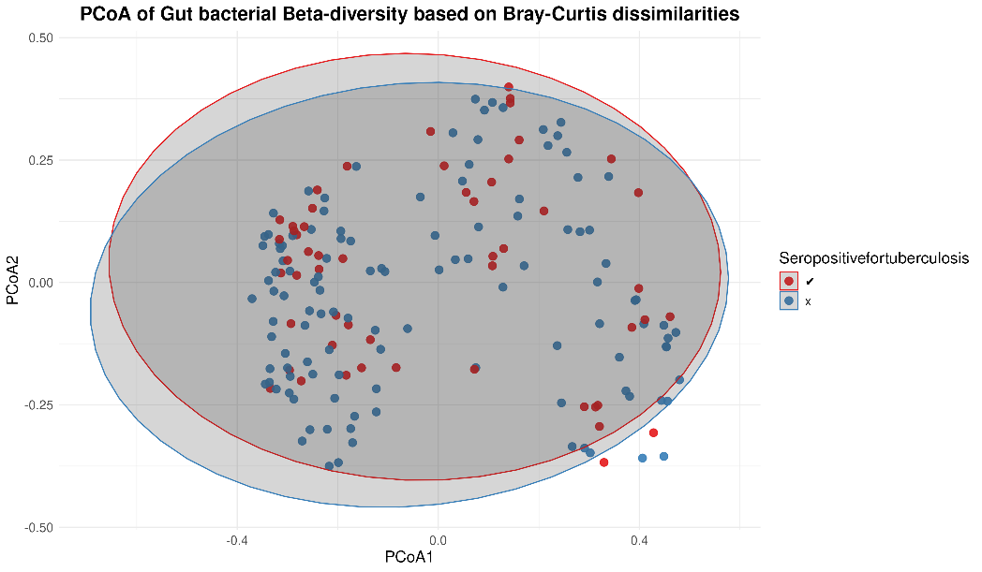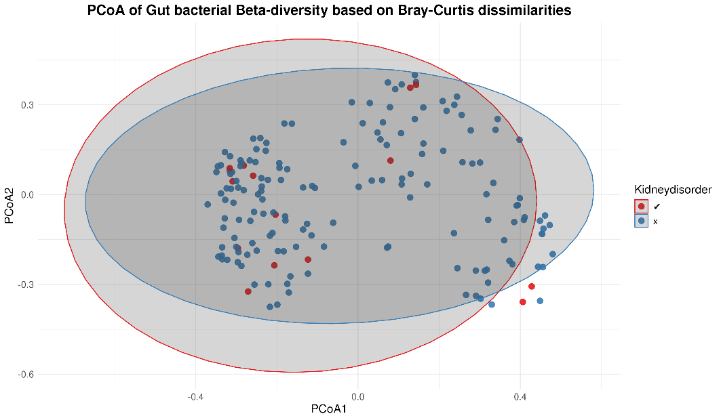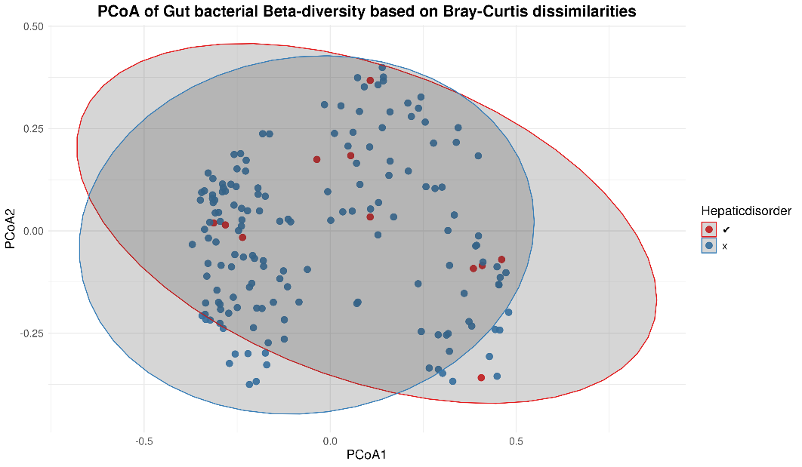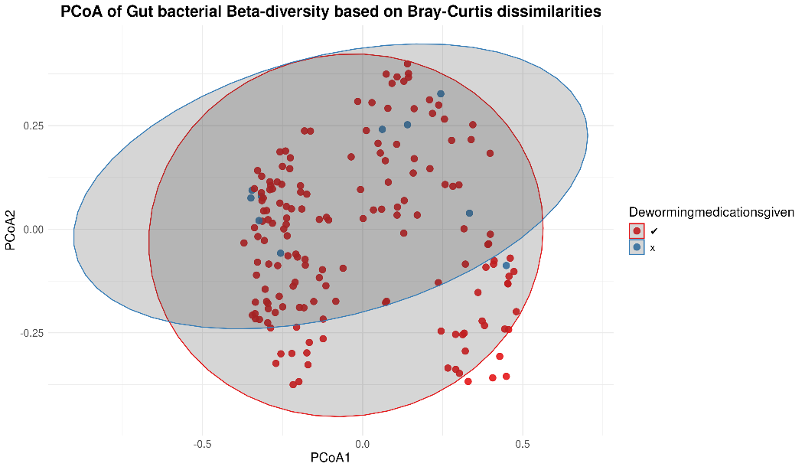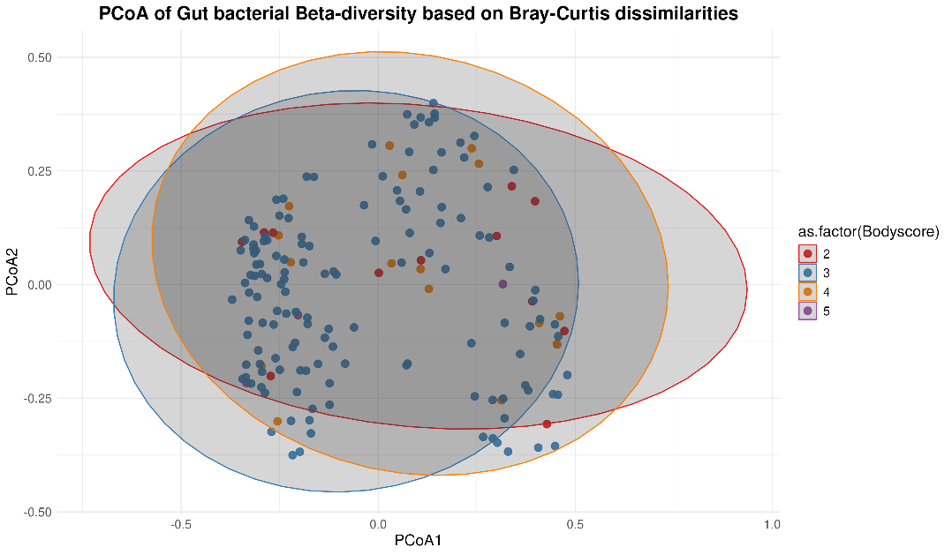
D
C
B
A
G
E
Figure S4 Beta diversity plot based on Bray-Curtis dissimilarity matrix for gut microbial diversity in captive sloth bear for the three wildlife SOS locations with additional co-variates – A) Location, B) Antibiotics given, C) Seropositive for tuberculosis, D) Kidney disorder, E) Hepatic disorder, F) Deworming medications given and G) Bodyscore index.

B
A
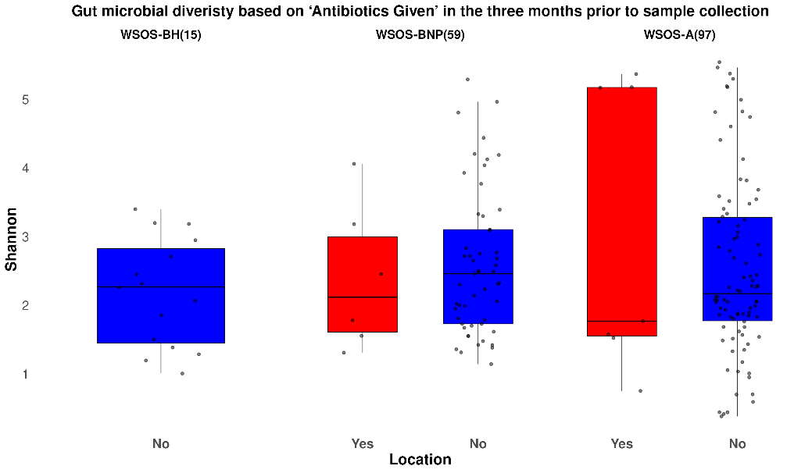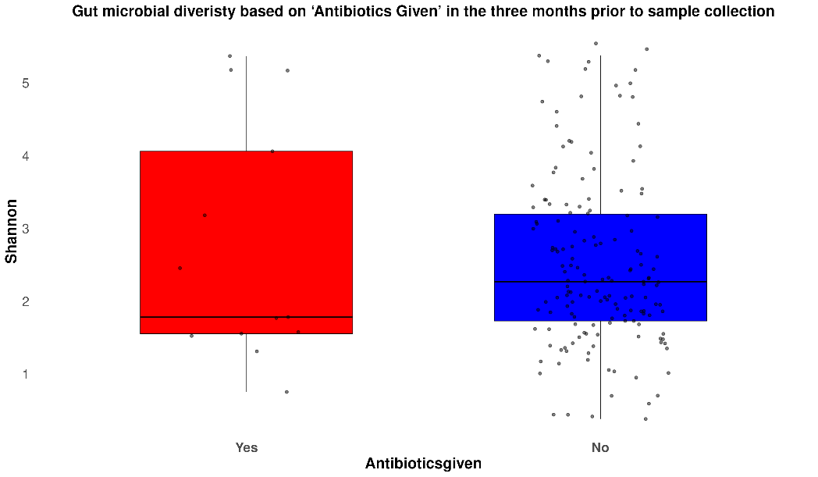

Figure S5 Gut microbial diversity based on antibiotics given to captive sloth bear in the three months prior to sample collection A) Location-wise and B) All 215 samples combined.

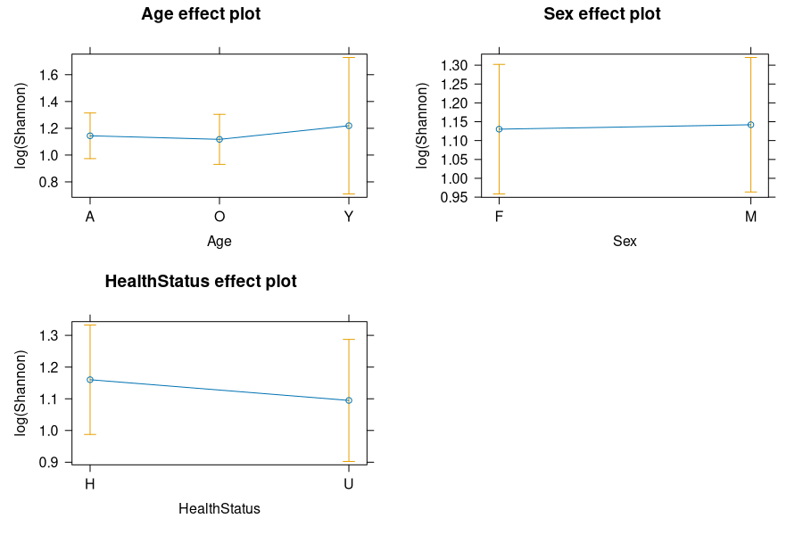
Figure S6 Linear mixed model (LMM) showing the effects of age, sex and health status of the animal on gut AMR alpha diversity in captive sloth bears.

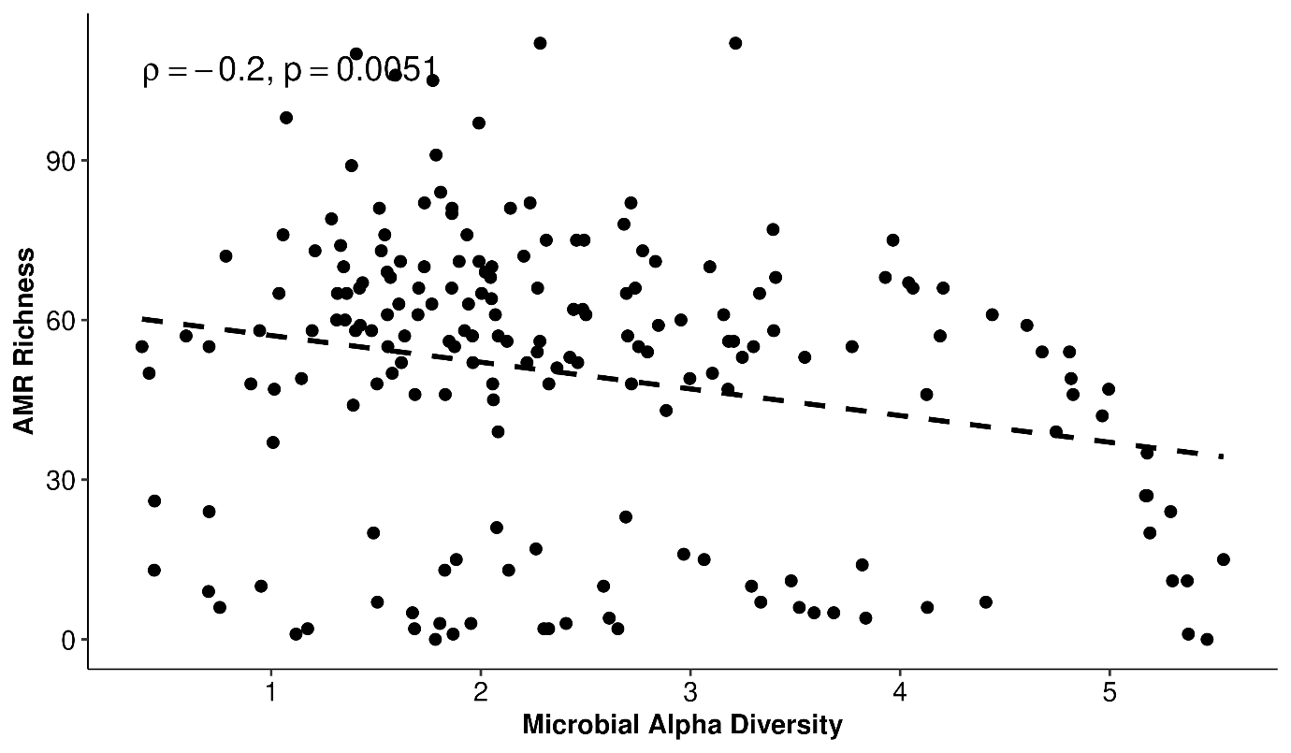

Figure S7 Spearman’s correlation test showing negative correlation between Shannon indices of microbial diversity and ARG richness.

