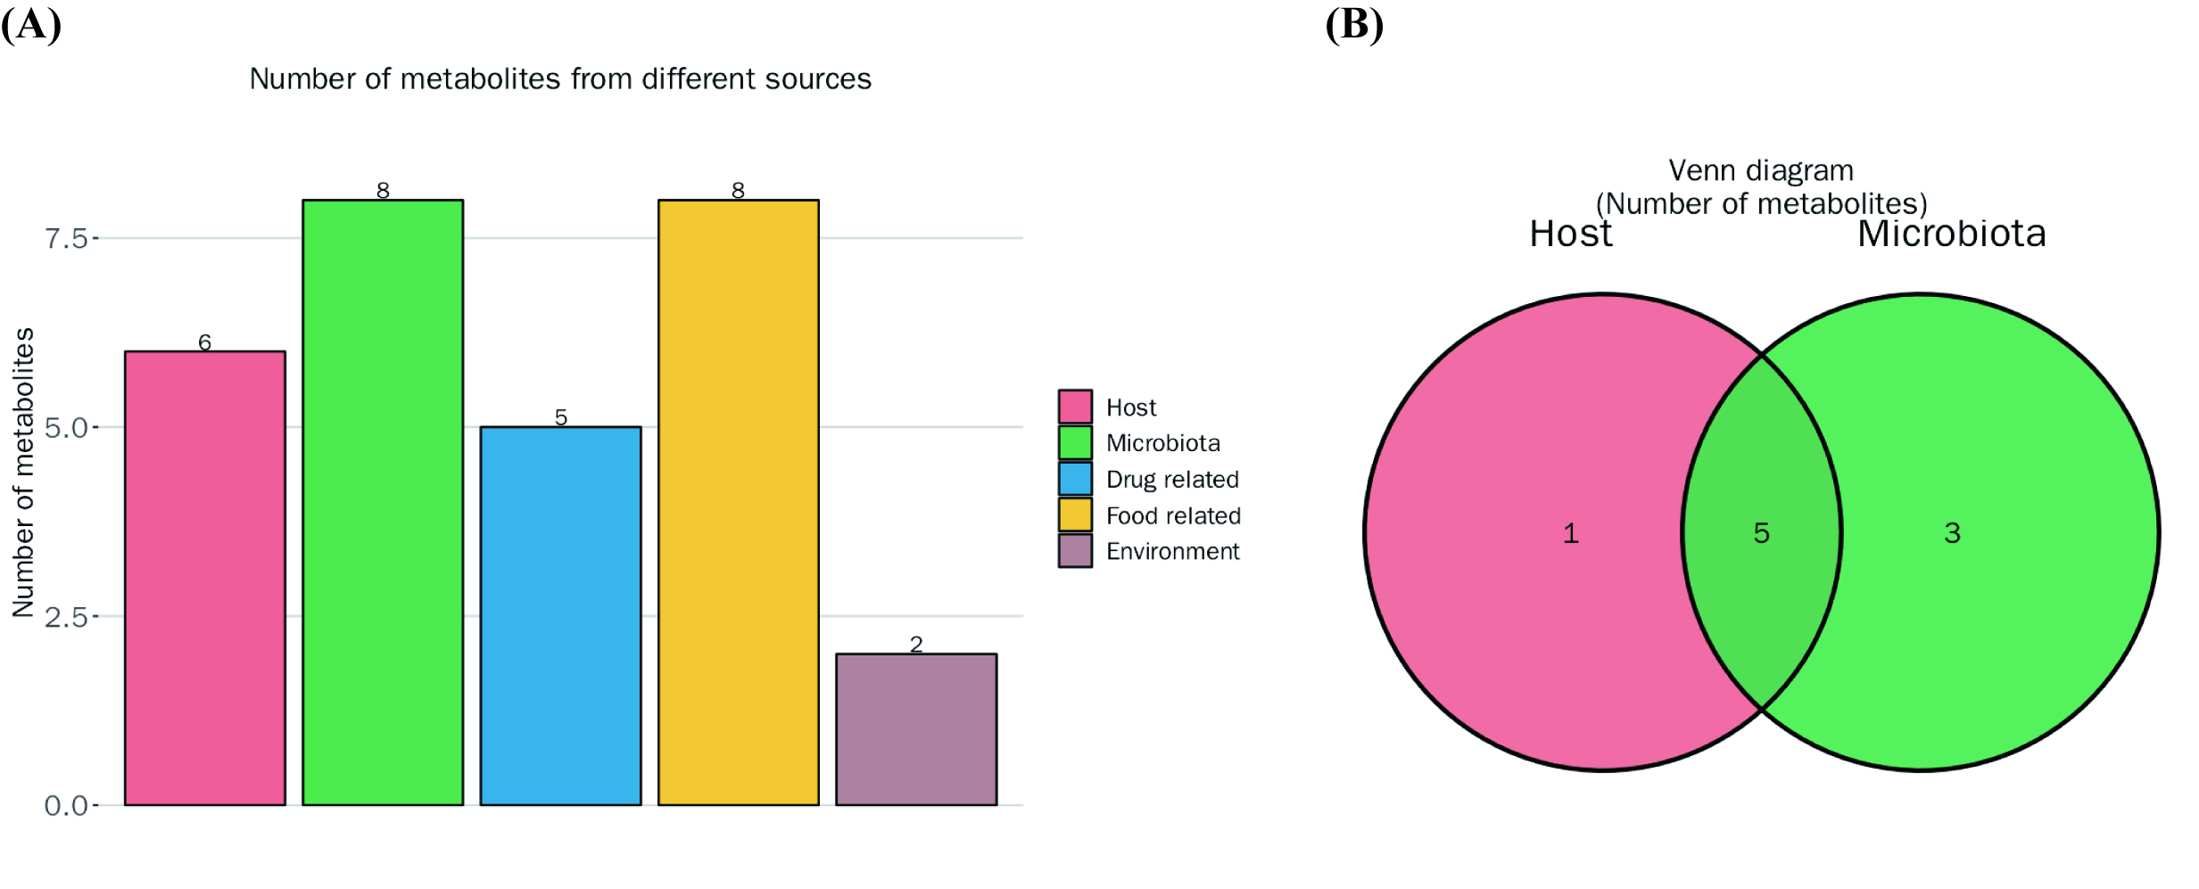
S1 Fig. Metabolite Source Analysis of non-targeted differential metabolites with significant reduction in the onset of NEC in preterm infants. A: Bar chart representing the quantities of metabolites derived from various sources; B: Venn diagram illustrating the overlap of metabolite quantities between host and microbial sources.
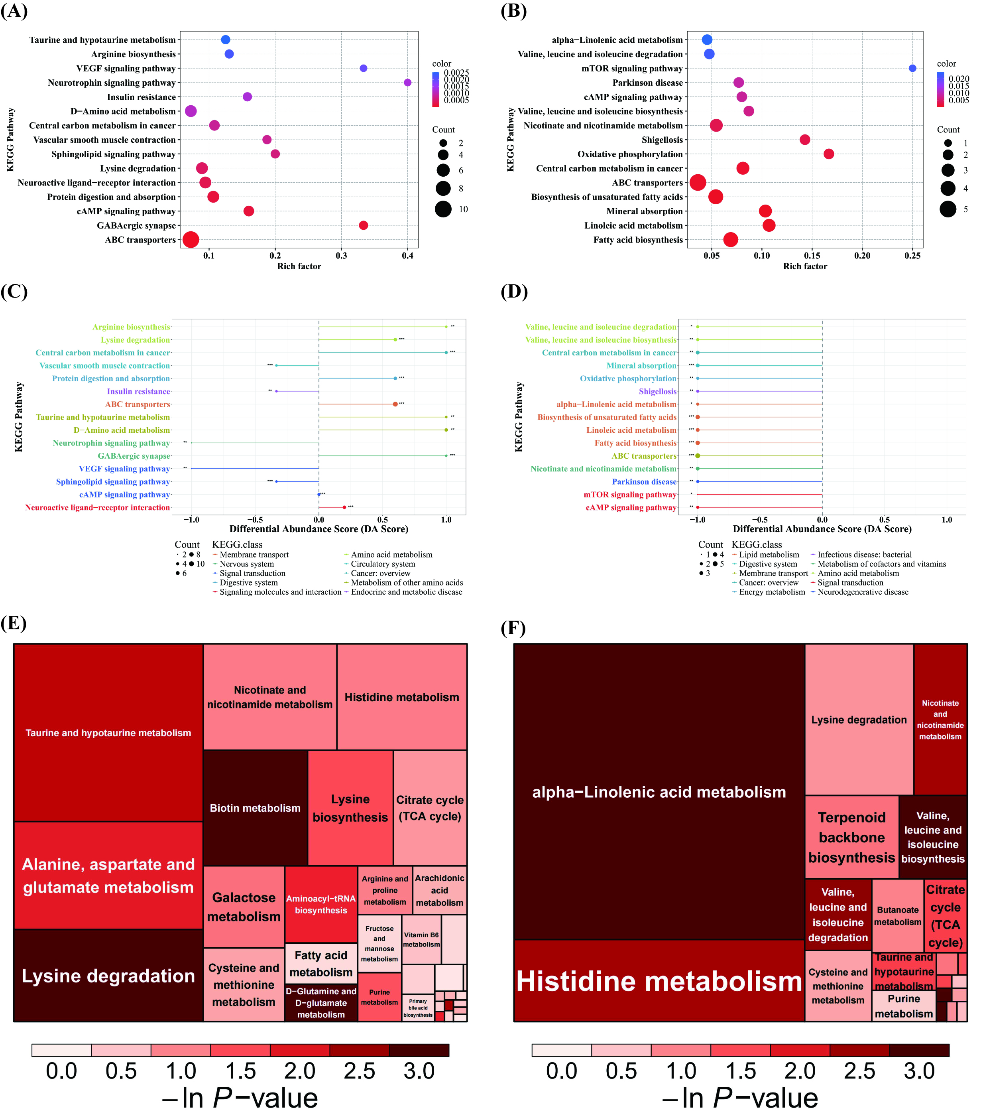
S2 Fig. Metabolic pathway analysis of non-targeted differential metabolites in feces of NEC preterm infants. (A) KEGG enrichment bubble plot of differential metabolites for group Control vs NEC. (B) KEGG enrichment bubble plot of differential metabolites for group NEC vs NEC-p. (C) KEGG differential abundance score plot of differential metabolites for group Control vs NEC. (D) KEGG differential abundance score plot of differential metabolites for group NEC vs NEC-p. (E) Metabolic pathway analysis treemap plot of differential metabolites for group Control vs NEC. (F) Metabolic pathway analysis treemap plot of differential metabolites for group NEC vs NEC-p. Control: Control group; NEC: NEC group; NEC-p: NEC post-treatment group. Sample size: Control (n = 8); NEC (n = 8); NEC-p（n = 6）. *P<0.05; **P<0.01; ***P<0.001.

