SUPPLEMENTARY INFORMATION
Colorimetric Sensor Detection of Cu²⁺, Fe²⁺, and Pb²⁺ Ions Using Curcumin-Derived Schiff Base Ligand.

A1. | ¹H NMR spectrum of CurAP.
A2. | ¹³C NMR Spectrum of CurAP.
A3. | FT-IR Spectrum of CurAP.
A4. | Mass Spectrometry of CurAP.
A5. | ¹H NMR spectrum of CurMP.
A6. | ¹³C NMR Spectrum of CurMP.
A7. | FT-IR Spectrum of CurMP.
A8. | Mass Spectrometry of CurMP.

A1: ¹H NMR spectrum of CurAP.
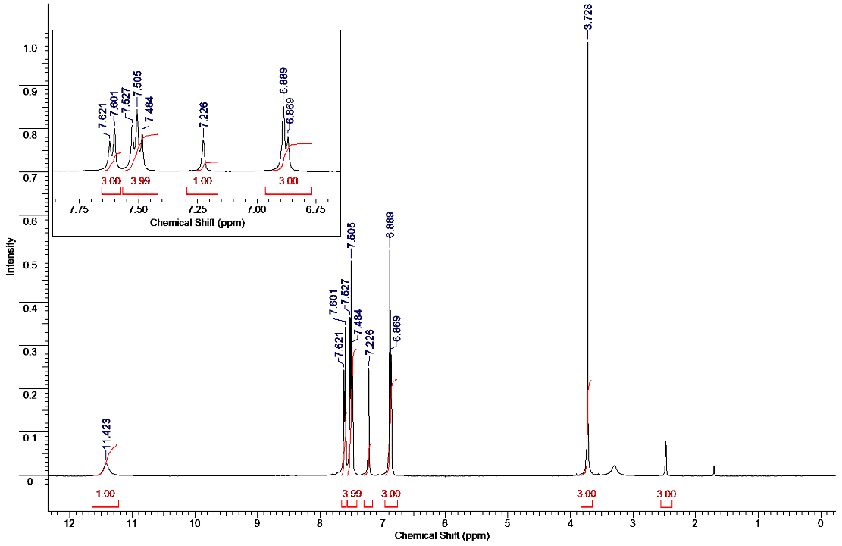
A2: ¹³C-NMR spectrum of CurAP.
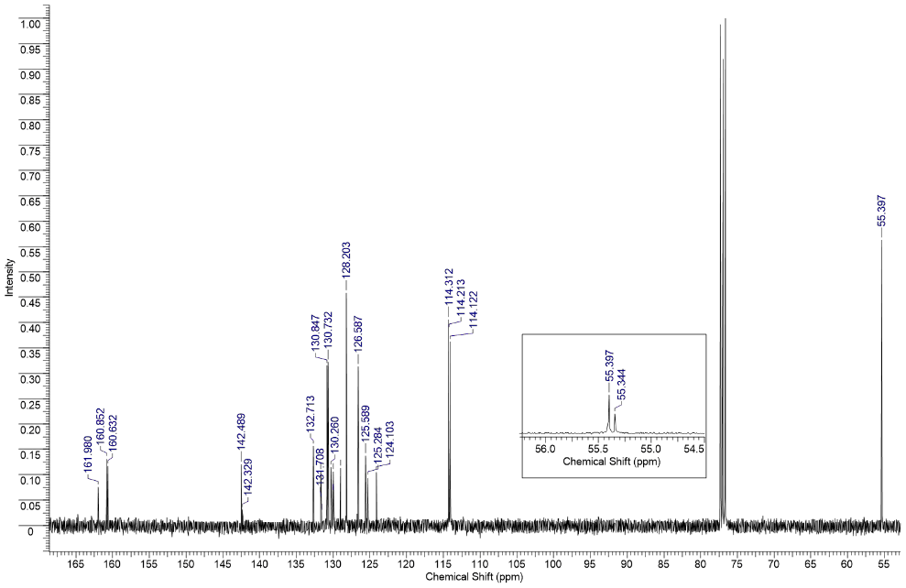
A3: FT-IR spectrum of CurAP.
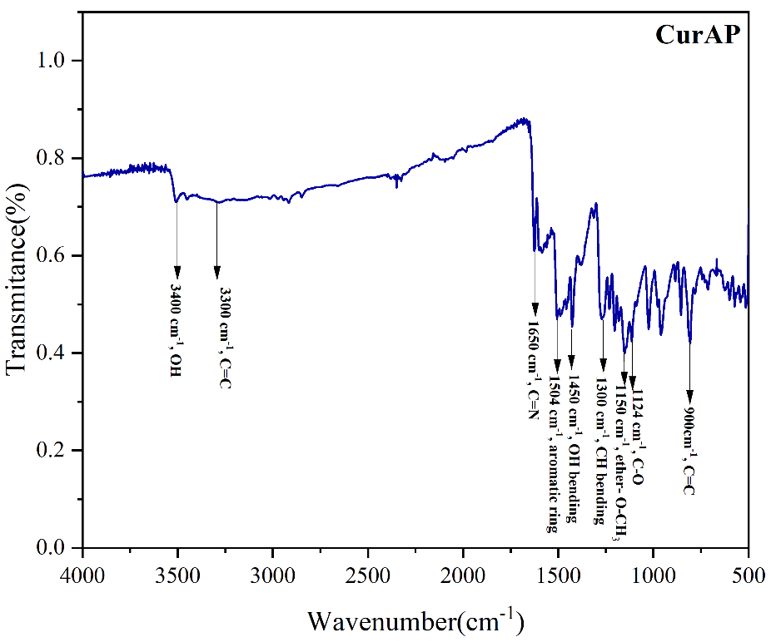
A4: LCMS spectrum of CurAP.
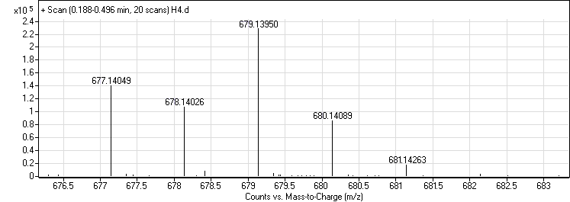
A5: ¹H-NMR spectrum of CurMP.
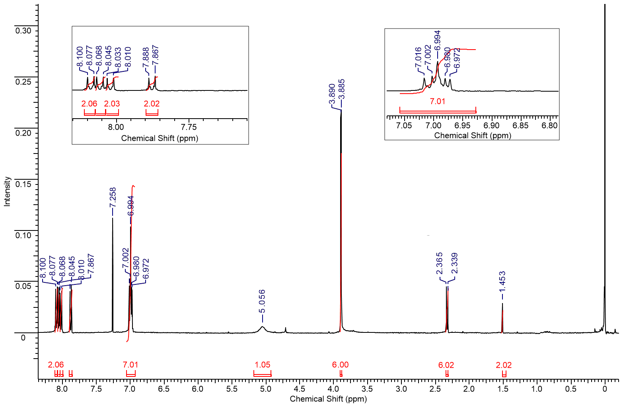
A6: ¹³C-NMR spectrum of CurMP.
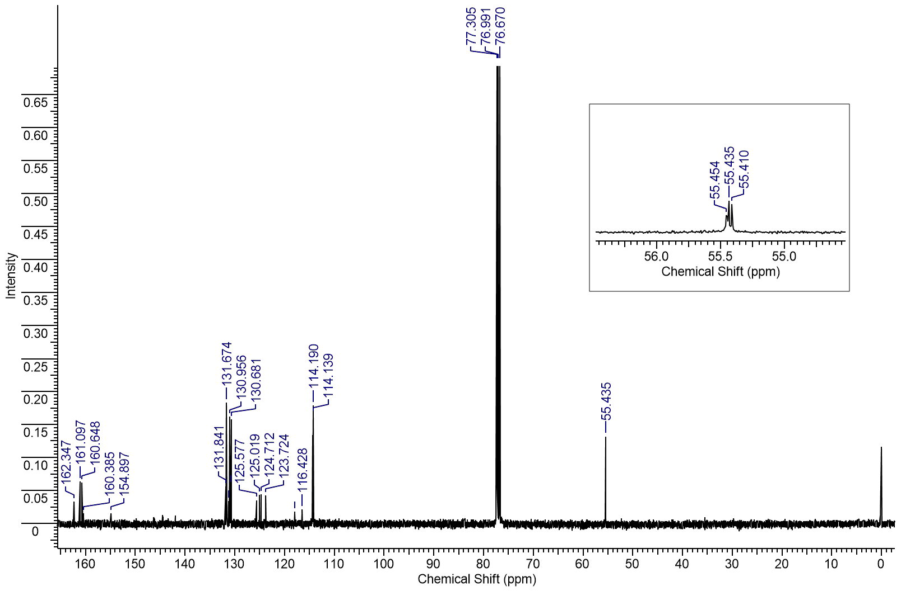

A7: FT-IR spectrum of CurMP.
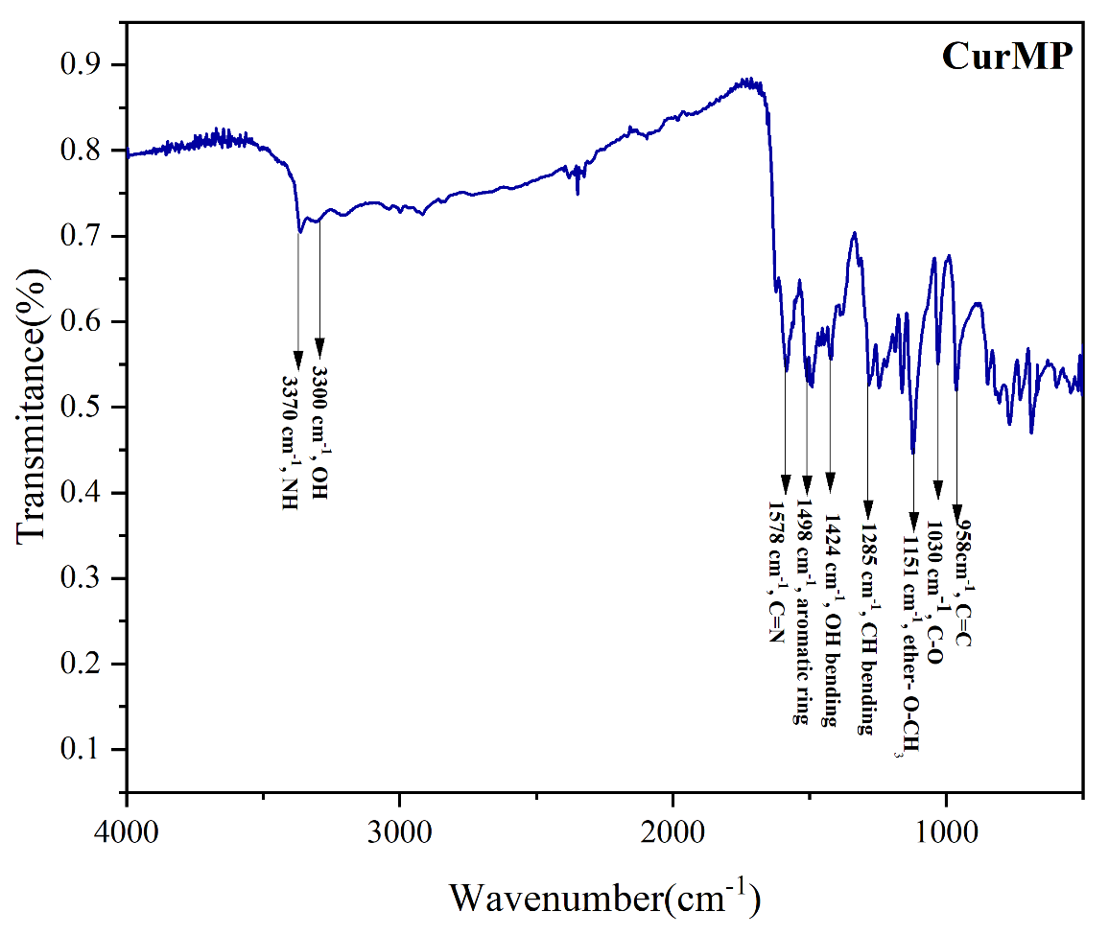
A8: LCMS spectrum of CurMP.
