Supplementary Information for:

Dissociating mechanical from biochemical platelet activation: dimethyl sulfoxide modulates the platelet membrane to attenuate shear-mediated activation

Sara Sheikhlary^{1,2*}, Phat L. Tran^{1*}, Alice Sweedo^{1,2}, Kaitlyn R. McKellar^{1,2}, Christine E. Outridge¹, Lorenzo Valerio³, Jonathan T. Yamaguchi¹, Jawaad Sheriff⁴, Danny Bluestein⁴, Joseph E. Italiano⁵, Michael T. Marty⁶, Craig A. Aspinwall⁷, Alberto Redaelli³, and Marvin J. Slepian^{1,2,7}*

This PDF file includes:
Figure S1-S5 and Table S1 and Table S2

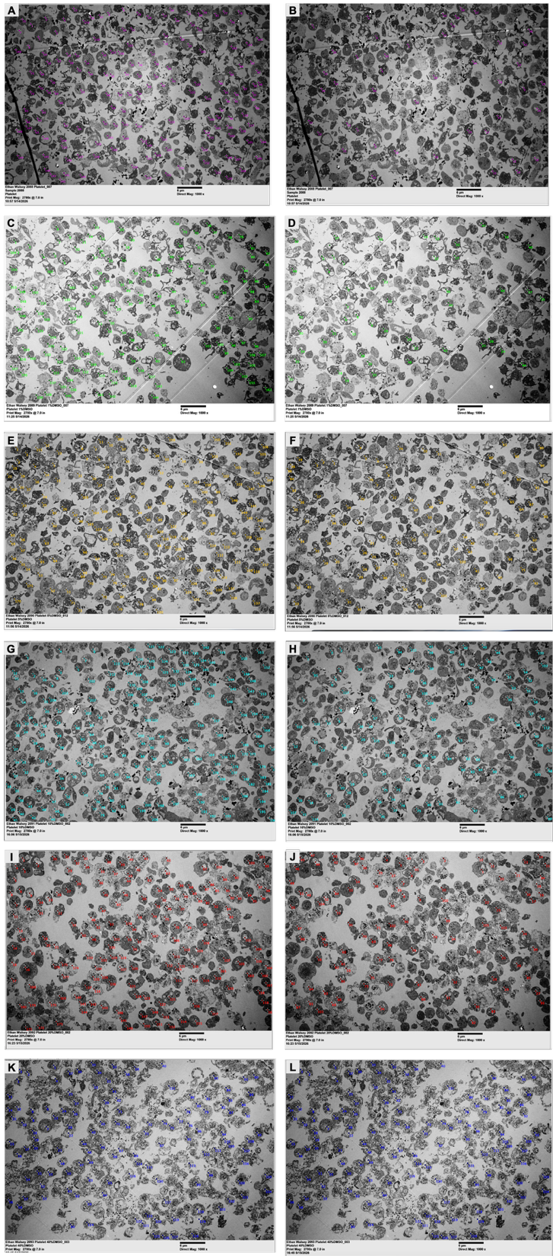

Figure S1. Representative transmission electron microscopy (TEM) images and quantification of the percentage of platelets exhibiting vacuoles after treatment with DMSO at different concentrations. Raw TEM micrographs of gel-filtered platelets treated with DMSO at the indicated concentrations (% v/v). Images are arranged from top to bottom corresponding to increasing DMSO concentration: control (platelet buffer only, 0% DMSO) (A and B), 1% DMSO (C and D), 5% DMSO (E and F), 10% DMSO (G and H), 20% DMSO (I and J), and 40% DMSO (K and L). After incubation, samples were centrifuged and washed prior to TEM processing. Scale bars = 600 µm. The left-hand column represents the image in which all platelets were counted, and the right-hand column demonstrates images in which only vacuole-containing platelets were counted. Quantification of vacuole-containing platelets were conducted. For each condition, TEM images were analyzed using via Fiji/Image J 1.54p by counting: A) the total number of platelets and B) the number of platelets containing one or more vacuoles. The percentage of platelets with vacuoles was calculated as:
$$\%\text{ Platelets with vacuoles}=\left(\frac{\text{Number of platelets containing vacuoles}}{\text{Total number of platelets counted}}\right)×100$$
Quantification results are summarized in Table S1:
TableS1: Quantification results if TEM micrographs
 | Total platelet number | Total number of platelets containing vacuoles | %platelets with vacuoles
Platelets + Buffer (DMSO 0%) | 164 | 45 | 27.44
DSMO 1% | 165 | 51 | 30.91
DMSO 5% | 172 | 101 | 58.72
DMSO 10% | 207 | 117 | 56.52
DMSO 20% | 180 | 105 | 58.33
DMSO 40% | 132 | 132 | 100
This analysis demonstrates a concentration-dependent increase in the proportion of platelets exhibiting vacuoles with increasing DMSO concentration.

Quantitative Morphometric Analysis of Vacuolization Area Fraction
To quantify the extent of ultrastructural changes in platelets following DMSO treatment, a detailed morphometric analysis was performed on TEM images using ImageJ/Fiji (version 1.54p).
Methods: Each TEM micrograph was divided into four quadrants (Northwest, Northeast, Southwest, and Southeast). Within each quadrant, the image was digitally zoomed to 150% magnification and 12 platelets were randomly selected. For each selected platelet, the total cross-sectional area was measured using the freehand selection tool and ROI Manager. The combined area of electron-lucent structures (white and light gray regions, holes, and pores) was measured on the same platelets; electron-dense granules (appearing black) were excluded from the analysis.

The vacuolization area fraction was calculated for each platelet as:
$$\text{Vacuolization area fraction (\%}=\left(\frac{\text{Area of electron-lucent vacuoles and internal organelles}}{\text{Total platelet cross-sectional area}}\right)×100$$
All measurements were performed using the ROI Manager in ImageJ/Fiji. The complete raw measurement data for all individual platelets across all conditions are provided in the accompanying Excel file (Supplementary Data1-TEM Morphometric Raw Data.xlsx).
Results: The vacuolization area fraction remained relatively stable at low to moderate DMSO concentrations but increased markedly at 40% DMSO (Table S2).
Table S2: Vacuolization area fraction of DMSO-treated platelets determined by quantitative morphometric analysis
DMSO Concentration (% v/v) | Vacuolization Area Fraction (%)
0 (Control) | 13.65
1 | 11.73
5 | 13.81
10 | 15.85
20 | 10.63
40 | 47.82
Note: Values represent the overall vacuolization area fraction calculated from measured platelets in each condition.

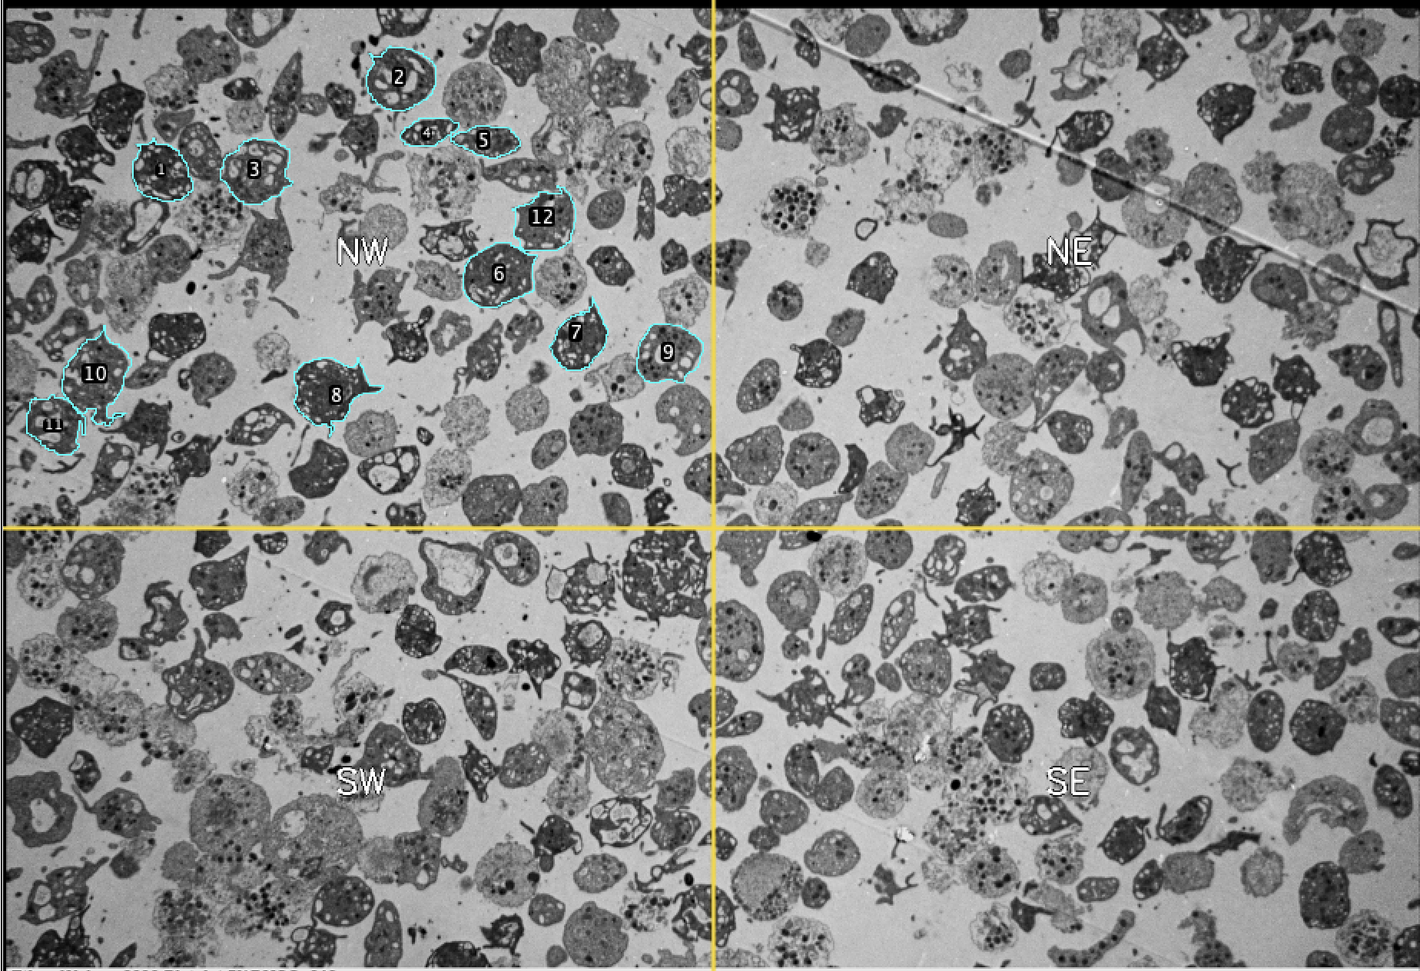
A

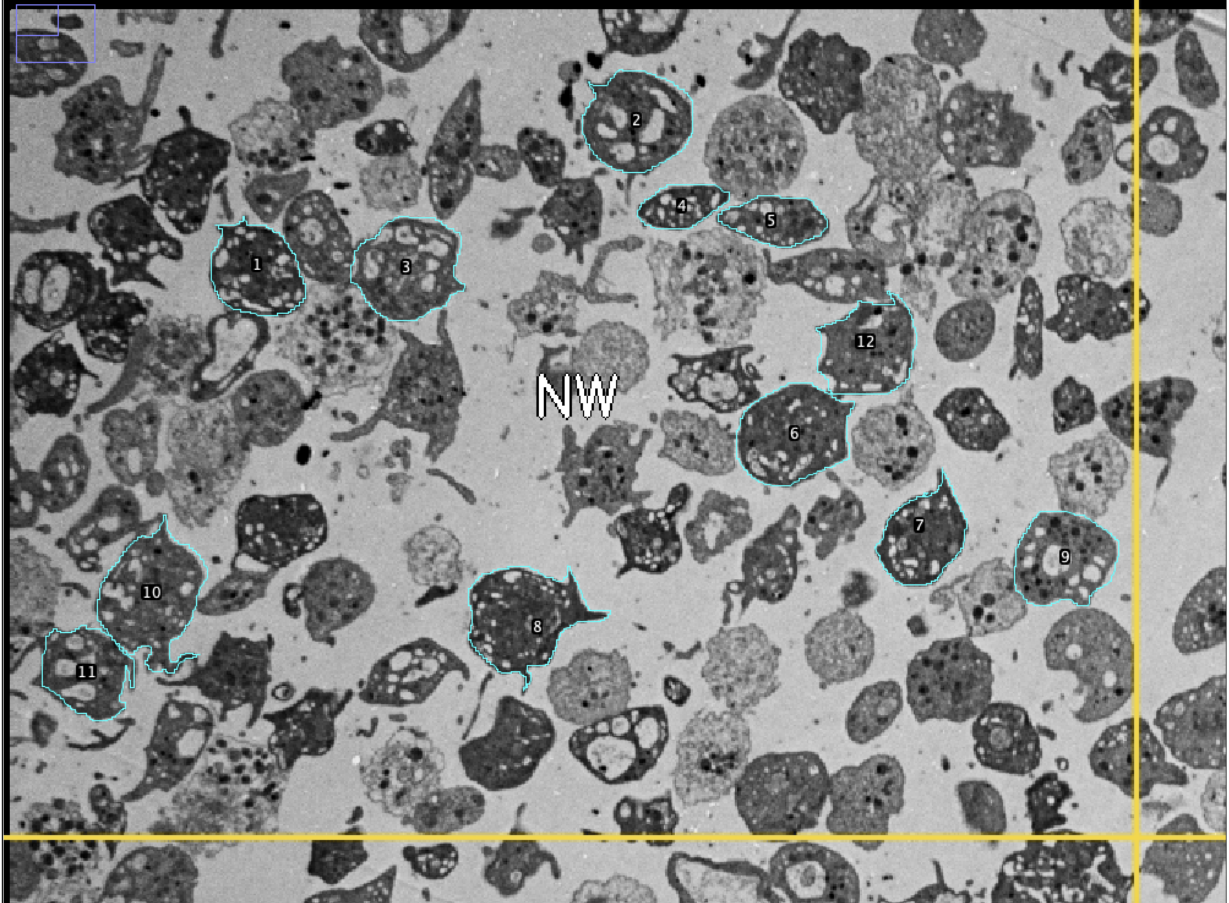
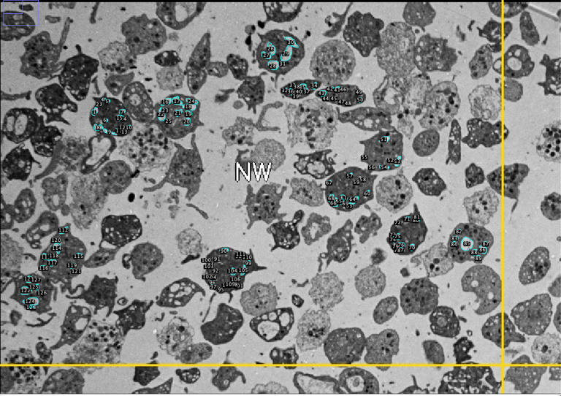
B
C
Figure S2. Workflow of quantitative morphometric analysis of vacuolization area fraction using ImageJ/Fiji.
(A) Representative TEM micrograph showing the division of the image into four quadrants (Northwest - NW, Northeast - NE, Southwest - SW, and Southeast - SE) for systematic platelet selection. (B) and (C) Example of the measurement workflow at 150% digital zoom. Twelve platelets were selected per quadrant. For each platelet, the total cross-sectional area (yellow outline) and the combined area of electron-lucent structures (white and light gray regions, holes, and pores; red outlines) were measured using the freehand selection tool and ROI Manager in ImageJ/Fiji (version 1.54p). Electron-dense granules (black) were excluded from the analysis. The vacuolization area fraction was calculated as:
$$\text{Vacuolization area fraction (\%)}=\left(\frac{\text{Area of electron-lucent structures}}{\text{Total platelet cross-sectional area}}\right)×100$$Scale bars: 6 µm
Zoomed insets in Figure 3 were prepared by cropping selected regions from the original transmission electron micrographs and digitally enlarging them by 200% using ImageJ/Fiji (version 1.54p). Scale bars were adjusted accordingly and represent 2 μm in the insets.

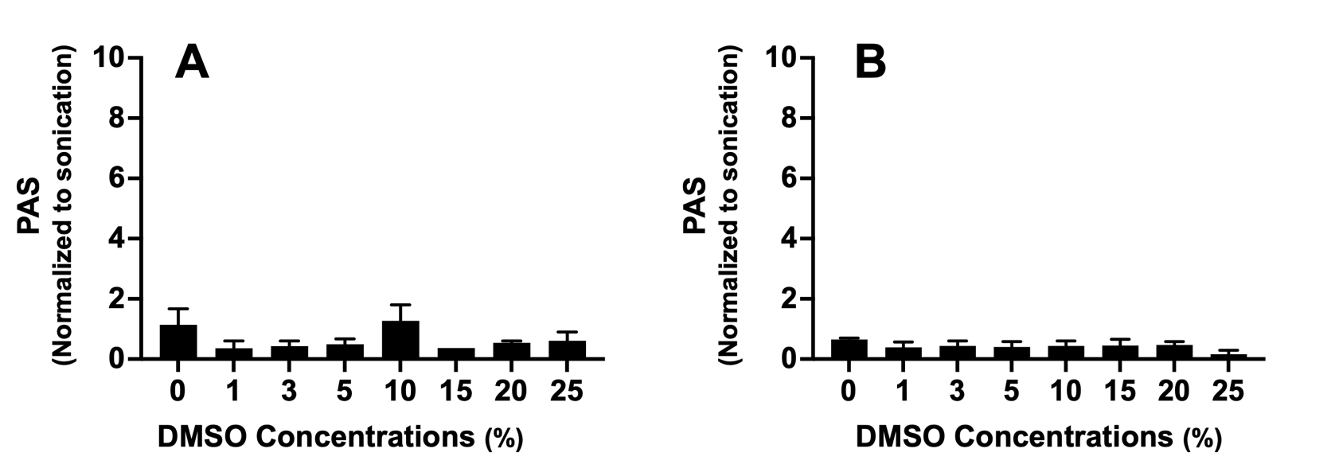

Figure S3: DMSO interference control for the PAS assay under static (A) and sonicated (B) conditions. Reactions containing the indicated concentrations of DMSO (1%, 3%, 5%, 10%, 15%, 20%, and 25%) but no platelets were performed under the same conditions as the standard PAS assay. No significant inhibition of the chromogenic reaction was observed, confirming that the reduction in thrombin generation rate seen in platelet experiments is attributable to effects on the platelets rather than direct assay interference.

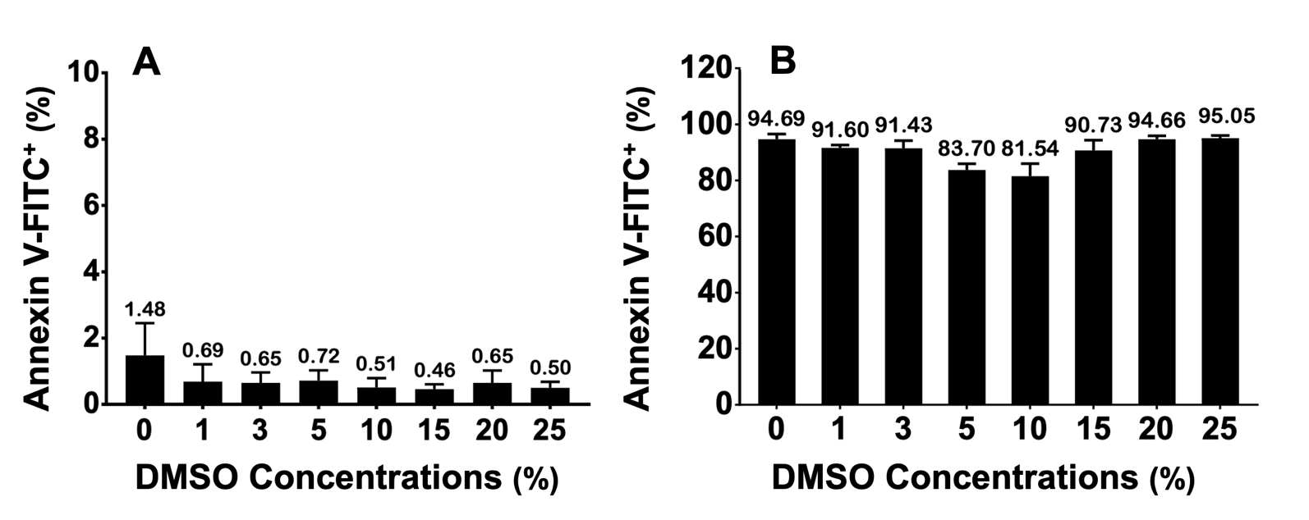
FIGURE S4. Effect of DMSO on phosphatidylserine (PS) externalization under static and shear conditions. GFP were incubated with the indicated concentrations of DMSO (% v/v; 10 min at 37 °C) and assessed for PS exposure via Annexin V-FITC binding measured by flow cytometry. (A) Static condition: DMSO treatment alone did not significantly alter Annexin V binding at any concentration tested. (B) Shear condition: Following constant shear stress at 70 dynes/cm² for 10 min, DMSO at < 3% had no significant effect compared to sheared controls, while 5% and 10% produced modest reductions in Annexin V–positive platelets; at ≥ 10%, PS externalization approached control levels. Values are mean ± SD (n = 6 independent donors). Statistical comparisons were performed using one-way ANOVA with Dunnett’s multiple comparisons test against untreated static control (A) or sheared control (B). There is no statistical significance in the data.

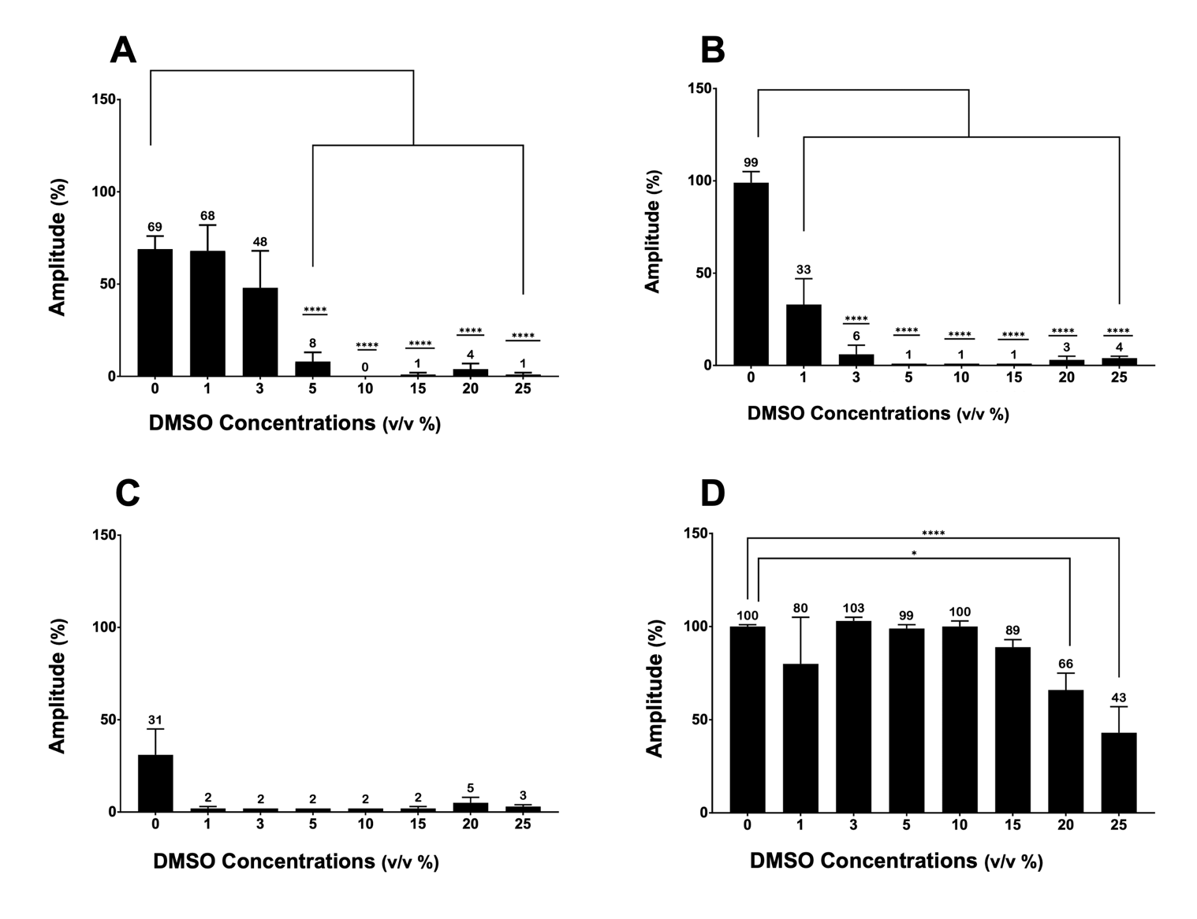
Figure S5. Aggregation of DMSO treated Platelets (PRP) Platelets were treated with DMSO (%v/v) for 10 minutes at 37$℃$. Aggregation was induced with ADP (10 µM), collagen (2 µg/mL), arachidonic acid (0.5 mM), or ristocetin (1.25 mg/mL) and recorded for 6 minutes using a Chrono-log aggregometer. (A-D) Representative aggregation traces for each agonist. (E-H) Maximum aggregation amplitude (mean ± SEM). (I-L) Lag time (mean ± SEM). n = 6 donors. Statistical analysis was performed by two-way ANOVA with Dunnett’s multiple comparisons test against the 0% DMSO control for each agonist. *p ≤ 0.05, ****p ≤ 0.0001. DMSO produced a concentration-dependent reduction in aggregation mediated by ADP and collagen. Arachidonic acid- and ristocetin-induced responses were not detectably reduced under the conditions tested.

