SUPPLEMENTARY INFORMATION
Influence of Inorganic Particle Incorporation on Biofilm Mechanical Stability
Shifa Mohamed Razzaq Shaikh, Khaled A. Mahmoud, Peter Desmond.

Table S1: EDX analyses presenting the chemical characteristics of particle-free synthetic biofilms, particles-embedded biofilms, and real SWRO foulant.
Element | BFs | Kaolin-embedded BFs | DE-embedded BFs | SWRO foulant
Element |  | Mass%
C | 42.75 | 34.82 | 58.39 | 23.24
O | 40.43 | 39.27 | 29.52 | 48.33
Ca | 3.89 | 0.85 | 1.14 | 0.6
Al | 3.41 | 11.32 | 0.78 | 4.09
P | 3.31 | 1.10 | 1.69 | 0.13
N | 2.54 | 0.00 | 3.50 | -
Cu | 1 | - | - | -
Zn | 0.94 | - | - | -
Na | 0.73 | 0.51 | 0.39 | 0.84
K | 0.32 | 0.38 | 1.37 | 1.04
Si | 0.21 | 10.82 | 2.28 | 13.18
Mg | 0.16 | 0.12 | 0.09 | 2.45
S | 0.12 | 0.05 | 0.33 | 2.01
Cl | 0.09 | - | 0.29 | 0.28
Fe | 0.05 | 0.31 | 0.10 | 3.47
Mn | 0.04 | - | 0.14 | -
Ti | - | 0.45 | - | 0.32

Table S2: ICP-OES elemental analyses of particle-free synthetic biofilms, particles-embedded biofilms, and real SWRO foulant.
Element | BFs | Kaolin-embedded BFs | DE-embedded BFs | SWRO Foulant
Element |  | mg/g biomass |  | mg/g foulant
Al | 0.09 | 15.27 | 0.15 | 43.99
Ba | 0.08 | 0.11 | 0.04 | 4.40
Ca | 2.00 | 4.88 | 1.97 | 133.08
Cd | 0.04 | 0.11 | 0.00 | 2.20
Co | 0.04 | 0.11 | 0.00 | 2.20
Cr | 0.06 | 0.15 | 0.00 | 3.30
Cu | 0.06 | 0.42 | 0.06 | 1.10
Fe | 0.08 | 3.99 | 0.16 | 24.20
K | 0.19 | 3.90 | 1.20 | 2.20
Li | 0.04 | 0.11 | - | 1.10
Mg | - | 0.61 | 0.74 | 37.39
Mn | 0.04 | 0.11 | 0.00 | 2.20
Ni | 0.04 | 0.00 | 0.00 | 4.40
Sr | 0.00 | 0.00 | 0.00 | 3.30
Zn | 0.11 | 0.34 | 0.00 | 4.29

Table S3: ATR‑FTIR peak assignments used for spectral interpretation
Functional group | SWRO biofouling layer | Particle-free biofilm | Kaolin-embedded biofilm | DE-embedded biofilm | Representative functional significance
O-H / N-H stretching | 3297 | 3300 | 3269, 3687* | 3286 | Hydroxyl- and amine-containing compounds, including EPS constituents and other organic foulants
Aliphatic C-H stretching | 2926 | 2964 | 2935 | 2930 | Aliphatic organic matter, including lipids and EPS-associated compounds
Amide I (C=O stretching) | 1636 | 1636 | 1638 | 1632 | Proteinaceous material, including EPS proteins and other protein-derived organic matter
Amide II (N-H bending) | 1578 | 1501 | 1541 | 1546 | Proteinaceous material, including EPS proteins and other nitrogen-containing organic matter
Amide III | 1242 | 1201 | 1215 | 1244 | Protein-associated functional groups
C-O / C-O-C stretching | 1236 | 1218 | 1238 | 1226 | Oxygenated organic compounds, including polysaccharides, EPS carbohydrates, and other ether-containing organic compounds
P-O / PO₂⁻ stretching | 1236 | 1215 | 1215 | 1244 | Phosphorylated organic compounds, including EPS-associated constituents
Aromatic C=C stretching | 1485 | - | - | - | Aromatic organic matter, including humic-like substances
Aromatic C-H out-of-plane bending | 832-872 | - | - | - | Aromatic structures associated with complex organic matter
Si-O stretching | 1078, 986, 977 | - | 1007 | 1040 | Silicate mineral phases
Si-O-Si stretching | - | - | - | 1072** | Silica-rich mineral phases
Al-O-Si stretching | 832-872 | - | 907 | - | Aluminosilicate mineral phases
* Characteristic hydroxyl vibration in kaolin.
** Characteristic Si-O-Si vibration in DE.

- Kaolin suspension (Unstained) | - Kaolin suspension (Stained (SYBR+PI)) | - Kaolin-embedded biofilms
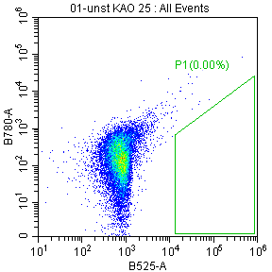 | 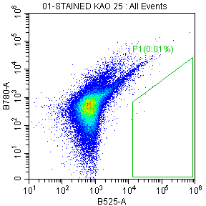 | 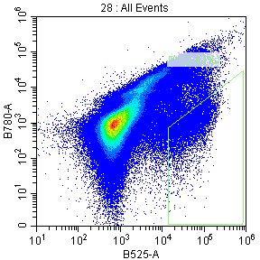
- DE suspension (Unstained) | - DE suspension (Stained (SYBR+PI)) | - DE-embedded biofilms
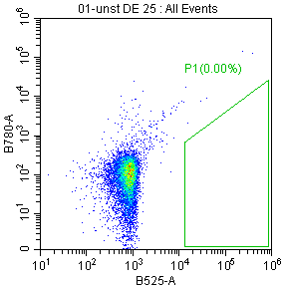 | 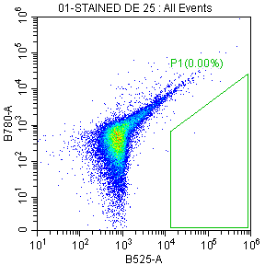 | 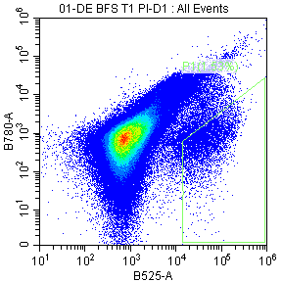
Figure S1: Flow cytometry gating controls used for intact cell count (ICC) determination. Scatter plots of unstained and SYBR Green I/propidium iodide (SYBR+PI)-stained kaolin suspensions ((a) and (b)) and DE suspensions ((d) and (e)), together with representative kaolin-embedded ((c)) and DE-embedded ((f)) biofilm samples. The green polygon denotes the ICC gate applied consistently across all samples. Particle-only suspensions exhibited negligible overlap with the ICC gate (≤0.01% gated events), whereas substantial gated populations were observed in the biofilm samples, indicating minimal contribution of mineral particles to ICC quantification.
Table S4: Rheological properties of representative biofilm and fouling matrices reported in literature using plate rheometry.
System | Yield point | Yield stress | Storage modulus  (Frequency Sweep) | Reference
 | (Pa) | (Pa) | (Pa)
Particle-free biofilm | 810 | - | 1165 | This work
P. fluorescens biofilm | - | 57 | 385 | [1]
B. subtilis biofilm | - | 248 | 2250 | [1]
P. aeruginosa biofilm | - | 100 | 655 | [1]
P. aeruginosa biofilm | - | - | 223 | [2]
P. aeruginosa biofilm | - | - | 2000 | [3]
P. aeruginosa biofilm | - | - | 1050 | [4]
Nutrient-enriched biofilm | - | 3 | 20.75 | [5]
Kaolin-embedded biofilm | 1603 | - | 1502 | This work
DE-embedded biofilm | 3192 | - | 3726 | This work
River-water biofilm | - | 203 | 70.9 | [5]
Drinking-water NF biofilm | - | - | 3000-3500 | [6]
NF biofouling layer  (COD 50 mg/L) | - | 0.59 | 14313 | [7]
NF biofouling layer + kaolin  (50 mg/L COD + 2 mg/L kaolin) | - | 32.81 | 797 | [7]
NF biofouling layer  (COD 250 mg/L) | - | 266.98 | 14050 | [7]
Seawater MF Pretreatment biofilm | - | - | 4153 | [8]
Seawater UF Pretreatment biofilm | - | - | 8358 | [8]
SWRO foulant | 18952 | - | 16879 | This work

Table S5: Nutrient Stock Solution Characteristics
Parameter | Concentration in Stock Solution  (mg/L) | Final Concentration in Annular Reactor  (mg/L) | Unit
Carbon from Sodium acetate (C) | 500 | 50 | mg C/L
Nitrogen from Sodium nitrate (N) | 100 | 10 | mg N/L
Phosphorus from sodium phosphate dibasic (P) | 50 | 5 | mg P/L
C:N:P ratio | 100:20:10 | 100:20:10

References
- Jana, S. et al. Nonlinear rheological characteristics of single species bacterial biofilms. npj Biofilms Microbiomes 6, 19 (2020).
- Wloka, M., Rehage, H., Flemming, H.-C. & Wingender, J. Structure and rheological behaviour of the extracellular polymeric substance network of mucoid Pseudomonas aeruginosa biofilms. Biofilms 2, 275–283 (2005).
- Lieleg, O., Caldara, M., Baumgärtel, R. & Ribbeck, K. Mechanical robustness of Pseudomonas aeruginosa biofilms. Soft Matter 7, 3307–3314 (2011).
- Kovach, K. et al. Evolutionary adaptations of biofilms infecting cystic fibrosis lungs promote mechanical toughness by adjusting polysaccharide production. npj Biofilms Microbiomes 3, 1 (2017).
- Desmond, P., Böni, L., Fischer, P., Morgenroth, E. & Derlon, N. Stratification in the physical structure and cohesion of membrane biofilms - Implications for hydraulic resistance. J. Memb. Sci. 564, 897–904 (2018).
- Houari, A. et al. Rheology of biofilms formed at the surface of NF membranes in a drinking water production unit. Biofouling 24, 235–240 (2011).
- Xiao, M., Peng, Z., Li, Z., Li, X. & Du, X. Rheological characterization of biofouling layers developing in nanofiltration processes: Macroscale rheological properties of biofouling layer and micro fluid field. Chemosphere 307, 135876 (2022).
- Ranieri, L., Esposito, R., Nunes, S. P., Vrouwenvelder, J. S. & Fortunato, L. Biofilm rigidity, mechanics and composition in seawater desalination pretreatment employing ultrafiltration and microfiltration membranes. Water Res. 253, 121282 (2024).

