Supporting Information
NaCl-Assisted Synthesis of Co/CoS₂ Heterostructures Encapsulated within N, S Co-doped Carbon Nanotubes as Electrocatalysts for Anion Exchange Membrane Fuel Cells and Rechargeable Liquid-State/flexible Zn-air Batteries
Hyeongseok Seo, Hoyeon Kang, Sejin Kim, Sang Eun Shim, and Sung-Hyeon Baeck*
Department of Chemistry and Chemical Engineering, Education and Research Center for Smart Energy Materials and Process, Inha University, Incheon 22212, Republic of Korea
*Corresponding author
E-mail address: shbaeck@inha.ac.kr

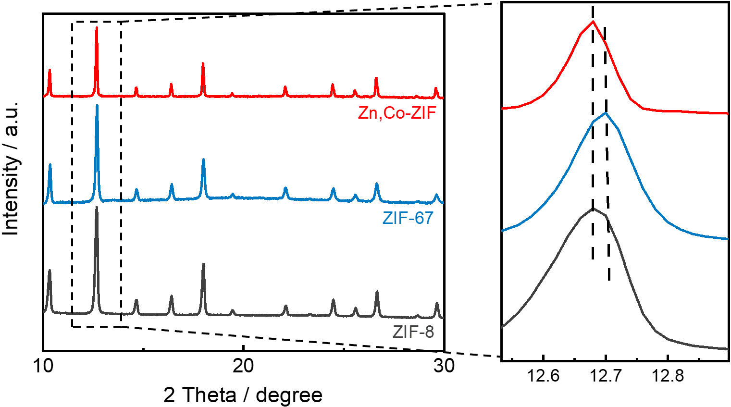
Fig. S1. X-ray diffraction (XRD) patterns of Zn, Co-ZIF, ZIF-67, and ZIF-8.

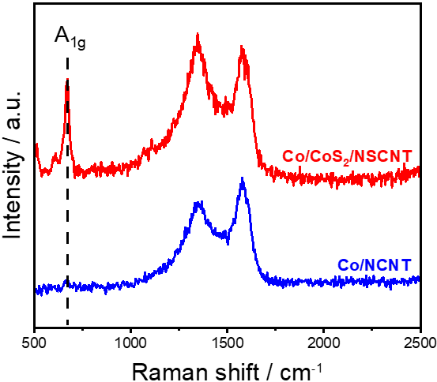
Fig. S2. Raman spectra comparison of Co/NCNT and Co/CoS₂/NSCNT.

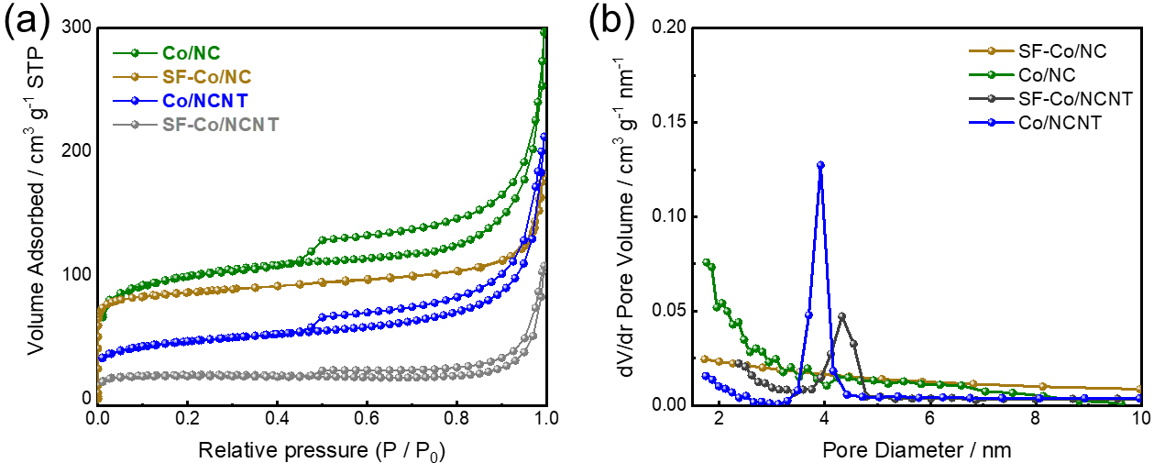
Fig. S3. (a) BET and (b) BJH curves for SF-Co/NC and SF-Co/NCNT

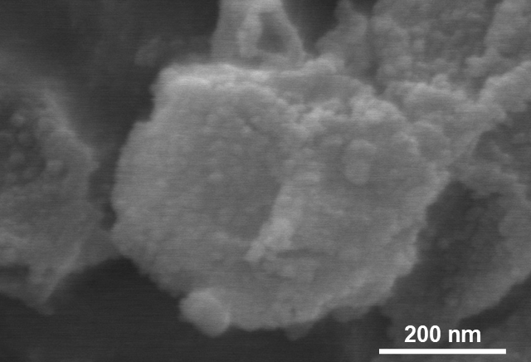
Fig. S4. Scanning electron microscopy (SEM) of the Co/NC before NaCl elimination.

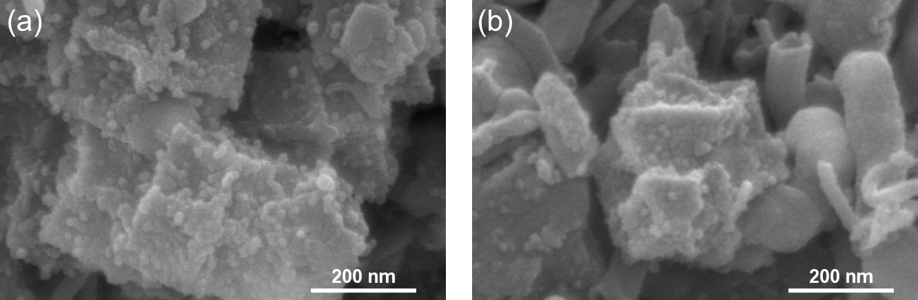
Fig. S5. Scanning electron microscopy (SEM) of the (a) SF-Co/NC and (b) SF-Co/NCNT

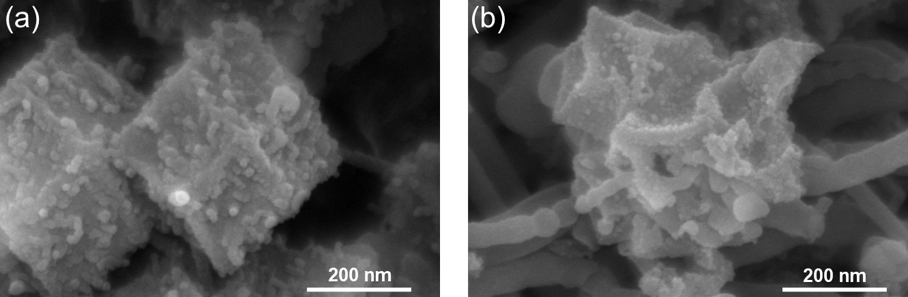
Fig. S6. Scanning electron microscopy (SEM) of (a) CoS₂/NSC and (b) SF-Co/CoS₂/NSCNT

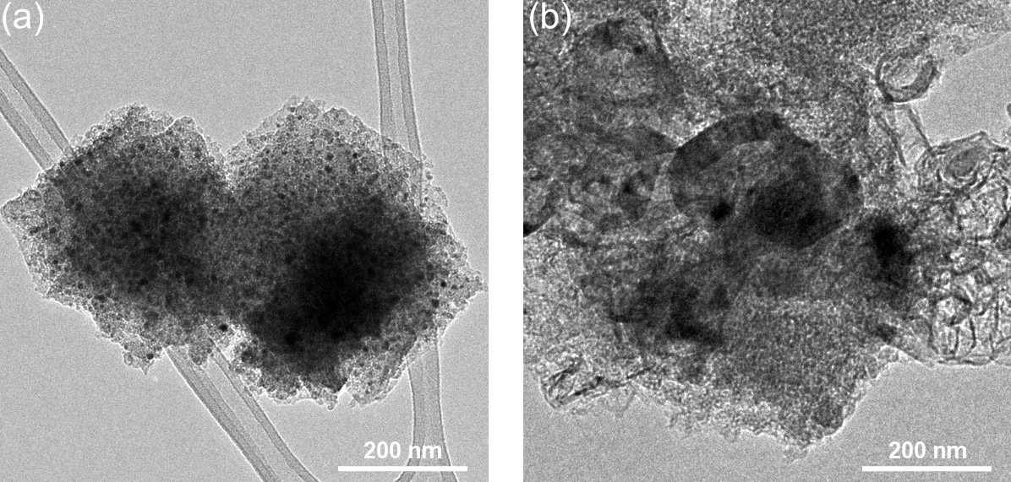
Fig. S7. Transmission electron microscopy (TEM) of (a) CoS₂/NSC and (b) SF-Co/CoS₂/NSCNT

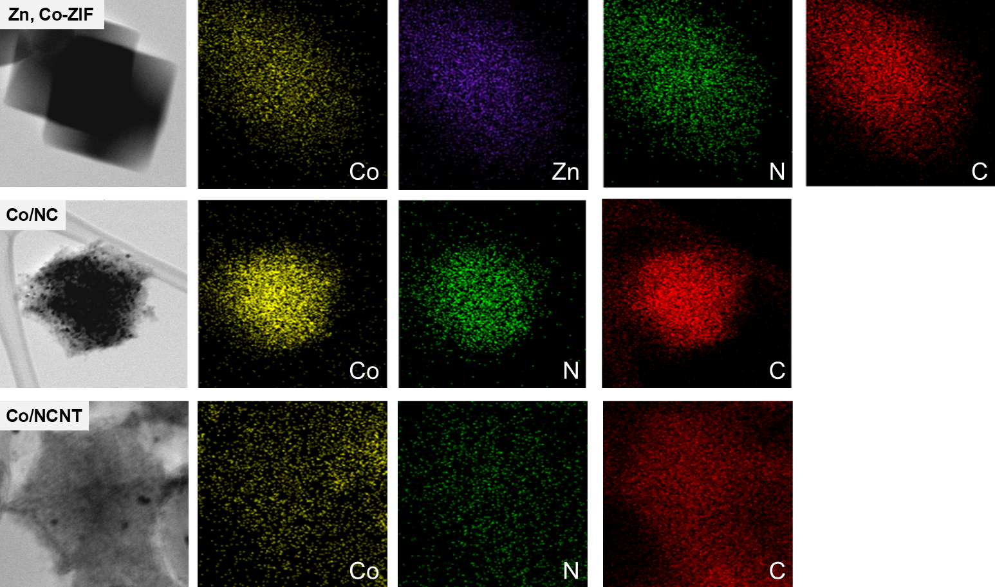
Fig. S8. Energy dispersive X-ray spectroscopy (EDS) elemental mapping images of Zn, Co-ZIF, Co/NC, and Co/NCNT

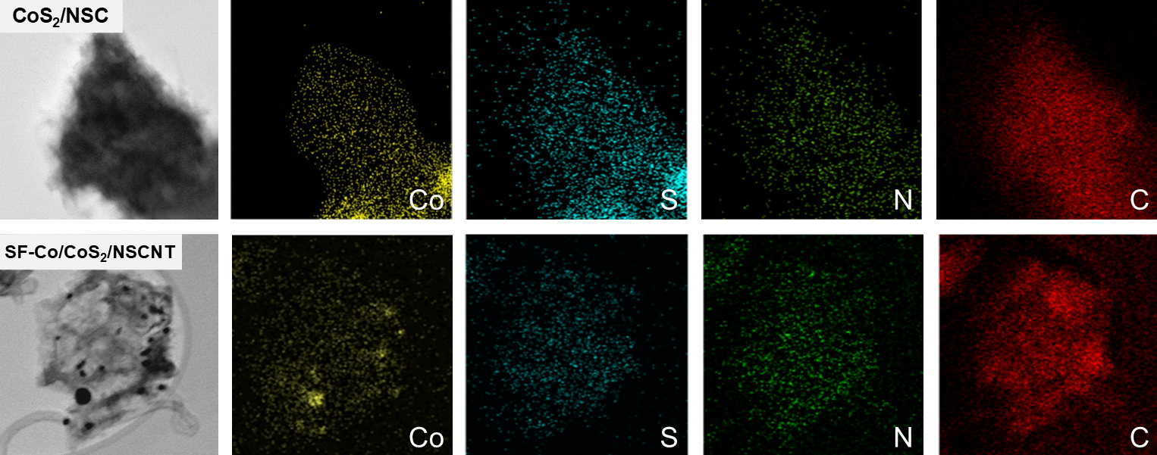
Fig. S9. Energy dispersive X-ray spectroscopy (EDS) elemental mapping images of CoS₂/NSC and SF-Co/CoS₂/NSCNT

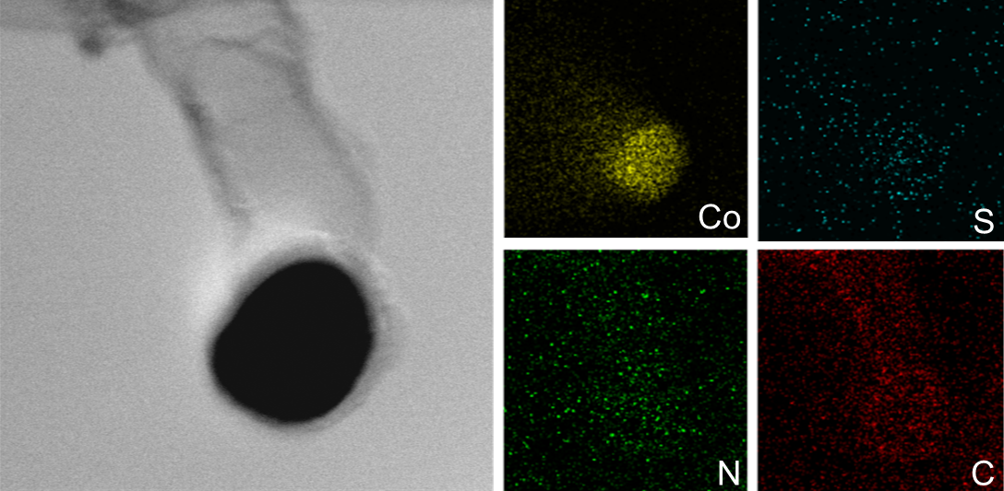
Fig. S10. EDS elemental mapping images of single carbon nanotube in Co/CoS₂/NSNCT.

Notably, not all cobalt species are involved in the CNT growth reaction, which leads to the presence of cobalt and sulfur species in both the shell of the hollow sphere and the CNT nanowires, as illustrated in Fig. S8. However, most of the cobalt species are mainly located within the CNT nanowires.

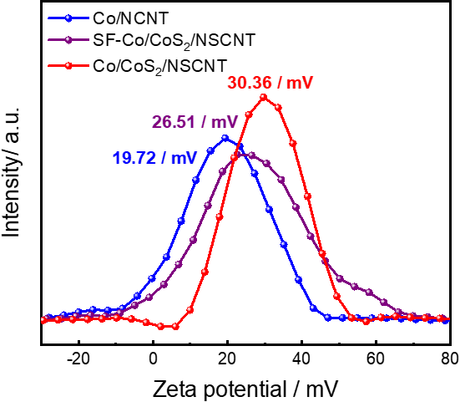
Fig. S11. Zeta potential of Co/NCNT, SF-Co/CoS₂/NSCNT and Co/CoS₂/NSCNT in DI water

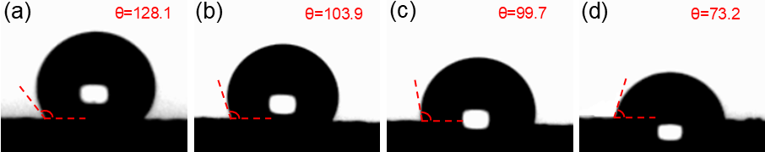
Fig. S12. Contact angle images of water droplets on the surface of (a) bare Carbon cloth, (b) Co/NCNT, (c) SF-Co/CoS₂/NSCNT, (d) Co/CoS₂/NSCNT-coated CC

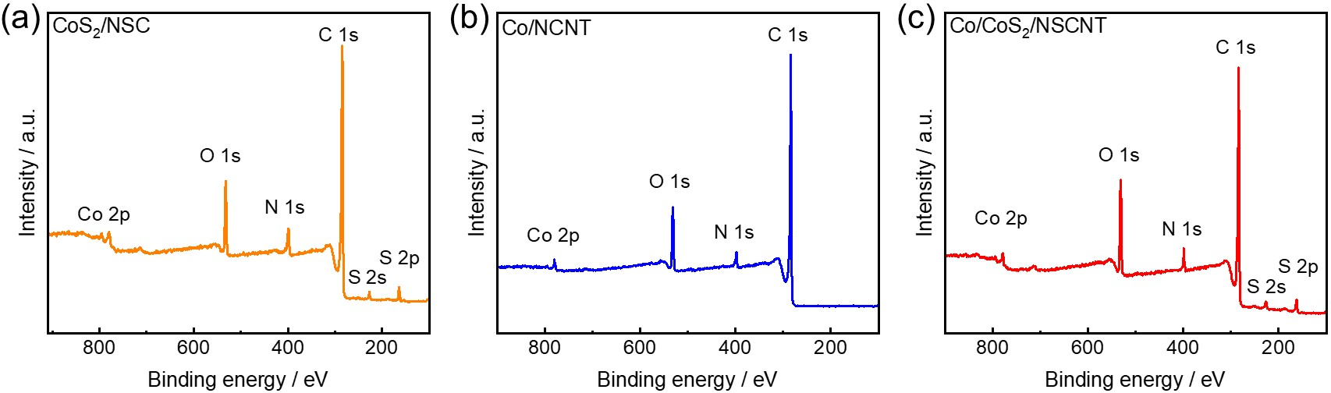
Fig. S13. XPS survey spectrum of (a) CoS₂/NSC, (b) Co/NCNT, and (C) Co/CoS₂/NSCNT

Fig. S14. Randle’s circuit model for the fitting of EIS plot

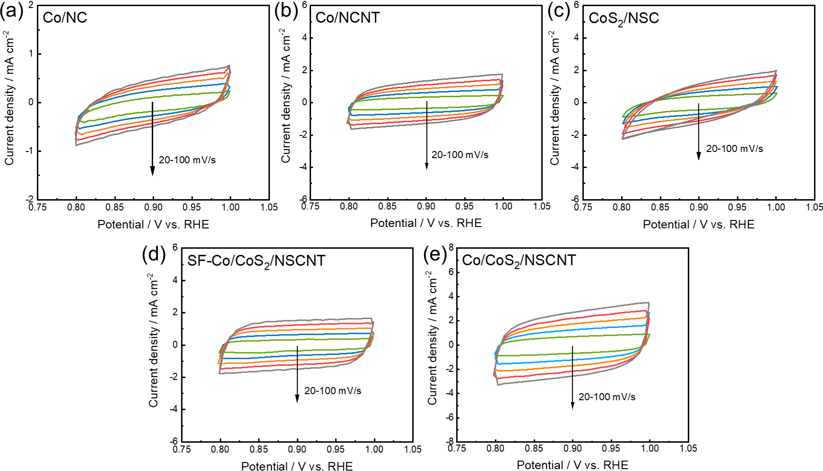
Fig. S15. CV curves of (a) Co/NC, (b) Co/NCNT, (c) CoS₂/NSC, (d) SF-Co/CoS₂@NSCNT, and (e) Co/CoS₂@NSCNT measured in non-faradaic potential range.

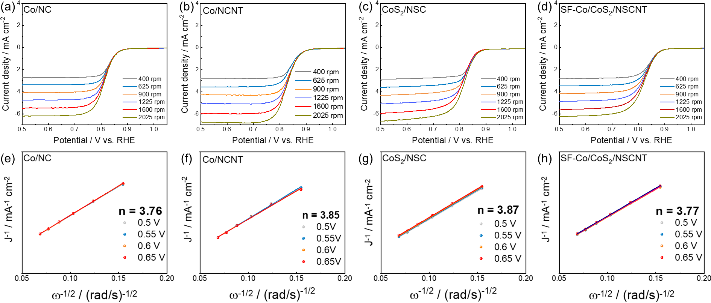
Fig. S16. (a-d) Rotating disk voltammograms at various rotating speeds and (e-h) the corresponding Koutecky-Levich plots for Co/NC, Co/NCNT, CoS₂/NSC, and SF-Co/CoS₂/NSCNT

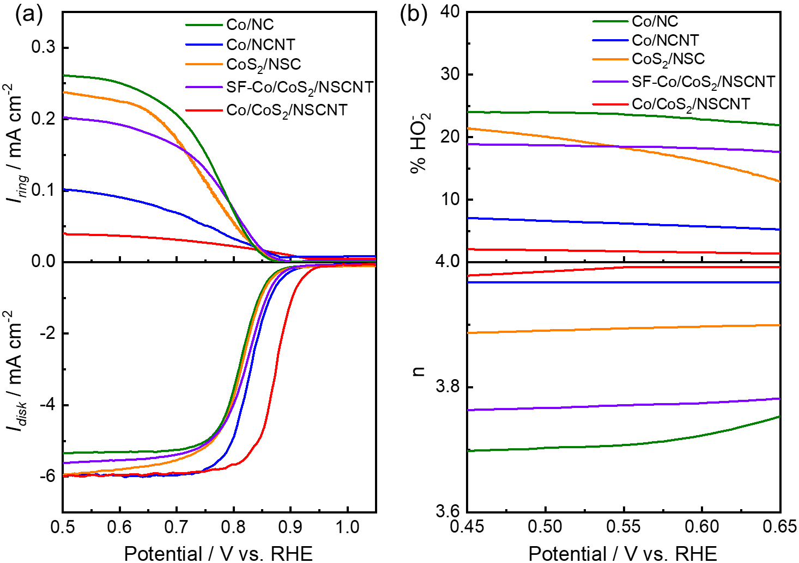
Fig. S17. (a) Ring and disk current measured by RRDE and (b) the corresponding HO₂– yield and n values of the as-prepared electrocatalysts.

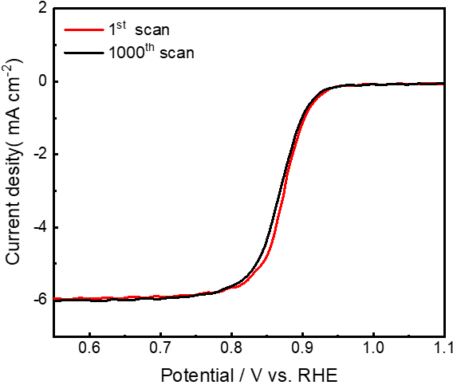
Fig. S18. ORR LSV polarization curves of Co/CoS₂/NSCNT before and after ADT

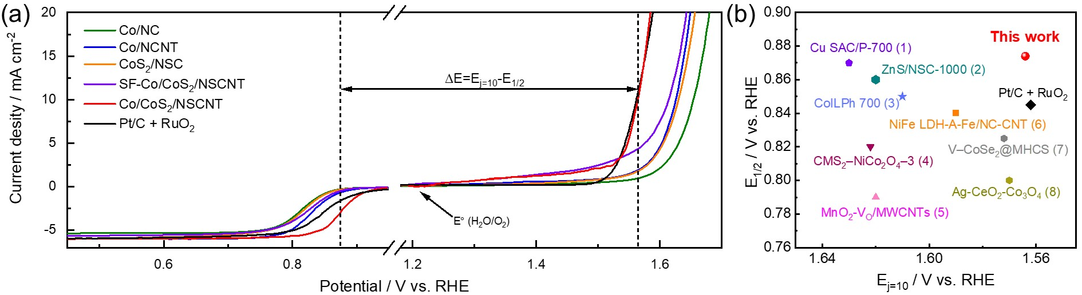
Fig. S19. (a) LSV curves of Co/NC, Co/NCNT, CoS₂/NSC, SF-Co/CoS₂/NSCNT, Co/CoS₂/NSCNT, and Pt/C+RuO₂ catalysts in the ORR/OER region. (b) Bifunctional electrocatalytic activity comparison of Co/CoS₂/NSCNT and Pt/C+RuO₂ with recently reported bifunctional transition metal electrocatalysts (1) Cu SAC/P-700 [1] (2) ZnS/NSC-1000 [2] (3) CoILPh 700 [3] (4) CMS₂–NiCo₂O₄–3 [4] (5) MnO₂-V_{O}/MWCNTs [5] (6) NiFe LDH-A-Fe/NC-CNT [6] (7) V–CoSe₂@MHCS [7] (8) Ag-CeO₂-Co₃O₄ [8]

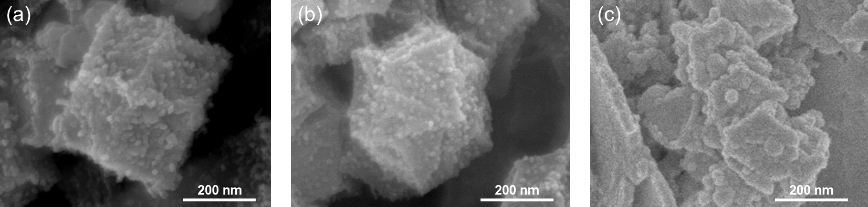
Fig. S20. Scanning electron microscopy (SEM) images of Co/NCNT samples prepared by various pyrolysis temperature of (a) 850°C, (b) 900°C, and (c) 950°C.

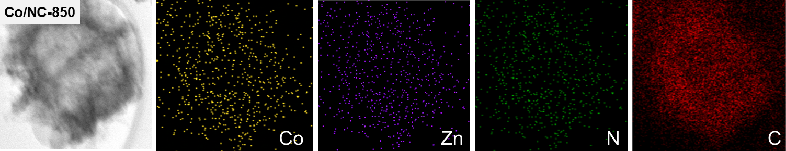
Fig. S21. Energy dispersive X-ray spectroscopy (EDS) elemental mapping images of Zn, Co-ZIF-850.

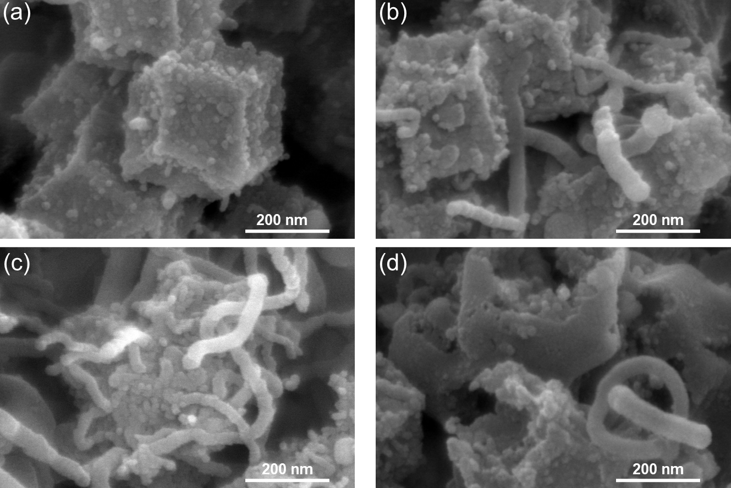
Fig. S22. Scanning electron microscopy (SEM) images of Co/NCNT samples prepared by various pyrolysis temperature of (a) 650°C, (b) 700°C, (c) 750°C, and (d) 800°C.

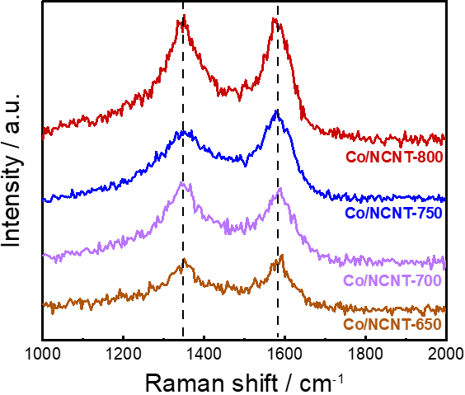
Fig. S23. Raman spectra of Co/NCNT samples synthesized with various pyrolysis temperatures.

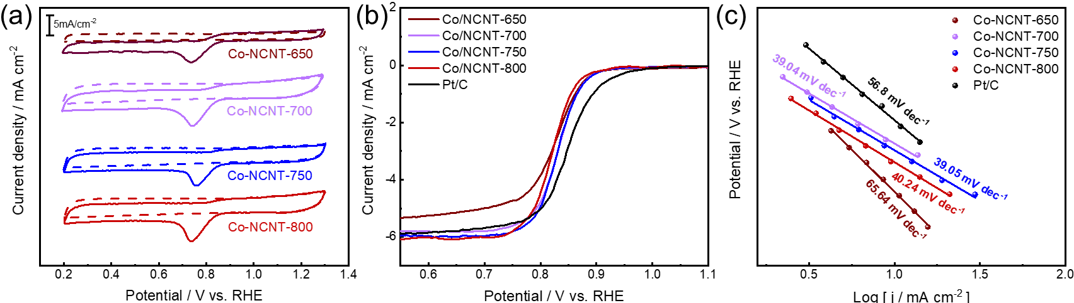
Fig. S24. Electrochemical characterization of the Co/NCNT samples synthesized at various temperatures for ORR. (a) CV curves measured from N₂-saturated and O₂-saturated 0.1 M KOH solutions, (b) LSV polarization curves, and (c) Tafel plots of Co/NCNT samples prepared with various pyrolysis temperatures.

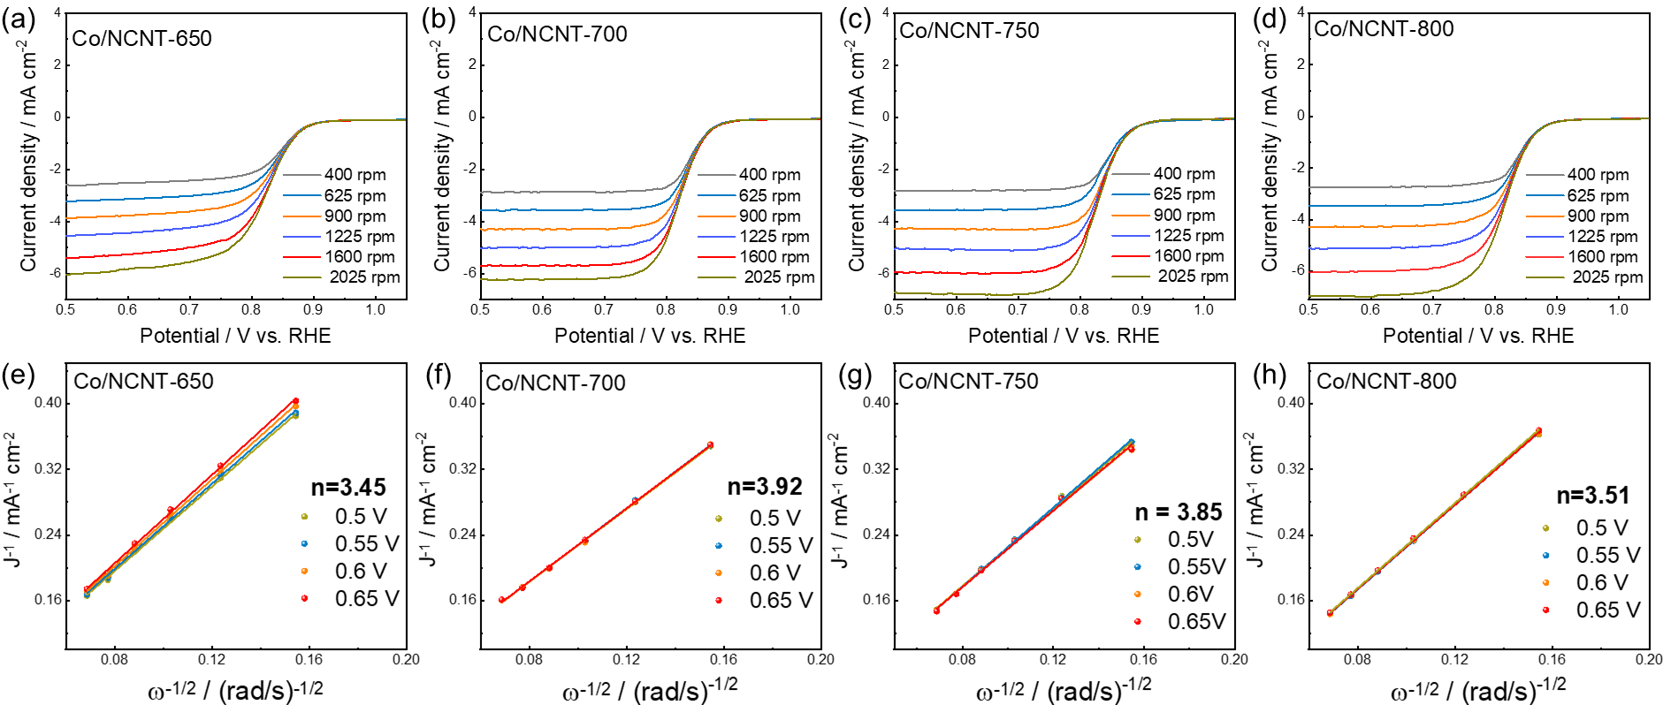
Fig. S25. (a-d) Rotating disk voltammograms at various rotating speeds and (e-h) the corresponding Koutecky-Levich plots for Co/NCNT samples prepared with various pyrolysis temperatures.

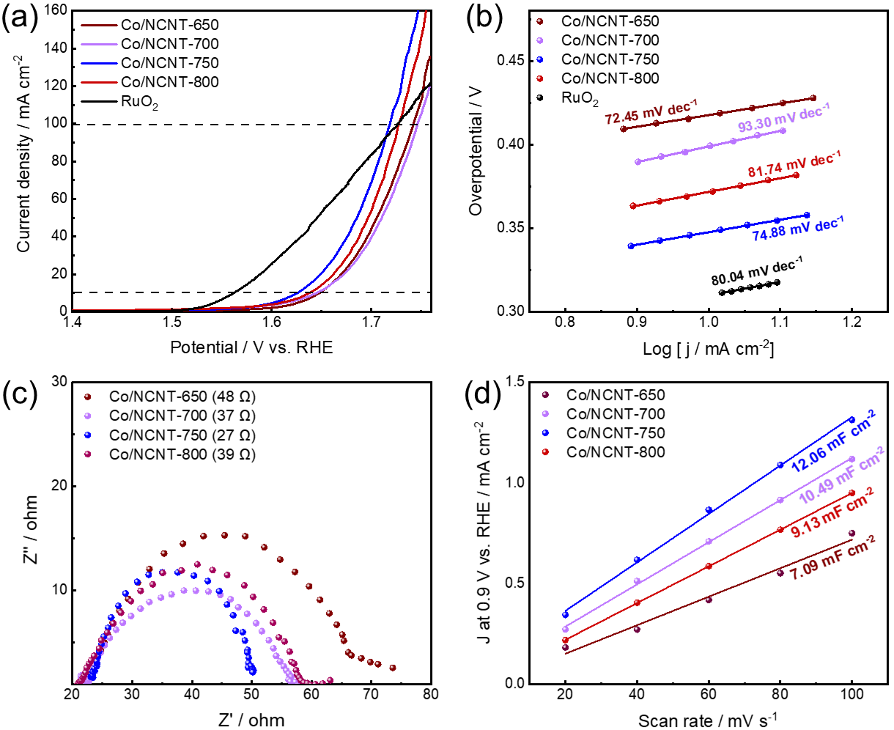
Fig. S26. Electrochemical characterization of the Co/NCNT samples synthesized at various temperatures for OER. (a) LSV polarization curves measured from N₂-saturated 1 M KOH solutions, (b) Tafel plots, (c) EIS measurements, and (d) linear plots of capacitive current densities from different scan rates of Co/NCNT samples prepared with various pyrolysis temperatures.

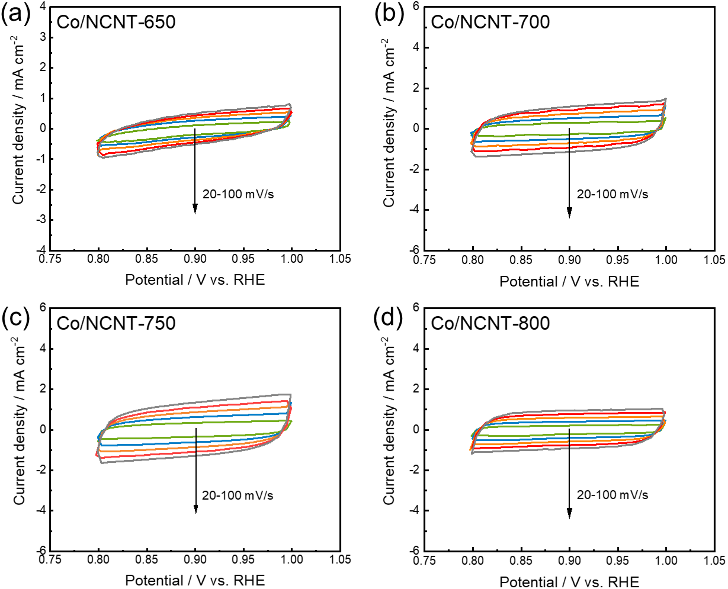
Fig. S27. (a-d) CV curves of Co/NCNT samples prepared with various pyrolysis temperatures measured in non-faradaic potential range.

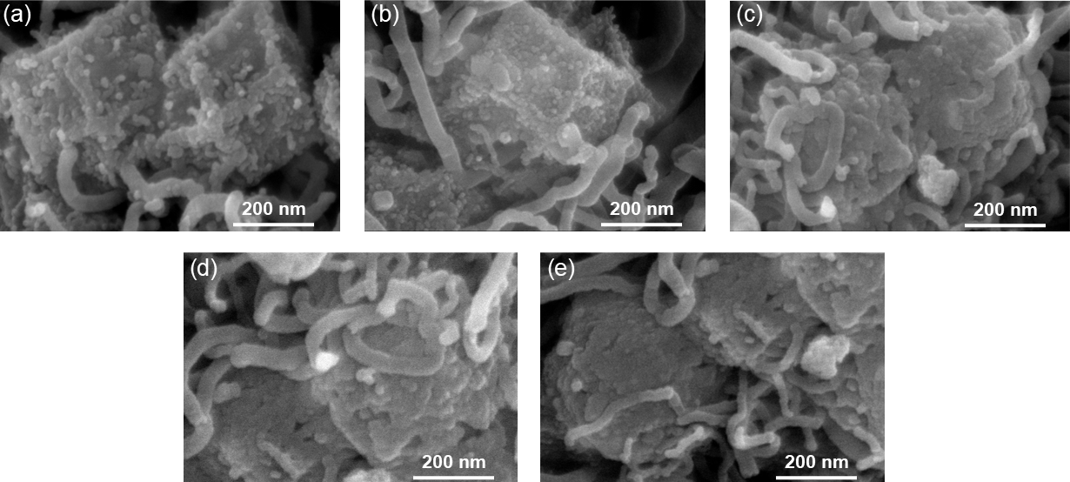
Fig. S28. Scanning electron microscopy (SEM) images of Co/NCNT samples prepared from various sulfidation temperatures of (a) 350°C, (b) 400°C, (c) 450°C, (d) 500°C, and (e) 550°C.

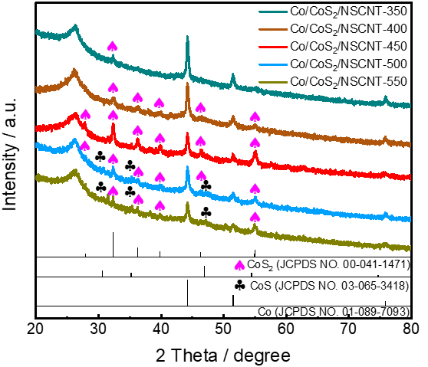
Fig. S29. XRD patterns of Co/CoS₂/NSCNT samples prepared from various sulfidation temperatures.

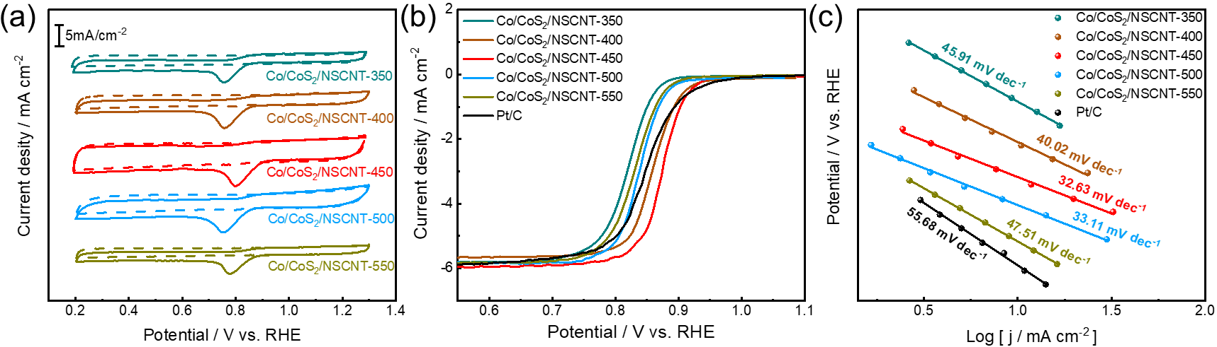
Fig. S30. Electrochemical characterization of the Co/CoS₂/NSCNT samples synthesized at various temperatures for ORR. (a) CV curves measured from N₂-saturated and O₂-saturated 0.1 M KOH solutions, (b) LSV polarization curves, and (c) Tafel plots of Co/CoS₂/NSCNT samples prepared from various sulfidation temperatures.

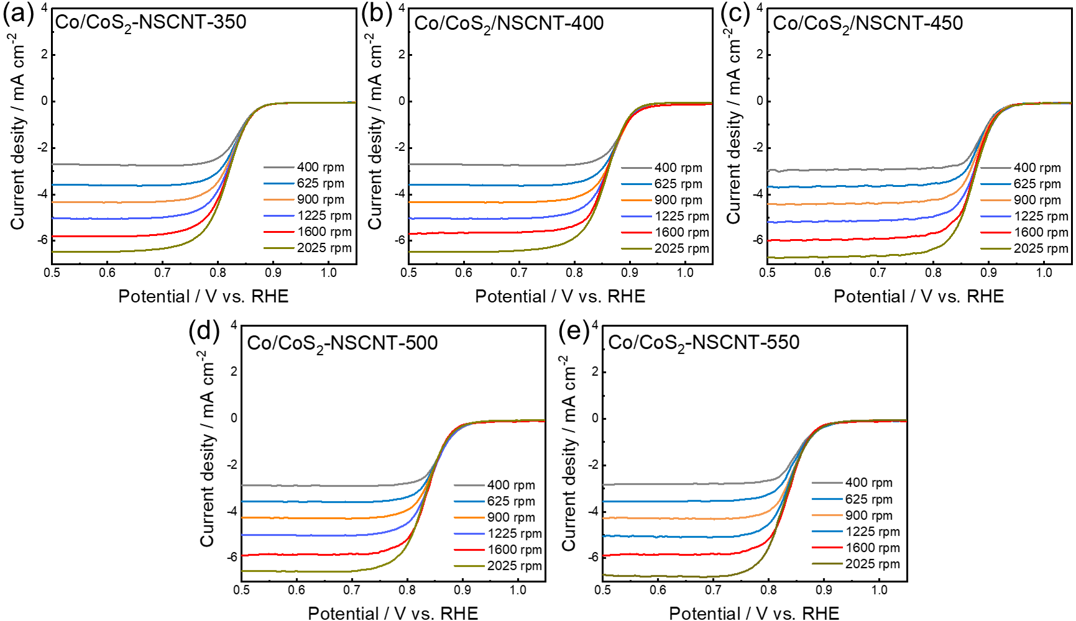
Fig. S31. (a-e) Rotating disk voltammograms at various rotating speeds for Co/CoS₂/NSCNT samples prepared from various sulfidation temperatures.

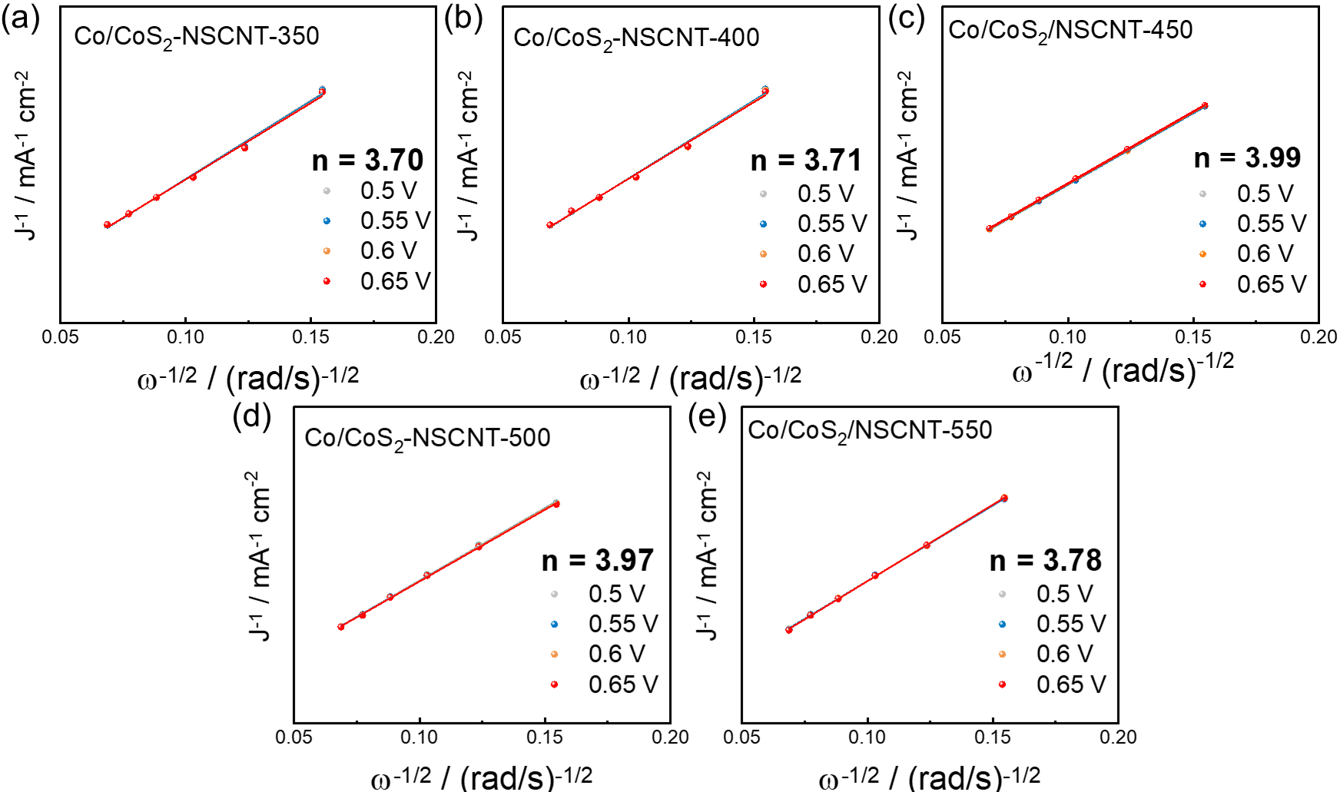
Fig. S32. (a-e) The Koutecky-Levich plots for Co/CoS₂/NSCNT samples prepared from various sulfidation temperatures.

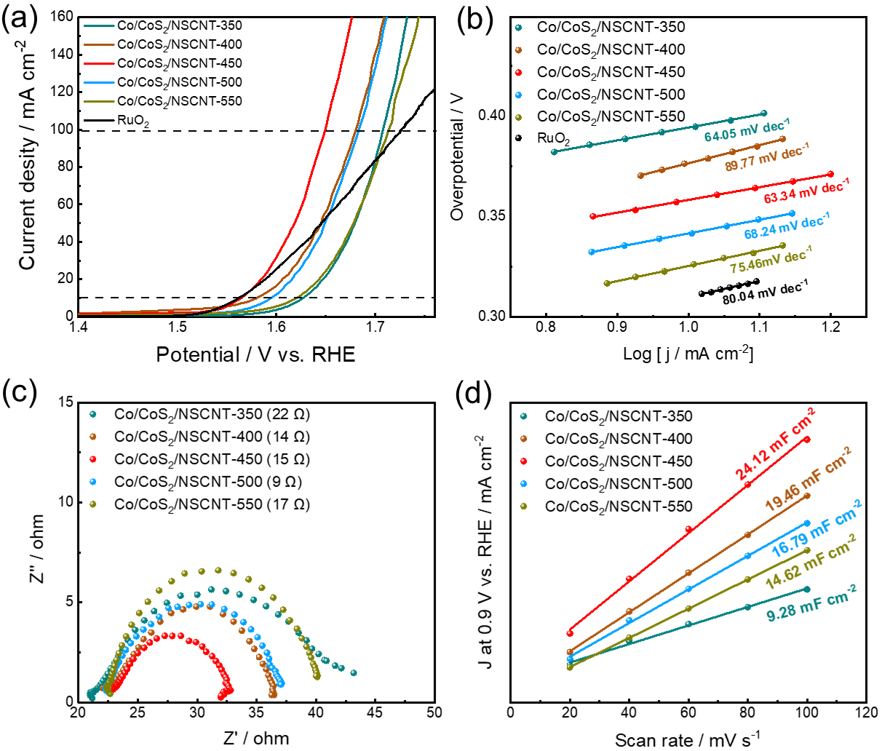
Fig. S33. Electrochemical characterization of the Co/CoS₂/NSCNT samples synthesized at various temperatures for OER. (a) LSV polarization curves measured from N₂-saturated 1 M KOH solutions, (b) Tafel plots, (c) EIS measurements, and (d) linear plots of capacitive current densities from different scan rates of Co/CoS₂/NSCNT samples prepared from various sulfidation temperatures.

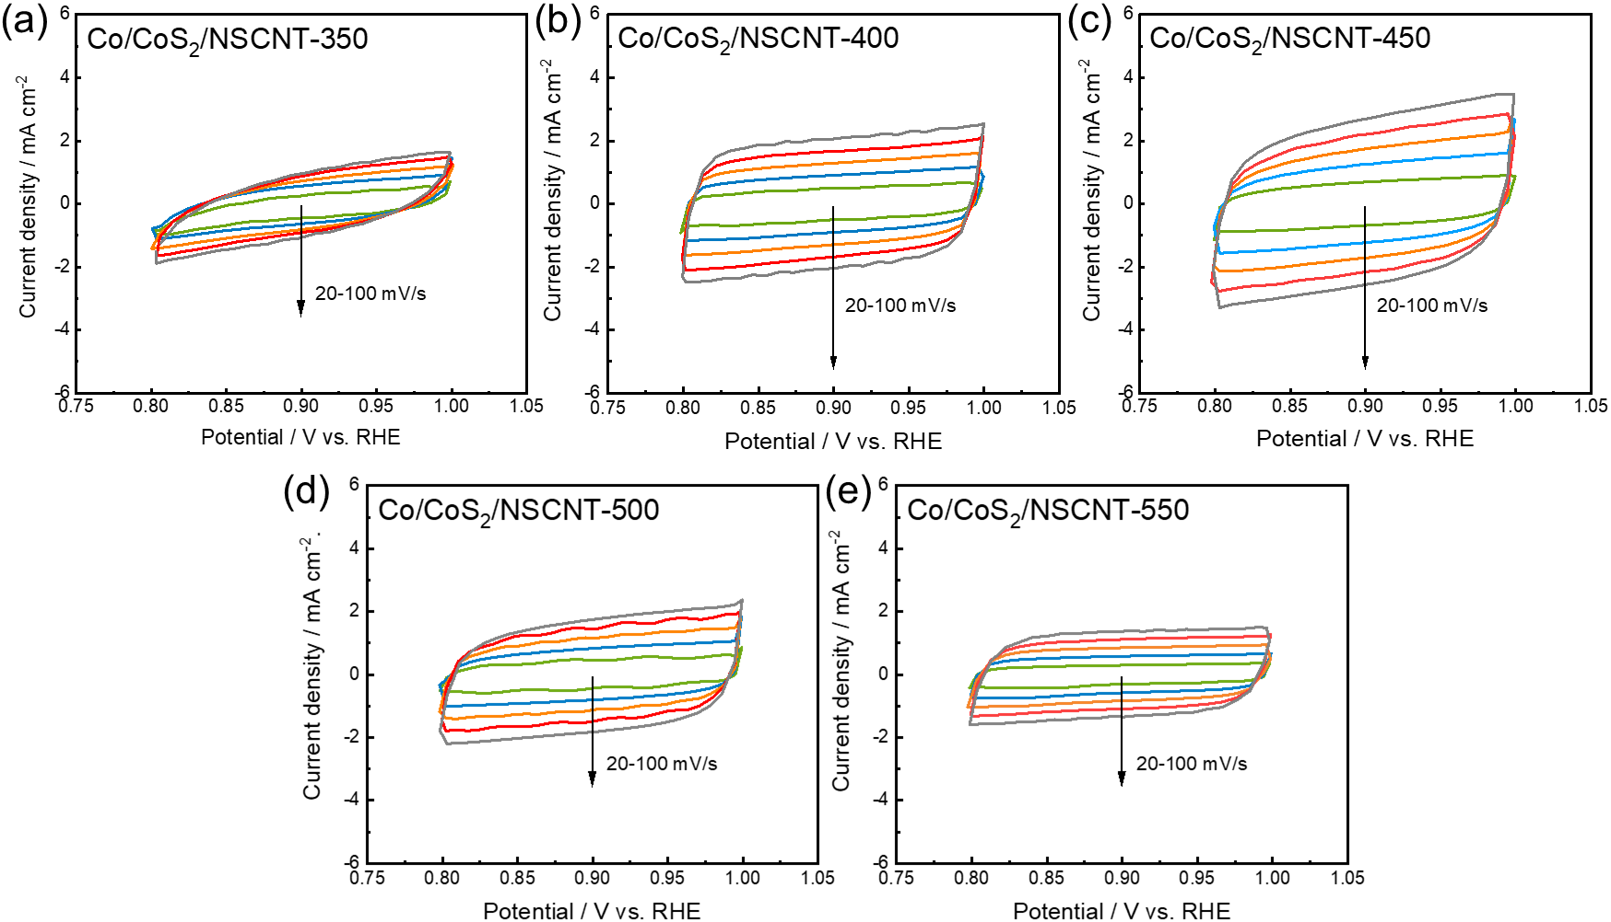
Fig. S34. (a-d) CV curves of Co/CoS₂/NSCNT samples prepared from various sulfidation temperatures measured in non-faradaic potential range.

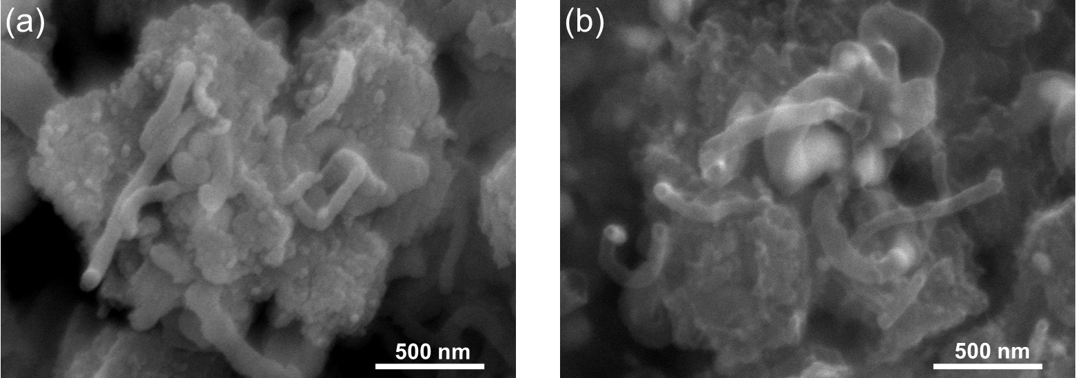
Fig. S35. SEM images of Co/CoS₂/NSCNT electrocatalyst (a) before and (b) after the long-term ZAB cyclability test.

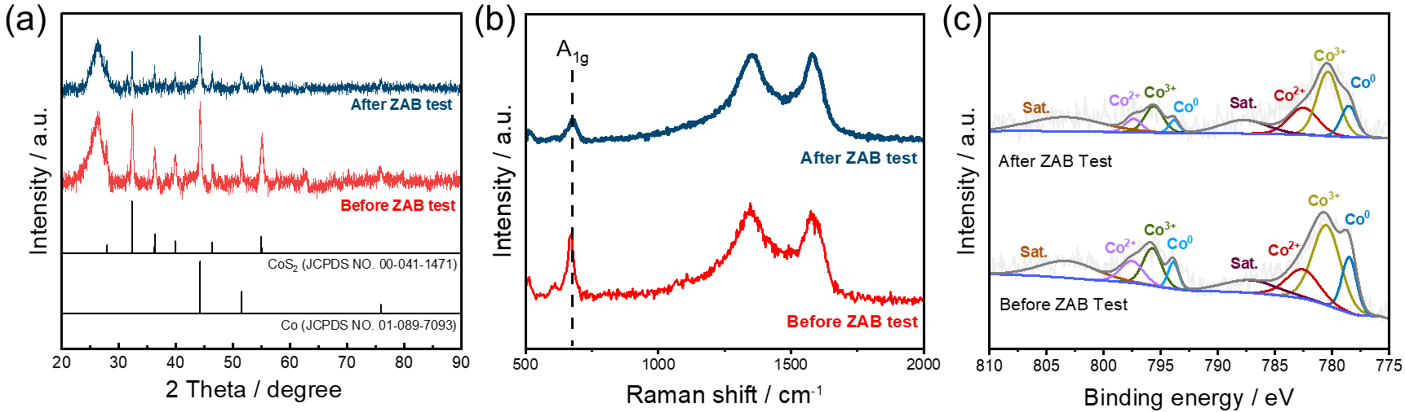
Fig. S36. (a) XRD patterns (b) Raman spectra and (c) XPS Co 2p spectra of the Co/CoS₂/NSCNT before and after the ZAB cyclability test.

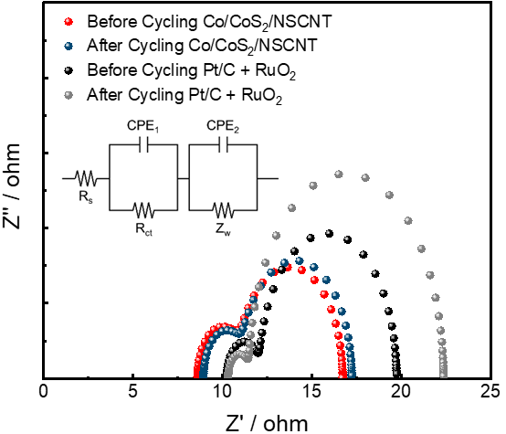
Fig. S37. Nyquist plots calculated from EIS measurement before and after cyclability test for Co/CoS₂/NSCNT-based ZAB.

Table S1. Elemental proportion of Co, S, N and C for Co/CoS₂/NSCNT measured by TEM-EDS and XPS
 | Co/CoS₂/NSCNT
 | TEM-EDS | XPS survey
Co (at%) | 0.49 | 1.13
S (at%) | 1.19 | 2.61
N (at%) | 2.27 | 2.77
C (at%) | 96.05 | 93.49
Total (%) | 100 | 100

Table S2. Comparison of the OER catalytic activity in 1 M KOH of Co/CoS₂/NSCNT
Catalysts | Overpotential  at 10 mA cm^{–2} (mV) | Tafel slope  (mV dec^{–1}) | References
Co/CoS₂/NSCNT | 334 | 63.34 | This work
Fe─N/FeCo@NGA | 350 | 64 | [9]
LaFeO₃ | 390 | 74 | [10]
CoNiCuMnFe/C | 350 | 79 | [11]
CuO – N | 385 | 76 | [12]
Cu_{x}S@MoS₂ | 334 | 225 | [13]
g-C₃N₄ | 355 | 46.8 | [14]
MFO | 359 | 80 | [15]
NMN-MO-NO | 363 | 139 | [16]
CoSe₂@NC | 340 | 104.2 | [17]

Table S3. Comparison of the ORR catalytic activity in 0.1 M KOH of Co/CoS₂/NSCNT
Catalysts | Half wave-  potential  (mV) | Tafel slope  (mV dec^{–1}) | References
Co/CoS₂/NSCNT | 874 | 32.63 | This work
Co-HOPS-CNTs20D | 863 | 72.04 | [18]
CoNi-NCNT | 810 | 85.1 | [19]
Co-Ni/NiF₂@PCNFs | 845 | 92.1 | [20]
J-CeO₂/ZCS | 870 | 55 | [21]
P-MnCo₂O₄@PWC | 870 | 81.2 | [22]
PDA-Fe-900 | 840 | 120 | [23]
F-NPC | 860 | 81.8 | [24]
CoP₃/CeO₂/C-2 | 752 | 58 | [25]
Co@C–O–Cs | 820 | 81.1 | [26]

Table S4. Comparison of the performance of AEMFCs assembled with various electrocatalysts
Catalysts | Catalyst  loading  (mg cm⁻²) | Peak power  density  (mW cm^{–2}) | References
Co/CoS₂/NSCNT | 2 | 199.15 | This work
Pt/C | 2 | 169.48 | This work
FePc-GA + CB + PTFE | 2 | 160 | [27]
Fe-N-C | 2 | 212 | [28]
Co/CoSe₂/NSeC | 2 | 171.23 | [29]
1.3Fe | 4.5 | 87 | [30]
Fe₁Co₂-ZNT-900 | 2 | 215 | [31]
PDCC_ZnCl₂ | 4 | 51 | [32]
Ni₂₀Co₂₀@B/GNF-H | 0.5 | 70 | [33]
FeFPc@BP2000 | 2 | 165 | [34]

Table S5. Comparison of the performance of rechargeable liquid Zn-air batteries assembled with various electrocatalysts
Catalysts | Specific capacity  (mAh g_{zn}^{–1}) | Peak power  density  (mW cm^{–2}) | References
Co/CoS₂/NSCNT | 784.08 | 163.57 | This work
Pt/C + RuO₂ | 672.34 | 135.73 | This work
FeMn DAS/FeMn NC | 786.2 | 114.0 | [35]
NiO/IrO₂-NF | 726 | 134.8 | [36]
G/Co-N-C | 789.2 | 82 | [37]
NiCoP/NiO@CC | 704.93 | 74.74 | [38]
CoN-N_{d} | 702 | 120 | [39]
NiFe@C@Co CNFs | 694 | 130 | [40]
Co/Co₉S₈/MnS-NMC | 692.7 | 148.9 | [41]
Co-Co₂P@NC | 715 | 120 | [42]

Table S6. Comparison of the performance of rechargeable flexible Zn-air batteries assembled with various electrocatalysts
Catalysts | Electrolyte | OCV (V) | Peak power density  (mW cm^{–2}) | References
Co/CoS₂/NSCNT | PAA | 1.43 | 95.19 | This work
Pt/C + RuO₂ | PAA | 1.38 | 73.82 | This work
Co@N-GC/CF | PAM | 1.42 | 67.83 | [43]
Co-Co₂Nb₅O₁₄ | PAA | 1.4 | 68.4 | [44]
SA-FeCNS-800 | PVA | 1.35 | 71 | [45]
CNFs/CoZn-MOF@COF | PVA | 1.41 | 66.6 | [46]
Co₂P/Co-N-C | PVA | 1.35 | 94 | [47]
Fe₃C|Fe-N-C | PANa | 1.414 | 63 | [48]
Ni-SAs/HCNFs/Co-NAs | PVA | 1.38 | 57.6 | [49]
FeCo-P/PNC | PVA | 1.4 | 90.8 | [50]

References
1. Wang L, Tian WW, Zhang W, et al (2023) Boosting oxygen electrocatalytic performance of Cu atom by engineering the d-band center via secondary heteroatomic phosphorus modulation. Appl Catal B Environ 338:123043. https://doi.org/10.1016/j.apcatb.2023.123043
2. Gao S, Li M, Li N, et al (2024) Porous carbon-nanostructured electrocatalysts for zinc-air batteries: from materials design to applications. Nanoscale Adv 7:60–88. https://doi.org/10.1039/d4na00847b
3. Allwyn N, Nikhil Chandran MK, Maithreyan V, et al (2025) Ionic-liquid-engineered, interfacial π-π-anchored, cobalt-dispersed, and N-, F-, B-doped carbon matrix as an oxygen electrocatalyst for advanced zinc-air batteries. J Mater Chem A 13:13935–13950. https://doi.org/10.1039/d5ta00770d
4. Wang C, Wang T, Liu Q, et al (2023) Starch-based porous carbon microsphere composited NiCo2O4 nanoflower as bifunctional electrocatalyst for zinc-air battery. Int J Biol Macromol 241:124604. https://doi.org/10.1016/j.ijbiomac.2023.124604
5. He M, Zhou T, Meng W, Zhang L (2026) MnO2-VO nanorods hybridized with multi-walled carbon nanotubes as an efficient bifunctional oxygen electrocatalyst for rechargeable Zn-air batteries. Int J Hydrogen Energy 207:. https://doi.org/10.1016/j.ijhydene.2026.153484
6. Wang WH, Han CH, Hong WX, et al (2024) NiFe layered double hydroxide (LDH) anchored, Fe single atom and nanoparticle embedded on nitrogen-doped carbon-CNT (carbon nanotube) framework as a bifunctional catalyst for rechargeable zinc-air batteries. J Energy Storage 85:111058. https://doi.org/10.1016/j.est.2024.111058
7. Cheong S, Shin J, Kang S, et al (2026) Vanadium-doped cobalt selenide nanoparticles embedded in mesoporous hollow carbon spheres as highly efficient bifunctional electrocatalyst for rechargeable Zn-air batteries. Carbon N Y 250:121318. https://doi.org/10.1016/j.carbon.2026.121318
8. Li T, He Z, Liu X, et al (2022) Interface interaction of Ag-CeO2-Co3O4 facilitate ORR/OER activity for Zn-air battery. Surfaces and Interfaces 33:102270. https://doi.org/10.1016/j.surfin.2022.102270
9. Tang R, Yuan X, Yang W, et al (2025) Fe─N4 and Fe7Co3 Nanoalloy Dual-Site Modulation by Skeleton Defect in N-Doped Graphene Aerogel for Enhanced Bifunctional Oxygen Electrocatalyst in Zinc-air Battery. Small 21:1–10. https://doi.org/10.1002/smll.202410264
10. Mathialagan K, Surendran A, Thankappakurup S, et al (2025) Application of perovskite-type LaFeO3 as a bifunctional electrocatalyst for high performance electrically rechargeable zinc-air batteries. J Alloys Compd 1021:179596. https://doi.org/10.1016/j.jallcom.2025.179596
11. Wang Z zhan, Gao K xu, Yan X, et al (2025) Flower-sphere CoNiCuMnFe/C high-entropy alloy catalysts for enhanced oxygen evolution reaction kinetics. J Alloys Compd 1026:180421. https://doi.org/10.1016/j.jallcom.2025.180421
12. Dantas AP, Raimundo RA, Neto PFC, et al (2024) Copper oxide nanofibers obtained by solution blow spinning as catalysts for oxygen evolution reaction. Ceram Int 50:13034–13045. https://doi.org/10.1016/j.ceramint.2024.01.213
13. Young C, Lai MY (2024) Core–shell bimetallic copper–molybdenum sulfides nanomaterials derived from a Cu-based metal-organic framework as efficient bifunctional electrocatalyts. Int J Hydrogen Energy 51:655–666. https://doi.org/10.1016/j.ijhydene.2023.07.021
14. Torres-Pinto A, Díez AM, Silva CG, et al (2024) Tuning graphitic carbon nitride (g-C3N4) electrocatalysts for efficient oxygen evolution reaction (OER). Fuel 360:. https://doi.org/10.1016/j.fuel.2023.130575
15. Maurya A, Yadav M (2023) Sphere shaped Mo- doped transition metal oxide as electrocatalyst for oxygen evolution reaction in alkaline medium. J Alloys Compd 956:170208. https://doi.org/10.1016/j.jallcom.2023.170208
16. Peng B, Hao J, Tian Z, et al (2022) Enhanced Oxygen Evolution Catalytic Activity of Ni3Mo3N-MoO2-NiO Nanoparticles via Synergistic Effect. Energy and Fuels 36:4902–4910. https://doi.org/10.1021/acs.energyfuels.2c00586
17. Ding K, Hu J, Luo J, et al (2022) Confined N-CoSe2 active sites boost bifunctional oxygen electrocatalysis for rechargeable Zn–air batteries. Nano Energy 91:106675. https://doi.org/10.1016/j.nanoen.2021.106675
18. Wen S, Ma K, Zhang Y, et al (2026) Carbon Nanotubes Assembled Ordered Macro-Microporous Superstructure as Bifunctional Oxygen Electrocatalyst for Long-Life Rechargeable Zn–Air Batteries. Adv Funct Mater 1–15. https://doi.org/10.1002/adfm.202531733
19. Du Y, Zhong Z, Shi Z, et al (2025) Dual-ligand engineered CoNi alloy/N-doped carbon nanotubes bifunctional ORR/OER electrocatalyst for long-lifespan rechargeable Zn-air batteries. J Colloid Interface Sci 683:631–640. https://doi.org/10.1016/j.jcis.2024.12.036
20. Wang Y, Wang H, Chi H, et al (2025) Co-doped Ni/NiF2 heterojunction electrocatalyst with bitter melon-like surface structures in porous carbon nanofibers for high-performance zinc-air batteries. Appl Catal B Environ 379:125651. https://doi.org/10.1016/j.apcatb.2025.125651
21. Zhang J, Dong X, Wang G, et al (2024) Interfacial engineering-induced Janus heterostructures with enhanced electronic regulation for efficient oxygen electrocatalysis in rechargeable Zn-air batteries. Appl Catal B Environ 342:123459. https://doi.org/10.1016/j.apcatb.2023.123459
22. Liu Y, Liu S, Zhang P, et al (2024) Electronic Structure Regulation of MnCo2O4 via Surface-Phosphorization Coupling to Monolithic Carbon for Oxygen Electrocatalysis in Zn–Air Batteries. Adv Funct Mater 34:1–11. https://doi.org/10.1002/adfm.202400522
23. Zhang F, Liu X, Chen Y, et al (2023) Ordered mesoporous carbon fiber bundles with high-density and accessible Fe-NX active sites as efficient ORR catalysts for Zn-air batteries. Chinese Chem Lett 34:108142. https://doi.org/10.1016/j.cclet.2023.108142
24. Li W, Wang J, Jia C, et al (2023) Covalent organic framework-derived fluorine, nitrogen dual-doped carbon as metal-free bifunctional oxygen electrocatalysts. J Colloid Interface Sci 650:275–283. https://doi.org/10.1016/j.jcis.2023.06.210
25. Li J, Kang Y, Lei Z, Liu P (2023) Well-controlled 3D flower-like CoP3/CeO2/C heterostructures as bifunctional oxygen electrocatalysts for rechargeable Zn-air batteries. Appl Catal B Environ 321:122029. https://doi.org/10.1016/j.apcatb.2022.122029
26. Ding K, Ye Y, Hu J, et al (2023) Aerophilic Triphase Interface Tuned by Carbon Dots Driving Durable and Flexible Rechargeable Zn-Air Batteries. Nano-Micro Lett 15:. https://doi.org/10.1007/s40820-022-00994-3
27. Li J, Wang L, Fu Y, et al (2025) Engineering the Catalyst Layer of a Pyrolysis-Free Nonprecious Metal Catalyst for Enhancing Anion-Exchange Membrane Fuel Cells. ACS Appl Energy Mater 8:552–558. https://doi.org/10.1021/acsaem.4c02739
28. Choi Y, Huynh TBN, Lee S, et al (2024) Single atom catalyst induced by redox reaction between iron ion and aniline monomer. Chem Eng J 496:154334. https://doi.org/10.1016/j.cej.2024.154334
29. Seong H, Min K, Lee G, et al (2025) Development of an efficient bifunctional electrocatalyst based on Co/CoSe2 nanoparticles embedded in N, Se co-doped carbon for AEMFC and rechargeable Zn-air battery. Appl Catal B Environ 362:. https://doi.org/10.1016/j.apcatb.2024.124725
30. Ricciardi B, Mecheri B, da Silva Freitas W, et al (2023) Porous Iron-Nitrogen-Carbon Electrocatalysts for Anion Exchange Membrane Fuel Cells (AEMFC). ChemElectroChem 10:1–11. https://doi.org/10.1002/celc.202201115
31. Kumar R, Mooste M, Ahmed Z, et al (2023) Highly active ZIF-8@CNT composite catalysts as cathode materials for anion exchange membrane fuel cells. Ind Chem Mater 1:526–541. https://doi.org/10.1039/d3im00081h
32. Teppor P, Jäger R, Paalo M, et al (2022) Peat as a carbon source for non-platinum group metal oxygen electrocatalysts and AEMFC cathodes. Int J Hydrogen Energy 47:16908–16920. https://doi.org/10.1016/j.ijhydene.2022.03.199
33. Das SK, Kesh A, Akula S, et al (2022) Co-, Ni-Catalyzed Borylation of Carbon Nanofibers for Oxygen Reduction Reaction in an Anion Exchange Membrane Fuel Cell. ACS Appl Energy Mater 5:10240–10253. https://doi.org/10.1021/acsaem.2c01957
34. Friedman A, Mizrahi M, Levy N, et al (2021) Application of Molecular Catalysts for the Oxygen Reduction Reaction in Alkaline Fuel Cells. ACS Appl Mater Interfaces 13:58532–58538. https://doi.org/10.1021/acsami.1c16311
35. Wang CY, Ren CZ, Feng JJ, et al (2026) Dual-atom engineering and alloying strategies to trigger multi-site synergies for boosting oxygen reduction and Zn-air battery. J Energy Storage 152:120687. https://doi.org/10.1016/j.est.2026.120687
36. Karthikeyan SC, Sidra S, Ramakrishnan S, et al (2024) Heterostructured NiO/IrO2 synergistic pair as durable trifunctional electrocatalysts towards water splitting and rechargeable zinc-air batteries: An experimental and theoretical study. Appl Catal B Environ 355:124196. https://doi.org/10.1016/j.apcatb.2024.124196
37. Xie H, Lei J, Li Q, et al (2024) Novel coal-based carbon encapsulating Co-N-C derived from ZIF-67 composite as an efficient chainmail electrocatalyst for zinc-air batteries. J Power Sources 615:235103. https://doi.org/10.1016/j.jpowsour.2024.235103
38. Hu X, Fan J, Wang R, et al (2023) Vacancies and interfaces engineering of core–shell heterostuctured NiCoP/NiO as trifunctional electrocatalysts for overall water splitting and zinc-air batteries. Green Energy Environ 8:601–611. https://doi.org/10.1016/j.gee.2021.11.003
39. Hu Y, Guo M, Hu C, et al (2022) Engineering cobalt nitride nanosheet arrays with rich nitrogen defects as a bifunctional robust oxygen electrocatalyst in rechargeable Zn–air batteries. J Colloid Interface Sci 608:2066–2074. https://doi.org/10.1016/j.jcis.2021.10.128
40. Chen X, Pu J, Hu X, et al (2022) Janus Hollow Nanofiber with Bifunctional Oxygen Electrocatalyst for Rechargeable Zn–Air Battery. Small 18:. https://doi.org/10.1002/smll.202200578
41. Chen K, Wang X, Zhang C, et al (2022) Three-phases Co/Co9S8/MnS heterostructures engineering for boosted ORR/OER activities in Zn–air batteries. Mater Today Energy 30:101150. https://doi.org/10.1016/j.mtener.2022.101150
42. Zhu P, Wang L, Su Z, Liu S (2022) Effectively engineering in situ coupled cobalt-cobalt phosphide nanoparticles with nitrogen-doped carbon materials for advanced bifunctional oxygen electrocatalysts in rechargeable Zn-air batteries. J Alloys Compd 908:164595. https://doi.org/10.1016/j.jallcom.2022.164595
43. Wang Q, Wang J, Wang Q, Wei Q (2026) Rational design of N-doped ultrathin graphitic carbon shells encapsulating cobalt nanoparticles for efficient oxygen reduction and evolution reactions in flexible Zinc-air batteries. J Power Sources 663:238900. https://doi.org/10.1016/j.jpowsour.2025.238900
44. Chen S, Zhang L, Liu Z, et al (2025) Constructing Stable Bifunctional Electrocatalyst of Co─Co2Nb5O14 with Reversible Interface Reconstitution Ability for Sustainable Zn-Air Batteries. Adv Sci 12:1–12. https://doi.org/10.1002/advs.202413796
45. Zhao P, Zhang L, Chen J, et al (2024) From wood to flexible Zn-air Battery: Fe3O4 nanoparticles synergistic single iron atoms on N-doped carbon nanosheets electrocatalyst and Lignosulfonate-Functionalized gel electrolyte. Chem Eng J 484:149415. https://doi.org/10.1016/j.cej.2024.149415
46. Liu L, He Q, Dong S, et al (2024) Building synergistic multiple active sites in branch-leaf nanostructured carbon nanofiber derived from MOF/COF hybrid for flexible wearable Zn-air battery. J Colloid Interface Sci 666:35–46. https://doi.org/10.1016/j.jcis.2024.04.024
47. Liu X, Yan W, Song J, et al (2024) Kirkendall effect induced the formation of hollow Co2P in Co-N-C for ORR, OER, HER and flexible Zn–Air battery. Chem Eng J 492:. https://doi.org/10.1016/j.cej.2024.152301
48. Chen Y, Kong X, Wang Y, et al (2023) A binary single atom Fe3C|Fe–N–C catalyst by an atomic fence evaporation strategy for high performance ORR/OER and flexible Zinc-air battery. Chem Eng J 454:140512. https://doi.org/10.1016/j.cej.2022.140512
49. Chen Y, Qiao S, Tang Y, et al (2022) Double-Faced Atomic-Level Engineering of Hollow Carbon Nanofibers as Free-Standing Bifunctional Oxygen Electrocatalysts for Flexible Zn-Air Battery. ACS Nano 16:15273–15285. https://doi.org/10.1021/acsnano.2c06700
50. Yang M, Liu Y, Sun J, et al (2022) Integration of partially phosphatized bimetal centers into trifunctional catalyst for high-performance hydrogen production and flexible Zn-air battery. Sci China Mater 65:1176–1186. https://doi.org/10.1007/s40843-021-1902-2

