Genetic and environmental factors driving functional trait variation in Pericopsis elata seedlings
Jean Pierre Ngongo* ^{,1,2,3}, Bloude L.B. Toumba-Paka ^{3,4}, Janvier Lisingo ², Surabhi Ranavat ³, Michael Dasse ³,
Nils Bourland ⁵, Thomas Drouet ⁶, Sertillanges B. Ango ⁷, Gaël U. Dipelet Bouka ⁴,
Bonaventure Sonké ⁷, Olivier J. Hardy ³
- Department of Natural and Renewable Resources Management, Faculty of Agricultural Sciences, University of Kindu, B-122 Kindu, DRC.
- Faculty of Sciences. University of Kisangani. B-2012 Kisangani, DRC.
- Evolutionary Biology and Ecology, CP 160/12. Faculty of Sciences. Université Libre de Bruxelles. Avenue F. D. Roosevelt, 50. BE-1050 Brussels, Belgium.
- Laboratory of Biodiversity and Ecosystems and Environmental Management, Faculty of Science and Technology, Marien Ngouabi University, Brazzaville, Congo.
- Service of Wood Biology, Royal Museum for Central Africa, Leuvensesteenweg 13, 3080 Tervuren, Belgium.
- Plant Ecology and Biogeochemistry, CP 244, Faculty of Sciences, Université Libre de Bruxelles, Brussels, Belgium.
- Plant Systematics and Ecology Laboratory, Department of Biology, Higher Teachers' Training College, University of Yaoundé I, P.O. Box 047, Yaoundé, Cameroon.

* Correspondence author : Jean Pierre Ngongo. E-mail : fistonngongo1@gmail.com

Supplementary material
S1. Plantation design
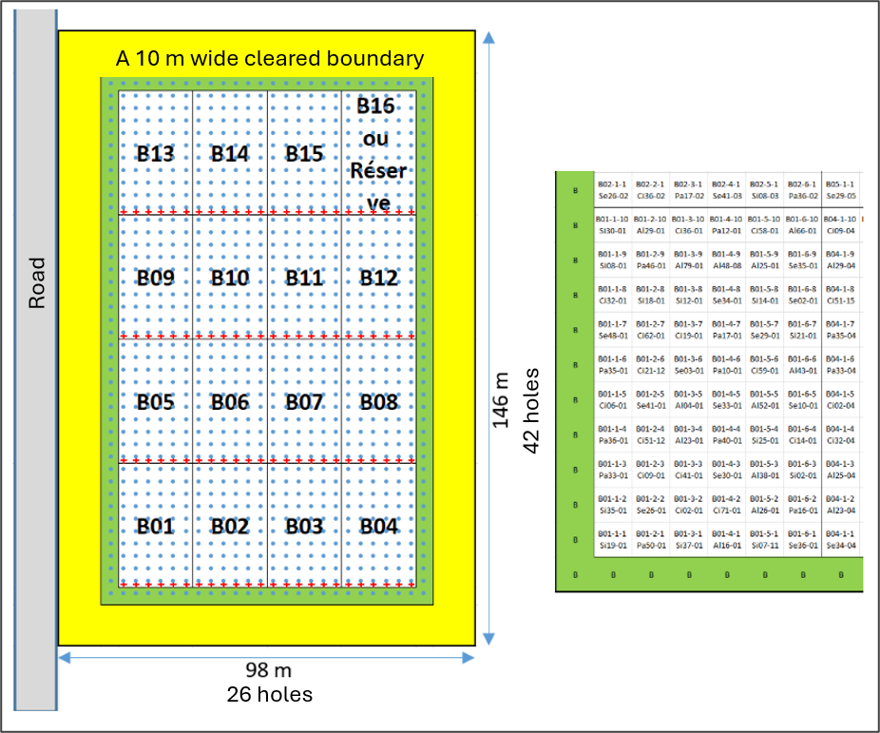
Figure S1. Layout of the experimental plot (146 × 98 m) organised into 16 blocks. Each block contains 6 rows × 10 trees (60 trees per block), spaced 3 m apart. A peripheral row of trees (green area) surrounds the blocks to reduce edge effects, itself encircled by a 10 m unplanted buffer zone (yellow area). Red markers (±) are placed at the beginning of each row, indicating the block number (Bxx) and row number (1–6). Each tree is labelled with Bxx (block) – row (1–6) – position within the row (1–10), followed by the seed provenance code, seed donor number, and offspring number (see zoom on block B01, right).

Geographical distribution of seed donors sampled between January and April 2022
Table S1. Geographic coordinates of seed provenances and number of families per provenance.
Provenance | Country | Provenance code | Mean Latitude | Mean Latitude | Number of Families
Pallisco | Cameroon | Pa | 14.05 | 3.38 | 13
Alpicam | Cameroon | Al | 14.72 | 3.12 | 21
SIFCO | Republic of Congo | Si | 15.28 | 1.92 | 20
SEFAC | Cameroon | Se | 15.85 | 2.62 | 20
CIB | Republic of Congo | Ci | 16.11 | 2.04 | 24
Trait distribution density over time
A marked contrast is observed between seedlings measured in 2023 in the nursery and those measured in 2024 after one year in the plantation. This shift in trait distribution reflects a typical physiological and morphological transition from the nursery stage to the establishment phase in the field.
Figure S2. Density distributions of five foliar and structural traits (Leaf Area – LA, Specific Leaf Area – SLA, Leaf Dry Mass – LDM, stem diameter at collar, and height) measured in juvenile Pericopsis elata seedlings in 2023 (nursery) and 2024 (one year after transplantation to the plantation). Seedlings in the nursery exhibited larger leaves and higher SLA, characteristic of a controlled environment promoting foliar allocation. After one year in the plantation, seedlings showed substantial increases in diameter and height, accompanied by lower LA and SLA values, reflecting adaptation to more open, competitive field conditions.
Density distributions by provenance
The density distributions of foliar and growth traits show substantial overlap among provenances for most measured traits (SLA, LDM, LA), whereas CHL, leaf thickness (Lth), and leaf number (Nleaf) exhibit slight differences in distribution between provenances.

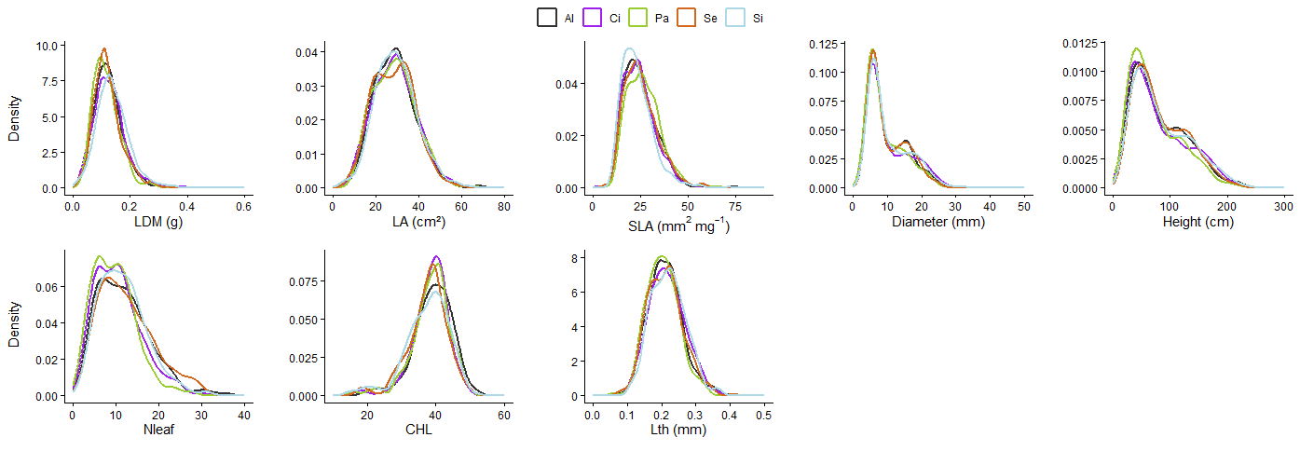
Figure S3. Kernel density estimates of foliar and growth traits measured on juvenile Pericopsis elata plants, separated by provenance. Each small panel shows the distribution of a trait: LDM = leaf dry mass (g), LA = leaf area (cm²), SLA = specific leaf area (mm² mg⁻¹), Diameter = stem diameter (mm), Height = height (cm), Nleaf = number of leaves, CHL = chlorophyll content (SPADE value), Lth = leaf thickness (mm). Coloured curves indicate provenance (Al = black, Ci = purple, Pa = green, Se = orange, Si = light blue). Densities were calculated across all measured individuals; the vertical axis represents estimated density (relative proportion).
Figure S4. Spearman correlations among ten functional traits of juvenile Pericopsis elata plants, shown by provenance. (A) Correlations observed in the nursery (2023); (B) correlations observed after one year in the plantation (2024). Global and provenance-specific correlation coefficients are shown with significance levels (* P < 0.05; ** P < 0.01; *** P < 0.001). Diagonal panels display the distribution of each trait (histograms) by provenance, and scatterplots are colored by provenance to illustrate within-provenance variation and potential differences in covariation structure.
Figure S5 Effects of provenance on ten functional traits of juvenile Pericopsis elata. Each panel shows adjusted values from a linear mixed model, with estimated marginal means (red points) and homogeneous groups from post-hoc emmeans tests (identical letters = no significant difference). Plot, Block, Family, and Year were included as random effects. Boxplots depict the distribution of individual values (N = number of observations per trait). The p-value corresponds to the overall effect of provenance in the model.
Figure S6. Comparison of aboveground biomass transformed to the cube root. Family means of AGB in AlpN vs AlpS. Each point represents the mean of a family; colours indicate provenance. The dashed ellipses represent 95 % confidence intervals by provenance. The diagonal line (y = x) indicates equality of means between plots. The Pearson correlation is r = 0.38 (P= 0.004).
Intra-plot Soil Analysis
Figure S7. Factorial analyses (PCA biplots in panels A and C) and spatial projections of PCA scores of soil variables (panels B and D) for 60 sub-blocks in two Alpicam plantations: AlpN(P16, panels A and B) and AlpS (P19, panels C and D). Sub-blocks are identified by the block ID (B01 to B30) followed by the letter A or B for the lower or upper half of the block, respectively. Colors of sub-block IDs in panels A and C indicate cos² (quality of representation on the factorial plane). The color and size of symbols in panels B and D represent the scores along PC1 and PC2, respectively. Sub-blocks layout follows field arrangement (reference square in upper right corner).

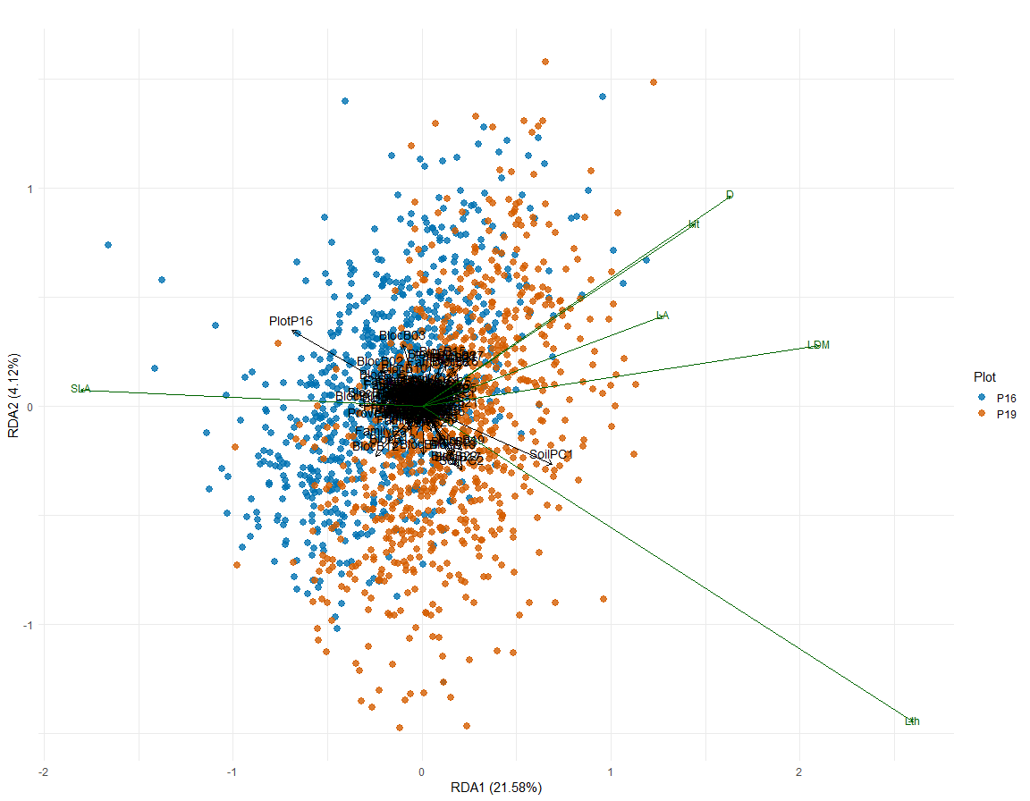
Figure S8 Redundancy Analysis (RDA) of leaf traits, constrained by soil variables summarized by PCA axes, plot structure (plot and blocks), provenance, and family. Green vectors represent leaf traits, and black vectors represent explanatory variables. Values in parentheses indicate the proportion of variance explained by each constrained axis.

Effect of Family
Family-level means of aboveground biomass (${AGB}^{1/3}$, kg) exhibited heterogeneous responses between P16 and P19, with P19 generally favoring greater juvenile biomass for a large number of families. The importance of variance among families indicates a notable genetic component and suggests that seedling selection can strongly influence performance in both nursery and plantation. We recommend a conservation and reforestation strategy that combines the selection of locally high-performing provenances with the maintenance of a broad family pool to preserve adaptive resilience. All other figures comparing family effects on traits are presented below and show similar trends, except for SLA and LA.
Figure S9. Comparison of family-level means ± standard errors (error bars) of transformed aboveground biomass (cube-rooted values, ${AGB}^{1/3}$, with AGB in kg) in two experimental plots (green P16 = plot AlpN, purple P19 = plot AlpS). Numbers next to points indicate the sample size (n) per family and per plot. Families are grouped by provenance along the x-axis; the upper panels arrange provenances along a West → East gradient: Pa, Al, Si, Se, Ci.
Figure S10. Comparison of family-level means ± standard errors (error bars) of total height (Ht), with Ht in cm, in two experimental plots (green P16 = plot AlpN, purple P19 = plot AlpS). Numbers next to points indicate the sample size (n) per family and per plot. Families are grouped by provenance along the x-axis; the upper panels arrange provenances along a West → East gradient: Pa, Al, Si, Se, Ci.
Figure S11. Comparison of family-level means ± standard errors (error bars) of diameter (D), with D in mm, in two experimental plots (green P16 = plot AlpN, purple P19 = plot AlpS). Numbers next to points indicate the sample size (n) per family and per plot. Families are grouped by provenance along the x-axis; the upper panels arrange provenances along a West → East gradient: Pa, Al, Si, Se, Ci.

Figure S12. Comparison of family-level means ± standard errors (error bars) of Leaf area (LA), with LA in cm², in two experimental plots (green P16 = plot AlpN, purple P19 = plot AlpS). Numbers next to points indicate the sample size (n) per family and per plot. Families are grouped by provenance along the x-axis; the upper panels arrange provenances along a West → East gradient: Pa, Al, Si, Se, Ci.

Figure S13. Comparison of family-level means ± standard errors (error bars) of Leaf dry mass (LDM), with LDM in g, in two experimental plots (green P16 = plot AlpN, purple P19 = plot AlpS). Numbers next to points indicate the sample size (n) per family and per plot. Families are grouped by provenance along the x-axis; the upper panels arrange provenances along a West → East gradient: Pa, Al, Si, Se, Ci.

Figure S14. Comparison of family-level means ± standard errors (error bars) of Leaf thickness (Lth), with Lth in mm, in two experimental plots (green P16 = plot AlpN, purple P19 = plot AlpS). Numbers next to points indicate the sample size (n) per family and per plot. Families are grouped by provenance along the x-axis; the upper panels arrange provenances along a West → East gradient: Pa, Al, Si, Se, Ci.

Figure S15. Comparison of family-level means ± standard errors (error bars) of Specific leaf area (SLA), with SLA in cm² g⁻¹, in two experimental plots (green P16 = plot AlpN, purple P19 = plot AlpS). Numbers next to points indicate the sample size (n) per family and per plot. Families are grouped by provenance along the x-axis; the upper panels arrange provenances along a West → East gradient: Pa, Al, Si, Se, Ci.

