Supplementary information
Higher exposure to antibiotics is associated with greater clinical improvement of chronic low back pain with Modic changes
European Spine Journal

Clinical Studies and outcomes

Chronic low back pain with Modic changes clinical trials with 12 month outcomes
Study | Design | Population | Regimen | Comparator | Analytical status | Reason included / excluded
Albert 2008[1] | Prospective open-label uncontrolled | MRI-confirmed prior lumbar disc herniation (not current); n = 32 | Oral co-amoxiclav 500 mg/125 mg, 1 tablet q8h for 100 days | None | Excluded | Mild to moderate patient population with low baseline scores
Albert 2013[2] | Prospective 4-arm parallel RCT | MRI-confirmed prior lumbar disc herniation (not current); n = 162 (45/36/45/36 across 1- and 2-tablet active vs placebo arms) | Oral co-amoxiclav 500 mg/125 mg, 1 or 2 tablets q8h for 100 days | 1 or 2 placebo tablets q8h for 100 days | Included | Placebo-controlled RCT;  Individual patient data provided as a personal communication from the author in 2018
Albert 2017[3] | Open-label cohort (uncontrolled) | MRI-confirmed prior lumbar disc herniation (not current); included MC2 (proportion not disclosed); n = 1024 at baseline, 602 at 12 months. Difference in baseline to 12m patient numbers was largely due to recruitment. | Oral co-amoxiclav 500 mg/125 mg, 2 tablets q8h for 100 days | None | Included | cLBP with Modic changes with prior, not current, herniation. Large real-world cohort providing long-term effectiveness and durability data complementary to the RCTs.
Bråten 2019[4] | Prospective 2-arm parallel RCT | MRI-confirmed prior lumbar disc herniation (not current); n = 118 (amoxicillin 58, placebo 59) | Oral amoxicillin 750 mg, 1 overwrapped capsule q8h for 90 days | 1 overwrapped placebo capsule q8h for 90 days | Included | Placebo-controlled RCT
Lassen 2026[5] | Prospective 2-arm parallel RCT | No prior herniation history required (current herniation excluded);  n = 40 (20 active, 20 placebo) | Intradiscal linezolid 150 mg on days 1 and 5 ± 1 | Sham intradiscal procedure on days 1 and 5 ± 1 | Included for cross-therapy analysis | Different antibiotic class (oxazolidinone) and route (intradiscal). No requirement for documented prior herniation increases generalisability of study population. Informs cross-therapy generalization.
Cicuttini 2026[6] | Prospective 2-arm parallel RCT | MRI-confirmed current herniation with or without Modic changes (54% with Modic at baseline); n = 170 (85 active, 85 placebo) | Oral amoxicillin 500 mg, 1 tablet q12h for 90 days | Placebo | Excluded | Population differs (current herniation; Modic changes not required). Population heterogeneity precludes pooling with other Modic-change trials.

Supplementary Table S1: Characteristics of clinical studies considered for the exposure-response analysis of antibiotic treatment in chronic low back pain (cLBP) with Modic changes. Clinical trials including cLBP patients with MC1 or mixed MC1 and MC2 changes with 12-month follow-up on pain intensity (LBP NRS) and Disability (RMDQ) were considered. Bråten 2019 reported results from patients with MC1 and mixed MC1/2 patients vs MC2 in supplemental materials. Studies are classified as included in the primary analysis, included for cross-therapy analysis, or excluded. Design summarises trial architecture; Population describes the enrolled sample (Modic change subtype, prior/current herniation status, and sample size); Regimen and Comparator describe the active and control exposures; Analytical status indicates how each study was used in the present analysis; and Reason provides the rationale for inclusion or exclusion. Excluded studies (Albert 2008, Cicuttini 2026) were excluded because of population heterogeneity (low baseline symptom scores or current herniation). Lassen 2026 was included for cross-therapy analysis because it uses a different antibiotic class (oxazolidinone) and route (intradiscal).

Clinical study arm data for included studies.

Pain intensity LBP NRS (0-10) | Albert 2013[2]  (Pers comm) |  |  |  | Albert 2013[2]  (Pers comm) |  |  |  | Albert 2017[3]
Antibiotic | Co-amoxiclav |  | Placebo |  | Co-amoxiclav |  | Placebo |  | Co-amoxiclav
Dose g | 0.5 q8h 100d |  | 0.0 q8h 100d |  | 1.0 q8h 100d |  | 0.0 q8h 100d |  | 1.0 q8h 100d
Intradiscal MIC₉₀ PTA | 0.1295 |  | 0.0000 |  | 0.5635 |  | 0.000 |  | 0.5635
Exposure rank | 2 |  | 1 |  | 4 |  | 1 |  | 4
 | N | Mean±SD | N | Mean±SD | N | Mean±SD | N | Mean±SD | N | Mean±SD
Baseline | 36 | 6.24±2.10 | 33 | 6.45±2.06 | 39 | 6.48±1.94 | 34 | 5.95±2.07 | 1024 | 6.0±1.8
12 months | 36 | 3.83±2.72 | 33 | 5.95±2.45 | 39 | 3.68±2.65 | 34 | 5.60±2.70 | 602 | 3.3±2.3
Change from Baseline |  | -2.41±2.47 |  | -0.51±2.28 |  | -2.80±2.38 |  | -0.35±2.45 |  | -2.7±2.28

Pain intensity LBP NRS (0-10) | Bråten 2019[4]
Antibiotic | Amoxicillin |  | Placebo
Dose g | 0.75 q8h 90d |  | 0.0 q8h 90d
Intradiscal MIC₉₀ PTA | 0.3643 |  | 0.00
Exposure rank | 3 |  | 1
 | N | Mean±SD | N | Mean±SD
Baseline | 58 | 6.5±1.1 | 59 | 6.3±1.3
12 months | 55 | 4.5±2.5 | 56 | 5.2±2.2
Change from Baseline |  | -2.00±2.42 |  | -1.10±2.17
Supplementary Table S2: Study arm-level 12-month change from baseline in low back pain numerical rating scale score (LBP NRS, 0-10) for included oral amoxicillin/co-amoxiclav studies. Intradiscal MIC₉₀ PTA is the model-estimated probability of attaining the predefined 40% fT>MIC target at Cutibacterium acnes MIC₉₀ (0.12 mg.L⁻¹ for amoxicillin). N is the sample number at each time point. Exposure rank ranges from 1 (placebo/sham) to 4 (1.0 g amoxicillin/co-amoxiclav q8h). N is the sample size at each time point. For Albert 2013, dose-group statistics were calculated from patient-level data provided by the original investigators (pers. comm.); the randomised sample was 45 / 36 / 45 / 36 across the 0.5g, 1-tablet placebo, 1.0g and 2-tablet placebo arms, and the analytic sample shown here is the completer sample at 12 months. Only patients with both baseline and 12-month results were included. Albert 2017 included Modic changes types 1, 2 or mixed. The proportion of Modic type 2 changes was not disclosed. For Albert 2017, baseline N = 1024 and 12-month N = 602 reflect the open-label cohort design with ongoing recruitment. More negative change values indicate greater clinical improvement.

Disability RMDQ23  (0-23) | Albert 2013[2]  Pers comm |  |  |  | Albert 2013[2]  Pers comm |  |  |  | Albert 2017[3]
Antibiotic | Co-amoxiclav |  | Placebo |  | Co-amoxiclav |  | Placebo |  | Co-amoxiclav
Dose g | 0.5 q8h 100d |  | 0.0 q8h 100d |  | 1.0 q8h 100d |  | 0.0 q8h 100d |  | 1.0 q8h 100d
Intradiscal MIC₉₀ PTA | 0.1295 |  | 0.0000 |  | 0.5635 |  | 0.0000 |  | 0.5635
Exposure rank | 2 |  | 1 |  | 4 |  | 1 |  | 4
 | N | Mean±SD | N | Mean±SD | N | Mean±SD | N | Mean±SD | N | Mean±SD
Baseline | 36 | 14.33±4.88 | 33 | 14.21±5.13 | 39 | 14.87±3.83 | 34 | 14.94±4.04 | 1024 | 15.5±4.4
12 months | 36 | 8.28±7.14 | 33 | 13.42±6.65 | 39 | 8.00±6.66 | 34 | 12.21±6.27 | 602 | 8.3±6.2
Change from Baseline | 36 | -6.05±6.32 | 33 | -0.79±6.04 | 39 | -6.87±5.79 | 34 | -2.73±5.50 | 602 | -7.20±6.44

Disability RMDQ24  (0-24) | Bråten 2019[4]  RMDQ24
Antibiotic | Amoxicillin |  | Placebo
Dose g | 0.75 q8h 90d |  | 0.0 q8h 90d
Intradiscal MIC₉₀ PTA | 0.3643 |  | 0.000
Exposure rank | 3 |  | 1
 | N | Mean±SD | N | Mean±SD
Baseline | 58 | 12.9±4.3 | 60 | 12.3±3.7
12 months | 55 | 8.2±6.0 | 56 | 10.3±5.4
Change from Baseline |  | -4.70±6.20 |  | -2.00±5.61
Supplementary Table S3: Study arm-level 12-month change from baseline in Roland-Morris Disability Questionnaire score for included study arms, sorted by ordinal exposure rank. Albert 2013 and Albert 2017 used RMDQ23 (0-23); Bråten 2019 used RMDQ24 (0-24); RMDQ23 and RMDQ24 scores were treated as comparable interval scales for the meta-regression, with the version noted per arm. All other conventions as in Supplementary Table S2.

Pain intensity | Lassen 2026[5]
Antibiotic | Linezolid |  | Placebo (Sham)
Dose g | 0.15g Days 1 & 5 |  | 0.0
Intradiscal MIC₉₀ PTA | 0.9214 |  | 0.0000
Exposure rank | 5 |  | 1
 | N | Mean±SD | N | Mean±SD
LBP NRS (0-10)
Baseline | 20 | 6.7±1.04 | 20 | 6.9±1.52
12 months | 18 | 3.3±1.89 | 19 | 4.7±2.55
Change from Baseline |  | -3.4±1.64 |  | -2.2±2.22
Supplementary Table S4: Study arm-level 12-month change from baseline in low back pain numerical rating scale score (LBP NRS, 0-10) for intradiscal linezolid study arms. Exposure rank ranges from 1 (placebo/sham) to 5 (intradiscal linezolid). Intradiscal MIC₉₀ PTA is the model-estimated probability of attaining the predefined 24hAUC/MIC≥80 target at Cutibacterium acnes MIC₉₀ (1.0 mg.L⁻¹ for linezolid). N is the sample number at each time point. More negative change values indicate greater clinical improvement.

Disability | Lassen 2026[5]
Antibiotic | Linezolid |  | Placebo (Sham)
Dose g | 0.15g Days 1 & 5 |  | 0.0
Intradiscal MIC₉₀ PTA | 0.9214 |  | 0.0000
Exposure rank | 5 |  | 1
 | N | Mean±SD | N | Mean±SD
RMDQ23 (0-23)
Baseline | 20 | 14.9±3.83 | 20 | 16.2±3.59
12 months | 18 | 6.1±5.43 | 19 | 9.9±7.10
Change from Baseline |  | -8.8±4.84 |  | -6.3±6.15
Supplementary Table S5: Study arm-level 12-month change from baseline in Roland-Morris Disability Questionnaire RMDQ23 (0-23) score for included study arms. RMDQ23 and RMDQ24 scores were treated as comparable interval scales for the meta-regression, with the version noted per arm. All other conventions as in Supplementary Table S4.

Estimation of intradiscal exposure and probability of target attainment (PTA) for oral amoxicillin and intradiscal linezolid (PP353).
To enable comparison of different antibiotics, doses and routes of administration a common framework was required and so the intradiscal probability of pharmacokinetic/pharmacodynamic target attainment was estimated. The pharmacokinetic models were developed to be transparent, reproducible, and appropriately simplified PK/PD models suitable for use for comparative inference.

Amoxicillin plasma-concentration time population model
An oral amoxicillin population pharmacokinetic model was developed to support dose-regimen analyses for intradiscal PTA. The development of the model was based on a published framework and aimed to balance agreement with digitised plasma concentration-time percentile curves and reference PK measurements from product labels.[7, 8]
The selection of the model prioritised plausible oral absorption behaviour, recovery of systemic exposure, stable extrapolation across clinically relevant dose-regimen combinations, and preservation of interval-dependent PK differences. A transit-compartment absorption model with first-order absorption and two-compartment disposition provided the most consistent overall fit. Parameter values are summarised in Supplementary Table S6.
Parameter | Description | Value | Unit | Notes | %CV
F | Oral bioavailability | 0.595 | fraction | Calculated as typical value 0.7 x model scale factor 0.85 | 28.00
MTT | Mean transit time to depot | 0.660 | h | Calculated as typical value 0.524 x model scale factor 1.26 | -
KA | First-order absorption rate constant | 2.256 | h⁻¹ | 1x model KA scale factor | 11.64
N | Transit compartments shape parameter | 4.41 | Unitless | Structural absorption parameter
Vc | Central volume of distribution | 27.7 | L | Typical value | 34.40
CL | Clearance | 21.3 | L.h⁻¹ | Typical value | 25.80
Q | Intercompartmental clearance | 1.70 | L.h⁻¹ | Typical value | -
Vp | Peripheral volume of distribution | 3.02 | L | Typical value | -
Supplementary Table S6: Oral amoxicillin plasma model parameters: N, Vc, CL, Q and Vp values obtained from De Veld et al.[7]
A fixed virtual population of 10,000 subjects was generated via Monte Carlo simulation using the calibrated parameter means and between-subject variability terms, with a fixed random seed to ensure reproducibility. Plasma concentration-time profiles were simulated for regimens of 250, 500, 750, 875, and 1000 mg, administered q8h or q12h.

Evaluation of oral amoxicillin plasma model performance
The performance of the model was assessed against both PK values on the labels and published plasma percentile curves (Supplementary Table S7). The calibrated model reproduced central exposure reasonably well on the clinically relevant higher-dose regimens, with the best overall agreement for C_{max} and AUC at 875 mg q12h and acceptable agreement for lower regimens. Predicted T_{max} ranged from 1.3 to 1.5 h across regimens, occurring approximately 0.15 h than the reference values at 250 mg, 0.24 h at 500 mg, and 0.36 h at 875 mg.
Oral Amoxicillin dose-regimen | Predicted C_{max} | Label C_{max} | C_{max} % label | Pred AUC_{0-24h} | Label AUC_{0-24h} | AUC predicted/label %
250 mg q8h | 3.28 | 3.30±1.12 | 99.4% | 22.33 | 26.7±4.56 | 83.63%
500 mg q8h | 6.56 | 7.19±2.26 | 91.23% | 44.67 | 53.5±8.87 | 83.50%
875 mg q12h | 11.34 | 11.64±2.78 | 97.42% | 52.11 | 53.5±12.31 | 97.40%
Supplementary Table S7: Predicted versus co-amoxiclav drug label pharmacokinetics
Comparison with the digitised percentile profiles showed generally good recovery of central tendency and post-peak decline, with some residual mismatch in the outer peak percentiles, particularly at higher exposure extremes (Supplemental Figure S1).
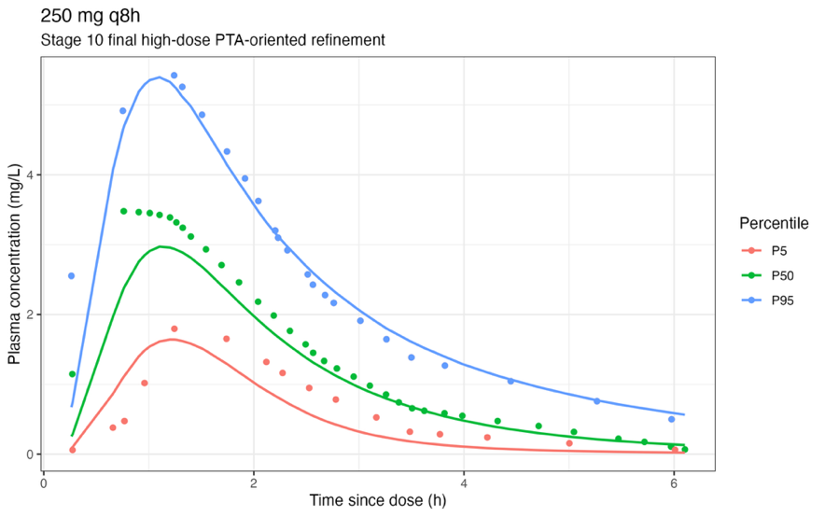
A

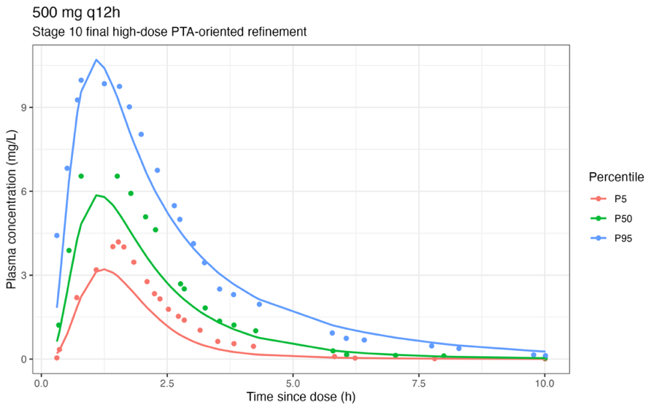
B

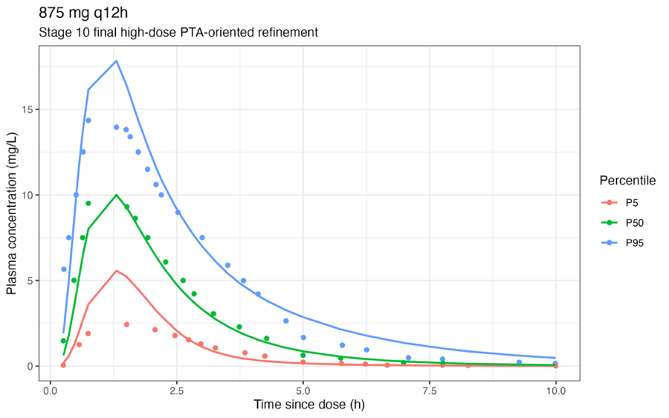
C

Supplementary Figure S1: Model estimated plasma concentration (solid lines) compared with de Veld digitised model results (symbols). A (top) amoxicillin 250 mg q8h, B (middle) 500 mg q12h, C (bottom) 875 mg q12h.

Predicted plasma exposure for PTA regimens used to treat cLBP with Modic changes
Clinical studies investigating treatment of cLBP with Modic changes tend to use higher dose regimens than are typically used and described on the drug label. Having validated the amoxicillin PK model against literature and labels, higher exposures were modelled. Steady-state exposure simulations of clinically relevant oral regimens used to derive fT>MIC showed monotonic increases in systemic exposure with increasing dose and higher daily exposure for q8h than q12h administration, supporting use of the model for comparative PTA analyses (Supplementary Table S8).[2, 4]
Oral amoxicillin dose and regimen | Predicted mean C_{max} mg.L⁻¹ | Predicted mean AUC_{0-24h} mg.h.L⁻¹
500 mg q8h | 6.56 | 44.67
500 mg q12h | 6.48 | 29.78
750 mg q8h | 9.84 | 67.00
750 mg q12h | 9.72 | 44.67
1000 mg q8h | 13.12 | 89.34
1000 mg q12h | 12.96 | 59.56
Supplementary Table S8: Predicted model plasma amoxicillin C_{max} and AUC_{0-24h} for oral doses of 500 mg, 750 mg and 1,000 mg q8h and q12h.

Estimation of free intradiscal amoxicillin exposure
Free intradiscal amoxicillin concentrations used in the PTA analysis are not derived from a fitted tissue-compartment model. Instead, they are obtained by scaling simulated plasma concentrations using an assumed free fraction (0.8) and a fixed disc:plasma exposure ratio of 6.5%, drawn from historical serum–disc concentration data after intravenous administration.[9] The scaling approach was adopted to facilitate cross-regimen comparisons on a common exposure axis. It serves as a pragmatic standardisation method. The ratio is treated as a fixed scalar applied uniformly across dose, interval, and time. Disc penetration is known in principle to be concentration- and time-dependent, and the model does not capture this dependency. The principal mitigation is to vary the scalar itself in sensitivity analysis (Supplementary Table S11), which preserves the rank ordering of regimens but does not address the assumption's form. Amoxicillin is assumed to be equally distributed throughout disc tissue. PTA values reported below should therefore be read as comparative exposure metrics, not as absolute probabilities of target attainment in disc tissue. Intradiscal free amoxicillin exposure was calculated as 0.8x6.5% = 5.2% of plasma concentration (Supplementary Figure S2).
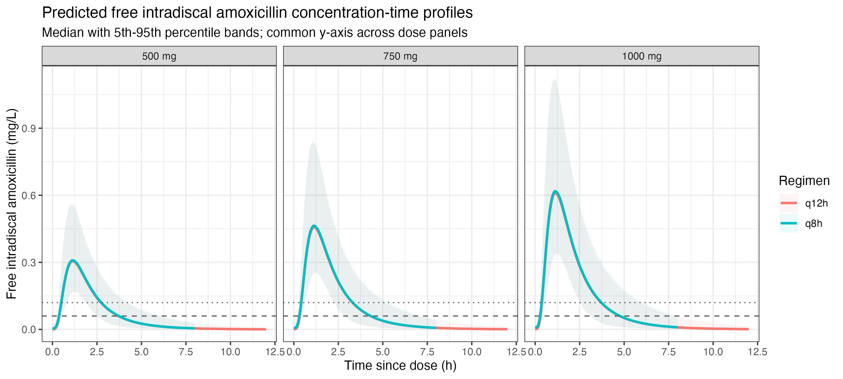Supplementary Figure S2: Estimated free intradiscal amoxicillin concentration-time profiles for oral doses of 500 mg, 750 mg and 1000 mg administered q8h (green lines) and q12h (red lines) under base-case assumptions (disc:plasma ratio 6.5%, free fraction 0.8). Median (line) and 95% interval (ribbon) across the 10 000-subject virtual population. Horizontal dashed and dotted lines indicate C. acnes MIC₅₀ (0.06 mg.L-1) and MIC₉₀ (0.12 mg.L-1). The figure illustrates dose- and interval-dependent separation of intradiscal free exposure above the MIC thresholds that underlies the regimen-specific PTA values reported in Supplementary Table S8
Estimated intradiscal free concentration-time profiles showed clear dose ordering and a consistent dosing-interval effect. Across the full interval, q8h regimens maintained concentrations above MIC thresholds for longer than corresponding q12h regimens, indicating that dosing interval was a major determinant of target attainment.

Mean free-amoxicillin time above MIC
Mean free-amoxicillin time above MIC increased monotonically with dose and was higher for q8h than q12h regimens. For the base-case penetration scenario of 6.5% of plasma concentration, mean free-amoxicillin time above MIC₅₀ ranged from 210.1 min with 500 mg q12h to 283.3 min with 1000 mg q8h, and at MIC₉₀ it ranged from 138.3 min with 500 mg q12h to 213.1 min with 1000 mg q8h (Supplementary Table S9).
Oral amoxicillin dose mg | Regimen | Mean fT>MIC₅₀ ±SD min | Mean fT>MIC₉₀ ±SD min
500 | q12h | 210.1±63.8 | 138.3±45.2
750 | q12h | 252.0±78.4 | 180.6±54.6
1,000 | q12h | 282.3±88.9 | 210.1±63.8
500 | q8h | 213.1±66.6 | 141.0±47.5
750 | q8h | 254.5±78.5 | 183.5±57.7
1,000 | q8h | 283.3±84.9 | 213.1±66.6
Supplementary Table S9: Estimated mean fT>MIC (±SD ) for oral amoxicillin doses and regimens

Estimated intradiscal amoxicillin probability of target attainment (PTA)
Intradiscal PTA were estimated from Mean fT>MIC₉₀ (Supplementary Table S9). Reported amoxicillin PTA targets vary across infectious disease settings, with higher targets often used in critically ill patients. Because cLBP with Modic changes has been hypothesised to involve a low-burden indolent C. acnes infection, a high but submaximal target of at least 40% fT>MIC was selected for the main analysis.
The target of at least 40% fT>MIC was evaluated at amoxicillin C. acnes MIC₅₀ 0.06 mg.L⁻¹ and MIC₉₀ 0.12 mg.L⁻¹.[9] PTA was defined as the proportion of simulated subjects meeting the target. Because the target is interval-dependent, the corresponding required time above MIC was 192 min for q8h regimens and 288 min for q12h regimens. Sensitivity analyses examined modestly higher plasma exposure and alternative disc:systemic exposure ratios.
Under base-case assumptions, PTA increased with dose and was consistently higher for q8h than q12h regimens, particularly at MIC₉₀ (Supplementary Table S10).
Oral amoxicillin dose mg | Regimen | MIC₅₀ PTA±SD | MIC₉₀ PTA±SD
500 | q12h | 0.1105±0.0887 | 0.0067±0.0628
750 | q12h | 0.2653±0.1088 | 0.0440±0.0758
1,000 | q12h | 0.3969±0.1235 | 0.1105±0.0887
500 | q8h | 0.5635±0.1388 | 0.1295±0.0989
750 | q8h | 0.7839±0.1636 | 0.3643±0.1203
1,000 | q8h | 0.8780±0.1770 | 0.5635±0.1388
Supplementary Table S10: Model estimated intradiscal PTA for oral amoxicillin doses of 500 mg, 750 mg and 1,000 mg q8h and q12h.
The best-performing regimen under the base-case assumptions was therefore 1000 mg q8h, which achieved an MIC₉₀ PTA of 0.5635, but it fell short of the conventional PTA benchmark target of 90% at both MIC thresholds.

Relationship between oral dose and PTA
Within oral studies, nominal dose and modelled intradiscal PTA were strongly correlated (Supplementary Figure S3). PTA increased with increasing oral amoxicillin/co-amoxiclav exposure, producing a near-linear relationship between the two metrics. In a simple linear model, PTA increased by 0.558 per 1 g increase in oral dose (SE 0.043, 95% CI 0.463 to 0.653, p <0.001), with R² = 0.945 and adjusted R² 93.2%. The Pearson correlation between dose and PTA was r = 0.972.
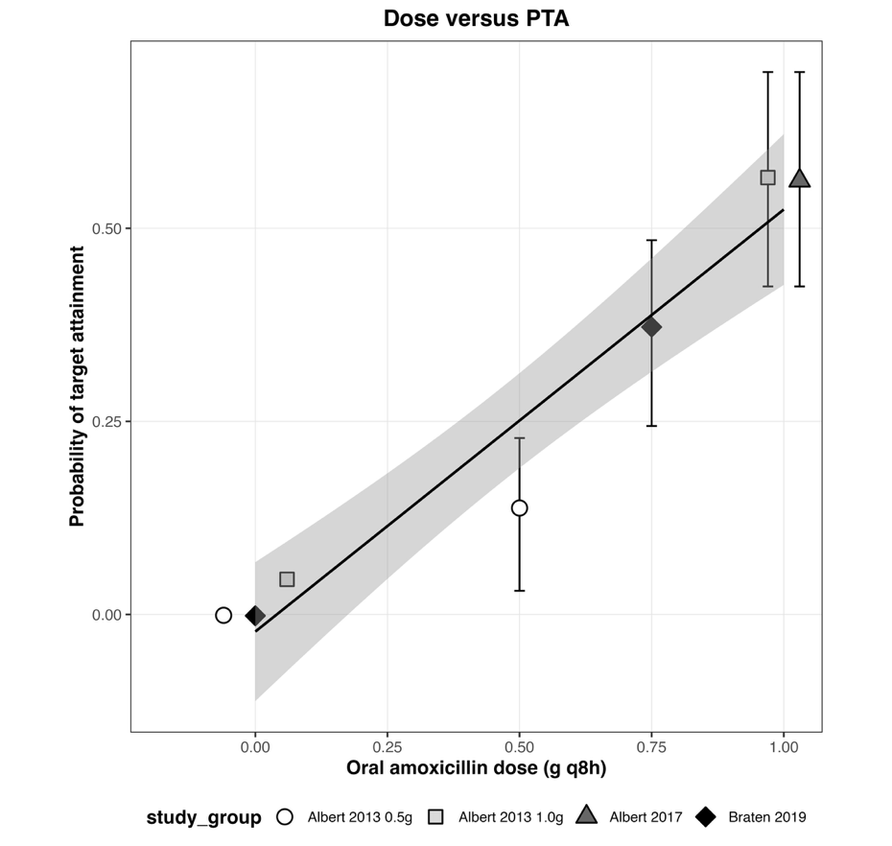
Supplementary Figure S3. Relationship between nominal oral dose and modelled intradiscal PTA in oral amoxicillin-based regimens.
Each point represents an oral study arm or oral exposure level. The fitted line shows the linear association between administered dose and modelled intradiscal PTA.

Plasma concentration sensitivity analysis
A sensitivity analysis was performed in which individual plasma concentration-time profiles were increased uniformly by 10% before estimation of intradiscal free amoxicillin concentrations. The 10% increase brought the predicted 500 mg q8h C_{max} to 100% of the product label concentration.[8] This demonstrated proportional increases in plasma PK metrics and corresponding upward shifts in estimated intradiscal free amoxicillin concentrations. At MIC₉₀ the 500 mg q8h regimen, mean time above MIC increased from 141.0 to 151.2 min and PTA increased from 0.1295 to 0.1748. For the 750 mg q8h regimen at MIC₉₀ mean time above MIC increased from 183.5 to 193.3 min and PTA increased from 0.3643 to 0.4299. For the 1,000 mg q8h regimen at MIC₉₀ mean time above MIC from 213.1 to 222.8 min and PTA increased from 0.5635 to 0.6215.

Penetration sensitivity analysis
Sensitivity analysis using disc penetration ratios of 5.0%, 6.5%, and 8.0% showed the expected directional effect on intradiscal exposure, with higher assumed penetration increasing PTA across regimens. While the absolute magnitude of target attainment depended on the penetration assumption, the overall regimen ordering was robust. (Supplementary Table S11). Note that with an increase in disc penetration from 6.5% to 8.0% the 1000 mg q8h regimen did not achieve PTA 0.9.
Regimen MIC₉₀ PTA | Amoxicillin disc penetration (Mean)
 | 5.0% | 6.5% | 8.0%
500 mg q8h | 4.46 | 12.95 | 23.74
750 mg q8h | 20.08 | 36.43 | 50.77
1000 mg q8h | 38.31 | 56.35 | 68.38
500 mg q12h | 0.10 | 0.67 | 1.82
750 mg q12h | 1.37 | 4.40 | 8.80
1000 mg q12h | 4.8 | 11.05 | 18.16
Supplementary Table S11. Sensitivity analysis of predicted intradiscal amoxicillin target attainment across disc penetration assumptions. Predicted intradiscal target attainment is shown for disc penetration ratios of 5.0%, 6.5% (base case), and 8.0%. Free intradiscal concentrations were derived from simulated plasma concentrations using the assumed penetration ratio and free fraction, and PTA was defined as the proportion of simulated subjects achieving 40% fT>MIC in disc free concentrations. For each regimen the table reports the mean PTA (%).

Amoxicillin model limitations
The disc:plasma scaling assumption underlying the oral PTA estimates is a fixed scalar rather than a tissue-compartment model, as discussed in the PTA methods section above; this limits absolute PTA interpretation but not cross-regimen ranking.

Amoxicillin modelling summary
A first-order transit absorption population PK model provided a suitable and internally coherent basis for PTA analysis of oral amoxicillin regimens. When translated to free intradiscal exposure using a base-case disc ratio of 6.5% and free fraction of 0.8, PTA increased with dose and was consistently higher for q8h than for q12h regimens. Under these assumptions, 1000 mg q8h was the best-performing regimen, achieving 0.8780 PTA at MIC₅₀ (0.06 mg.L⁻¹) and 0.5635 PTA at MIC₉₀ (0.12 mg.L⁻¹), while all q12h regimens performed substantially worse. Sensitivity analysis confirmed that although absolute PTA values were penetration-dependent, the superiority of q8h dosing and the dose-ordering of regimen performance were robust.

Exploratory intradiscal linezolid pharmacokinetic and target attainment modelling
An exploratory plasma-constrained model, informed by the IV/Oral PK/PD model developed by Boak et al., (2014) was developed to estimate intradiscal free-linezolid exposure and to assess whether sustained antibacterial exposure plausibly persisted to the planned repeat dose at approximately 96 h.[10]

Linezolid pharmacokinetic modelling
Plasma pharmacokinetic data following intradiscal administration of linezolid were analysed using a one-compartment systemic disposition model with first-order elimination and biexponential input representing depot-mediated release from the intradiscal formulation. The input rate was defined as:
$$input\left(t\right)=A_{fast}e^{-k_{fast}t}+A_{slow}e^{-k_{slow}t}$$
where A_{fast} and A_{slow} represent the amplitudes of the rapid and sustained release rate components, respectively, and k_{fast} and k_{slow} are the corresponding first-order release rate constants. Plasma concentration was described as:
$$\frac{dC}{dt}=\frac{input\left(t\right)}{V_{c}}-\frac{CL}{V_{c}}C$$
where CL is systemic clearance and V_{c} is the apparent central volume of distribution. The selected parameter set is shown in Supplementary Table S12.
Parameter | Value | Units | Description | %CV
A_{fast} | 19.2256 | mg.h⁻¹ | Fast release amplitude | 40
A_{slow} | 0.2410 | mg.h⁻¹ | Slow release amplitude | 70
k_{fast} | 0.4054 | h⁻¹ | Fast release rate constant | 30
k_{slow} | 0.01980 | h⁻¹ | Slow release rate constant | 25
CL | 5.5 | L.h-¹ | Plasma clearance | -
V_{c} | 32 | L | Apparent central volume | -
Supplementary Table S12: Intradiscal linezolid model parameters and coefficients of variance
The volume of the central compartment of 32 L may seem lower than literature values[10] but this reflects the high proportion of female trial participants (72.5%) in the PP353 clinical trial which provided the observed plasma linezolid concentrations.[5] This may affect the generalisability of the model to other patient populations. This model was selected because it reproduced the late plasma profile closely, including the 96 h concentration, while retaining a biologically plausible sustained-release tail.

Population simulation
A virtual population of 10,000 subjects was generated using log-normal interindividual variability around the typical parameter values. Coefficients of variation were specified as in Supplementary Table S12. No interindividual variability was applied to CL or V_{c} in the simulation framework.

Plasma pharmacokinetics
Plasma pharmacokinetics following intradiscal administration of linezolid were described adequately by a one-compartment systemic model with biexponential depot input representing a rapid release phase followed by a sustained low-level release phase. The selected base model reproduced the observed plasma profile closely, particularly at the late time point most relevant to the sustained-release hypothesis (Supplementary Table S13; Supplementary Figure S4).

Metric | Predicted | Observed | % difference  Predicted - Observed
C_{max} mg.L⁻¹ | 0.8078 | 0.7163 | +11.3
T_{max} h | 3.75 | 4.00 | +6.7
Plasma 96h mg.L⁻¹ | 0.007401 | 0.007412 | -0.15
Model RMSE | 0.0616 | - | -
Supplementary Table S13. Comparison of predicted and observed linezolid plasma profiles after administration of intradiscal linezolid (0.15g linezolid).
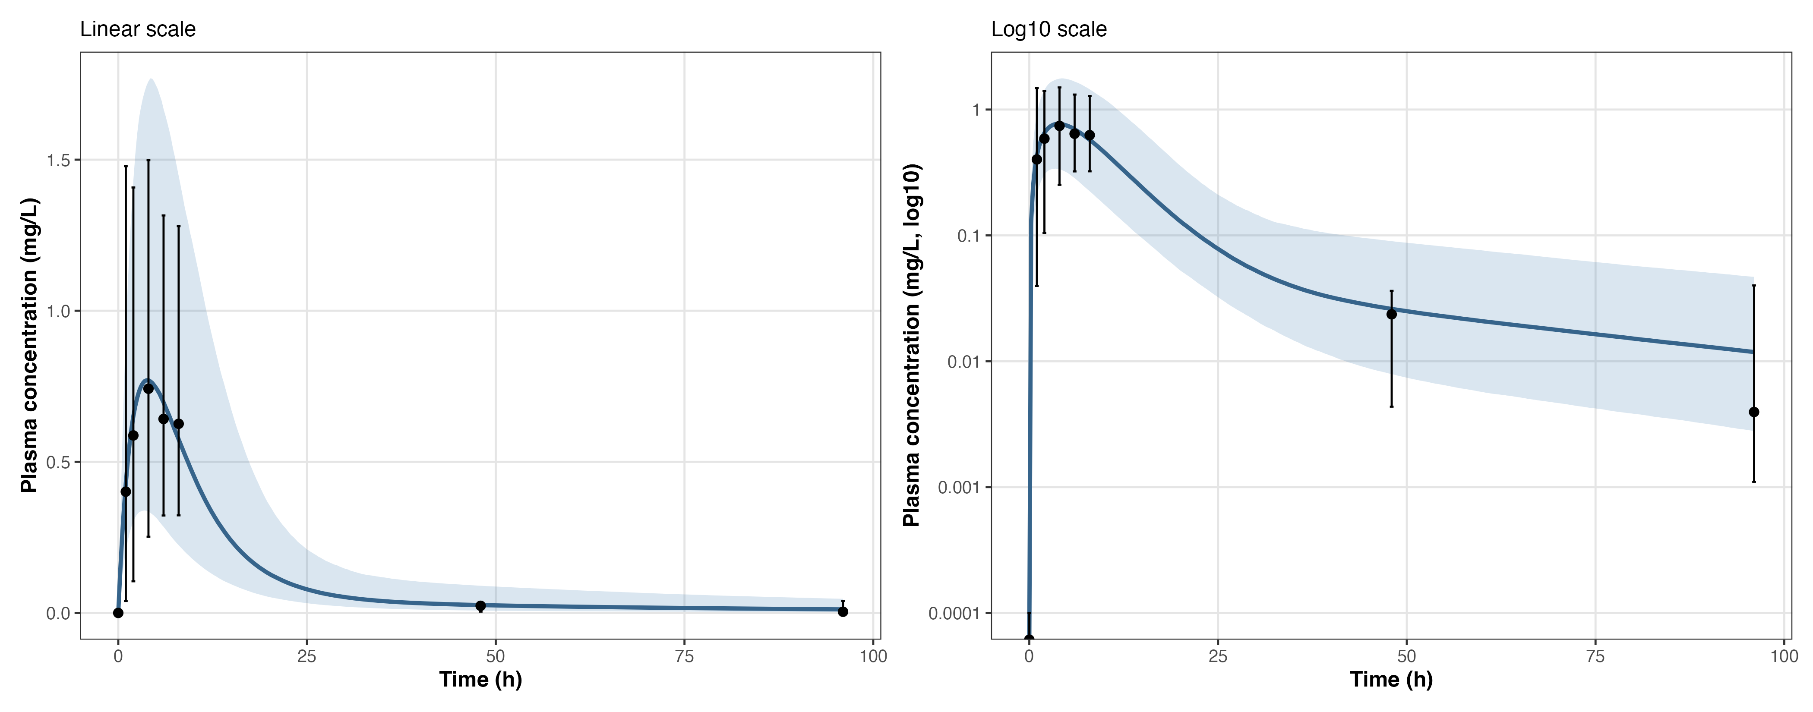Supplementary Figure S4: Observed and simulated plasma concentration-time profile following intradiscal linezolid (0.15 g) administration. Left-hand panel show linear and the right-hand panel log₁₀ scale plasma concentration. The solid blue line shows the simulated median plasma concentration-time profile across the virtual population, and the shaded ribbon shows the corresponding 2.5th-97.5th percentile interval. Black points show the observed median plasma concentrations, and vertical error bars show the observed 2.5th-97.5th percentile interval at each sampling time. Concentrations are expressed in mg.L⁻¹and time in hours after intradiscal administration. Median and 2.5-97.5th percentile interval shown on log10 axis, interval asymmetry reflects the skeweed concentration distribution. The figure provides a visual comparison of observed and model-predicted systemic exposure over 96 hours and supports use of the final plasma release model as the basis for estimating surrogate intradiscal exposure, interval-specific fAUC/MIC, and probability of target attainment (PTA).

Mass balance assessment
The cumulative amount of parent linezolid entering the systemic circulation was estimated by integrating the depot input function over time (Supplementary Table S14).
Interval (h) | Linezolid entering plasma (mg)
0-24 | 52.02
24-48 | 2.86
48-72 | 1.78
72-96 | 1.11
Total 0-96 | 57.77
Supplementary Table S14: Estimated amount of linezolid released from the disc to account for observed plasma linezolid concentration over time.
Using the selected parameter set, the model implied that approximately 57.8 mg of parent linezolid entered the systemic circulation by 96 h from the administered 150 mg intradiscal dose. Consequently, about 92.2 mg of administered parent drug was not systemically recovered by 96 h within the model framework. This amount was conservatively interpreted as non-systemically recovered parent drug and may reflect delayed release, local partitioning, non-systemic distribution, or metabolism before or during systemic appearance, rather than exclusively active drug retained within the disc.

Estimation of human nucleus pulposus volume
Measurements of the volume of the human nucleus pulposus were not directly available in literature, so the volume was estimated from the reported morphological features assuming that the nucleus pulposus approximated a flat cylinder in shape.[11, 12] O’Connell et al., reported morphometric data for three non-degenerated human L4/L5 discs, including mean disc area of 1727 mm² (SD 549 mm²) and a nucleus pulposus-to-whole-disc area ratio of 30%. Mean human disc height was 8.93 mm (SD 0.13 mm), and the nucleus pulposus height was estimated to be approximately 70% of total disc height. Together, these values yielded an estimated nucleus pulposus volume of 3.2 mL. Zhong et al., provided morphological estimates of average L4/L5 and L5/S1 nucleus pulposus dimensions from 41 Chinese subjects, with a mean length of 20 mm and height of 8 mm, providing an estimated nucleus pulposus volume of 2.5 mL.
For the base-case PTA calculations, the larger and therefore more conservative estimate of 3.2 mL was used for concentration calculations. The smaller volume estimates were retained for sensitivity analyses. Linezolid is assumed to be homogeneously dispersed throughout disc tissue.

Local nucleus pulposus exposure surrogate and PTA
Because direct intradiscal linezolid concentrations were not measured, local antibacterial exposure was represented using a release-derived local exposure surrogate rather than a direct tissue concentration estimate. The interval - was defined as:
$$E_{local}\left(t\right)=\frac{release\left(t\right)⋅f_{u}}{V_{disc}}$$
where release (t) is the estimated time-varying depot release rate, f_{u} (0.8) is the assumed unbound fraction, and V_{disc} (0.0032 L) is the nominal nucleus pulposus volume.[11] Sensitivity analyses explored lower free fraction (0.6) and lower disc volumes, 0.0025 L and 0.0027 L.[12]
For each subject, 24 h surrogate free exposure was calculated for the intervals 0-24 h, 24-48 h, 48-72 h, and 72-96 h. Interval-specific PK/PD target attainment was expressed as:
$$\frac{fAUC_{24}}{MIC}$$
Using MIC values of MIC₅₀ 0.5 and MIC₉₀ 1 mg.L⁻¹.[13–18]
There is a range of linezolid probability of target attainment metrics in literature from >50, ≥80 to ≥100 with higher metrics associated with critically ill patients with life-threatening bacterial infection. For this indication, and aligned with target selection for amoxicillin, a high target of ≥80 was selected. PTA was defined as:
$$PTA=P\left(\frac{fAUC_{24}}{MIC}≥80\right)$$
The 72-96 h interval was considered the most clinically relevant interval for evaluating whether pharmacologically meaningful exposure plausibly persisted up to the planned repeat dosing time at 96 h (Supplementary Table S15).
Interval | MIC₅₀ PTA±SD  (95% CI) | MIC₉₀ PTA±SD  (95% CI)
0-24h | 1.0000±0.0000  (1.0000 to 1.0000) | 1.0000±0.0000  (1.0000 to 1.0000)
24-48h | 1.0000±0.0000  (1.0000 to 1.0000) | 0.9994±0.0245  (0.9989 to 0.9999)
48-72h | 0.9989±0.0331  (0.9983 to 0.9995) | 0.9855±0.1195  (0.9832 to 0.9878)
72-96h | 0.9887±0.1057  (0.9866 to 0.9908) | 0.9214±0.2691  (0.9161 to 0.9267)
Supplementary Table S15. Estimated linezolid intradiscal target attainment across 24-hour intervals after intradiscal administration: Probability of target attainment (PTA) was defined as the proportion of 10,000 virtual subjects achieving a surrogate intradiscal free-drug exposure target of 24-hour fAUC/MIC ≥ 80 within each interval (0-24, 24-48, 48-72, and 72-96 h). Local free linezolid exposure was estimated from the model-derived release rate divided by assumed disc volume and multiplied by the assumed free fraction. Results are shown for MIC₅₀ 0.5 mg.L⁻¹ and MIC₉₀ 1.0 mg.L⁻¹. Mean, SD and 95% CI are provided. Under the base-case assumptions, PTA remained near-complete through 48 h and then declined modestly over time, with a greater reduction at MIC₉₀ than at MIC₅₀, consistent with progressive decline in intradiscal exposure over successive intervals.
Note that for all intervals and MICs intradiscal linezolid achieved population PTA >0.9, even in the final post-dosing interval immediately preceding the planned repeat dose.

Intradiscal linezolid PTA sensitivity analyses
Sensitivity analyses examined the effect of varying assumed nucleus pulposus volume and unbound fraction on the 72-96 h interval (Supplementary Table S16).
V_{disc} (L) | f_{u} | MIC₅₀ PTA | MIC₉₀ PTA
0.0025 | 0.6 | 0.9836 | 0.9033
0.0025 | 0.8 | 0.9948 | 0.9508
0.0027 | 0.6 | 0.9798 | 0.8877
0.0027 | 0.8 | 0.9921 | 0.9442
0.0032 | 0.6 | 0.9689 | 0.8396
0.0032 | 0.8 | 0.9868 | 0.9169
Supplementary Table S16. Sensitivity analysis of predicted probability of linezolid intradiscal target attainment during the 72-96h post-dosing interval varying nucleus pulposus volume (V_{disc}), free-fraction (f_{u}) and MICs.
Sensitivity analyses in Supplementary Table S16 were generated from a separate Monte Carlo simulation run from the same model and seed specification. Because Monte Carlo sampling introduces small run-to-run variation, the base-case MIC90 PTA in S16 (0.9169) differs slightly from the value reported in S15 (0.9214); the difference is within Monte Carlo error and does not affect the qualitative conclusion of sustained high PTA through the 72-96 h interval. These sensitivity analyses indicate that the conclusion of sustained pharmacologically plausible late exposure was preserved across a reasonable range of disc-volume and free-fraction assumptions, although attainment was quantitatively lower under more conservative assumptions.

Linezolid modelling summary
This exploratory analysis supports the interpretation that intradiscal linezolid can produce a depot-mediated release profile with an early burst phase followed by prolonged lower-level release. The selected plasma-constrained model reproduced the clinically relevant late plasma concentration at 96 h and supported the plausibility of sustained release to the planned repeat dose.
Within that framework, the main finding was that simulated target attainment remained high through the final 72-96 h interval. Under the main-case assumptions, PTA at MIC 1.0 mg.L⁻¹ remained above 0.9, while PTA at MIC 0.5 mg.L⁻¹ was near-complete. Sensitivity analyses varying disc volume and free fraction preserved the same qualitative conclusion, although absolute attainment was lower under more conservative assumptions.
The findings of the parent-drug mass-balance should be interpreted cautiously. The model required only part of the dose administered to appear in plasma as parent drug in order to reproduce the observed profile, which is compatible with delayed depot release, but does not establish that unrecovered drug remained in the disc. This analysis is therefore best viewed as contextual pharmacologic support rather than proof of local tissue exposure.
The strengths of this analysis include a close reproduction of the plasma concentration in the 72-96h interval and the ability to evaluate interval-specific antibacterial exposure under alternative assumptions. The main limitations are that the model was constrained by plasma data alone, and local exposure was represented by a release-derived surrogate rather than direct intradiscal measurement. Thus, the analysis is therefore exploratory and aims to support the plausibility of the intradiscal dose regimen rather than to establish definitive tissue pharmacokinetics.

Meta-regression analyses

Study arm-level 12-month change-from-baseline outcomes were related to antibiotic exposure using inverse-variance-weighted random-effects meta-regression, with restricted maximum likelihood used for variance estimation. The unit of analysis was the study arm. Although the randomized dose-specific groups in Albert et al. (2013) were non-overlapping and therefore sampling-independent at the arm level, arms within the same trial share protocol- and study-level characteristics that were not explicitly modelled. This is acknowledged as a limitation, as the current models do not include a multilevel random-effects structure to account for within-study arm clustering. Pseudo-R² was calculated as the proportional reduction in between-arm variance (τ²) relative to the intercept-only random-effects model. Three exposure metrics were evaluated: nominal oral dose (oral studies only), modelled intradiscal MIC₉₀ probability of target attainment (PTA), and ordinal exposure rank (1 = placebo/sham, ascending through oral dose groups to 5 = intradiscal linezolid). SDs were imputed from baseline and 12-month SDs using the standard variance formula and an assumed baseline-follow-up correlation. A value of r = 0.50 was applied across all studies in the analyses. This was supported by individual patient data which indicated r=0.55. Model fit was assessed using residual heterogeneity statistics (τ², I², and QE), the omnibus moderator test (QM), and Pseudo-R². AIC and BIC are reported. Leave-one-arm-out and leave-one-study-out sensitivity analyses were conducted by refitting the primary models after sequential removal of each arm or study. Linear regression was selected as the primary model because it consistently provided the most stable estimates and best overall fit across outcomes and sensitivity analyses. For sensitivity analyses, PTA exposure levels were converted to ordered exposure ranks, and separate models were fitted for pain and disability outcomes in both the oral-only and all-study datasets. The oral-only analyses (excluding Lassen) contained four unique PTA ranks (1-4), whereas the all-study analyses contained five ranks (1-5). Additional leave-one-arm-out and leave-one-study-out analyses were performed using these ranked-exposure models. The oral-only and all-study PTA-based slopes were compared using an approximate z-test of the difference between fitted coefficients. This comparison was descriptive and was not intended to replace a formal interaction model. Meta-regression analyses were performed in R through RStudio (2026.04.0+526). R code was written and debugged with assistance from Microsoft Copilot and ChatGPT 5.4; all analyses were designed, reviewed, and interpreted by the authors.
To confirm that the meta-regression results were not contingent on the R implementation, eight analyses, oral-only and all-studies, pain and disability vs Dose and PTA were independently re-run in JASP (v0.18.3) using the Classical Meta-Analysis module. Each analysis was specified with Hedges' g as the effect size and its standard error as the sampling variance, restricted maximum likelihood (REML) estimation, and a z-distribution for the fixed-effect test. The effect-size model term was set to the moderator of interest (PTA or Dose); the heterogeneity model term was left blank so that residual between-study variance was estimated freely. Across all eight analyses the JASP output reproduced the metafor results. Pooled effect-size estimates, residual heterogeneity statistics (Qₑ, τ², I²), omnibus moderation tests (Qₘ), and meta-regression coefficients (intercept and slope, with standard errors and 95% confidence intervals) agreed in every case. The direction, magnitude, and statistical significance of the moderator effects were identical between the two implementations: Residual heterogeneity was reduced toward zero after accounting for Dose in both pain analyses, consistent with dose accounting for the bulk of between-study variance; for the disability analyses and for PTA moderators, residual heterogeneity remained non-trivial in both implementations. No deviations from the primary metafor analyses were observed, confirming that the reported results are robust to the choice of meta-analytic software.

Supplementary oral-only studies
Dataset | k | Slope (β) [95% CI] | SE | p | τ² | I² | Pseudo-R² | QE (p) | QM (p) | AIC | BIC | ΔAIC | ΔBIC
Pain Dose | 7 | -1.85  [-2.26, -1.45] | 0.206 | < 0.001 | 0.000 | 0.0% | 100.0% | 6.21 (0.286) | 81.34  (< 0.001) | 10.20 | 9.03 | -11.13 | -11.89
Disability Dose | 7 | -5.09  [-6.30, -3.88] | 0.618 | < 0.001 | 0.095 | 14.1% | 98.3% | 6.61 (0.252) | 67.85  (< 0.001) | 19.60 | 18.43 | -12.55 | -13.31
Pain PTA | 7 | -3.25  [-4.57, -1.93] | 0.675 | < 0.001 | 0.105 | 51.8% | 88.7% | 10.35 (0.066) | 23.22  (< 0.001) | 13.81 | 12.64 | -7.52 | -8.28
Disability PTA | 7 | -8.44  [-11.49, -5.39] | 1.555 | < 0.001 | 0.509 | 46.0% | 91.1% | 9.91 (0.078) | 29.43  (< 0.001) | 22.61 | 21.44 | -9.54 | -10.30
Pain Rank | 7 | -0.62  [-0.81, -0.43] | 0.097 | < 0.001 | 0.037 | 27.6% | 96.0% | 8.34 (0.139) | 40.74  (< 0.001) | 12.30 | 11.13 | -9.03 | -9.79
Disability Rank | 7 | -1.66  [-2.06, -1.27] | 0.202 | < 0.001 | 0.089 | 13.0% | 98.4% | 7.91 (0.161) | 67.77  (< 0.001) | 21.01 | 19.84 | -11.14 | -11.90
Supplementary Table S17. Meta-regression results evaluating the association between the amoxicillin/co-amoxiclav dose or PTA and pain or disability change from baseline. k= number of study arms included in the meta-regression analysis; Beta (β): estimated meta-regression coefficient (slope), representing the change in effect size associated with a one-unit increase in the moderator; SE: standard error of the meta-regression coefficient; p: p-value associated with the Wald z-test for the moderator coefficient; 95% CI: lower and upper limits of the 95% confidence interval for the regression coefficient; τ²: residual between-study variance after inclusion of the moderator (REML estimation); I²: proportion of total variance attributable to between-study heterogeneity (0–100%); Pseudo-R²: proportion of between-study heterogeneity (τ²) explained by the moderator relative to the intercept-only (null) model; QE: Cochran's Q test statistic for residual heterogeneity after accounting for moderators (p-value in parentheses); QM: omnibus test statistic for moderator effects (p-value in parentheses); AIC: Akaike Information Criterion; BIC: Bayesian Information Criterion; ΔAIC and ΔBIC: difference between the moderator model and the null model (negative values favour the moderator model). BIC can be smaller than AIC when k ≤ 8 (log(n) < 2) — this is expected for small samples. All models fitted using restricted maximum likelihood (REML) with inverse-variance weighting. Tables S18–S39 follow the same conventions; tables marked "Leave-one-arm-out" omit one study arm at a time and refit the moderator model, while "Leave-one-study-out" omits all arms from one study at a time.
Supplementary all-studies meta-regression analyses
Dataset | k | Slope (β) [95% CI] | SE | p | τ² | I² | Pseudo-R² | QE (p) | QM (p) | AIC | BIC | ΔAIC | ΔBIC
Pain PTA All | 9 | -2.64  [-3.74, -1.54] | 0.559 | < 0.001 | 0.156 | 62.8% | 84.0% | 16.18  (0.024) | 22.32  (< 0.001) | 18.78 | 18.62 | -8.82 | -9.14
Disability PTA All | 9 | -6.73  [-9.80, -3.67] | 1.565 | < 0.001 | 1.283 | 67.5% | 79.5% | 18.49  (0.010) | 18.51  (< 0.001) | 32.63 | 32.47 | -9.83 | -10.15

Supplementary Table S18. See S17 legend.

Supplementary rank-based analysis
Since intradiscal PTA after oral amoxicillin/co-amoxiclav dose regimens have not been previously characterised, estimated ordinal rank order exposure was used to reduce emphasis on the precision of the PTA estimate (Supplementary Figure S5, Supplementary Table S19). Increasing rank was assigned to intradiscal exposure from placebo, through amoxicillin/co-amoxiclav 0.5 g, 0.75 g and 1.0 g q8h.
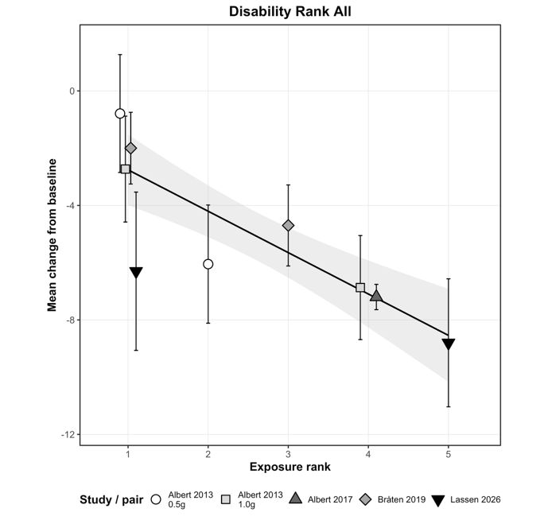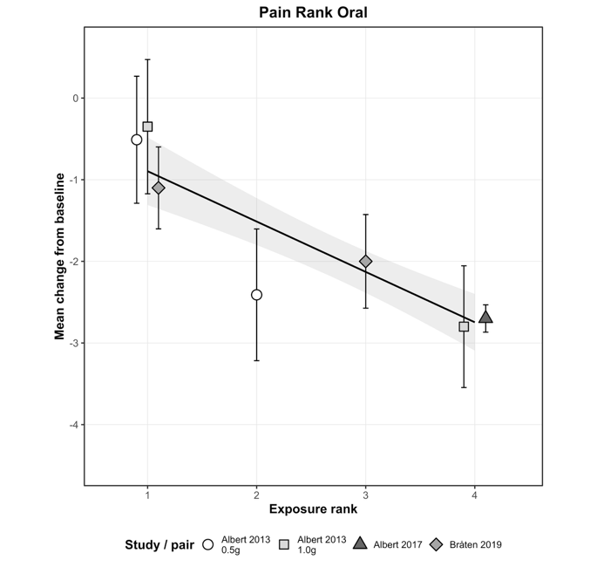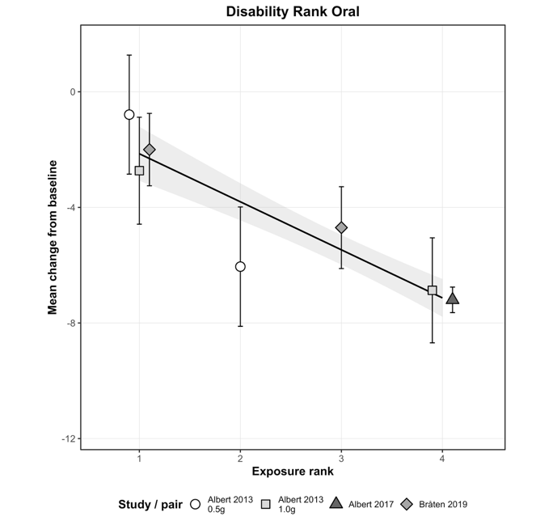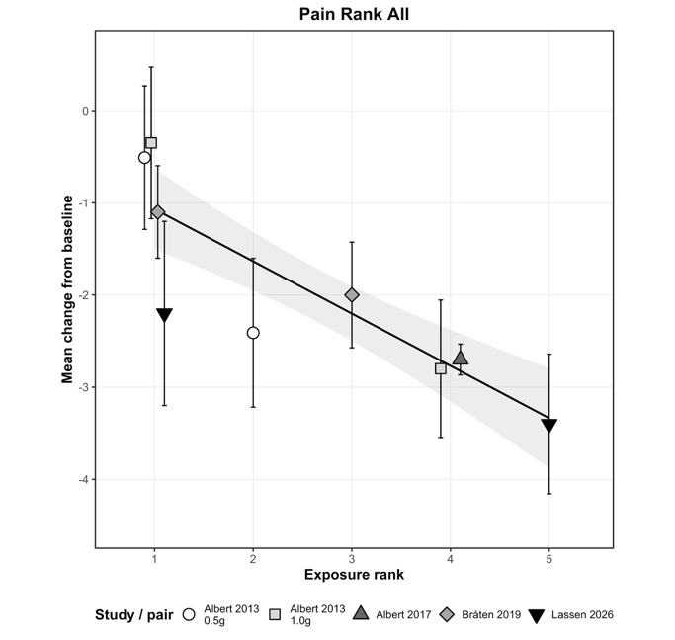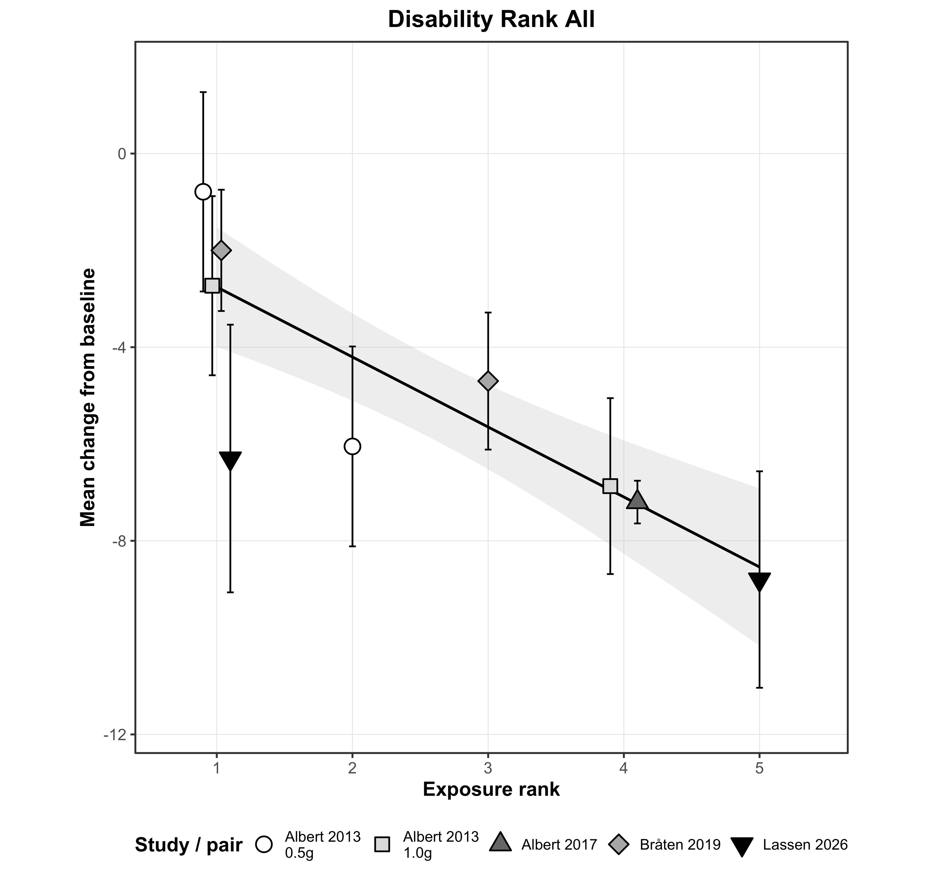
D
B
C
A
Supplementary Figure S5. Oral ranked exposure-response analyses for pain (A) and disability (B). Cross-therapy ordinal rank analysis including oral and intradiscal arms for pain (C) and disability (D).with additional Rank 5 for intradiscal linezolid. The intradiscal placebo results were assigned Rank 1. Inverse-variance weighted random-effects meta-regression results. Panels show change from baseline against ordered exposure rank. Rank 1 study placebo. Rank 2 Albert 2013 co-amoxiclav po 0.5g q8h 100d; Rank 3 Bråten 2019 amoxicillin po 0.75g q8h 90d; Rank 4 Albert 2013 & Albert 2017 co-amoxiclav po 1.0g q8h 100d. Regression line with 95% CI ribbon.

Dataset | k | Slope (β) [95% CI] | SE | p | τ² | I² | Pseudo-R² | QE (p) | QM (p) | AIC | BIC | ΔAIC | ΔBIC
Pain Rank All | 9 | -0.57  [-0.76, -0.37] | 0.100 | < 0.001 | 0.088 | 47.5% | 91.0% | 14.08 (0.050) | 31.99  (< 0.001) | 17.62 | 17.46 | -9.98 | -10.30
Pain Rank Oral | 7 | -0.62  [-0.81, -0.43] | 0.097 | < 0.001 | 0.037 | 27.6% | 96.0% | 8.34 (0.139) | 40.74  < 0.001) | 12.30 | 11.13 | -9.03 | -9.79
Disability Rank All | 9 | -1.45  [-2.02, -0.87] | 0.293 | < 0.001 | 0.899 | 58.3% | 85.6% | 15.88 (0.026) | 24.33  (< 0.001) | 31.89 | 31.72 | -10.58 | -10.90
Disability Rank Oral | 7 | -1.66  [-2.06, -1.27] | 0.202 | < 0.001 | 0.089 | 13.0% | 98.4% | 7.91 (0.161) | 67.77  (< 0.001) | 21.01 | 19.84 | -11.14 | -11.90
Supplementary Table S19: See S17 legend.

Supplementary leave one out analyses

This present analysis included relatively few studies and arms. To test the sensitivity of the headline results to study and arm selection, both leave-one-arm-out and leave-one-study-out analyses were performed for both pain and disability outcomes using PTA as the exposure metric (Supplementary Tables S20 to S34). The section is split into oral-only studies first and then all-studies. Each outcome by metric is presented with leave-one-arm-out followed by leave-one-study-out analyses.

Oral-only studies
Dataset | Omitted arm | k | Slope (β)  [95% CI] | SE | p | τ² | I² | Pseudo-R² | QE (p) | QM (p) | AIC | BIC | ΔAIC | ΔBIC
Pain Dose | Albert 2013  0.5g placebo | 6 | -1.76  [-2.21, -1.31] | 0.228 | < 0.001 | 0.000 | 0.0% | 100.0% | 5.28 (0.260) | 59.36  (< 0.001) | 9.40 | 7.56 | -8.42 | -9.48
Pain Dose | Albert 2013 1g placebo | 6 | -1.73  [-2.17, -1.29] | 0.225 | < 0.001 | 0.000 | 0.0% | 100.0% | 4.46 (0.348) | 59.02  (< 0.001) | 8.50 | 6.66 | -8.85 | -9.91
Pain Dose | Braten 2019 | 6 | -2.13  [-2.69, -1.57] | 0.284 | < 0.001 | 0.000 | 0.0% | 100.0% | 4.22 (0.376) | 56.22  (< 0.001) | 8.74 | 6.89 | -10.28 | -11.34
Pain Dose | Albert 2013 0.5g | 6 | -1.91  [-2.32, -1.50] | 0.208 | < 0.001 | 0.000 | 0.0% | 100.0% | 3.70 (0.448) | 83.85  (< 0.001) | 7.72 | 5.88 | -11.16 | -12.22
Pain Dose | Braten 2019 | 6 | -1.92  [-2.48, -1.37] | 0.284 | < 0.001 | 0.031 | 22.4% | 97.2% | 5.50 (0.240) | 45.92  (< 0.001) | 10.15 | 8.31 | -9.16 | -10.22
Pain Dose | Albert 2013 1g | 6 | -1.89  [-2.48, -1.29] | 0.305 | < 0.001 | 0.037 | 27.5% | 95.8% | 6.15 (0.188) | 38.30  (< 0.001) | 10.50 | 8.66 | -7.65 | -8.71
Pain Dose | Albert 2017 | 6 | -1.98  -2.86, -1.11] | 0.444 | < 0.001 | 0.068 | 35.2% | 92.2% | 6.20 (0.185) | 19.94  (< 0.001) | 10.92 | 9.08 | -7.39 | -8.45

Supplementary Table S20. Pain vs Dose: Leave-one-arm-out. See S17 legend.

Dataset | Omitted study | k | Slope (β) [95% CI] | SE | p | τ² | I² | Pseudo-R² | QE (p) | QM (p) | AIC | BIC | ΔAIC | ΔBIC
Pain Dose | Braten 2019 | 5 | -2.14  [-2.79, -1.50] | 0.329 | < 0.001 | 0.018 | 13.5% | 98.7% | 3.82  (0.281) | 42.46  (< 0.001) | 9.07 | 6.36 | -7.84 | -9.32
Pain Dose | Albert 2017 | 6 | -1.98  [-2.86, -1.11] | 0.444 | < 0.001 | 0.068 | 35.2% | 92.2% | 6.20  (0.185) | 19.94  (< 0.001) | 10.92 | 9.08 | -7.39 | -8.45

Supplementary Table S21 Pain vs Dose: Leave-one-study-out. See S17 legend.

Dataset | Omitted arm | k | Slope (β)  [95% CI] | SE | p | τ² | I² | Pseudo-R² | QE  (p) | QM  (p) | AIC | BIC | ΔAIC | ΔBIC
Pain PTA | Albert 2013  0.5g placebo | 6 | -2.99  [-4.44, -1.53] | 0.742 | < 0.001 | 0.110 | 54.6% | 86.3% | 8.70 (0.069) | 16.19  (< 0.001) | 12.45 | 10.61 | -5.38 | -6.44
Pain PTA | Albert 2013 1g placebo | 6 | -2.90  [-4.11, -1.69] | 0.619 | < 0.001 | 0.061 | 40.2% | 91.7% | 7.73 (0.102) | 21.96  (< 0.001) | 11.69 | 9.85 | -5.66 | -6.72
Pain PTA | Braten 2019 | 6 | -3.47  [-5.27, -1.68] | 0.916 | < 0.001 | 0.182 | 64.4% | 82.6% | 9.83 (0.043) | 14.40  (< 0.001) | 13.22 | 11.38 | -5.80 | -6.86
Pain PTA | Albert 2013 0.5g | 6 | -3.37  [-4.09, -2.65] | 0.367 | < 0.001 | 0.000 | 0.0% | 100.0% | 3.13 (0.536) | 84.41  (< 0.001) | 7.21 | 5.37 | -11.67 | -12.73
Pain PTA | Braten 2019 | 6 | -3.34  [-5.01, -1.66] | 0.855 | < 0.001 | 0.201 | 64.4% | 82.1% | 10.24 (0.037) | 15.26  (< 0.001) | 13.36 | 11.52 | -5.95 | -7.01
Pain PTA | Albert 2013 1g | 6 | -3.29  [-5.15, -1.42] | 0.950 | < 0.001 | 0.201 | 65.9% | 77.3% | 10.29 (0.036) | 11.95  (< 0.001) | 13.38 | 11.54 | -4.77 | -5.83
Pain PTA | Albert 2017 | 6 | -3.49  [-5.65, -1.33] | 1.102 | 0.002 | 0.211 | 63.1% | 75.7% | 10.18 (0.037) | 10.01  (0.002) | 13.45 | 11.61 | -4.86 | -5.92

Supplementary Table S22. Pain vs PTA: Leave-one-arm-out. See S17 legend.

Dataset | Omitted study | k | Slope (β)  [95% CI] | SE | p | τ² | I² | Pseudo-R² | QE (p) | QM (p) | AIC | BIC | ΔAIC | ΔBIC
Pain PTA | Braten 2019 | 5 | -3.53  [-5.77, -1.29] | 1.144 | 0.002 | 0.332 | 73.7% | 75.2% | 9.79  (0.020) | 9.52  (0.002) | 12.44 | 9.74 | -4.47 | -5.95
Pain PTA | Albert 2017 | 6 | -3.49  [-5.65, -1.33] | 1.102 | 0.002 | 0.211 | 63.1% | 75.7% | 10.18  (0.037) | 10.01  (0.002) | 13.45 | 11.61 | -4.86 | -5.92

Supplementary Table S23. Pain vs PTA: Leave-one-study-out. See S17 legend.

Dataset | Omitted arm | k | Slope (β) [95% CI] | SE | p | τ² | I² | Pseudo-R² | QE (p) | QM (p) | AIC | BIC | ΔAIC | ΔBIC
Disability Dose | Albert 2013  0.5g placebo | 6 | -4.75  [-6.11, -3.39] | 0.694 | < 0.001 | 0.119 | 18.3% | 97.3% | 5.06 (0.281) | 46.79  (< 0.001) | 16.24 | 14.40 | -9.84 | -10.90
Disability Dose | Albert 2013 1g placebo | 6 | -5.34  [-6.75, -3.92] | 0.721 | < 0.001 | 0.132 | 19.5% | 97.9% | 5.75 (0.218) | 54.70  (< 0.001) | 17.10 | 15.26 | -10.84 | -11.90
Disability Dose | Braten 2019 | 6 | -5.02  [-6.88, -3.16] | 0.950 | < 0.001 | 0.313 | 35.0% | 94.3% | 6.60 (0.159) | 27.93  (< 0.001) | 18.03 | 16.18 | -9.38 | -10.44
Disability Dose | Albert 2013 0.5g | 6 | -5.18  [-6.40, -3.96] | 0.622 | < 0.001 | 0.096 | 15.4% | 98.5% | 4.46 (0.347) | 69.33  (< 0.001) | 15.58 | 13.74 | -12.32 | -13.38
Disability Dose | Braten 2019 | 6 | -5.13  [-6.14, -4.12] | 0.515 | < 0.001 | 0.000 | 0.0% | 100.0% | 3.91 (0.418) | 99.51  (< 0.001) | 15.94 | 14.10 | -12.43 | -13.49
Dataset | Albert 2013 1g | 6 | -5.06  [-6.65, -3.46] | 0.814 | < 0.001 | 0.305 | 33.4% | 94.6% | 6.52 (0.164) | 38.56  (< 0.001) | 17.97 | 16.13 | -9.37 | -10.43
Disability Dose | Albert 2017 | 6 | -4.65  [-6.64, -2.66] | 1.014 | < 0.001 | 0.263 | 25.5% | 94.5% | 5.84 (0.211) | 21.03  (< 0.001) | 18.13 | 16.29 | -8.71 | -9.77

Supplementary Table S24: Disability vs Dose: Leave-one-arm-out. See S17 legend

Dataset | Omitted study | k | Slope (β) [95% CI] | SE | p | τ² | I² | Pseudo-R² | QE (p) | QM (p) | AIC | BIC | ΔAIC | ΔBIC
Disability Dose | Braten 2019 | 5 | -5.05  [-6.43, -3.66] | 0.708 | < 0.001 | 0.000 | 0.0% | 100.0% | 3.88  (0.275) | 50.79  (< 0.001) | 14.60 | 11.90 | -9.05 | -10.52
Disability Dose | Albert 2017 | 6 | -4.65  [-6.64, -2.66] | 1.014 | < 0.001 | 0.263 | 25.5% | 94.5% | 5.84  (0.211) | 21.03  (< 0.001) | 18.13 | 16.29 | -8.71 | -9.77

Supplemental Table S25: Disability vs Dose: Leave-one-study-out. See S17 legend.

Dataset | Omitted arm | k | Slope (β)  [95% CI] | SE | p | τ² | I² | Pseudo-R² | QE (p) | QM (p) | AIC | BIC | ΔAIC | ΔBIC
Disability PTA | Albert 2013  0.5g placebo | 6 | -7.65  [-10.78, -4.53] | 1.595 | < 0.001 | 0.433 | 44.1% | 90.0% | 7.60 (0.108) | 23.02  (< 0.001) | 18.50 | 16.66 | -7.57 | -8.63
Disability PTA | Albert 2013 1g placebo | 6 | -8.65  [-12.63, -4.66] | 2.033 | < 0.001 | 0.909 | 61.7% | 85.6% | 9.57 (0.048) | 18.10  (< 0.001) | 20.21 | 18.37 | -7.72 | -8.78
Disability PTA | Braten 2019 | 6 | -8.00  [-12.30, -3.70] | 2.194 | < 0.001 | 1.014 | 62.3% | 81.6% | 9.64 (0.047) | 13.30  (< 0.001) | 20.35 | 18.51 | -7.06 | -8.12
Disability PTA | Albert 2013 0.5g | 6 | -9.40  [-11.20, -7.60] | 0.917 | < 0.001 | 0.000 | 0.0% | 100.0% | 2.72 (0.606) | 104.98  (< 0.001) | 13.99 | 12.14 | -13.92 | -14.98
Disability PTA | Braten 2019 | 6 | -8.59  [-12.24, -4.94] | 1.863 | < 0.001 | 0.864 | 56.1% | 87.6% | 8.82 (0.066) | 21.27  (< 0.001) | 20.12 | 18.28 | -8.25 | -9.31
Disability PTA | Albert 2013 1g | 6 | -8.55  [-12.93, -4.17] | 2.236 | < 0.001 | 1.082 | 62.9% | 80.9% | 9.80 (0.044) | 14.62  (< 0.001) | 20.44 | 18.60 | -6.89 | -7.95
Disability PTA | Albert 2017 | 6 | -8.08  [-13.24, -2.92] | 2.633 | 0.002 | 1.169 | 60.7% | 75.3% | 9.64 (0.047) | 9.43  (0.002) | 20.59 | 18.75 | -6.25 | -7.31
Supplementary Table S26. Disability vs PTA: Leave-one-arm-out. See S17 legend.

Dataset | Omitted study | k | Slope (β)  [95% CI] | SE | p | τ² | I² | Pseudo-R² | QE (p) | QM (p) | AIC | BIC | ΔAIC | ΔBIC
Disability PTA | Braten 2019 | 5 | -8.17  [-13.23, -3.11] | 2.582 | 0.002 | 1.600 | 68.9% | 77.6% | 8.26 (0.041) | 10.01  (0.002) | 17.54 | 14.83 | -6.11 | -7.59
Disability PTA | Albert 2017 | 6 | -8.08  [-13.24, -2.92] | 2.633 | 0.002 | 1.169 | 60.7% | 75.3% | 9.64 (0.047) | 9.43  0.002) | 20.59 | 18.75 | -6.25 | -7.31

Supplementary Table S27. Disability vs PTA: Leave-one-study-out. See S17 legend.

Dataset | Omitted arm | k | Slope (β) [95% CI] | SE | p | τ² | I² | Pseudo-R² | QE (p) | QM (p) | AIC | BIC | ΔAIC | ΔBIC
Pain Rank | Albert 2013  0.5g placebo | 6 | -0.57  [-0.74, -0.39] | 0.090 | < 0.001 | 0.016 | 14.7% | 98.1% | 7.00 (0.136) | 40.11  (< 0.001) | 11.17 | 9.33 | -6.65 | -7.71
Pain Rank | Albert 2013 1g placebo | 6 | -0.55  [-0.70, -0.41] | 0.073 | < 0.001 | 0.000 | 0.0% | 100.0% | 6.09 (0.193) | 57.38  (< 0.001) | 10.18 | 8.34 | -7.17 | -8.23
Pain Rank | Braten 2019 | 6 | -0.68  [-0.94, -0.42] | 0.134 | < 0.001 | 0.069 | 41.1% | 93.3% | 7.36 (0.118) | 25.83  (< 0.001) | 11.75 | 9.90 | -7.27 | -8.33
Pain Rank | Albert 2013 0.5g | 6 | -0.63  [-0.77, -0.50] | 0.069 | < 0.001 | 0.000 | 0.0% | 100.0% | 3.18 (0.529) | 84.37  (< 0.001) | 7.24 | 5.40 | -11.64 | -12.70
Pain Rank | Braten 2019 | 6 | -0.64  [-0.91, -0.38] | 0.134 | < 0.001 | 0.116 | 51.1% | 89.7% | 8.18 (0.085) | 23.14  (< 0.001) | 12.19 | 10.35 | -7.12 | -8.18
Pain Rank | Albert 2013 1g | 6 | -0.63  [-0.92, -0.35] | 0.144 | < 0.001 | 0.114 | 52.6% | 87.1% | 8.28 (0.082) | 19.20  (< 0.001) | 12.23 | 10.39 | -5.92 | -6.98
Pain Rank | Albert 2017 | 6 | -0.68  [-1.03, -0.33] | 0.179 | < 0.001 | 0.128 | 50.8% | 85.3% | 8.14 (0.087) | 14.33  (< 0.001) | 12.34 | 10.50 | -5.97 | -7.03

Supplementary Table S28. Pain vs Rank: Leave-one-arm-out. See S17 legend.

Dataset | Omitted study | k | Slope (β)  [95% CI] | SE | p | τ² | I² | Pseudo-R² | QE (p) | QM (p) | AIC | BIC | ΔAIC | ΔBIC
Pain Rank | Braten 2019 | 5 | -0.70  [-1.05, -0.35] | 0.179 | < 0.001 | 0.190 | 61.8% | 85.8% | 7.32 (0.062) | 15.21  (< 0.001) | 11.41 | 8.71 | -5.50 | -6.98
Pain Rank | Albert 2017 | 6 | -0.68  [-1.03, -0.33] | 0.179 | < 0.001 | 0.128 | 50.8% | 85.3% | 8.14 (0.087) | 14.33  (< 0.001) | 12.34 | 10.50 | -5.97 | -7.03

Supplementary Table S29. Pain vs Rank: Leave-one-study-out. See S17 legend.

Dataset | Omitted arm | k | Slope (β)  [95% CI] | SE | p | τ² | I² | Pseudo-R² | QE (p) | QM (p) | AIC | BIC | ΔAIC | ΔBIC
Disability Rank | Albert 2013 | 6 | -1.54  [-1.99, -1.10] | 0.226 | < 0.001 | 0.114 | 17.3% | 97.4% | 5.94 (0.204) | 46.53  (< 0.001) | 17.22 | 15.38 | -8.86 | -9.92
Disability Rank | Albert 2013 | 6 | -1.71  [-2.25, -1.18] | 0.274 | < 0.001 | 0.271 | 32.6% | 95.7% | 7.39 (0.117) | 39.18  (< 0.001) | 18.77 | 16.93 | -9.16 | -10.22
Disability Rank | Braten 2019 | 6 | -1.59  [-2.28, -0.91] | 0.350 | < 0.001 | 0.532 | 46.7% | 90.3% | 7.84 (0.098) | 20.72  (< 0.001) | 19.26 | 17.42 | -8.14 | -9.20
Disability Rank | Albert 2013 | 6 | -1.77  [-2.10, -1.43] | 0.173 | < 0.001 | 0.000 | 0.0% | 100.0% | 2.98 (0.562) | 104.73  (< 0.001) | 14.23 | 12.39 | -13.67 | -14.73
Disability Rank | Braten 2019 | 6 | -1.67  [-2.12, -1.22] | 0.230 | < 0.001 | 0.185 | 21.5% | 97.3% | 6.63 (0.157) | 52.54  (< 0.001) | 18.65 | 16.81 | -9.72 | -10.78
Disability Rank | Albert 2013 | 6 | -1.66  [-2.31, -1.02] | 0.328 | < 0.001 | 0.545 | 46.3% | 90.4% | 7.80 (0.099) | 25.79  (< 0.001) | 19.27 | 17.42 | -8.07 | -9.13
Disability Rank | Albert 2017 | 6 | -1.58  [-2.40, -0.75] | 0.420 | < 0.001 | 0.652 | 46.2% | 86.2% | 7.67 (0.105) | 14.11  (< 0.001) | 19.50 | 17.66 | -7.34 | -8.40

Supplementary Table S30. Disability vs Rank: Leave-one-arm-out. See S17 legend.

Dataset | Omitted study | k | Slope (β)  [95% CI] | SE | p | τ² | I² | Pseudo-R² | QE (p) | QM (p) | AIC | BIC | ΔAIC | ΔBIC
Disability Rank | Braten 2019 | 5 | -1.62  [-2.40, -0.83] | 0.402 | < 0.001 | 0.864 | 54.7% | 87.9% | 6.37 (0.095) | 16.16  (< 0.001) | 16.62 | 13.92 | -7.03 | -8.50
Disability Rank | Albert 2017 | 6 | -1.58  [-2.40, -0.75] | 0.420 | < 0.001 | 0.652 | 46.2% | 86.2% | 7.67 (0.105) | 14.11  (< 0.001) | 19.50 | 17.66 | -7.34 | -8.40

Supplementary Table S31. Disability vs Rank: Leave-one-study-out. See S17 legend.

All studies.
Note leaving the Lassen 2026 study out is the same as oral-only and has been omitted

Dataset | Omitted arm | k | Slope (β)  [95% CI] | SE | p | τ² | I² | Pseudo-R² | QE (p) | QM (p) | AIC | BIC | ΔAIC | ΔBIC
Pain PTA All | Bråten 2019 Placebo | 8 | -2.63  [-3.89, -1.38] | 0.640 | < 0.001 | 0.240 | 70.8% | 79.0% | 15.94 (0.014) | 16.96  (< 0.001) | 18.13 | 17.51 | -7.49 | -8.01
Pain PTA All | Albert 2013 0.5g | 8 | -2.95  [-3.58, -2.32] | 0.322 | < 0.001 | 0.000 | 0.0% | 100.0% | 10.66 (0.100) | 83.82  (< 0.001) | 14.38 | 13.76 | -11.00 | -11.52
Pain PTA All | Albert 2013 1.0g | 8 | -2.58  [-3.86, -1.30] | 0.654 | < 0.001 | 0.227 | 70.8% | 77.8% | 16.08 (0.013) | 15.55  (< 0.001) | 17.99 | 17.37 | -6.92 | -7.44
Pain PTA All | Albert 2017 | 8 | -2.59  [-3.98, -1.21] | 0.705 | < 0.001 | 0.262 | 66.3% | 74.8% | 16.02 (0.014) | 13.5  (< 0.001) | 18.36 | 17.73 | -6.74 | -7.25
Pain PTA All | Lassen 2026 placebo | 8 | -2.88  [-4.52, -1.24] | 0.837 | < 0.001 | 0.224 | 67.6% | 72.4% | 15.58 (0.016) | 11.82  (< 0.001) | 17.94 | 17.32 | -5.51 | -6.03
Pain PTA All | Albert 2013 0.5g | 8 | -2.40  [-3.49, -1.31] | 0.557 | < 0.001 | 0.126 | 59.0% | 84.5% | 13.23 (0.039) | 18.60  (< 0.001) | 16.39 | 15.76 | -7.12 | -7.64
Pain PTA All | Albert 2013 1.0g | 8 | -2.39  [-3.38, -1.40] | 0.506 | < 0.001 | 0.087 | 50.1% | 88.5% | 12.10 (0.060) | 22.31  (< 0.001) | 15.49 | 14.86 | -7.49 | -8.00
Pain PTA All | Bråten 2019 0.75g | 8 | -2.58  [-3.94, -1.23] | 0.692 | < 0.001 | 0.244 | 72.2% | 75.8% | 16.15 (0.013) | 13.91  (< 0.001) | 18.17 | 17.55 | -6.76 | -7.27
Pain PTA All | Lassen 2026 active | 8 | -2.92  [-3.80, -2.05] | 0.447 | < 0.001 | 0.052 | 38.0% | 95.4% | 11.31 (0.079) | 42.88  (< 0.001) | 14.57 | 13.94 | -10.89 | -11.40

Supplementary Table S32. Pain vs PTA: Leave-one-arm-out. See S17 legend.

Dataset | Omitted study | k | Slope (β)  [95% CI] | SE | p | τ² | I² | Pseudo-R² | QE (p) | QM (p) | AIC | BIC | ΔAIC | ΔBIC
Pain PTA All | Braten 2019 | 7 | -2.57  [-4.11, -1.04] | 0.784 | 0.001 | 0.354 | 77.6% | 70.8% | 15.88 (0.007) | 10.77  (0.001) | 17.22 | 16.05 | -5.68 | -6.44
Pain PTA All | Albert 2013 | 5 | -2.42  [-3.18, -1.67] | 0.385 | < 0.001 | 0.000 | 0.0% | 100.0% | 4.37 (0.224) | 39.56  (< 0.001) | 8.48 | 5.78 | -5.67 | -7.15
Pain PTA All | Albert 2017 | 8 | -2.59  -3.98, -1.21] | 0.705 | < 0.001 | 0.262 | 66.3% | 74.8% | 16.02 (0.014) | 13.52  (< 0.001) | 18.36 | 17.73 | -6.74 | -7.25

Supplementary Table S33. Pain vs PTA: Leave-one-study-out. See S17 legend.

Dataset | Omitted arm | k | Slope (β)  [95% CI] | SE | p | τ² | I² | Pseudo-R² | QE (p) | QM (p) | AIC | BIC | ΔAIC | ΔBIC
Disability PTA All | Bråten 2019 placebo | 8 | -6.74  [-10.10, -3.38] | 1.716 | < 0.001 | 1.694 | 71.5% | 76.8% | 17.04 (0.009) | 15.42  (< 0.001) | 29.75 | 29.12 | -8.87 | -9.38
Disability PTA All | Albert 2013 0.5g | 8 | -7.49  [-9.91, -5.07] | 1.234 | < 0.001 | 0.478 | 45.1% | 93.3% | 13.05 (0.042) | 36.83  (< 0.001) | 27.34 | 26.71 | -11.09 | -11.60
Disability PTA All | Albert 2013 1.0g | 8 | -6.61  [-10.21, -3.02] | 1.833 | < 0.001 | 1.806 | 73.9% | 73.1% | 18.43 (0.005) | 13.00  (< 0.001) | 29.93 | 29.31 | -8.17 | -8.69
Disability PTA All | Albert 2017 | 8 | -6.39  [-10.12, -2.65] | 1.905 | < 0.001 | 1.870 | 68.7% | 70.7% | 17.10 (0.009) | 11.25  (< 0.001) | 30.07 | 29.44 | -7.84 | -8.36
Disability PTA All | Lassen 2026 placebo | 8 | -7.09  [-11.53, -2.65] | 2.265 | 0.002 | 1.729 | 72.2% | 67.0% | 17.45 (0.008) | 9.80  (0.002) | 29.85 | 29.22 | -6.57 | -7.08
Disability PTA All | Albert 2013 0.5g | 8 | -6.01  [-8.99, -3.03] | 1.521 | < 0.001 | 0.967 | 62.4% | 79.3% | 14.62 (0.023) | 15.61  (< 0.001) | 27.33 | 26.71 | -8.35 | -8.87
Disability PTA All | Albert 2013 1.0g | 8 | -6.50  [-10.12, -2.89] | 1.847 | < 0.001 | 1.794 | 75.2% | 72.2% | 18.49 (0.005) | 12.41  (< 0.001) | 29.86 | 29.23 | -7.97 | -8.48
Disability PTA All | Bråten 2019  active | 8 | -6.11  [-9.59, -2.62] | 1.777 | < 0.001 | 1.503 | 70.4% | 73.3% | 16.50 (0.011) | 11.81  (< 0.001) | 29.34 | 28.72 | -7.79 | -8.30
Disability PTA All | Lassen 2026 active | 8 | -7.80  [-10.19, -5.42] | 1.216 | < 0.001 | 0.417 | 42.7% | 94.0% | 11.38 (0.077) | 41.21  (< 0.001) | 25.25 | 24.63 | -13.03 | -13.54

Supplementary Table S34. Disability vs PTA: Leave-one-arm-out. See S17 legend.

Dataset | Omitted study | k | Slope (β)  [95% CI] | SE | p | τ² | I² | Pseudo-R² | QE (p) | QM (p) | AIC | BIC | ΔAIC | ΔBIC
Disability PTA All | Braten 2019 | 7 | -6.10  [-9.87, -2.32] | 1.927 | 0.002 | 1.945 | 73.3% | 70.9% | 14.33 (0.014) | 10.01  (0.002) | 26.24 | 25.07 | -7.06 | -7.81
Disability PTA All | Albert 2013 | 5 | -5.91  [-10.06, -1.75] | 2.121 | 0.005 | 1.727 | 77.5% | 72.1% | 10.19 (0.017) | 7.75  (0.005) | 17.81 | 15.11 | -5.25 | -6.72
Disability PTA All | Albert 2017 | 8 | -6.39  [-10.12, -2.65] | 1.905 | < 0.001 | 1.870 | 68.7% | 70.7% | 17.10 (0.009) | 11.25  (< 0.001) | 30.07 | 29.44 | -7.84 | -8.36

Supplementary Table S35. Disability vs PTA: Leave-one-study-out. See S17 legend.

Dataset | Omitted arm | k | Slope (β) [95% CI] | SE | p | τ² | I² | Pseudo-R² | QE (p) | QM (p) | AIC | BIC | ΔAIC | ΔBIC
Pain Rank All | Bråten 2019 placebo | 8 | -0.52  [-0.72, -0.32] | 0.102 | < 0.001 | 0.071 | 43.4% | 91.3% | 11.82 (0.066) | 26.08  (< 0.001) | 15.60 | 14.97 | -7.91 | -8.42
Pain Rank All | Albert 2013 0.5g | 8 | -0.51  [-0.64, -0.38] | 0.066 | < 0.001 | 0.000 | 0.0% | 100.0% | 10.76 (0.096) | 58.93  (< 0.001) | 14.61 | 13.98 | -8.37 | -8.89
Pain Rank All | Albert 2013 1.0g | 8 | -0.57  [-0.83, -0.31] | 0.133 | < 0.001 | 0.173 | 63.6% | 82.9% | 14.02 (0.029) | 18.23  (< 0.001) | 17.30 | 16.67 | -7.63 | -8.15
Pain Rank All | Albert 2017 | 8 | -0.60  [-0.73, -0.47] | 0.065 | < 0.001 | 0.000 | 0.0% | 100.0% | 8.39 (0.211) | 85.92  (< 0.001) | 11.90 | 11.28 | -13.55 | -14.07
Pain Rank All | Lassen 2026 placebo | 8 | -0.58  [-0.71, -0.46] | 0.063 | < 0.001 | 0.000 | 0.0% | 100.0% | 9.94 (0.127) | 84.53  (< 0.001) | 13.81 | 13.18 | -11.57 | -12.09
Pain Rank All | Albert 2013 0.5g | 8 | -0.57  [-0.81, -0.34] | 0.119 | < 0.001 | 0.161 | 60.4% | 85.9% | 13.76 (0.032) | 23.19  (< 0.001) | 17.10 | 16.48 | -8.52 | -9.04
Pain Rank All | Albert 2013 1.0g | 8 | -0.57  [-0.81, -0.32] | 0.125 | < 0.001 | 0.162 | 61.9% | 84.2% | 14.03 (0.029) | 20.46  (< 0.001) | 17.16 | 16.53 | -7.76 | -8.28
Pain Rank All | Bråten 2019 0.75g | 8 | -0.58  [-0.85, -0.31] | 0.139 | < 0.001 | 0.191 | 58.6% | 81.6% | 13.87 (0.031) | 17.51  (< 0.001) | 17.46 | 16.84 | -7.63 | -8.15
Pain Rank All | Lassen 2026 active | 8 | -0.56  [-0.84, -0.28] | 0.142 | < 0.001 | 0.166 | 60.9% | 79.5% | 13.96 (0.030) | 15.44  (< 0.001) | 17.20 | 16.58 | -6.25 | -6.77
Supplementary Table S36. Pain vs Rank: Leave-one-arm-out. See S17 legend.
Dataset | Omitted study | k | Slope (β)  [95% CI] | SE | p | τ² | I² | Pseudo-R² | QE (p) | QM (p) | AIC | BIC | ΔAIC | ΔBIC
Pain Rank All | Albert 2013 | 5 | -0.48  [-0.63, -0.33] | 0.077 | < 0.001 | 0.000 | 0.0% | 100.0% | 4.68 (0.197) | 39.25  (< 0.001) | 8.97 | 6.26 | -5.18 | -6.66
Pain Rank All | Braten 2019 | 7 | -0.57  [-0.87, -0.27] | 0.153 | < 0.001 | 0.267 | 71.0% | 78.0% | 13.73 (0.017) | 13.99  (< 0.001) | 16.46 | 15.29 | -6.45 | -7.20
Pain Rank All | Albert 2017 | 8 | -0.58  [-0.85, -0.31] | 0.139 | < 0.001 | 0.191 | 58.6% | 81.6% | 13.87 (0.031) | 17.51  (< 0.001) | 17.46 | 16.84 | -7.63 | -8.15

Supplementary Table S37. Pain vs Rank: Leave-one-study-out. See S17 legend.

Dataset | Omitted arm | k | Slope (β)  [95% CI] | SE | p | τ² | I² | Pseudo-R² | QE (p) | QM (p) | AIC | BIC | ΔAIC | ΔBIC
Disability Rank All | Albert 2013 0.5g placebo | 8 | -1.29  [-1.87, -0.72] | 0.294 | < 0.001 | 0.722 | 54.2% | 84.5% | 12.73 (0.047) | 19.45  (< 0.001) | 26.94 | 26.31 | -8.75 | -9.26
Disability Rank All | Albert 2013 1.0g placebo | 8 | -1.42  [-2.12, -0.71] | 0.360 | < 0.001 | 1.406 | 69.3% | 78.2% | 15.81 (0.015) | 15.48  (< 0.001) | 29.33 | 28.70 | -8.50 | -9.01
Disability Rank All | Bråten 2019 placebo | 8 | -1.32  [-2.02, -0.62] | 0.356 | < 0.001 | 1.250 | 65.4% | 77.8% | 14.81 (0.022) | 13.75  (< 0.001) | 28.96 | 28.34 | -8.17 | -8.68
Disability Rank All | Lassen 2026 placebo | 8 | -1.68  [-2.00, -1.36] | 0.164 | < 0.001 | 0.000 | 0.0% | 100.0% | 7.91 (0.245) | 105.07  (< 0.001) | 22.63 | 22.01 | -15.65 | -16.16
Disability Rank All | Albert 2013 0.5g active | 8 | -1.57  [-1.97, -1.18] | 0.201 | < 0.001 | 0.150 | 19.8% | 97.9% | 12.00 (0.062) | 61.13  (< 0.001) | 27.15 | 26.53 | -11.27 | -11.79
Disability Rank All | Bråten 2019 0.75g active | 8 | -1.46  -2.09, -0.84] | 0.318 | < 0.001 | 1.159 | 61.9% | 84.1% | 14.19 (0.028) | 21.17  (< 0.001) | 28.91 | 28.28 | -9.71 | -10.22
Disability Rank All | Albert 2013 1.0g active | 8 | -1.45  -2.15, -0.75] | 0.359 | < 0.001 | 1.414 | 67.7% | 79.0% | 15.78 (0.015) | 16.29  (< 0.001) | 29.35 | 28.72 | -8.76 | -9.28
Disability Rank All | Albert 2017 | 8 | -1.41  [-2.17, -0.64] | 0.390 | < 0.001 | 1.587 | 64.7% | 75.1% | 15.66 (0.016) | 13.04  (< 0.001) | 29.63 | 29.01 | -8.27 | -8.79
Disability Rank All | Lassen 2026 active | 8 | -1.39  [-2.16, -0.61] | 0.394 | < 0.001 | 1.387 | 67.7% | 73.5% | 15.87 (0.014) | 12.38  (< 0.001) | 29.29 | 28.66 | -7.13 | -7.65

Supplementary Table S38. Disability vs Rank: Leave-one-arm-out. See S17 legend.

Dataset | Omitted study | k | Slope (β)  [95% CI] | SE | p | τ² | I² | Pseudo-R² | QE (p) | QM (p) | AIC | BIC | ΔAIC | ΔBIC
Disability Rank All | Albert 2013 | 5 | -1.24  [-2.17, -0.32] | 0.472 | 0.008 | 1.898 | 77.5% | 69.3% | 9.48 (0.024) | 6.96  (0.008) | 18.06 | 15.36 | -5.00 | -6.47
Disability Rank All | Braten 2019 | 7 | -1.34  [-2.08, -0.59] | 0.380 | < 0.001 | 1.530 | 67.1% | 77.1% | 12.56 (0.028) | 12.38  (< 0.001) | 25.75 | 24.57 | -7.55 | -8.31
Disability Rank All | Albert 2017 | 8 | -1.41  [-2.17, -0.64] | 0.390 | < 0.001 | 1.587 | 64.7% | 75.1% | 15.66 (0.016) | 13.04  (< 0.001) | 29.63 | 29.01 | -8.27 | -8.79

Supplementary Table S39. Disability vs Rank: Leave-one-study-out. See S17 legend.

All leave-one-out analyses retained clear exposure response relationships which were significant at p<0.05. Most were highly significant.

Supplementary Oral vs All slope comparisons
To assess whether inclusion of intradiscal linezolid materially altered the exposure-response relationship, Oral and All PTA- and rank-based regressions were compared using the fitted slope estimates and their standard errors (Supplemental Table S36). Comparison of Oral and All regressions showed no evidence of a material change in the fitted exposure-response relationship after inclusion of intradiscal linezolid. For PTA-based models, the Oral and All slopes were similar for both pain and disability, and approximate comparison of the fitted coefficients did not indicate a statistically significant difference between the Oral and All regressions. The same pattern was observed for rank-based models. These findings support the stability of the exposure-response relationship across Oral-only and combined analyses.
The similarity of the Oral and All regressions for both PTA- and rank-based analyses reduces concern that the overall exposure-response relationship was materially altered by inclusion of intradiscal linezolid. Instead, the linezolid findings are consistent with placement at the upper end of the same exposure-response continuum.
Comparison | Oral slope  (95% CI) | Oral p value | All slope  (95% CI) | All p value | Slope difference (Oral - All) | Approx p value for difference | Interpretation
Pain PTA | -3.40  (-4.80 to -2.00) | <0.001 | -2.79  (-3.95 to -1.63) | <0.001 | -0.61 | 0.512 | Not significantly different
Disability PTA | -8.54  (-12.43 to -4.65) | <0.001 | -7.15  (-10.51 to -3.78) | <0.001 | -1.39 | 0.596 | Not significantly different
Pain Rank | -0.66  (-0.87 to -0.44) | <0.001 | -0.60  (-0.81 to -0.39) | <0.001 | -0.06 | 0.713 | Not significantly different
Disability Rank | -1.68  (-2.30 to -1.06) | <0.001 | -1.52  (-2.14 to -0.89) | <0.001 | -0.16 | 0.719 | Not significantly different
Supplementary Table S40. Comparison of Oral and All regression slopes for PTA- and rank-based models Approximate p values for slope differences were derived by comparing fitted Oral and All slope estimates using the reported standard errors. These comparisons are descriptive and are intended to assess whether inclusion of intradiscal linezolid materially altered the fitted exposure-response relationship. They do not replace a formal interaction model.

Cross-therapy validation by Monte Carlo simulation

To evaluate whether observed linezolid outcomes were consistent with the exposure-response relationship established in oral studies, we performed Monte Carlo simulation of the oral-only random-effects meta-regression models. The rationale for using the oral-only (rather than all-studies) model was to obtain an independent prediction: the oral-only model was fitted to oral amoxicillin/co-amoxiclav arms and had not been exposed to the intradiscal linezolid data during estimation.

Observed linezolid outcomes: pain change from baseline -3.30 +/- 1.89 (LBP NRS 0-10), disability change -8.80 +/- 4.84 (RMDQ 0-23), both from the active treatment arm at 12 months (N = 18) (Supplementary Tables S4 and S5). The standard errors of the observed outcomes were derived from the reported standard deviations and sample size $\left(SE=SD/sqrt\left(N\right)\right)$. Modelled intradiscal PTA for linezolid was 0.9214 +/- 0.2691 (Supplementary Table S15).

The oral-only PTA meta-regression models were fitted by restricted maximum likelihood using the metafor package. Pain model: intercept -0.935 (SE 0.2513), slope -3.252 (SE 0.6749), tau-squared 0.1049, I-squared 57.8%, k = 7 arms. Disability model: intercept -2.324 (SE 0.5897), slope -8.4386 (SE 1.5554), tau-squared 0.5088, I-squared 46.0%, k = 7 arms.

We drew 10,000 sets of regression coefficients (intercept, slope) from their joint multivariate normal sampling distribution, using the variance-covariance matrix extracted from each fitted model via vcov. This preserves the actual correlation between intercept and slope (approximately -0.71 for both models), which strongly influences prediction interval width. For each draw, the predicted outcome at the linezolid PTA (0.9214) was computed as b0 + b1 * 0.9214 + epsilon, where epsilon ~ N(0, tau) represents residual between-arm heterogeneity. The 2.5th and 97.5th percentiles of the 10,000 predictions form the 95% prediction interval.

For each simulated coefficient draw, we also drew the observed linezolid outcome from its sampling distribution N(observed_mean, SE²) and computed the implied PTA as (observed_draw - b0) / b1. This propagates uncertainty from both the model parameters and the observed outcome through the ratio. Extreme outliers (implied PTA > 5) were excluded for numerical stability.

The correlation between intercept and slope is not directly reported in standard meta-regression output; rather, it is embedded in the variance-covariance matrix. To assess robustness, we repeated simulations using assumed correlations of -0.3, -0.6, and -0.9 in place of the true VCV. Results were qualitatively similar, with implied PTA standard deviations ranging from 0.18 to 0.26 for pain and 0.24 to 0.30 for disability, confirming that the uncertainty estimate is not driven solely by the correlation structure.

The oral-only model predicted a linezolid pain change of -3.93 (SD 0.57, 95% PI -5.06 to -2.81) and disability change of -10.09 (SD 15.73, 95% PI -12.33 to -6.12) (Supplemental Table S37). The observed values (-3.30 and -8.80) both fell within their respective prediction intervals.

The PTA implied by the observed pain outcome was 0.754 (SD 0.2066, 95% CI 0.43 to 1.21); the PTA implied by disability was 0.789 (SD 0.185, 95% CI 0.48 to 1.20). Both ranges overlap substantially with the modelled intradiscal PTA of 0.9214. Implied PTA CI above 1 reflect model extrapolation beyond the oral-only range and wide confidence intervals.

For reference, the same simulation applied to the all-studies model (which includes linezolid in the training data) produced predicted pain change of -3.59 (SD 0.54) and implied PTA of 0.8338 (SD 0.233). The oral-only model gives slightly more conservative predictions, as expected because it has not been informed by the linezolid data.

Model | Pain All (PTA) | Pain Oral (PTA) | Disability All (PTA) | Disability Oral (PTA)
Observed_mean | -3.3 | -3.3 | -8.8 | -8.8
Observed_sd | 1.89 | 1.89 | 4.84 | 4.84
Predicted_mean | -3.5947 | -3.9262 | -9.204 | -10.0921
Predicted_sd | 0.5446 | 0.57 | 1.5732 | 1.2821
Predicted_CI_lower | -4.6574 | -5.0608 | -12.3284 | -12.6005
Predicted_CI_upper | -2.5509 | -2.8126 | -6.1191 | -7.527
Difference_mean | 0.2947 | 0.6262 | 0.404 | 1.2921
Difference_CI_lower | -0.7491 | -0.4874 | -2.6809 | -1.273
Difference_CI_upper | 1.3574 | 1.7608 | 3.5284 | 3.8005
Implied_PTA_mean | 0.8338 | 0.754 | 0.8982 | 0.7892
Implied_PTA_sd | 0.2338 | 0.2066 | 0.2751 | 0.185
Implied_PTA_CI_lower | 0.4474 | 0.4324 | 0.4921 | 0.4824
Implied_PTA_CI_upper | 1.3648 | 1.2135 | 1.5502 | 1.2048
PTA_difference | 0.0876 | 0.1674 | 0.0232 | 0.1322
Model_tau2 | 0.1562 | 0.1049 | 1.2832 | 0.5088
Model_I2 | 62.81 | 51.79 | 67.51 | 46.03
Model_k | 9 | 7 | 9 | 7
b0_b1_correlation | -0.706 | -0.74 | -0.698 | -0.748

Supplementary Table S41. Cross-therapy Monte Carlo validation results
Predicted mean and SD are from Monte Carlo simulation of 10,000 draws. The prediction interval incorporates both regression coefficient uncertainty and residual between-arm heterogeneity (tau-squared). Implied PTA is the PTA value that would produce the observed outcome according to the oral model, propagated with uncertainty from both model parameters and observed outcome sampling error.

The oral-only model close prediction of linezolid intradiscal PTA on the basis of observed outcome provides triangulation in support of the PK/PD population estimate of intradiscal linezolid probability of target attainment.

References

1. Albert HB, Manniche C, Sorensen JS, Deleuran BW (2008) Antibiotic treatment in patients with low-back pain associated with Modic changes Type 1 (bone oedema): a pilot study. Br J Sports Med 42:969–973. https://doi.org/10.1136/bjsm.2008.050369
2. Albert HB, Sorensen JS, Christensen BS, Manniche C (2013) Antibiotic treatment in patients with chronic low back pain and vertebral bone edema (Modic type 1 changes): a double-blind randomized clinical controlled trial of efficacy. Eur Spine J 22:697–707. https://doi.org/10.1007/s00586-013-2675-y
3. Albert HB (2017) Antibiotic treatment of patients with chronic low back pain and Modic changes. Schmerzmed 33:49–52. https://doi.org/10.1007/s00940-017-0534-3
4. Bråten LCH, Rolfsen MP, Espeland A, et al (2019) Efficacy of antibiotic treatment in patients with chronic low back pain and Modic changes (the AIM study): double blind, randomised, placebo controlled, multicentre trial. BMJ 367:l5654. https://doi.org/10.1136/bmj.l5654
5. Lassen M, Scarborough M, Gilchrist N, et al (2026) Intradiscal linezolid (PP353) treatment for chronic Low Back Pain associated with Modic Change type 1: a first-in-human, randomised, sham procedure-controlled, double-blinded, international phase 1b clinical trial. eClinicalMedicine. https://doi.org/10.1016/j.eclinm.2026.103764
6. Cicuttini FM, Wluka AE, Pan F, et al (2026) Efficacy of Antibiotics for Chronic Low Back Pain With Disc Herniation: A Randomized Clinical Trial. JAMA Netw Open 9:e2612848. https://doi.org/10.1001/jamanetworkopen.2026.12848
7. de Velde F, de Winter BCM, Koch BCP, et al (2016) Non-linear absorption pharmacokinetics of amoxicillin: consequences for dosing regimens and clinical breakpoints. Journal of Antimicrobial Chemotherapy 71:2909–2917. https://doi.org/10.1093/jac/dkw226
8. Co-amoxiclav product labels
9. Czaplewski LG, Zeitlinger M, Standing JF (2023) Intradiscal pharmacokinetics of oral antibiotics to treat Chronic Lower Back Pain. npj Antimicrob Resist 1:1–9. https://doi.org/10.1038/s44259-023-00002-7
10. Boak LM, Li J, Rayner CR, Nation RL (2007) Pharmacokinetic/pharmacodynamic factors influencing emergence of resistance to linezolid in an in vitro model. Antimicrob Agents Chemother 51:1287–1292. https://doi.org/10.1128/AAC.01194-06
11. O’Connell G, Vresilovic E, Elliott D (2007) Comparison of animals used in disc research to human lumbar disc geometry. PubMed
12. Zhong W, Driscoll SJ, Wu M, et al (2014) In vivo morphological features of human lumbar discs. Medicine (Baltimore) 93:e333. https://doi.org/10.1097/MD.0000000000000333
13. Łysakowska ME, Ciebiada-Adamiec A, Sienkiewicz M, et al (2016) The cultivable microbiota of primary and secondary infected root canals, their susceptibility to antibiotics and association with the signs and symptoms of infection. Int Endod J 49:422–430. https://doi.org/10.1111/iej.12469
14. Khassebaf J, Hellmark B, Davidsson S, et al (2015) Antibiotic susceptibility of Propionibacterium acnes isolated from orthopaedic implant-associated infections. Anaerobe 32:57–62. https://doi.org/10.1016/j.anaerobe.2014.12.006
15. Martín-Gandul C, Mayorga-Buiza MJ, Castillo-Ojeda E, et al (2016) Sequential antimicrobial treatment with linezolid for neurosurgical infections: efficacy, safety and cost study. Acta Neurochir (Wien) 158:1837–1843. https://doi.org/10.1007/s00701-016-2915-0
16. Crane JK, Hohman DW, Nodzo SR, Duquin TR (2013) Antimicrobial Susceptibility of Propionibacterium acnes Isolates from Shoulder Surgery. Antimicrobial Agents and Chemotherapy 57:3424–3426. https://doi.org/10.1128/AAC.00463-13
17. Wright TE, Boyle KK, Duquin TR, Crane JK (2016) Propionibacterium acnes Susceptibility and Correlation with Hemolytic Phenotype. Infect Dis (Auckl) 9:39–44. https://doi.org/10.4137/IDRT.S40539
18. Maraki S, Mavromanolaki VE, Stafylaki D, et al (2023) In Vitro Activities of Ceftobiprole, Dalbavancin, Tedizolid and Comparators against Clinical Isolates of Methicillin-Resistant Staphylococcus aureus Associated with Skin and Soft Tissue Infections. Antibiotics (Basel) 12:900. https://doi.org/10.3390/antibiotics12050900

