SUPPLEMENTARY FIGURES AND TABLES
Supplementary Table 1. Co-morbidities and long-term medications included in the analysis.
Comorbidity | ICD10-CM codes
Asthma | J45, J45.20, J45.21, J45.22
Cancer (all except non-melanoma skin cancer) | C00-C97 (except C44), D00-D09
Atrial fibrillation | I48.0. I48.1, I48.2, I48.91
Cerebrovascular disease | G45.0, G45.1, G45.2, G45.8, G45.9, G46.0, G46.1, G46.2, G46.3, G46.4, G46.5, G46.6, G46.7, G46.9, I63.00, I63.10, I63.20, I63.30, I63.40, I63.50, I63.6, I63.8, I63.9, I67.82, I67.9, I69.30, I69.320 I69.398, I69.80, I69.998  I61.0, I61.1, I61.2, I61.3, I61.4, I61.5, I61.6, I61.8, I61.9, I61.10
Chronic Kidney Disease | E66.01, E66.09, E66.1, E66.2, E66.8, E66.9
Chronic obstructive pulmonary disease | J43.0, J43.1, J43.2, J43.8, J43.9, J44, J44.0, J44.1, J44.9
Diabetes mellitus (type I and II) | E10.10, E10.29, E10.311, E10.359, E10.39, E10.49, E10.59, E10.621, E10.65, E10.69, E10.8, E10.9  E11.01, E11.21, E11.22, E11.29, E11.311, E11.39, E11.40, E11.43, E11.49, E11.51, E11.59, E11.610. E11.621, E11.638, E11.641, E11.649, E11.65, E11.69, E11.8, E11.9, E13.10, E13.29, E13.39, E13.49, E13.59, E13.641, E13.69, E13.8, E13.9
Heart failure | I50.1, I50.20, I50.30, I50.32, I50.9
HIV infection | Z21, B20, B97.35
Hypertension | I10, I11.0, I11.9, I12.0, I12.9, I13.0, I13.10, I13.2, I15.0, I15.1, I15.2, I15.8, I15.9
Ischaemic heart disease | I20, I20.0, I20.8, I20.9, I24.0, I24.1, I24.8, I24.9, I25, I25.10, I25.2, I25.41, 125.5, I25.6, I25.89, I25.9, I70.90, I21, I21.0, I21.01, I21.02,I21.09, I21.1, I21.11, I21.19, I21.2, I21.29, I21.3, I21.4, I22.0, I22.1, I22.2, I22.8, I22.9, I23.0, I23.1, I23.2, I23.3, I23.4, I23.5, I23.6, I23.8
Liver disease | K70.0, K70.10, K70.2, K70.30, K70.9, K73.0, K73.1, K73.2, K73.8, K73.9, K75.0, K75.2, K75.3, K75.4, K75.89, k75.9, K76.5, K76.7, K76.9
Obesity | E66.01, E66.09, E66.1, E66.2, E66.8, E66.9
Type B hepatitis | B16.0, B16.1, B16.2, B16.9
Type C hepatitis | B17.10, B18.2
Medicine or drug class | ATC codes
Analgesics | M01AX%, N02AA%, N02AB%, N02AC%, N02AD%, N02AE%, N02AX%, N02BA%, N02BB%, N02BE%  M01AA%, M01AB%, M01AC%, M01AE%, M01AG%, M01AH%.
Sedatives/hypnotics | N05BA%, N05BB%, N05BE%, N05BX%, N05CD%, N05CF%, N05CM%,
Anticoagulants | B01AA%, B01AB%, B01AC%, B01AE%, B01AF%, B01AX%
Antidepressants | N06AA%, N06AB%, N06AG%, N06AX%
Antiepileptics | N03AA%, N03AB%, N03AC%, N03AD%, N03AE%, N03AF%, N03AG%, N03AX%
Anti-psychotics | N05AA%, N05AB%, N05AC%, N05AD%, N05AE%, N05AF%, N05AH%, N05AX%, N05AK%, N05AL%
Antiacids | A02AB%, A02AD%, A02AX%, A02BA%, A02BB%, A02BC%, A02BX%,
Systemic corticoids | H02AB%, H02BX91
Oral antidiabetics agents | A10BA%, A10BB%, A10BD%, A10BF%, A10BG%, A10BH%, A10BX%, A10BK%, A10BJ%
Insulin | A10AB%, A10AC%, A10AD%, A10AE%
Lipid modifying agents | C10AA%  C10AB%, C10AC%, C10AD%, C10AX%, C10BA%, C10BX%,
Alpha blockers | C02CA%
Beta blockers | C07AA%, C07AB%, C07AG%
Calcium channel blockers | C08CA%, C08DA%, C08DB%
Diuretics | C03AA%, C03BA%, C03DA%, C03DB%, C03EA%, C03EB%
ACEI/ARBs | C09AA%, C09CA%
Inhalers | R03AA%, R03AC%, R03AK%, R03AL%, R03BA%, R03BB%

Supplementary Table S2. Diagnostic codes (ICD-10) of adverse events considered in the study
Adverse event | ICD-10 codes
Venous thromboembolism (VTE), includes cerebral venous sinus thrombosis, mesenteric thrombosis, portal vein thrombosis, non-limb venous thrombosis, venous thrombosis of extremities, non-specific venous thrombosis, pulmonary embolism | G08, I676, I636, K55011, K55012, K55019, K55021, K55022, K55029, K55031, K55032, K55039, K55041, K55042, K55049, K55051, K55052, K55059, K55061, K55062, K55069, I81, I821, I82210, I82220, I82290, I823, I82B11, I82B12, I82B13, I82B19, I82C11, I82C12, I82C13, I82C19, I82401, I82402, I82403, I82409, I82411, I82412, I82413, I82419, I82421, I82422, I82423, I82429, I82431, I82432, I82433, I82439, I82441, I82442, I82443, I82449, I82491, I82492, I82493, I82499, I824Y1, I824Y2, I824Y3, I824Y9, I824Z1, I824Z2, I824Z3, I824Z9, I82601, I82602, I82603, I82609, I82611, I82612, I82613, I82619, I82621, I82622, I82623, I82629, I82811, I82812, I82813, I82819, I82A11, I82A12, I82A13, I82A19, I8000, I8001, I8002, I8003, I8010, I8011, I8012, I8013, I80201, I80202, I80203, I80209, I80211, I80212, I80213, I80219, I80221, I80222, I80223, I80229, I80231, I80232, I80233, I80239, I80291, I80292, I80293, I80299, I803, I82890, I8290, I808, I809, I2601, I2602, I2609, I2690, I2692, I2699
Thrombocytopenia | D693, D6959, D696, D7582
Pericarditis/myocarditis | I30, I40, I010, I012, I090, I092, I241, I300, I301, I308, I309, I310, I311, I32, I400, I401, I408, I409, I41, I514, I970, D8685, J1182, A3952, B2682, A3953, B3323, B3322, J1082, M3212, A381, B5881

Supplementary Figure 1. Standardised mean differences (SMD) in the matched study population, showing confounder imbalance

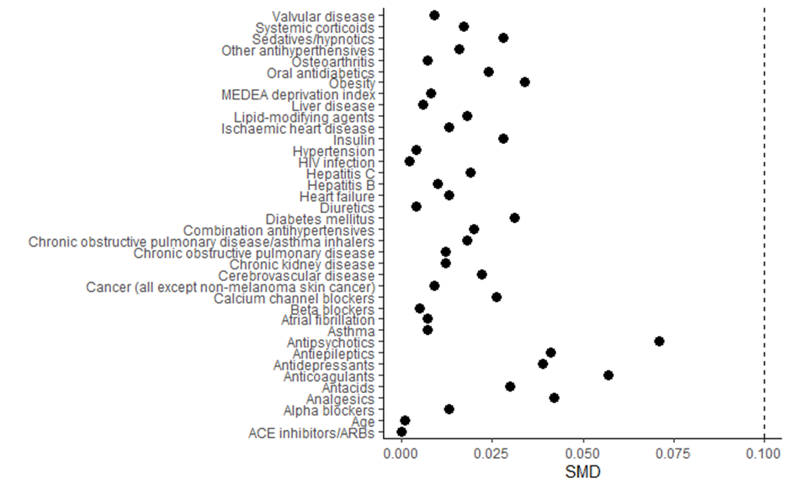

Supplementary Figure 2. Kaplan-Meier of low back pain according to vaccination schedule

