Multi-Scale Long-Term Forecasting of Meteorological Drought Using Wavelet-Decomposed LSTM Models across Six Climatic Regions of Tanzania

Paul T.S. Limbu¹ and Andongwisye John Mwakisisile ²

¹ Environmental and Atmospheric Sciences Group, Physics Department, University of Dar es Salaam,

P.O. Box 35063, Dar es Salaam, Tanzania.

² Department of Mathematics, College of Natural and Applied Sciences, University of Dar es Salaam,

P.O. Box 35091, Dar es Salaam, Tanzania.

*Corresponding author: Paul T.S. Limbu, Email: paul.limbu@ymail.com
Co-author Email: johnandongwisye@gmail.com

Introduction
The supplementary figures accompanying the submitted manuscript are adequately discussed in the main manuscript, particularly in the discussion associated with Figure 5.

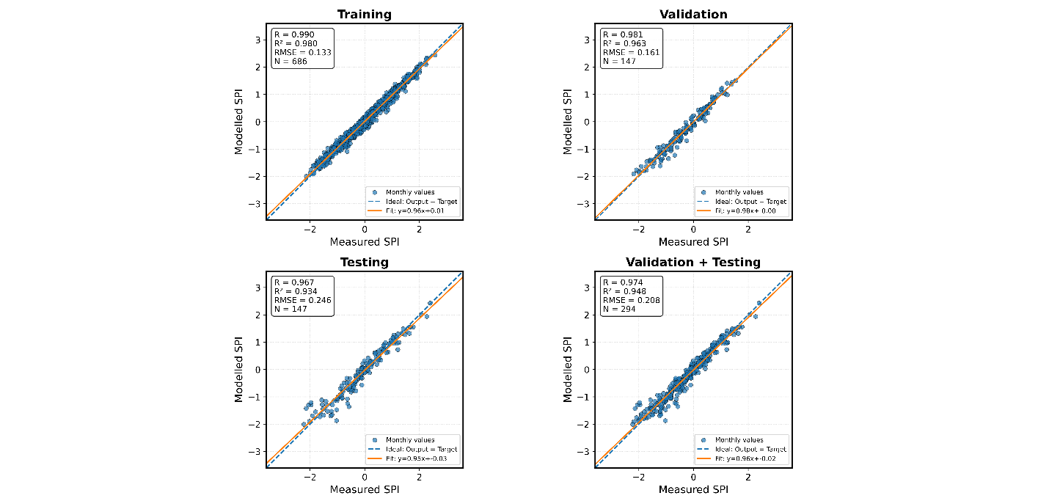
S1: Sample statistic of the input combinations for forecasting of SPI6, showing the relationship between the output and target in Arusha region
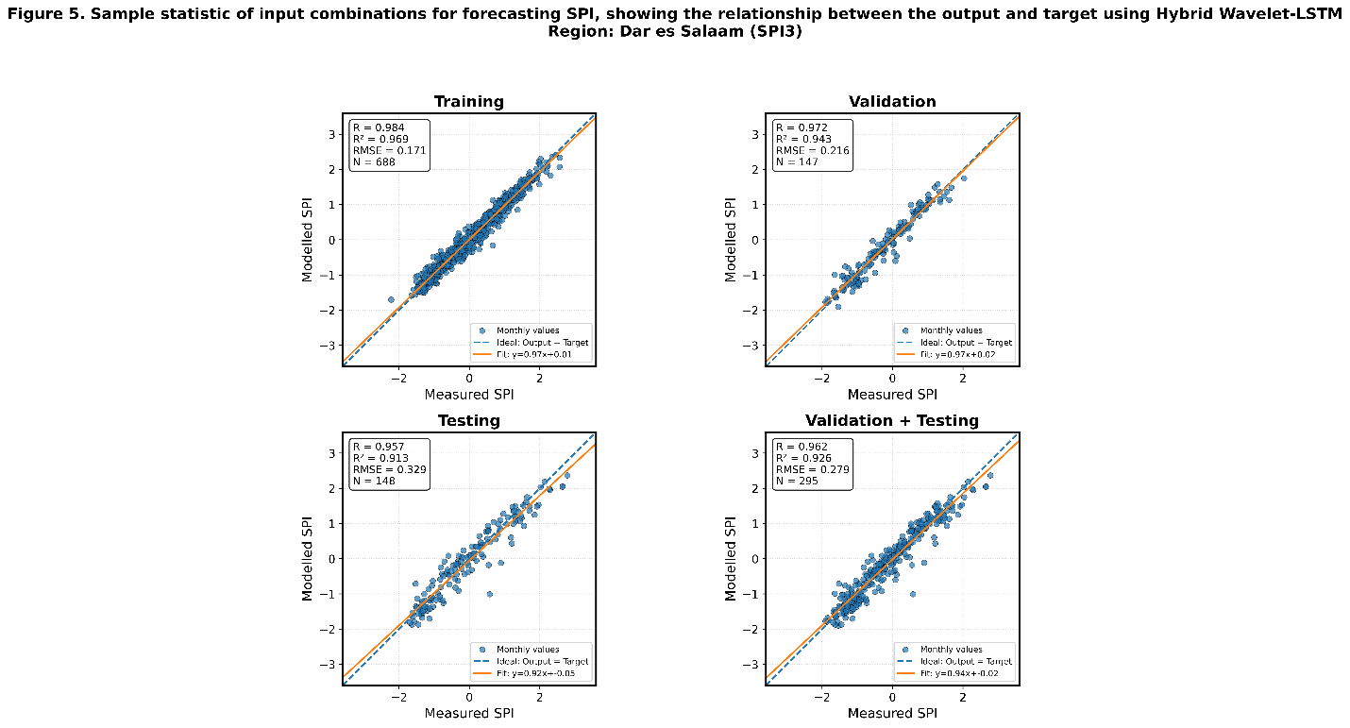
S2: Sample statistic of the input combinations for forecasting of SPI3, showing the relationship between the output and target in Dar es Salaam region

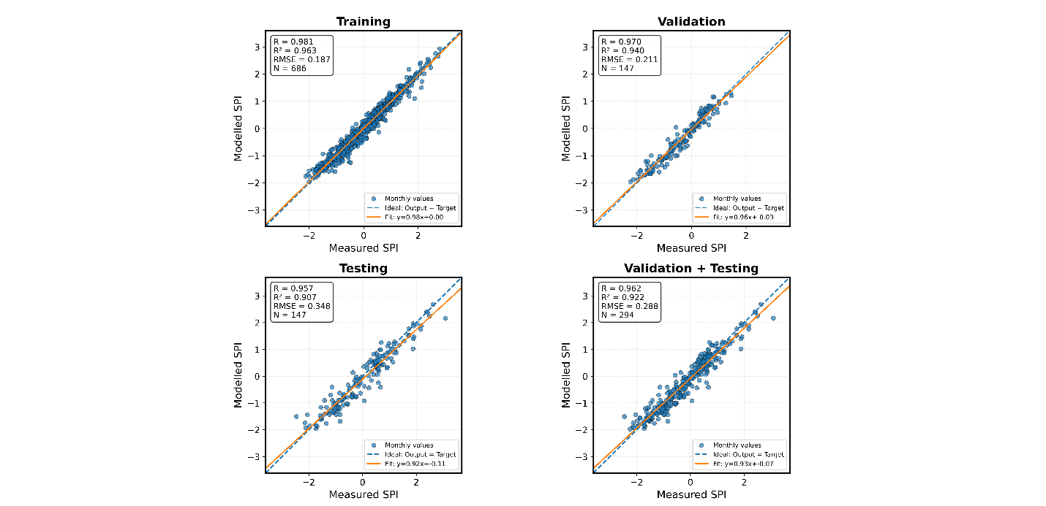
S3: Sample statistic of the input combinations for forecasting of SPI6, showing the relationship between the output and target in Dar es Salaam region

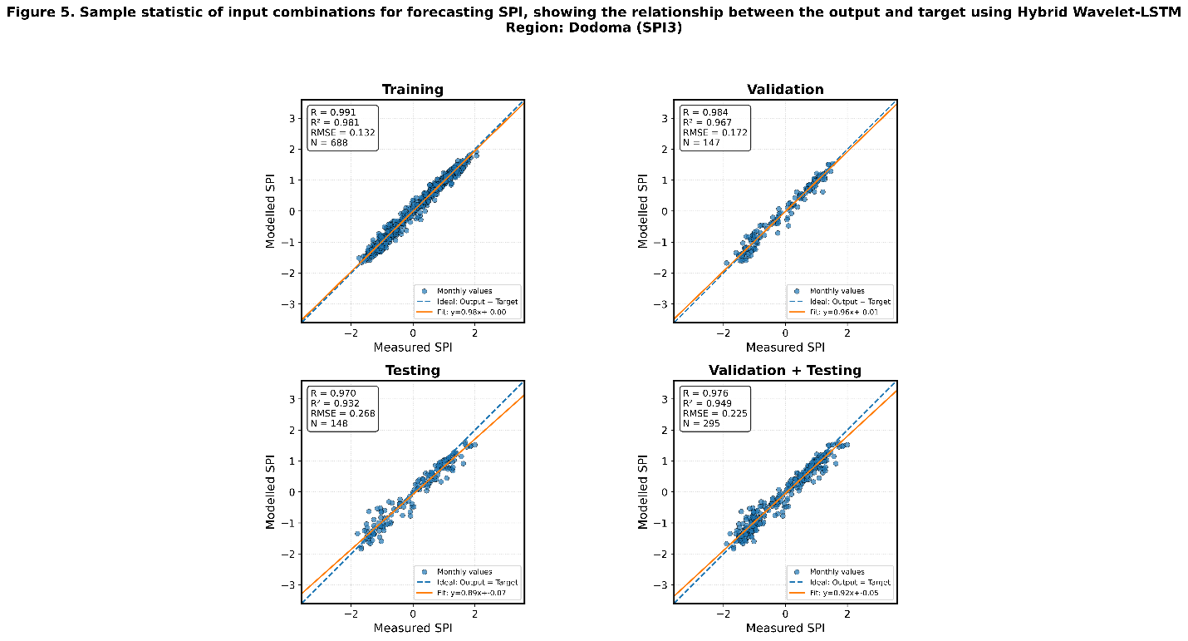
S4: Sample statistic of the input combinations for forecasting of SPI3, showing the relationship between the output and target in Dodoma region

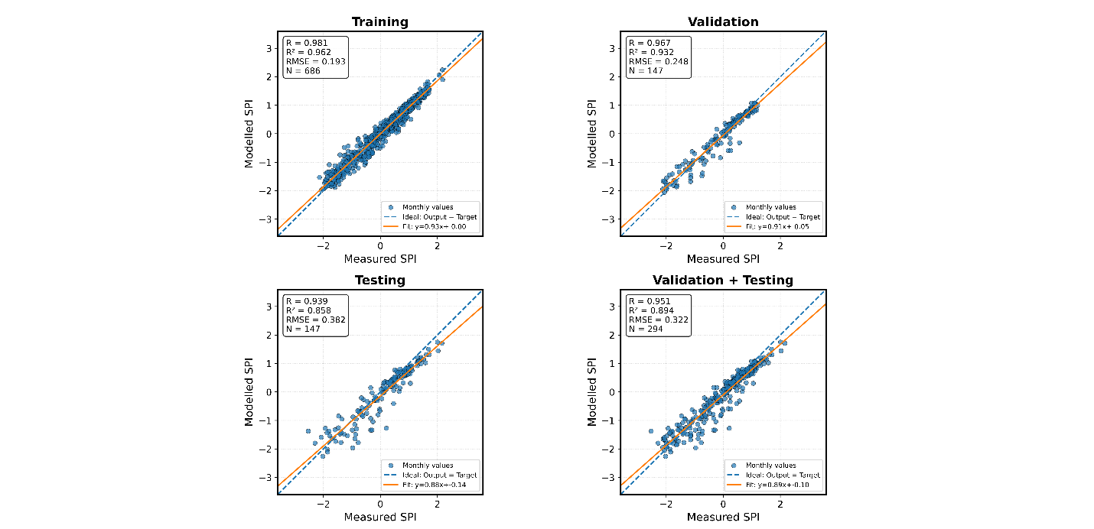
S5: Sample statistic of the input combinations for forecasting of SPI6, showing the relationship between the output and target in Dodoma region
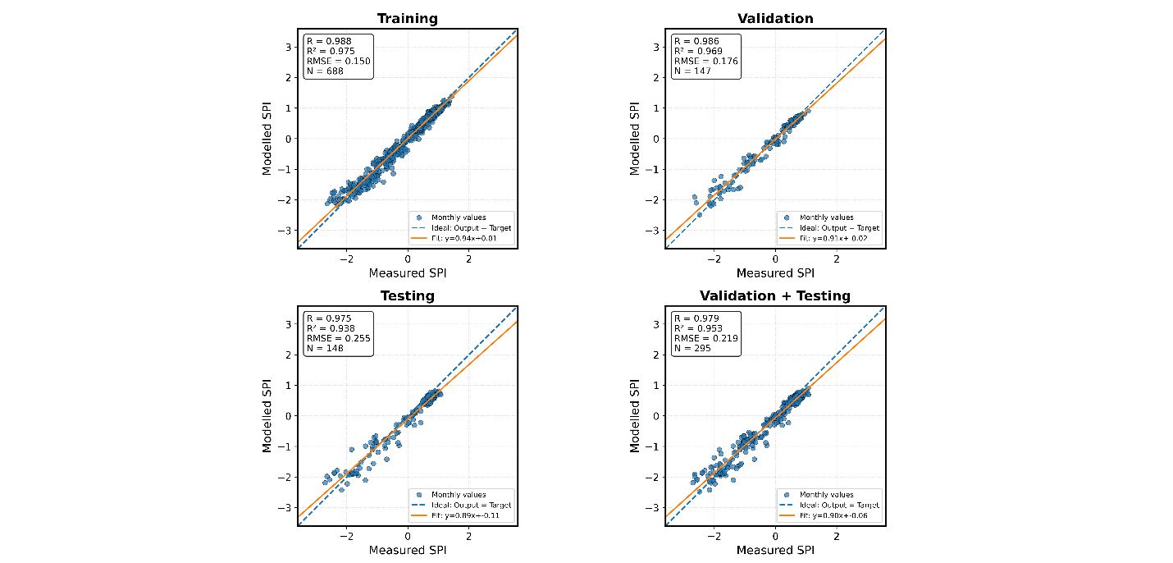
S6: Sample statistic of the input combinations for forecasting of SPI3, showing the relationship between the output and target in Kigoma region

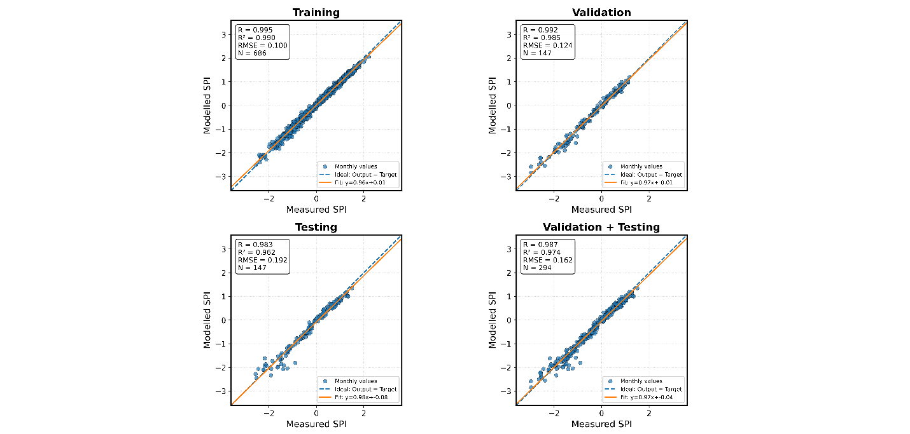
S7: Sample statistic of the input combinations for forecasting of SPI6, showing the relationship between the output and target in Kigoma region

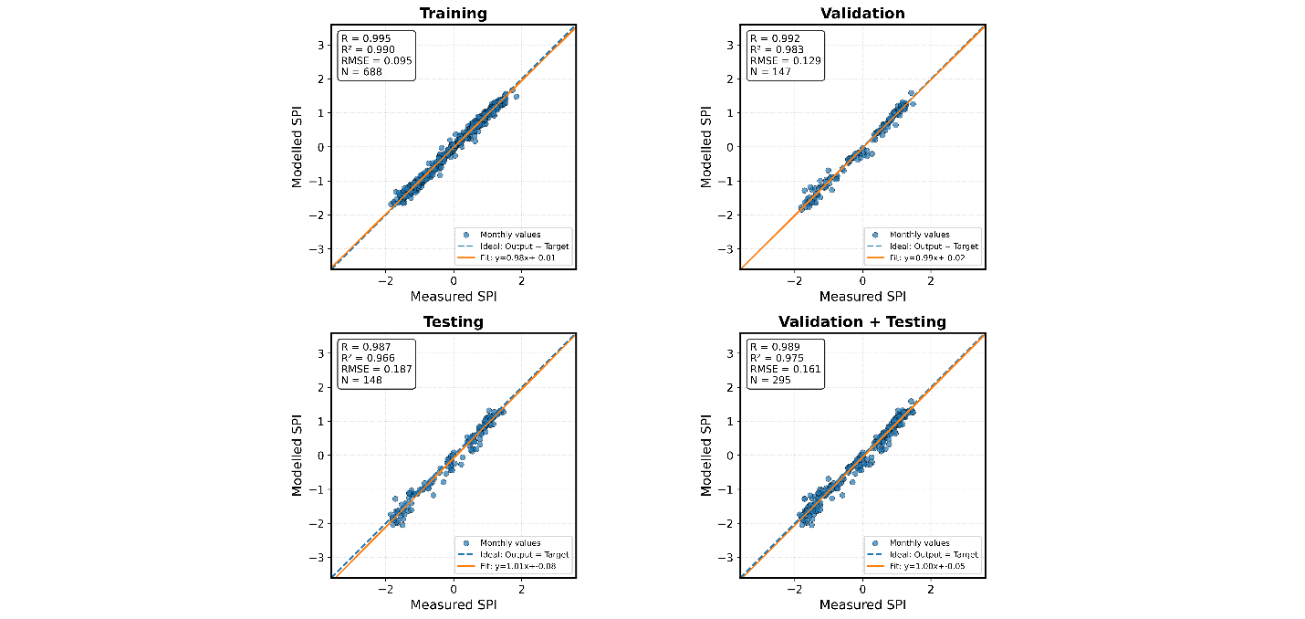
S8: Sample statistic of the input combinations for forecasting of SPI3, showing the relationship between the output and target in Mbeya region

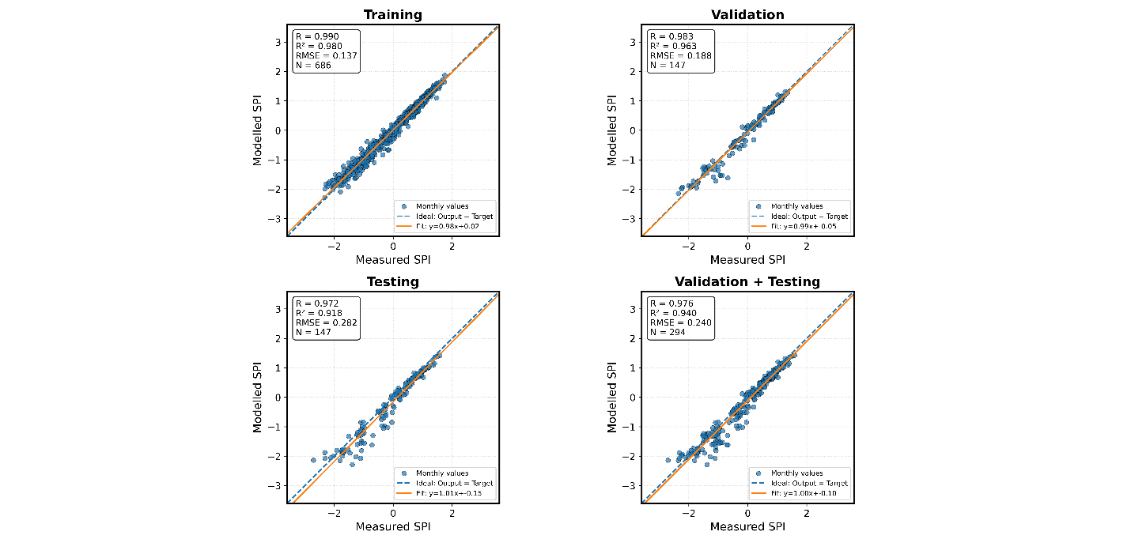
S9: Sample statistic of the input combinations for forecasting of SPI6, showing the relationship between the output and target in Mbeya region

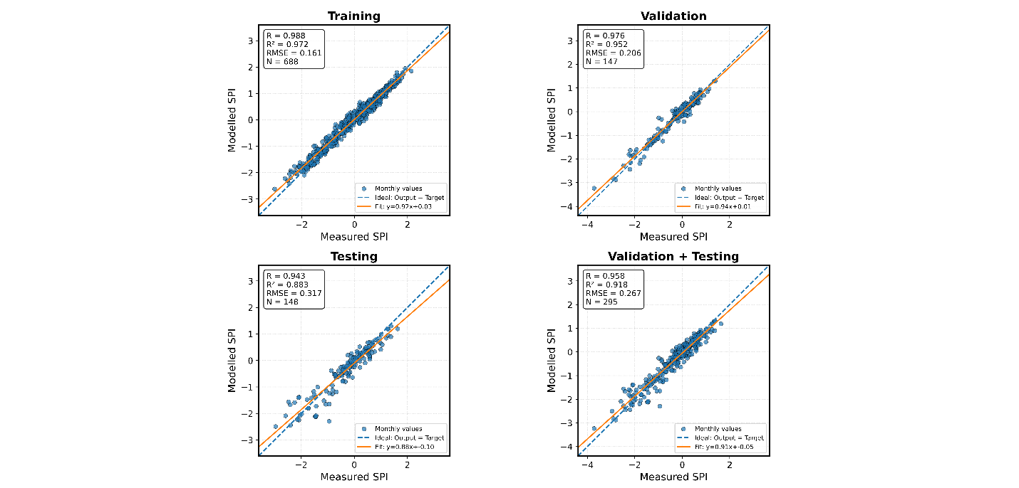
S10: Sample statistic of the input combinations for forecasting of SPI3, showing the relationship between the output and target in Mwanza region

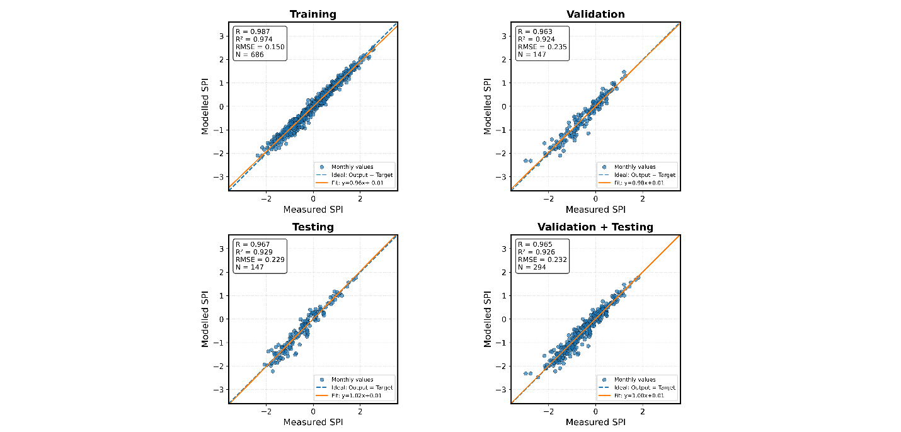
S11: Sample statistic of the input combinations for forecasting of SPI6, showing the relationship between the output and target in Mwanza region

