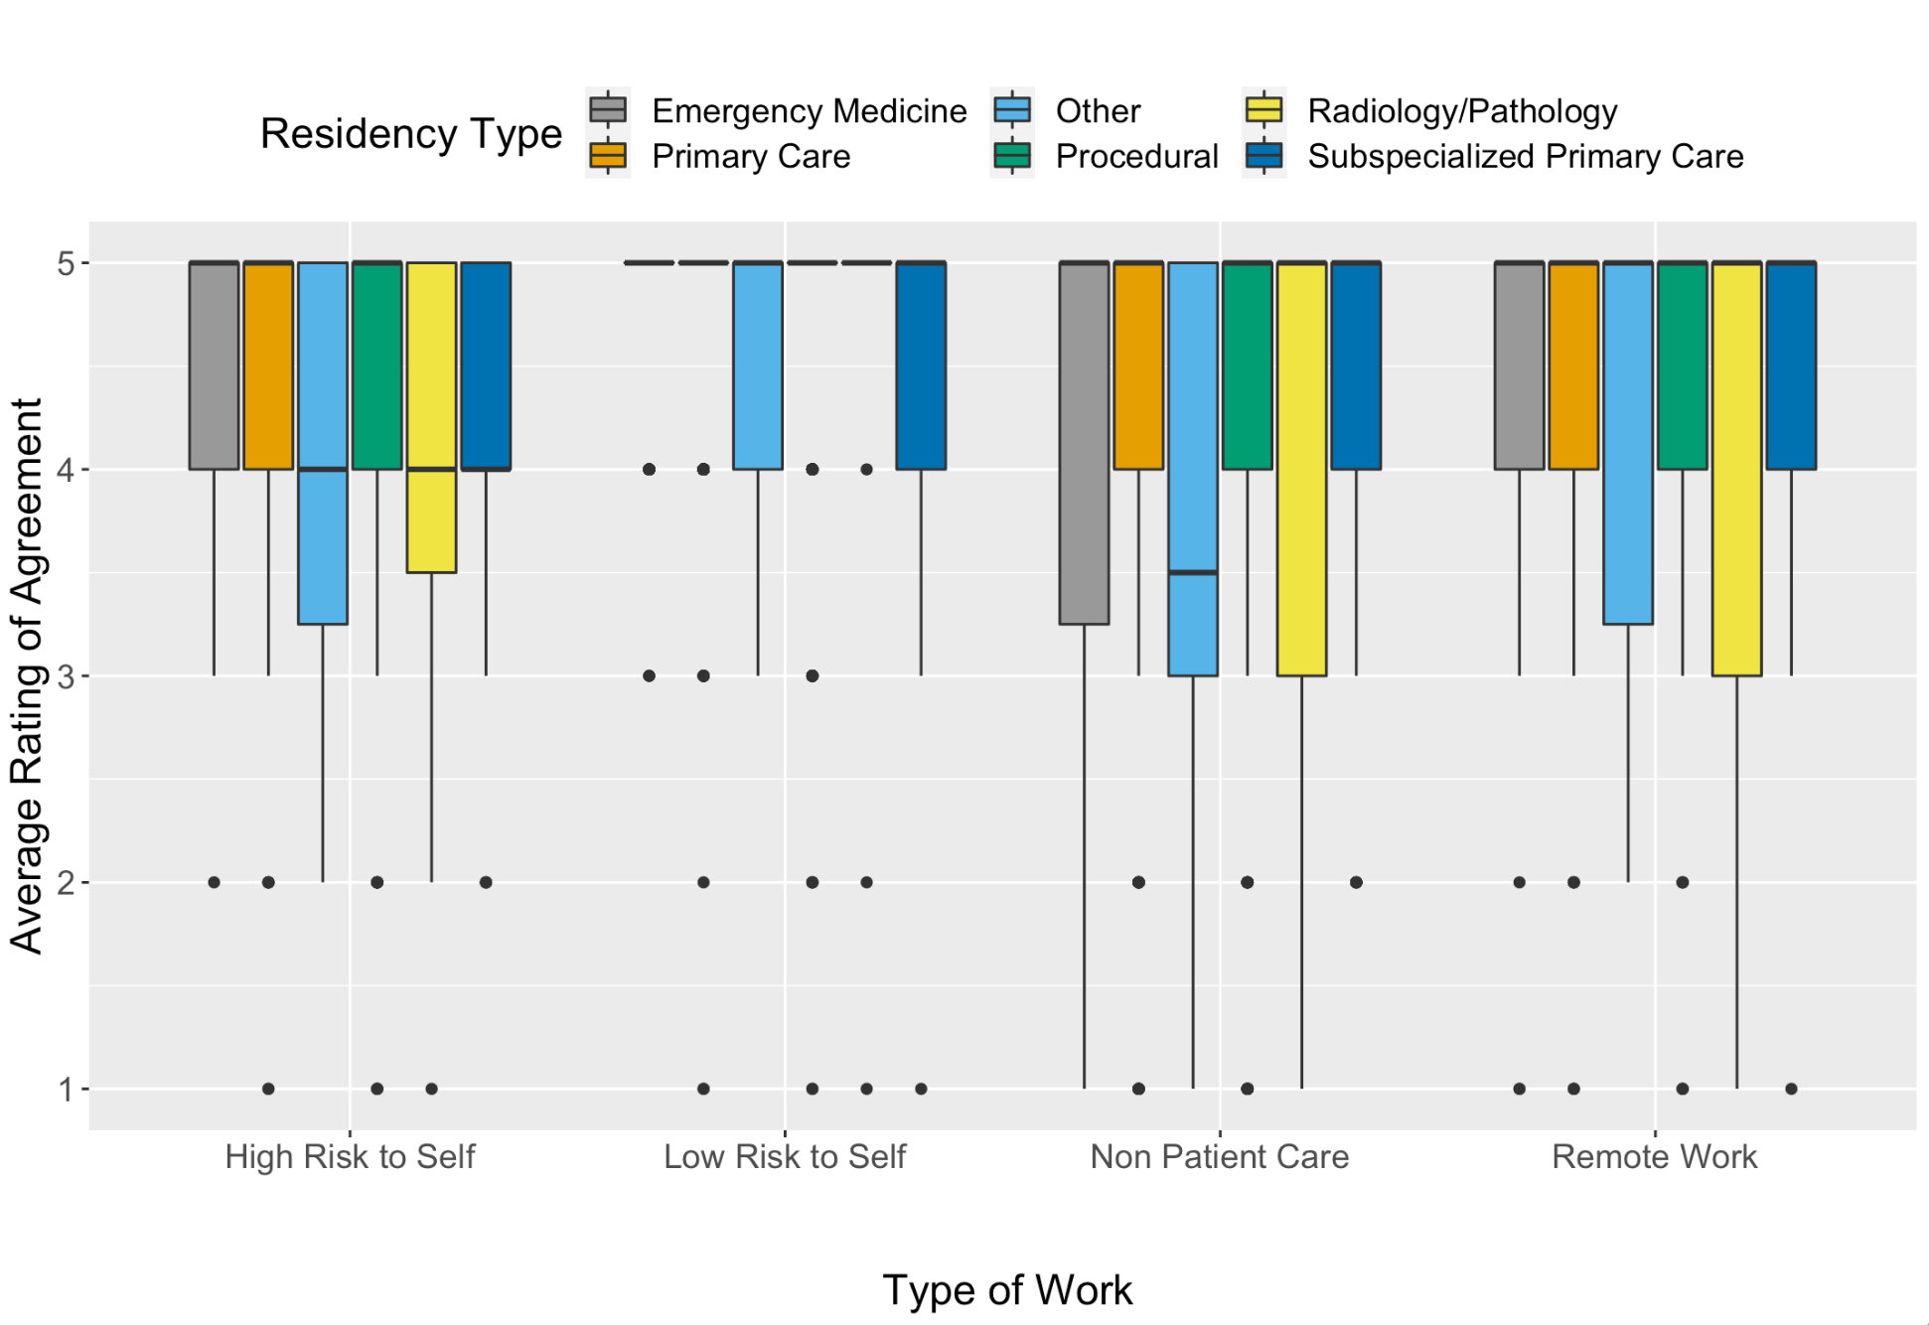

Supplemental Figure 4. Box and whisker plot of medical students’ rating of agreement with whether physicians have a duty to work in various risk settings during a pandemic. Stratified by student’s self selected future residency type. Likert scale with 1 representing strongly disagreeing and 5 representing strongly agreeing with working in various risk settings.

