Supplement 2

eSupplement: Detailed Neuroimaging Protocol
eFigure 1. The sham placebo acupuncture device
eFigure 2. Qihuang needle and blind operation
eFigure 3. LEDD-adjusted sensitivity analysis of ΔFC group effects.
eTable 1. Complete seed-to-whole-brain functional connectivity findings and baseline PD-HC findings.
eTable 2. Baseline PD-HC trends and same-coordinate verification at the six VA group-defined peaks.
eTable 3. Complete partial correlation results between peak-level FC measures and clinical variables.
eTable 4. LEDD-adjusted sensitivity analyses for peak-level ΔFC findings.
eTable 5. Summary of Adverse Events

eSupplement: Detailed Neuroimaging Protocol

1. MRI Acquisition

All imaging data were acquired on a 3.0T Siemens MAGNETOM Prisma MRI scanner (Siemens Healthcare, Erlangen, Germany) using a 64-channel head coil. Routine clinical sequences were used to rule out other potential brain pathologies.

①3D T1-weighted structural imaging: High-resolution anatomical images were acquired using a magnetization-prepared rapid gradient-echo (MPRAGE) sequence with the following parameters: repetition time = 2530 ms, echo time = 2.98 ms, inversion time = 1100 ms, flip angle = 7°, field of view = 256×256 mm, matrix size = 256×256, slice thickness = 1.0 mm (no gap), 192 sagittal slices, voxel size = 1×1×1 mm³, and total acquisition time = 5 min 58 s.

②Resting-state functional MRI: rs-fMRI data were acquired using a simultaneous multi-slice (SMS) echo-planar imaging (EPI) sequence optimized for blood oxygenation level-dependent (BOLD) contrast. The acquisition parameters were: repetition time = 500 ms, echo time = 30 ms, flip angle = 60°, field of view = 224×224 mm, matrix size = 64×64, slice thickness = 3.5 mm, 35 contiguous axial slices (no gap), voxel size = 3.5×3.5×3.5 mm³, SMS acceleration factor = 2, and 960 volumes per participant, resulting in a total scan duration of 8 min 7 s.

2. Quality Control and Exclusion Criteria

Two experienced radiologists independently screened all raw images for artifacts; severely degraded images were discarded.

For rs-fMRI, framewise displacement (FD) was computed using the Jenkinson method. Participants were excluded if >20% of volumes had FD > 0.5 mm, or if maximum head motion exceeded 3.0 mm translation or 3.0° rotation. Whole-brain mean temporal signal-to-noise ratio (tSNR) was calculated for the fMRI data; values below 50 led to exclusion. T1-weighted images were assessed for adequate gray/white matter contrast and the absence of gross structural abnormalities.

3. Preprocessing and Analysis Pipelines

3.1 Resting-state fMRI preprocessing

Resting-state fMRI preprocessing was performed using DPABI (version 6.1) and DPARSF (version 4.5), running under MATLAB R2013b (MathWorks, Natick, MA, USA).

After removal of the first 10 time points, functional images underwent slice-timing correction, head-motion correction, co-registration, segmentation, and DARTEL-based normalization to Montreal Neurological Institute (MNI) space, followed by resampling to 3×3×3 mm³. Nuisance covariates, including head-motion parameters, white-matter signal, and cerebrospinal-fluid signal, were regressed out, and residual time series were band-pass filtered at 0.01-0.10 Hz. The predefined head-motion exclusion threshold was maximum translation > 3 mm or maximum rotation > 3°; no participant exceeded this threshold.

3.2 Seed-based functional connectivity analysis

Seed-based functional connectivity analyses were performed in standard space. Based on the a priori motor-circuit hypothesis in Parkinson’s disease, 23 AAL116 seed regions were selected to cover motor cortical, basal-ganglia, thalamic, and cerebellar nodes. These seeds included the bilateral precentral gyri, bilateral supplementary motor areas, bilateral postcentral gyri, bilateral paracentral lobules, bilateral caudate nuclei, bilateral putamina, bilateral pallida, bilateral thalami, bilateral cerebellar lobule VI, bilateral cerebellar lobule VIII, and vermis VI, VII, and VIII.

For each seed region, the mean BOLD time series was extracted and correlated with the time series of every whole-brain voxel using Pearson correlation. The resulting correlation coefficients were transformed using Fisher’s r-to-z transformation to improve normality for subsequent group-level statistical analyses. All subsequent analyses were based on the z-transformed functional connectivity maps.

3.3 Whole-brain group-level comparisons

Image-level statistical analyses were performed using SPM25. All group-level models included sex, age, and years of education as covariates. Whole-brain functional connectivity analyses comprised three components. First, two-sample models compared baseline patients with Parkinson’s disease and healthy controls. Second, paired models were conducted separately in the VAgroup and the SAgroup to assess pre- to post-treatment FC changes. Third, individual FC change maps were calculated and compared between the VAgroup and SAgroups using two-sample models.

FC change was defined as ΔFC = post-treatment FC minus pre-treatment FC. The direct between-group comparison examined ΔVAgroup > ΔSAgroup and ΔSAgroup > ΔVAgroup. Positive and negative ΔFC values indicate increased and decreased FC after treatment, respectively.

3.4 Thresholding and multiple-comparison correction

For each seed-level whole-brain statistical map, a voxel-level uncorrected threshold of p < 0.001 was first applied with a minimum cluster size of k ≥ 10 voxels. The uncorrected p values of all cluster peaks surviving this screening threshold were then corrected using the Benjamini-Hochberg false discovery rate (BH-FDR) procedure. Peak-level BH-FDR q < 0.05 was considered statistically significant.

3.5 Peak-value extraction and between-group comparison

To further characterize differences in treatment-related FC change between the VAgroup and SAgroups, subject-level ΔFC values were extracted at significant peak coordinates identified in the whole-brain analyses. For each peak, the mean FC value was extracted from a spherical region centered on the peak coordinate in each participant’s corresponding seed-to-voxel FC map, and ΔFC was calculated for visualization, effect-size description, and supplementary analyses.

For peaks that survived peak-level BH-FDR correction in the ΔVAgroup vs ΔSAgroup whole-brain comparison, mean ΔFC values were extracted separately for the VAgroup and SAgroup at the same peak coordinates. These peak-level summaries were used to clarify the pattern of the corrected whole-brain findings and were not considered additional whole-brain tests.

Baseline PD-HC differences were also described at the same peak coordinates. This analysis was used to indicate whether the corresponding connections were relatively higher or lower in patients before treatment. These baseline comparisons were provided only as contextual information and were not used as evidence of treatment efficacy.

3.6 Imaging-clinical correlation analysis

To explore the clinical relevance of peak-level FC findings, imaging-clinical correlation analyses were performed. Baseline analyses were conducted in the patient sample and examined associations between baseline FC values at key peak coordinates and baseline clinical scale scores. Change analyses were performed in the VAgroup, the SAgroup, and the combined patient sample to examine associations between ΔFC and changes in clinical scores.

Imaging-clinical associations were examined using partial correlation analyses controlling for sex, age, and years of education. Baseline analyses assessed associations between peak-level baseline FC and baseline clinical measures. Change analyses assessed associations between treatment-related ΔFC and clinical changes matched to each intervention condition. For the SAgroup condition, clinical change was defined as the SAgroup post-treatment score minus the baseline score, whereas for the VAgroup condition, clinical change was defined as the VAgroup post-treatment score minus the baseline score. In the combined patient analysis, the clinical change variable was matched to each participant’s intervention group. BH-FDR correction was applied within the predefined analysis families, with q < 0.05 considered statistically significant. Sensitivity analyses further included levodopa equivalent daily dose as an additional covariate.

3.7 Sensitivity and supplementary analyses

Several supplementary analyses were performed to evaluate the robustness and interpretability of the main findings. First, levodopa equivalent daily dose (LEDD) was added as an additional covariate at the peak level to test whether the main FC changes and between-group differences were explained by medication burden. Second, ΔFC was compared at the same peak coordinates in both treatment groups. Third, baseline PD-HC trends were traced at key peak coordinates to provide interpretive context for treatment-related findings.

4. Software and Version Information

SPM25 r7771 (https://www.fil.ion.ucl.ac.uk/spm/)

DPABI v6.1 (http://rfmri.org/dpabi)

DPARSF v4.5 (http://rfmri.org/dpabi)

MATLAB R2013b (MathWorks, Natick, MA)

MRIcron (https://www.nitrc.org/projects/mricron)

BrainNet Viewer(https://www.nitrc.org/projects/bnv/
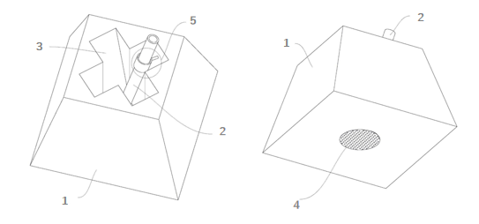
eFigure 1. The sham placebo acupuncture device
Note. The sham placebo acupuncture device (SPAD; Patent No. 202321515328.8) was utilized to ensure participant blinding. Its key structural components are labeled: 1. Base: The main body of the device, featuring a through-channel that allows for needle passage and permits angular adjustment of insertion; 2. Needle Tube: Houses either the verum Qihuang needle or the blunt-tipped sham needle; 3. Channel: The through-hole within the base guiding the needle; 4. Adhesive Patch: Secures the device firmly to the skin at the acupuncture point; 5. Support Sleeve: Provides structural stability to the needle tube.

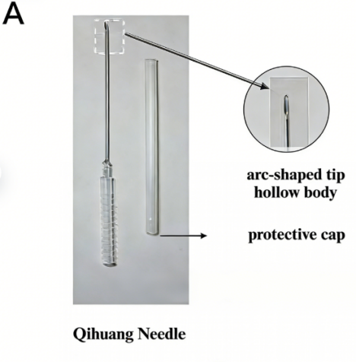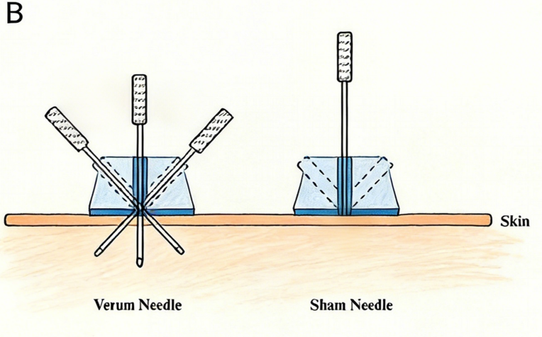

eFigure 2. Qihuang needle and blind operation
Note: A.Qihuang needle, comprises four components: tip, body, handle, and protective cap. B.A sham placebo acupuncture device (SPAD) integrates verum and sham needles. During application, the SPAD is attached to acupoints. For verum acupuncture, sharp needles penetrate the skin through the SPAD base. In contrast, sham needles feature a blunt tip; upon contact with the base, internal microneedles within the SPAD simulate tactile penetration without skin puncture.

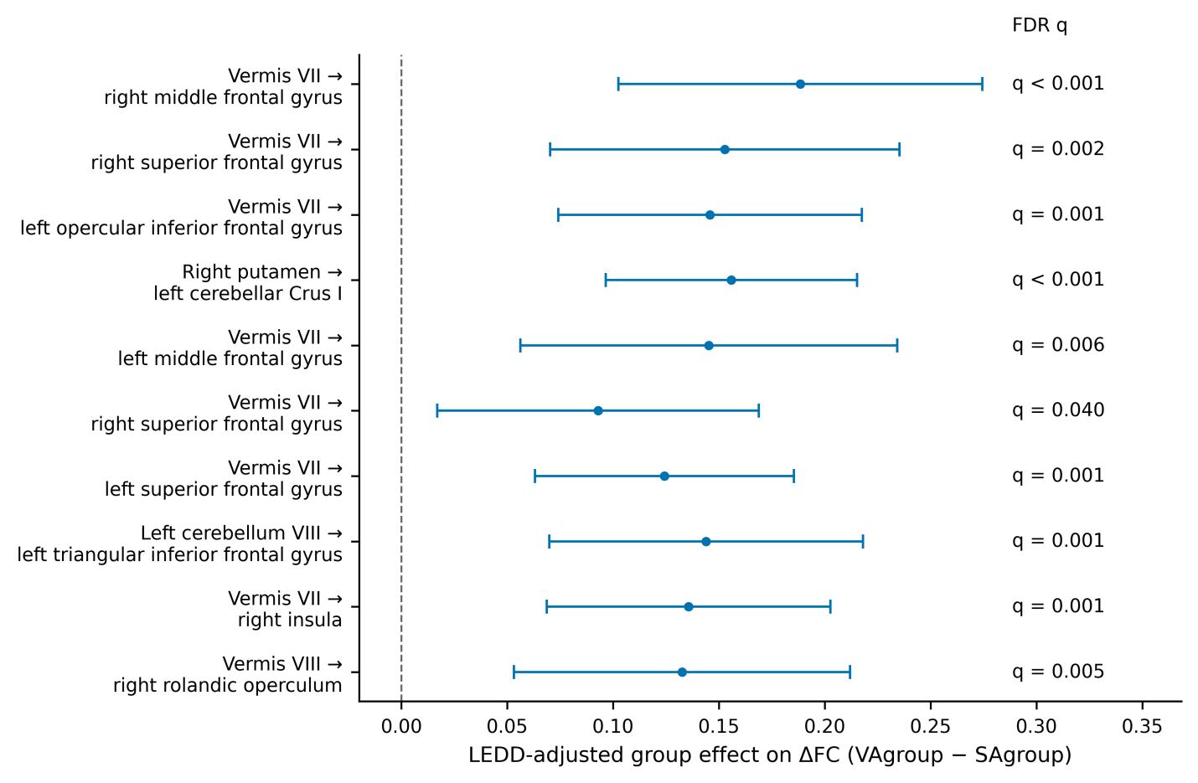
eFigure 3. LEDD-adjusted sensitivity analysis of ΔFC group effects.
Note:Dots indicate LEDD-adjusted group effects on ΔFC for the 10 pathways identified in the ΔVA group > ΔSA group comparison. Horizontal lines show approximate 95% confidence intervals derived from the model coefficient and t statistic. FDR q values are displayed on the right. The model included sex, age, education, and levodopa equivalent daily dose as covariates.

eTable 1. Complete seed-to-whole-brain functional connectivity findings and baseline PD-HC findings.

Seed region | Direction | Target region | MNI coordinates | k | Peak T | P value | FDR q value
Panel A. Baseline PD vs HC findings.
left precentral gyrus | HC > PD | left middle occipital gyrus | (-27, -93, -9) | 13 | 4.45 | <0.001 | <0.001
left precentral gyrus | HC > PD | right lingual gyrus | (9, -99, -9) | 12 | 4.35 | <0.001 | <0.001
vermis VI | HC > PD | left superior occipital gyrus | (-21, -99, 3) | 19 | 4.66 | <0.001 | <0.001
vermis VII | HC > PD | left superior occipital gyrus | (-21, -99, 3) | 16 | 4.49 | <0.001 | <0.001
right precentral gyrus | HC > PD | left middle occipital gyrus | (-42, -78, -9) | 15 | 4.48 | <0.001 | <0.001
right precentral gyrus | HC > PD | left postcentral gyrus | (-51, -18, 48) | 13 | 4.36 | <0.001 | <0.001
right supplementary motor area | HC > PD | right cerebellar lobule X | (21, -30, -36) | 10 | 4.97 | <0.001 | <0.001
right thalamus | HC > PD | right precuneus | (6, -66, 42) | 15 | 4.36 | <0.001 | <0.001
right cerebellum VI | PD > HC | left superior frontal gyrus | (-24, 48, 15) | 10 | 4.66 | <0.001 | <0.001
vermis VI | PD > HC | left superior frontal gyrus | (-24, 48, 15) | 10 | 4.35 | <0.001 | <0.001
vermis VII | PD > HC | left superior medial frontal gyrus | (-18, 54, -3) | 11 | 5.10 | <0.001 | <0.001
vermis VII | PD > HC | right medial orbitofrontal cortex | (6, 51, -12) | 29 | 4.61 | <0.001 | <0.001
vermis VII | PD > HC | left orbital inferior frontal gyrus | (-30, 33, -21) | 11 | 4.54 | <0.001 | <0.001
vermis VII | PD > HC | left superior frontal gyrus | (-24, 48, 12) | 13 | 4.52 | <0.001 | <0.001
vermis VII | PD > HC | left medial orbitofrontal cortex | (-9, 45, 3) | 10 | 4.24 | <0.001 | <0.001
vermis VII | PD > HC | left postcentral gyrus | (-12, -30, 42) | 10 | 4.20 | <0.001 | <0.001
vermis VIII | PD > HC | left medial orbitofrontal cortex | (-18, 51, -15) | 27 | 5.00 | <0.001 | <0.001
vermis VIII | PD > HC | medial orbitofrontal cortex | (9, 39, -6) | 12 | 4.06 | <0.001 | <0.001
left supplementary motor area | PD > HC | left precuneus | (-12, -42, 54) | 24 | 4.70 | <0.001 | <0.001
left supplementary motor area | PD > HC | right cerebellar lobule IV-V | (24, -42, -21) | 11 | 4.50 | <0.001 | <0.001
left supplementary motor area | PD > HC | right precuneus | (15, -36, 48) | 13 | 4.23 | <0.001 | <0.001
right supplementary motor area | PD > HC | left precuneus | (-15, -36, 45) | 19 | 4.65 | <0.001 | <0.001
right supplementary motor area | PD > HC | right precuneus | (15, -36, 48) | 10 | 4.48 | <0.001 | <0.001
left paracentral lobule | PD > HC | right cerebellar lobule IV-V | (15, -45, -24) | 16 | 4.35 | <0.001 | <0.001
left paracentral lobule | PD > HC | left postcentral gyrus | (-21, -48, 72) | 12 | 4.27 | <0.001 | <0.001
left paracentral lobule | PD > HC | right precuneus | (15, -36, 48) | 11 | 4.27 | <0.001 | <0.001
left caudate | PD > HC | left cerebellar lobule VIIb | (-27, -48, -45) | 10 | 4.60 | <0.001 | <0.001
left putamen | PD > HC | medial orbitofrontal cortex | (0, 45, 3) | 10 | 4.78 | <0.001 | <0.001
left cerebellum VI | PD > HC | left superior frontal gyrus | (-24, 48, 15) | 12 | 4.64 | <0.001 | <0.001
Panel B. VA group: pre-treatment vs post-treatment FC changes.
left caudate | Pre > Post | left lingual gyrus | (-12, -99, -9) | 28 | 5.00 | <0.001 | <0.001
left caudate | Pre > Post | left middle temporal gyrus | (-54, -54, 15) | 10 | 4.96 | <0.001 | <0.001
left caudate | Pre > Post | right lingual gyrus | (9, -60, 6) | 12 | 4.66 | <0.001 | <0.001
left caudate | Pre > Post | right calcarine cortex | (12, -81, 6) | 18 | 4.44 | <0.001 | <0.001
left caudate | Pre > Post | right lingual gyrus | (3, -66, 9) | 10 | 4.32 | <0.001 | <0.001
right thalamus | Pre > Post | left middle temporal gyrus | (-60, -63, -9) | 14 | 5.26 | <0.001 | <0.001
Panel C. SA group: pre-treatment vs post-treatment FC changes.
right cerebellum VI | Post > Pre | right superior occipital gyrus | (27, -93, 21) | 10 | 4.33 | <0.001 | <0.001
left cerebellum VI | Post > Pre | right middle occipital gyrus | (30, -93, 9) | 10 | 3.84 | <0.001 | <0.001
right cerebellum VI | Pre > Post | right medial orbitofrontal cortex | (9, 54, -12) | 12 | 4.63 | <0.001 | <0.001
right cerebellum VI | Pre > Post | left caudate | (-18, -3, 12) | 13 | 4.32 | <0.001 | <0.001
left cerebellum VIII | Pre > Post | right middle temporal gyrus | (57, -18, -6) | 12 | 5.08 | <0.001 | <0.001
left cerebellum VIII | Pre > Post | left middle temporal gyrus | (-57, -54, -9) | 13 | 5.08 | <0.001 | <0.001
left cerebellum VIII | Pre > Post | right superior temporal gyrus | (48, -30, 9) | 17 | 5.07 | <0.001 | <0.001
left cerebellum VIII | Pre > Post | left inferior frontal gyrus, triangular part | (-51, 18, 24) | 12 | 4.53 | <0.001 | <0.001
right cerebellum VIII | Pre > Post | right superior temporal gyrus | (60, 0, -6) | 12 | 5.88 | <0.001 | <0.001
right cerebellum VIII | Pre > Post | right precentral gyrus | (42, 3, 42) | 10 | 5.59 | <0.001 | <0.001
right cerebellum VIII | Pre > Post | left inferior temporal gyrus | (-42, -78, -21) | 13 | 4.67 | <0.001 | <0.001
vermis VI | Pre > Post | middle cingulate cortex | (-6, 0, 42) | 11 | 5.90 | <0.001 | <0.001
vermis VI | Pre > Post | left inferior frontal gyrus, opercular part | (-48, 6, 36) | 15 | 5.35 | <0.001 | <0.001
vermis VI | Pre > Post | right precentral gyrus | (39, -15, 39) | 16 | 5.30 | <0.001 | <0.001
vermis VI | Pre > Post | right precentral gyrus | (45, 9, 48) | 12 | 4.54 | <0.001 | <0.001
vermis VI | Pre > Post | left insula | (-42, 3, 0) | 12 | 4.29 | <0.001 | <0.001
vermis VII | Pre > Post | medial superior frontal gyrus | (3, 30, 48) | 33 | 7.45 | <0.001 | <0.001
vermis VII | Pre > Post | anterior cingulate cortex | (3, 30, 24) | 126 | 7.06 | <0.001 | <0.001
vermis VII | Pre > Post | right insula | (33, -21, 3) | 11 | 6.83 | <0.001 | <0.001
vermis VII | Pre > Post | right middle frontal gyrus | (48, 15, 42) | 424 | 6.54 | <0.001 | <0.001
vermis VII | Pre > Post | medial orbitofrontal cortex | (3, 54, -3) | 97 | 6.50 | <0.001 | <0.001
vermis VII | Pre > Post | right middle temporal gyrus | (60, -51, -15) | 55 | 5.94 | <0.001 | <0.001
vermis VII | Pre > Post | left middle temporal gyrus | (-63, -39, -3) | 48 | 5.76 | <0.001 | <0.001
vermis VII | Pre > Post | left Heschl gyrus | (-66, -24, 9) | 12 | 5.74 | <0.001 | <0.001
vermis VII | Pre > Post | right precentral gyrus | (15, -6, 63) | 12 | 5.63 | <0.001 | <0.001
vermis VII | Pre > Post | left superior frontal gyrus | (-18, 36, 42) | 58 | 5.61 | <0.001 | <0.001
vermis VII | Pre > Post | right parahippocampal gyrus | (12, -12, -9) | 12 | 5.56 | <0.001 | <0.001
vermis VII | Pre > Post | left Heschl gyrus | (-63, -42, 15) | 14 | 5.51 | <0.001 | <0.001
vermis VII | Pre > Post | midline angular gyrus | (0, -51, 18) | 13 | 5.44 | <0.001 | <0.001
vermis VII | Pre > Post | left superior frontal gyrus | (-21, 3, 48) | 10 | 5.40 | <0.001 | <0.001
vermis VII | Pre > Post | left precentral gyrus | (-51, -3, 39) | 63 | 5.39 | <0.001 | <0.001
vermis VII | Pre > Post | left inferior frontal gyrus, opercular part | (-48, 12, 15) | 45 | 5.35 | <0.001 | <0.001
vermis VII | Pre > Post | posterior cingulate cortex | (6, -27, 39) | 58 | 5.27 | <0.001 | <0.001
vermis VII | Pre > Post | right orbital inferior frontal gyrus | (36, 60, 3) | 14 | 5.25 | <0.001 | <0.001
vermis VII | Pre > Post | right superior temporal gyrus | (63, -21, 3) | 62 | 5.16 | <0.001 | <0.001
vermis VII | Pre > Post | left orbital inferior frontal gyrus | (-48, 24, -6) | 21 | 5.05 | <0.001 | <0.001
vermis VII | Pre > Post | left medial orbitofrontal cortex | (-24, 51, 12) | 18 | 5.04 | <0.001 | <0.001
vermis VII | Pre > Post | left middle frontal gyrus | (-39, 36, 24) | 28 | 5.03 | <0.001 | <0.001
vermis VII | Pre > Post | right orbital inferior frontal gyrus | (48, 30, -18) | 19 | 4.94 | <0.001 | <0.001
vermis VII | Pre > Post | left superior parietal lobule | (-51, -66, 24) | 16 | 4.91 | <0.001 | <0.001
vermis VII | Pre > Post | left Heschl gyrus | (-54, 3, 0) | 16 | 4.86 | <0.001 | <0.001
vermis VII | Pre > Post | right insula | (39, -21, 6) | 17 | 4.80 | <0.001 | <0.001
vermis VII | Pre > Post | right medial orbitofrontal cortex | (18, 42, -21) | 11 | 4.79 | <0.001 | <0.001
vermis VII | Pre > Post | left precentral gyrus | (-51, -3, 24) | 11 | 4.62 | <0.001 | <0.001
vermis VII | Pre > Post | left caudate | (-33, 9, -3) | 12 | 4.62 | <0.001 | <0.001
vermis VII | Pre > Post | left medial orbitofrontal cortex | (-30, 24, -3) | 11 | 4.55 | <0.001 | <0.001
vermis VII | Pre > Post | left caudate | (-12, 0, 12) | 11 | 4.52 | <0.001 | <0.001
vermis VII | Pre > Post | right supramarginal gyrus | (54, -42, 27) | 15 | 4.50 | <0.001 | <0.001
vermis VII | Pre > Post | anterior cingulate cortex | (-9, 51, 24) | 12 | 4.32 | <0.001 | <0.001
vermis VIII | Pre > Post | right medial orbitofrontal cortex | (24, 48, 6) | 16 | 6.67 | <0.001 | <0.001
vermis VIII | Pre > Post | right middle frontal gyrus | (33, 18, 36) | 13 | 6.29 | <0.001 | <0.001
vermis VIII | Pre > Post | medial orbitofrontal cortex | (-9, 57, -6) | 17 | 5.19 | <0.001 | <0.001
vermis VIII | Pre > Post | medial orbitofrontal cortex | (3, 48, -15) | 13 | 5.12 | <0.001 | <0.001
vermis VIII | Pre > Post | right middle temporal gyrus | (51, -27, -12) | 10 | 4.86 | <0.001 | <0.001
vermis VIII | Pre > Post | medial superior frontal gyrus | (-3, 3, 54) | 22 | 4.67 | <0.001 | <0.001
vermis VIII | Pre > Post | right Heschl gyrus | (48, -21, 9) | 11 | 4.57 | <0.001 | <0.001
vermis VIII | Pre > Post | right inferior frontal gyrus, triangular part | (45, 24, 21) | 10 | 4.51 | <0.001 | <0.001
vermis VIII | Pre > Post | right medial orbitofrontal cortex | (21, 45, -18) | 13 | 4.29 | <0.001 | <0.001
right supplementary motor area | Pre > Post | left cuneus | (-30, -93, -15) | 15 | 4.73 | <0.001 | <0.001
left paracentral lobule | Pre > Post | right supramarginal gyrus | (57, -24, 48) | 15 | 6.14 | <0.001 | <0.001
left paracentral lobule | Pre > Post | left middle occipital gyrus | (-33, -84, -9) | 16 | 5.04 | <0.001 | <0.001
left paracentral lobule | Pre > Post | left superior parietal lobule | (-33, -51, 48) | 10 | 4.15 | <0.001 | <0.001
left caudate | Pre > Post | precuneus | (0, -30, 45) | 36 | 5.90 | <0.001 | <0.001
right putamen | Pre > Post | right lingual gyrus | (9, -75, 6) | 24 | 5.06 | <0.001 | <0.001
right putamen | Pre > Post | left cerebellar Crus I | (-15, -78, -36) | 16 | 4.79 | <0.001 | <0.001
right putamen | Pre > Post | right cerebellar Crus I | (12, -66, -18) | 13 | 4.70 | <0.001 | <0.001
left thalamus | Pre > Post | right superior temporal gyrus | (45, -30, -9) | 18 | 5.53 | <0.001 | <0.001
left thalamus | Pre > Post | left inferior frontal gyrus, triangular part | (-54, 21, 24) | 14 | 5.37 | <0.001 | <0.001
left thalamus | Pre > Post | right Heschl gyrus | (39, -24, 6) | 10 | 5.09 | <0.001 | <0.001
left thalamus | Pre > Post | left superior temporal pole | (-63, -9, -12) | 16 | 4.74 | <0.001 | <0.001
left thalamus | Pre > Post | left inferior frontal gyrus, opercular part | (-48, 12, 30) | 11 | 4.65 | <0.001 | <0.001
right thalamus | Pre > Post | medial superior frontal gyrus | (-9, 33, 51) | 10 | 4.99 | <0.001 | <0.001
right thalamus | Pre > Post | right precentral gyrus | (48, 15, 45) | 15 | 4.93 | <0.001 | <0.001
right thalamus | Pre > Post | right middle temporal gyrus | (48, -42, 3) | 10 | 4.19 | <0.001 | <0.001
left cerebellum VI | Pre > Post | left caudate | (-15, 6, 9) | 21 | 6.46 | <0.001 | <0.001
left cerebellum VI | Pre > Post | left insula | (-42, 0, 0) | 27 | 5.64 | <0.001 | <0.001
left cerebellum VI | Pre > Post | right putamen | (33, 3, 3) | 10 | 5.26 | <0.001 | <0.001
left cerebellum VI | Pre > Post | right precentral gyrus | (48, -3, 48) | 18 | 4.98 | <0.001 | <0.001
left cerebellum VI | Pre > Post | right superior temporal gyrus | (54, -18, 0) | 17 | 4.96 | <0.001 | <0.001
left cerebellum VI | Pre > Post | right superior temporal gyrus | (51, -30, 6) | 11 | 4.51 | <0.001 | <0.001
Panel D. Between-group comparison of treatment-related FC changes (ΔVA group vs ΔSA group).
vermis VII | ΔVAgroup > ΔSAgroup | right middle frontal gyrus | (48, 15, 42) | 138 | 6.13 | <0.001 | <0.001
vermis VII | ΔVAgroup > ΔSAgroup | right superior frontal gyrus | (30, 27, 42) | 19 | 4.99 | <0.001 | <0.001
vermis VII | ΔVAgroup > ΔSAgroup | left inferior frontal gyrus, opercular part | (-45, 12, 18) | 21 | 4.60 | <0.001 | <0.001
right putamen | ΔVAgroup > ΔSAgroup | left cerebellar Crus I | (-36, -48, -39) | 16 | 4.59 | <0.001 | <0.001
vermis VII | ΔVAgroup > ΔSAgroup | left middle frontal gyrus | (-42, 9, 39) | 10 | 4.33 | <0.001 | <0.001
vermis VII | ΔVAgroup > ΔSAgroup | right superior frontal gyrus | (24, 12, 60) | 11 | 4.28 | <0.001 | <0.001
vermis VII | ΔVAgroup > ΔSAgroup | left superior frontal gyrus | (-21, 6, 45) | 22 | 4.15 | <0.001 | <0.001
left cerebellum VIII | ΔVAgroup > ΔSAgroup | left inferior frontal gyrus, triangular part | (-48, 24, 15) | 11 | 4.06 | <0.001 | <0.001
vermis VII | ΔVAgroup > ΔSAgroup | right insula | (33, -21, 3) | 10 | 4.05 | <0.001 | <0.001
vermis VIII | ΔVAgroup > ΔSAgroup | right rolandic operculum | (54, -21, 12) | 11 | 3.94 | <0.001 | <0.001
Note. Supplementary Table S1 provides the complete peak-level corrected seed-to-whole-brain FC results corresponding to the representative findings summarized in Table 2. ΔFC was defined as post-treatment FC minus pre-treatment FC. Peak-level BH-FDR correction was applied after voxel-level cluster formation at p < 0.001 and k ≥ 10. Baseline PD–HC findings are included for descriptive context and for correspondence with the main text.

eTable 2. Baseline PD-HC trends and same-coordinate verification at the six VA group-defined peaks.
Seed region | Target region | MNI coordinates | Baseline trend | Mean ΔFC in  VA group | Mean ΔFC in  SA group | ΔVA group vs ΔSA group  P value | ΔVA group vs ΔSA group FDR q value
left caudate | left lingual gyrus | (-12, -99, -9) | PD < HC | -0.091 | -0.033 | 0.127 | 0.749
left caudate | left middle temporal gyrus | (-54, -54, 15) | PD > HC | -0.087 | -0.092 | 0.898 | 0.898
left caudate | right lingual gyrus | (9, -60, 6) | PD < HC | -0.080 | -0.120 | 0.499 | 0.749
left caudate | right calcarine cortex | (12, -81, 6) | PD < HC | -0.118 | -0.066 | 0.298 | 0.749
left caudate | right lingual gyrus | (3, -66, 9) | PD < HC | -0.079 | -0.129 | 0.460 | 0.749
right thalamus | left middle temporal gyrus | (-60, -63, -9) | PD > HC | -0.056 | -0.061 | 0.854 | 0.898
Note. Baseline trend indicates patient baseline FC relative to healthy controls. Mean ΔFC VA group and mean ΔFC S Agroup represent post-treatment minus pre-treatment FC changes extracted at the six VA group-defined peak coordinates. ΔVA group vs ΔSA group p values compare ΔFC VA group with ΔFC SA group at the same coordinates, and FDR q values were calculated using BH-FDR correction across the six peaks. None of the six ΔVA group vs ΔSA group comparisons survived FDR correction, indicating that these within-group VAgroup peaks did not support a strict VA group-specific interpretation.
eTable 3. Complete partial correlation results between peak-level FC measures and clinical variables.
FC measure | Pathway | Clinical variable | r | P value | FDR q value
Baseline FC | vermis VII → right insula | UPDRS-III baseline | -0.440 | <0.001 | 0.015
ΔFC | vermis VII → left superior frontal gyrus | ΔPDQ-39 (matched) | -0.472 | <0.001 | 0.002
ΔFC | right putamen → left cerebellar Crus I | ΔPDQ-39 (matched) | -0.468 | <0.001 | 0.002
ΔFC | vermis VII → right insula | ΔPDQ-39 (matched) | -0.462 | <0.001 | 0.002
ΔFC | vermis VII → right superior frontal gyrus | ΔPDQ-39 (matched) | -0.442 | <0.001 | 0.003
ΔFC | left cerebellum VIII → left inferior frontal gyrus, triangular part | ΔPDQ-39 (matched) | -0.430 | <0.001 | 0.004
ΔFC | vermis VII → left inferior frontal gyrus, opercular part | ΔPDQ-39 (matched) | -0.419 | <0.001 | 0.004
ΔFC | vermis VII → right insula | ΔUPDRS-III (matched) | -0.418 | 0.001 | 0.004
ΔFC | vermis VII → left middle frontal gyrus | ΔPDQ-39 (matched) | -0.417 | 0.001 | 0.004
ΔFC | vermis VII → right middle frontal gyrus | ΔUPDRS-III (matched) | -0.405 | 0.001 | 0.005
ΔFC | vermis VII → right superior frontal gyrus | ΔUPDRS-III (matched) | -0.394 | 0.002 | 0.006
ΔFC | vermis VII → right middle frontal gyrus | ΔPDQ-39 (matched) | -0.392 | 0.002 | 0.006
ΔFC | right putamen → left cerebellar Crus I | ΔUPDRS-III (matched) | -0.390 | 0.002 | 0.006
ΔFC | vermis VII → left superior frontal gyrus | ΔUPDRS-III (matched) | -0.386 | 0.003 | 0.006
ΔFC | vermis VIII → right rolandic operculum | ΔPDQ-39 (matched) | -0.369 | 0.004 | 0.009
ΔFC | vermis VII → left inferior frontal gyrus, opercular part | ΔUPDRS-III (matched) | -0.362 | 0.005 | 0.010
ΔFC | vermis VII → right superior frontal gyrus | ΔPDQ-39 (matched) | -0.351 | 0.006 | 0.012
ΔFC | vermis VII → left middle frontal gyrus | ΔUPDRS-III (matched) | -0.336 | 0.009 | 0.016
ΔFC | right putamen → left cerebellar Crus I | ΔNMSS (matched) | -0.329 | 0.011 | 0.017
ΔFC | left cerebellum VIII → left inferior frontal gyrus, triangular part | ΔUPDRS-III (matched) | -0.329 | 0.011 | 0.017
ΔFC | vermis VIII → right rolandic operculum | ΔNMSS (matched) | -0.306 | 0.018 | 0.028
ΔFC | vermis VII → right superior frontal gyrus | ΔNMSS (matched) | -0.298 | 0.022 | 0.031
ΔFC | vermis VII → right superior frontal gyrus | ΔUPDRS-III (matched) | -0.280 | 0.032 | 0.044
Note. Partial correlations controlled for sex, age, and education. Baseline FC associations were examined in patients. ΔFC associations were estimated in the combined patient sample using intervention-matched clinical changes: VA group post-treatment minus baseline for VA group, and SA group post-treatment minus baseline for SA group

Effect | Pathway | MNI | β | t | P value | FDR q value
VA group vs SA group ΔFC difference | right putamen → left cerebellar Crus I | (-36,-48,-39) | 0.156 | 5.265 | <0.001 | <0.001
VA group vs SA group ΔFC difference | vermis VII → right middle frontal gyrus | (48,15,42) | 0.188 | 4.394 | <0.001 | <0.001
VA group vs SA group ΔFC difference | vermis VII → left inferior frontal gyrus, opercular part | (-45,12,18) | 0.146 | 4.079 | <0.001 | 0.001
VA group vs SA group ΔFC difference | vermis VII → left superior frontal gyrus | (-21,6,45) | 0.124 | 4.076 | <0.001 | 0.001
VA group vs SA group ΔFC difference | vermis VII → right insula | (33,-21,3) | 0.136 | 4.060 | <0.001 | 0.001
VA group vs SA group ΔFC difference | left cerebellum VIII → left inferior frontal gyrus, triangular part | (-48,24,15) | 0.144 | 3.896 | <0.001 | 0.001
VA group vs SA group ΔFC difference | vermis VII → right superior frontal gyrus | (30,27,42) | 0.153 | 3.712 | <0.001 | 0.002
VA group vs SA group ΔFC difference | vermis VIII → right rolandic operculum | (54,-21,12) | 0.133 | 3.348 | 0.002 | 0.005
VA group vs SA group ΔFC difference | vermis VII → left middle frontal gyrus | (-42,9,39) | 0.145 | 3.273 | 0.002 | 0.006
VA group vs SA group ΔFC difference | vermis VII → right superior frontal gyrus | (24,12,60) | 0.093 | 2.454 | 0.017 | 0.040
Mean ΔFC in SA group | vermis VII → right insula | (33,-21,3) | -0.127 | -5.817 | <0.001 | <0.001
Mean ΔFC in SA group | left cerebellum VIII → left inferior frontal gyrus, triangular part | (-48,24,15) | -0.132 | -4.836 | <0.001 | <0.001
Mean ΔFC in SA group | vermis VII → left superior frontal gyrus | (-21,6,45) | -0.108 | -4.650 | <0.001 | <0.001
Mean ΔFC in SA group | vermis VII → left inferior frontal gyrus, opercular part | (-45,12,18) | -0.141 | -4.644 | <0.001 | <0.001
Mean ΔFC in SA group | vermis VII → right middle frontal gyrus | (48,15,42) | -0.201 | -4.638 | <0.001 | <0.001
Mean ΔFC in SA group | vermis VII → right superior frontal gyrus | (30,27,42) | -0.177 | -4.537 | <0.001 | <0.001
Mean ΔFC in VA group | right thalamus → left middle temporal gyrus | (-60, -63, -9) | -0.056 | -4.151 | <0.001 | <0.001
Mean ΔFC in VA group | left caudate → left middle temporal gyrus | (-54, -54, 15) | -0.087 | -4.090 | <0.001 | <0.001
Mean ΔFC in VA group | left caudate → right calcarine cortex | (12, -81, 6) | -0.118 | -3.798 | <0.001 | 0.001
Mean ΔFC in VA group | left caudate → left lingual gyrus | (-12, -99, -9) | -0.091 | -3.712 | <0.001 | 0.001
Mean ΔFC in SA group | vermis VII → left middle frontal gyrus | (-42,9,39) | -0.163 | -3.882 | 0.001 | 0.002
Mean ΔFC in SA group | vermis VIII → right rolandic operculum | (54,-21,12) | -0.123 | -3.809 | 0.001 | 0.002
Mean ΔFC in SA group | right putamen → left cerebellar Crus I | (-36,-48,-39) | -0.098 | -3.612 | 0.002 | 0.003
Mean ΔFC in VA group | left caudate → right lingual gyrus | (9, -60, 6) | -0.080 | -3.256 | 0.003 | 0.004
Mean ΔFC in SA group | vermis VII → right superior frontal gyrus | (24,12,60) | -0.100 | -3.347 | 0.003 | 0.005
Mean ΔFC in VA group | left caudate → right lingual gyrus | (3, -66, 9) | -0.079 | -3.164 | 0.004 | 0.005
Mean ΔFC in SA group | right thalamus → left middle temporal gyrus | (-60, -63, -9) | -0.061 | -2.451 | 0.024 | 0.031
Mean ΔFC in VA group | right putamen → left cerebellar Crus I | (-36,-48,-39) | 0.038 | 2.366 | 0.025 | 0.032
Mean ΔFC in SA group | left caudate → left middle temporal gyrus | (-54, -54, 15) | -0.092 | -2.353 | 0.030 | 0.037
eTable 4. LEDD-adjusted sensitivity analyses for peak-level ΔFC findings.
Abbreviations: LEDD-adjusted sensitivity analyses included sex, age, education, and levodopa equivalent daily dose as covariates. “VA group vs SA group ΔFC difference” tests the between-group difference in treatment-related FC change after LEDD adjustment. “Mean ΔFC in VA group” and “Mean ΔFC in SA group” test the adjusted within-group mean FC change at extracted peak coordinates in the VA group and SA group, respectively. These analyses were performed at predefined peak coordinates and were not new whole-brain tests.
eTable 5. Summary of Adverse Events
Adverse Event | Treatment group (N=70) |  | Control group (N=70)
Adverse Event | Participants, n(%) | Events, n(%) | Participants, n(%) | Events, n(%)
Total | 7 | 10(43.5) | 0 | 0
Fainted during acupuncture | 0 | 0 | 0 | 0
Needle left in participant | 0 | 0 | 0 | 0
Hematoma | 3 | 5(21.7) | 0 | 0
Severe sharp pain | 1 | 0 | 0 | 0
Sharp pain lasting >30 min | 0 | 0 | 0 | 0
Bleeding at the acupuncture site | 3 | 8(34.8) | 0 | 0
Infection at the acupuncture site | 0 | 0 | 0 | 0
Pneumothorax | 0 | 0 | 0 | 0
Other discomforts | 0 | 0 | 0 | 0

