a
b
c
d
621 bp
500 bp
750 bp
682 bp
Supplementary Fig. 1 Haplotype identification of 25 wheat cultivars using four SSP markers
(a): Amplification results of SSP-H1-1; (b): SSP-H1-2; (c): SSP-H2-1; (d): SSP-H2-2; M: marker; 1: Tang Y958; 2: Jimai 4; 3: Tang Y2; 4: Luyuan 205; 5: Gaoyou 2018; 6: Zhongmai 175; 7: Jingdong 22; 8: Shijiazhuang 11; 9: Aifeng 8; 10: Jingdong 20; 11: Jingdong 11; 12: Heng 4399; 13: Baofeng 104; 14: Lunxuan 987; 15: Jingdong 18; 16: Jingdong 12; 17: Luyuan 502; 18: Jing 9428; 19: Tang Y605; 20: Jimai 21; 21: Jinan 17; 22: Yaomai 16; 23: Tang Y959; 24: Hongmai 15-1; 25: Jingdong 23. Representative results from three independent replicates are shown.
682 bp
750 bp
500 bp
621 bp
100 bp
250 bp
500 bp
100 bp
250 bp
500 bp
150 bp
150 bp
319 bp
100 bp
250 bp
500 bp
250 bp
100 bp
500 bp
319 bp
500 bp
750 bp
500 bp
750 bp

a
b
c

d
e
f

Supplementary Fig.2 Pedigree of six wheat cultivars (lines) carrying the Lr21 gene
(a): Pedigree of Shijiazhuang 11; (b): Pedigree of Hongmai 15‑1; (c): Pedigree of Baofeng 104; (d): Pedigree of Aifeng 8; (e): Pedigree of Zhongmai 175; (f): Pedigree of Jimai 21

Supplementary Fig.3 CAPS detection of eight wheat mini-core germplasm accessions using BstEII digestion
M: DNA marker; A: TcLr21 (functional control); lanes 1–8: eight mini-core accessions (1: Fengkang 2; 2: Youbao; 3: Lovrin 10; 4: Beijing 8; 5: Lumai 1; 6: Xiaoyan 6; 7: Xinong 6028; 8: Yumai 49). A representative result from three independent replicates is shown.
2000 bp
1700 bp
1000 bp
700 bp
1000 bp

750 bp

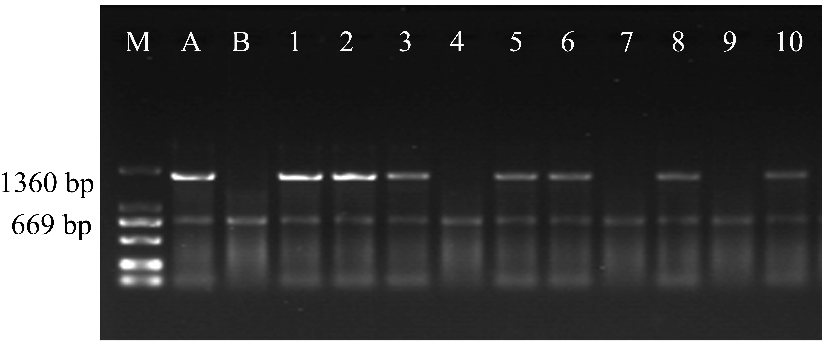
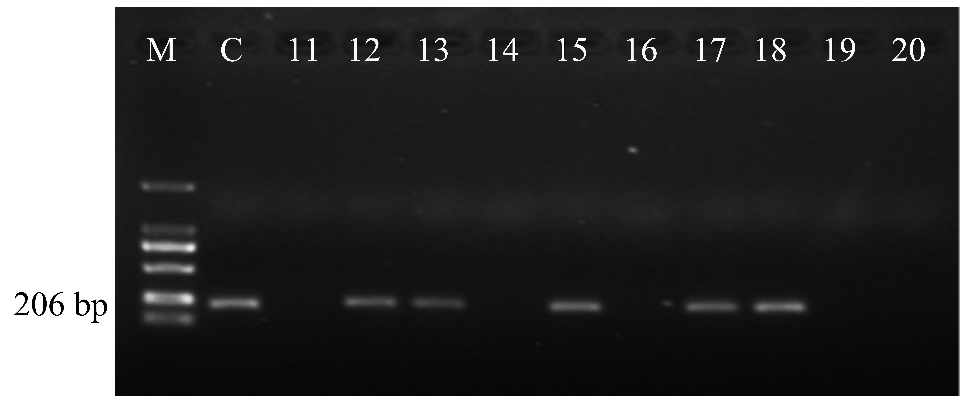
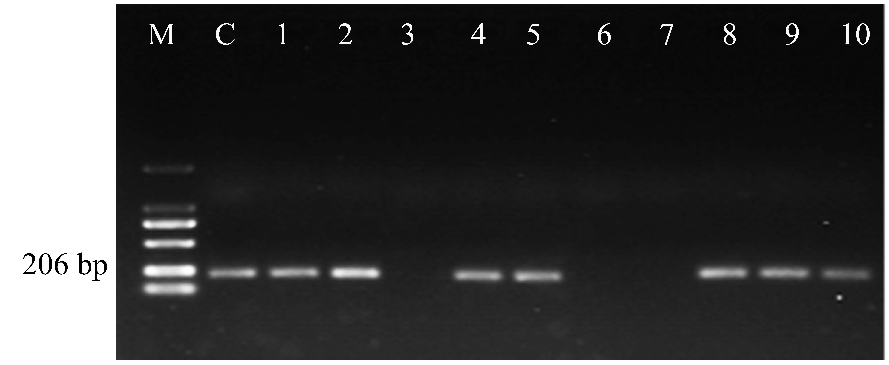
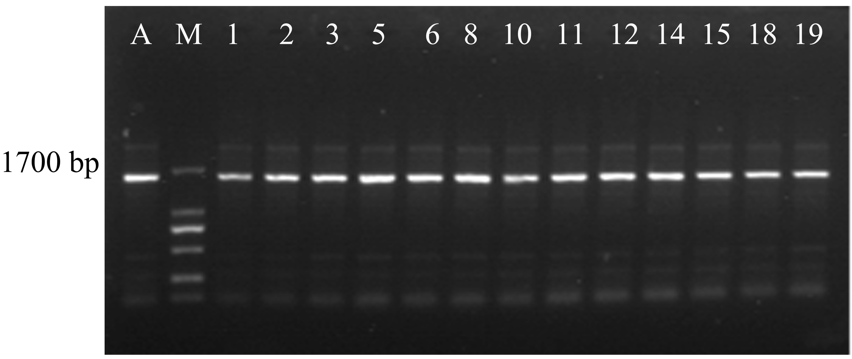
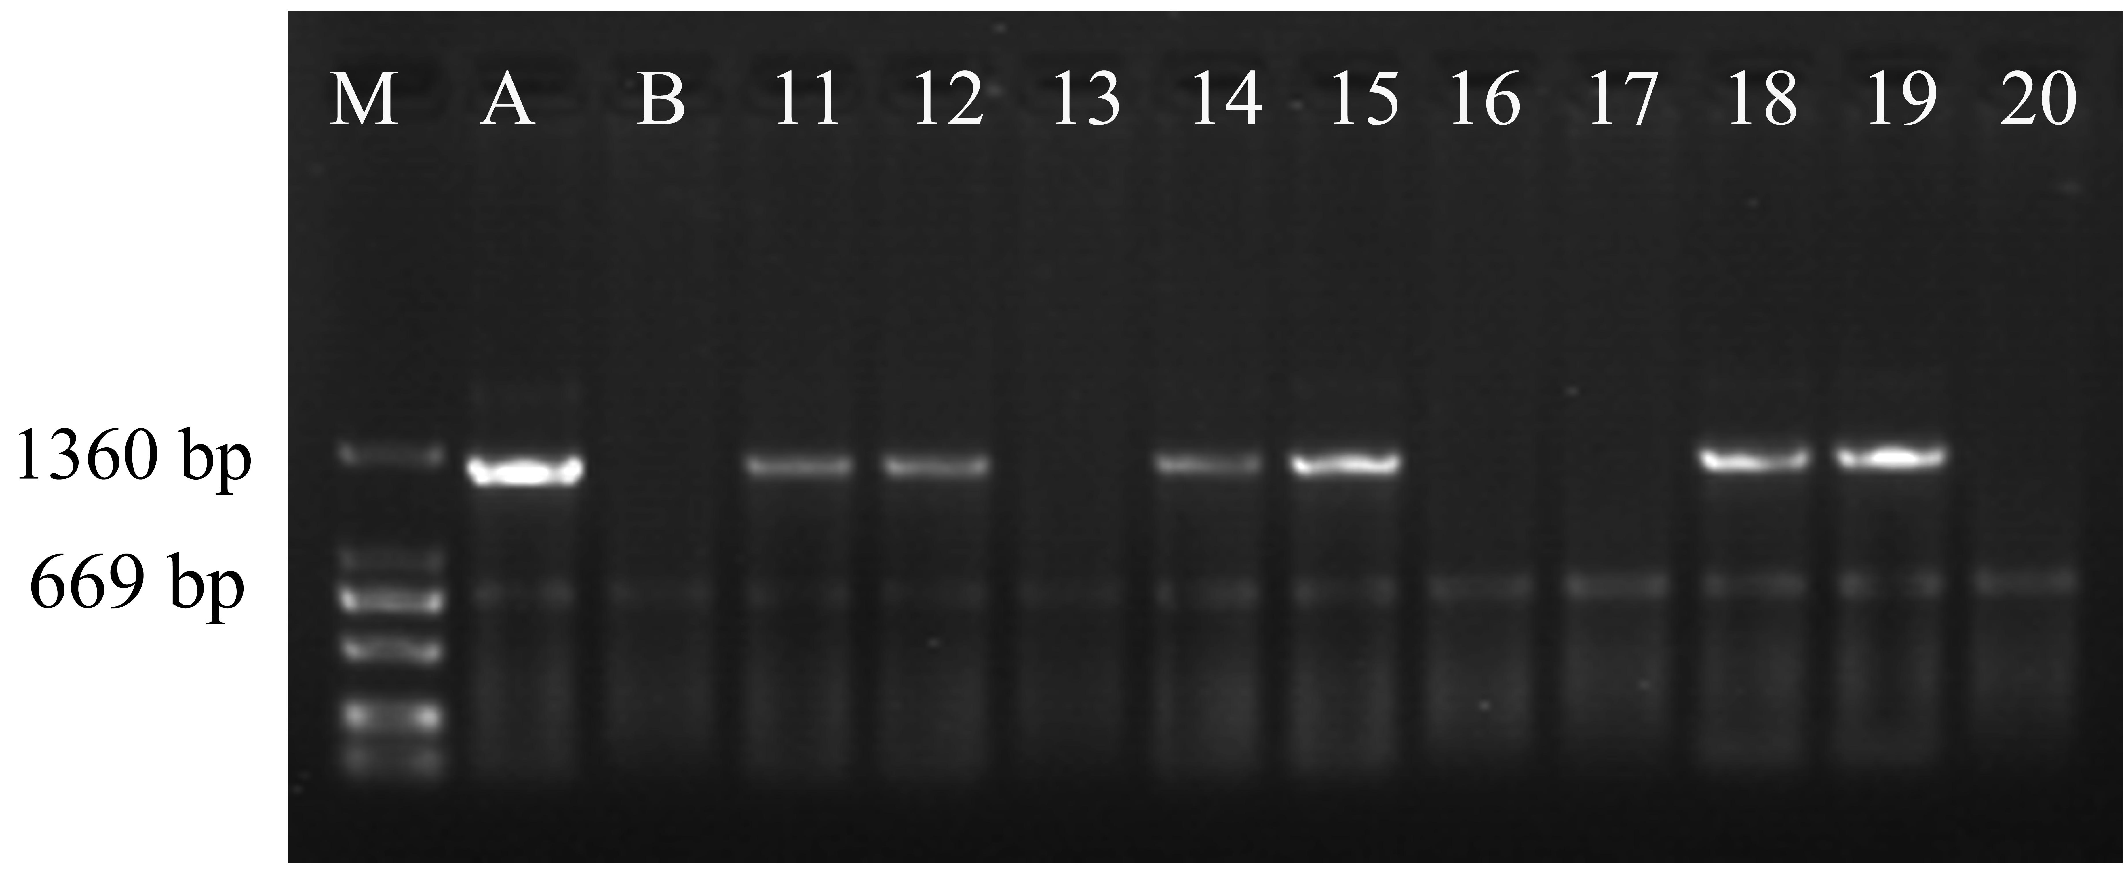
100 bp
500 bp
206 bp
750 bp
2000 bp
1000 bp
669 bp
1369 bp
669 bp
1369 bp
c
d
eE
bB
a
Supplementary Fig. 4 Identification of some F₂ wheat materials from TcLr21-ZKPm36 hybrid
(a-b): Molecular marker detection of Lr21 gene; (c): Single enzyme digestion verification of BstE Ⅱ; (d-e): Molecular marker detection of Pm36 gene; M: marker; A: TcLr21; B: Thatcher; C: ZKPm36: 1-20: F₂ generation of TcLr21-ZKPm36 hybrid wheat. Representative results from three independent replicates are shown.
750 bp
2000 bp
1000 bp
1700 bp
206 bp
100 bp
250 bp
500 bp
250 bp

