Supplementary Materials
Table S1. Full weighted adjacency matrix after removing autoregressive paths
T1 node -> T2 node | IAT-1 | IAT-2 | IAT-3 | IAT-4 | IAT-5 | IAT-6 | IAT-7 | IAT-8 | IAT-9 | IAT-10 | IAT-11 | IAT-12 | IAT-13 | IAT-14 | IAT-15 | IAT-16 | IAT-17 | IAT-18 | IAT-19 | IAT-20 | PSQI-1 | PSQI-2 | PSQI-4 | PSQI-5 | PSQI-6 | PSQI-7
IAT-1 | 0.0 | 0.016 | 0.062 | 0.0 | 0.0 | 0.0 | 0.0 | 0.01 | 0.0 | 0.0 | 0.0 | 0.0 | 0.0 | 0.027 | 0.031 | 0.0 | 0.0 | 0.034 | 0.071 | 0.0 | -0.0 | -0.0 | 0.0 | 0.0 | 0.0 | 0.0
IAT-2 | 0.012 | 0.0 | 0.073 | 0.0 | 0.041 | 0.081 | 0.071 | 0.131 | 0.0 | 0.007 | 0.04 | 0.038 | 0.095 | 0.145 | 0.057 | 0.119 | 0.091 | 0.139 | 0.062 | 0.167 | 0.0 | 0.0 | 0.0 | -0.0 | 0.0 | 0.0
IAT-3 | 0.006 | 0.002 | 0.0 | -0.036 | 0.0 | -0.0 | -0.027 | -0.0 | -0.0 | -0.0 | 0.0 | 0.002 | 0.0 | -0.0 | -0.0 | -0.0 | 0.0 | 0.0 | 0.054 | -0.0 | -0.0 | 0.0 | 0.0 | -0.0 | 0.0 | 0.0
IAT-4 | 0.0 | -0.035 | 0.0 | 0.0 | 0.017 | 0.0 | 0.01 | 0.0 | 0.0 | 0.046 | -0.0 | 0.046 | -0.0 | 0.0 | 0.0 | 0.0 | -0.0 | 0.0 | 0.0 | 0.013 | 0.0 | -0.041 | -0.0 | -0.0 | 0.0 | 0.0
IAT-5 | 0.0 | -0.0 | -0.0 | 0.0 | 0.0 | 0.0 | -0.0 | 0.0 | 0.003 | 0.035 | 0.014 | 0.035 | 0.073 | 0.074 | 0.0 | 0.001 | 0.0 | 0.031 | -0.04 | 0.0 | -0.0 | 0.0 | 0.0 | -0.0 | -0.0 | 0.0
IAT-6 | 0.112 | 0.154 | 0.044 | 0.059 | 0.035 | 0.0 | 0.054 | 0.078 | 0.053 | 0.0 | 0.087 | 0.079 | 0.041 | 0.027 | 0.07 | 0.029 | 0.047 | 0.089 | 0.071 | -0.0 | 0.0 | -0.004 | 0.0 | -0.0 | -0.0 | 0.0
IAT-7 | -0.0 | -0.0 | -0.0 | 0.0 | -0.0 | -0.0 | 0.0 | 0.0 | 0.0 | 0.0 | -0.0 | 0.0 | 0.0 | -0.0 | -0.0 | -0.0 | -0.026 | 0.0 | 0.0 | 0.0 | 0.0 | -0.004 | -0.035 | -0.0 | 0.0 | -0.0
IAT-8 | 0.0 | 0.0 | 0.069 | -0.0 | -0.0 | 0.007 | 0.0 | 0.0 | -0.0 | -0.067 | -0.0 | 0.0 | 0.0 | -0.0 | -0.0 | -0.0 | 0.0 | 0.0 | 0.074 | 0.031 | 0.029 | -0.0 | 0.0 | 0.0 | 0.0 | 0.006
IAT-9 | 0.0 | -0.0 | 0.0 | 0.0 | 0.0 | 0.051 | -0.0 | -0.0 | 0.0 | -0.0 | 0.0 | 0.067 | 0.0 | -0.0 | 0.0 | 0.012 | 0.018 | 0.003 | 0.0 | -0.0 | 0.0 | 0.0 | -0.0 | 0.035 | 0.0 | 0.035
IAT-10 | 0.0 | -0.0 | -0.04 | -0.0 | 0.0 | -0.0 | -0.0 | -0.0 | 0.007 | 0.0 | 0.0 | 0.0 | 0.0 | 0.0 | 0.0 | 0.0 | 0.012 | -0.0 | -0.051 | -0.0 | -0.0 | -0.0 | 0.0 | 0.0 | 0.006 | 0.0
IAT-11 | -0.0 | 0.0 | -0.0 | 0.0 | 0.002 | -0.0 | 0.001 | 0.015 | 0.0 | 0.001 | 0.0 | 0.0 | 0.005 | 0.0 | 0.129 | 0.052 | 0.0 | 0.0 | 0.0 | 0.044 | 0.0 | 0.0 | -0.0 | 0.0 | 0.0 | 0.0
IAT-12 | 0.0 | 0.0 | -0.0 | -0.0 | -0.0 | 0.0 | 0.048 | 0.0 | 0.0 | 0.026 | 0.045 | 0.0 | 0.0 | 0.0 | 0.015 | 0.0 | 0.0 | 0.0 | 0.0 | 0.0 | 0.0 | -0.0 | 0.0 | 0.0 | 0.0 | 0.0
IAT-13 | 0.023 | 0.051 | 0.0 | -0.0 | 0.027 | 0.0 | -0.0 | 0.065 | 0.0 | 0.0 | -0.0 | 0.0 | 0.0 | 0.0 | 0.008 | 0.0 | -0.0 | 0.0 | -0.0 | 0.008 | 0.0 | 0.0 | 0.0 | 0.0 | 0.0 | -0.0
IAT-14 | 0.0 | 0.0 | 0.027 | 0.034 | 0.0 | 0.026 | 0.0 | 0.027 | 0.049 | 0.101 | 0.002 | 0.061 | 0.0 | 0.0 | 0.024 | 0.0 | -0.0 | 0.0 | 0.035 | 0.029 | 0.049 | -0.0 | 0.0 | 0.0 | 0.038 | 0.014
IAT-15 | 0.0 | 0.0 | 0.0 | -0.0 | 0.044 | 0.0 | -0.0 | 0.0 | 0.0 | 0.043 | 0.049 | 0.097 | 0.0 | 0.006 | 0.0 | 0.0 | -0.0 | 0.0 | 0.066 | 0.0 | -0.0 | 0.0 | 0.0 | -0.0 | 0.0 | 0.032
IAT-16 | 0.0 | 0.095 | 0.0 | 0.0 | 0.054 | 0.0 | 0.0 | 0.016 | 0.007 | -0.0 | 0.059 | 0.023 | 0.032 | 0.0 | 0.055 | 0.0 | 0.054 | 0.063 | 0.0 | 0.0 | 0.0 | 0.0 | 0.0 | -0.0 | 0.0 | 0.031
IAT-17 | 0.004 | 0.01 | -0.0 | 0.0 | 0.0 | 0.048 | 0.025 | 0.0 | 0.09 | 0.0 | 0.0 | 0.019 | 0.025 | 0.062 | -0.0 | 0.081 | 0.0 | 0.022 | -0.0 | 0.023 | 0.0 | -0.0 | 0.0 | 0.0 | -0.0 | 0.0
IAT-18 | 0.006 | 0.035 | 0.0 | 0.063 | 0.0 | 0.047 | 0.043 | 0.141 | 0.028 | 0.0 | 0.006 | 0.033 | 0.063 | 0.036 | 0.0 | 0.025 | 0.055 | 0.0 | 0.005 | 0.001 | -0.0 | 0.0 | 0.0 | -0.046 | -0.0 | 0.0
IAT-19 | 0.0 | 0.014 | 0.134 | -0.042 | 0.0 | 0.039 | -0.0 | 0.002 | 0.0 | -0.0 | 0.0 | -0.0 | 0.03 | 0.0 | 0.0 | 0.0 | -0.0 | 0.0 | 0.0 | 0.02 | -0.0 | -0.0 | -0.0 | 0.0 | 0.017 | 0.041
IAT-20 | 0.0 | 0.0 | -0.0 | -0.027 | -0.0 | 0.0 | 0.0 | 0.002 | -0.0 | -0.0 | 0.023 | 0.015 | 0.027 | -0.0 | 0.004 | 0.0 | 0.023 | 0.0 | 0.0 | 0.0 | 0.0 | -0.03 | 0.0 | -0.0 | 0.008 | 0.0
PSQI-1 | -0.0 | 0.0 | 0.0 | -0.0 | 0.026 | 0.0 | 0.0 | -0.0 | 0.027 | -0.0 | -0.0 | -0.0 | -0.0 | -0.0 | 0.0 | 0.0 | -0.004 | 0.019 | 0.0 | 0.0 | 0.0 | 0.0 | 0.006 | -0.0 | 0.057 | 0.029
PSQI-2 | -0.0 | -0.014 | -0.0 | -0.0 | 0.0 | 0.0 | -0.0 | -0.0 | -0.0 | 0.0 | -0.0 | -0.028 | -0.015 | -0.0 | -0.013 | -0.032 | -0.0 | 0.0 | -0.021 | -0.012 | -0.0 | 0.0 | -0.0 | -0.0 | -0.01 | 0.0
PSQI-4 | 0.0 | 0.0 | 0.0 | 0.0 | 0.0 | 0.0 | 0.0 | 0.0 | 0.0 | 0.0 | 0.0 | 0.0 | 0.0 | 0.0 | 0.0 | 0.0 | 0.0 | 0.0 | 0.0 | 0.0 | 0.0 | 0.0 | 0.0 | 0.0 | 0.0 | 0.0
PSQI-5 | 0.0 | 0.0 | 0.0 | -0.0 | 0.017 | 0.012 | -0.0 | 0.0 | 0.046 | 0.038 | 0.031 | 0.015 | -0.0 | -0.0 | 0.0 | 0.039 | 0.015 | 0.0 | 0.012 | 0.0 | 0.093 | 0.046 | 0.029 | 0.0 | 0.032 | 0.059
PSQI-6 | 0.0 | 0.0 | 0.043 | 0.027 | 0.05 | 0.024 | 0.078 | 0.027 | 0.094 | 0.049 | 0.0 | 0.03 | 0.057 | 0.071 | 0.04 | 0.006 | 0.0 | 0.0 | 0.001 | 0.062 | 0.051 | -0.021 | 0.0 | 0.0 | 0.0 | 0.165
PSQI-7 | 0.013 | 0.063 | 0.077 | 0.041 | 0.036 | 0.055 | 0.008 | 0.0 | 0.033 | 0.127 | 0.004 | 0.0 | 0.018 | 0.002 | 0.063 | 0.068 | 0.025 | 0.0 | 0.056 | 0.015 | 0.0 | -0.0 | 0.004 | 0.0 | 0.034 | 0.0
Note. Rows indicate T1 predictor nodes, and columns indicate T2 predicted nodes. Values are standardized LASSO regression coefficients; diagonal autoregressive paths were set to zero.

Figure S1. Bootstrap difference test for node bridge expected influence
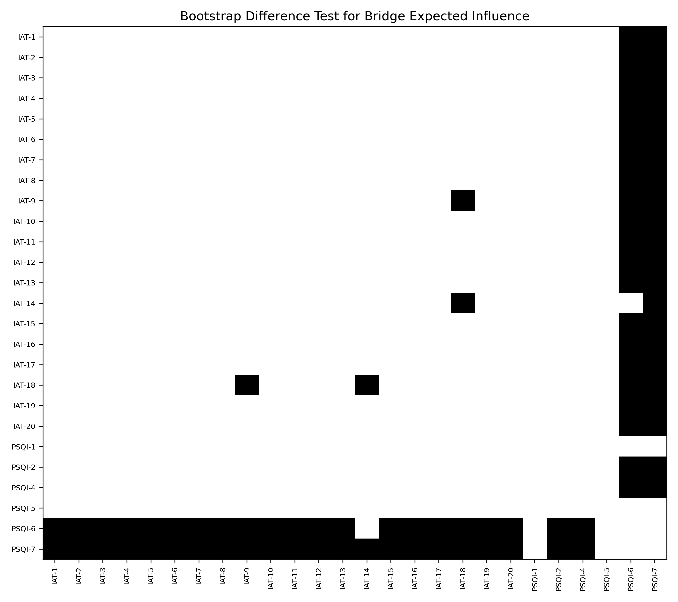
Note. Black cells indicate that the difference in bridge expected influence between the corresponding two nodes did not include zero in the bootstrap 95% confidence interval (300 bootstrap resamples).

Table S2. Sensitivity analysis results
Indicator | lambda.min network | lambda.1se sensitivity network | Consistency index
Number of nonzero edges | 248 | 60 | --
Edge-weight correlation | -- | -- | r=0.708
Bridge expected influence rank correlation | -- | -- | ρ=0.625
Note. The sensitivity network used lambda.1se as the penalty-parameter selection rule and was compared with the lambda.min network reported in the main text.
Table S3. Ranking of node bridge expected influence
Node | Bridge expected influence
PSQI-7 | 0.703
PSQI-6 | 0.658
PSQI-5 | 0.226
IAT-14 | 0.101
IAT-9 | 0.069
PSQI-1 | 0.069
IAT-19 | 0.058
IAT-8 | 0.035
IAT-15 | 0.032
IAT-16 | 0.031
IAT-10 | 0.006
IAT-3 | 0.0
PSQI-4 | 0.0
IAT-17 | 0.0
IAT-5 | 0.0
IAT-2 | 0.0
IAT-13 | 0.0
IAT-12 | 0.0
IAT-11 | 0.0
IAT-1 | 0.0
IAT-6 | -0.004
IAT-20 | -0.022
IAT-7 | -0.04
IAT-4 | -0.041
IAT-18 | -0.046
PSQI-2 | -0.135

