Supplementary Material

Table S1. Full Pointer Year Catalogue
All years in the Ziarat Master Chronology meeting the single, uniformly applied > 70% negative pointer-year threshold used throughout the main text (Section 3.4).
Year (CE) | % Trees Affected | Sample Depth | Above 70% threshold?
1767 | 92.9 | 14 | Yes
1801 | 92.0 | 25 | Yes
1761 | 91.7 | 12 | Yes
1808 | 88.5 | 26 | Yes
1803 | 88.0 | 25 | Yes
1910 | 87.1 | 70 | Yes
1820 | 79.3 | 29 | Yes
1929 | 77.8 | 81 | Yes
1919 | 77.3 | 75 | Yes
1827 | 75.8 | 33 | Yes
2010 | 73.3 | 101 | Yes
1776 | 70.6 | 17 | Yes
1831 | 70.6 | 34 | Yes
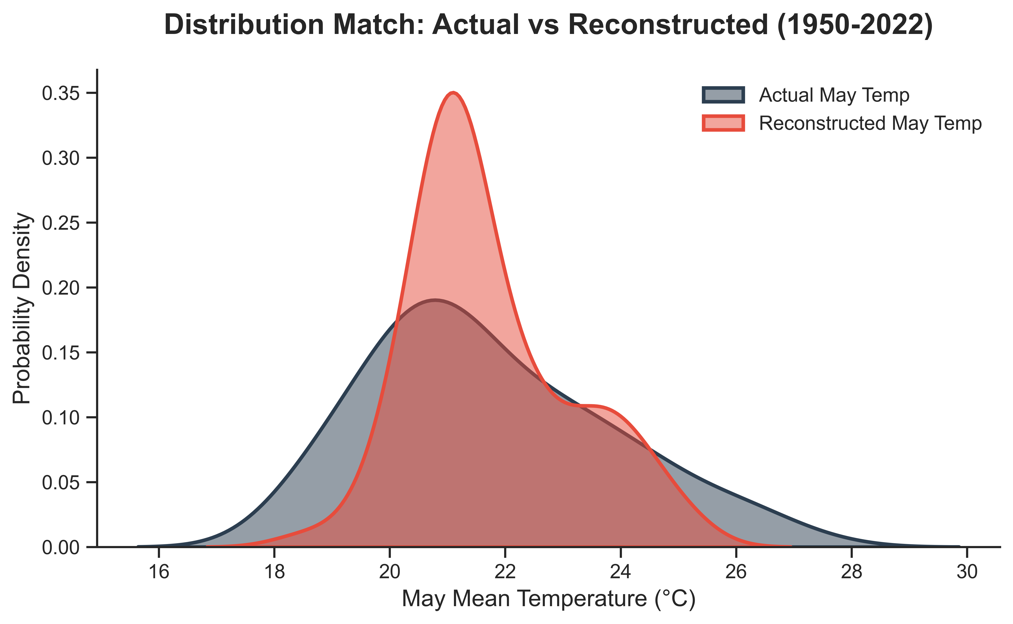
Figure S1. Distribution comparison of actual versus reconstructed May mean temperature during the calibration period (1950–2022 CE). Kernel density estimates show that the reconstruction captures the modal temperature range reasonably well but produces a narrower, more sharply peaked distribution than the instrumental record and underestimates density in the extreme warm tail (> 25°C). This is the expected signature of linear-regression variance attenuation in single-site dendroclimatic models (Cook et al., 1994; Cook et al., 1999) and is discussed critically, including its implications for interpreting modern-warmth claims, in Sections 4.3 and 5.2 of the main text.
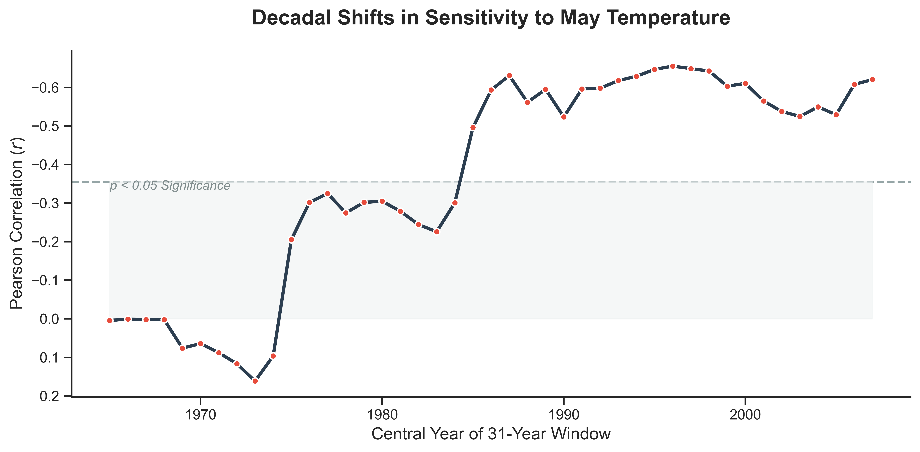
Figure S2. Temporal stability of the climate-growth relationship. Points show the 31-year sliding-window Pearson correlation (r) between the Juniperus excelsa master chronology and CRU TS4.07 May mean temperature, centered on the year given on the x-axis, over the continuous instrumental period (1950–2022). The shaded band indicates the region where correlations do not reach the p<0.05 significance threshold. Correlations are weak and inconsistent for windows centered before the mid-1970s, strengthen sharply for windows centered from the mid-to-late 1970s onward, and reach r ≈ −0.55 to −0.66 for most windows centered from the mid-1980s through the 2000s. As discussed in Section 4.5 of the main text, we interpret this most parsimoniously as a warming-driven physiological threshold response, while noting that chronic anthropogenic disturbance over the same period is a plausible, non-exclusive compounding factor that this analysis alone cannot exclude.
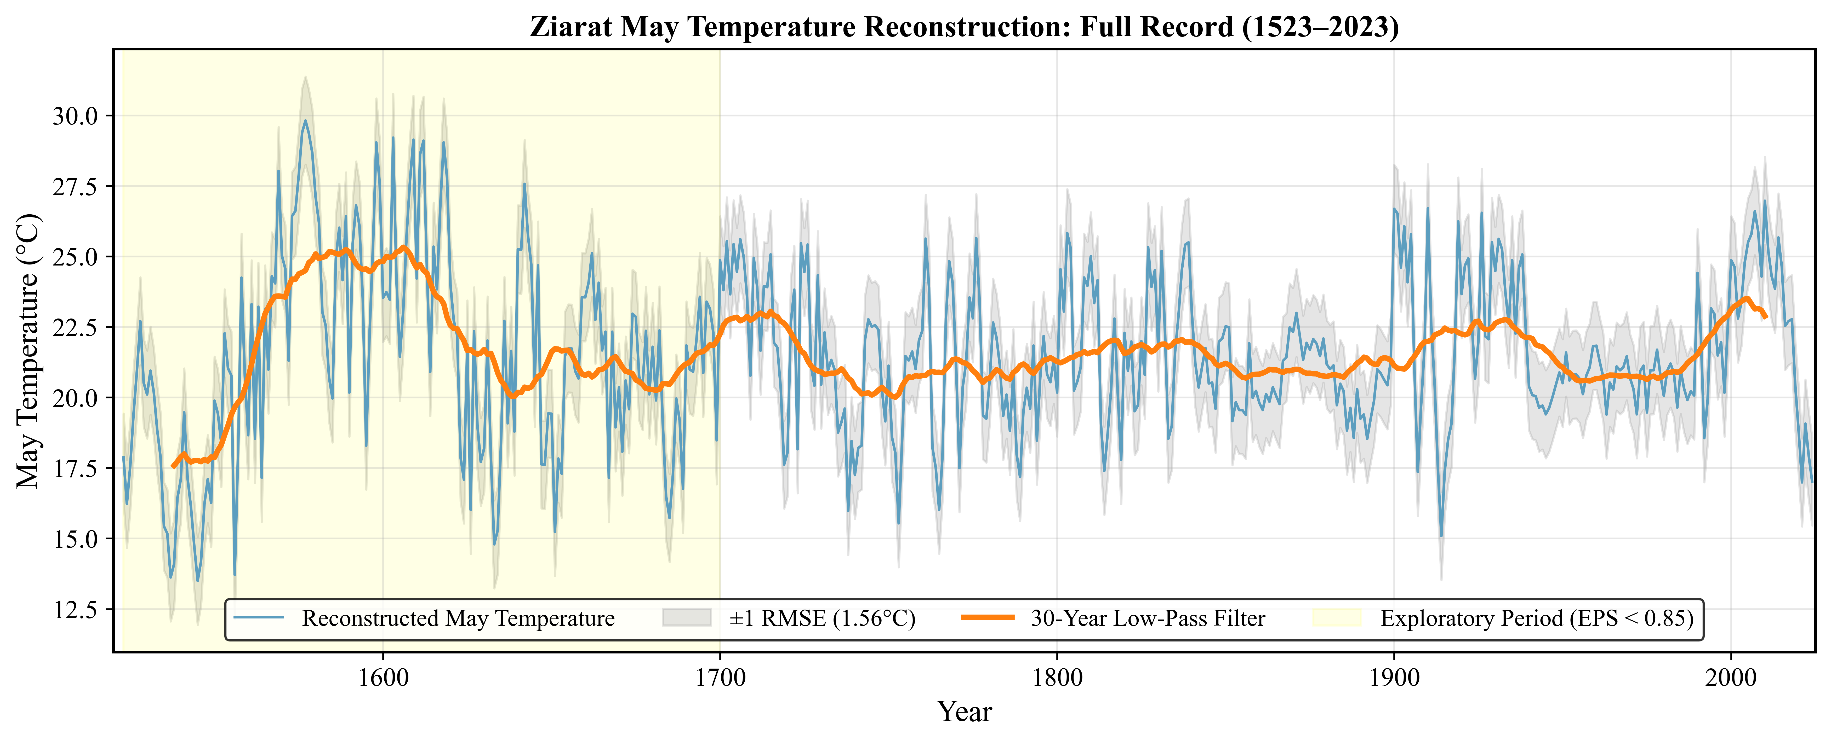
Figure S3. Full-length Ziarat May temperature reconstruction, 1523–2023 CE. The shaded band (1523–c.1700 CE) marks the exploratory, EPS < 0.85 interval in which sample depth falls below the 10–15-series threshold required for reliable paleoclimate interpretation (as low as a single tree before c. 1650 CE; Fig. 3b); no quantitative climatic conclusion in the main text is drawn from this shaded interval. The unshaded 1700–2023 CE portion is the robust record presented as Fig. 5 in the main text. This figure is provided so that the full multi-century pattern remains visible and available for comparison with other regional records, while keeping the distinction between exploratory and robust intervals explicit.

