Supplementary Information for:
Increasing coldward shift of karst vegetation carbon sink driven by climate warming

Supplementary Table S1. Fit indices of structural equation models across different warm–cold dimensions.
Supplementary Table S2. Direct, indirect, and total effects of climate factors on NPP across different dimensions.
Supplementary Fig. S1. Spatial trends of annual precipitation and temperature under historical and future climate scenarios.
Supplementary Fig. S2. Spatial distribution of slope-aspect classes in the karst trough valley.
Supplementary Fig. S3. Spatial patterns of environmental factors during 2000–2020.

Table S1. Fit indices of structural equation models across different warm–cold dimensions.
Model | CMIN/DF | GFI | IFI | AIC | RMSEA | SRMR
Sunny slope NPP | 1.59 | 0.96 | 0.96 | 216.65 | 0.17 | 0.09
Shady slope NPP | 1.76 | 0.95 | 0.94 | 222.35 | 0.19 | 0.09
Aboveground NPP | 0.80 | 0.95 | 1.01 | 1143.83 | 0.00 | 0.08
Belowground NPP | 0.34 | 0.98 | 1.03 | 1250.55 | 0.00 | 0.04
High elevation NPP | 5.53 | 0.74 | 0.66 | 288.72 | 0.46 | 0.23
Low elevation NPP | 6.21 | 0.71 | 0.84 | 198.93 | 0.50 | 0.31

Table S2. Direct, indirect, and total effects of climate factors on NPP across different dimensions.
factor | Direct  effects | Indirect  effects | Total effects | Direct  effects | Indirect  effects | Total effects
Slope aspect | Sunny slope |  |  | Shady slope
CO₂ | 0.07 | 0 | 0.08 | 0.15 | 0 | 0.15
T | -0.07 | 0.07 | 0.01 | -0.01 | 0.01 | 0
P | 0.54 | 0.28 | 0.81 | 0.58 | 0.24 | 0.82
ESM | 0.35 | 0 | 0.35 | 0.30 | 0 | 0.30
SR | -0.06 | 0 | -0.06 | -0.01 | 0 | -0.01
Elevation | Low elevation |  |  | High elevation
CO₂ | -0.03 | 0 | -0.04 | -0.03 | 0.05 | 0.02
T | -0.01 | 0 | -0.01 | 0 | 0.14 | 0.14
P | 0.03 | -0.03 | 0 | 0.57 | 0.13 | 0.70
pCO₂ | 1.00 | -0.01 | 0.99 | 0.18 | 0 | 0.19
ESM | -0.03 | 0 | -0.03 | 0.28 | 0 | 0.28
Spatial | Aboveground |  |  | Belowground
CO₂ | 0.11 | 0.04 | 0.15 | 0 | 0 | 0
T | -0.01 | 0.11 | 0.10 | 0 | 0 | 0
P | 0.59 | 0.24 | 0.82 | 0.55 | 0.19 | 0.74
pCO₂ | 0.00 | 0 | 0.00 | 0.17 | -0.04 | 0.13
ESM | 0.28 | 0 | 0.28 | 0.22 | 0 | 0.22
SR | -0.08 | 0.02 | -0.06 | -0.06 | -0.07 | -0.13
ST | 0 | 0 | 0 | 0.15 | 0.01 | 0.16
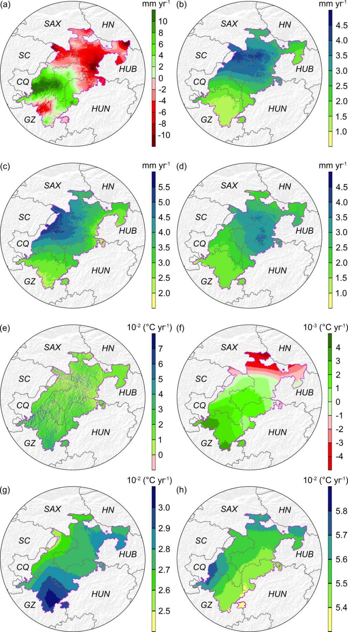
Fig. S1. Spatial trends of annual precipitation and temperature under historical and future climate scenarios. (a) Annual precipitation trend during 2000–2020; (b) precipitation trend under SSP119 during 2021–2100; (c) precipitation trend under SSP245; (d) precipitation trend under SSP585; (e) annual mean temperature trend during 2000–2020; (f) temperature trend under SSP119 during 2021–2100; (g) temperature trend under SSP245; (h) temperature trend under SSP585.
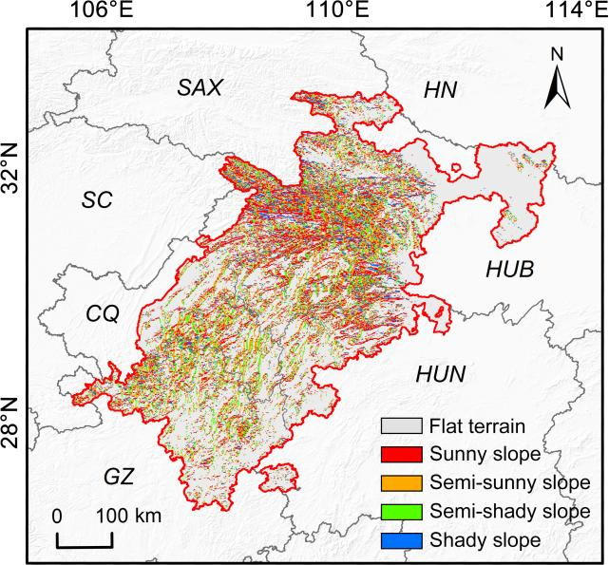
Fig. S2. Spatial distribution of slope-aspect classes in the karst trough valley.
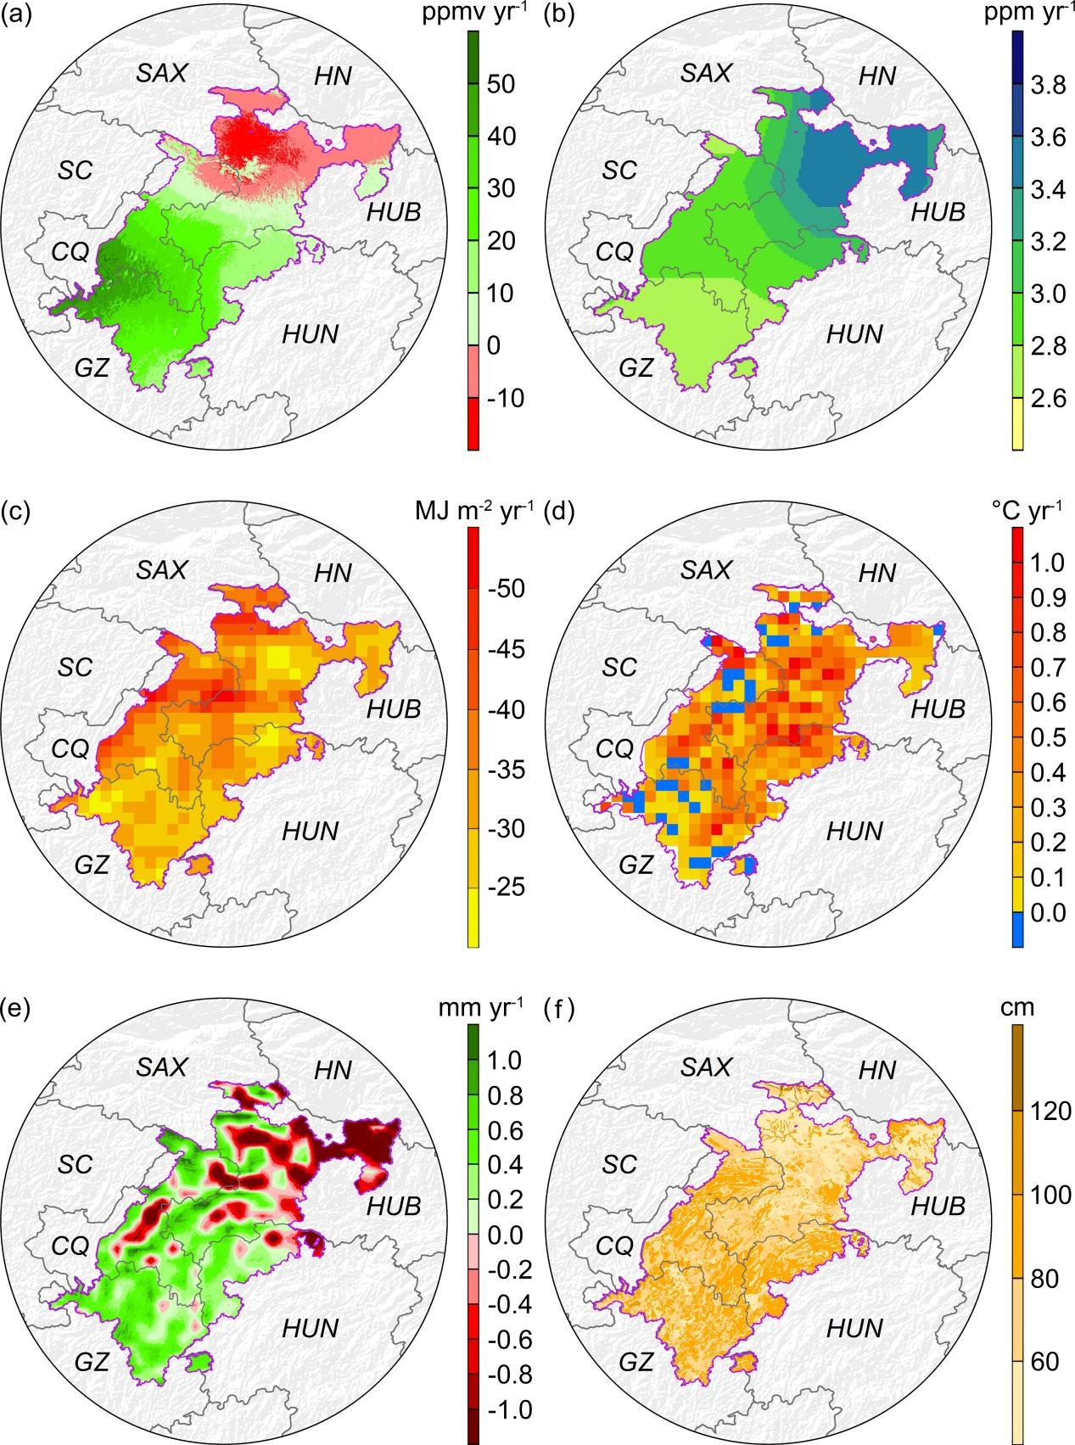
Fig. S3. Spatial patterns of environmental factors during 2000–2020. (a) Trend in soil CO₂ partial pressure; (b) trend in atmospheric CO₂ concentration; (c) trend in solar radiation; (d) trend in soil temperature; (e) trend in effective soil moisture; and (f) spatial distribution of soil depth.

