Supporting Information
Boosting the Supercapacitor Performance of CuWO₄ Deposited on Ni Foam
E.P. Ribeiroª, S.S. Eduardo^{b}, R.M.P. Da Silvaª, M.J.S. Costaª, R.A. Antunes^{c}, F.A.A. Barros^{c}, R.S. Santosª, L.S. Cavalcante^{a*}
ªPPGQ-CETEM-GERATEC-GrEETec, Universidade Estadual do Piauí, Rua: João Cabral, N. 2231, P.O. Box 381, 64002–150, Teresina-PI, Brazil
^{b}Instituto de Química, Universidade Federal do Rio de Janeiro (UFRJ), Rio de Janeiro, RJ 21941–909, Brazil
^{c}Center for Engineering, Modeling and Applied Social Sciences - Federal University of ABC/UFABC, Bangu, Santo André, 09210–580, SP, Brazil
* Tel: +55 86 3213-7942, Mob: +55 86 99412-1001. *Email address: laeciosantos@ccn.uespi.br (L.S. Cavalcante)
Preprint submitted to Journal of Inorganic and Organometallic Polymers and Materials August 19, 2026

Micro-Raman spectroscopy analysis of CuWO₄ crystals
Micro-Raman spectroscopy is a powerful technique for failure analysis, sample identification, characterization, and structural analysis of different oxide materials. It can verify the degree of order/disorder in the lattice at short ranges [RSI-1]. We have performed this spectral analysis to find the vibrational modes of the triclinic structure of our CuWO₄ crystals. Based on the group theory calculations, confirms (3N = 36 active vibrational modes) for the tungstates with triclinic structure, space group (P$\overline{1}$), and point group symmetry (C_{i}) at infrared and Raman spectra [RSI-2], as described in equation (I), below:
$Γ_{\left\{\left(Raman\right) +\left[Infrared\right]\right\}}=\{\left(18 A_{g}\right)+\left[{18 A}_{u}\right]\}$ (I)
The symbols g and u derive from the German words gerade and ungerade, meaning even and odd, respectively. Therefore, only gerade species related to 18A_{g} vibrational modes are active at the Raman spectrum, while the ungerade species assigned to 18A_{u} vibrational modes are active at the Fourier-transform infrared spectrum. Therefore, we have allowed a total of 18 Raman active vibrational modes expected for the CuWO₄ crystal, as presented in equation (II) below:
$Γ_{(Raman)}=\left(18 A_{g}\right)$ (II)
The Raman spectrum of CuWO₄ crystals reveals multiple distinct and intense vibrational peaks within the 50 to 1,000 cm⁻¹ range, providing compelling evidence of the highly organized triclinic crystal structure of the CuWO₄ phase, as illustrated in Fig. SI-1.
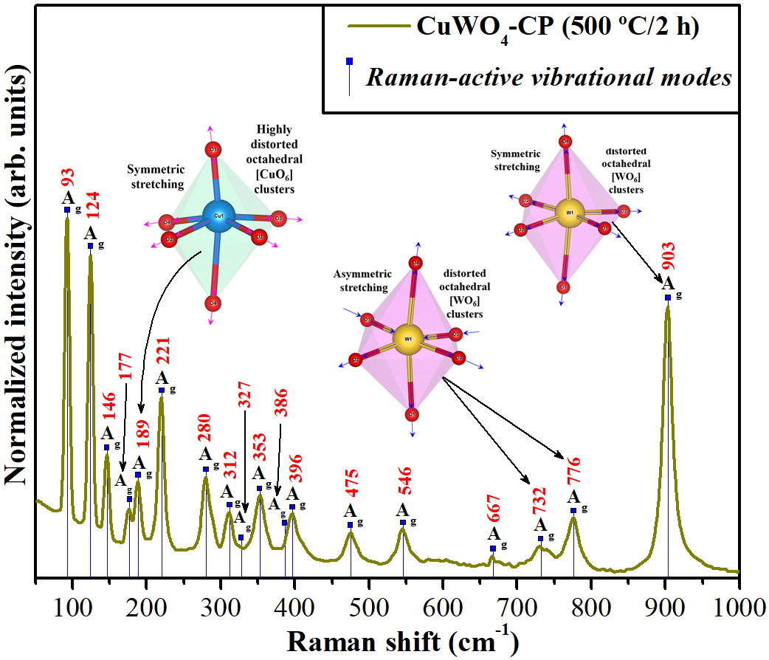
Fig. SI-1: micro-Raman spectrum of α-CuWO₄ crystals. Inset shows a typical symmetric stretching vibration and asymmetric of O–W–O bonds in distorted octahedral [WO₆] clusters and symmetric stretching vibration of O–Cu–O bonds in highly distorted octahedral [CuO₆] clusters. The vertical dotted lines with symbol () indicate the relative positions and intensities of Raman-active modes of CuWO₄ crystals, respectively.

Fig. SI-1 shows the micro-Raman spectrum for CuWO₄ crystals prepared by CP method and heat-treated at 500 ºC for 2 h, as it was this sample that presented the good t degree of crystallinity. In it is possible to notice the presence of 18 active vibration modes (93, 124, 146, 177, 189, 221, 280, 312, 327, 353, 386, 396, 475, 546, 667, 732, 776, and 903 cm⁻¹) in the Raman spectrum, characteristic of the triclinic structure space group (P$\overline{1}$), and point group symmetry (C_{i}). Corroborating with the calculations of the group theory for the same [RSI-3, RSI-4]. Based on the literature, these Raman spectrums show the external and internal active modes present in tungstates [RSI-5]. The distorted octahedral [WO₆] clusters have symmetry (O_{h}), in which the active Raman vibrational A_{g} mode at around 903 cm⁻¹ is related to internal mode with symmetric stretching of the ←O←W→O→ bonds [RSI-6], while the two active Raman vibrational A_{g} modes found at 732 and 776 cm⁻¹ are ascribed to asymmetric stretching of the ←O→W→O←W←O→ bonds [RSI-7]. Moreover, the others internal modes or phonon vibrations of the lattice located from 667 to 221 cm⁻¹ are related to the active Raman vibrational A_{g} modes of the distorted octahedrons [WO₆] clusters interconnected with highly distorted octahedral [CuO₆] clusters [RSI-8,RSI-9]. The external modes from 189 to 93 cm⁻¹ are related to the active Raman vibrational A_{g} modes, which are assigned to highly distorted octahedral [CuO₆] clusters [RSI-10]. In particular, the active Raman vibrational A_{g} mode at around 193 cm⁻¹ is related to external mode with symmetric stretching of the ←O←Cu→O→ bonds [RSI-11]. The micro-Raman results align with the XRD patterns findings, providing strong evidence for the notion that a precisely organized triclinic structure facilitated the formation of the α-CuWO₄ crystals.

FT-IR spectra analysis

The FT-IR spectrum analysis is a key method that provides valuable insights into the vibrational modes of the chemical bonds in CuWO₄ crystals, particularly the (O–Cu–O)/(O–W–O) bonds of the triclinic lattice [RSI-12]. As shown in equation (7), the CuWO₄ crystals exhibit 36 active vibrational modes. However, by excluding the 18 Raman active vibrational modes, we are able to focus on the 18 infrared active modes, as demonstrated in equation (III):

$Γ_{(Infrared)}=\left(18 A_{u}\right)$ (III)
Fig. SI-2 shows the FT-IR spectrum of CuWO₄ crystals, which reveals multiple distinct and intense vibrational bands within the 400 to 1,000 cm⁻¹ range.
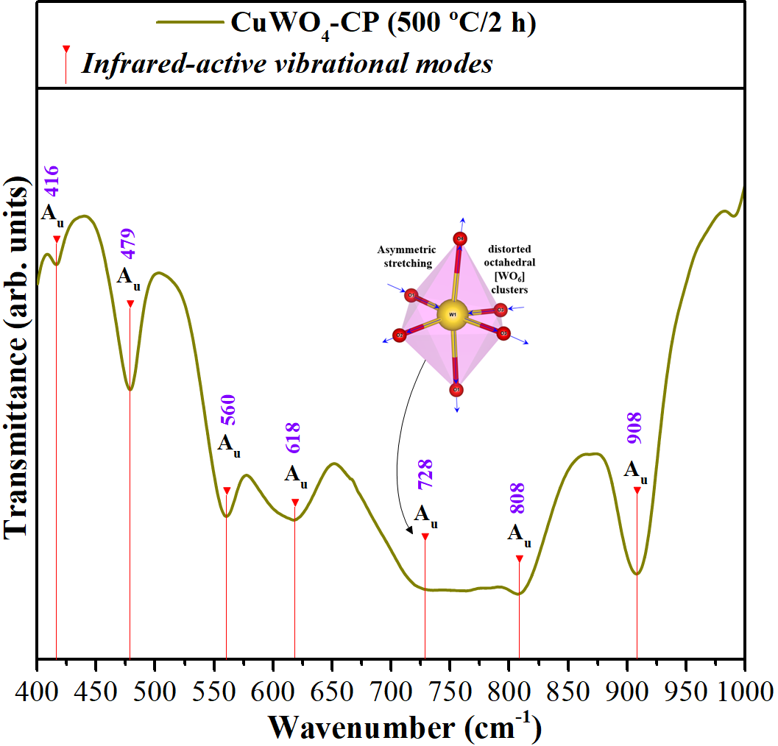
Fig. SI-2: FT-IR spectrum of α-CuWO₄ crystals. Inset shows a typical assymmetric stretching vibration of O–W–O bonds in distorted octahedral [WO₆] clusters. The vertical dotted lines with symbol () indicate the relative positions and intensities of IR-active modes of CuWO₄ crystals, respectively.

Among the 18 vibrational modes predicted theoretically in IR-spectrum, it is possible to detect only 7 IR-active vibrational bands related to A_{u} modes detected in our FT-IR spectrophotometer. Two points are fundamental that justify the presence of less than 18 IR-active vibrational modes. The first point is related to low symmetry of triclinic lattice of CuWO₄ crystals, and the second is related to the low detection level of the equipment used in the far region. In this way, the Cu, W, and O atoms dynamics moving after IR laser interaction at highest energy modes can be understood based on the primary atomic shifts. Therefore, our α-CuWO₄ crystals exhibit only the more intense IR-modes in the region from 400 to 1,000 cm⁻¹, each characteristic of CuWO₄ crystals with a triclinic lattice. These vibrational A_{u} modes correspond to the O–Cu–O vibration modes in the highly distorted octahedral [CuO₆] clusters, and the active infrared vibrational A_{u} modes at 908 cm⁻¹ are attributed to the symmetric stretching modes in the distorted octahedral [WO₆] clusters [RSI-13]. The vibrational modes at 808 cm⁻¹ and 728 cm⁻¹ are related to the antisymmetric stretching vibration modes of the distorted octahedral [WO₆] clusters [RSI-14]. The active infrared vibrational A_{u} modes at positions of 560 and 618 cm⁻¹ are precisely ascribed to symmetric stretching vibration (←O←W→O←W→O→) between the [WO₆]↔[WO₆] clusters [RSI-15]. The vibrational modes at 479 and 416 cm⁻¹ in the FT-IR spectrum are also accurately identified as the symmetric stretching vibrations of (O–Cu–O) bonds in the highly distorted octahedral [CuO₆] clusters, as shown in inset Fig. SI-2, [RSI-16]. These findings significantly contribute to the understanding of crystallography, spectroscopy, and materials science, which is a testament to the value of our research.

UV-vis spectrum and optical gap energy (E_{gap}) analysis of CuWO₄ crystals
The method described by Kubelka and Munk [RSI-17] provides an effective way to calculate the optical band gap energy (E_{gap}) in semiconductors [RSI-18]. The resulting Kubelka-Munk equation (III) is versatile, as it can be applied to any wavelength [RSI-19].
${F(R}_{∞}) ≡ \frac{{(1-R}_{∞})}{{2 R}_{∞}}= \frac{K}{s}$ (III)
The ${F(R}_{∞})$ is the Kubelka–Munk function, R∞ is the reflectance, k is the molar absorption coefficient and s is the scattering coefficient. The E_{gap} and absorption coefficient of semiconductor oxides [RSI-20,RSI-21] can be calculated using the following equation (IV):
$αhν= C_{1 }{( hν- E_{gap})}^{n}$ (IV)
where α is the linear absorption coefficient of the material, hv is the photon energy, C₁ is a constant of proportionality, and the n is a constant, associated with the type of electron transition. Therefore, we have four types of electronic transitions, related to n = 0.5 to direct allowed n = 2 for indirect allowed, n = 1.5 for direct forbidden, and n = 3 for indirect forbidden [RSI-21]. According to the literature, CuWO₄ crystals have an optical absorption spectrum governed by indirect transitions [RSI-22]. This means that immediately after the electronic absorption, the electrons that were located in the conduction band (BC), which have minimum energy, have the ability to relax to the valence band (VB), which has maximum energy state at different k-points in the Brillouin zone [RSI-23]. Based on this information, the o E_{gap} of CuWO₄ crystals was calculated using n = 2 in equation (IV). Then, using equation (V), a modified Kubelka-Munk equation was obtained, as shown below:
${[F\left(R_{∞}\right)hν]}^{0.5}= C_{2 }(hν- E_{gap})$ (V)
The values of [F(R∞) hν]^{0.5} versus hν were obtained, and, using equation (V), the E_{gap} values of the CuWO₄ crystals were calculated by extrapolating the linear portion of the UV-Vis curve to the y-axis intercept.
Fig. SI-3 shows the UV–Vis spectrum for CuWO₄ crystals heat-treated at 500 ºC for 2 h prepared by the CP method.
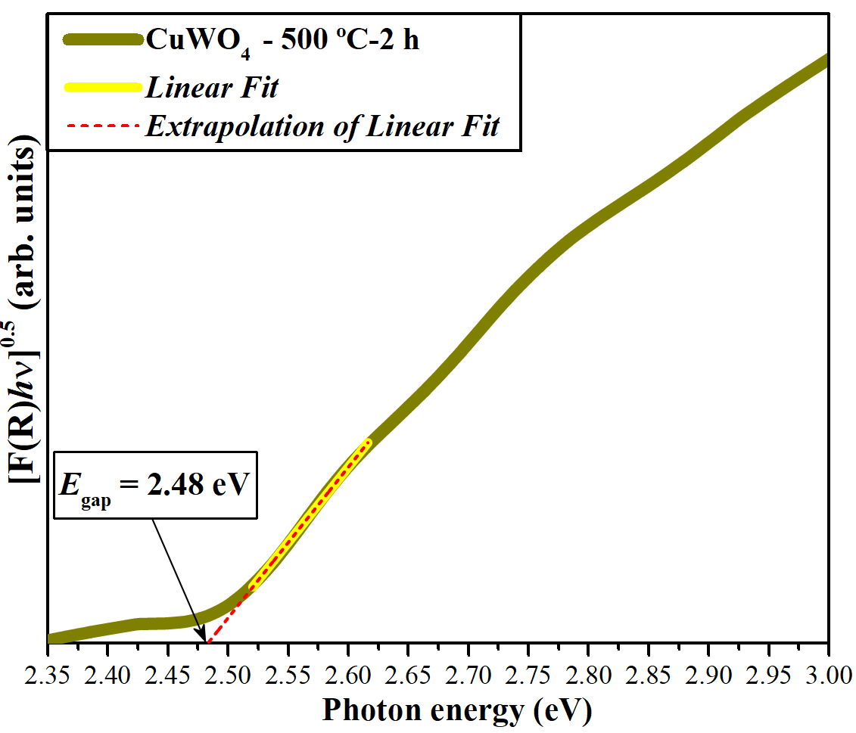
Fig. SI-3: UV–vis transmittance spectra and corresponding Kubelka-Munk plot of α-CuWO₄ crystals.

As displayed in Fig. SI-3, the proﬁles of the UV–vis spectra of the CuWO₄ crystals indicate an optical behavior characteristic of structurally-ordered crystalline materials. This sample heat-treated at 500 ºC for 2 h exhibit an E_{gap} value at around 2.48 eV, may be associated with the presence of a single triclinic CuWO₄ phase with low symmetry, highly distorted octahedral [CuO₆] clusters and distorted octahedral [WO₆] clusters [RSI-24]. Its possibly related to the Jahn-Teller effect (d^{n}; n = 9) [RSI-25], presence of intermediary electronic levels, or electronic structure defects, as previously explained in Fig. SI-3.

TGA/DSC measurements analysis
The thermal decomposition behavior of the coprecipted precursor powders analyzed by differential scanning calorimetry and thermogravimetric analysis is shown in Fig. S4(a,b), respectively.
(a) (b)
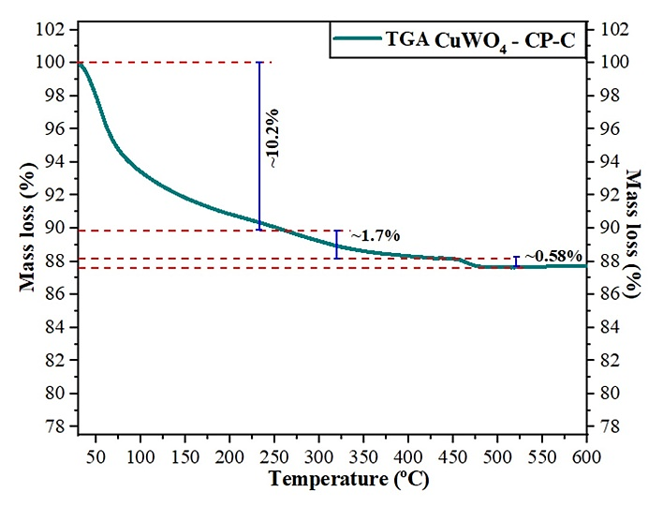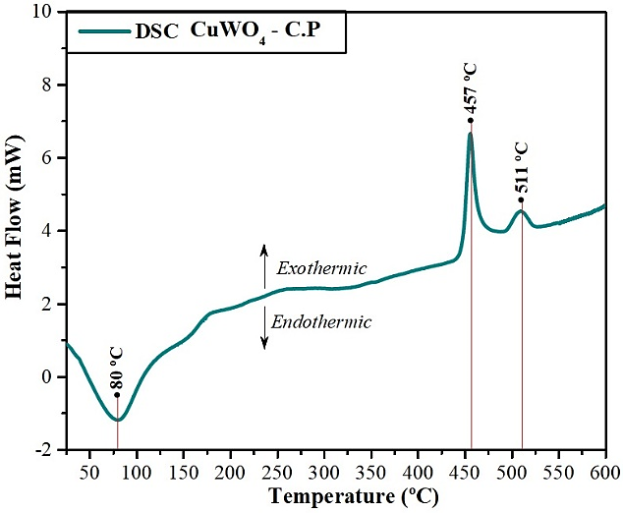
Figs. S4(a,b): TGA/DSC curves of the dried coprecipitated powders, respectively.

Reference for Supporting Information
[RSI-1] D.K. Pathak, C. Rani, A. Sati, R. Kumar, ACS Phys. Chem. Au (2024).
[RSI-2] S.A.T. Redfern, Phys. Rev. B Condens. Matter 48 (1993) 5761–5765.
[RSI-3] B. Polyakov, A. Kuzmin, S. Vlassov, E. Butanovs, J. Zideluns, J. Butikova, R. Kalendarev, M. Zubkins, J. Cryst. Growth 480 (2017) 78–84.
[RSI-4] J. Ruiz-Fuertes, M.N. Sanz-Ortiz, J. González, F. Rodríguez, A. Segura, D. Errandonea, J. Phys. Conf. Ser. 215 (2010) 012048.
[RSI-5] J. Ruiz-Fuertes, D. Errandonea, A. Segura, F.J. Manjón, Z. Zhu, C.Y. Tu, High Press. Res. 28 (2008) 565–570.
[RSI-6] T.T. Basiev, A.A. Sobol, Y.K. Voronko, P.G. Zverev, Opt. Mater. (Amst.) 15 (2000) 205–216.
[RSI-7] R. Salimi, A.A. Sabbagh Alvani, N. Naseri, S.F. Du, D. Poelman, New J Chem 42 (2018) 11109–11116.
[RSI-8] J. Ahmed, T. Ahamad, N. Alhokbany, B.M. Almaswari, T. Ahmad, A. Hussain, E.S.S. Al-Farraj, S.M. Alshehri, ChemElectroChem 5 (2018) 3938–3945.
[RSI-9] A. Kuzmin, A. Kalinko, R.A. Evarestov, Acta Mater. 61 (2013) 371–378.
[RSI-10] A. Sarwar, A. Razzaq, M. Zafar, I. Idrees, F. Rehman, W.Y. Kim, Results Phys. 45 (2023) 106253.
[RSI-11] Z. Lin, W. Li, G. Yang, Appl. Catal. B 227 (2018) 35–43.
[RSI-12] G. Bakradze, E. Welter, A. Kuzmin, J. Phys. Chem. Solids 172 (2023) 111052.
[RSI-13] A. Thomas, C. Janáky, G.F. Samu, M.N. Huda, P. Sarker, J.P. Liu, V. van Nguyen, E.H. Wang, K.A. Schug, K. Rajeshwar, ChemSusChem 8 (2015) 1652–1663.
[RSI-14] D. Xiang, X. Jin, G. Sun, C. Zhong, S. Gao, Dalton Trans. 53 (2024) 7839–7847.
[RSI-15] R. Chen, J. Xia, Y. Chen, H. Shi, Wuli Huaxue Xuebao 39 (2022) 2209012–2209010.
[RSI-16] K. Aravindraj, S. Mohana Roopan, J. Photochem. Photobiol. A Chem. 456 (2024) 115832.
[RSI-17] J. Ji, H. Zhuang, L. Zhou, Y. Zhang, Appl. Catal. A Gen. 677 (2024) 119696.
[RSI-18] J. Kalita, A. Bose, D. Chakraborty, L. Bharali, S.S. Dhar, ChemistrySelect 9 (2024).
[RSI-19] P. Kubelka, F.M. August, Z. Tech. Phys. 12 (1931) 593–601.
[RSI-20] R. Alcaraz de la Osa, I. Iparragirre, D. Ortiz, J.M. Saiz, ChemTexts 6 (2020).
[RSI-21] M.L. Myrick, M.N. Simcock, M. Baranowski, H. Brooke, S.L. Morgan, J.N. McCutcheon, Appl. Spectrosc. Rev. 46 (2011) 140–165.
[RSI-22] J. Klein, L. Kampermann, B. Mockenhaupt, M. Behrens, J. Strunk, G. Bacher, Adv. Funct. Mater. 33 (2023) 2304523.
[RSI-23] T. Montini, V. Gombac, A. Hameed, L. Felisari, G. Adami, P. Fornasiero, Chem. Phys. Lett. 498 (2010) 113–119.
[RSI-24] M.V. Lalić, Z.S. Popović, F.R. Vukajlović, Comput. Mater. Sci. 63 (2012) 163–167.
[RSI-25] N. Gaillard, Y. Chang, A. DeAngelis, S. Higgins, A. Braun, Int. J. Hydrogen Energy 38 (2013) 3166–3176.

