Water- and energy-efficient dialysate flow optimisation in haemodialysis using a data-driven porous media model
Ruhit Sinha*, Anne E. Staples
Department of Mechanical Engineering, Virginia Tech
*correspondence: ruhitsinha@vt.edu

Supplementary Notes

Ergun equation
Ergun (1952)¹ introduced a semi-empirical relation for pressure loss gradient based on fluid flow data in a packed column, which was later modified by Mehta and Hawley (1969)² to include a wall-effect parameter, given by:
 | $${\left(\frac{∆P_{D}}{L_{eff}}\right)}_{zz}=\frac{150M^{2}μ}{D_{p}^{2}}\frac{{\left(1-ϵ\right)}^{2}}{ϵ^{3}}u_{Dsup}+\frac{1.75Mρ}{D_{p}}\frac{\left(1-ϵ\right)}{ϵ^{3}}u_{Dsup}^{2}$$ | (S1)
where ΔP_{D} is the absolute pressure difference between two points along the axis of the packed column, L_{eff} is the effective distance between the two points considered, ϵ is the void fraction or bundle porosity, μ is the viscosity of the fluid, ρ is the density of the fluid, D_{p} is the characteristic diameter of the porous media, M is the wall effect parameter (Equation S13), u_{Dsup} is the superficial velocity of the fluid flowing through the packed column (Equation 13).
The Ergun equation (Equation S1) is also represented in its dimensionless form, given by
 | $$f^{'}=\frac{α}{Re'}+γ$$ | (S2)
where α is called the Blake-Kozeny constant and typically takes the value 150 and γ is called the Burke-Plummer constant and typically takes the value of 1.75. Another set of values for these constant widely used are α = 180 and γ = 1.8-4 depending particle roughness, as suggested by Macdonald et al. (1979)³. f’ (Equation 9) and Re’ (Equation 11) are called modified friction factor and modified Reynold number respectively.

Darcy permeability (κ) and Forchheimer coefficient (C_{F})

Module-scale 3D Navier-Stokes equations solution
After module-scale 3D Navier-Stokes equations (3D N-S) solution is obtained (Methods), we extracted the pressure drop data for the range of dialysate flow rate (10⁻⁴ to 10³ mLmin⁻¹) for all the dialysers listed in Supplementary Table S1. It is well established that pressure drop versus flow rate follows a quadratic behaviour⁴ given by:
 | $$∆P_{D}=au_{Dsup}+bu_{Dsup}^{2}$$ | (S3)
We can obtain the values ‘a’ and ‘b’ by regression. Now, according to the Darcy-Forchheimer equation, pressure loss gradient (say along the axis) is given by
 | $${\left(\frac{∆P_{D}}{L_{eff}}\right)}_{zz}=\frac{μ}{κ_{zz}}u_{Dsup}+\frac{C_{F}ρ}{\sqrt{κ_{zz}}}u_{Dsup}^{2}$$ | (S4)
where κ_{zz} is the axial Darcy permeability (also called viscous permeability; unit: m²) and C_{F} is the Forchheimer coefficient (dimensionless). The term √κ_{zz}/C_{F} is also called inertial permeability (unit: m), L_{eff} = L-2X = 0.8L
Comparing equations S3 and S4, we get:
 | $$κ_{zz}=\frac{μL_{eff}}{a}$$ | (S5)

 | $$C_{F}=\frac{b\sqrt{κ_{zz}}}{ρL_{eff}}$$ | (S6)
Notably, it is difficult to directly measure the radial Darcy permeability (κ_{rr}) because the dialysate inlet and outlet aren’t collinear and hence difficult to calculate a pressure gradient along the radius of the dialyser. We, therefore, find κ_{rr} by a parametric study of κ_{zz} and κ_{rr} until the pressure profile generated at a very low Reynolds number (say at Q_{Di} = 10⁻⁴ mLmin⁻¹) matches with the one obtained from 3D N-S equations. All the porous media parameters (κ_{zz}, κ_{rr}, and C_{F}) calculated for 20 dialyzers can be found in Supplementary Table S2.

Ergun equation
According to packed-column theory, κ_{zz} can be approximated using Ergun equation (Equation S1). Comparing equation S1 with equation S4, we get:
 | $$κ_{zz}=\frac{D_{p}^{2}}{150M^{2}}\frac{ϵ^{3}}{{\left(1-ϵ\right)}^{2}}$$ | (S7)

 | $$C_{F}=\sqrt{κ_{zz}}\frac{1.75M}{D_{p}}\frac{\left(1-ϵ\right)}{ϵ^{3}}$$ | (S8)

Note that this theory yields κ_{rr} to be same as κ_{zz}. D_{p} takes the value of the diameter of spherical particle for a packed bed. For its implementation in hollow fibre membrane module and shell-side flow to be modelled as a packed column, D_{p} varies across studies. For example: Suzuki et al. (2001)⁵ and Papathanasious et al. (2001)⁶ considered D_{p} = d_{o}, Yoshikawa et al. (1994)⁷ and Yamamoto et al. (2009)⁸ considered D_{p} = d_{h} while Kyan et al. (1970)³ considered D_{p} = 1.5 d_{o}.

Single-fibre models
Single-fibre models are idealised representations of flow in hollow-fibre membrane modules in which the complex fibre bundle is reduced to a periodic unit cell containing a single fibre. The surrounding fluid domain is defined based on an assumed packing geometry (e.g., triangular or square array) with a certain packing density φ (Supplementary Figure S1) in such a way that the following relation holds:
$$φ=\frac{A_{1}}{A_{1}+A_{2}}=\left\{\begin{aligned}\frac{N×12A_{1}}{A_{module}} (for triangular array) \\ \frac{N×8A_{1}}{A_{module}} (for square array)\end{aligned}\right.$$
 | $$⇒A_{1}+A_{2}=\left\{\begin{aligned}\frac{A_{module}}{12N}=\frac{{πd_{o}^{2}}/4}{12φ} \\ \frac{A_{module}}{8N}=\frac{{πd_{o}^{2}}/4}{8φ}\end{aligned}\right.$$ | (S9)
The flow profile is then approximated within this simplified domain by the Navier-Stokes equations under the assumption of viscous flow (Stokes flow). As a result, axial Darcy permeability can be given by
 | $$κ_{zz}=\frac{μ}{{\left(\frac{∆P_{D}}{L_{eff}}\right)}_{zz}}u_{Dsup}$$ | (S10)

 | $$u_{Dsup}=\frac{Q_{Di}}{A_{module}}=\frac{Q_{di}}{A_{1}+A_{2}}$$ | (S11)

where Q_{Di} is the dialysate flow rate through the entire dialyser module cross-section of area A_{module}, Q_{di} is the dialysate flow rate through the elemental cross-section of area A₁ + A₂. Decades ago, Sparrow and Loeffler (1959)⁹ worked on the analytical solution for the longitudinal fully developed laminar flow between cylinders arranged in triangular and square array. Their solution can be interpreted as the pressure drop along the axis versus dialysate flow rate (viscous regime) in the single-fiber model. They expressed the quantity $\frac{16Q_{di}μ }{{\left(\frac{∆P_{D}}{L_{eff}}\right)}_{zz}d_{o}^{2}}$ in terms of pitch-to-outer fiber diameter (d_{o}) ratio. We further derived the expression for Darcy permeability for axial flow (κ_{zz}) for both triangular and square array as shown in Supplementary Table S3. In the same year, Happel (1959)¹⁰ introduced free-surface annulus model for flow around cylinders. Their solution can be interpreted as another single-fiber model based on which Darcy permeability for axial flow (κ_{zz}) and radial flow (κ_{rr}) has been derived by the author. Radial flow for triangular and square array is a bit complicated. Nonetheless, we derived their κ_{zz} and κ_{rr} from the findings of Drummond and Tahir (1984)⁹ for triangular array, and a combination of Keller(1964)¹¹, Sangani and Acrivos (1982)¹² and Sangani and Acrivos (1982)¹³ for square array in the porosity range 0.2146 to 0.4, 0.4 to 0.95 and 0.95 to 1 respectively, as shown in Supplementary Table S3.

Hydraulic diameter and the Kozeny constant
When the flow through porous structures such as the shell region of a hollow-fibre dialyser is described using Darcy’s law, tube-bundle or capillary models are commonly employed. In this framework, the porous medium is approximated as a bundle of parallel capillaries with a common hydraulic diameter, d_{h} (Equation S12). For a packed column, Mehta and Hawley (1969)² pointed out that the hydraulic diameter not only depends on the particle diameter but also on the column diameter. They introduced a wall effect parameter M and suggested a modification to the classical Ergun equation to include the wall effect. Following their methodology, we derived the hydraulic diameter d_{h} for a dialyser module of diameter d_{module} packed with cylindrical fibres of outer diameter d_{o} and length L.
$$d_{h}=4\left(\frac{volume of voids}{wetted surface}\right)=4\left(\frac{\frac{volume of voids}{volume of module}}{\frac{wetted surface of fibers}{volume of module}+\frac{wetted surface of wall}{volume of module}}\right)$$
 | $$=4\left(\frac{ϵ}{\frac{4Nπd_{o}L}{πd_{module}^{2}L}+\frac{4πd_{module}L}{πd_{module}^{2}L}}\right)=\frac{ϵd_{o}}{φ+\frac{d_{o}}{d_{module}}}=\frac{ϵd_{o}}{φM}$$ | (S12)

 | $$where M= 1+\frac{d_{o}}{{φd}_{module}}=1+\sqrt{\frac{1}{φN}}$$ | (S13)
It is noteworthy that M values of all the modules studied here are almost equal to 1 (Supplementary Table S1). The wall effect only starts to be significant when M > 1. Nevertheless, it is always good practice to include M in the subsequent calculations for accuracy and generalisation.
Consequently, it is important to include the wall in the calculation of specific surface s.
 | $$s =\frac{wetted surface}{volume of fibers}=\frac{Nπd_{o}L+πd_{module}L}{φ\frac{1}{4}πd_{module}^{2}L}=\frac{4M}{d_{o}}=\frac{4ϵ}{φd_{h}}$$ | (S14)

Combining Darcy permeability with specific surface, porosity, and packing density yields the dimensionless Kozeny constant k (Equation S15), which is often assumed to have a nearly universal value for random porous media, independent of particle size and porosity¹⁴. However, capillary theory becomes unreliable at very low (<0.4) or very high (>0.8) porosities^{6,14,15}. In the ideal case of laminar flow in a circular pipe, k = 2 (page 403 in Happel and Brenner (1963)¹⁴) , whereas experiments for packed beds typically report k ≈ 5¹⁴.
 | $$k= \frac{ϵ^{3}}{φ^{2}}\frac{1}{s^{2}}\frac{1}{κ}=\frac{ϵ^{3}}{φ^{2}}\frac{d_{o}^{2}}{16M^{2}}\frac{1}{κ}=\frac{ϵd_{h}^{2}}{16κ}$$ | (S15)

4. Dimensionless pressure-drop metrics
To characterise the fluid flow in a packed column, Ergun (1952)¹ defined a modified friction factor f_{Ergun} given by
 | $$f_{Ergun}={\left(\frac{∆P_{D}}{L_{eff}}\right)}_{zz}\frac{d_{o}}{ρu_{Dsup}^{2}}\frac{ϵ^{3}}{φM}$$ | (S16)

and a modified Reynold number
 | $${Re}_{Ergun}=\frac{ρu_{Dsup}d_{o}}{μϕM}$$ | (S17)

Note that both the terms written above are further modified version to include the wall effect parameter (M) as per Metha and Hawley (1969)². Also, f_{Ergun} = f’ (when D_{p} = d_{o}, Equation 9) and Re_{Ergun} = Re’ (when D_{p} = d_{o}, Equation 11)
Hence,
 | $$f_{Ergun}{Re}_{Ergun}={\left(\frac{∆P_{D}}{L_{eff}}\right)}_{zz}\frac{d_{o}}{ρu_{Dsup}^{2}}\frac{ϵ^{3}}{φM}×\frac{ρu_{sup}d_{o}}{μϕM}=16k=α ({Re}_{Ergun}≪1)$$ | (S18)

This term is also called Blake-Kozeny constant and takes the value of 150 when k ≈ 9.4 for fibrous media⁶. However, this term remains almost constant, just like k, when porosity is varied. We would, therefore, consider the following metrics to characterize the fluid flow.

i) Fanning friction factor times Reynolds number (f_{Fanning}Re)
Following Bird et al. (2002)¹⁶’s and Erdim et al. (2015)¹⁷’s presentation of defining Fanning friction factor, we find that shear force F_{k} exerted by the dialysate flow on the fibres and the wall of the module can be expressed as
$$F_{k}= f_{Fanning}A_{ext}K$$
where,
A_{ext} = total external surface area = specific surface x volume of fibers = $sφA_{module}L$
A_{module} = cross-section area of the module = πd_{module}²/4
K = characteristic kinetic energy per unit volume $= \frac{1}{2}ρu_{m}^{2}$
u_{m} = mean dialysate velocity

A force balance on the dialysate gives:
$$F_{k}=\left(∆P\right){ϵA}_{module}$$
Equating F_{k}, we get:
$$∆Pϵ=f_{Fanning}s φL\frac{1}{2}ρu_{m}^{2}$$
$$⇒f_{Fanning}=2{\left(\frac{∆P_{D}}{L_{eff}}\right)}_{zz}\frac{1}{ρu_{m}^{2}}\frac{ϵ}{sφ}=2{\left(\frac{∆P_{D}}{L_{eff}}\right)}_{zz}\frac{1}{ρu_{m}^{2}}\frac{ϵd_{o}}{4Mφ}=\frac{f_{Ergun}}{2}$$

If we define, Reynolds number $Re=\frac{ρu_{m}d_{o}}{μM}$, then
 | $$f_{Fanning}Re=\frac{8φ}{ϵ}k$$ | (S19)
which is basically the already known formula(Equation 8-4.48 in Happel and Brenner (1963)¹⁴). This same quantity was also calculated by Sparrow and Loeffler (1959)⁹, of course for triangular and square arrays. In the ideal case, when the flow region is a circular pipe, f_{Fanning}Re = 16.

ii) Darcy friction factor times superficial Reynolds number (f_{Darcy}Re_{sup})
Following Cancilla et al. (2021)¹⁸’s presentation of defining Darcy friction factor and superficial Reynolds number, we have
$$f_{Darcy}=2\frac{{\left({∆P_{D}}/{L_{eff}}\right)}_{zz}}{ρu_{sup}^{2}}d_{h}=2\frac{{\left({∆P_{D}}/{L_{eff}}\right)}_{zz}}{ρu_{sup}^{2}}\frac{{ϵd}_{o}}{φM}=\frac{4f_{Fanning}}{ϵ^{2}} \\ {Re}_{sup}=\frac{ρu_{sup}d_{h}}{μ}=\frac{ρu_{m}ϵ}{μ}\frac{ϵd_{o}}{φM}=Re\frac{ϵ^{2}}{φM}$$
 | $$⇒f_{Darcy}{Re}_{sup}=\frac{4f_{Fanning}Re}{φM}=\frac{32k}{ϵM}$$ | (S20)

In the ideal case, when the flow region is a circular pipe, f_{Darcy}Re_{sup}= 64.

iii) Dimensionless drag (F/μu_{sup})
Following previous studies^{10,12,19}, we define drag per unit length of each fibre, F as
$$F={\left(\frac{∆P_{D}}{L_{eff}}\right)}_{zz}\frac{1}{N}A_{module}$$
 | $$⇒\frac{F}{μu_{sup}}={\left(\frac{∆P_{D}}{L_{eff}}\right)}_{zz}\frac{A_{module}}{μu_{sup}N}= \frac{A_{module}}{κ_{zz}N}=\left(\frac{16kM}{d_{o}^{2}}\frac{ϕ^{2}}{ϵ^{3}}\right)\left(\frac{πd_{module}^{2}}{4N}\right)=4πk\frac{ϕ}{ϵ^{3}}M$$ | (S21)

5. Experimental conditions for measuring pressure-drop in dialyser modules

PHYLTER® HF 17SD and 15SD
For this two dialysers, dialysate-side axial pressure drop is defined as the pressure difference between the tappings separated by 15 cm, which is then extrapolated to the nominal distance between inlet and outlet ports of 23 cm, as reported in the supplementary document of Cancilla et al. (2022)²⁰ or in the PhD dissertation of Cancilla (2022)²¹. Note that this pressure drop is for the axial flow and doesn’t include the pressure drops associated with the header. Unfortunately, the authors did not report the temperature (which affects the viscosity) at which the hydraulic resistance experiment was conducted. It was through personal communication that we learned that the experiment was conducted in room temperature ranging from 18-28° C and the viscosity value considered was corresponding to 25° C. An error of ± 6% was added to the experimental values due to the experimental uncertainties ascribed as explained^{20,21}.

UNIPA test modules
For these modules, dialysate-side axial pressure drop is defined as the pressure difference between the tappings separated by 14.1 cm as reported in the in the PhD dissertation of Cancilla (2022)²¹. Note that the pressure difference wasn’t extrapolated for these modules. We assumed that the hydraulic experiment was performed at 25° C.

CT190G
For this dialyser, we couldn’t find a proper definition of the dialysate-side pressure drop and the temperature at which the experiment was performed in the PhD dissertation of Liao (2002)²². Thus, we assumed it as the pressure difference between dialysate inlet and outlet at 37 °C.

F6HPS
Eloot et al. (2005)²³ performed a dialysate flow visualization experiment at 37° C where they were more interested on determining radial velocity distribution rather than the pressure drop versus flow rate of dialysate. Hence, we don’t have experimental pressure drop data for this dialyzer. Nonetheless, they did report the axial and radial Darcy permeability (κ_{zz} = 6.25 x 10⁻¹⁰ m², κ_{rr} = 2.88 x 10⁻¹¹ m²).

Dialyser A and B
These two dialysers were studied by Suzuki et al. (2001)⁵ where they reported the experimental pressure drop over a range of dialysate flow rate at 37° C but no Darcy permeability value. Also, the definition of dialysate-side pressure drop is not clearly defined. Thus, we assumed it to be the dialysate-side axial pressure drop.

Supplementary Tables

Table S1

Table S1 | Geometry specifications of the dialyser modules, from published literature, computationally studied in this work.
 |  |  | Module |  | d_{in}  [μm] | t_{M}  [μm] | d_{o}  [μm] | N  [10³] | L  [cm] | A  [m²] | d_{module}  [mm] | ϵ | d_{h}  [μm] | M
Training cases |  | 1 | Fresenius | F60^{24–27} | 200 | 40 | 280 | 9 | 23 | 1.30 | 40 | 0.559 | 349 | 1.016
Training cases |  | 2 | Gambro | Polyflux 210H^{28–30} | 215 | 50 | 315 | 11.52 | 27 | 2.1 | 50 | 0.543 | 369 | 1.014
Training cases |  | 3 | Gambro | M60³¹ | 240 | 50 | 340 | 4.4 | 18.1 | 0.60 | 33 | 0.533 | 380 | 1.022
Training cases |  | 4 | Nipro | FB-130U³² | 200 | 15 | 230 | 9.71 | 21.3 | 1.3 | 32 | 0.498 | 225 | 1.014
Training cases |  | 5 | Gambro | GFE-15³³ | 230 | 9 | 248 | 8.13 | 23.8 | 1.4 | 31.5 | 0.496 | 240 | 1.016
Training cases |  | 6 | Baxter | Syntra 160³⁴ | 200 | 30 | 260 | 11.58 | 22 | 1.60 | 39 | 0.485 | 242 | 1.013
Training cases |  | 7 | Hospal | Filtral 12^{24,25,34–36} | 220 | 45 | 310 | 8.32 | 20 | 1.15 | 39 | 0.474 | 263 | 1.015
Training cases |  | 8 | Fresenius | Optiflux 160 NR³⁷ | 200 | 40 | 280 | 10.85 | 22 | 1.50 | 39 | 0.441 | 218 | 1.013
Training cases |  | 9 | Asahi-Kasei | APS-08SA⁸ | 185 | 45 | 275 | 5.195 | 26.5 | 0.80 | 26.5 | 0.441 | 212 | 1.019
Training cases |  | 10 | Asahi-Kasei | APS-15SA⁸ | 185 | 45 | 275 | 9.71 | 26.5 | 1.50 | 36.4 | 0.446 | 218 | 1.014
Training cases |  | 11 | Asahi-Kasei | APS-25SA⁸ | 185 | 45 | 275 | 16.2 | 26.5 | 2.50 | 45.8 | 0.416 | 194 | 1.010
Training cases | Validation cases | 1 | Medtronic | PHYLTER HF 15 SD²⁰ | 200 | 30 | 260 | 9.78 | 24.4 | 1.50 | 37 | 0.517 | 274 | 1.015
Training cases | Validation cases | 2 | Medtronic | PHYLTER HF 17 SD²⁰ | 200 | 30 | 260 | 11.09 | 24.4 | 1.70 | 40 | 0.531 | 291 | 1.014
Training cases | Validation cases | 3 | Special test modules from  UNIPA lab²¹ |  | 200 | 30 | 260 | 6.255 | 24.4 | 0.96 | 27 | 0.42 | 185 | 1.017
Training cases | Validation cases | 4 |  |  |  |  |  | 5.176 | 24.4 | 0.79 | 27 | 0.52 | 276 | 1.020
Training cases | Validation cases | 5 |  |  |  |  |  | 4.310 | 24.4 | 0.66 | 27 | 0.6 | 381 | 1.024
Training cases | Validation cases | 6 |  |  |  |  |  | 3.240 | 24.4 | 0.50 | 27 | 0.7 | 587 | 1.032
Training cases | Validation cases | 7 |  |  |  |  |  | 2.160 | 24.4 | 0.33 | 27 | 0.8 | 996 | 1.048
Training cases | Validation cases | 8 | Baxter | CT190G²² | 200 | 15 | 230 | 12.1 | 25 | 1.90 | 35 | 0.477 | 208 | 1.013
Training cases | Validation cases | 9 | Fresenius | F6HPS²³ | 200 | 40 | 280 | 9.2 | 22.5 | 1.30 | 40 | 0.549 | 336 | 1.016
Test cases | Validation cases | 10 | - | Dialyzer A⁵ | 188 | 38.9 | 265.8 | 8.84 | 24 | 1.5 | 36 | 0.518 | 281 | 1.015
Test cases | Validation cases | 11 | - | Dialyzer B⁵ | 214 | 35.3 | 284.6 | 7.26 | 26.5 | 1.5 | 36 | 0.546 | 336 | 1.017
Note: d_{in} = inner fibre diameter, t_{M} = thickness of hollow fibre membrane, d_{o} = outer fibre diameter, N = total number of fibres in the dialyser module, L = length of a fibre or the module,
A = total internal surface area of membranes, d_{module} = diameter of the module, ϵ = porosity of the fibre bundle, d_{h} = hydraulic diameter of the dialysate (shell) domain, M = wall-effect parameter.

Table S2

Table S2 | The porous media parameters of twenty modules computed from the module-scale three-dimensional Navier-Stokes solution found in this study.
S.No |  | Module |  | ϵ | κ_{zz}  [10⁻¹⁰ m²] | κ_{rr}  [10⁻¹⁰ m²] | κ_{rr}/κ_{zz} | C_{F}
1 | Commercial dialysers | Fresenius | F60 | 0.559 | 4.9249 | 2.3428 | 0.476 | 0.0024
2 | Commercial dialysers | Fresenius | F6HPS | 0.549 | 5.6394 | 2.9150 | 0.517 | 0.0073
3 | Commercial dialysers | Gambro | Polyflux 210H | 0.543 | 5.5627 | 2.6413 | 0.475 | 0.0019
4 | Commercial dialysers | Gambro | M60 | 0.533 | 6.2982 | 3.1100 | 0.494 | 0.0070
5 | Commercial dialysers | Medtronic | PHYLTER HF 17SD | 0.531 | 3.5569 | 1.7511 | 0.492 | 0.0029
6 | Commercial dialysers | Medtronic | PHYLTER HF 15SD | 0.517 | 3.1732 | 1.5770 | 0.497 | 0.0052
7 | Commercial dialysers | Nipro | FB-130U | 0.498 | 2.0783 | 0.9060 | 0.436 | 0.0082
8 | Commercial dialysers | Gambro | GFE-15 | 0.496 | 2.2142 | 0.9555 | 0.432 | 0.0064
9 | Commercial dialysers | Baxter | Syntra 160 | 0.485 | 2.4403 | 1.1846 | 0.485 | 0.0132
10 | Commercial dialysers | Baxter | CT190G | 0.477 | 1.6079 | 0.7590 | 0.472 | 0.0056
11 | Commercial dialysers | Hospal | Filtral 12 | 0.476 | 2.9778 | 1.3751 | 0.462 | 0.0181
12 | Commercial dialysers | Asahi-Kasei | APS-15SA | 0.446 | 1.7998 | 0.7965 | 0.443 | 0.0121
13 | Commercial dialysers | Fresenius | Optiflux 160 NR | 0.441 | 1.6747 | 0.6273 | 0.375 | 0.0134
14 | Commercial dialysers | Asahi-Kasei | APS-08SA | 0.441 | 1.7884 | 0.6227 | 0.348 | 0.0168
15 | Commercial dialysers | Asahi-Kasei | APS-25SA | 0.416 | 1.3244 | 0.4857 | 0.367 | 0.0146
16 | UNIPA test modules |  | 80% porosity | 0.800 | 60.4750 | 30.8250 | 0.510 | 0.0002
17 |  |  | 70% porosity | 0.700 | 19.830 | 10.3785 | 0.523 | 0.0009
18 |  |  | 60% porosity | 0.600 | 7.2087 | 3.4921 | 0.484 | 0.0020
19 |  |  | 52% porosity | 0.520 | 3.1291 | 1.5485 | 0.495 | 0.0046
20 |  |  | 42% porosity | 0.420 | 1.3439 | 0.4911 | 0.365 | 0.0161
Note: ϵ = porosity of the fibre bundle, κ_{zz} = axial Darcy permeability, calculated using Supplementary Equation S5, κ_{rr} = radial Darcy permeability, calculated using a parametric study, C_{F} = Forchheimer coefficient, calculated using Supplementary Equation S6, UNIPA = University of Palermo

Table S3

Table S3 | The axial Darcy permeability calculated for 20 modules using module-scale three-dimensional Navier-Stokes equation (3D N-S), both versions of modified Ergun equation developed in this study, and experimental values reported in published literature.
 |  |  |  |  | Axial Darcy permeability, κ_{zz} [10⁻¹⁰ m²]
S.No |  | Module |  | ϵ | 3D N-S | Modified  Ergun  (D_{p} = d_{o}) | Modified  Ergun  (D_{p} = d_{h}) | Experimental
1 | Commercial dialysers | Fresenius | F60 | 0.559 | 4.9249 | 5.5723 | 5.3418 | -
2 | Commercial dialysers | Fresenius | F6HPS²³ | 0.549 | 5.6394 | 5.0506 | 4.8816 | 6.25
3 | Commercial dialysers | Gambro | Polyflux 210H | 0.543 | 5.5627 | 6.0442 | 5.8894 | -
4 | Commercial dialysers | Gambro | M60 | 0.533 | 6.2982 | 6.2747 | 6.0637 | -
5 | Commercial dialysers | Medtronic | PHYLTER HF 17SD²⁰ | 0.531 | 3.5569 | 3.6557 | 3.5961 | 3.40
6 | Commercial dialysers | Medtronic | PHYLTER HF 15SD²⁰ | 0.517 | 3.1732 | 3.1770 | 3.1573 | 4.50
7 | Commercial dialysers | Nipro | FB-130U | 0.498 | 2.0783 | 2.0579 | 2.0792 | -
8 | Commercial dialysers | Gambro | GFE-15 | 0.496 | 2.2142 | 2.3392 | 2.3613 | -
9 | Commercial dialysers | Baxter | Syntra 160 | 0.485 | 2.4403 | 2.3143 | 2.3705 | -
10 | Commercial dialysers | Baxter | CT190G²² | 0.477 | 1.6079 | 1.6719 | 1.7252 | 12.90
11 | Commercial dialysers | Hospal | Filtral 12 | 0.476 | 2.9778 | 2.9912 | 3.0733 | -
12 | Commercial dialysers | Asahi-Kasei | APS-15SA | 0.446 | 1.7998 | 1.7375 | 1.8339 | -
13 | Commercial dialysers | Fresenius | Optiflux 160 NR | 0.441 | 1.6747 | 1.7130 | 1.8176 | -
14 | Commercial dialysers | Asahi-Kasei | APS-08SA | 0.441 | 1.7884 | 1.6339 | 1.7142 | -
15 | Commercial dialysers | Asahi-Kasei | APS-25SA | 0.416 | 1.3244 | 1.2773 | 1.3854 | -
16 | UNIPA test modules |  | 80% porosity²¹ | 0.800 | 60.4750 | 64.3210 | 68.3961 | 67.22
17 |  |  | 70% porosity²¹ | 0.700 | 19.830 | 19.7514 | 17.8540 | 29.50
18 |  |  | 60% porosity²¹ | 0.600 | 7.2087 | 7.1066 | 6.5318 | 11.51
19 |  |  | 52% porosity²¹ | 0.520 | 3.1291 | 3.2379 | 3.1752 | 5.11
20 |  |  | 42% porosity²¹ | 0.420 | 1.3439 | 1.1765 | 1.2571 | 1.69

Table S4
Table S4 | Formulas for Darcy permeabilities based on different single-fibre models used in this study.
Single-fibre  models | Darcy permeability (κ)
Single-fibre  models | Axial flow | Radial flow
Triangular  array^{9,19} | $$\frac{4Q_{di}μ }{{\left(-\frac{∆P_{D}}{L}\right)}_{zz}d_{o}^{2}}\frac{12ϕ}{π}$$ | $$\frac{d_{o}^{2}}{32ϕ}\left(-\ln{ϕ-}1.4975+2ϕ-0.5ϕ^{2}-0.7391ϕ^{4}+\frac{2.5342ϕ^{5}}{1+1.2758ϕ}\right)$$
Square array^{9,11–13} | $$\frac{4Q_{di}μ }{{\left(-\frac{∆P_{D}}{L}\right)}_{zz}d_{o}^{2}}\frac{8ϕ}{π}$$ | $$\left\{\begin{aligned}\frac{d_{o}^{2}}{9\sqrt{2}ϕ}{\left(1-\sqrt{\frac{4ϕ}{π}}\right)}^{5/2} (low ϵ) \\ \frac{d_{o}^{2}}{32ϕ}\left(-\ln{ϕ-}1.476+2ϕ-1.774ϕ^{2}+4.076ϕ^{3}\right) (high ϵ)\end{aligned}\right.$$
Free-surface annulus¹⁰ | $$\frac{d_{o}^{2}}{16ϕ}\left(-\ln{ϕ-}\frac{3}{2}+2ϕ-\frac{ϕ^{2}}{2}\right)$$ | $$\frac{d_{o}^{2}}{32ϕ}\left(-\ln{ϕ}+\frac{ϕ^{2}-1}{ϕ^{2}+1}\right)$$

Note: The expansion of the term $\frac{16Q_{di}μ }{{\left(-\frac{∆P}{L}\right)}_{zz}d_{o}^{2}}$ for triangular and square array can be found on the Appendix of Sparrow and Loeffler (1959)⁹.

Table S5

Table S5 | Mesh parameters considered for solving the dialysate flow field by the module-scale three-dimensional Navier Stokes equations and the continuity equation using the finite-element method in COMSOL 6.1.

 |  |  | Module |  | Porosity  ϵ | Mesh resolution | Maximum element size | Minimum element size | Mesh volume  (mm³) | No. of elements
Training cases | Validation cases | 1 | Medtronic | PHYLTER HF 15 SD | 0.517 | Finer+ | 0.552 | 0.0506 | 9,386 | 4,499,040
Training cases | Validation cases | 2 | Medtronic | PHYLTER HF 17 SD | 0.531 | Finer+ | 0.5815 | 0.0533 | 11,400 | 5,591,735
Training cases | Validation cases | 3 | Special test modules from  UNIPA lab |  | 0.42 | Extra fine | 0.343 | 0.0223 | 3553 | 3,534,090
Training cases | Validation cases | 4 |  |  | 0.52 | Finer+ | 0.447 | 0.04095 | 5004 | 2,421,615
Training cases | Validation cases | 5 |  |  | 0.6 | Finer+ | 0.447 | 0.04095 | 6128 | 3,316,110
Training cases | Validation cases | 6 |  |  | 0.7 | Finer | 0.551 | 0.0596 | 7488 | 2,092,860
Training cases | Validation cases | 7 |  |  | 0.8 | Finer | 0.551 | 0.0596 | 8851 | 2,721,075
Training cases | Validation cases | 8 | Baxter | CT190G | 0.477 | Finer+ | 0.536 | 0.04915 | 7,658 | 5,373,060
Training cases | Validation cases | 9 | Fresenius | F6HPS | 0.549 | Finer+ | 0.566 | 0.05185 | 11,070 | 5,201,490
Training cases |  | 1 | Fresenius | F60 | 0.559 | Finer | 0.703 | 0.076 | 11760 | 2,924,670
Training cases |  | 2 | Gambro | Polyflux 210H | 0.543 | Finer | 0.861 | 0.0931 | 20780 | 3,725,925
Training cases |  | 3 | Gambro | M60 | 0.533 | Finer+ | 0.4625 | 0.0424 | 5752 | 2,331,840
Training cases |  | 4 | Nipro | FB-130U | 0.498 | Extra fine | 0.367 | 0.0239 | 5701 | 8,663,382
Training cases |  | 5 | Gambro | GFE-15 | 0.496 | Extra fine | 0.377 | 0.0246 | 6101 | 7,567,382
Training cases |  | 6 | Baxter | Syntra 160 | 0.485 | Extra fine | 0.423 | 0.0276 | 8430 | 8,759,933
Training cases |  | 7 | Hospal | Filtral 12 | 0.474 | Extra fine | 0.41 | 0.0267 | 7358 | 6,023,115
Training cases |  | 8 | Fresenius | Optiflux 160 NR | 0.441 | Extra fine | 0.423 | 0.0276 | 7235 | 6,352,920
Training cases |  | 9 | Asahi-Kasei | APS-08SA | 0.441 | Extra fine | 0.348 | 0.0227 | 4001 | 3,000,270
Training cases |  | 10 | Asahi-Kasei | APS-15SA | 0.446 | Extra fine | 0.43 | 0.0281 | 7745 | 6,445,215
Training cases |  | 11 | Asahi-Kasei | APS-25SA | 0.416 | Extra fine | 0.502 | 0.0327 | 10830 | 9,203,786

Table S6

Table S6 | List of countries/regions whose Dialysis Water Savings Potential score fell in the upper quartile of all countries considered.
 | Country | Dialysis Water Savings Potential
1 | Kuwait | 21.4065
2 | United Arab Emirates | 6.7569
3 | Qatar | 5.0826
4 | Maldives | 1.7427
5 | Bahrain | 1.2842
6 | Saudi Arabia | 1.183
7 | Yemen | 1.057
8 | Singapore | 0.9326
9 | Libya | 0.9063
10 | Jordan | 0.8679
11 | Malta | 0.6102
12 | Palestinian Authority | 0.41
13 | Barbados | 0.3449
14 | Algeria | 0.3097
15 | Oman | 0.2979
16 | Israel | 0.2417
17 | Tunisia | 0.2212
18 | Djibouti | 0.2095
19 | Antigua and Barbuda | 0.1796
20 | Saint Kitts and Nevis | 0.1755
21 | Egypt | 0.1504
22 | Cape Verde | 0.1222
23 | South Africa | 0.1099
24 | Lebanon | 0.1045
25 | Cyprus | 0.0994
26 | Syria | 0.0967
27 | Saint Vincent and the Grenadines | 0.0967
28 | Morocco | 0.0961
29 | Kenya | 0.0842
30 | Burkina Faso | 0.0827
31 | Sudan | 0.0824
32 | Haiti | 0.0789
33 | Iran | 0.0776
34 | Nauru | 0.0771
35 | Grenada | 0.06
36 | Saint Lucia | 0.059
37 | Pakistan | 0.0586
38 | India | 0.0586
39 | The Bahamas | 0.056
40 | Nigeria | 0.0557
41 | Lesotho | 0.055
42 | Denmark | 0.055
43 | Uzbekistan | 0.0537
44 | Mauritius | 0.0516
45 | Malawi | 0.0513
46 | Zimbabwe | 0.0507

Supplementary Figures

Figure S1
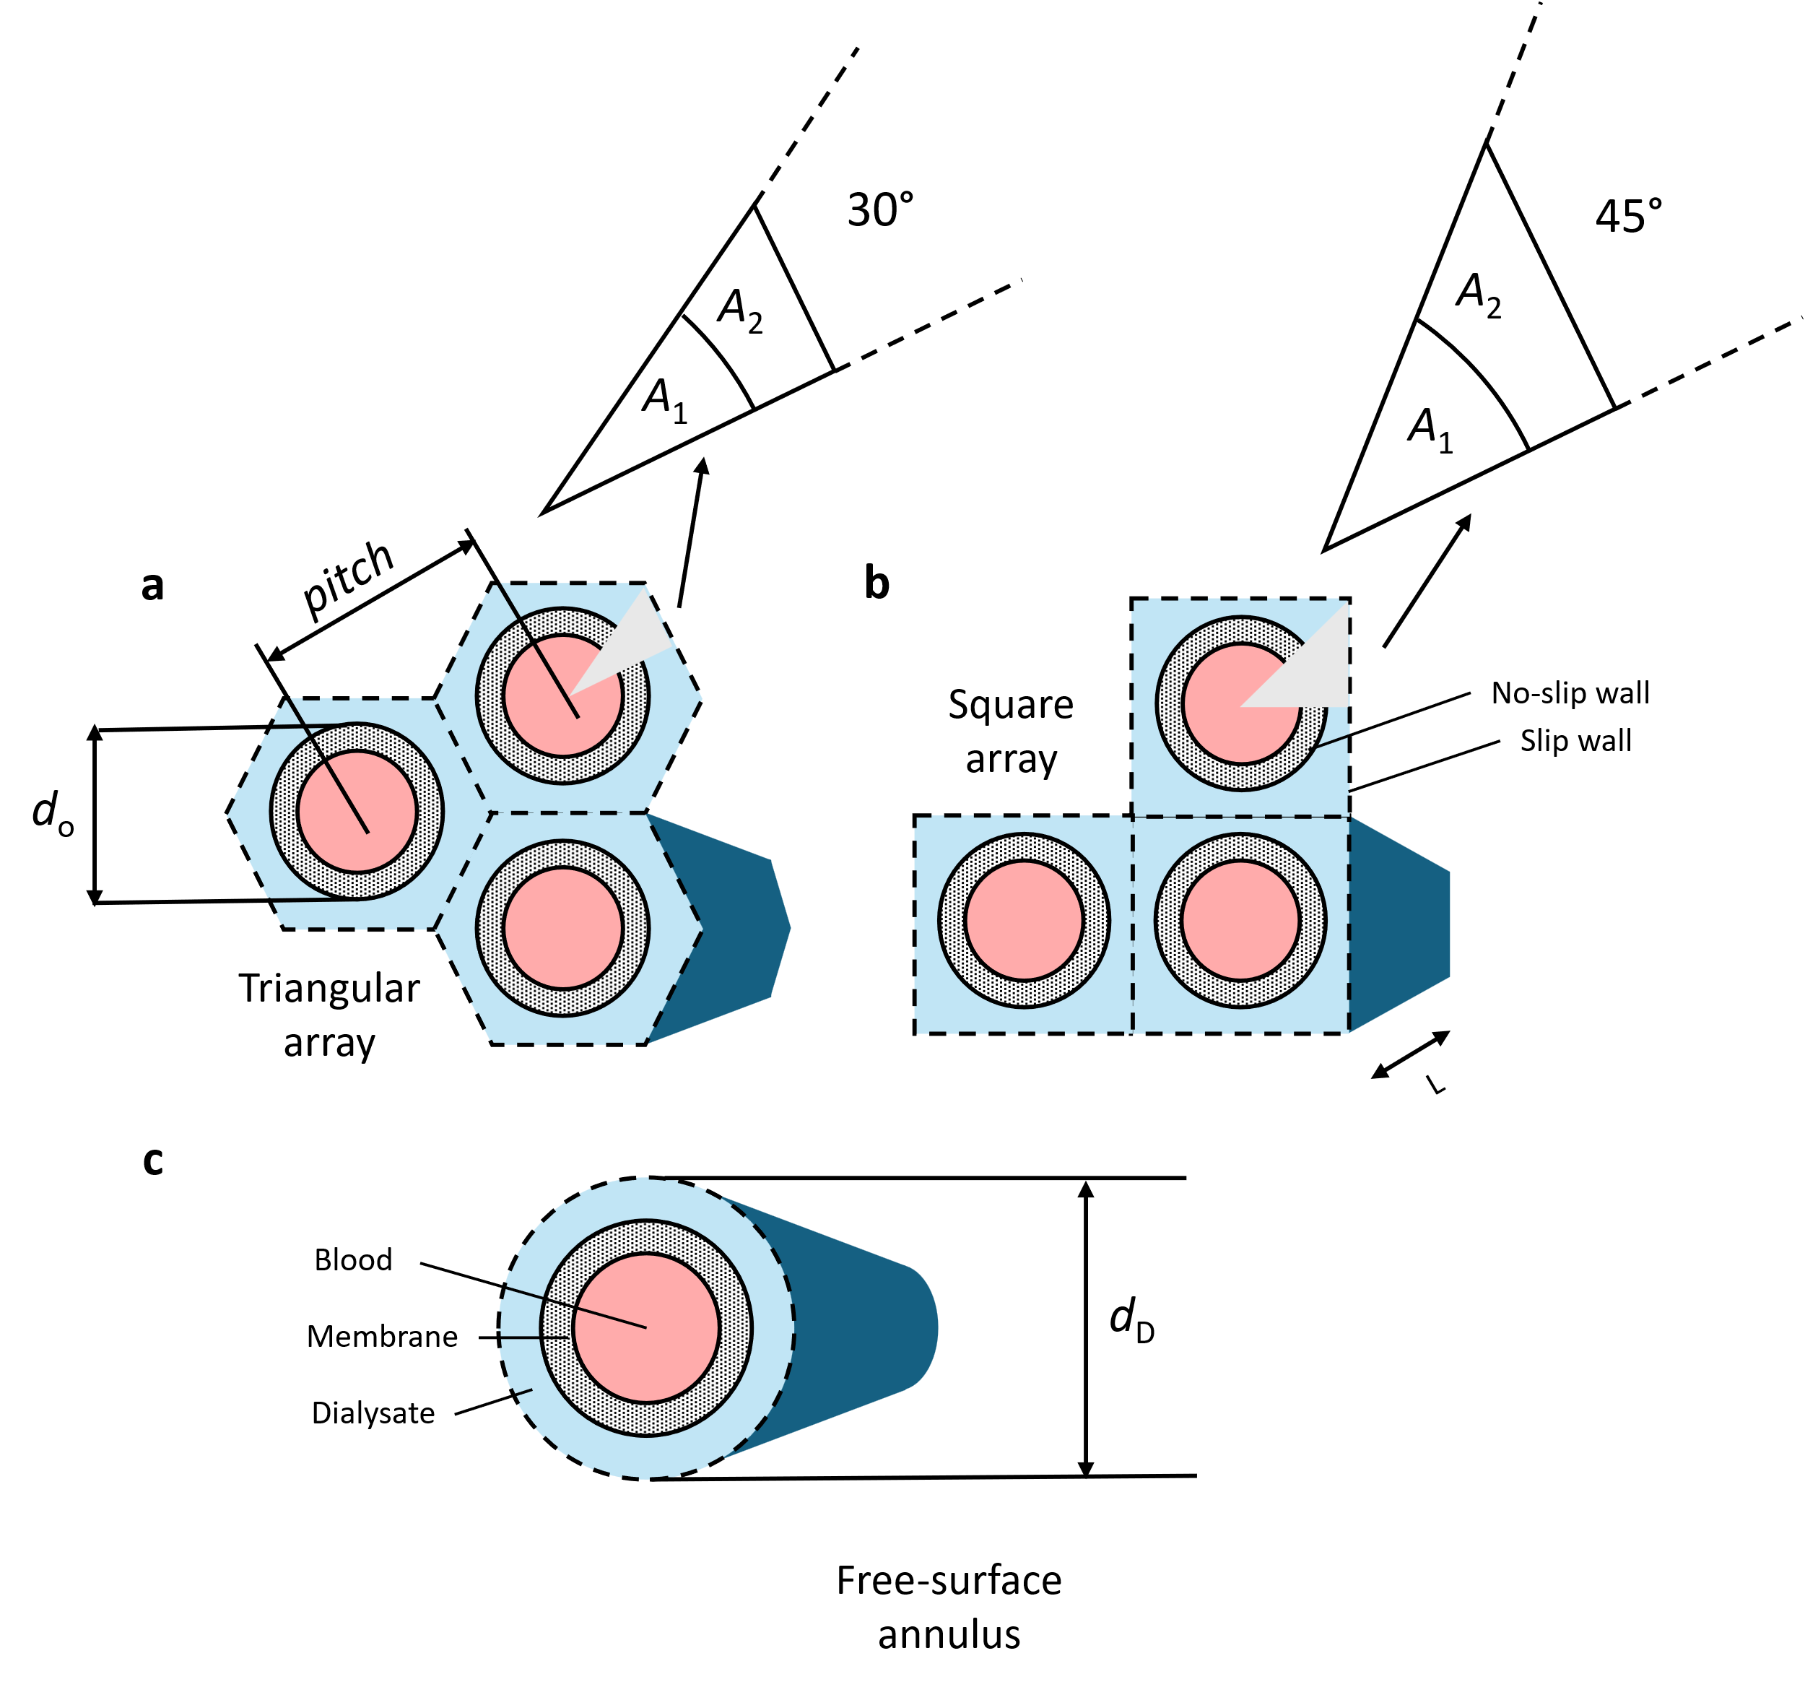
Figure S1 | Schematic of widely used single-fibre models for flow in hollow-fibre membrane modules such as haemodialyser. a, triangular array, b, square array, and c, free-surface annulus. These models are characterised by an envelope of fluid (dialysate) around a single fibre in the shape of hexagon, square, and circle respectively of appropriate size such that the porosity is conserved with respect to the module. d_{o} is the outer fibre diameter, pitch is the distance between the centres of two adjacent fibres, d_{D} is the Krogh cylinder diameter, L is the fibre length, and A₁, A₂ are area outside and inside the envelope, respectively. You can find more details of a,b in Sparrow and Loeffler(1959)⁹ and c, in Happel (1959)¹⁰.

Figure S2
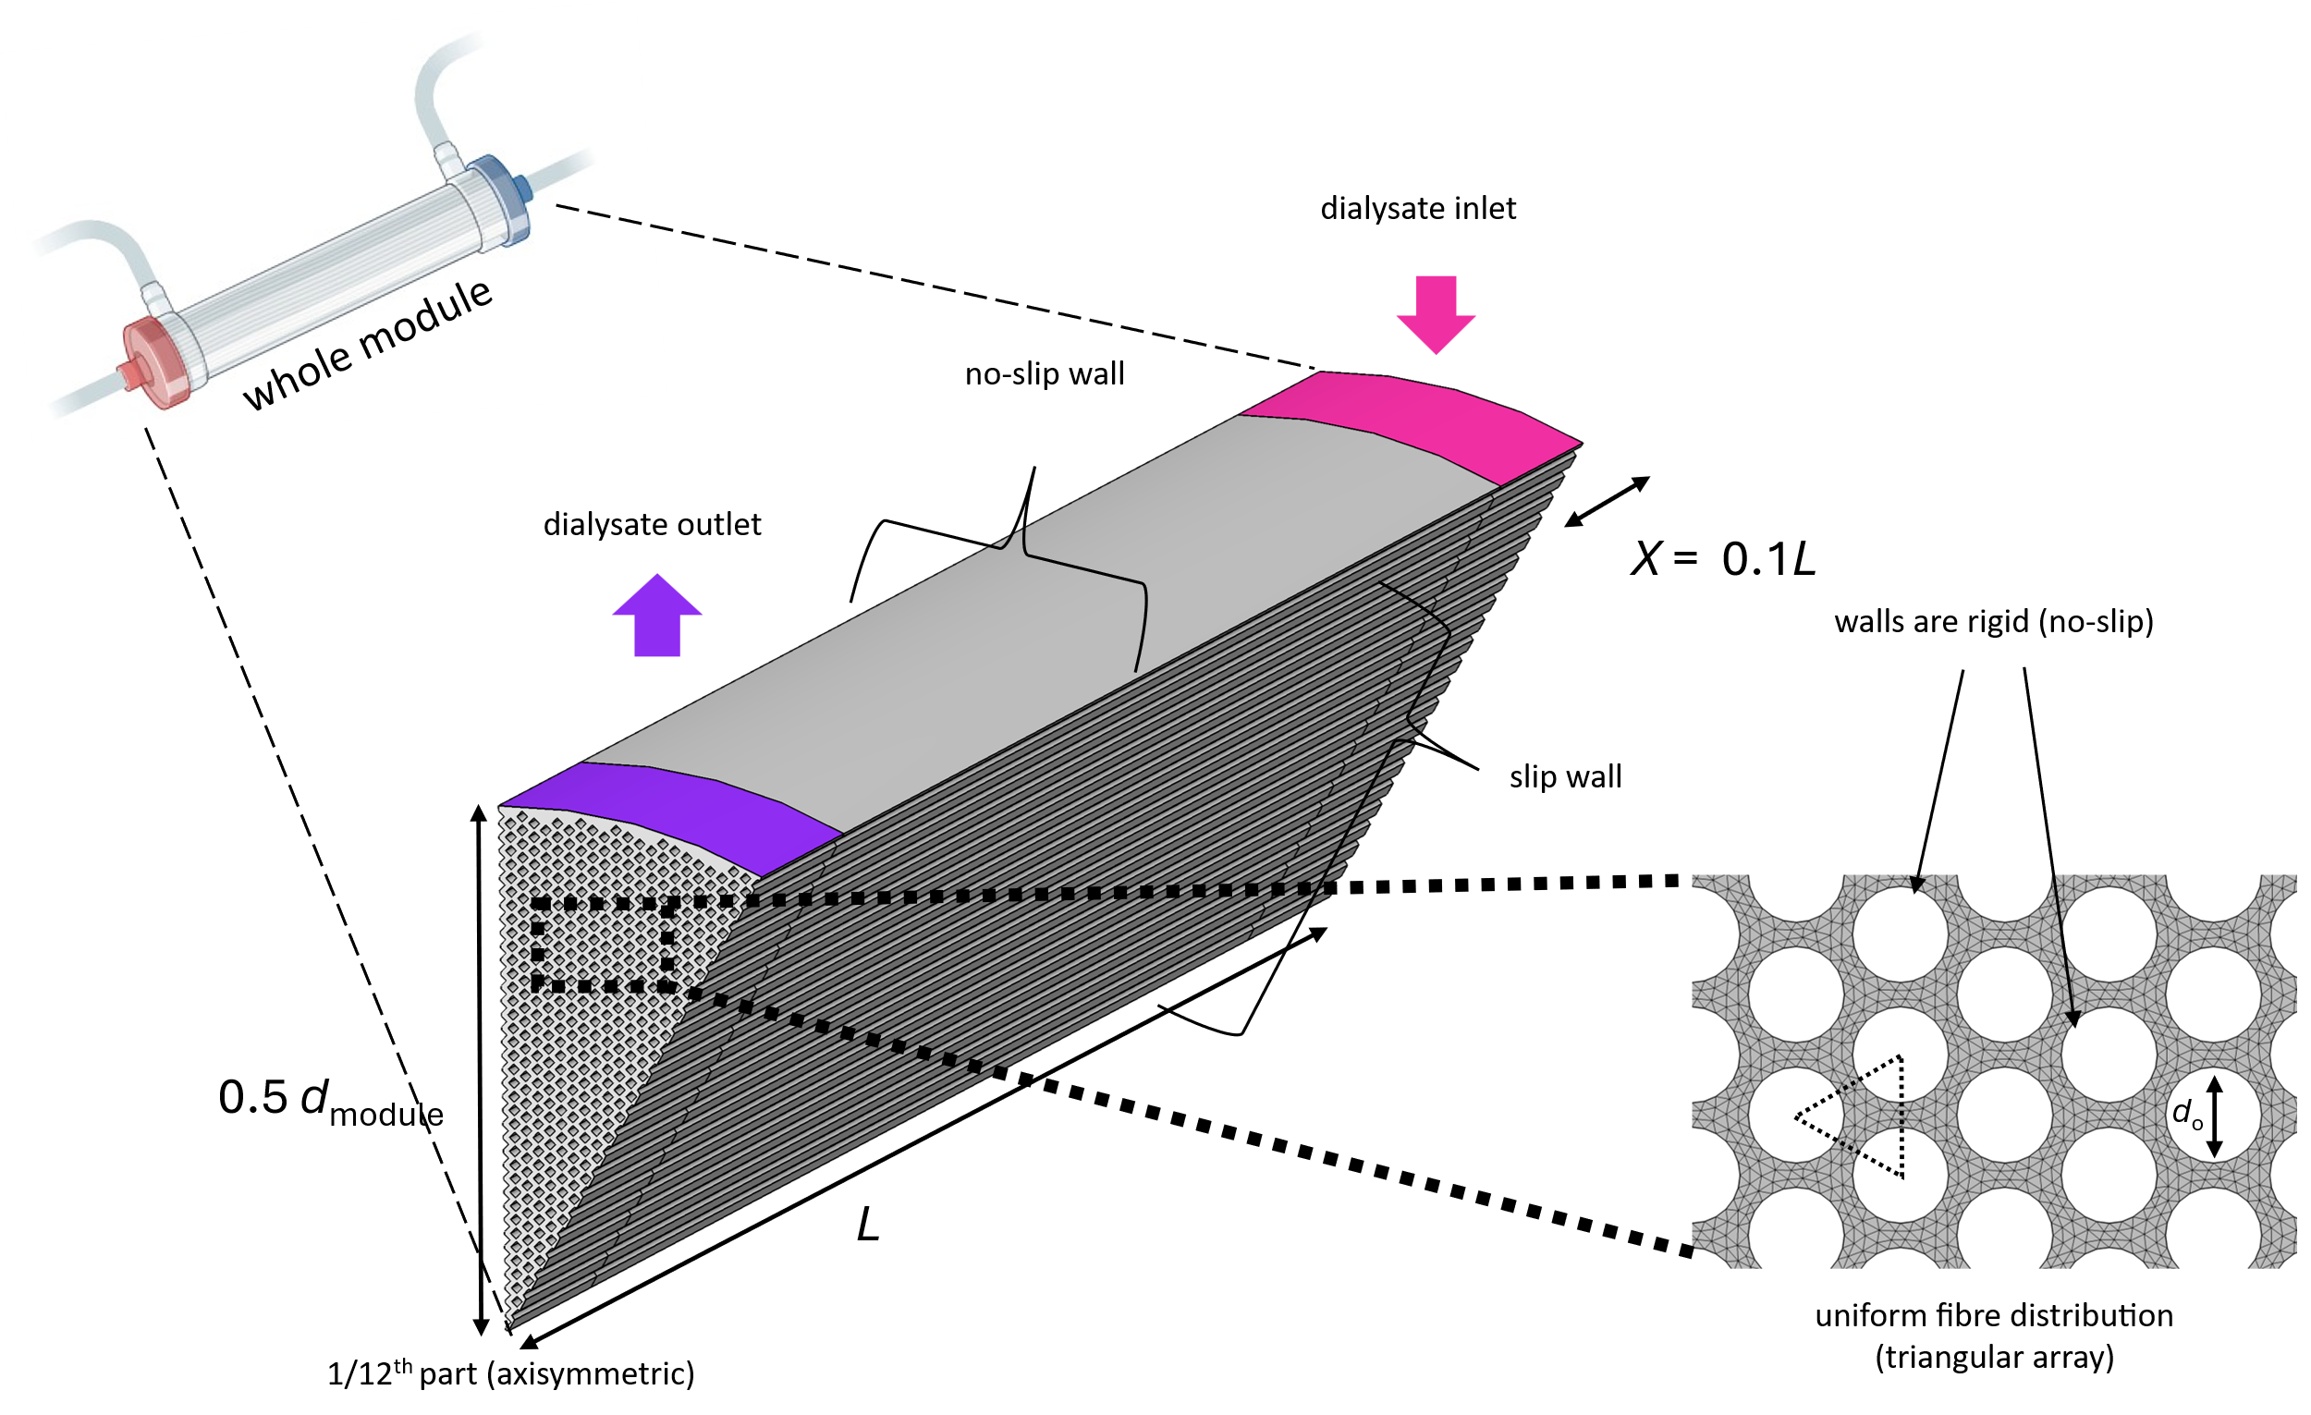
Figure S2 | Schematic of the computational domain for solving the dialysate flow field using the module-scale three-dimensional Navier Stokes equations and the continuity equation. We consider the following assumptions while modelling this: 1. Fibres are arranged in the most compact regular order i.e. triangular array. Accordingly, we generated a dialysate flow domain representing the shell-region of a dialyser. 2. Distribution tabs are perfect. i.e. the dialysate entering and exiting from the dialysate inlet and outlet ports respectively are distributed uniformly radially towards and away from the axis respectively. Accordingly, we created the inlet and outlet on the peripheral ends of the module. 3. The inlet and outlet were one-tenth of the module length L based on similar calculations of typical distributed tab lengths (also called raised collars) of dialysers³⁸,i.e. X = 0.1L. 4. As a result of all these assumptions, we can assume 1/12th cross-section with the total length L with side walls being slip wall as the working domain for computation. 5. Outer fibre membrane walls are assigned to no-slip wall boundary conditions on the basis that there is little effect of typical ultrafiltration on the hydrodynamics of dialysate flow²⁰. 6. Module wall is assigned no-slip wall boundary condition. 7. Dialysate is considered an incompressible fluid with density and dynamic viscosity 998.2 kgm⁻³ and 1.0093 mPas respectively (like water at 20 °C). 8. Pressure at the outlet is assigned to zero while a given flow rate (divided by 12 because of axisymmetry) is assigned at the inlet.

Figure S3
Figure S3 | Dimensionless parameters that incorporate the radial-to-axial Darcy permeability (κ_{rr}/κ_{zz}) of the shell region of the dialyser. a, Module aspect ratio defined as the ratio of length of module to the diameter of module (L/d_{module}) is another factor incorporated in these parameters. b. Osuga’s parameter³⁹ is one such dimensionless parameter whose value has been found to be between 1 and 10. c. Module geometry number⁴⁰ is another such dimensionless parameter whose typical value has been found to be in the range 10-100.

Figure S4

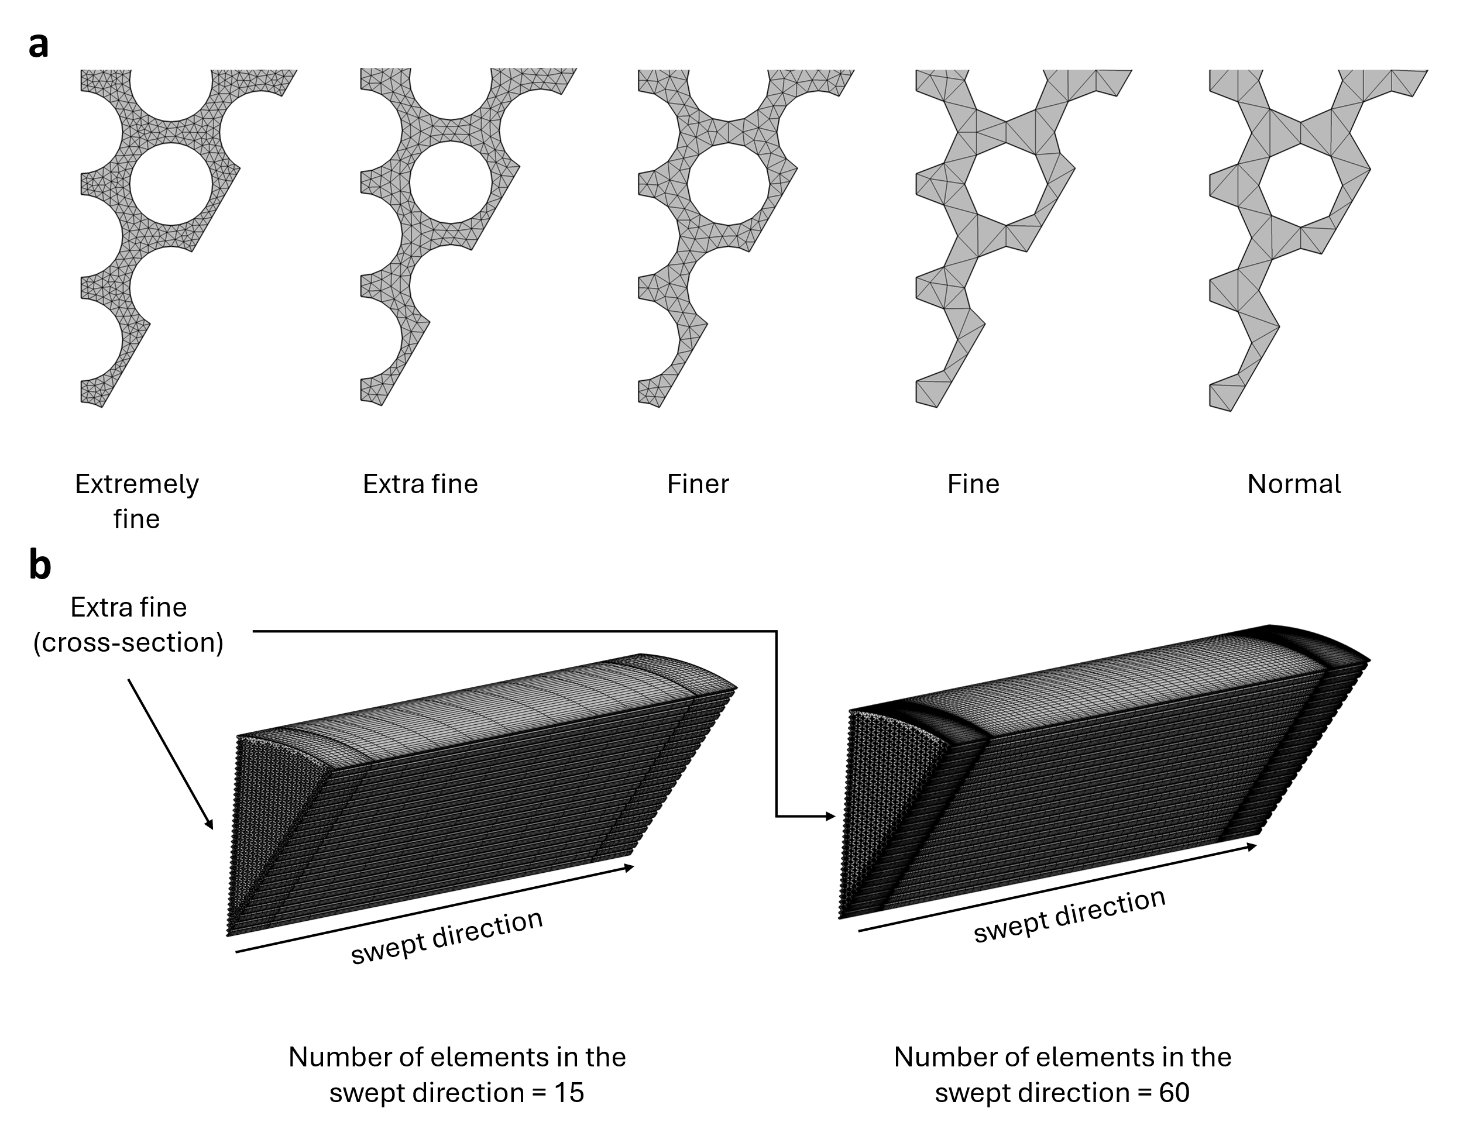
Figure S4 | Schematic of the mesh required to solve the dialysate flow field by the module-scale three-dimensional Navier Stokes equations and the continuity equation using the finite-element method in COMSOL 6.1. a, Representation of triangular meshes in the cross-section of the dialyser with suggested pre-defined mesh sizes. b, Representation of the mesh when “Extra-fine” mesh is selected for the cross-section and then swept along the axis for certain number of elements.

Figure S5

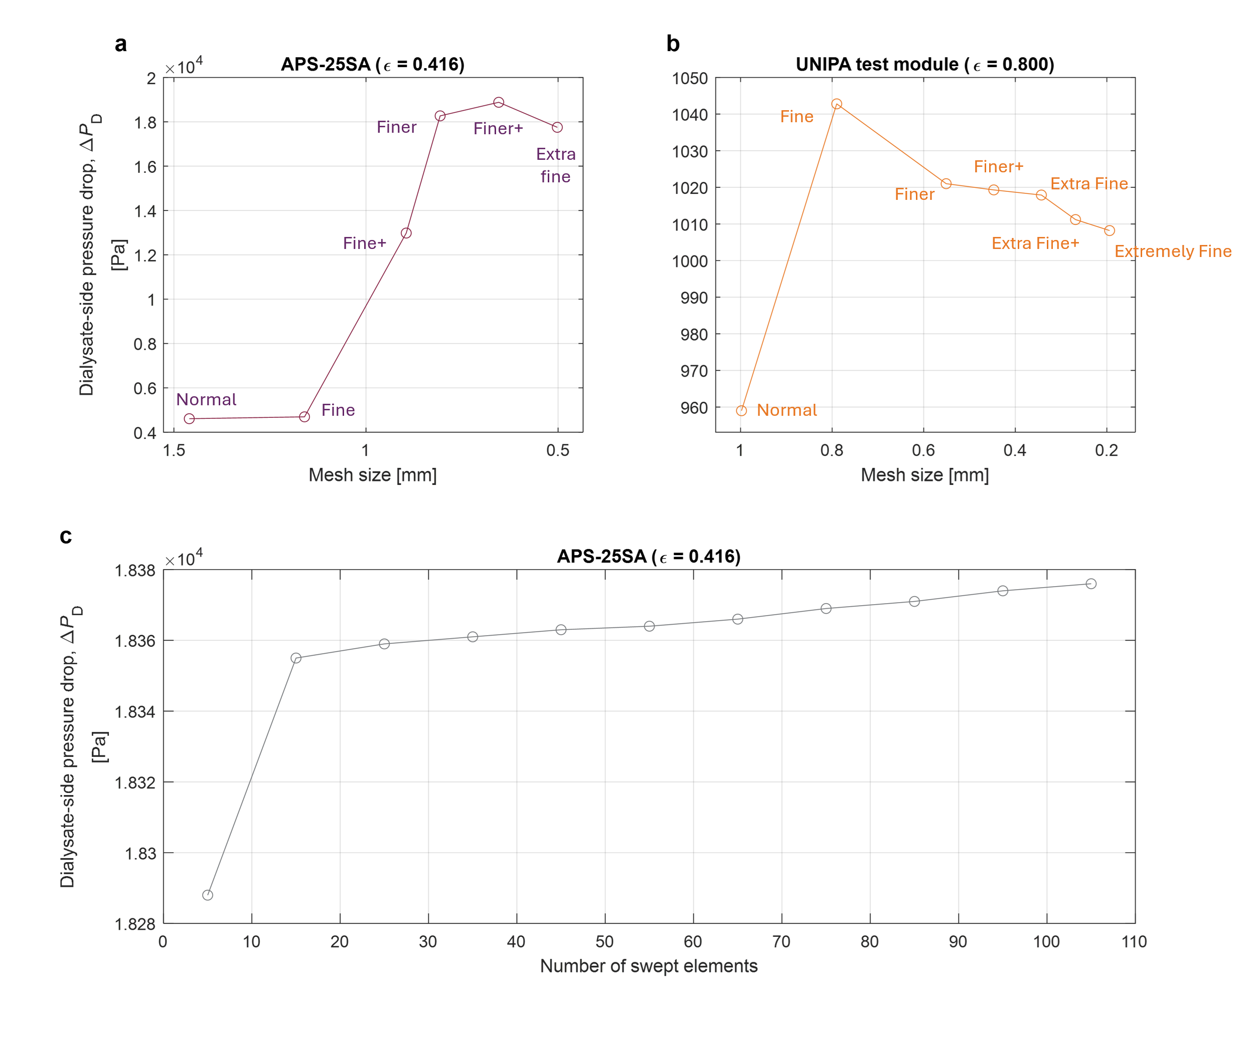
Figure S5 | Mesh independence study of dialyser comparing the dialysate-side pressure drop (∆P_{D}) as mesh size or parameter is altered. The dialyser module analysed were a, APS-25SA with the lowest porosity, and b, UNIPA 0.8 porosity with the highest porosity among the 20 dailyser tested in this study. We find that any mesh size smaller than “Finer” were within 5% error for both diayser modules. c, APS-25SA after selecting “Finer” mesh in the cross-section. We find that when the number of swept elements was more than 15, ∆P_{D} increased by only approximately 0.01%. Hence, we chose the parameter to be 35 keeping in mind that increasing it further increases the computational cost. Same result was found to be for UNIPA 0.8 porosity module. “Fine+” mesh size is the mesh size calculated by averaging the mesh sizes in “Fine’” and “Finer” as pre-defined by COMSOL 6.1. The complete list of mesh sizes considered for the module-scale three-dimensional Navier-Stokes simulations are tabulated in Table S5.

Figure S6

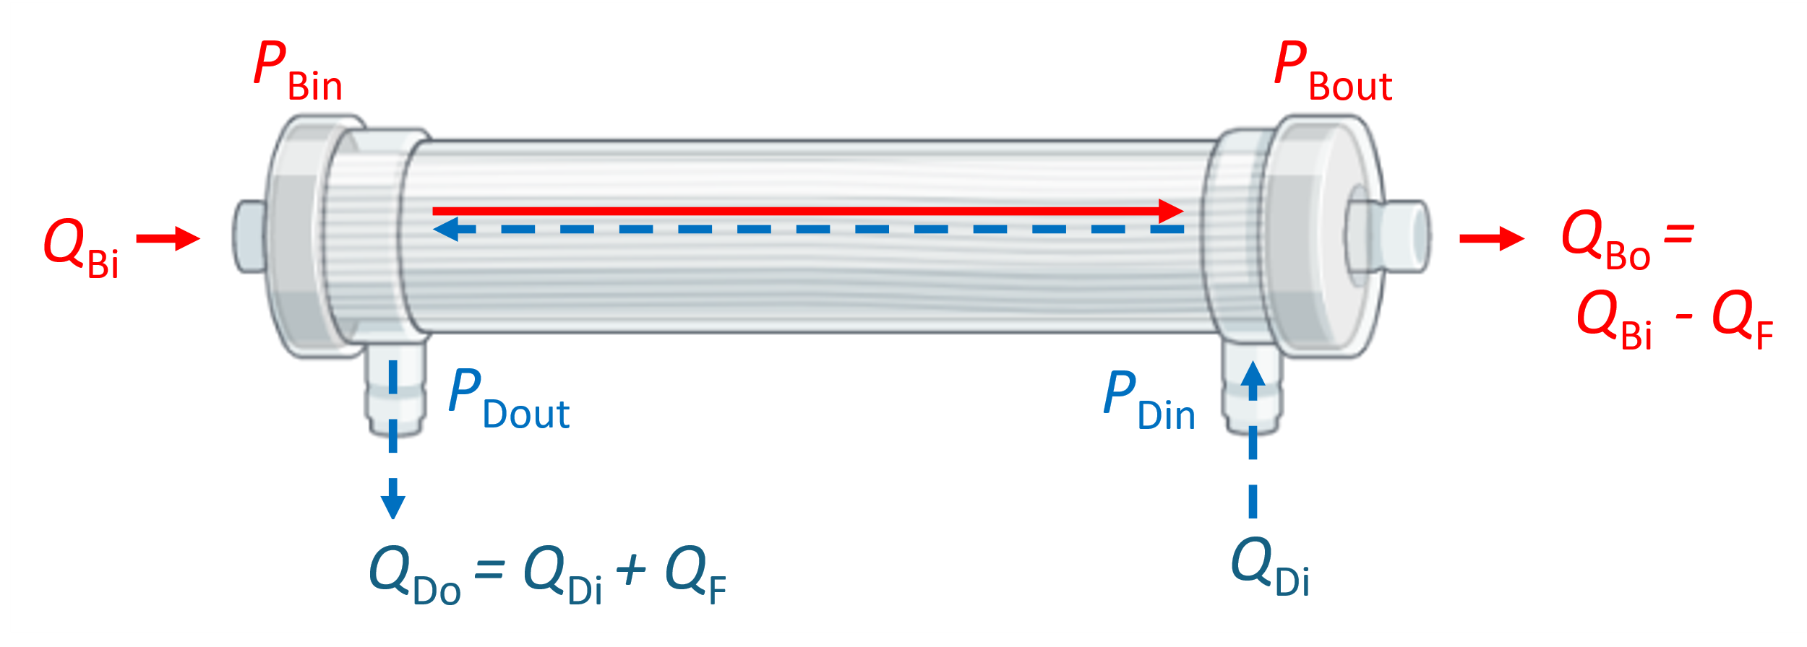
Figure S6 | Schematic of the dialyser module showing the dialysate and blood inlets and outlets in the countercurrent flow configuration. Fundamental flow field quantities are Q_{Bi} blood flow rate at inlet, Q_{F} net ultrafiltration flow rate, Q_{Bo} blood flow rate at outlet, Q_{Di} dialysate flow rate at inlet, Q_{Do} dialysate flow rate at outlet, P_{Bin} pressure at the blood inlet, P_{Bout} pressure at the blood outlet, P_{Din} pressure at the dialysate inlet, P_{Dout} pressure at the dialysate outlet.

Supplementary References
1. Ergun, S. Fluid Flow through Packed Columns. Chem. Eng. Prog. 48, 89–94 (1952).
2. Mehta, D. & Hawley, M. C. Wall effect in packed columns. Ind. Eng. Chem. Process Des. Dev. 8, 280–282 (1969).
3. Macdonald, I. F., El-Sayed, M. S., Mow, K. & Dullien, F. A. L. Flow through Porous Media—the Ergun Equation Revisited. Ind. Eng. Chem. Fundam. 18, 199–208 (1979).
4. Irmay, S. On the theoretical derivation of Darcy and Forchheimer formulas. Trans. Am. Geophys. Union 39, 702–707 (1958).
5. Suzuki, Y., Kohori, F. & Sakai, K. Computer-aided design of hollow-fiber dialyzers. J. Artif. Organs 4, 326–330 (2001).
6. Papathanasiou, T. D., Markicevic, B. & Dendy, E. D. A computational evaluation of the Ergun and Forchheimer equations for fibrous porous media. Phys. Fluids 13, 2795–2804 (2001).
7. Yoshikawa, S., Ogawa, K. & Minegishi, S. Distributions of pressure and flow rate in a hollow-fiber membrane module for plasma separation. J. Chem. Eng. Japan 27, 385–390 (1994).
8. Yamamoto, K. I. et al. Computational evaluation of dialysis fluid flow in dialyzers with variously designed jackets. Artif. Organs 33, 481–486 (2009).
9. Sparrow, E. M. & Loeffler, A. L. Longitudinal laminar flow between cylinders arranged in regular array. AIChE J. 5, 325–330 (1959).
10. Happel, J. Viscous flow relative to arrays of cylinders. AIChE J. 5, 174–177 (1959).
11. Keller, J. B. Viscous flow through a grating or lattice of cylinders. J. Fluid Mech. 18, 94–96 (1964).
12. Sangani, A. S. & Acrivos, A. Slow flow past periodic arrays of cylinders with application to heat transfer. Int. J. Multiph. Flow 8, 193–206 (1982).
13. Sangani, A. S. & Acrivos, A. Slow flow through a periodic array of spheres. Int. J. Multiph. Flow 8, 343–360 (1982).
14. Happel, J. & Brenner, H. Low Reynolds number hydrodynamics. vol. 1 (1963).
15. Skartsis, L. ., Kardos, J. L. . & Khomami, B. Resin flow through fiber beds during composite manufacturing processes. part I: review of Newtonian flow through fiber beds. Polym. Eng. Sci. 32, 221–230 (1992).
16. Bird, R. B., Stewart, W. E. & Lightfoot, E. N. Transport Phenomena. (2002).
17. Erdim, E., Akgiray, Ö. & Demir, I. A revisit of pressure drop-flow rate correlations for packed beds of spheres. Powder Technol. 283, 488–504 (2015).
18. Cancilla, N. et al. CFD prediction of shell-side flow and mass transfer in regular fiber arrays. Int. J. Heat Mass Transf. 168, 120855 (2021).
19. Drummond, J. E. & Tahir, M. . Laminar viscous flow through regular arrays of parallel solid cylinders. Int. J. Multiph. Flow 10, 515–540 (1984).
20. Cancilla, N. et al. A porous media CFD model for the simulation of hemodialysis in hollow fiber membrane modules. J. Memb. Sci. 646, 120219 (2022).
21. Cancilla, N. Experimental and computational investigation of hollow-fiber modules for biomedical applications. (Università degli Studi di Palermo, 2022).
22. Liao, Z. Numerical and Experimental studies of mass transfer in artificial kidney and hemodialysis. PhD Dissertation (University of Kentucky, 2002).
23. Eloot, S., D’Asseler, Y., De Bondt, P. & Verdonck, P. Combining SPECT medical imaging and computational fluid dynamics for analyzing blood and dialysate flow in hemodialyzers. Int. J. Artif. Organs 28, 739–749 (2005).
24. Legallais, C., Catapano, G., Harten, B. von & Baurmeister, U. A theoretical model to predict the in vitro performance of hemodiafilters. J. Memb. Sci. 168, 3–15 (2000).
25. Abaci, H. E. & Altinkaya, S. A. Modeling of hemodialysis operation. Ann. Biomed. Eng. 38, 3347–3362 (2010).
26. Eloot, S., De Wachter, D., Van Tricht, I. & Verdonck, P. Computational flow modeling in hollow-fiber dialyzers. Artif. Organs 26, 590–599 (2002).
27. Eloot, S., Vierendeels, J. & Verdonck, P. Optimisation of solute transport in dialysers using a three-dimensional finite volume model. Comput. Methods Biomech. Biomed. Engin. 9, 363–370 (2006).
28. Islam, S. & Szpunar, J. Study of dialyzer membrane ( Polyflux 210H ) and effects of different parameters on dialysis performance. Open J. Nephrol. 3, 161–167 (2013).
29. Yaqoob, T., Ahsan, M., Hussain, A. & Ahmad, I. Computational fluid dynamics (CFD) modeling and simulation of flow regulatory mechanism in artificial kidney using finite element method. Membranes (Basel). 10, 139 (2020).
30. Donato, D. et al. Optimization of dialyzer design to maximize solute removal with a two-dimensional transport model. J. Memb. Sci. 541, 519–528 (2017).
31. Goodarzi, M. R. & Mohebbi-Kalhori, D. Numerical modeling and parametric study of a hollow fiber dialyzer using double porous media approach. South African J. Chem. Eng. 42, 1–11 (2022).
32. Li, W. et al. Simulation and experimental study on the effect of channeling flows on the transport of toxins in hemodialyzers. J. Memb. Sci. 501, 123–133 (2016).
33. Łabȩcki, M., Piret, J. M. & Bowen, B. D. Two-dimensional analysis of fluid flow in hollow-fibre module. Chem. Eng. Sci. 50, 3369–3384 (1995).
34. Ding, W. et al. Double porous media model for mass transfer of hemodialyzers. Int. J. Heat Mass Transf. 47, 4849–4855 (2004).
35. Yang, C., Qinglian, W., Guo, J., Nakayama, A. & Qiu, T. Upscaling solute concentration transport equations of countercurrent dialyzer systems. Chem. Eng. Sci. 134, 108–118 (2015).
36. Sano, Y. & Nakayama, A. A porous media approach for analyzing a countercurrent dialyzer system. J. Heat Transfer 134, 072602 (2012).
37. Ding, W. et al. Three-dimensional simulation of mass transfer in artificial kidneys. Artif. Organs 39, E79–E89 (2015).
38. Annan, K. Mathematical modeling of the dynamic exchange of solutes during bicarbonate dialysis. Math. Comput. Model. 55, 1691–1704 (2012).
39. Osuga, T. et al. Dialysate pressure isobars in a hollow-fiber dialyzer determined from magnetic resonance imaging and numerical simulation of dialysate flow. Artif. Organs 22, 907–909 (1998).
40. Lemanski, J. & Lipscomb, G. G. Effect of shell-side flows on hollow-fiber membrane device performance. AIChE J. 41, 2322–2326 (1995).

