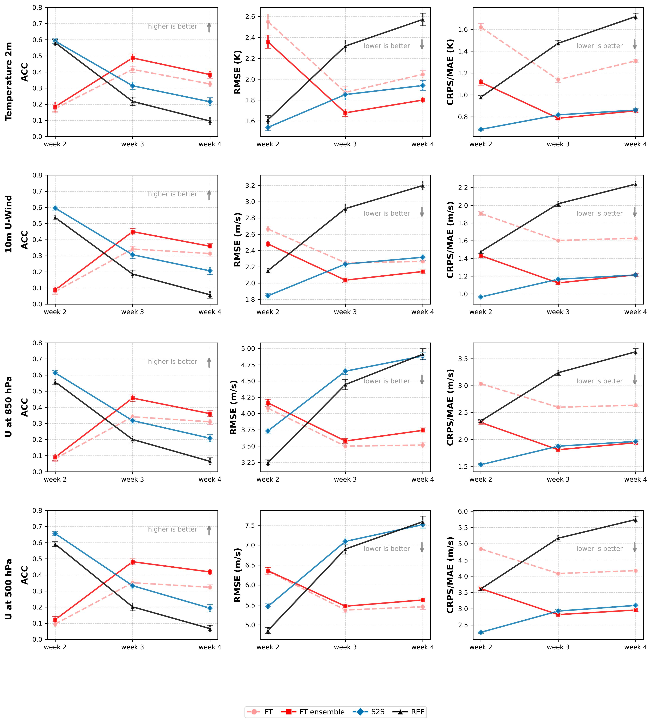
Figure S1. As Figure 1 (i.e. ACC, RMSE and CRPS for REF, FT, FT ensemble and S2S ensemble for all lead-times), but for other variables: temperature at 2 m, zonal wind U at 10 m, at 850 hPa and 500 hPa.

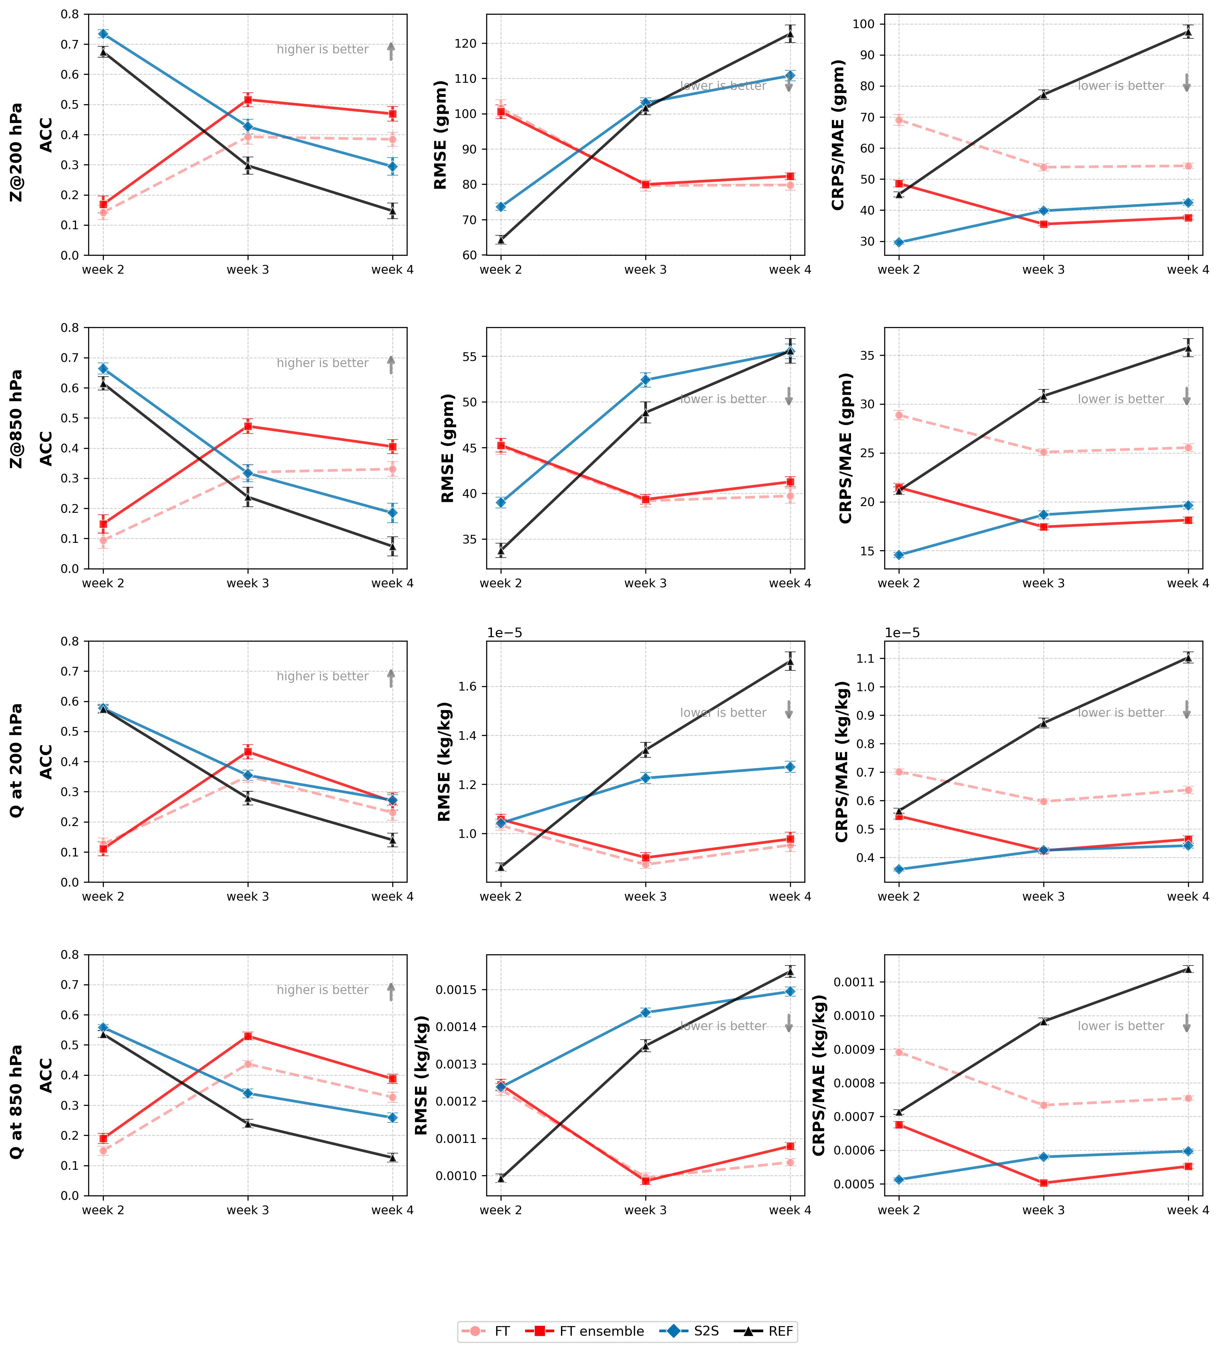
Figure S2. Same as Figure S1 but for Z200 and Z850, specific humidity Q at 200 hPa and 850 hPa.

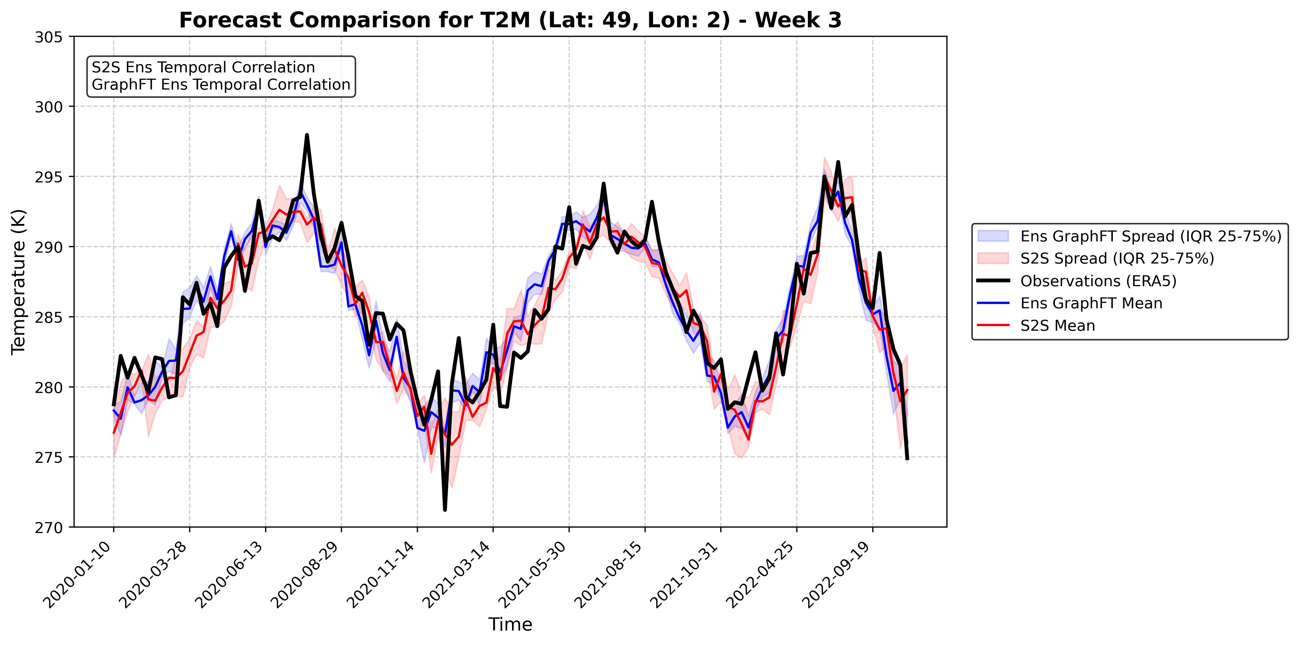
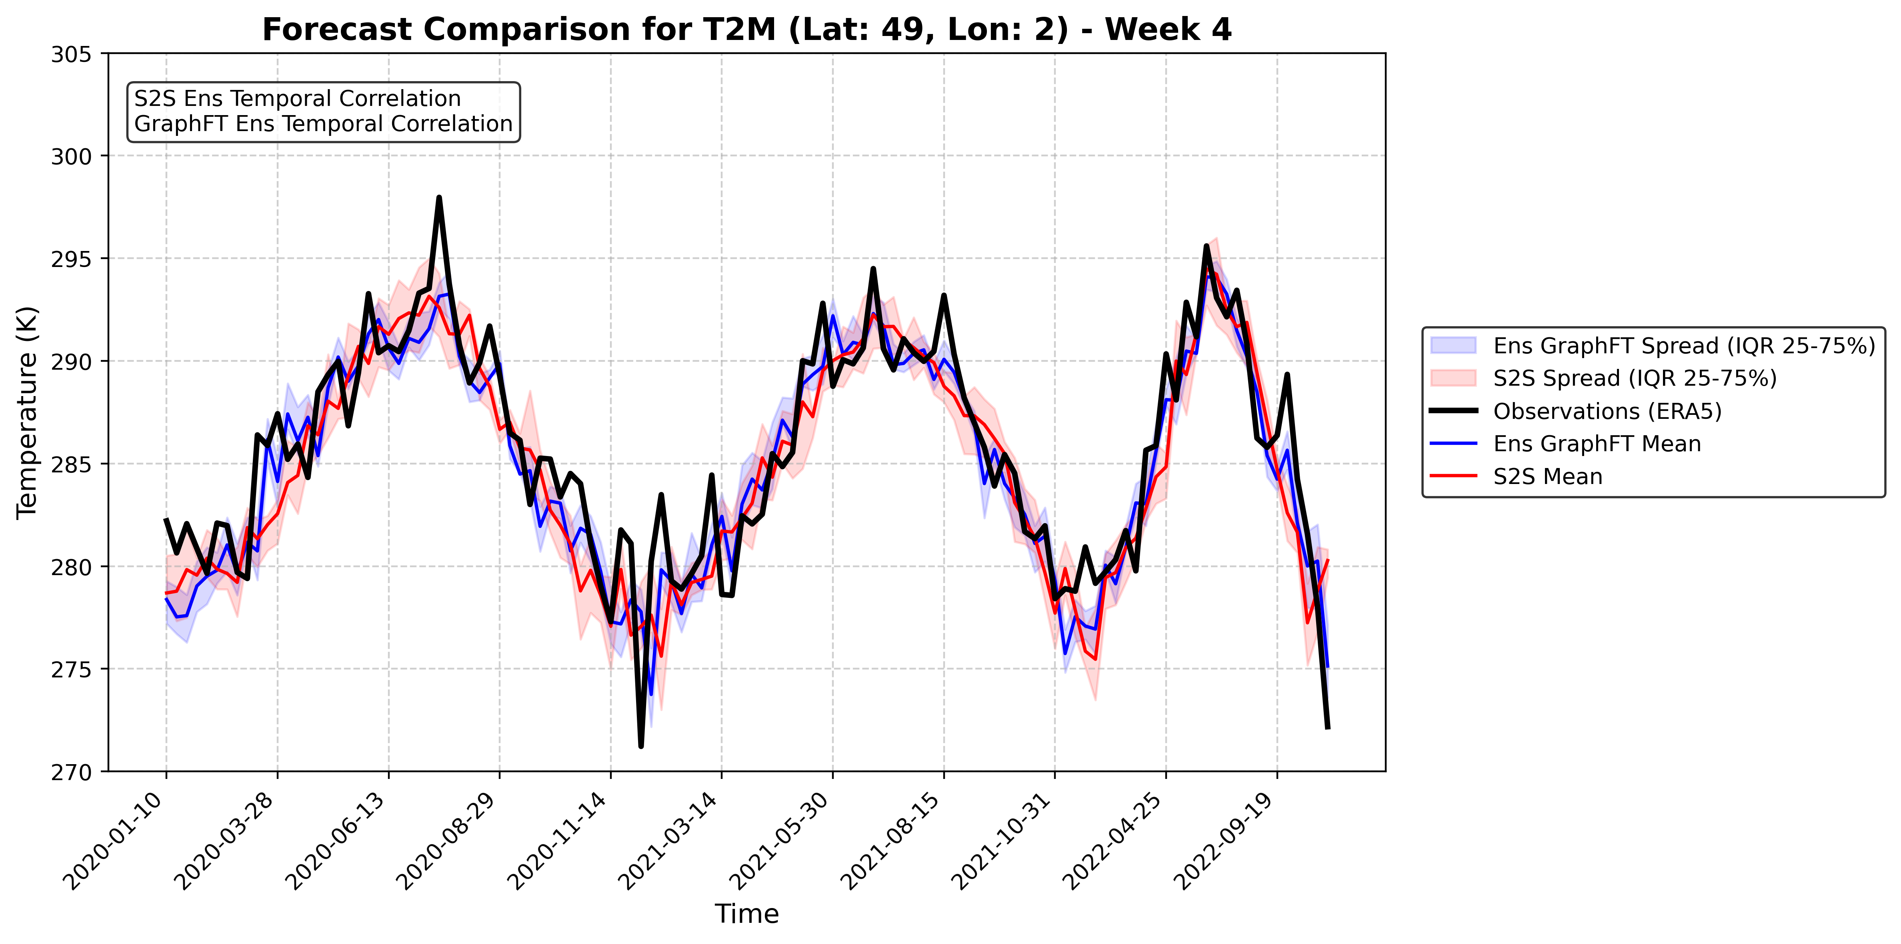
Figure S3. Forecasts for T2M for a week 3 (upper panel) and week 4 (lower panel) lead-time for the pixel encompassing Paris, with observations (in black), Graphcast-based “FT ensemble” (in blue) and S2S ensemble (in red). With confidence intervals representing the inter-quartile range 25-75%, computed from the distribution of the members of the ensemble models. GraphFT ensemble performs better than S2S for week 3 and 4 at capturing intra-seasonal variability (cf. R_{t} in France in the maps of Figure S4). For this figure, the climatology was not removed from the data, to show the seasonal cycle and the corresponding summer heatwaves and winter cold spells (note that all metrics in this paper were estimated after removing the climatology, cf. Methods).

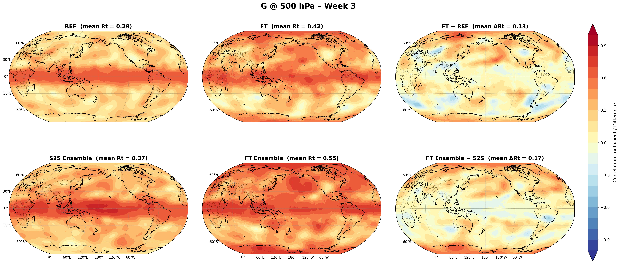
Week 3

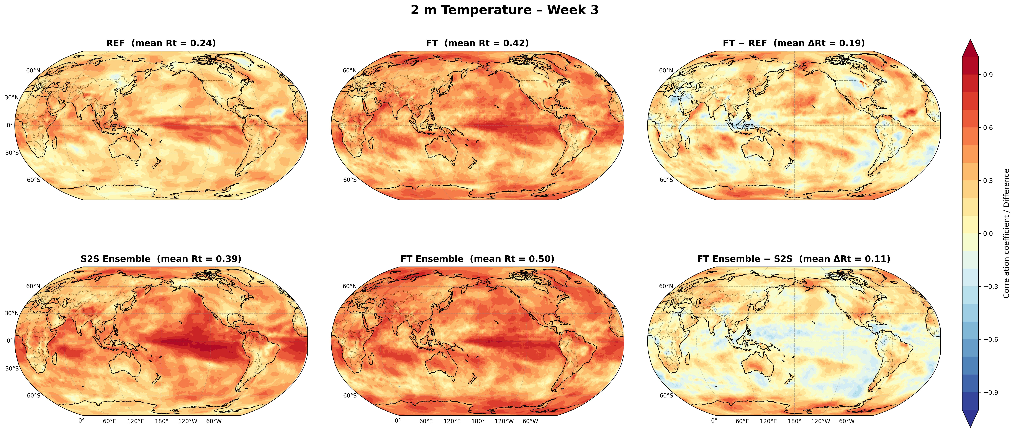
Week 3
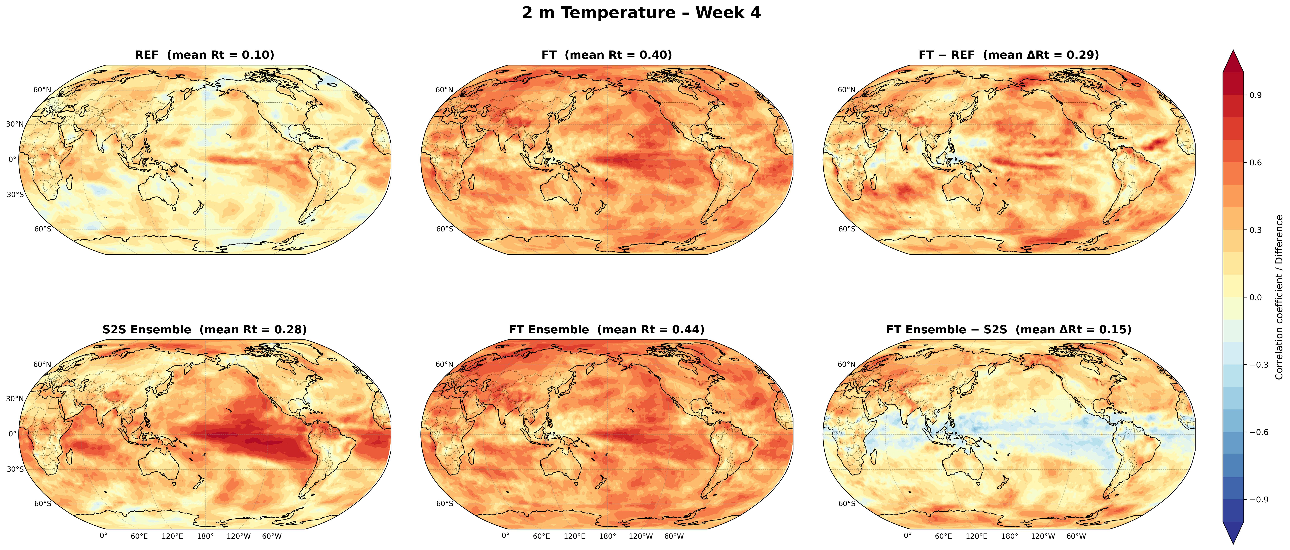
Week 4
Figure S4. Temporal correlation coefficient (Rt) comparison between GraphOP, deterministic GraphFT and between S2S ensemble and GraphFT with their respective difference for difference for Z500 for week 3 and temperature at 2 m for week 3 and 4.

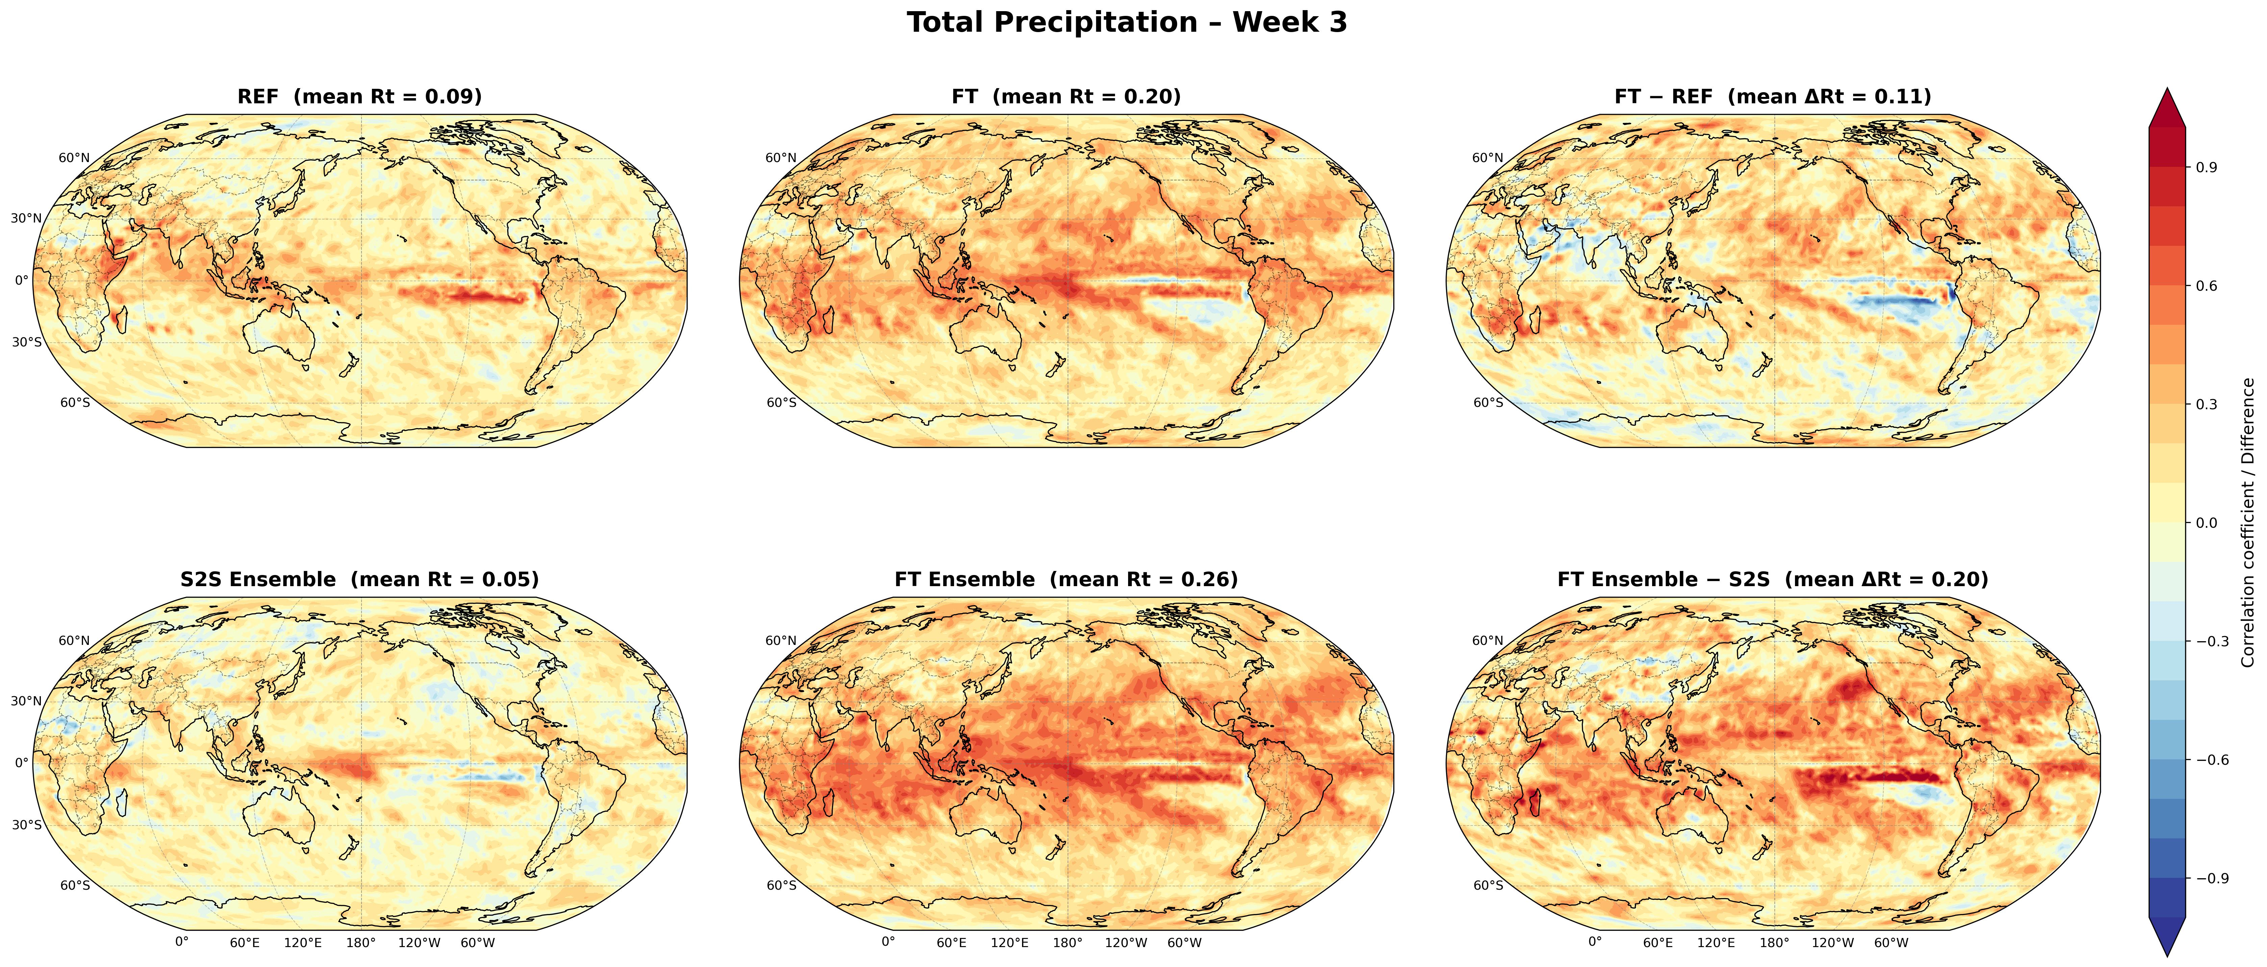
Week 3
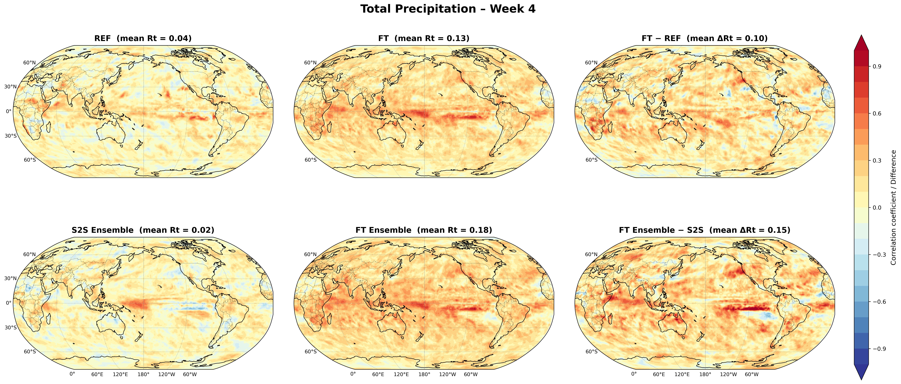
Week 4

Figure S5. Same as Figure S4 but for precipitation for week 3 and 4.

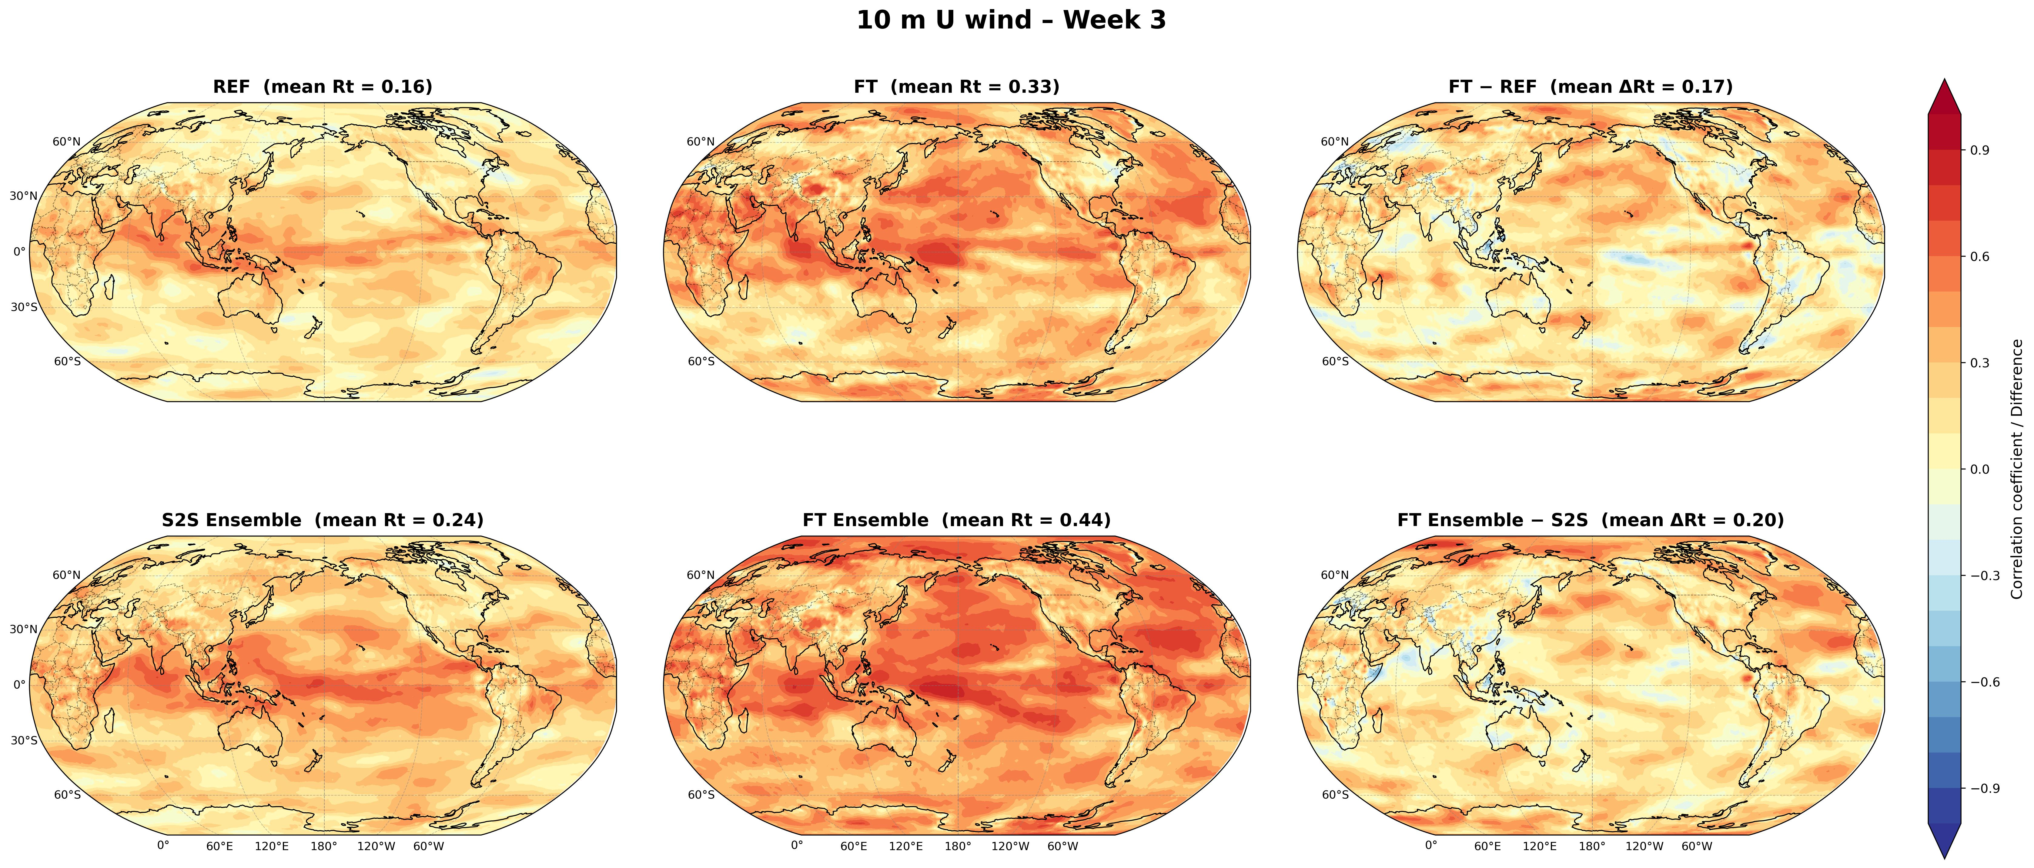
Week 3
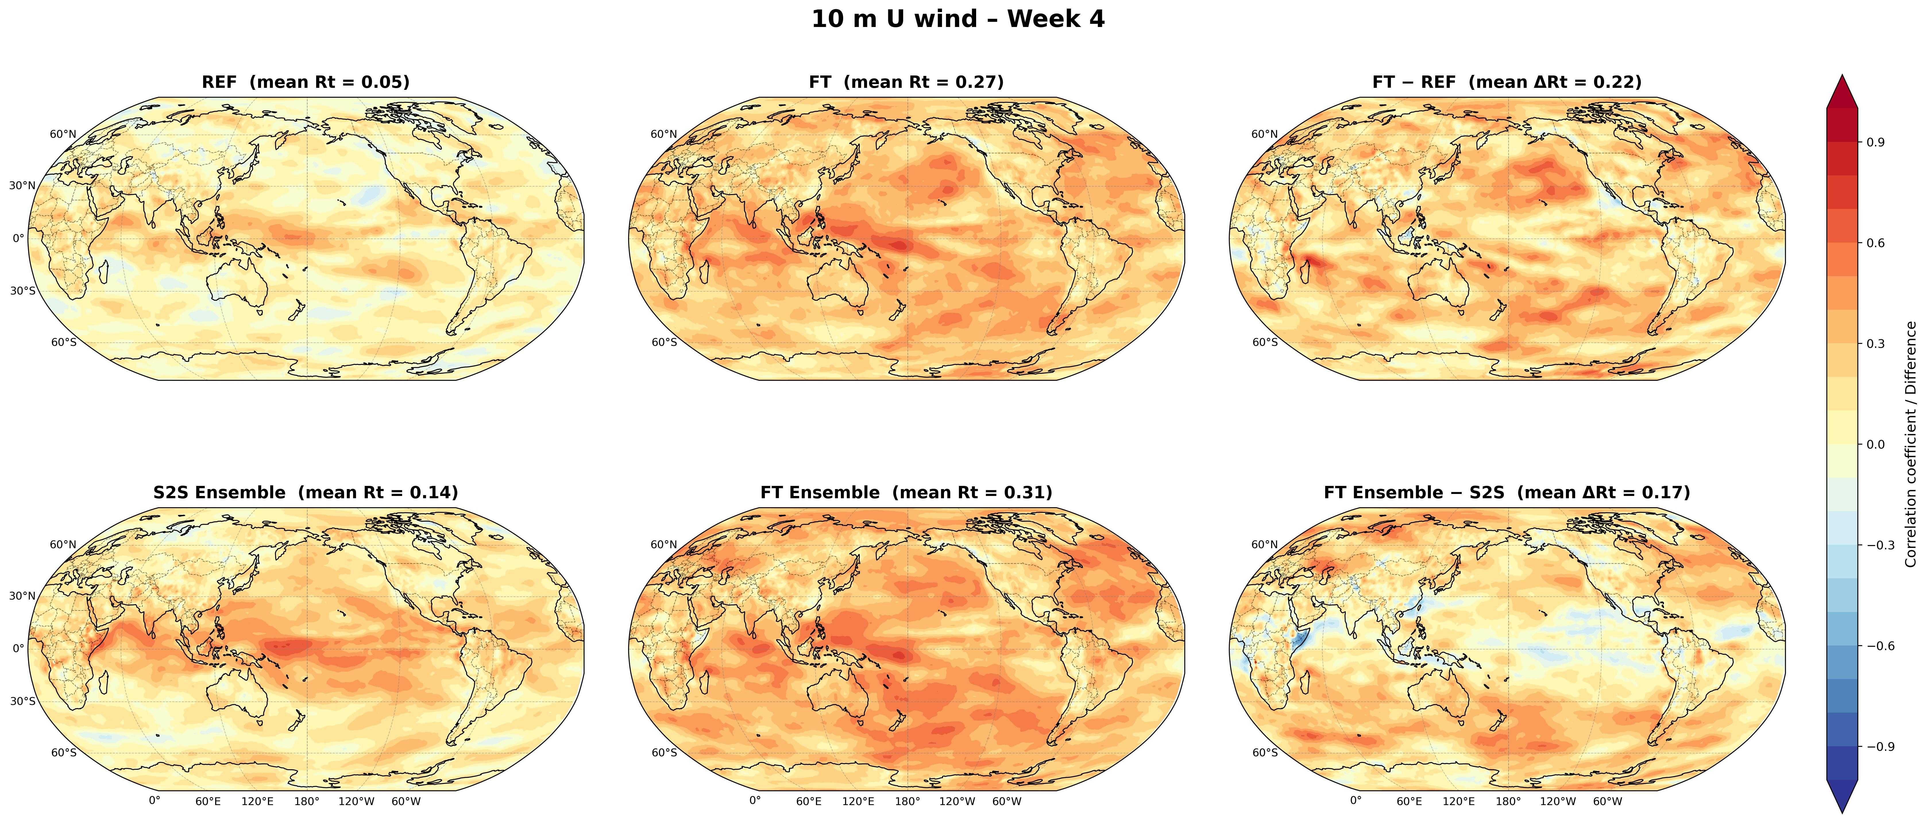
Week 4

Figure S6. Same as Figure S5 but for zonal winds U at 10m.

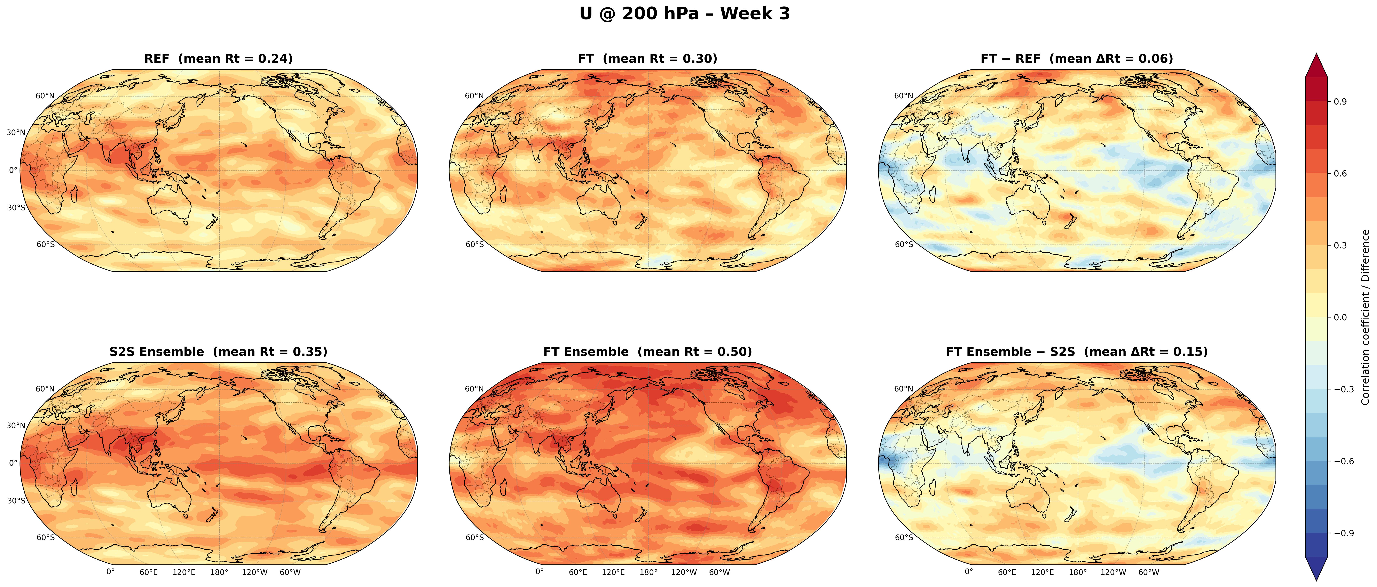
Week 3
Week 4
Figure S7. Same as Figure S5 but for zonal winds U @ 200 hPa.

Week 3
Week 4
Figure S8. Same as Figure S5 but for zonal winds U @ 850 hPa.

Week 4
Week 3
Figure S9. Same as Figure S5 for specific humidity Q @ 850 hPa.

R_{t,x}
R_{t,x}
Figure S10. As Figure 3 but for week 3 lead time.

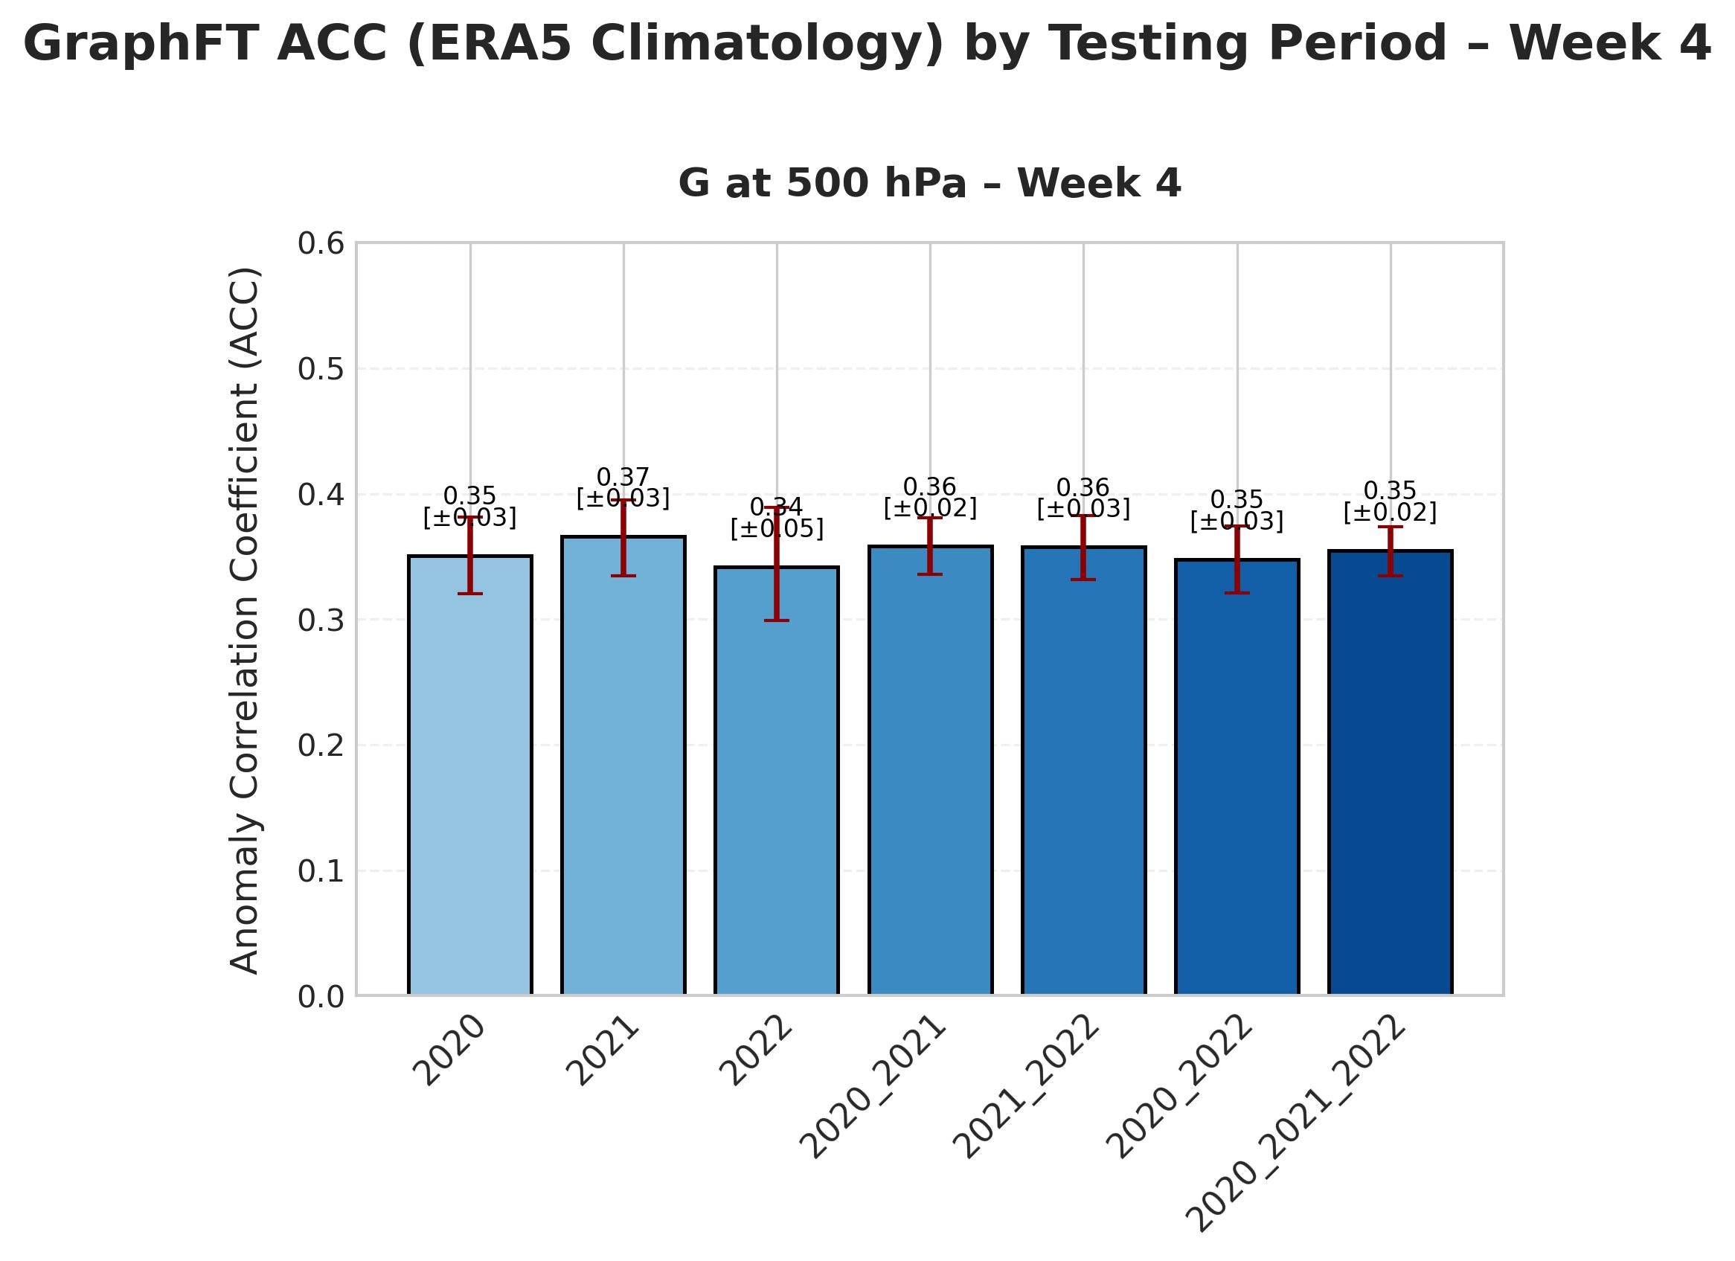
Figure S11. ACC for FT control member but tested on indivual years and subsets or on the whole of the test data, to verify that our forecasting skill assessment is reasonably robust and already stable when estimated over one or two years instead of three.

Figure S12. Study case of the heatwave in Siberia which happened in June 2020 with an initialization date of 30th of May 2020. The observations for week 3 and week 4 lead-time can be seen on the left column, while the S2S ensemble and GraphFT ensemble forecasts are in the middle and the right column respectively. The spatial-mean values of 2m temperature anomaliesare presented above each panel. GraphFT ensemble outperforms S2S ensemble in predicting more accurately the heatwave. E.g. for an observed weekly-mean value of temperature anomaly of 3.31 K for week 3, S2S predicts 1.56 K and GraphFT ensemble mean predicts 3.52 K. For week 4, both cannot capture the extremely-large observed anomaly of 6.05 K, as S2S ensemble mean predicts 0.29 K and GraphFT predicts 1.42 K. But still, GraphFT ensemble mean is closer to this observed extreme, even at such long lead-time. Overall, this suggests the possible superiority of GraphFT ensemble compared to S2S ensemble for extremes, at least for this case study.

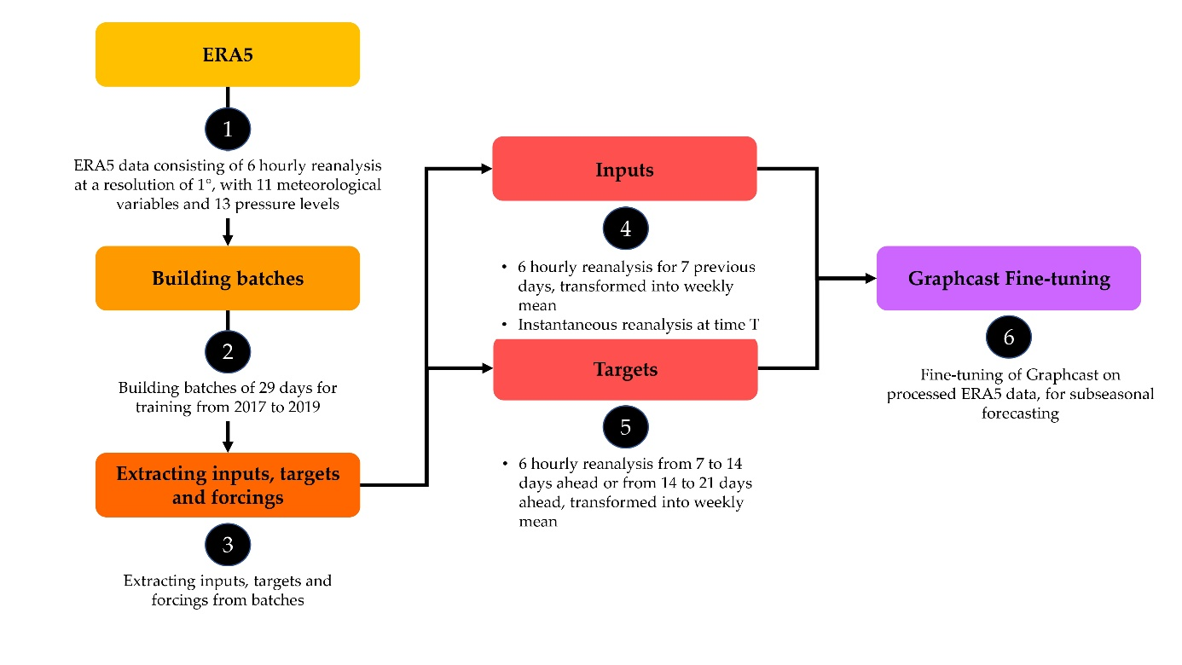
· 6 hourly reanalysis from 7 to 14 days
ahead or from 14 to 21 days ahead or
from 21 to 28 days ahead, transformed
into weekly means
Building batches of 29 days for training from 2016 to 2019
Figure S13. Fine-tuning data processing

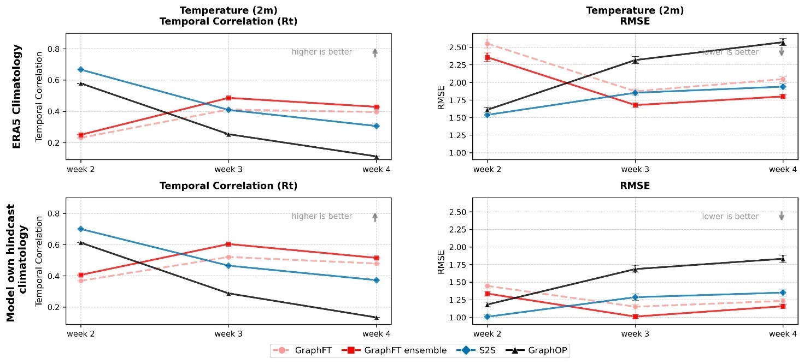
Figure S14. Comparison of forecasting skills when using ERA5 climatology (top panels) and model own hindcast climatology (bottom panels) for R_{t} and RMSE (latitude-weighted global means) metrics, for the air temperature at 2m (T2M) over all lead-times. Quantitatively, the skills are lower when using ERA5 climatology, but the conclusions concerning the comparison between forecasting systems remain the same (see Methods section for details).

Figure S15. Forecast activity for all lead-times for REF (GraphOP), FT (determistic GraphFT), and FT ensemble (GraphFT ensemble) and S2S ensemble. Overall, this metric provides a valuable layer to our evaluation, confirming that while our ML fine-tuning greatly improves traditional accuracy metrics, it does so at the cost of some spatial variance. Still, we can say that S2S is almost equivalent or worse than FT ensemble, for week 4, depending on the considered variable.

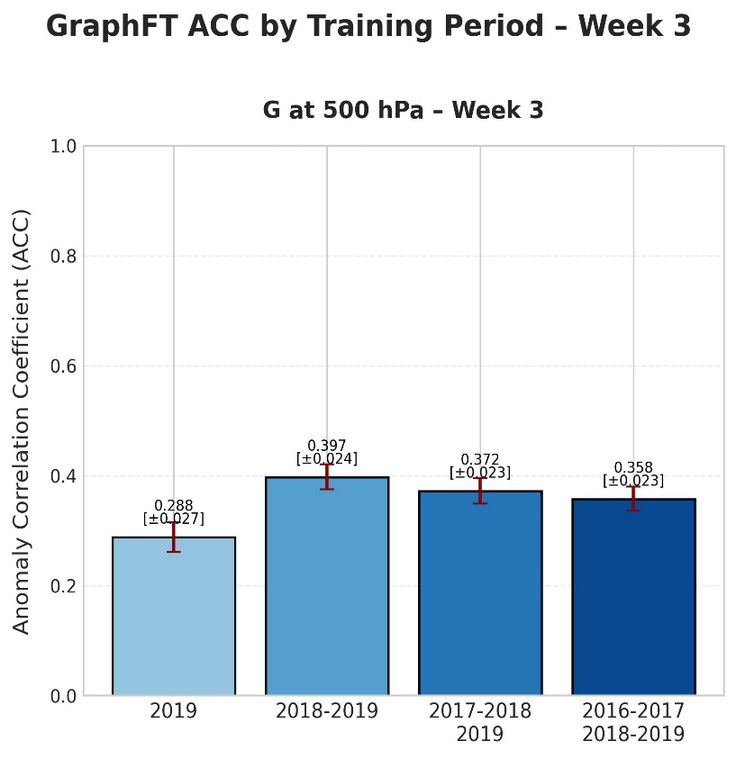
Z500 – week 4
Z500 – week 3

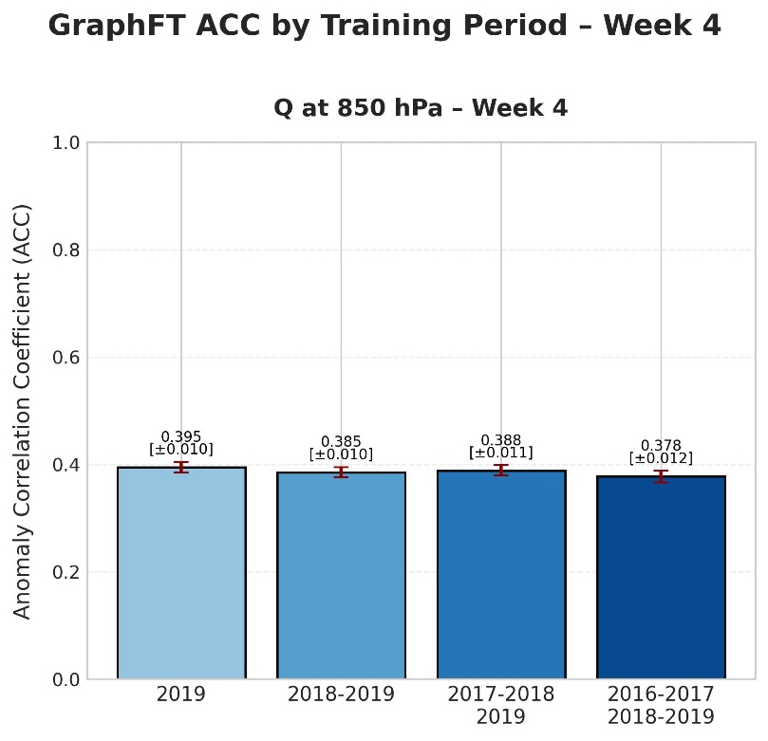

Figure S16. Evolution of ACC for Q@850 hPa for week 3 and 4 lead-times, for 4 different versions of FT (GraphFT) trained respectively on subsets or on the whole of the training data. The sensitivity tests reveal mixed results in the convergence of ACC when compared to the number of training years for Z500 and Q850. For Z500 and for week 3, we can see a convergence of ACC values, but not for week 4, we can see that ACC values still seems to slightly increase (but not significantly; the only significant difference is between 1 year and 4 training years)
We can assume that there is a high inter-variable variance when comparing the convergence of ACC with the training years. Still, we have seen that this method of fine-tuning improves REF (GraphOP) and enables the implementation of ensemble forecasting. Furthermore, it may be possible to increase further the forecast skill by adding more years in the training data.

Metrics and evaluation

This supplementary section provides an overview of the metrics used in the forecast evaluation process. Before assessment, we remove the daily climatology (cf. specific description on that in Main Text section Methods and subsection Climatology) to all variables to remove any seasonal component that may be present, so as to focus on anomalies. More precisely, we calculated a weekly climatology in order to compare it with the weekly forecasts generated by the forecasting models.

Anomaly Correlation Coefficient (ACC)

ACC is a classical metrics in meteorology to estimate forecast skills and represents the temporal mean of the global spatial correlation between observed and forecasted (ensemble-mean) anomalies.

We computed the Anomaly Correlation Coefficient (ACC) with the following equation:

$$ACC\left(τ,k\right)= \frac{1}{\left|D_{eval}\right|}\sum_{t_{0}ϵD_{eval}}{\frac{\sum_{iϵG_{1.5°}}{a_{i}{\hat{A}}_{i,j,k}^{t_{0}+τ }A_{i,j,k}^{t_{0}+τ }}}{\sqrt{\sum_{i,jϵG_{1.5°}}{a_{i}(}{\hat{A}}_{i,j,k}^{t_{0}+τ })²\sum_{i,jϵG_{1.5°}}{a_{i}(}A_{i,j,k}^{t_{0}+τ })²}}}$$
Where:
- $t_{0} ϵ D_{eval}$ represents forecast initialization date-times in the evaluation dataset

- $k ϵ K$ represents the index of the variables, e.g., k = {T2M, U10, V10, TP}

- $i,j ϵ G_{1.5°}$ are the location (latitude and longitude) coordinates in the grid

- $a_{i}$ is the area of the latitude-longitude grid cell (normalized to unit mean over the grid) which varies with latitude

- $τ$ refers to the forecast lead time steps added to $t_{0}$, e.g., $τ$ = {week 2, week 3, week 4}

- ${\hat{A}}_{i,j,k}^{t_{0}+τ }$ and $A_{i,j,k}^{t_{0}+τ }$ are predicted and observed anomalies for a given variable, location, $t_{0}$and lead time

Temporal Correlation Coefficient (R_{t})

We also computed R_{t}, defined, using the same notation as above, as:
$$R_{t}\left(τ,i,j,k\right)=\frac{\sum_{t_{0}ϵD_{eval}}{a_{i}{\hat{A}}_{i,j,k}^{t_{0}+τ }A_{i,j,k}^{t_{0}+τ }}}{\sqrt{\sum_{t_{0}ϵD_{eval}}{(}a_{i}{\hat{A}}_{i,j,k}^{t_{0}+τ })²\sum_{t_{0}ϵD_{eval}}{(}a_{i}A_{i,j,k}^{t_{0}+τ })²}}$$
Spatial maps of the R_{t} coefficient are presented in the results section.

Latitudinal dependence: the $R_{t,x}\left(τ,j,k\right)$ correlation coefficient

In order to have a better idea of the latitudinal distribution of R correlation coefficient, the correlation coefficient R_{t,x} was plotted for each latitude. R_{t,x} is directly calculated for each latitude on both time and longitude axis simultaneously with the following equation:
$$R_{t,x}\left(τ,i,k\right)=\frac{\sum_{t_{0}ϵD_{eval}, jϵG_{1.5°}}{a_{i}{\hat{A}}_{i,j,k}^{t_{0}+τ }A_{i,j,k}^{t_{0}+τ }}}{\sqrt{\sum_{t_{0}ϵD_{eval},jϵG_{1.5°}}{(}a_{i}{\hat{A}}_{i,j,k}^{t_{0}+τ })²\sum_{t_{0}ϵD_{eval},jϵG_{1.5°}}{(}a_{i}A_{i,j,k}^{t_{0}+τ })²}}$$

Continuous Ranking Probability Score (CRPS)

The temporal average of the spatial CRPS between observations and ensemble forecasts is also computed. For this, we first compute the spatial CRPS$\left(τ,i,j,k\right)$ for each grid cell (i,j).

$$CRPS\left(τ,i,j,k\right)= \frac{1}{M}\sum_{n=1}^{M}{\left|x_{τ,i,j,n}-y_{τ,i,j}\right|}- \frac{1}{2M²}\sum_{n=1}^{M}{\sum_{m=1}^{M}{\left|x_{τ,i,j,n}-x_{τ,i,jm}\right|}}$$

We then compute the temporal latitude weighted with the following equation:

$${CRPS}_{t}(τ,k)= \frac{1}{\left|D_{eval}\right|}\sum_{t_{0}ϵD_{eval}}{\frac{\sum_{iϵG_{1.5°}}{\sum_{jϵG_{1.5°}}{a_{i}CRPS\left(τ,i,j,k\right)}}}{\sum_{iϵG_{1.5°}}{\sum_{jϵG_{1.5°}}{a_{i}}}}}$$

Where:
- $M$ represents the number of members for one ensemble forecast

- $x_{j}$ is the forecast for ensemble member j
In case of deterministic forecasts, the CRPS is reduced to the MAE:

$$MAE\left(τ,k\right)=\frac{1}{\left|D_{eval}\right|}\sum_{t_{0}ϵD_{eval}}{\sum_{i,jϵG_{1.5°}}{\frac{1}{\left|G_{1.5°}\right|}a_{i}\left|{\hat{A}}_{i,j,k}^{t_{0}+τ }- A_{i,j,k}^{t_{0}+τ }\right|}}$$

Root Mean Square Error
We quantified the forecast skill using the latitude-weighted RMSE given by:
$$RMSE\left(τ,k\right)= \frac{1}{\left|D_{eval}\right|}\sum_{t_{0}ϵD_{eval}}{\sqrt{\sum_{i,jϵG_{1.5°}}{\frac{1}{\left|G_{1.5°}\right|}a_{i}({\hat{A}}_{i,j,k}^{t_{0}+τ }- A_{i,j,k}^{t_{0}+τ })²}}}$$

Bootstrapping for significance testing

We adopted a bootstrapping method as a significance test. Bootstrapping creates synthetic datasets by resampling with replacement, e.g. 1000 in this work, from the original data and provides measures of accuracy to sample estimates³⁷ such as variance or confidence intervals. Bootstrapping is used for computing the 95% confidence intervals for mean global ACC, RMSE and CRPS values and for the mean values of R_{t} throughout this paper. The sample value n is equal to 116, corresponding to one prediction per week for 3 years (2020-2021-2022).

