Supplement

Title
Perinatal and Early-Childhood Exposures and Risk of Autism: A Cosmos Cohort Study of 1.9 Million U.S. Children

Methods
Cosmos Background Information
Cosmos Data Models
Data for analysis was obtained from the Cosmos database, a dataset created in collaboration with a community of Epic health systems representing more than 300 million patient records from over 1,689 hospitals and 39,800 clinics from all 50 states, D.C., Lebanon, and Saudi Arabia. Data for this study was limited to the United States and is anonymized. The current count values for patients, hospitals, and clinics are available on cosmos.epic.com. Data for this study was obtained from the April 24, 2025 data update to Cosmos. Data sharing is available on request for Cosmos certified users.

Date Shifting in Cosmos
To maintain an anonymized status of the Cosmos data, Epic randomly shifts date events in the data from the actual date of the event in the EDDI model only. The number of days for this random shift is the same for all dates for an individual patient, preserving date associations between events. For patients under age 18, the random date shift forward is 0 to 30 days. For patients 18 and over, the date of birth also truncated to January 1 of the birth year they were born. The 4/24/2025 data pull had 298,642,708 patients using the Slicer Dicer method and 298,607,901 patients using the EDDI method. This difference is due to the date shifting of 0-30 days in EDDI which can cause newborn patients to have their date of birth shifted into the future. These patients are excluded from EDDI until their birthdate is no longer in the future.

Data Definitions
Diagnoses
Diagnoses are stored in Cosmos based on the Intelligent Medical Objects, a product of IMO Health, and mapped to ICD-10-CM (ICD-10) taxonomy. The care of autism and the risks factors analyzed are predominantly done in the outpatient setting and as encounter diagnosis are more reliably entered for conditions assessed at that visit than the problem list of diagnoses, the Encounter diagnosis type was used in this study unless otherwise specified. All diagnoses in this study were defined using ICD-10 codes. (eTable 1)

Diagnoses | ICD-10 Matching Syntax | Age Range
Attention Deficit Hyperactivity Disorder | F90* | Before 1 year postpartum
Autism | F84.0* | Varies in Study
Autism Spectrum Disorder – Slicer Dicer Method | Epic released grouper for ASD | Varies in Study
Autism Spectrum Disorder – EDDI method (for Birth Parent) | F84* in EDDI | Before 1 year postpartum
Asthma | J45.* | During pregnancy
Autoimmune thyroiditis | E06.3* | During pregnancy
Cerebral palsy | G80* | Any age
CMV Infection | B25.* | During pregnancy
Congenital heart disease | Q20.* through Q26.* | 1st year of life
Covid 19 | U07.* | 1st year of life and during pregnancy
Cyanotic congenital heart disease | Q20.0*, Q20.3*, Q21.3*, Q22.0*, Q22.1*, Q22.4*, Q22.5*, Q23.4*, Q25.21*, and Q26.2* | 1st year of life
Depression (Major) | F32.*, F33.*  F53.0* added for postpartum depression. | During pregnancy  Birth to 1 year post delivery.
Developmental delays | R62.0, F80.*, F82.*, F88.*, F89.* | 0-12 months of life
Diabetes mellitus | E10.*, E11.*, O23.* | During pregnancy
Down syndrome | Q90.* | 1st 2 years of life
Failure to thrive | P92.6* | 1st year of life
Fragile X syndrome | Q99.2* | 1st 5 years of life
Generalized Anxiety Disorder | F41.1* | Before 1 year postpartum
Genitourinary infections | N39.0*, O23.* | During pregnancy
HSV | B00.* | During pregnancy
Hypertension and pre-eclampsia | I1* , O14.* | During pregnancy
Influenza | J09.*, J10.*, J11.* | During pregnancy
Iron deficiency anemia | D50.* | 1st year of life
Lupus | L93.* | During pregnancy
Non Well Child Check Visits | All ICD10-CM codes excluding Z00.129 and F84.0* | Ages 0-12 months
Parvovirus | B34.3* | During pregnancy
Placental Dx | F043*, F044*, F045* in birth parent  P02.0*, P02.1*, P02.2*, P02.3* in child | During pregnancy to 30 days postpartum
Prolonged Labor | O63*, O64*, O65*, O66* | During pregnancy
Psoriasis | L40.* | During pregnancy
Respiratory distress in newborn | P22.* | 1st year of life
Rett syndrome | F84.2* | 1st 4 years of life
Rheumatoid arthritis | M05.*, M06.* | During pregnancy
Small for gestational age | P05.* | 1st year of life
Tuberous Sclerosis | Q85.1* | 1st 2 years of life
Ulcerative Colitis and Crohn’s | K50.*, K51.* | During pregnancy
Umbilical Cord Disease | O69* in birth parent  P02.4*, P02.5*, P026* | During pregnancy to 30 days postpartum
Vitamin D Deficiency | E55.* | During pregnancy
Well Child Check | Z00.129 | Ages 0 - 12 months
Zika | A92.5* | During pregnancy
eTable 1
Medications

Medications are stored in Cosmos using the RxNorm taxonomy. The medication records table maps these RxNorm codes to simple generic names, pharmaceutical classes, pharmaceutical subclasses, and therapeutic classes of the medication. Only medications with a route of oral, intravenous, or injection (topical, ocular and other routes excluded) were included, except opioids which included topical routes (transdermal). (eTables 2 and 3)

Medication Class | Field | Value
Acetaminophen | Simple Generic Name | Acetaminophen
Antihistamines | Therapeutic Class | *Antihistamine*
Opioids | Pharmaceutical Class | Opioid*
Caffeine | Pharmaceutical Class | *Xanthine*
Non-Opioid Antitussive | Pharmaceutical SubClass | *non-opioid antitussive*
Expectorant | Pharmaceutical SubClass | *expectorant*
Pamabrom | Simple Generic Name | *pamabrom*
NSAIDS | Pharmaceutical Class | *NSAID*
SSRI | Pharmaceutical Class | *Selective Serotonin Reuptake inhibitor*
SNRI | Pharmaceutical Class | * Serotonin-Norepinephrine Reuptake-inhib*
Antipsychotic/Neuroleptic | Epic Release Grouper | *Antipsychotic/Neuroleptic*
Antibiotics | Epic Release Grouper | Antibiotics*
PCN/Cephalosporin | Pharmaceutical Class | *Penicillin Antibiotics* or *Cephalosporin*
Macrolides | Pharmaceutical Class | *macrolide*
Quinolones | Pharmaceutical Class | *quinolone*
Nitrofuran | Pharmaceutical Class | *nitrofuran*
Topiramate | Simple Generic Name | *topiramate*
Insulins | Epic Release Grouper | *insulins*
Phenytoin | Generic Name | *phenytoin*
Carbamazepine | Generic Name | *carbamazepine*
Benzodiazepines | Pharmaceutical Class | *benzodiazepine*
Beta 2 agonists | Generic Name | *uterol* or *meterol*
eTable 2
Acetaminophen, NSAIDS, Opioids, Antihistamines, Non-opioid Antitussives, Expectorants, and other medications exist in single medication forms and in forms with combinations of other medications. Combinations studied are listed (eTable 3).

Medication | Acetaminophen | NSAIDS | Opioids | Antihistamines | Non-Opioid Antitussives | Expectorants
Acetaminophen | NA
NSAIDS |  | NA
Opioids |  |  | NA
Antihistamines |  |  |  | NA
Non-Opioid Antitussives |  |  |  |  | NA
Expectorants |  |  |  |  |  | NA
eTable 3 – Cells in green had medication combinations recorded in the data.

Labs
Laboratory values are stored in Cosmos using LOINC taxonomy. (eTable 4)
Lab | LOINC Code | Age Range
Lead | 5671-3, 5674-7, 77307-3, 10368-9 | Any age of patient
Vitamin D | 62292-8 | During Pregnancy
Hemoglobin | 718-7 | During Pregnancy
Ferritin | 5671-3 | During Pregnancy
eTable 4
Base Population Filters
Early and All Autism: To separate out children who were diagnosed earlier and had the opportunity for earlier treatment, the diagnosis of autism was studied in two groups. Early autism was defined as those children with an initial recorded encounter diagnosis between 12 and 36 months of age, inclusively. All autism was defined as those children with an initial recorded encounter diagnosis of autism between 12 and 84 months of age, inclusively.

Presence of a Birth Record Filtering: While data on the child is not dependent on the presence of a birth record, data on the pregnancy, delivery, and birth parent are dependent on having a birth record in Cosmos. For this reason, the primary and subgroup analyses filtered patients to those with a link to the pregnancy/delivery data from the birth parent. The linkage of birth records to the patient’s record began in Cosmos on 12/6/2012 so patients born before this date were excluded from the study.

Autism before 12m of age Filtering: As ADOS-2 (Autism Diagnostic Observation Schedule, Second Edition) is considered a gold standard evaluation for autism and is only valid for children 12 months or older, children with a diagnosis of autism at 11 months or younger were excluded from the study.

Current Age and Date of Birth Filtering: Children were required to be old enough to allow observation for autism diagnosis while remaining within the defined study window. Eligible children were those aged 2 to 7 years during the study period (January 1, 2015 to December 31, 2024), corresponding to births between December 6, 2012 and December 31, 2022.
In the Slicer Dicer data model, which stores only current age rather than date of birth, a minimum current age of ≥2 years was applied to ensure that children had reached at least one year beyond the earliest possible autism diagnosis age (12 months). Because this approach can include a number of children born after December 31, 2022 and before April 24, 2022, diagnosis-age filters for early and all autism were applied to ensure correct age-at-diagnosis classification.
In the EDDI data model, which stores date of birth (shifted by 0–30 days for de-identification), patients were directly filtered to those with shifted birthdates between December 6, 2012 and December 31, 2022, ensuring accurate age eligibility within the study period.
Encounter type and Department Specialty Filtering: Cosmos represents data on care from primary care, emergency, inpatient and specialist encounters with patients. When patients are seen outside of primary care, their full medical history, is often not recorded. If primary care for a patient is not part of the Cosmos data set and specialty/emergency/inpatient care is in the Cosmos data set, the potential for bias becomes present from incomplete data. For children, primary care encounters were defined as having a department specialty of either Pediatrics or Family Medicine. Because telemedicine visits were uncommon before the outbreak of Covid 19, the study filtered data to encounter types of “office visits.” As many of the variables in the models are obtained or documented when the first signs of childhood developmental delay are presenting, we restricted the study population to those seen between 12 and 24 months of age to assure better data capture. In total then, the filter of an office visit encounter type, occurring between the ages 12 and 24 months, in a Family Medicine or Pediatrics department, was added to the study.

Active Patient Filtering: All queries were done using Cosmos Active Patient filter (called Base Patient filter in Slicer Dicer) which limits data to patients seen in a face-to-face visit more than once within a two-year period during any two-year period in the date range of the study. This is recommended by Epic to improve data accuracy. This was used in both the Slicer Dicer and EDDI data models.

Anonymized Line-Level Data Analysis (EDDI method)
Cleaning of Data (EDDI data only)
Legal sex was limited to Male or Female, eliminating 84 records that were not either Male or Female. There were 1,349 children who died before the end of the study (12/31/2024). These were removed from the data. EDDI subgroup numeric variables were cleaned to eliminate extreme outliers as determined by a lower limit less than 3 SD (for non-skewed) or 3 IQR (for skewed) below the median and an upper limit of greater than 3SD (for non-skewed) or 3 IQR (for skewed) above the median. For gestational age, the limit of earliest surviving infants in the literature was used. According to ACOG it is exceedingly rare for pregnancies to go beyond 42 weeks, so 44 weeks was chosen as a safe maximum cutoff. For numeric values with 98% or more data completeness, values below the lower limit were set to the lower limit, values above higher limit were set to the higher limit and unknown/missing values were set to the median value (eTable 5). For numeric values with <98% completeness, values were binned into categories. Values below lower limit and above higher limit in this group were set to unknown (eTable 6). Invalid categorical values of the delivery method (e.g. medical delivery method) were set to unknown (eTable 6). Numeric values that had a nonlinear relationship to the log odds of the autism outcome were binned including: Maternal age, Birth Weight, Apgar scores and Newborn length of stay, well child check visits and non-well child check visits.

Variable | Lower Limit | Higher Limit | % Complete | Median | Number records cleaned
Gestational age (weeks) | 22 | 44 | 99.8% | 39 | 4,916
Birth Count | 1 | NA | 98.8% | 1 | 67
eTable 5
Binned Variable | % Complete or counts cleaned () | Categorization (binning)
ADI Percentile (US) | 43.96% | Binned to deciles and unknown
Delivery Method | (30,612) | Values for non-delivery methods (e.g. medical, incomplete) changed to unknown
C-Section | (12,006) | Unknown changed to not c-section
BMI before delivery | 50.55% | Values < 14 or >80 kg/m² set to unknown (n=206).  Binned to standard BMI groupings
BMI before conception | 43.45% | Values < 14 or >80 kg/m² set to unknown (n=228).  Binned to standard BMI groupings⁴
BMI gained during pregnancy  (have both BMId and BMIc) | 24.48% | Values <-2 or >10 kg/m² set to unknown (n=113,869).  Binned to 2kg/m² intervals from -2 to 10.
Maternal Age | 100% | Binned to 5-year age groups starting at <20 through >39. (Teenage, Young Adult, Adult, Older Adult, Advanced, Very Advanced)
Newborn Length of Stay | 98.78% | Binned to Short (0-1days), Standard (2-3d), Prolonged (4-7d), Short Extended (8-28d), Extended (29-89d), Very Extended (90-366d)
Birth Weight | 99.89% | Binned to Extremely Low (255-1000 grams), Very Low (1001-1500g), Low (1501-2500g), Normal (2501-4000g), High (4001-7229)
1 min Apgar score | 98.33% | Binned to Critically Low (0-3), Moderately Low (4-6) and Normal (7-10)
Well child check visits (0-12 months) | 100% | Binned to None (0), Below Average (1-3), Average (4-6) and Above Average (7-11)
Non well child check visits (0-12 months) | 100% | Binned to None (0), Below 25th %ile (1-2), Average (3-7), and Above 75th %ile (8-19)
eTable 6
Evaluation of Skewness of Numeric Data
Median values for continuous numeric variables were calculated, and the variables were evaluated for skewness. Variables with skewness between -0.25 and 0.25 were considered normally distributed and measurements of variability were calculated using standard deviation. Variables with skewness above 0.25 or below -0.25 were considered not normally distributed and measurements of variability were calculated using interquartile range (IQR). Distributional characteristics of continuous variables were assessed using skewness and visual inspection of histograms to determine appropriate modeling or binning.

Subgroup Determinations
Subgroups of known/suspected and possible risks of autism were identified from a literature search and limited to those that have data stored in Cosmos (paternal age is a risk factor but this data is not stored in Cosmos linked to the pregnancy). The references for these are listed next to the variable below.

Subgroups on data from child’s records: The following subgroups were studied on data from the child: legal sex, race, ethnicity⁵, and Area Deprivation Index – US (ADI).⁵ Cosmos stores up to 5 races per patient. A patient was included in a racial group if any of the 5 fields stored had that race value. Also included were the presence of a hospital admission within the first 12 months of age (not including birth admission), hospitalization length of stay for the birth admission, antibiotic exposure in the first 12 months of age and blood lead level at any time during the study. The following diagnosis, of any diagnosis type, during first 12 months, were also included: Covid (no studies identified to date associated with autism), Small for Gestational Age, Failure to Thrive, Respiratory Distress of Newborn, Congenital Heart Disease, Cyanotic Congenital Heart Disease, Iron Deficiency Anemia, Fragile X (dx in first 5 yrs), Rett syndrome (4 yrs), Tuberous Sclerosis (2 years), Down syndrome (2 years), Developmental delay (0-12 months), and Cerebral palsy (0-12 months).

Subgroups on data from pregnancy, delivery and postpartum period: The following subgroups were included: maternal age at birth, gestational age at birth, 1 min Apgar score¹¹, birth weight, birth count (e.g. twins), birth delivery method (e.g. C-section), birth parent’s BMI pre-conception (BMIc) and at delivery (BMId). The BMIc is the latest BMI within 1 year before the estimated date of conception. BMI gained (BMIg) was calculated as the difference between BMId and BMIc, when both values were present. Placental disease (diagnosed in birth parent or child), umbilical cord disease (diagnosed in birth parent or child), or prolonged/obstructed³¹ labor were included for dates during pregnancy to 30 days postpartum. Exposure to the following medications during pregnancy (up to 3 days before delivery date to remove medications given during delivery admission) were included: acetaminophen, NSAIDS, opioids, antihistamines, non-opioid antitussives, expectorants³⁴, SSRIs, SNRIs³⁵, Antipsychotic/Neuroleptics, Topiramate, Phenytoin³⁷, Carbamazepine³⁷, Benzodiazepines, Beta 2 agonists, Insulin, and Antibiotics. The antibiotics were further subclassified as Penicillin/Cephalosporins, Macrolides, Quinolones and Nitrofurans. Tetracyclines and sulfa antibiotics are contraindicated in pregnancy and data confirmed these were rarely prescribed. The presence of a birth parent’s diagnoses (all diagnosis types) during pregnancy, were also included: diabetes mellitus⁴⁰, hypertension, genitourinary infections, major depression, asthma, autoimmune thyroiditis, lupus, rheumatoid arthritis, ulcerative colitis/Crohn’s, psoriasis⁴⁸, Covid 19, and hypovitaminosis D, Zika virus, CMV, HSV, influenza and parvovirus infections. ADHD, ASD⁵⁸, Generalized Anxiety Disorder⁵⁸ were included if diagnosed at any time before 1 year postpartum. Also included was the birth parent’s diagnosis (all types) postpartum, from delivery date to 1 year post delivery date of major depression or postpartum depression. Also included were the presence of abnormal birth parent’s labs during pregnancy for Vitamin D⁴⁹¸ hemoglobin, and ferritin results⁵⁷.

Subgroups on data from birth parent’s record during pregnancy: The following social history data from the birth parent’s record, during the pregnancy, were included: alcohol status, food scarcity history, homeless history, smoking status, substance use status, residency by US census division. As this data in Cosmos is overwritten with newer data, we only included data that was last recorded during the pregnancy period. The last marital status was included but Cosmos does not store the date when the last marital status was entered and therefore, we could not determine if the marital status was at the time of the pregnancy.

Unadjusted Odds Ratios (uORs)
Continuous numerical variables
Continuous numeric subgroup variables were assessed for linearity in the logit by plotting log-odds of the outcome across deciles of the predictor. A linear pattern supported inclusion as a continuous term; variables with nonlinear patterns were binned for categorization. Gestational age was found to be linear. Well child check visit counts, Non-well child check visit counts, Birth weight, Apgar scores and initial newborn length of stay were non-linear and were binned (eTable 6).

Categorical variables
Dummied variables were created for all values for all the categorical variables. uORs for these dummied categorical variables were calculated by univariate logistic regression against the reference value (chosen by highest % for that variable) for that variable (eTable 7). While males outnumbered females, we used females as the reference value to create a OR >1 for male children.

Variable | Reference Value
Sex | Female
Race | White
Ethnicity | Non-Hispanic or Latino
ADI | 50th %ile
Well Child Check Visits | Average Well Child Check Visits (5-8 visits)
Non-Well Child Check Visits | Average Non Well Child Check Visits (5-12 visits)
Maternal Age | Adult (age 25-29)
Birth Weight | Normal (2500-4000 g)
Apgar score | Normal (7-10)
Newborn Length of Stay | Standard (2-3 days)
Delivery Method | Vaginal Spontaneous
BMI before delivery | Overweight (25-30 kg/m²)
BMI before conception | Normal weight (18.5-25 kg/m²)
BMI gained during pregnancy | 4-6 kg/m²
Alcohol history | No
Food insecurity | Never
Homeless | No
Smoking Status | Never
Substance Use | Never
Highest Education (Slicer Dicer) | Bachelor’s degree
Marital Status | Married
Census Division | East North Central
eTable 7
Adjusted Odds Ratios (aORs)
To determine aORs, two adjustment models (primary models) were created using the cleaned data from EDDI, one for early autism and one for all autism.

Removal of Subgroups (Boolean only) with low counts from model
To avoid unstable estimates due to small sample sizes and sparse data bias, subgroups representing fewer than 5% of cases or 0.5% of the total population were excluded from the multivariate logistic regression model.,, For the fully adjusted model for early autism, this cutoff was 1,532 patients, and for the all autism model, the cutoff was 3,080 patients. The following 14 variables were excluded:

Fragile X, Rett syndrome, Tuberous sclerosis, Acetaminophen/Antihistamine, Acetaminophen/Non-opioid Antitussive, Acetaminophen/Expectorant, NSAID/opioid, Antihistamine/Expectorant, Phenytoin, Carbamazepine, Lupus, Zika virus, CMV, Parvovirus. Birth parent ASD was below the cutoff but important enough we included it in the model due to its strong biological relevance. Topiramate also was below the lower cutoff but was included as we wanted to look a minimum of one of the antiseizure medicines given their past association with autism. Including the 3 bias variables of well child check visits, non-well child check visits and early developmental delay, there were then 77 variables in the adjusted logistic regression analyses, plus the 2 Slicer Dicer variables in the non-adjusted analyses.

Setting of Reference Values for categorical variables in the model
Categorical odds ratios were calculated against the reference value (chosen by highest % for that variable) for that variable (eTable 7).

Shifting of Numeric Values to Median for the model
The continuous numeric variable (gestational age) was center shifted to the median, so the odds ratio would be relative to the median. aORs for gestational age were shown as the inverse of the calculated aOR so that the lower values of the variable would be associated with an increase aOR. The aOR is per unit of the variable (weeks).

Identification of Modifiers to include in Logistic Regression Models
DAG were used to identify modifiers of specific variables felt to have direct relationships. Table S8 shows the modifiers included in the logistic regression analysis for each variable felt to be dependent on another variable(s) to show the corrected aOR for that variable. In Cosmos patients can endorse up to 5 races. To avoid forcing mutually exclusive categories, race was modeled as six non-mutually exclusive binary indicators (White, Black, Asian, American Indian/Alaska Native, Hawaiian/Pacific Islander, Other), coded 1 if the race was present and 0 otherwise. The outcome was regressed on these indicators simultaneously. Under this specification, each race coefficient captures the incremental association of that race conditional on the other race indicators.

Medications during pregnancy for pain and for cold symptoms (see Table S8) were harmonized across each domain to create a single binary exposure for that medication, either as a standalone product or combination product. To address confounding by indication and co-medication without double-counting the medication, we summarized all non-medication use into a mutually exclusive categorical covariates for each medication, referred to as the non-medication pattern. For example, with acetaminophen, a variable for any acetaminophen use was established for either acetaminophen alone or acetaminophen in combination with other medications. Then a non-acetaminophen medication pattern categorical variable was created with the following levels: no pain or cold medications, NSAIDS only, Opioids only, Antihistamine only, Non-opioid antitussives only, Expectorants only, and multi non acetaminophen medications (≥2 of these non-acetaminophen classes, including all combination pain or cold medications without acetaminophen). Medications that were just cold medications were harmonized and summarized against just the other cold medications. This specification allowed for the aOR calculation of each pain/cold and only cold medication. It also explicitly controlled for the accompanying non-medication context and for prenatal confounders identified in the DAG and avoided double counting that medication.

Because Cosmos allows multiple race designations per patient, race categories were modeled as non-mutually exclusive binary indicators.

Variable | Confounders Included in the adjusted Logistic regression
Well Child Check Visits | ADI, Early developmental delay, Marital status, Newborn LOS, maternal age
Non Well Child Check Visits | 1 minute Apgar, ADI, BMI at delivery, Congenital heart disease, Cerebral palsy, Covid 1st year, Covid in pregnancy, HSV in pregnancy, Influenza in pregnancy, cyanotic CHD, DM in pregnancy, Downs, Early developmental delay, Ethnicity, Failure to thrive, Generalized anxiety disorder, Gestational age, HTN in pregnancy, Iron Def Anemia, Maternal age, Newborn LOS, Race, Respiratory Distress in Newborn, Small for gestational age, Substance use, Well child check visits
Early Developmental Delay | Cerebral palsy, Downs
Sex | None
Race | Other 5 races
Ethnicity | None
ADI - US | Ethnicity, Marital status, Maternal age, Race, Substance use
US Census Division Last Residence | None
Current Marital Status of Birth Parent | ADI, Ethnicity, Maternal age, Race, Substance use
Newborn Length of Stay | 1 minute Apgar, Congenital heart disease, Cyanotic CHD, DM in pregnancy, Downs, GU Infection in pregnancy, Gestational age, Respiratory Distress in newborn, Small for gestational age
Hospital Admission in 1st 12m | 1 minute Apgar, ADI, BMI at delivery, CHD, Cerebral palsy, Covid 1st year, Covid in pregnancy, HSV in pregnancy, Influenza in pregnancy, Cyanotic CHD, DM in pregnancy, Downs, Early Developmental Delay, Ethnicity, GAD, Gestational Age, HTN pregnancy, Iron Def Anemia, Newborn LOS, Non Well Child Check Visits, Race, Resp Distress, SGA, Substance Use, Well Child Check Visits, maternal age
Antibiotics in 1st 12m | Hospital Admission in 1st year, Newborn LOS
Lead level abnormal | ADI, Ethnicity, Race, Sex
Covid in 1st 12m | None
Small for Gestational Age | BMId, Birth Count, DM pregnancy, Placental dx, Sex
Failure to Thrive | CHD, SGA, Sex
Respiratory Distress of Newborn | 1M Apgar, Birth Count, CHD, Cyanotic CHD, Gestational Age, Long Labor, Placental Disease, Sex, Umbilical Cord Disease
Congenital Heart Disease | Down’s, Maternal Age, Sex
Cyanotic Congenital Heart Disease | CHD, Downs, FTT, Iron Def Anemia, Sex
Iron Deficiency Anemia | CHD, Cyanotic CHD, Downs, FTT, Sex
Down’s Syndrome | Maternal age, Sex
Cerebral Palsy | Newborn LOS, Sex, Umbilical Cord Disease
Delivery Method | Cyanotic CHD, Gestational Age, Long labor, Placental Disease
Gestational Age | Birth Count, CHD, Maternal age, Sex
1min Apgar | Birth Count, CHD, Covid/HSV/Influenza in pregnancy, Cyanotic CHD, Gestational Age, HTN pregnancy, Long Labor, Maternal age, Placental Disease, Sex, Umbilical Cord Disease
Maternal Age | ADI, Ethnicity, Marital Status, Race, Substance Use
BMI Conception | BMId, BMIg
BMI Delivery | BMIc, BMIg
BMI Gained | BMIc, BMId
Birth Weight | BMId, Birth Count, DM (pregnancy), Sex
Birth Count | Maternal age
Acetaminophen in pregnancy (pain and cold medication, alone or in combination) | RA, UCC, Psoriasis, Covid/HSV/Influenza in pregnancy, Depression in pregnancy/post-partum, and non-acetaminophen pain/cold medication pattern in pregnancy.
NSAIDS in pregnancy (pain med and cold med) | RA, UCC, Psoriasis, Covid/HSV/Influenza in pregnancy, Depression in pregnancy/post-partum, and non-NSAID pain/cold medication pattern in pregnancy.
Opioids in pregnancy, (pain and cold medication, alone or in combination) | RA, UCC, Psoriasis, Covid/HSV/Influenza in pregnancy, Depression in pregnancy/post-partum, and non-opioid pain/cold medication pattern in pregnancy.
Antihistamines in pregnancy (cold medication, alone or in combination) | Covid/HSV/Influenza in pregnancy, and non-antihistamine cold medication pattern in pregnancy.
Non-opioid antitussives in pregnancy (cold medication, alone or in combination) | Covid/HSV/Influenza in pregnancy, and non - non-opioid antitussive cold medication pattern in pregnancy.
Expectorants in pregnancy (cold medication, alone or in combination) | Covid/HSV/Influenza in pregnancy, and non-expectorant cold medication pattern in pregnancy.
SSRI in pregnancy | ADHD, ASD, RA, UCC, Psoriasis, Depression in pregnancy/post-partum, GAD
SNRI in pregnancy | ADHD, ASD, RA, UCC, Psoriasis, Depression in pregnancy/post-partum, GAD
Antipsychotics/Neuroleptics in pregnancy | ADHD, ASD, RA, UCC, Psoriasis, Depression in pregnancy/post-partum, GAD
Topiramate in pregnancy | None
Insulin | DM pregnancy
Benzodiazepines | Depression in pregnancy/post-partum, GAD
Beta 2 agonists | Asthma – pregnancy
Diabetes in pregnancy | HTN pregnancy, Maternal age, Race
HTN in pregnancy | DM pregnancy, Maternal age, Race
Genito-urinary infection in pregnancy | DM pregnancy, Ethnicity, Maternal age, Race
Major Depression in pregnancy | Post Partum Depression
ADHD in birth parent before 1yr postpartum | None
Autism Spectrum Disorder in birth parent before 1yr postpartum | None
Generalized Anxiety Disorder in birth parent before 1yr postpartum | None
Asthma in pregnancy | Race
Autoimmune thyroiditis in pregnancy | Race
Covid 19 in pregnancy | Race
Vitamin D Deficiency by dx in pregnancy | Vitamin D by lab
HSV in pregnancy | Race, Ethnicity
Influenza in pregnancy | Race, Ethnicity
Placental disease | Gestational Age, Maternal age
Umbilical cord disease | Birth Count, Delivery Method
Long labor | Maternal age
Major Depression delivery to 1 yr postpartum | Depression in pregnancy
Abnormal Vitamin D lab in pregnancy | Vitamin D deficiency dx
Abnormal Hemoglobin in pregnancy | Iron deficiency Anemia, Ferritin
Abnormal Ferritin in pregnancy | Iron deficiency Anemia, Hemoglobin
All antibiotics in pregnancy | GU infection in pregnancy, all other abx subclasses
PCN/Cephalosporin abx | GU infection in pregnancy, all abx, all other abx subclasses
Macrolide abx | GU infection in pregnancy, all abx, all other abx subclasses
Quinolone abx | GU infection in pregnancy, all abx, all other abx subclasses
Nitrofuran abx | GU infection in pregnancy, all abx, all other abx subclasses
Alcohol history in pregnancy | ADHD, ADI, ASD, Depression in pregnancy/post-partum, Ethnicity, GAD, Race, Substance Use
Smoking history in pregnancy | ADHD, ADI, ASD, Alcohol hx, Asthma - pregnancy, Depression in pregnancy/post-partum, Ethnicity, GAD, Race, Substance Use
Substance use in pregnancy | ADHD, ADI, ASD
Food Insecurity in pregnancy | ADHD, ADI, ASD, Alcohol hx, Depression in pregnancy/post-partum, Ethnicity, GAD, Race, Substance Use
Homelessness in pregnancy | ADHD, ADI, ASD, Alcohol hx, Depression in pregnancy/post-partum, Ethnicity, GAD, Race, Substance Use
eTable 8

Results
Subgroup analysis of odds ratios for autism

These analyses are done to identify any subgroups that may be at higher risk for autism. Definitions of result category and their color legend for result category for tables S9-20 are in the legend below. Lower confidence intervals (LCI) and higher confidence intervals (HCI) were calculated from the Cohen’s d of 0.2. Minimum detectable odds ratio (MDOR) was used to confirm sufficient data to reach a result.

Category | Definition -99% CI Low(LCI) High(HCI), MDOR | Color
Insufficient Data | MDOR>1.437 and ((LCI < 0.696 and HCI > 0.696) or (LCI <1.437 and HCI>1.437))
Negative | LCI>0.696 and HCI <1.437
Positive (Harm) | LCI>1.437
Inconclusive (Harm) | MDOR$≤$1.437 and (LCI <1.437 and HCI>1.437)
Positive (Protection) | HCI <0.696
Inconclusive (Protection) | MDOR$≤$1.437 and (LCI <0.696 and HCI>0.696)
Legend for eTables 9 to 20

eTable 9 shows uORs and aORs (with 99% confidence intervals) on the risk for early autism in various child subgroups.

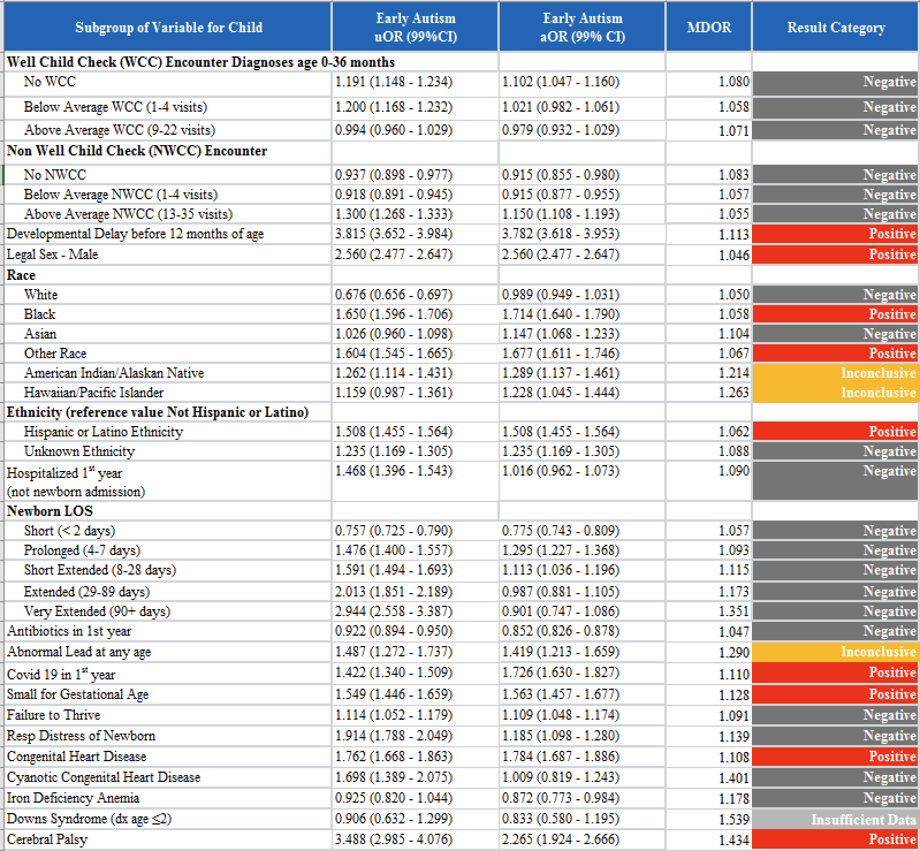
eTable 9

eTable 10 shows uORs and aORs (with 99% confidence intervals) on the risk for all-autism in various child subgroups.

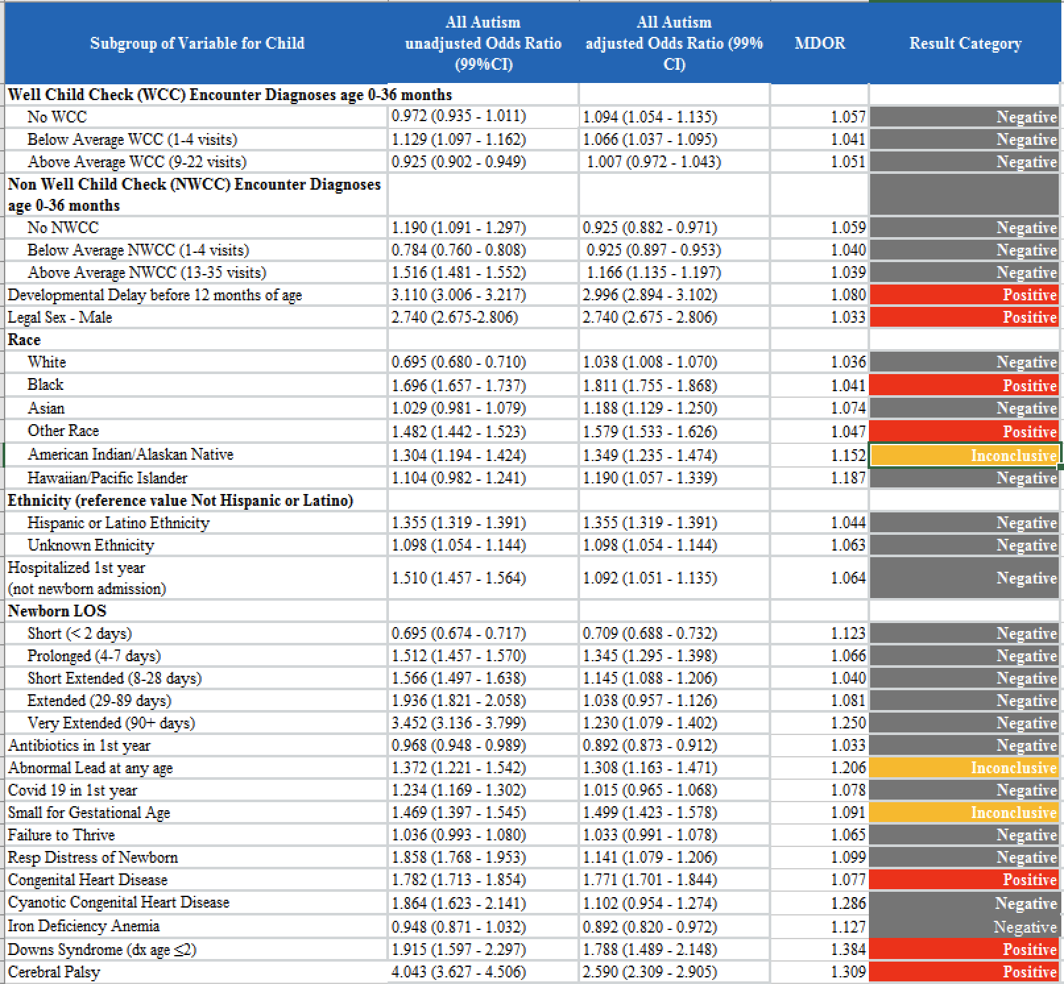
eTable 10

eTable 11 shows uORs and aORs (with 99% confidence intervals) on the risk of early autism in various pregnancy data subgroups.

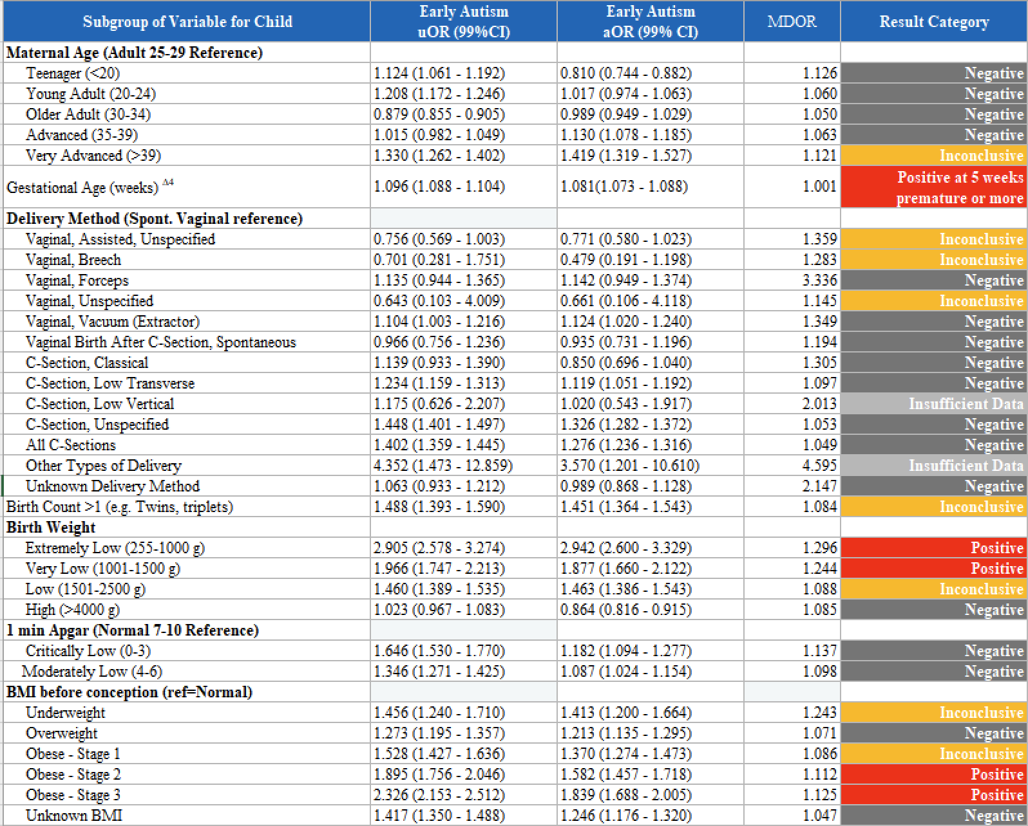
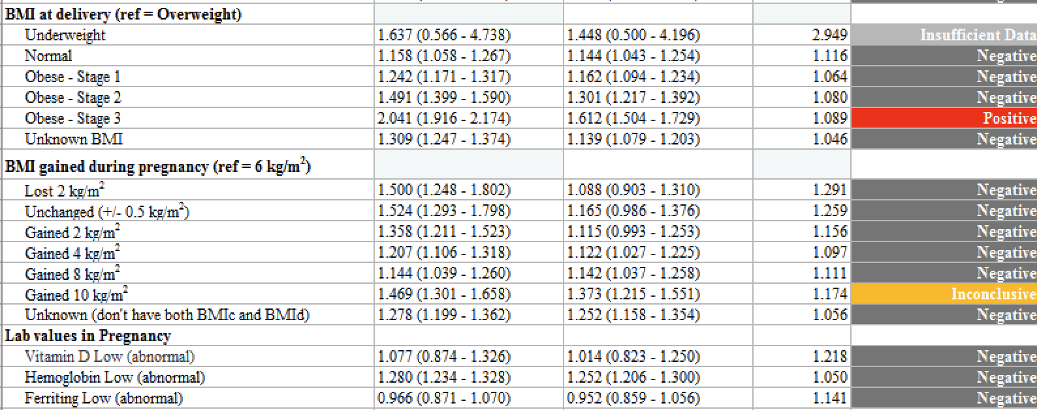
eTable 11
∆4 - uOR and aOR associated between autism and gestational age is shift centered at the median of gestational age (39 weeks). uOR and aOR are per week of gestational age below median.

eTable 12 shows uORs and aORs (with 99% confidence intervals) on the risk of all autism in various pregnancy data subgroups.

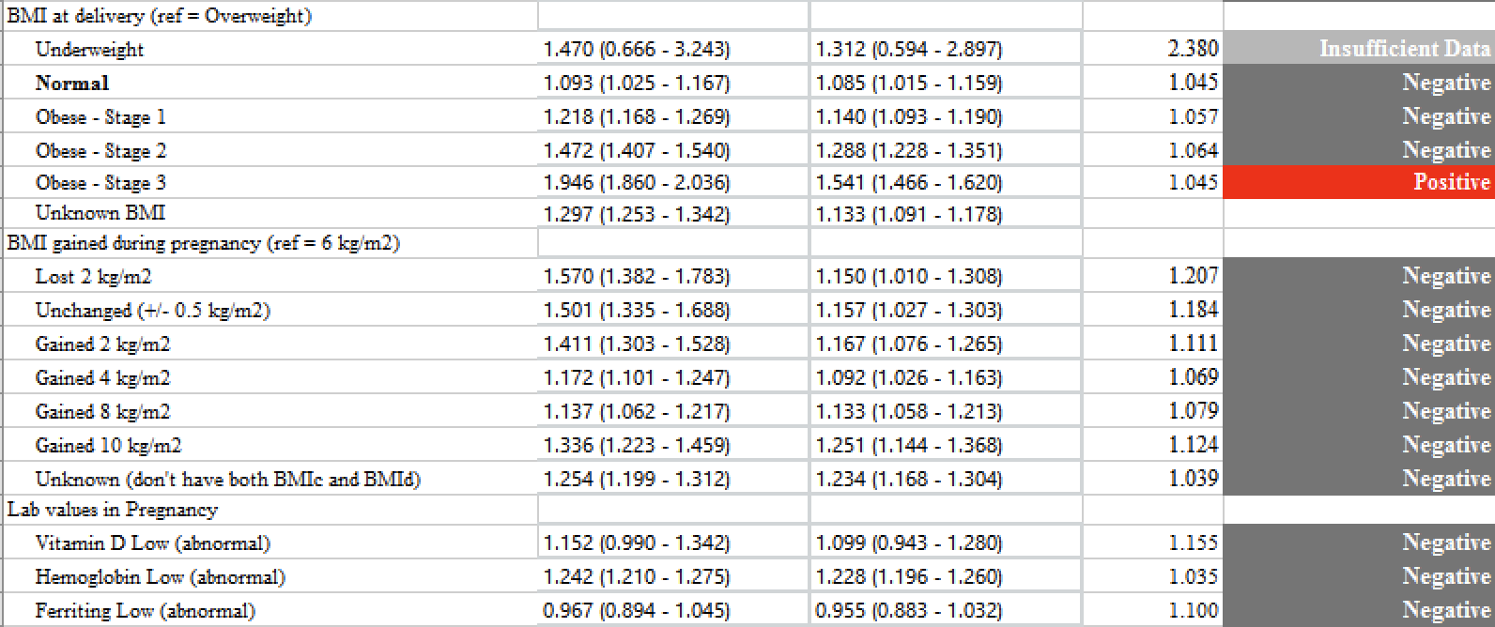
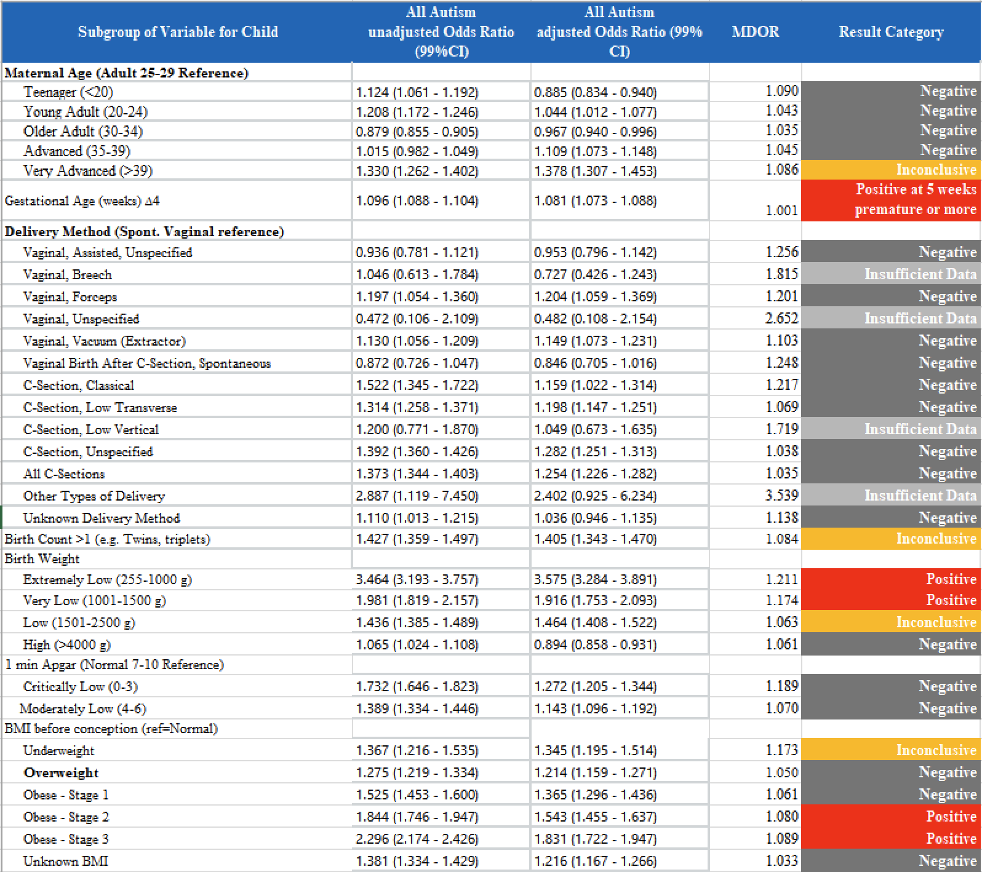
eTable 12
∆4 - uOR and aOR associated between autism and gestational age is shift centered at the median of gestational age (39 weeks). uOR and aOR are per week of gestational age below median.

eTable 13 shows uORs and aORs (with 99% confidence intervals) on the risk of early autism for subgroups taking various medications during pregnancy from estimated date of conception to 3 days prior to delivery date.

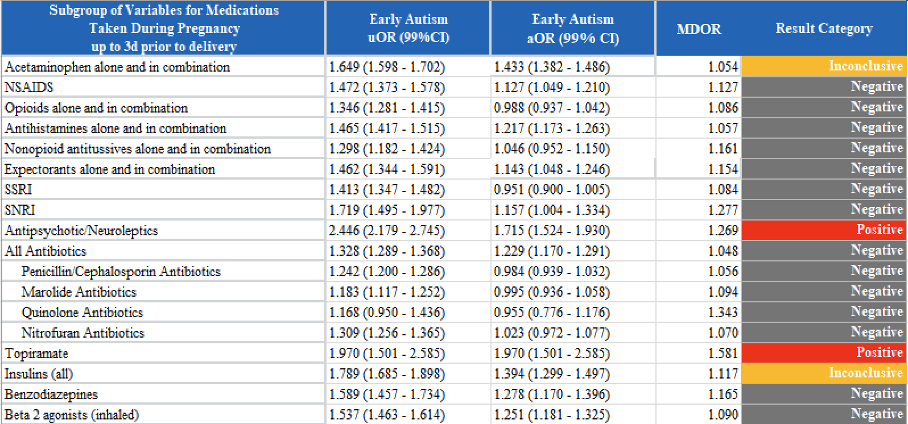
eTable 13

eTable 14 shows uORs and aORs (with 99% confidence intervals) on the risk of all autism for subgroups taking various medications during pregnancy from estimated date of conception to 3 days prior to delivery date.

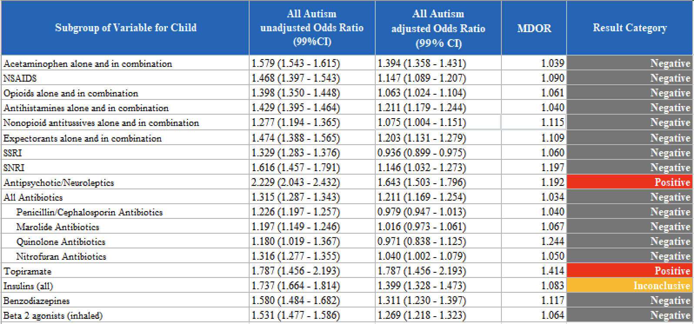
eTable 14

eTable 15 shows uORs and aORs (with 99% confidence intervals) on the risk of early autism for subgroups of birth parent diagnoses during pregnancy.

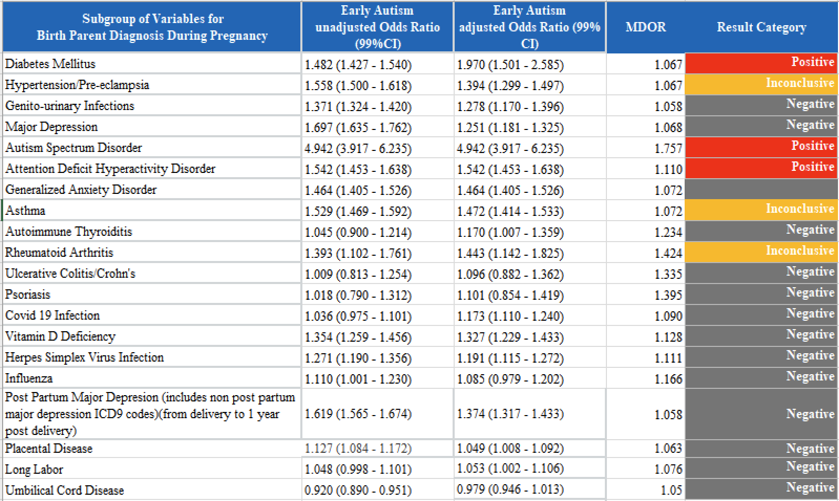
eTable 15

eTable 16 shows uORs and aORs (with 99% confidence intervals) on the risk of all autism for subgroups of birth parent diagnoses during pregnancy.

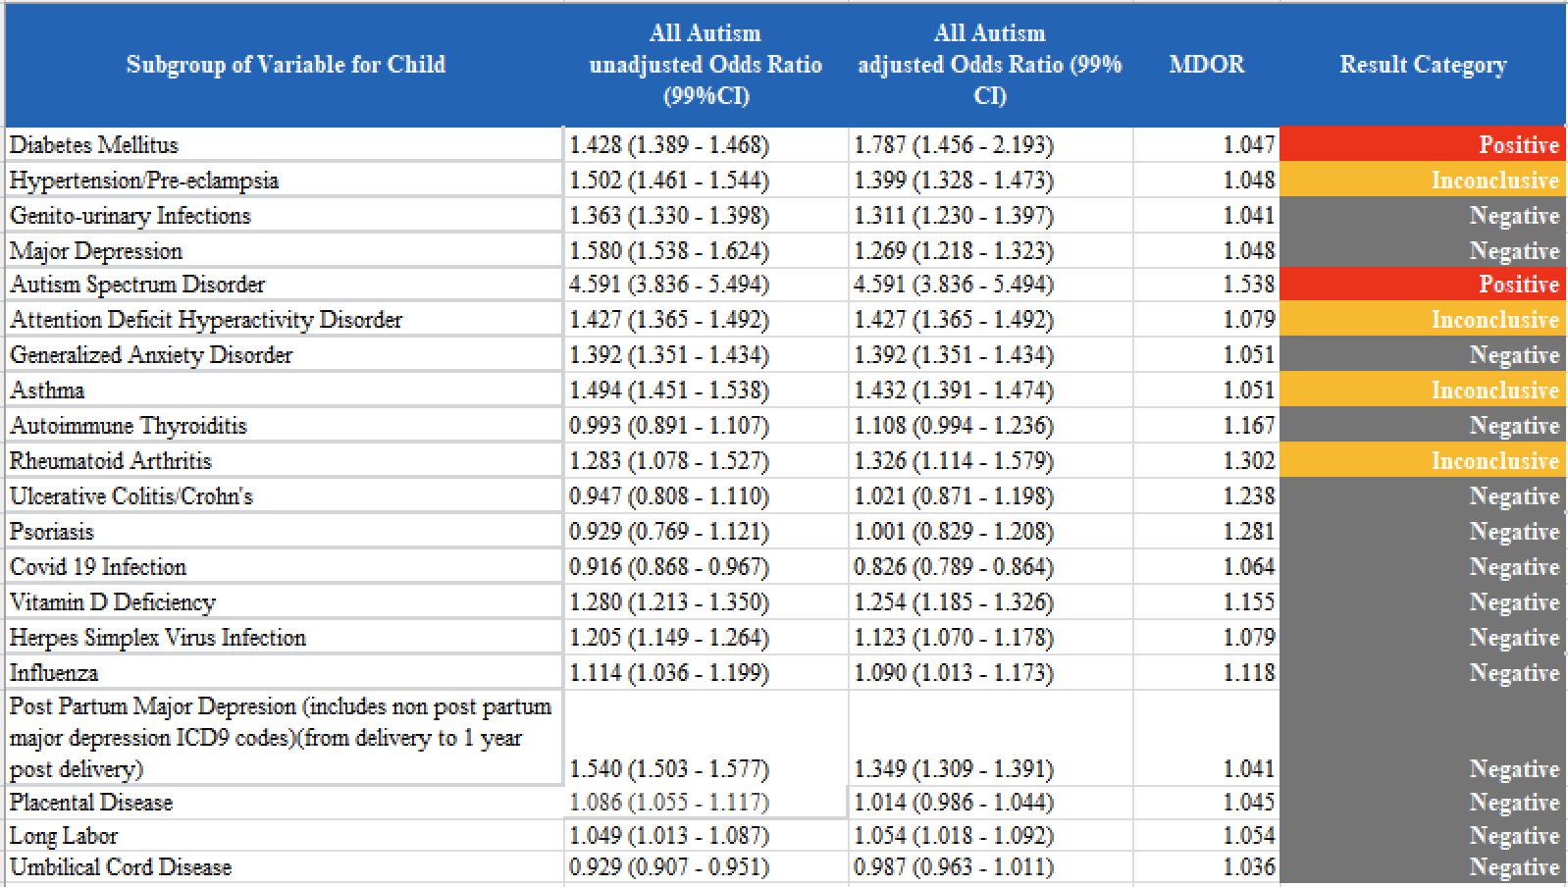
eTable 16

eTable 17 shows uORs and aORs (with 99% confidence intervals) on the risk of early autism for subgroups of social history data of the birth parent recorded during pregnancy.
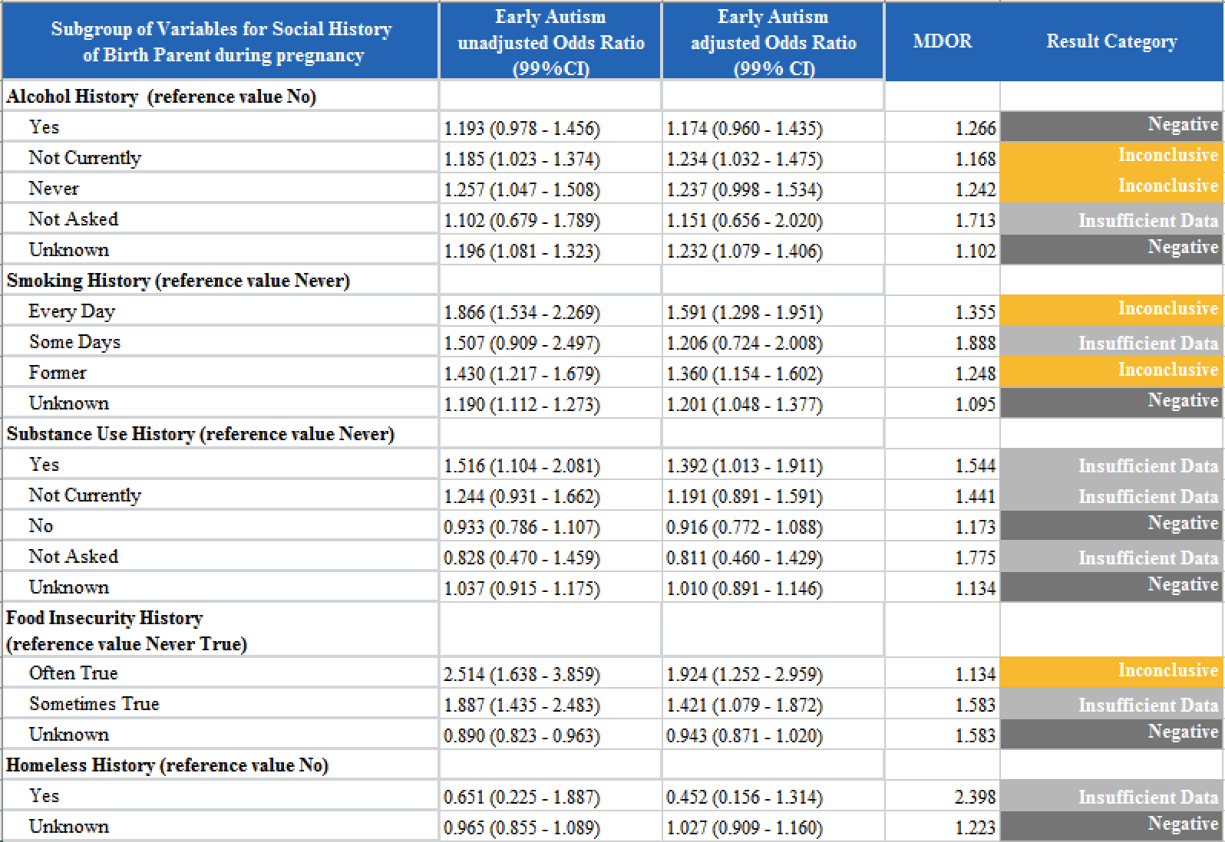
eTable 17

eTable 18 shows uORs and aORs (with 99% confidence intervals) on the risk of all autism for subgroups of social history data of the birth parent recorded during pregnancy.

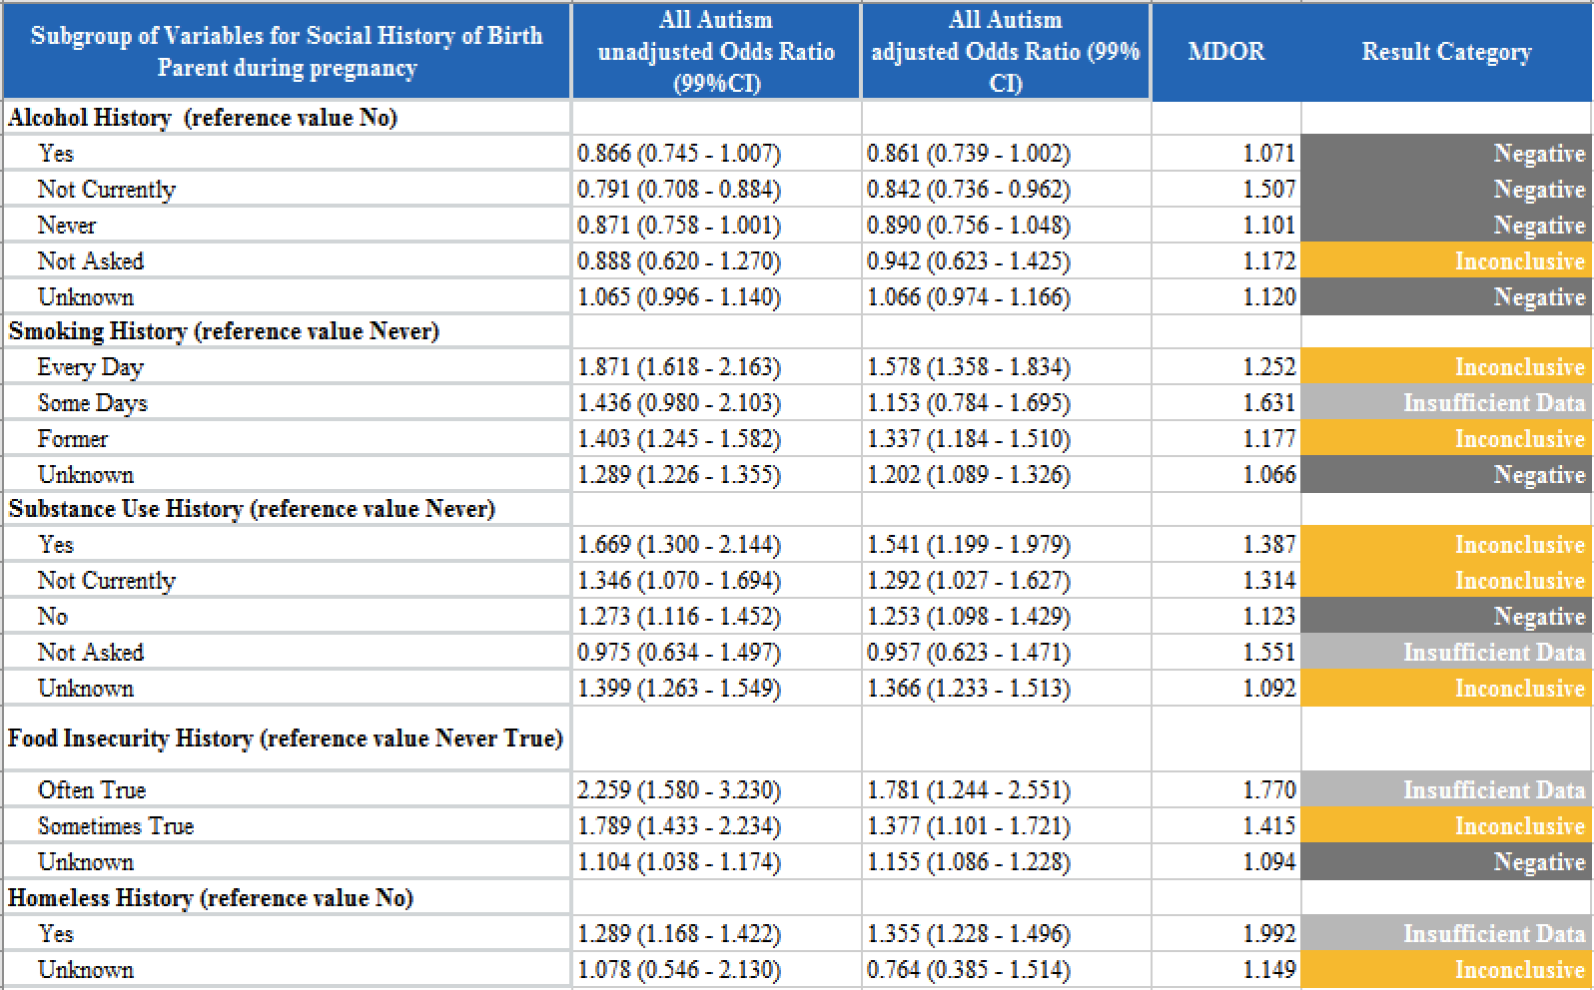
eTable 18

eTable 19 shows uORs and aORs (with 99% confidence intervals) on the risk of early autism for subgroups of social history data of the birth parent or child last recorded at any time.

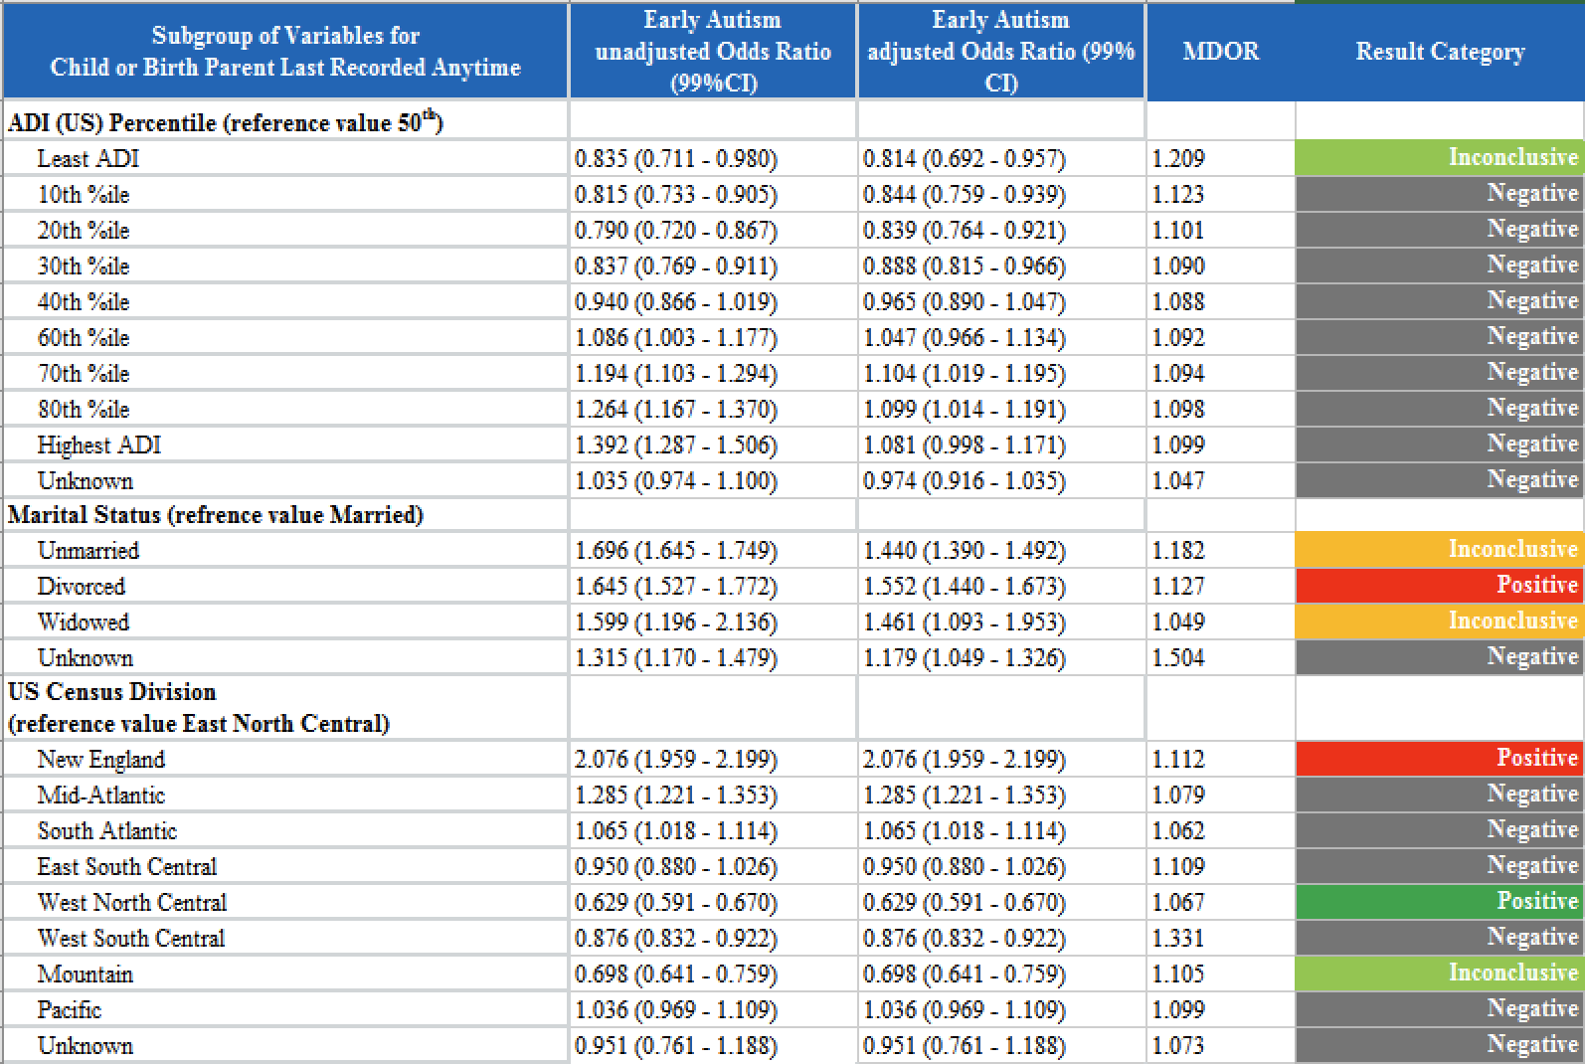
eTable 19

eTable 20 shows uORs and aORs (with 99% confidence intervals) on the risk of all autism for subgroups of social history data of the birth parent or child last recorded at any time.

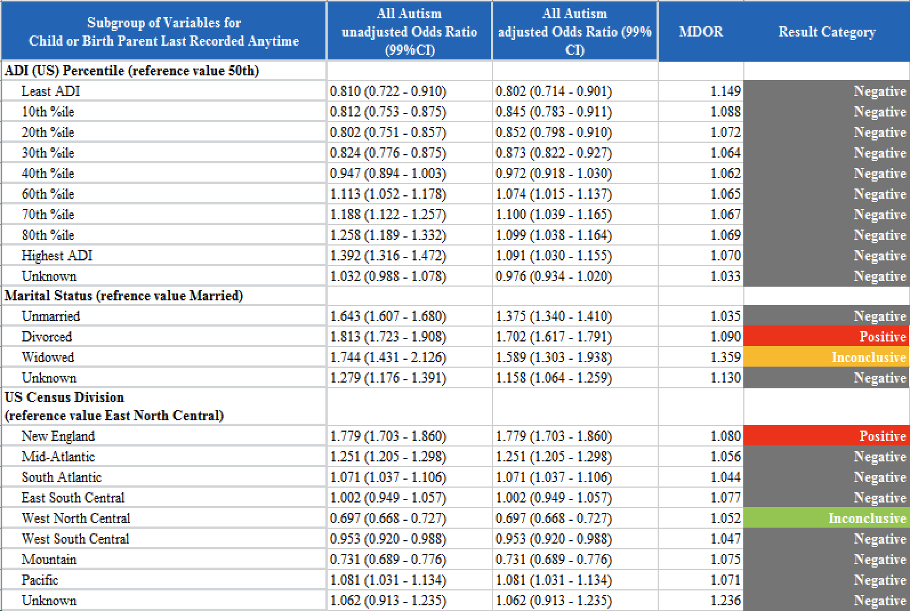
eTable 20

eTable 21 shows uORs (with 99% confidence intervals) and p values on the risk of both early and all autism for Family History and Birth Parent Highest Education level. Data was obtained from Slicer Dicer method.

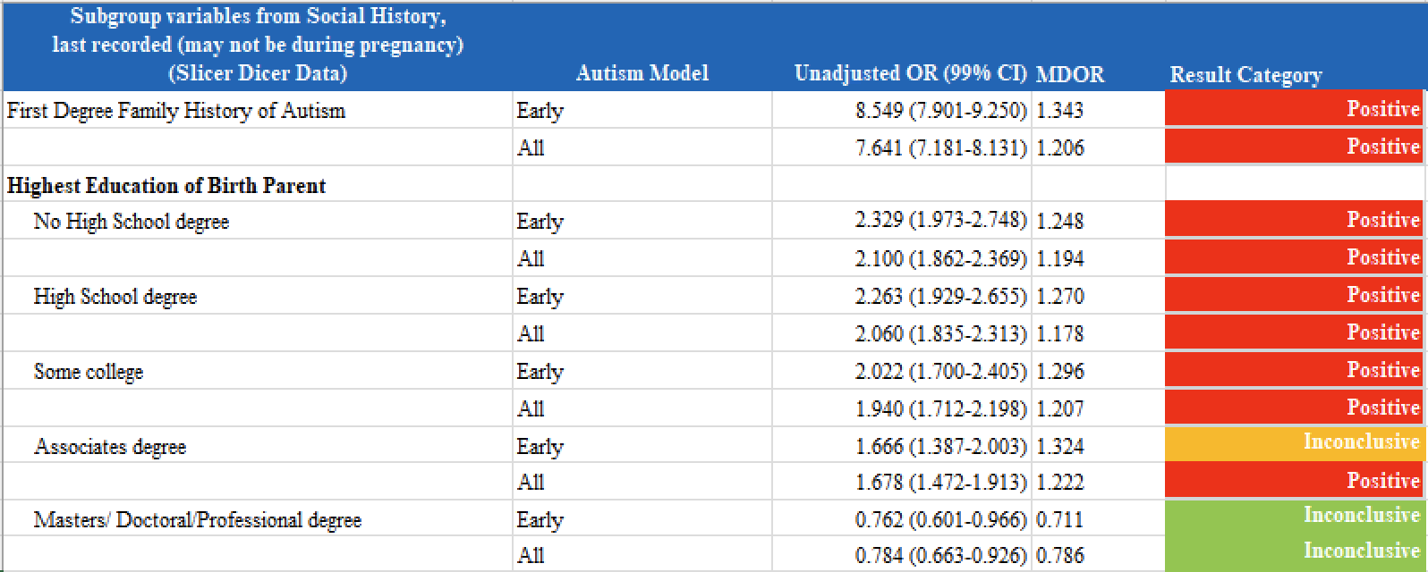
eTable 21

Supplementary Population Comparisons

Some observed differences in the baseline population variables were seen. The percentage of developmental delay was less than in the literature, but the only studies found look at delay before 24 months vs this study’s definition of before 12 months. This study had lower Hispanic and Asian race percentages and higher Other race, Multiple race and Other Ethnicity percentages. This is likely due to definitional differences in racial and ethnic groupings between the CDC benchmarks and Cosmos.

Rates of vaginal birth after C-Section (VBAC) were much lower in the Cosmos data suggesting that most VBAC births are being recorded as just vaginal deliveries.

Anemia and low ferritin levels were both more common in the Cosmos data suggesting this may be under reported in the literature.

The geographic distribution of the current study population over weighted the East North Central Division, which has a higher EHR adoption rate compared to the rest of the US.

Rates of birth parents being married in the study population were slightly lower than published data from 2016, but the trend from 1990 to 2016 was declining.²⁰

In the current study 47% of birth parents had a Bachelor’s/Associate/Advanced degree compared to published data showing 41.7% of mothers over the age of 25.

References

Epic Systems Corporation. Cosmos. Available from: https://cosmos.epic.com/
Epic Systems Corporation. Epic. Available from: https://www.epic.com/
University of Alabama at Birmingham. UAB Hospital delivers record‑breaking premature baby. UAB News. November 10, 2021. Available at: https://www.uab.edu/news/health-medicine/uab-hospital-delivers-record-breaking-premature-baby (accessed August 7, 2025).
Centers for Disease Control and Prevention. About Adult BMI. 2023. Available from: https://www.cdc.gov
Fombonne E. Epidemiology of pervasive developmental disorders. Pediatr Res. 2009 Jun;65(6):591–8. doi:10.1203/PDR.0b013e31819e7203.
Durkin MS, Maenner MJ, Meaney FJ, et al. Socioeconomic inequality in the prevalence of autism spectrum disorder. Am J Public Health. 2010;100(11):2156–62. doi:10.2105/AJPH.2009.178491
Atladóttir HÓ, Thorsen P, Schendel DE, Østergaard L, Lemcke S, Parner ET. Association of hospitalization for infection in childhood with diagnosis of autism spectrum disorders: a Danish cohort study. Arch Pediatr Adolesc Med. 2010;164(5):470–7. doi:10.1001/archpediatrics.2010.9.
Croen LA, Grether JK, Selvin S. Neonatal risk factors for autism spectrum disorders. J Autism Dev Disord. 2002;32(6):525–33. doi:10.1023/A:1021217015111.
Schmidt RJ, Tancredi DJ, Ozonoff S, Hansen RL, Hartiala J, Allayee H, et al. Maternal periconceptional folic acid intake and risk of autism spectrum disorders and developmental delay in the CHARGE (Childhood Autism Risks from Genetics and Environment) case-control study. Am J Clin Nutr. 2012;96(1):80–9. doi:10.3945/ajcn.110.004416.
Roberts AL, Lyall K, Hart JE, Laden F, Just AC, Bobb JF, et al. Perinatal air pollutant exposures and autism spectrum disorder in the children of Nurses' Health Study II participants. Environ Health Perspect. 2013;121(8):978–84. doi:10.1289/ehp.1206187.
Kolevzon A, Gross R, Reichenberg A. Prenatal and perinatal risk factors for autism: a review and integration of findings. Arch Pediatr Adolesc Med. 2007 Apr;161(4):326–33. doi:10.1001/archpedi.161.4.326.
Schreck KA, Williams K. Food preferences and factors influencing food selectivity for children with autism spectrum disorders. Res Dev Disabil. 2006;27(4):353–63. doi:10.1016/j.ridd.2005.03.005.
Glasson EJ, Bower C, Petterson B, de Klerk N, Chaney G, Hallmayer JF. Perinatal factors and the development of autism: a population study. Arch Gen Psychiatry. 2004;61(6):618–27. doi:10.1001/archpsyc.61.6.618.
Jenkins KJ, et al. Neurodevelopmental outcomes in children with congenital heart disease. Curr Opin Pediatr. 2015;27(5):627–35.
Bellinger DC, Watson CG, Rivkin MJ, Robertson RL, Roberts AE, Stopp C, et al. Neurodevelopmental outcomes in children with congenital heart disease. Prog Pediatr Cardiol. 2015;38:21–8. doi:10.1016/j.ppedcard.2014.10.002.
Dosman CF, Drmic IE, Brian JA, Senthilselvan A, Harford MM, Smith RW, Roberts SW. Ferritin as an indicator of suspected iron deficiency in children with autism spectrum disorder: prevalence of low serum ferritin concentration. Dev Med Child Neurol. 2006;48(12):1008–9. doi:10.1017/S0012162206232225.
Hagerman RJ, Protic D, Rajaratnam A, Salcedo-Arellano MJ, Aydin EY, Schneider A. Fragile X syndrome and autism: Intersecting pathways and prospects for treatment. Mol Autism. 2017;8(1):18. doi:10.1186/s13229-017-0121-6.
Neul JL, Kaufmann WE, Glaze DG, Christodoulou J, Clarke AJ, Bahi-Buisson N, et al. Rett syndrome: revised diagnostic criteria and nomenclature. Ann Neurol. 2010;68(6):944–50. doi:10.1002/ana.22124.
Jeste SS, Varcin KJ, Hellemann GS, Gulsrud AC, Bhatt R, Kasari C, et al. Symptom profiles of autism spectrum disorder in tuberous sclerosis complex. Neurology. 2016;87(8):766–72. doi:10.1212/WNL.0000000000003002.
Zigman WB, Lott IT. Autism and Down syndrome: roles of genetics, environment, and epigenetics. Curr Psychiatry Rep. 2007;9(2):131–7. doi:10.1007/s11920-007-0019-8.
Zwaigenbaum L, Bryson S, Garon N. Early identification of autism spectrum disorders. Behav Brain Res. 2013;251:133–46. doi:10.1016/j.bbr.2013.04.004.
Chen Q, Chen M, Bao W, Strathearn L, Zang X, Meng L, Xu G. Association of cerebral palsy with autism spectrum disorder and attention‑deficit/hyperactivity disorder in children: a large‑scale nationwide population‑based study. BMJ Paediatr Open. 2024;8(1):e002343. PMID:38594193; PMCID: PMC11015243. doi:10.1136/bmjpo‑2023‑002343
Sandin S, Hultman CM, Kolevzon A, Gross R, MacCabe JH, Reichenberg A. Advancing maternal age is associated with increasing risk for autism: a review and meta-analysis. J Am Acad Child Adolesc Psychiatry. 2012;51(5):477–486.e1. doi:10.1016/j.jaac.2012.02.018
Johnson S, Marlow N. Preterm birth and childhood psychiatric disorders. Pediatr Res. 2011;69(5 Pt 2):11R–18R. doi:10.1203/PDR.0b013e318212faa0.
Gardener H, Spiegelman D, Buka SL. Prenatal risk factors for autism: comprehensive meta-analysis. Br J Psychiatry. 2009;195(1):7–14. doi:10.1192/bjp.bp.108.051672.
Gregory SG, Anthopolos R, Osgood CE, Grotegut CA, Miranda ML. Association of autism with induced or augmented childbirth in North Carolina birth record data. JAMA Pediatr. 2013;167(10):959–66. doi:10.1001/jamapediatrics.2013.2904.
Yip BHK, Leonard H, Stock S, Stoltenberg C, Francis RW, Gissler M, et al. Caesarean section and risk of autism across gestational age: a multi-national cohort study of 5 million births. Int J Epidemiol. 2017;46(2):429–39. doi:10.1093/ije/dyw336.
Connolly N, Anixt J, Manning P, Ping-I Lin D, Marsolo K, Bowers K. Maternal obesity and the risk of autism spectrum disorder in offspring: a meta-analysis. J Child Psychol Psychiatry. 2016;57(5):505–514. doi:10.1111/jcpp.12490.
Xu W, Strathearn L, Zang X, Meng L, Bao W, Chen Q, et al. Defective placentation syndromes and autism spectrum disorder in offspring: a population-based cohort and sibling-controlled study. JAMA Netw Open. 2022;5(3):e224123. doi:10.1001/jamanetworkopen.2022.4123
Gardener H, Spiegelman D, Buka SL. Perinatal and neonatal risk factors for autism: A comprehensive meta-analysis. Paediatr Perinat Epidemiol. 2011;25(1):65–81. doi:10.1111/j.1365-3016.2010.01146.x.
Liew Z, Ritz B, Rebordosa C, Lee PC, Olsen J. Acetaminophen use during pregnancy and neurodevelopment: attention function and behavior in 7-year-old children. Pediatrics. 2014;134(1):e1–e8. doi:10.1542/peds.2014-0167.
Wang Y, et al. Prenatal analgesic exposure and neurodevelopmental outcomes: a systematic review and meta-analysis. BMC Med. 2021;19:57. doi:10.1186/s12916-021-01903-8.
Lee BK, Park H, McGrath JJ, et al. Maternal opioid use during pregnancy and the risk of autism spectrum disorder in the offspring: a population-based study. Autism Res. 2019;12(9):1363–70. doi:10.1002/aur.2162.
Gidaya NB, Lee BK, Burstyn I, Yudell M, Mortensen EL, Newschaffer CJ. In utero exposure to medications and autism spectrum disorders: a systematic review. Autism Res. 2014;7(1):103–16. doi:10.1002/aur.1342.
Harrington RA, Lee LC, Crum RM, Zimmerman AW, Hertz-Picciotto I. Prenatal SSRI use and offspring with autism spectrum disorder or developmental delay. Pediatrics. 2014;133(5):e1241–8. doi:10.1542/peds.2013-3406.
Clements CC, Castro VM, Blumenthal SR, Rosenfield HR, Murphy SN, Fava M, et al. Prenatal antipsychotic exposure and risk of neurodevelopmental disorders in offspring: a population-based study. JAMA Psychiatry. 2018;75(3):270–7. doi:10.1001/jamapsychiatry.2017.3551.
Hernández-Díaz S, Smith CR, Shen A, Mittendorf R, Hauser WA, Yerby M, et al. Comparative safety of antiepileptic drugs during pregnancy. Neurology. 2012;78(21):1692–9. doi:10.1212/WNL.0b013e3182574f39.
Louik C, Lin AE, Werler MM, Hernández-Díaz S, Mitchell AA. Benzodiazepine use in pregnancy and risk of autism spectrum disorder. J Autism Dev Disord. 2017;47(10):3253–62. doi:10.1007/s10803-017-3212-9.
Palmsten K, Andrade SE, Mitchell AA, Rai D, Cooper WO, Hernández-Díaz S. Prenatal exposure to short-acting β2-agonists and risk of autism spectrum disorders. Arch Pediatr Adolesc Med. 2013;167(5):438–43. doi:10.1001/jamapediatrics.2013.133.
Xiang AH, Wang X, Martinez MP, Walthall JC, Curry ES, Page K, et al. Association of maternal diabetes with autism in offspring. JAMA. 2015;313(14):1425–34. doi:10.1001/jama.2015.2707.
Christensen J, Grønborg TK, Sørensen MJ, Schendel D, Pedersen LH, Pedersen HS, et al. Prenatal antibiotic exposure and risk of autism spectrum disorders: a population-based cohort study. Int J Epidemiol. 2019;48(4):1162–70. doi:10.1093/ije/dyz071.
Walker CK, Krakowiak P, Baker A, Hansen RL, Ozonoff S, Hertz-Picciotto I. Preeclampsia, placental insufficiency, and autism spectrum disorder or developmental delay. JAMA Pediatr. 2015;169(2):154–62. doi:10.1001/jamapediatrics.2014.2645.
Zerbo O, Qian Y, Yoshida C, Grether JK, Van de Water J, Croen LA. Maternal infection during pregnancy and autism spectrum disorders. J Autism Dev Disord. 2015;45(12):4015–25. doi:10.1007/s10803-013-2016-3.
Elder JH, Kreider CM, Schaefer NM, de Laosa MB. Maternal depression during pregnancy and risk for autism spectrum disorder. Autism Res. 2017;10(6):1125–34. doi:10.1002/aur.1743.
Xu G, Snetselaar LG, Jing J, Liu B, Strathearn L, Bao W. Maternal asthma and risk of autism spectrum disorder in offspring. J Autism Dev Disord. 2018;48(3):719–27. doi:10.1007/s10803-017-3340-7.
Roman GC, Ghassabian A, Bongers-Schokking JJ, Jaddoe VWV, Hofman A, de Rijke YB, et al. Association of maternal thyroid autoantibodies with autism spectrum disorders in offspring. J Autism Dev Disord. 2013;43(8):1815–25. doi:10.1007/s10803-012-1738-2.
Wang L, Wang F, Zhao H, Zhang Y, Wang S, Zhang Y, et al. Maternal systemic lupus erythematosus and risk of neurodevelopmental disorders in offspring: a population-based cohort study. Clin Rheumatol. 2021;40(4):1267–75. doi:10.1007/s10067-020-05507-6.
Croen LA, Yoshida CK, Braunschweig D, Haapanen L, Grether JK, Kharrazi M, et al. Maternal autoimmune diseases associated with autism spectrum disorders in offspring. J Autism Dev Disord. 2019;49(3):1016–27. doi:10.1007/s10803-018-3811-5.
Pedersen L, et al. Maternal inflammatory bowel disease and risk of autism spectrum disorders in offspring. Inflamm Bowel Dis. 2020;26(4):509–15. doi:10.1093/ibd/izz284.
Edlow AG, Castro VM, Shook LL, Kaimal AJ, Perlis RH. Neurodevelopmental outcomes at 12 months in infants born to mothers with SARS-CoV-2 infection during pregnancy. JAMA Netw Open. 2022;5(6):e2215787. doi:10.1001/jamanetworkopen.2022.15787.
Vinkhuyzen AAE, Eyles DW, Burne THJ, Blanken LME, Kruithof CJ, Verhulst FC, et al. Gestational vitamin D deficiency and autism-related traits: the Generation R Study. Mol Psychiatry. 2018;23(2):240–6. doi:10.1038/mp.2016.213.
Rice ME, Galang RR, Roth NM, Ellington SR, Moore CA, Valencia-Prado M, et al. Vital signs: Zika-associated birth defects and neurodevelopmental abnormalities possibly associated with congenital Zika virus infection—U.S. territories and freely associated states, 2018. MMWR Morb Mortal Wkly Rep. 2018 Aug 10;67(31):858–67. doi:10.15585/mmwr.mm6731e1.
Lau B, Fong WC, Leung WC, et al. Autism spectrum disorder and congenital cytomegalovirus infection: a case series and literature review. J Pediatr Infect Dis Soc. 2020;9(3):368–74. doi:10.1093/jpids/piaa045.
Whitley RJ, Kimberlin DW. Herpes simplex encephalitis: children and adults. Neurol Clin. 2005;23(3):673–85. doi:10.1016/j.ncl.2005.03.001.
Zerbo, O., Iosif, A. M., Walker, et. al. Is maternal influenza or fever during pregnancy associated with autism or developmental delays? Results from the CHARGE (CHildhood Autism Risks from Genetics and Environment) study. J Autism Dev Dis, 2013;43(1), 25–33. doi.org/10.1007/s10803-012-1540-x
Sood S, Soni S, Sood R. Maternal parvovirus B19 infection and risk of adverse pregnancy outcomes. J Infect Dis. 2014;210(Suppl 1):S544–S549. doi:10.1093/infdis/jiu273.
Khachadourian V, Arildskov ES, Grove J, O’Reilly PF, Buxbaum JD, Reichenberg A, et al. Familial confounding in the associations between maternal health and autism. Nat Med. 2025;31:996–1007. doi:10.1038/s41591-024-02997-0.
Grace SL, Evindar A, Stewart DE. The effect of postpartum depression on child cognitive development and behavior: a review and critical analysis of the literature. Arch Womens Ment Health. 2003;6(4):263–74. doi:10.1007/s00737-003-0024-6.
Slykerman RF, Thompson JMD, Waldie KE, Murphy R, Mitchell EA. Maternal iron deficiency anemia and risk of neurodevelopmental disorders in the offspring. Pediatrics. 2009;123(2):494–501. doi:10.1542/peds.2008-1865.
Mattson SN, Crocker N, Nguyen TT. Fetal alcohol spectrum disorders: neuropsychological and behavioral features. Neuropsychol Rev. 2011;21(2):81–101. doi:10.1007/s11065-011-9167-9.
Baker EA, Schootman M, Barnidge E, Kelly C. Food insecurity and child health: a systematic review. Pediatrics. 2017;139(6):e20170379. doi:10.1542/peds.2017-0379.
Bassuk EL, DeCandia CJ, Tsertsvadze A, Richard MK. The relationship between homelessness and child development. Pediatrics. 2015;135(2):e438–e446. doi:10.1542/peds.2014-3128.
Rai D, Lee BK, Dalman C, Golding J, Lewis G, Magnusson C. Parental depression, maternal antidepressant use during pregnancy, and risk of autism spectrum disorders: population based case-control study. BMJ. 2013;346:f2059. doi:10.1136/bmj.f2059.
Behnke M, Smith VC; Committee on Substance Abuse; Committee on Fetus and Newborn. Prenatal substance abuse: short- and long-term effects on the exposed fetus. Pediatrics. 2013;131(3):e1009–e1024. doi:10.1542/peds.2012-3931.
Maenner MJ, Shaw KA, Baio J, et al. Prevalence of autism spectrum disorder among children aged 8 years — Autism and Developmental Disabilities Monitoring Network, 11 sites, United States, 2016. MMWR Surveill Summ. 2020;69(4):1–12. doi:10.15585/mmwr.ss6904a1.
Zuckerman KE, Lindly OJ, Reyes NM, et al. Disparities in diagnosis and treatment of autism in Latino and non-Latino white families. Pediatrics. 2017;139(5):e20163010. doi:10.1542/peds.2016-3010.
Harrell FE Jr. Regression Modeling Strategies: With Applications to Linear Models, Logistic and Ordinal Regression, and Survival Analysis. 2nd ed. Springer; 2015. doi:10.1007/978-3-319-19425-7.
Vittinghoff E, McCulloch CE. Relaxing the rule of ten events per variable in logistic and Cox regression. Am J Epidemiol. 2007;165(6):710–8. doi:10.1093/aje/kwk052.
Peduzzi P, Concato J, Kemper E, Holford TR, Feinstein AR. A simulation study of the number of events per variable in logistic regression analysis. J Clin Epidemiol. 1996;49(12):1373–9. doi:10.1016/S0895-4356(96)00236-3.
Anzalone AJ, Geary CR, Dai R, Watanabe-Galloway S, McClay JC, Campbell JR. Lower electronic health record adoption and interoperability in rural versus urban physician participants: a cross-sectional analysis from the CMS quality payment program. BMC Health Serv Res. 2025;25(1):128. doi:10.1186/s12913-024-12168-5

