Support Information
Evaluation of Toxicity and Antibacterial Activity of Sr²⁺-Substituted β-Tricalcium Phosphate Prepared by the Polymeric Precursor Route
S.L.C. Matiasª, J.R.S. Farias^{b}, R.P. Feitosa^{b}, J.N. Silva^{c}, P.M.P. Ferreira^{d}, G.A. Neves^{f}, J.A. Osajima^{b}, E.C. da Silva Filho^{b}, L.S. Cavalcante^{e*}, A.N.S. Braga^{f}
ªPRPG-PPGCM, Federal University of Piauí–UFPI, Teresina 64000-040, Brazil
^{b}Interdisciplinary Laboratory of Advanced Materials, Federal University of Piauí, Teresina 64064-260, Brazil
^{c}Interdisciplinary Laboratory of Advanced Materials, Federal University of Piauí, Teresina 64064-260, Brazil
^{d}Laboratory of Experimental Cancerology (LabCancer), Department of Biophysics and Physiology, Federal University of Piauí, Teresina, Brazil
^{e}PPGQ-CETEM-CCN-DQ, State University of Piauí-UESPI, N. 2231, João Cabral, Teresina, PI 64002-150, Brazil
^{f}Academic Unit of Materials Engineering, Federal University of Campina Grande, Campina Grande 58429-900, Brazil
* Tel: +55 86 3213-7942, Mob: +55 86 99412-1001. *Email address: laeciosantos@ccn.uespi.br (L.S. Cavalcante)
Preprint submitted to Journal of Inorganic and Organometallic Polymers and Materials August 18, 2026
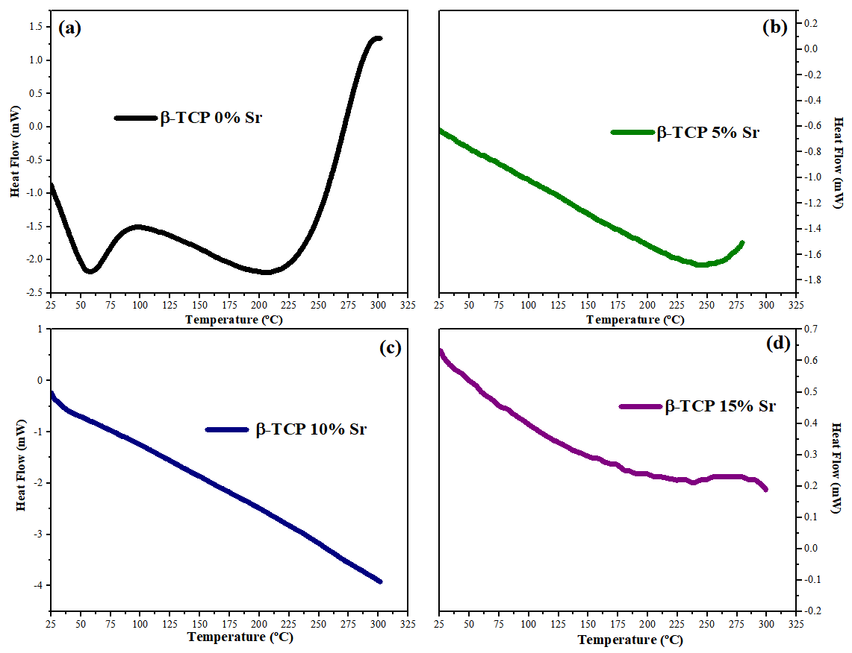
Figs. SI1(a–d): DSC curves for β-TCP powders prepared by the polymeric precursor method doped with Sr²⁺ ions at different concentrations: (a) 0%, (b) 5%, (c) 10%, and (d) 15%, respectively.

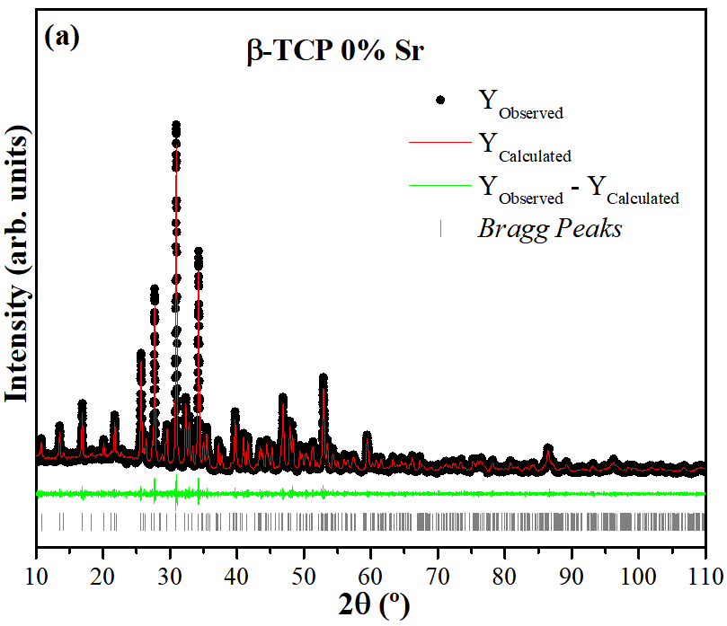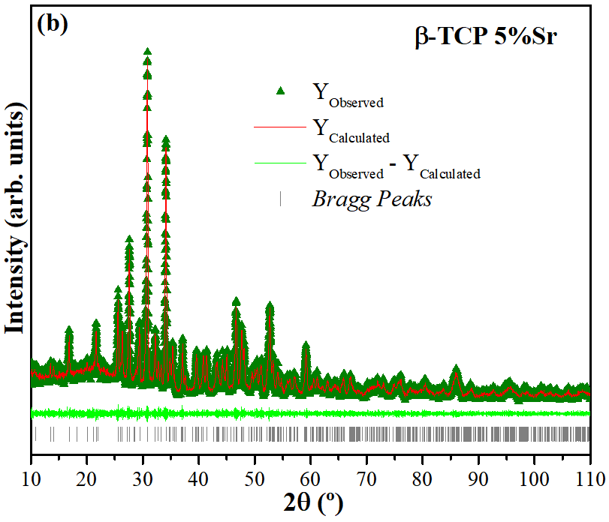

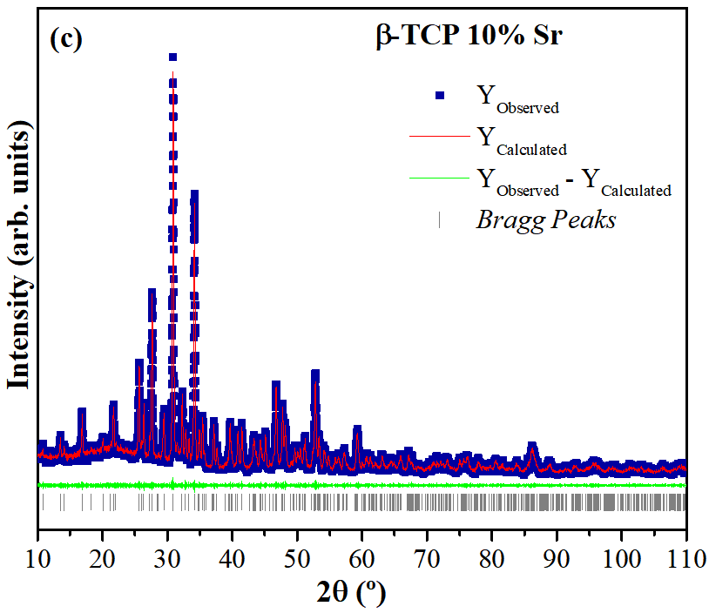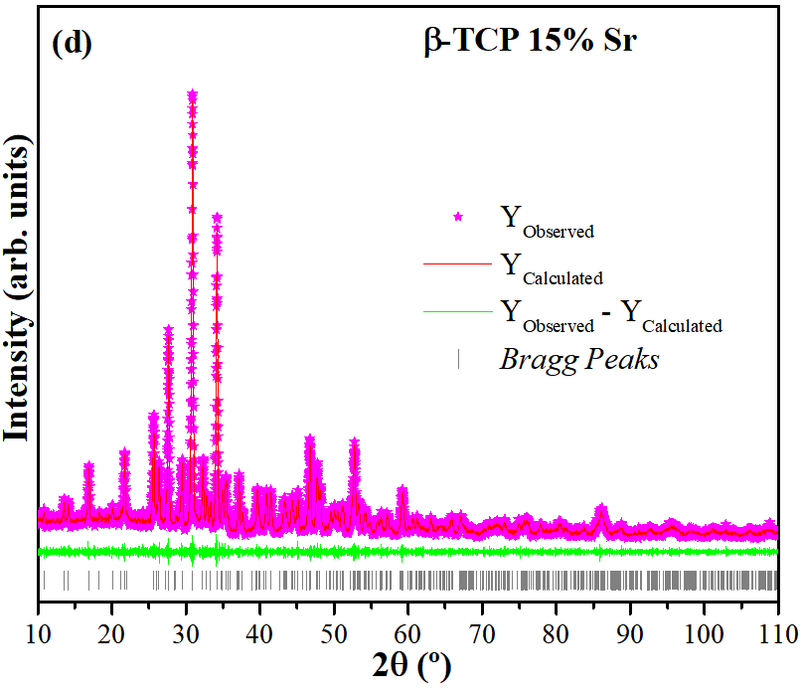
Figs. SI2(a–d): Rietveld refinement plot of β-TCP ceramics doped with Sr²⁺ ions at different concentrations: (a) 0%, (b) 5%, (c) 10%, and (d) 15%, respectively.

Reference for Support Information
[RSI1] Marques, C.F., Matos, A.C., Ribeiro, I.A.C. et al. Insights on the properties of levofloxacin-adsorbed Sr- and Mg-doped calcium phosphate powders. J Mater Sci: Mater Med 27, 123 (2016). https://doi.org/10.1007/s10856-016-5733-2

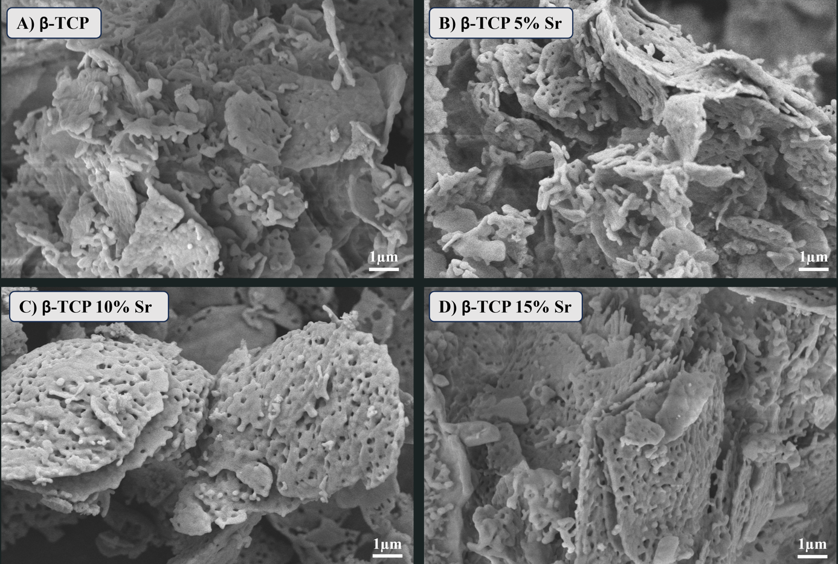
Figs. SI3(a–d): SEM images in high magnification for β-TCP crystals doped with Sr²⁺ ions at different concentrations: (a) 0%, (b) 5%, (c) 10%, and (d) 15%, respectively.

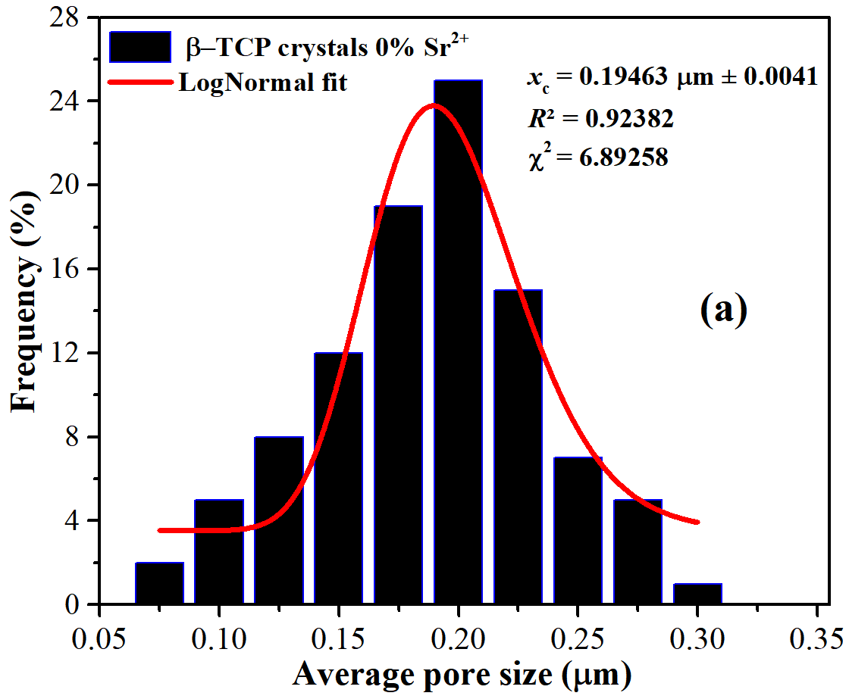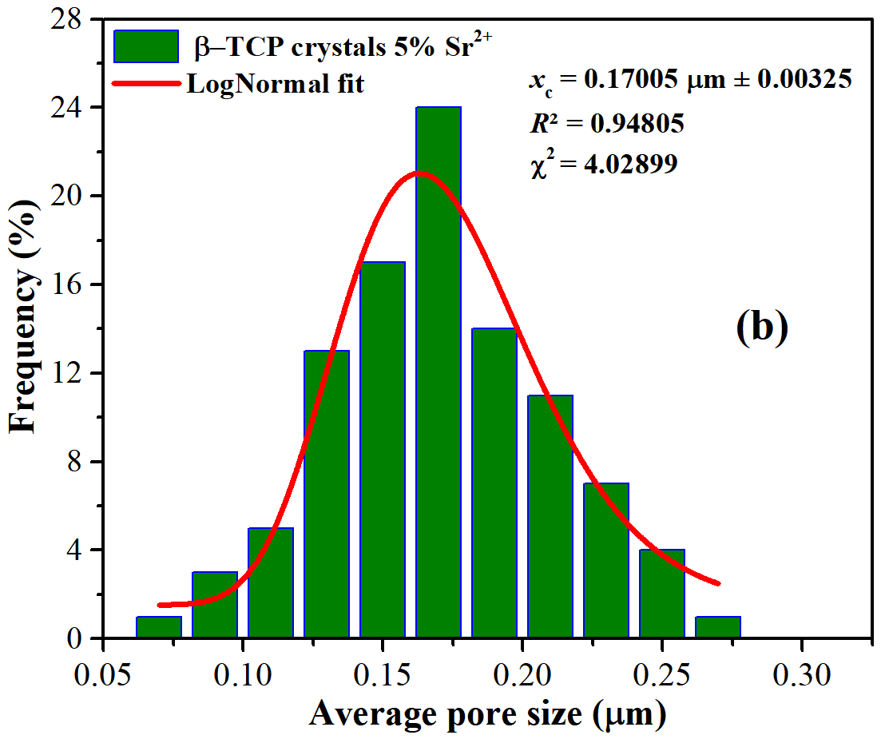
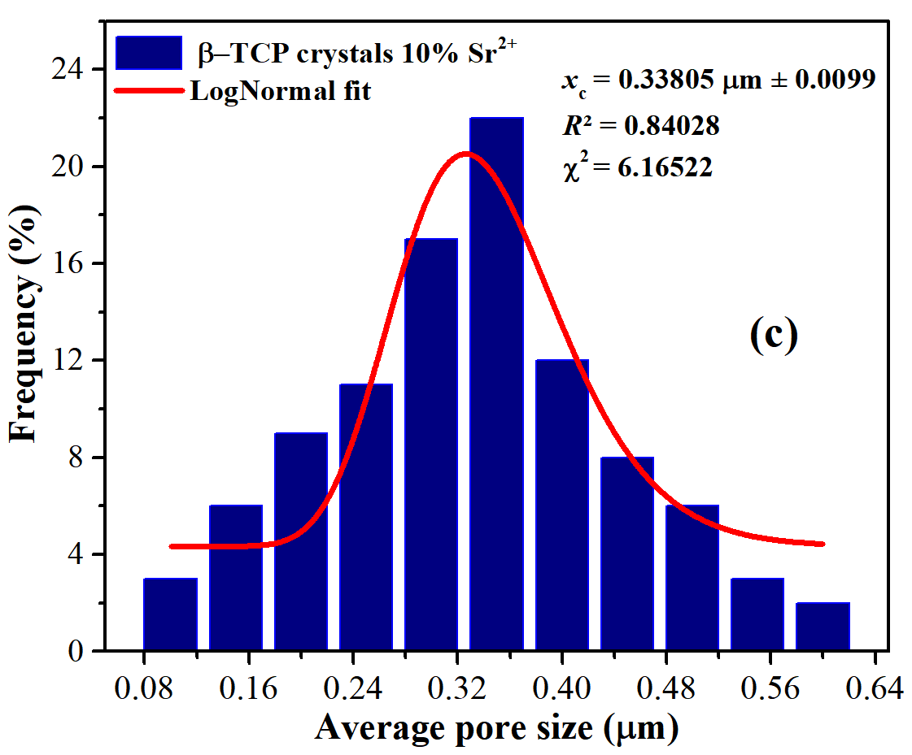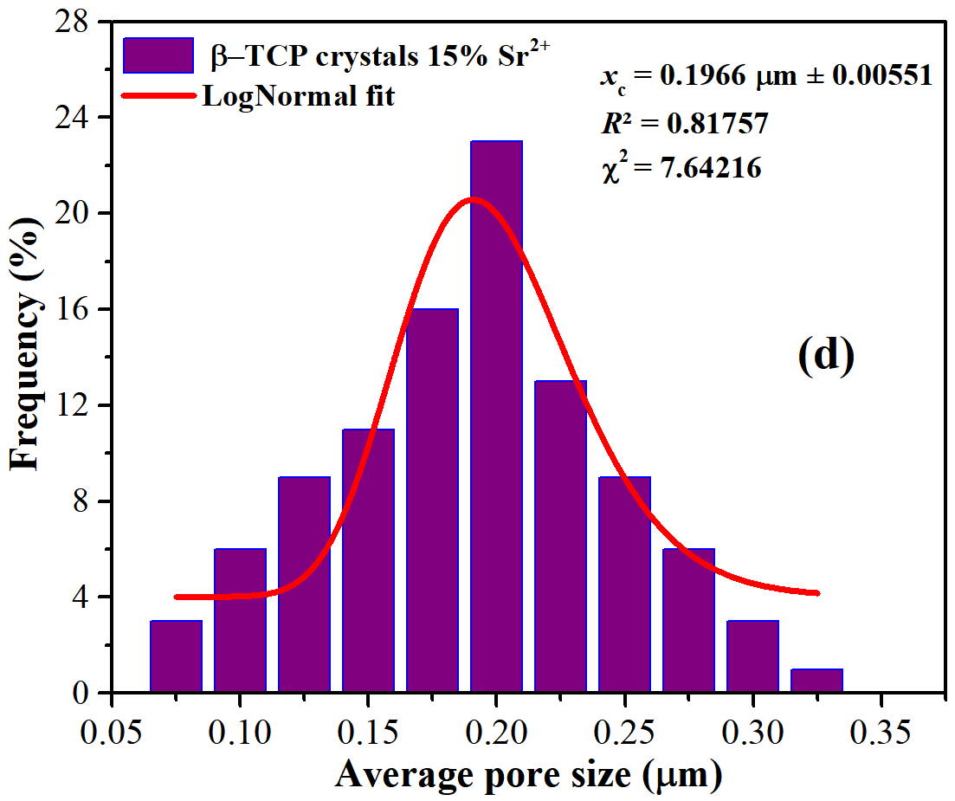
Figs. SI4(a–d): Histograms of the average pore size distribution for β-TCP ceramics doped with Sr²⁺ ions at different concentrations: (a) 0%, (b) 5%, (c) 10%, and (d) 15%. Inset show the red curves represent the LogNormal fitting for each dataset and statistical data x_{c} (±SD), R², and χ².

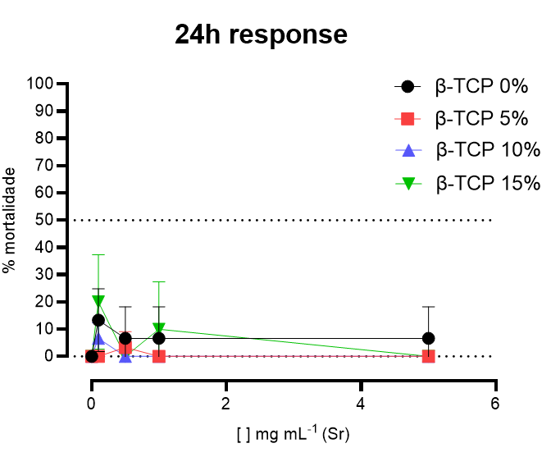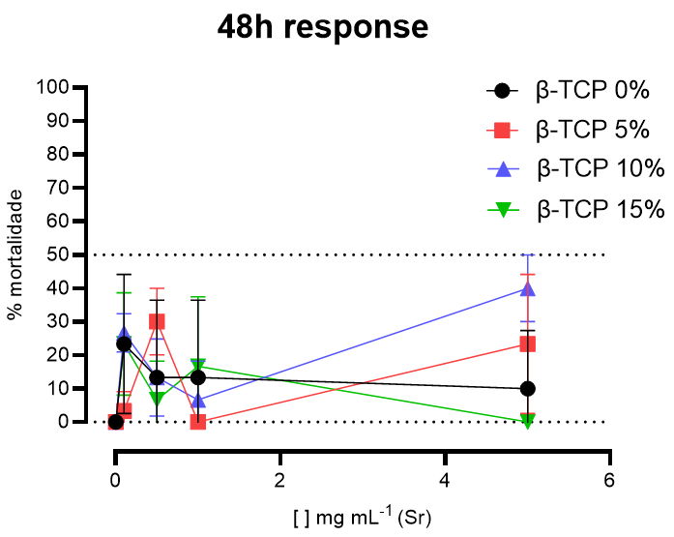
- (b)
Figs. SI5(a,b): Percentage of mortality (%) at different concentrations tested of β-TCP ceramics doped with Sr²⁺ ions at different concentrations, with responses at (a) 24 h and (b) 48 h points evaluated.

