Supplemental information
Dual-Mode Colorimetric-SERS Detection of Fenthion Pesticide with γ-Cyclodextrin-Capped Nanozymes

Xiaotong Liu¹, Udit Pant¹, Natasha Logan¹, Cuong Cao^{1,2*}

¹Institute for Global Food Security, School of Biological Sciences, Queen’s University Belfast, 19 Chlorine Gardens, Belfast, BT9 5DL, United Kingdom (UK)
²Material and Advanced Technologies for Healthcare, Queen’s University of Belfast – 18-30 Malone Road Belfast, BT9 5DL, United Kingdom (UK)

* Corresponding author. Email: c.cao@qub.ac.uk

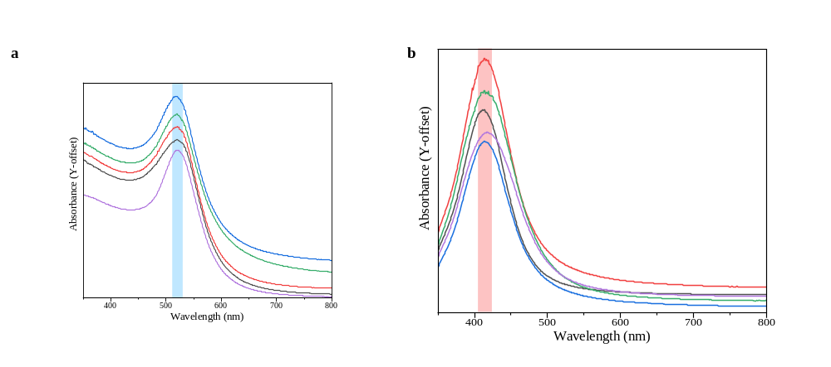
Fig. S1. UV–vis absorption spectra of γ-CD@AuNPs (left, a) and γ-CD@AgNPs (right, b) synthesized in five independent batches and recorded after storage. The minimal variation in LSPR peak positions and spectral profiles demonstrates good batch-to-batch reproducibility and long-term colloidal stability of the γ-CD-synthesised nanoparticles.

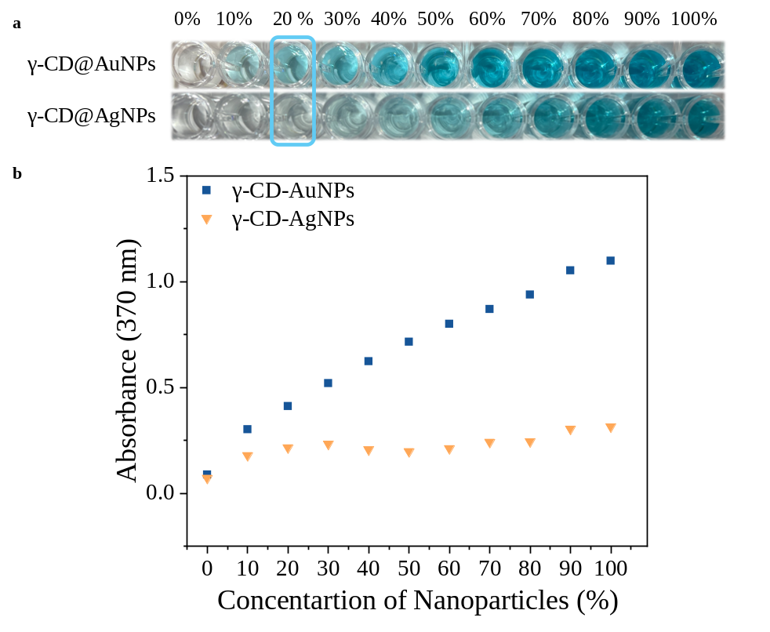
Fig. S2. The effect of γ-CD nanozyme (γ-CD@AuNPs and γ-CD@AgNPs) concentration on POD-like activity. (a) Colour photograph of POD-like activity of γ-CD@AuNPs and γ-CD@AgNPs at the same concentration and addition of TMB/ H₂O₂ after 10 min incubation. (b) Concentration dependence analysis showing the effect of AuNP concentration at a fixed wavelength of 370 nm.
Section 1. Calculate the concentration of γ-CD@AuNPs and γ-CD@AgNPs
This method yields spherical, γ-CD@AuNPs with an average diameter of 10 nm and the surface plasmon resonance occurred at 519 nm. The molar concentration (C, M) of the spherical face-centered cubic (fcc) Au nanoseeds produced in this method was calculated by Equation (1), which is about $1.45×{10}^{-8}M$, or equivalent to $1.489×{10}^{14}$particles. γ-CD@AgNPs with an average diameter of 29 nm and the surface plasmon resonance occurred at 412 nm. The molar concentration which is about $5.015×{10}^{-9}M$, or equivalent to $5.15×{10}^{13}$particles.
$c= \frac{N_{total}}{N× V_{col}×N_{A}}$ (1)¹
In Equation (1), V_{col} (L) is the volume of the synthesized colloidal AuNPs, N_{A} is Avogadro's constant. The total number of Au atoms (N_{total}) is equivalent to the initial amount of HAuCl₄ (C_{Au}³⁺) added to the reaction solution (V_{Au}³⁺), calculated using Equation (2):
$N_{total}=N_{A}×C_{{Au}^{3+}}×V_{{Au}^{3+}}$ (2)²
The average number of Au atoms per nanoparticle (N) is calculated from Equation (3)
$N_{particle}=\frac{πρd^{3}}{6M} N_{A}$ (3)³
$$N_{particle}=30.89602d^{3}$$
Where d (nm) is the average core diameter of the synthesized particles as measured by TEM. Where ρ is the density of face-centered cubic (fcc) gold (g nm⁻³), M is the atomic weight of gold (g mol⁻¹), and N_{A} is the Avogadro constant.
Therefore, the total number of AuNPs (n) is calculated with Equation (4):
$n=C{×N}_{A}{×V}_{col}$ (4)⁴
For the γ-CD@AuNPs:
$$N_{particle}=\frac{πρd^{3}}{6M} N_{A}$$

$$N_{particle}=\frac{3.14 ×19.3×{10}^{-21}×d^{3}}{6×197} ×6.023×{10}^{23}$$
$$N_{particle}=30.89602×d^{3}$$
$$N_{particle}=30896$$
The density of gold nanoparticles can be calculated using the bulk density of fcc gold, which is 19.3 g/cm³, and the atomic mass of gold, which is approximately 197 g/mol ​⁵, the average diameter of CD-AuNPs was 10 nm.
Due to $C_{{Au}^{3+}}=\frac{3 mM × 7 ml}{17.05 ml}=1.23×{10}^{-3} M$， $V_{{Au}^{3+}}=17.05×{10}^{-3}L$;

$$N_{total}=N_{A}×C_{{Au}^{3+}}×V_{{Au}^{3+}}$$

Thus $N_{total}=6.023×{10}^{23}×1.23×{10}^{-3}×17.05×{10}^{-3}=1.264×{10}^{19}$
Now, the molar concentration of the spherical fcc Au nanoseeds produced in this method was:
$$c= \frac{N_{total}}{N× V_{col}×N_{A}}$$

$$c= \frac{1.264×{10}^{19}}{30896× 17.05×{10}^{-3}×6.023×{10}^{23}}$$
$$c=3.98×{10}^{-8}M$$
$$n=C{×N}_{A}{×V}_{col}$$
$$n=3.98×{10}^{-8}×6.023×{10}^{23}×17.05×{10}^{-3}$$
$$n=4.09×{10}^{14}$$
For γ-CD@AgNPs:
The average number of Ag atoms per nanoparticle (N) is:

$$N_{particle}=\frac{πρd^{3}}{6M} N_{A}$$

$$N_{particle}=\frac{3.14 ×10.49×{10}^{-21}×d^{3}}{6×107.87} ×6.023×{10}^{23}$$

$$N_{particle}=30.652512×d^{3}$$
$$N_{particle}=747584$$
The density of silver states it as 10.49 g/cm³, atomic-weight-value for silver Ag was 107.868 ⁶, the average diameter of CD-AgNPs was 29 nm.
The total number of Ag atoms (N_{total}):
$$N_{total}=N_{A}×C_{{Ag}^{2+}}×V_{{Ag}^{3+}}$$

$N_{total}=6.023×{10}^{23}×1.23{×10}^{-3}×17.05×{10}^{-3}=1.263×{10}^{19}$
$$c= \frac{N_{total}}{N× V_{col}×N_{A}}$$

$$c= \frac{1.263×{10}^{19}}{747584× 17.05×{10}^{-3}×6.023×{10}^{23}}=1.645×{10}^{-9}M$$

$$n=C{×N}_{A}{×V}_{col}$$

$$n=1.645×{10}^{-9}×6.023×{10}^{23}×17.05×{10}^{-3}=1.69×{10}^{13}$$

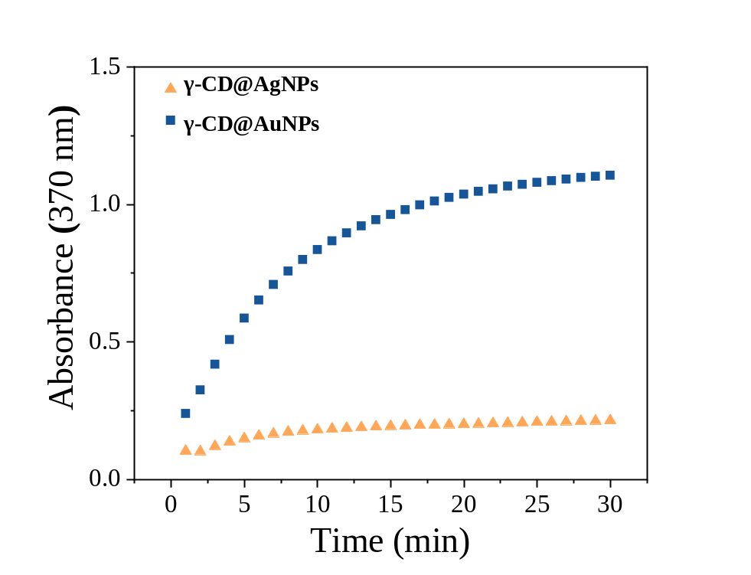
Fig. S3. Kinetic analysis of peroxidase-like activity at a fixed wavelength of 370 nm over 30 min, highlighting the rapid catalytic reaction of γ-CD@AuNPs compared to γ-CD@AgNPs. The significantly higher slope for γ-CD@AuNPs confirms their superior catalytic efficiency.
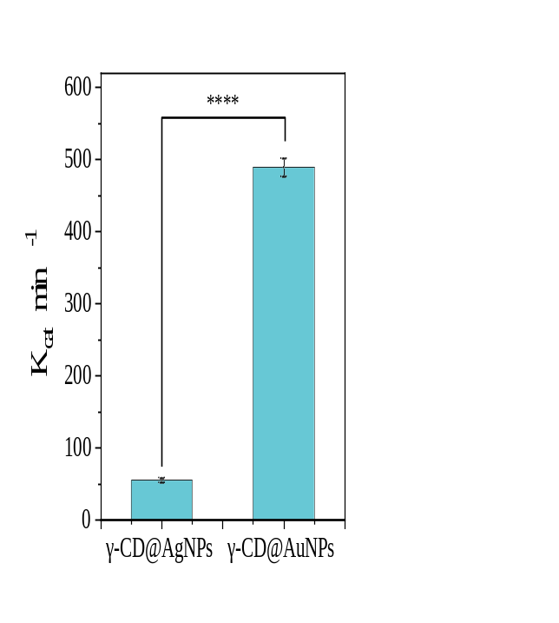
Fig. S4. Comparison of catalytic constants (K_{cat}) for γ-CD@AgNPs and γ-CD@AuNPs. The γ-CD@AuNPs exhibit a significantly higher catalytic activity compared to γ-CD@AgNPs, indicating superior catalytic efficiency. Statistical significance: ****P < 0.0001.
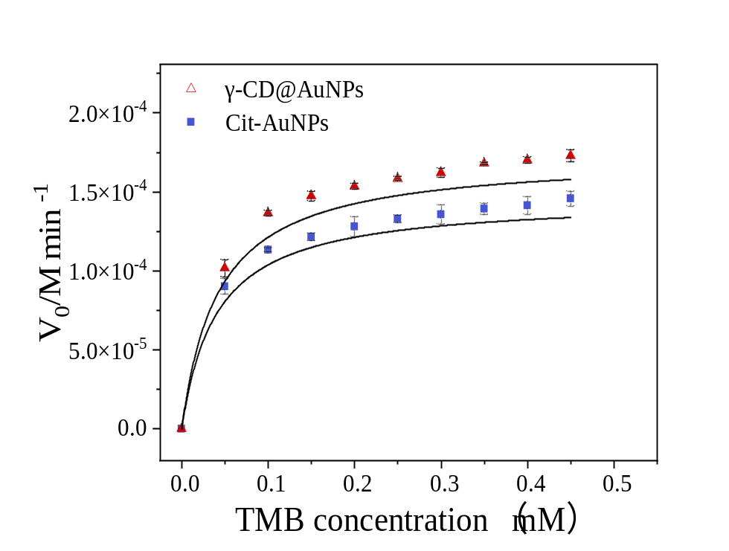
Fig. S5. Steady-state kinetic curves of γ-CD@AuNPs and Cit-AuNPs. Initial reaction velocities were measured over a final TMB concentration range of 0–0.45 mM and fitted using the Michaelis–Menten model. Data are presented as mean ± SD (n = 3). The corresponding kinetic parameters are provided in Table S1.

Table S1. Michaelis-Menten parameters obtained from the kinetic analyses of different types of nanoparticles in relation to their POD mimicking properties.
Nanoparticles  types | V_{max}  (M min⁻¹) | K_{M}  (mM) | k_{cat}  (min⁻¹) | Catalytic efficiency  (k_{cat}/K_{M}) (mM⁻¹.min⁻¹)
Cit-AuNPs | 1.458$×{10}^{-4}$ | $$4.0×{10}^{-2}$$ | 411.840 | 1.03$×{10}^{4}$
γ-CD@AuNPs | 1.727$×{10}^{-4}$ | $$4.2×{10}^{-2}$$ | 488.020 | 1.16$×{10}^{4}$
γ-CD@AgNPs | 1.994$×{10}^{-5}$ | $$3.6×{10}^{-2}$$ | 56.320 | 1.56$×{10}^{3}$
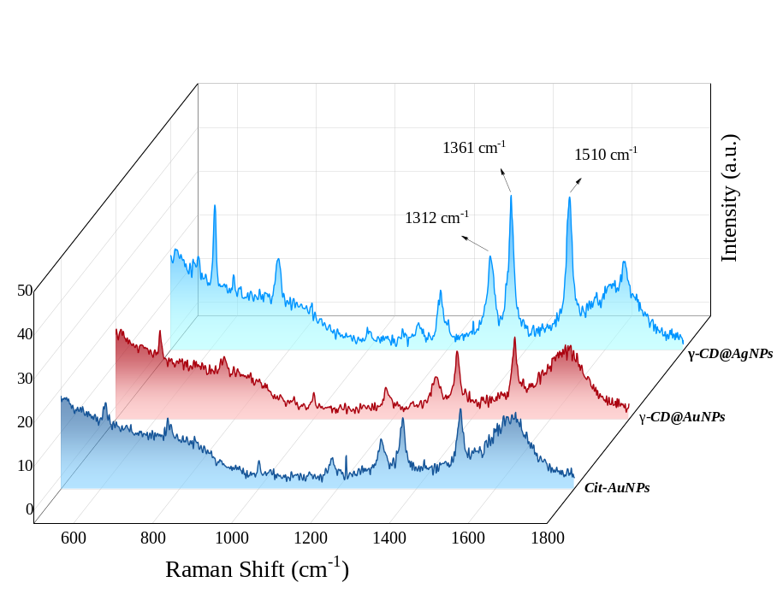
Fig. S6. SERS activity of Cit-AuNPs, γ-CD@AuNPs and γ-CD@AgNPs in the presence of R6G (10⁻⁵ M).

Section 2. Computational Modelling of γ-CD@AuNPs and γ-CD@AgNPs
Model Building
Near field enhancement of the γ-CD@AuNPs and γ-CD@AgNPs was studied by finite element modelling (FEM) ⁷. For a γ-CD@AuNP, a 3d sphere of 10 nm diameter was constructed (size acquired from the TEM image), inside a 3d spherical cell as the computational domain with a diameter of 500 nm (Fig. S7a), which was illuminated normally with a plane wave, having the amplitude E₀ = 1 V/m on the γ-CD@AuNP (Fig. S7b). The thickness of the computational domain was kept as 80 nm and was made as the Perfectly Matched Layer (PMLs), to avoid any unwanted radiation. The same geometry was kept for depicting the γ-CD@AuNPs aggregation system, except for building four γ-CD@AuNPs separated by a distance of 0.5 nm (Fig. S7c).
Similarly, for a γ-CD@AgNP (Figure S7d), a 3d sphere of 29 nm diameter was constructed, keeping the other dimensions the same as above (Fig. S7e), illuminated normally with a plane wave, E₀ = 1 V/m on the γ-CD@AgNP. The same geometry was kept for depicting the γ-CD@AgNPs aggregation system, except for building four γ-CD@AgNPs separated by a distance of 0.5 nm (Fig. S7f). The optical properties of AuNPs were acquired from Christy et al ⁸ and Rakic et al. ⁹.
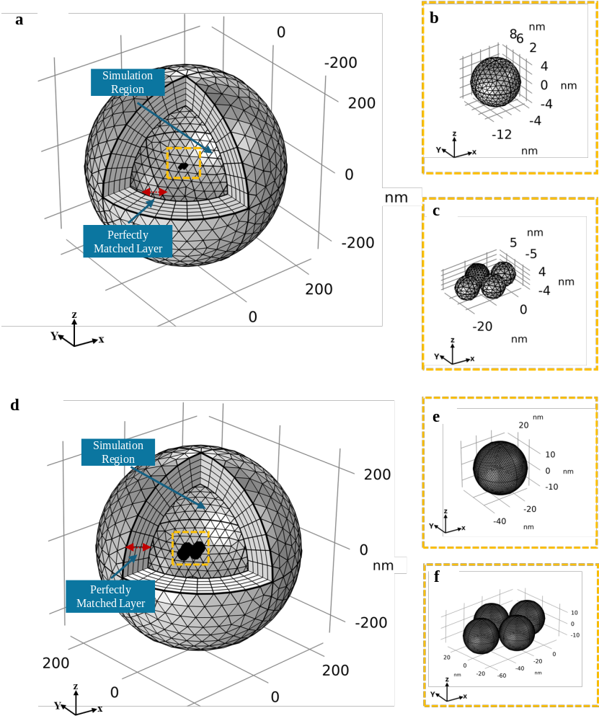
Fig. S7. Computational models simulating the SERS enhancement of (a) γ-CD@AuNPs, including cross-sectional views of (b) a single γ-CD@AuNP and (c) aggregated γ-CD@AuNPs, and (d) γ-CD@AgNPs, including cross-sectional views of (e) a single γ-CD@AgNP and (f) aggregated γ-CD@AgNPs.

For the incident wavelengths 785 nm, the numerical FEM solver solved the following Maxwell’s equations:
$∇ × \frac{1}{μ_{r}}$[ ∇ ×E ] =$- {k_{0}}^{2}\left[ϵ_{r}-\frac{jσ}{ωϵ_{0}}\right] E$ (1)
Where $k_{0}$ is the wavenumber in free space, μ_{r} = the relative permeability of the medium, $ϵ_{r}$= the permittivity of the medium, j = current density, E = the electric field, and $σ$ = the electrical conductivity of the medium.
The incident energy flux was calculated as:
$S_{inc}= \frac{1}{2 } ϵ_{0}c\left|{E_{inc}}^{2}\right|$ (2)
The simulated enhancement factor was calculated using the equation as:
$G(ω_{R})= {\left|\frac{E_{loc} (ω_{0})}{E_{in}(ω_{0})}\right|}^{4}$ (3)
Where, $E_{in} (ω_{0})$ is the incident electric field at frequency $(ω_{0})$, and $E_{loc }(ω_{o})$ is the localised electric field.

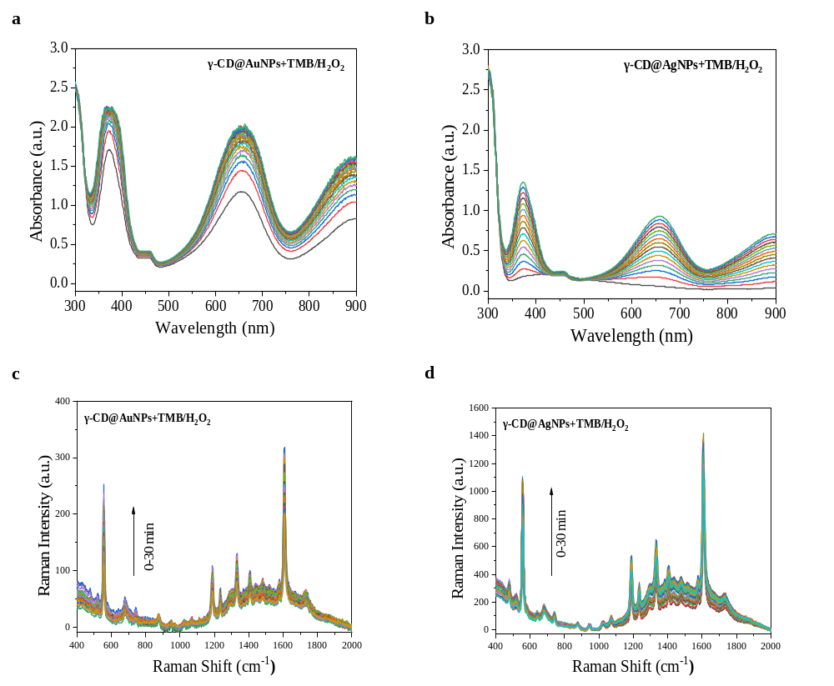
Fig. S8. Time-dependent absorption spectra (top, a and b) and SERS spectra (bottom, c and d) of γ-CD@AuNPs and γ-CD@AgNPs nanozyme reactions with TMB/H₂O₂. The data illustrate the gradual catalytic oxidation of TMB and the corresponding SERS signal enhancement over time.

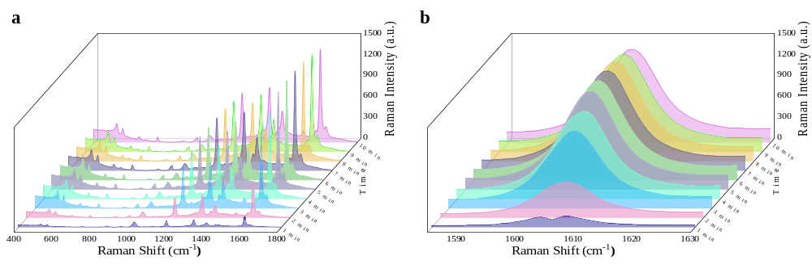
Fig. S9. Time-dependent SERS response of the γ-CD@AgNPs and TMB/H₂O₂ system. (a) Full SERS spectra collected at different reaction times. (b) SERS spectra in the 1580–1630 cm⁻¹ region, showing the maximum signal at 5 min.
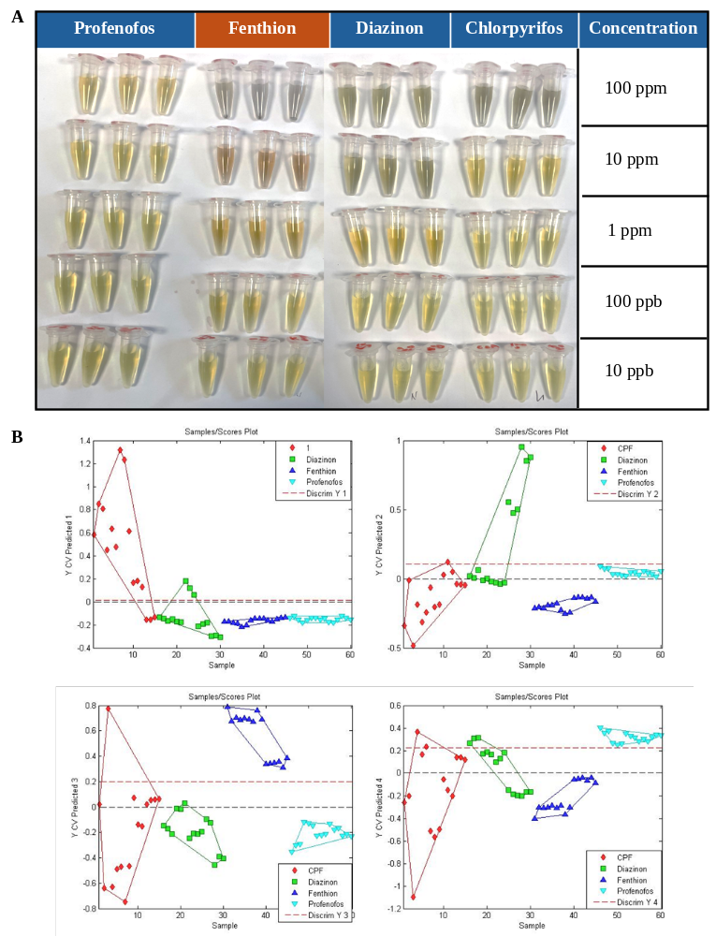
Fig. S10. Visual response of γ-CD@AgNPs to profenofos, fenthion, diazinon, and chlorpyrifos at different concentrations. Photographs demonstrating the colorimetric response and aggregation of γ-CD@AgNPs upon incubation with different OPPs. The distinct color change and settling (aggregation) observed only with fenthion, even at lower concentrations, visually supports a stronger aggregation response toward fenthion under the tested conditions.
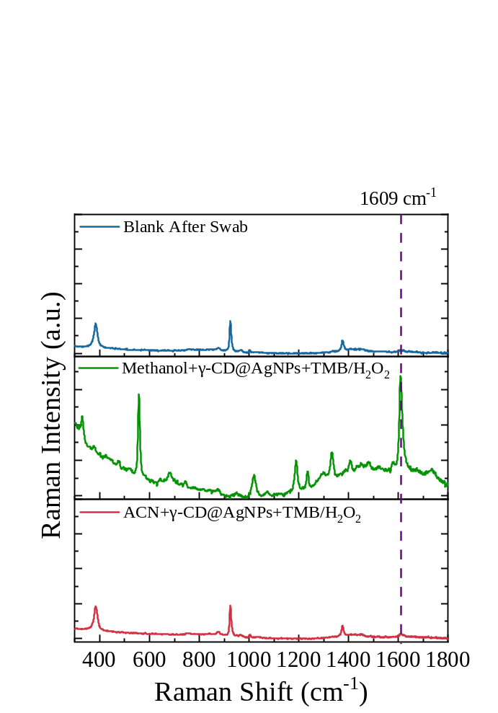
Fig. S11. Comparison of swab solvents for SERS detection of fenthion (1 ppm), showing that methanol provided a stronger oxTMB SERS signal than acetonitrile and was therefore selected as the extraction solvent.
Table S2. Analysis recovery and precision of fenthion from spiked tomato surfaces using the swab-SERS method.
Spiked concentration (ppm) | Measured concentration (ppm) | Recovery (%) | RSD (%)
0.2 | 0.177 ± 0.006 | 88.5 | 3.39
1 | 0.995 ± 0.024 | 99.5 | 2.41
2 | 2.364 ± 0.151 | 118 | 6.39

Section 3: Matrix effect calculation:
The matrix effect was evaluated to assess the influence of the tomato matrix on the SERS response by comparing the analytical sensitivity (slope) of the calibration curve obtained in the tomato matrix with that obtained in the buffer system:
$Matrix effect \left(\%\right)=\frac{{Slope}_{tomato}}{{Slope}_{buffer}}×100= \frac{-293.15}{-344}×100=85.21\%$
where Slope_{tomato} and Slope_{buffer} represent the slopes of the calibration curves obtained in the tomato matrix and buffer system, respectively.
References
1. Cao, C., Gontard, L. C., Thuy Tram, L. L., Wolff, A. & Bang, D. D. Dual enlargement of gold nanoparticles: From mechanism to scanometric detection of pathogenic bacteria. Small 7, 1701–1708 (2011).
2. Park, S.-J., Taton, T. A. & Mirkin, C. A. Array-Based Electrical Detection of DNA with Nanoparticle Probes. New Series 22, 1503–1506 (2002).
3. Wang, C. & Irudayaraj, J. Gold nanorod probes for the detection of multiple pathogens. Small 4, 2204–2208 (2008).
4. Cao, C. & Sim, S. J. Resonant Rayleigh light scattering response of individual Au nanoparticles to antigen–antibody interaction. Lab Chip 9, 1836–1839 (2009).
5. Balderas-Vázquez, F. del R. et al. Gold nanoparticle synthesis: assessment of the Turkevich, green synthesis, and Good’s buffer methods. Mundo nano. Revista interdisciplinaria en nanociencias y nanotecnología 19, e69861 (2026).
6. Marinenko, G. & Foley, R. T. Absolute Determination of the Electrochemical Equivalent and the Atomic Weight of Zinc II. Final Determination. J. Res. Natl. Bur. Stand. A Phys. Chem. 79A, 747 (1975).
7. Pant, U. et al. From automated Raman to cost-effective nanoparticle-on-film (NPoF) SERS spectroscopy: A combined approach for assessing micro- and nanoplastics released into the oral cavity from chewing gum. J. Hazard. Mater. 486, 136978 (2025).
8. Johnson, P. B. & Christy, R. W. Optical Constants of the Noble Metals. Phys. Rev. B 6, 4370 (1972).
9. Elazar, J. M., Djurišić, A. B., Rakić, A. D. & Majewski, M. L. Optical properties of metallic films for vertical-cavity optoelectronic devices. Applied Optics, Vol. 37, Issue 22, pp. 5271-5283 37, 5271–5283 (1998).

