Supplementary Information
Leakage-Safe Cross-Domain Partial-Discharge Void Diagnosis: A Benchmark on the PURE Dataset
Journal: Electrical Engineering
Authors: Yan Hong, Jia’ao Li, Jingming Su, and Zihan Gao
Affiliation: School of Electrical and Information Engineering, Anhui University of Science and Technology, Huainan 232001, China
Corresponding author: Jia’ao Li (1471023246@qq.com)
All entries use the frozen acquisition-file-level partitions described in the manuscript. Pulse records from the same acquisition file are never split across training and evaluation sets.
Supplementary Tables S1–S6 and Fig. S1

Supplementary Table S1. File-level RBF-SVM results for all tasks in the four evaluation protocols.
Protocol | Task | Target domain | Macro-F1 | Balanced accuracy | Recall 1 | Recall 2p | Recall 2s
In-domain | D1 (LDPE-AC), grouped CV | D1 (LDPE-AC) | 1.0000 | 1.0000 | 1.0000 | 1.0000 | 1.0000
In-domain | D2 (LDPE-DC+), grouped CV | D2 (LDPE-DC+) | 1.0000 | 1.0000 | 1.0000 | 1.0000 | 1.0000
In-domain | D3 (LDPE-DC-), grouped CV | D3 (LDPE-DC-) | 0.9556 | 0.9583 | 0.8750 | 1.0000 | 1.0000
In-domain | D4 (PP-AC), grouped CV | D4 (PP-AC) | 1.0000 | 1.0000 | 1.0000 | 1.0000 | 1.0000
Cross-voltage | LDPE-AC to LDPE-DC- | D3 (LDPE-DC-) | 0.4381 | 0.5333 | 0.0000 | 0.6000 | 1.0000
Cross-voltage | LDPE-AC to LDPE-DC+ | D2 (LDPE-DC+) | 0.2188 | 0.3333 | 0.0000 | 0.0000 | 1.0000
Cross-voltage | LDPE-DC- to LDPE-AC | D1 (LDPE-AC) | 0.1405 | 0.3125 | 0.0000 | 0.9375 | 0.0000
Cross-voltage | LDPE-DC- to LDPE-DC+ | D2 (LDPE-DC+) | 0.4924 | 0.5833 | 0.0000 | 1.0000 | 0.7500
Cross-voltage | LDPE-DC+ to LDPE-AC | D1 (LDPE-AC) | 0.1481 | 0.3333 | 0.0000 | 1.0000 | 0.0000
Cross-voltage | LDPE-DC+ to LDPE-DC- | D3 (LDPE-DC-) | 0.5266 | 0.6500 | 0.0000 | 0.9500 | 1.0000
Cross-material | LDPE-AC to PP-AC | D4 (PP-AC) | 0.2500 | 0.2000 | 0.0000 | 0.0000 | 0.6000
Cross-material | PP-AC to LDPE-AC | D1 (LDPE-AC) | 0.1157 | 0.2500 | 0.0000 | 0.7500 | 0.0000
Multi-source LODO | Leave out D1 (LDPE-AC) | D1 (LDPE-AC) | 0.1253 | 0.2708 | 0.0000 | 0.8125 | 0.0000
Multi-source LODO | Leave out D2 (LDPE-DC+) | D2 (LDPE-DC+) | 0.5556 | 0.6667 | 0.0000 | 1.0000 | 1.0000
Multi-source LODO | Leave out D3 (LDPE-DC-) | D3 (LDPE-DC-) | 0.9327 | 0.9333 | 0.9000 | 1.0000 | 0.9000
Multi-source LODO | Leave out D4 (PP-AC) | D4 (PP-AC) | 0.2068 | 0.3500 | 0.0500 | 0.0000 | 1.0000

Supplementary Table S2. File-level LODO performance of additional neural architectures.
Model | Target domain | Macro-F1 mean | Macro-F1 SD | Balanced accuracy mean | Balanced accuracy SD | Parameters
CNN1D | D1 (LDPE-AC) | 0.3576 | 0.0542 | 0.3667 | 0.0745 | 105827
CNN1D | D2 (LDPE-DC+) | 0.3492 | 0.0828 | 0.3867 | 0.0558 | 105827
CNN1D | D3 (LDPE-DC-) | 0.5492 | 0.0142 | 0.6533 | 0.0298 | 105827
CNN1D | D4 (PP-AC) | 0.2365 | 0.0241 | 0.3333 | 0.0000 | 105827
ResNet1D | D1 (LDPE-AC) | 0.3409 | 0.0731 | 0.3400 | 0.1065 | 445155
ResNet1D | D2 (LDPE-DC+) | 0.3955 | 0.1852 | 0.4667 | 0.2309 | 445155
ResNet1D | D3 (LDPE-DC-) | 0.5486 | 0.0233 | 0.6400 | 0.0365 | 445155
ResNet1D | D4 (PP-AC) | 0.3252 | 0.0697 | 0.3933 | 0.0585 | 445155
TCN1D | D1 (LDPE-AC) | 0.3875 | 0.1135 | 0.4167 | 0.1795 | 314691
TCN1D | D2 (LDPE-DC+) | 0.3762 | 0.0673 | 0.4000 | 0.0816 | 314691
TCN1D | D3 (LDPE-DC-) | 0.5527 | 0.0065 | 0.6667 | 0.0000 | 314691
TCN1D | D4 (PP-AC) | 0.2889 | 0.0609 | 0.3333 | 0.0000 | 314691

Supplementary Table S3. Paired file-level bootstrap comparisons for feature groups.
Protocol | Feature group | Difference vs all | CI low | CI high | Holm-adjusted p
Cross-voltage | time | -0.1826 | -0.2132 | -0.1522 | 0.0024
Cross-voltage | frequency | -0.0296 | -0.0540 | -0.0035 | 0.1760
Cross-voltage | wavelet | 0.0907 | 0.0332 | 0.1373 | 0.0090
Cross-material | time | 0.1389 | 0.0847 | 0.2219 | 0.0024
Cross-material | frequency | -0.1042 | -0.1544 | -0.0250 | 0.1392
Cross-material | wavelet | 0.0533 | 0.0202 | 0.0970 | 0.0144
Multi-source LODO | time | -0.3319 | -0.3698 | -0.2888 | 0.0024
Multi-source LODO | frequency | -0.1017 | -0.1557 | -0.0318 | 0.0308
Multi-source LODO | wavelet | 0.0365 | -0.0002 | 0.0686 | 0.2064

Supplementary Table S4. Exploratory failure-boundary audit on the non-redundant XLPE cable records.
Method | Non-redundant files | Single-void pulse recall | Consensus-correct files | Predicted-2p fraction
RBF-SVM | 7 | 0.0000 | 0 | 1.0000
CNN1D | 7 | 0.0000 | 0 | 1.0000
CNN1D + physics | 7 | 0.0357 | 0 | 0.9643

Supplementary Table S5. Leave-one-direction sensitivity of the Spearman association between mean class-conditional MMD squared and directed-transfer Macro-F1.
Omitted direction | Remaining directions | Spearman rho | p value
LDPE-AC to LDPE-DC- | 7 | -0.8929 | 0.0068
LDPE-AC to LDPE-DC+ | 7 | -0.9643 | 0.0005
LDPE-AC to PP-AC | 7 | -0.8929 | 0.0068
LDPE-DC- to LDPE-AC | 7 | -1.0000 | <0.0001
LDPE-DC- to LDPE-DC+ | 7 | -0.8929 | 0.0068
LDPE-DC+ to LDPE-AC | 7 | -0.9643 | 0.0005
LDPE-DC+ to LDPE-DC- | 7 | -0.8929 | 0.0068
PP-AC to LDPE-AC | 7 | -0.8929 | 0.0068

Supplementary Table S6. Target-domain results for the source-only time-frequency domain-generalization baselines under LODO.
Method | Target domain | Macro-F1 | Balanced accuracy | Recall 1 | Recall 2p | Recall 2s
Time-frequency ERM | D1 (LDPE-AC) | 0.2659 | 0.2858 | 0.0000 | 0.2875 | 0.5700
Time-frequency ERM | D2 (LDPE-DC+) | 0.4951 | 0.5767 | 0.0000 | 1.0000 | 0.7300
Time-frequency ERM | D3 (LDPE-DC-) | 0.5272 | 0.6267 | 0.1200 | 0.9900 | 0.7700
Time-frequency ERM | D4 (PP-AC) | 0.3553 | 0.4833 | 0.0000 | 0.4500 | 1.0000
Source-domain Deep CORAL (λ = 0.1) | D1 (LDPE-AC) | 0.2701 | 0.2925 | 0.0000 | 0.2875 | 0.5900
Source-domain Deep CORAL (λ = 0.1) | D2 (LDPE-DC+) | 0.4951 | 0.5767 | 0.0000 | 1.0000 | 0.7300
Source-domain Deep CORAL (λ = 0.1) | D3 (LDPE-DC-) | 0.5204 | 0.6200 | 0.1200 | 0.9900 | 0.7500
Source-domain Deep CORAL (λ = 0.1) | D4 (PP-AC) | 0.3662 | 0.4917 | 0.0000 | 0.4750 | 1.0000
Source-domain DANN (λ = 0.1) | D1 (LDPE-AC) | 0.2618 | 0.2825 | 0.0100 | 0.1875 | 0.6500
Source-domain DANN (λ = 0.1) | D2 (LDPE-DC+) | 0.4866 | 0.5667 | 0.0100 | 1.0000 | 0.6900
Source-domain DANN (λ = 0.1) | D3 (LDPE-DC-) | 0.4721 | 0.5733 | 0.1400 | 1.0000 | 0.5800
Source-domain DANN (λ = 0.1) | D4 (PP-AC) | 0.3105 | 0.4192 | 0.0200 | 0.2375 | 1.0000

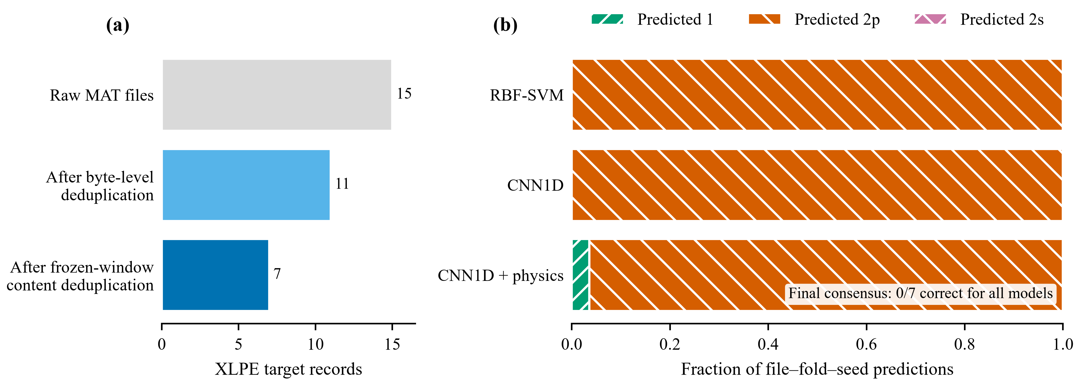
Supplementary Fig. S1. Failure-boundary audit on seven non-redundant single-void XLPE cable records. The thin-film-trained classifiers assign the records predominantly to the parallel-void class; this same-repository audit is not treated as independent external validation.

