The Complete Plastome Sequence of Caragana and Comparative Analysis with Their Congeneric Species
Yihui Tan¹, Jingling Li¹, Yuanyu Shan¹ , Qingqing Zhou¹, Guoan Shen¹,*, Chang Liu¹,*
¹ Key Laboratory for Quality Ensurance and Sustainable Use of Dao-Di Herbs, Key Laboratory of Bioactive Substances and Resources Utilization of Chinese Herbal Medicine affiliated with Ministry of Education of China, Institute of Medicinal Plant Development, Chinese Academy of Medical Sciences, Haidian District, Beijing, China 100193;
* Correspondence: gashen@implad.ac.cn (GAS), cliu@implad.ac.cn (CL).

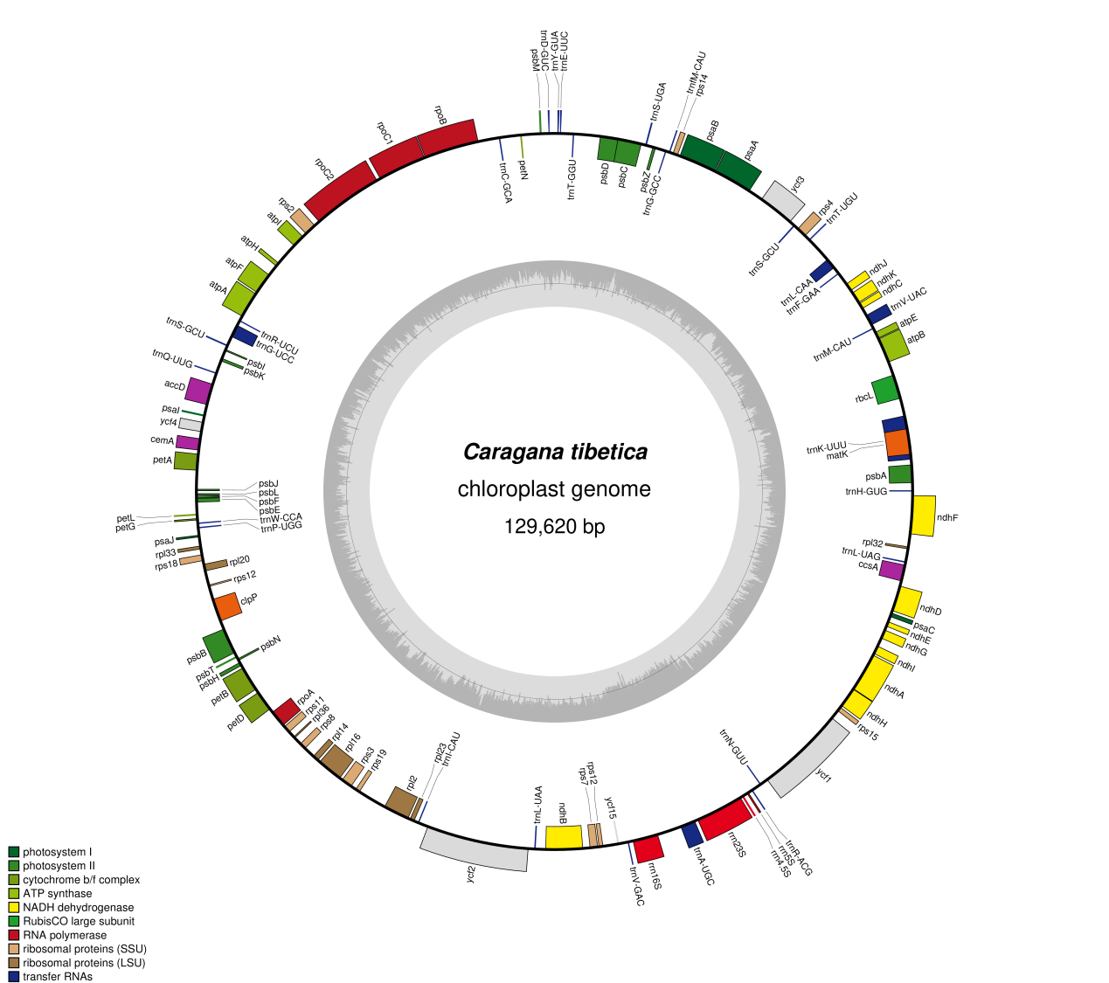
Fig. S1 Plastome map of C. tragacanthoides

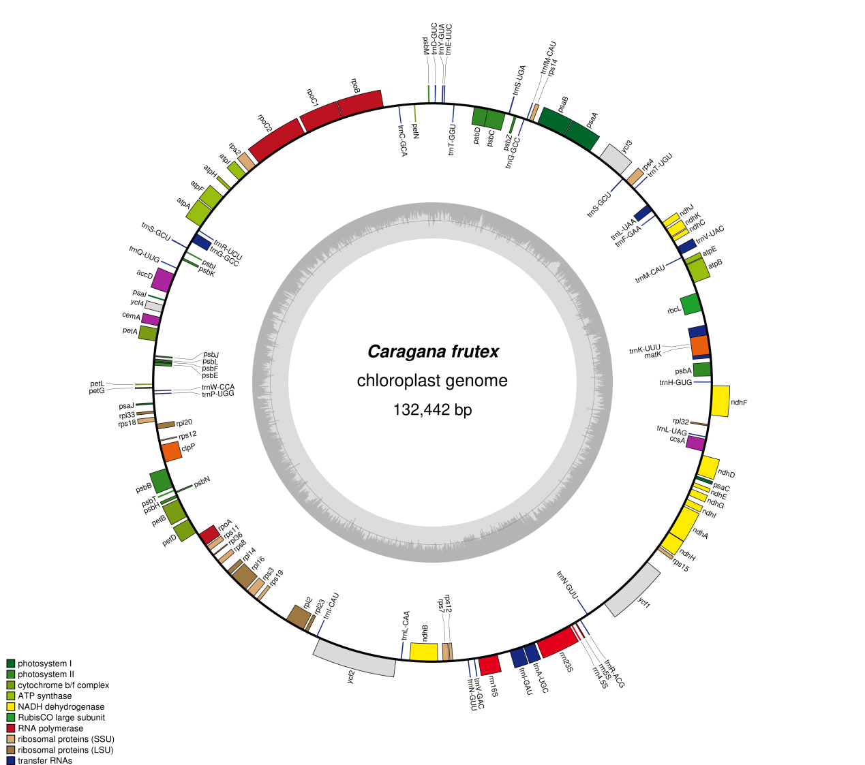
Fig. S2 Plastome map of C. frutex

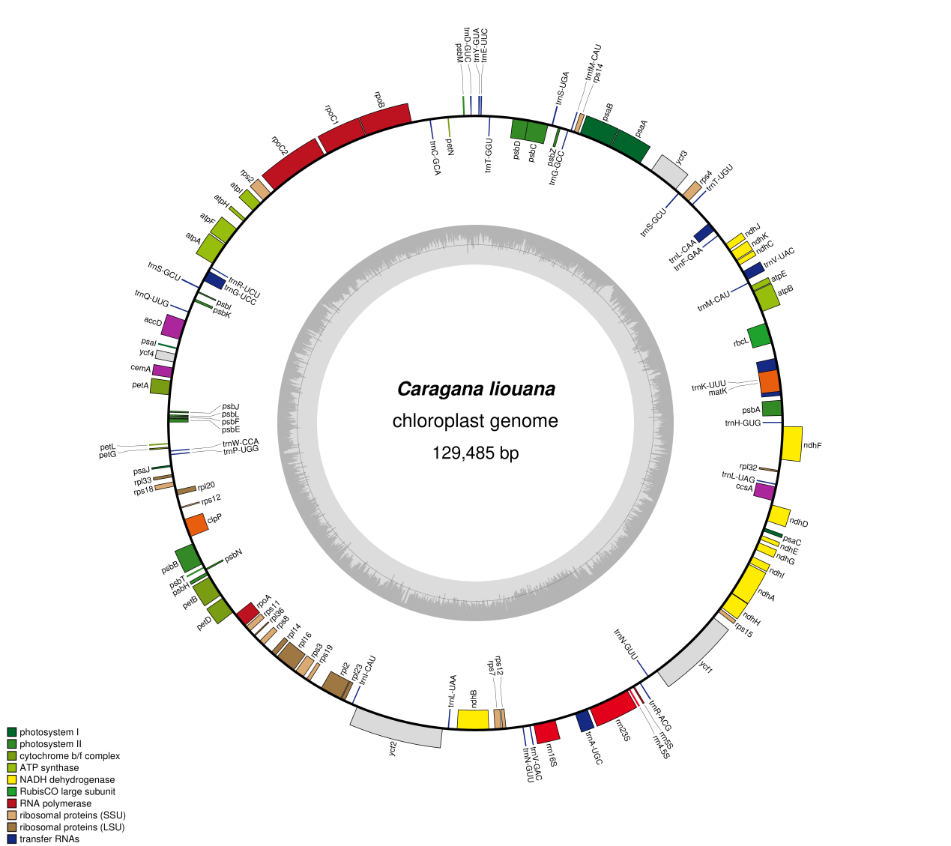
Fig. S3 Plastome map of C. liouana

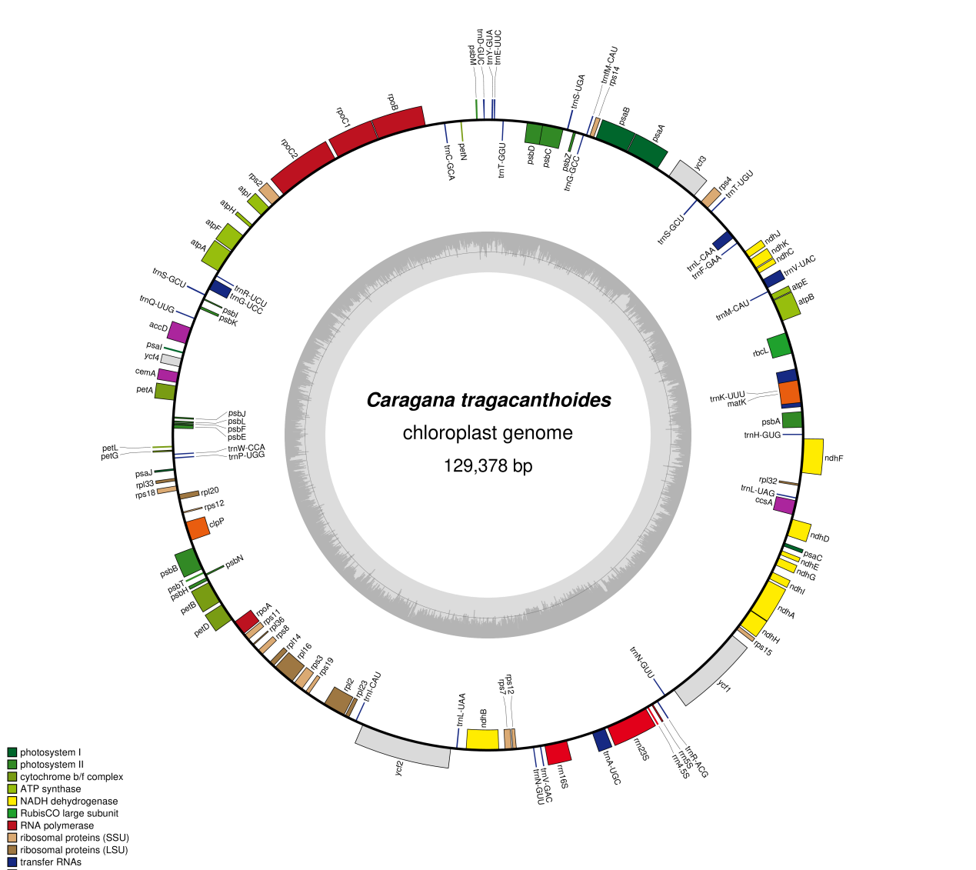Fig. S4 Plastome map of C. tibetica
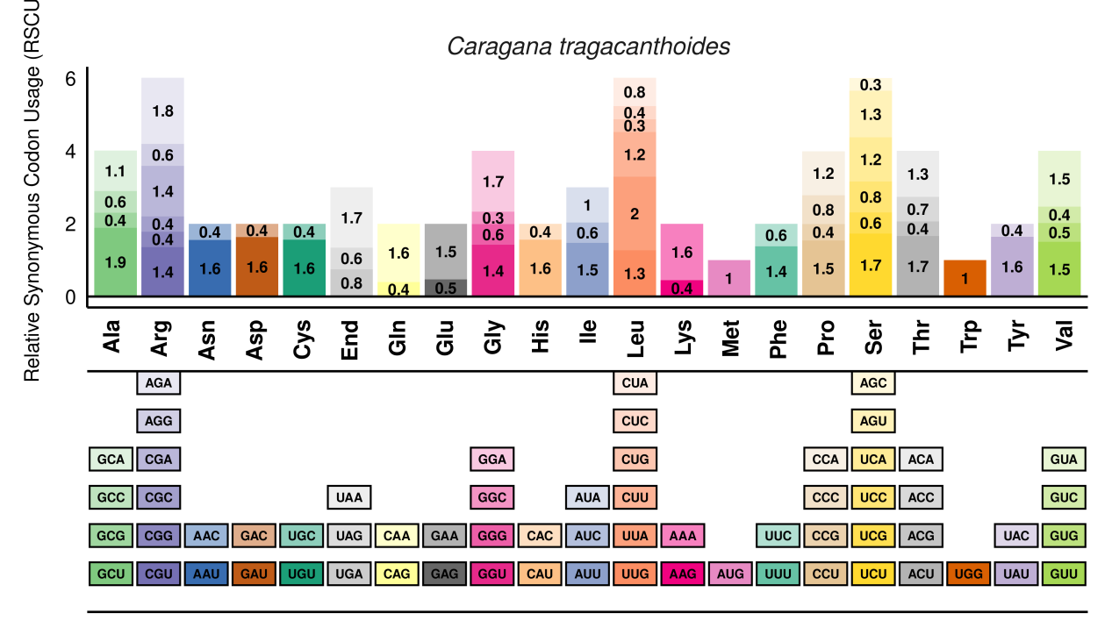
Fig. S5 RSCU analysis of plastome genes of C. tragacanthoides. X‐axis: Amino acid type; Y‐axis: RSCU value
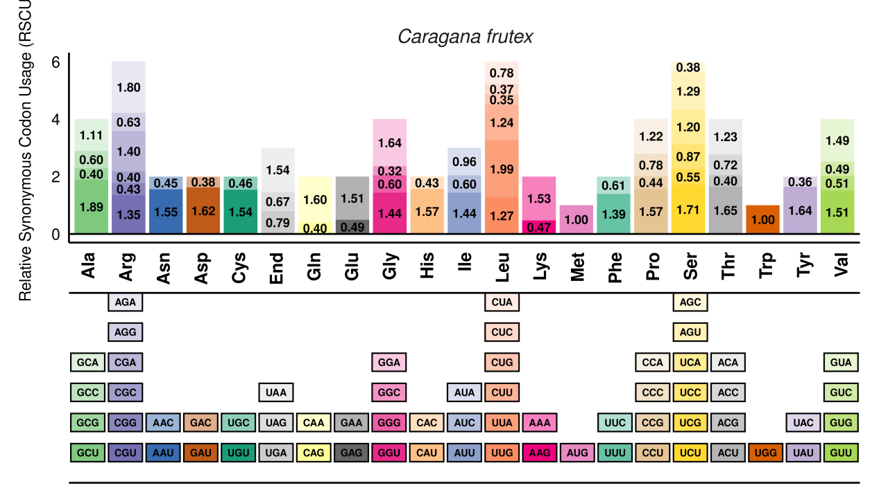
Fig. S6 RSCU analysis of plastome genes of C. frutex. X‐axis: Amino acid type; Y‐axis: RSCU value
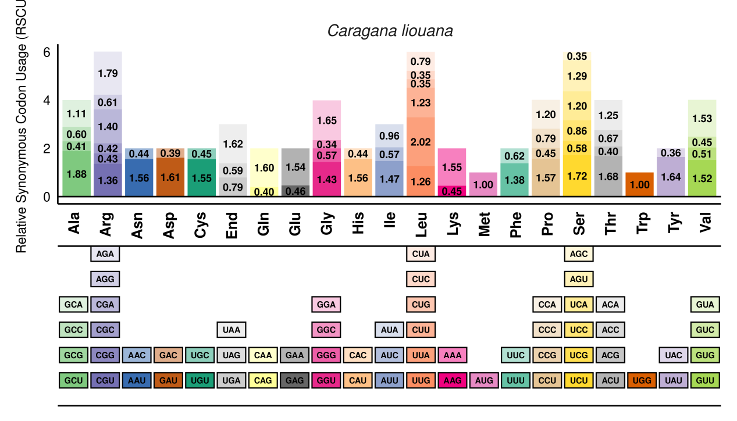
Fig. S7 RSCU analysis of plastome genes of C. liouana. X‐axis: Amino acid type; Y‐axis: RSCU value
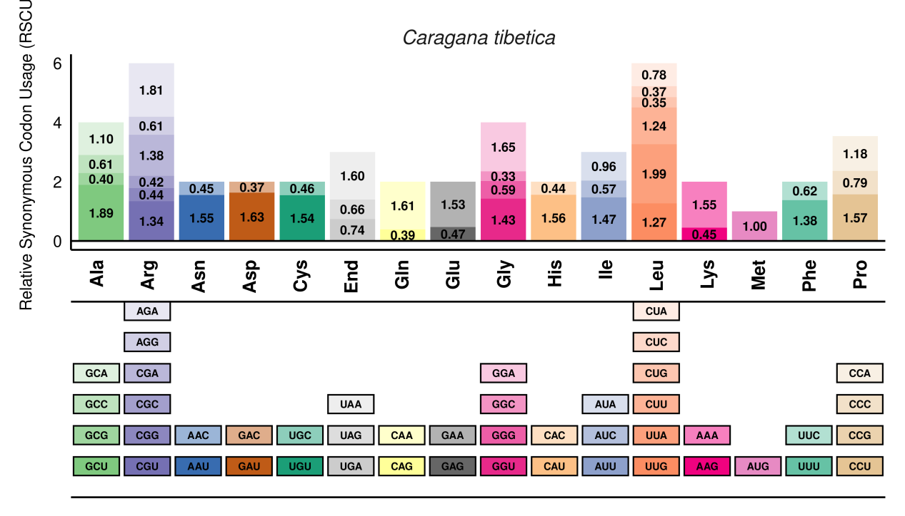
Fig. S8 RSCU analysis of plastome genes of C. tibetica. X‐axis: Amino acid type; Y‐axis: RSCU value 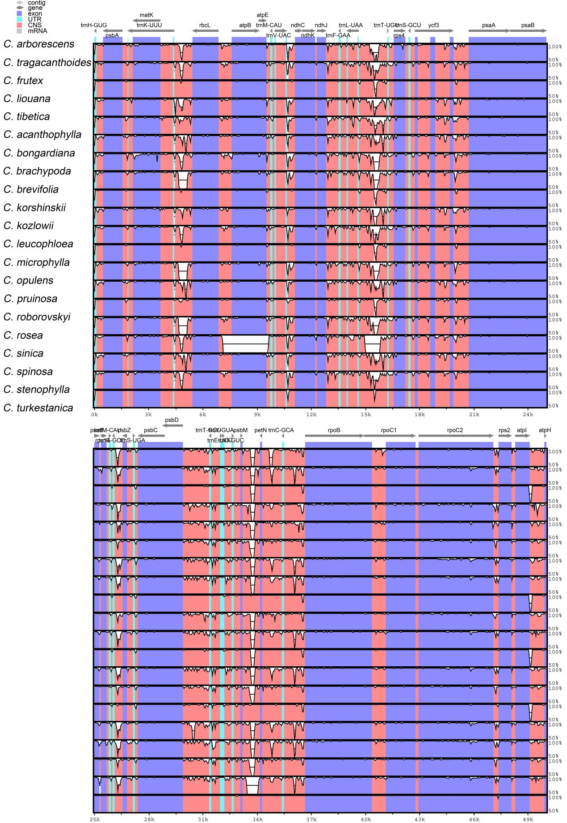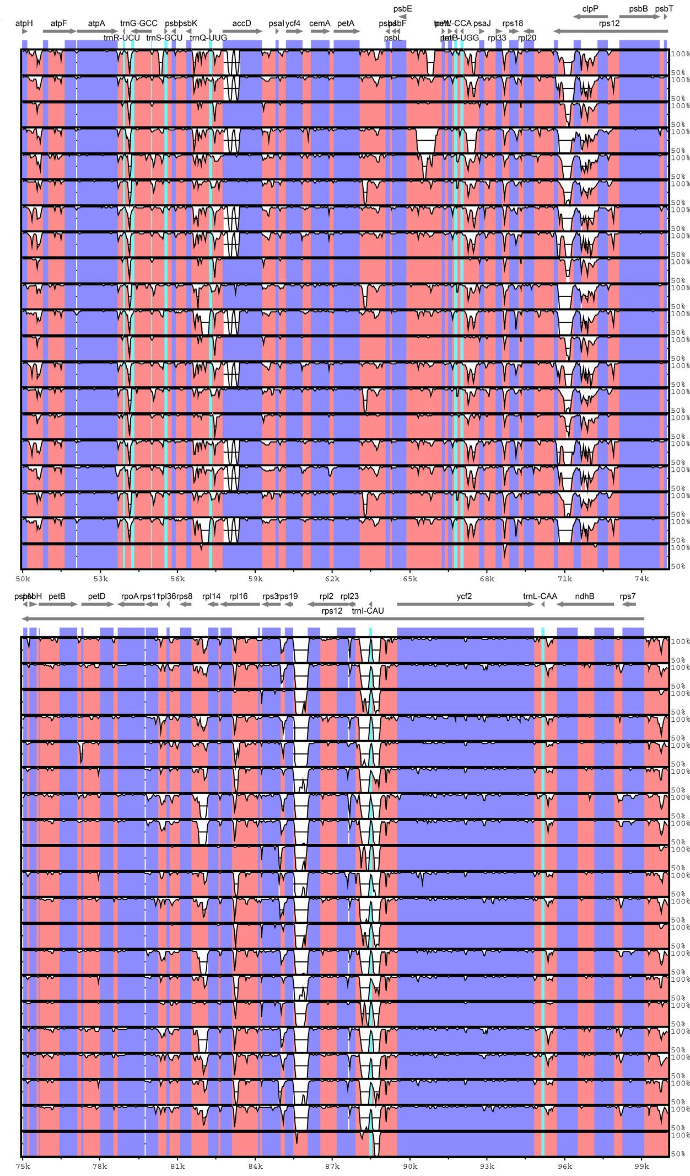
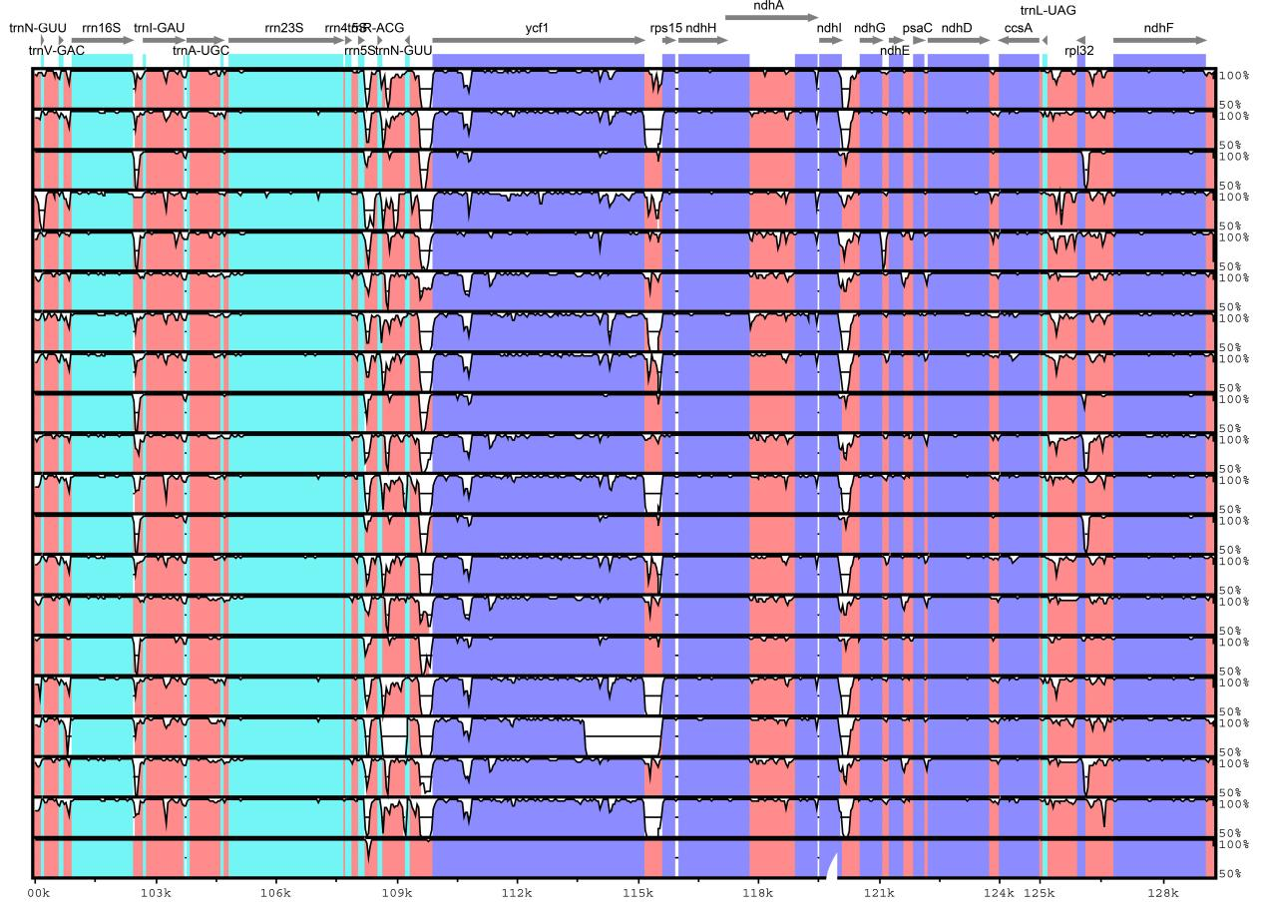Fig. S9 Comparative genomic analyses of 21 species of Caragana. Gray arrows indicate the gene orientation, pink indicates non-coding sequences, purple indicates exons, light blue indicates rRNAs and white bumps indicate different regions of plastome genes. The x-axis delineates aligned nucleotide positions from the reference plastome genome of C. arborescens (PP140448), and the y-axis displays pairwise identity percentages, ranging from 50% to 100%
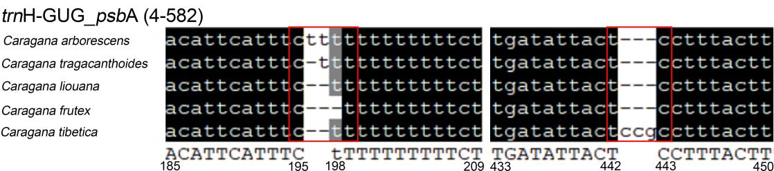
Fig. S10 The alignment of the sequence variations of molecular markers in 5 Caragana species, with conserved nucleotides shown in black and regions of single nucleotide polymorphisms (SNPs) and insertions/deletions (indels) highlighted with red squares.The numbers indicate the positions of the sequences on the plastome using C. arborescens as the reference

