Supplementary Information for

Comparing geospatial interpolation techniques for estimating ambient PM_{2.5} mass concentrations from sugarcane burning in South Florida

Anne Mielnik,¹ Olivia Sablan,² Jeffrey R. Pierce,² Lilah M. Besser,³ Juyoung Park,⁴ Diana Mitsova,⁵ Diane Cook,⁶ Sherry WeMott,¹ Christine L. Williams,⁷ Lisa A. K. Wiese,⁷ & Sheryl Magzamen^{1*}

- Department of Environmental and Radiological Health Sciences, Colorado State University, Fort Collins, Colorado, 80523-1019, United States
- Department of Atmospheric Science, Colorado State University, Fort Collins, Colorado, 80523-1371, United States
- Comprehensive Center for Brain Health, University of Miami School of Medicine, Boca Raton, Florida, 33433, United States
- College of Nursing, University of Arizona, Tucson, Arizona 85721-0203, United States
- Department of Urban and Regional Planning, Florida Atlantic University, Boca Raton, Florida, 33431-0991, United States
- School of Electrical Engineering and Computer Science, Washington State University, Pullman, Washington, 99164-2752, United States
- C.E. Lynn College of Nursing, Florida Atlantic University, Boca Raton, Florida, 33431- 0991, United States

*Corresponding Author:
Sheryl Magzamen
Department of Environmental and Radiological Health Sciences
Colorado State University
1618 Campus Delivery
Fort Collins, CO 80523-1618
sheryl.magzamen@colostate.edu

Supplementary Information (19 pages) includes 10 tables and 10 figures.

Figure S1. Measured hourly maximum PM_{2.5} mass concentrations for each PurpleAir sensor and EPA AQS FRM monitor (listed by ID/site number) with dashed lines at 20 μg/m³ and gray shaded areas on days NOAA HMS smoke plumes overlap PM_{2.5} measurements (i.e., illustrating smoke-impacted day criteria “C1”).

Table S1. Summary statistics for estimated 24-hour average PM_{2.5} concentrations from OK models with a Bessel fit by meteorological season, by smoke-impacted vs. non-smoke-impacted days, and overall, for the entire study period.
 | n | Mean | SD | Min. | Q1 | Median | Q3 | Max.
Spring (MAM) | 92 | 5.77 | 9.07 | 0.048 | 4.18 | 5.26 | 6.93 | 1.65x10⁴
Summer (JJA) | 133 | 3.46 | 1.58 | 0 | 2.51 | 3.25 | 3.94 | 14.0
Fall (SON) | 134 | 3.66 | 1.80 | 0.058 | 2.46 | 3.13 | 4.45 | 14.7
Winter (DJF) | 86 | 3.93x10⁷ | 7.09x10⁹ | 0 | 3.51 | 4.46 | 5.19 | 1.28x10¹²
Smoke (C1) | 169 | 5.28 | 6.86 | 0 | 3.70 | 4.90 | 6.51 | 1.65x10³
No smoke (C1) | 276 | 1.22x10⁷ | 3.96x10⁹ | 0 | 2.53 | 3.40 | 4.28 | 1.28x10¹²
Smoke (C2) | 247 | 1.36x10⁷ | 4.19x10⁹ | 0 | 3.41 | 4.53 | 6.18 | 1.28x10¹²
No smoke (C2) | 198 | 3.37 | 1.55 | 0 | 2.34 | 3.11 | 4.02 | 14.0
Overall | 445 | 7.59x10⁶ | 3.12x10⁹ | 0 | 2.84 | 3.83 | 5.08 | 1.28x10¹²
All values are reported in μg/m³ except for n (the number of estimated, gridded/area-weighted 24-hour average PM_{2.5} surfaces generated during the measurement period [i.e., of 541 days total]). Note: Models predicted values well below 0 μg/m³, which are represented as “0” in table. “C1” and “C2” denote different criteria for identifying smoke-impacted days: “C1” indicates [PM_{2.5}] ≥ 20 μg/m³ for at least one hour within a 24-hour period or a NOAA HMS smoke plume overlapped a PurpleAir sensor or EPA monitor; “C2” shows an OBA for sugarcane crop management was administered within the EAA. Spatial resolution is 2 km per grid cell.

Table S2. Summary statistics for estimated 24-hour average PM_{2.5} concentrations from UK models with a Bessel fit by meteorological season, by smoke-impacted vs. non-smoke-impacted days, and overall, for the entire study period.
 | n | Mean | SD | Min. | Q1 | Median | Q3 | Max.
Spring (MAM) | 92 | 6.33 | 124 | 0 | 4.09 | 5.13 | 6.90 | 2.31x10⁴
Summer (JJA) | 133 | 3.49 | 1.69 | 0 | 2.51 | 3.27 | 3.98 | 17.5
Fall (SON) | 134 | 3.73 | 2.06 | 0.051 | 2.36 | 3.23 | 4.62 | 23.8
Winter (DJF) | 86 | 3.36x10⁷ | 6.08x10⁹ | 0 | 3.38 | 4.47 | 5.39 | 1.10x10¹²
Smoke (C1) | 169 | 5.65 | 91.5 | 0 | 3.64 | 4.81 | 6.49 | 2.31x10⁴
No smoke (C1) | 276 | 1.04x10⁷ | 3.39x10⁹ | 0 | 2.43 | 3.39 | 4.34 | 1.09x10¹²
Smoke (C2) | 247 | 1.17x10⁷ | 3.59x10⁹ | 0 | 3.34 | 4.50 | 6.11 | 1.10x10¹²
No smoke (C2) | 198 | 3.39 | 1.65 | 0 | 2.34 | 3.20 | 4.05 | 17.5
Overall | 445 | 6.50x10⁶ | 2.67x10⁷ | 0 | 2.77 | 3.82 | 5.13 | 1.10x10¹²
All values are reported in μg/m³ except for n (the number of estimated, gridded/area-weighted 24-hour average PM_{2.5} surfaces generated during the measurement period [i.e., of 541 days total]). Note: Models predicted values well below 0 μg/m³, which are represented as “0” in table. “C1” and “C2” denote different criteria for identifying smoke-impacted days: “C1” indicates [PM_{2.5}] ≥ 20 μg/m³ for at least one hour within a 24-hour period or a NOAA HMS smoke plume overlapped a PurpleAir sensor or EPA monitor; “C2” shows an OBA for sugarcane crop management was administered within the EAA. Spatial resolution is 2 km per grid cell.
Table S3. Summary statistics for estimated 24-hour average PM_{2.5} concentrations from OK models with an exponential fit by meteorological season, by smoke-impacted vs. non-smoke-impacted days, and overall, for the entire study period.
 | n |  | Mean |  | SD |  | Min. |  | Q1 |  | Median |  | Q3 |  | Max.
Spring (MAM) |  | 92 |  | 5.72 |  | 2.01 |  | 1.34 |  | 4.19 |  | 5.25 |  | 6.87 |  | 13.3
Summer (JJA) |  | 133 |  | 3.46 |  | 1.57 |  | 0.001 |  | 2.55 |  | 3.25 |  | 3.95 |  | 12.0
Fall (SON) |  | 134 |  | 3.66 |  | 1.80 |  | 0.084 |  | 2.45 |  | 3.16 |  | 4.45 |  | 11.1
Winter (DJF) |  | 86 |  | 4.82 |  | 2.30 |  | 0.050 |  | 3.49 |  | 4.44 |  | 5.20 |  | 16.2
Smoke (C1) |  | 169 |  | 5.25 |  | 2.17 |  | 0.083 |  | 3.72 |  | 4.90 |  | 6.43 |  | 14.6
No smoke (C1) |  | 276 |  | 3.63 |  | 1.77 |  | 0.001 |  | 2.51 |  | 3.40 |  | 4.32 |  | 16.2
Smoke (C2) |  | 247 |  | 4.96 |  | 2.20 |  | 0.050 |  | 3.41 |  | 4.51 |  | 6.16 |  | 16.2
No smoke (C2) |  | 198 |  | 3.37 |  | 1.54 |  | 0.001 |  | 2.36 |  | 3.09 |  | 4.01 |  | 12.0
Overall |  | 445 |  | 4.25 |  | 2.09 |  | 0.001 |  | 2.83 |  | 3.85 |  | 5.10 |  | 16.2
All values are reported in μg/m³ except for n (the number of estimated, gridded/area-weighted 24-hour average PM_{2.5} surfaces generated during the measurement period [i.e., of 541 days total]). “C1” and “C2” denote different criteria for identifying smoke-impacted days: “C1” indicates [PM_{2.5}] ≥ 20 μg/m³ for at least one hour within a 24-hour period or a NOAA HMS smoke plume overlapped a PurpleAir sensor or EPA monitor; “C2” shows an OBA for sugarcane crop management was administered within the EAA. Spatial resolution is 2 km per grid cell.

Table S4. Summary statistics for estimated 24-hour average PM_{2.5} concentrations from UK models with an exponential fit by meteorological season, by smoke-impacted vs. non-smoke-impacted days, and overall, for the entire study period.
 | n | Mean | SD | Min. | Q1 | Median | Q3 | Max.
Spring (MAM) | 92 | 5.66 | 2.10 | 1.33 | 4.10 | 5.14 | 6.90 | 14.1
Summer (JJA) | 133 | 3.47 | 1.69 | 0.001 | 2.49 | 3.27 | 3.97 | 17.9
Fall (SON) | 134 | 3.72 | 2.05 | 0.052 | 2.35 | 3.23 | 4.62 | 23.8
Winter (DJF) | 86 | 4.77 | 2.39 | 0.051 | 3.36 | 4.46 | 5.39 | 17.1
Smoke (C1) | 169 | 5.28 | 2.35 | 0.081 | 3.64 | 4.80 | 6.51 | 23.1
No smoke (C1) | 276 | 3.61 | 1.83 | 0.001 | 2.42 | 3.38 | 4.34 | 17.0
Smoke (C2) | 247 | 4.94 | 2.35 | 0.051 | 3.33 | 4.49 | 6.11 | 23.8
No smoke (C2) | 198 | 3.39 | 1.64 | 0.001 | 2.33 | 3.20 | 4.05 | 17.9
Overall | 445 | 4.25 | 2.20 | 0.001 | 2.76 | 3.81 | 5.13 | 23.8
All values are reported in μg/m³ except for n (the number of estimated, gridded/area-weighted 24-hour average PM_{2.5} surfaces generated during the measurement period [i.e., of 541 days total]). “C1” and “C2” denote different criteria for identifying smoke-impacted days: “C1” indicates [PM_{2.5}] ≥ 20 μg/m³ for at least one hour within a 24-hour period or a NOAA HMS smoke plume overlapped a PurpleAir sensor or EPA monitor; “C2” shows an OBA for sugarcane crop management was administered within the EAA. Spatial resolution is 2 km per grid cell.

Table S5. Summary statistics for estimated 24-hour average PM_{2.5} concentrations from OK models with a Gaussian fit by meteorological season, by smoke-impacted vs. non-smoke-impacted days, and overall, for the entire study period.
 | n | Mean | SD | Min. | Q1 | Median | Q3 | Max.
Spring (MAM) | 92 | 6.80 | 197 | 0.063 | 4.16 | 5.33 | 6.61 | 3.68x10⁴
Summer (JJA) | 133 | 1.42x10¹² | 2.74x10¹⁴ | 0 | 2.57 | 3.31 | 3.96 | 6.06x10¹⁶
Fall (SON) | 134 | 1.47x10⁵ | 3.11x10⁷ | 0.008 | 2.52 | 3.17 | 4.42 | 7.02x10⁹
Winter (DJF) | 86 | 1.78x10³⁴ | 3.21x10³⁶ | 0 | 3.52 | 4.44 | 5.19 | 5.80x10³⁸
Smoke (C1) | 169 | 5.26 | 2.70 | 0 | 3.68 | 4.91 | 6.49 | 197
No smoke (C1) | 276 | 5.53x10³³ | 1.79x10³⁶ | 0 | 2.56 | 3.41 | 4.34 | 5.80x10³⁸
Smoke (C2) | 247 | 6.18x10³³ | 1.89x10³⁶ | 0 | 3.45 | 4.52 | 6.17 | 5.80x10³⁸
No smoke (C2) | 198 | 9.56x10¹¹ | 2.25x10¹⁴ | 0 | 2.38 | 3.16 | 4.04 | 6.06x10¹⁶
Overall | 445 | 3.43x10³³ | 1.41x10³⁶ | 0 | 2.87 | 3.81 | 5.12 | 5.80x10³⁸
All values are reported in μg/m³ except for n (the number of estimated, gridded/area-weighted 24-hour average PM_{2.5} surfaces generated during the measurement period [i.e., of 541 days total]). Note: Models predicted values well below 0 μg/m³, which are represented as “0” in table. “C1” and “C2” denote different criteria for identifying smoke-impacted days: “C1” indicates [PM_{2.5}] ≥ 20 μg/m³ for at least one hour within a 24-hour period or a NOAA HMS smoke plume overlapped a PurpleAir sensor or EPA monitor; “C2” shows an OBA for sugarcane crop management was administered within the EAA. Spatial resolution is 2 km per grid cell.

Table S6. Summary statistics for estimated 24-hour average PM_{2.5} concentrations from UK models with a Gaussian fit by meteorological season, by smoke-impacted vs. non-smoke-impacted days, and overall, for the entire study period.
 | n | Mean | SD | Min. | Q1 | Median | Q3 | Max.
Spring (MAM) | 92 | 7.34 | 311 | 0.027 | 4.09 | 5.14 | 6.83 | 5.81x10⁴
Summer (JJA) | 133 | 3.22x10¹⁴ | 6.10x10¹⁶ | 0 | 2.52 | 3.31 | 4.03 | 1.34x10¹⁹
Fall (SON) | 134 | 3.81 | 5.56 | 0.004 | 2.38 | 3.26 | 4.63 | 1.12x10³
Winter (DJF) | 86 | 5.48x10²⁹ | 9.91x10³¹ | 0 | 3.39 | 4.44 | 5.39 | 1.79x10³⁴
Smoke (C1) | 169 | 5.32 | 3.24 | 0.004 | 3.63 | 4.81 | 6.51 | 273
No smoke (C1) | 276 | 1.70x10²⁹ | 5.52x10³¹ | 0 | 2.45 | 3.41 | 4.39 | 1.97x10³⁴
Smoke (C2) | 247 | 1.91x10²⁹ | 5.85x10³¹ | 0 | 3.36 | 4.49 | 6.15 | 1.79x10³⁴
No smoke (C2) | 198 | 2.16x10¹⁴ | 5.00x10¹⁶ | 0 | 2.35 | 3.25 | 4.09 | 1.34x10¹⁹
Overall | 445 | 1.06x10²⁹ | 4.36x10³¹ | 0 | 2.80 | 3.85 | 5.15 | 1.79x10³⁴
All values are reported in μg/m³ except for n (the number of estimated, gridded/area-weighted 24-hour average PM_{2.5} surfaces generated during the measurement period [i.e., of 541 days total]). Note: Models predicted values well below 0 μg/m³, which are represented as “0” in table. “C1” and “C2” denote different criteria for identifying smoke-impacted days: “C1” indicates [PM_{2.5}] ≥ 20 μg/m³ for at least one hour within a 24-hour period or a NOAA HMS smoke plume overlapped a PurpleAir sensor or EPA monitor; “C2” shows an OBA for sugarcane crop management was administered within the EAA. Spatial resolution is 2 km per grid cell.
Table S7. Summary statistics for estimated 24-hour average PM_{2.5} concentrations from OK models with a linear fit by meteorological season, by smoke-impacted vs. non-smoke-impacted days, and overall, for the entire study period.
 | n | Mean | SD | Min. | Q1 | Median | Q3 | Max.
Spring (MAM) | 92 | 5.72 | 2.00 | 1.30 | 4.18 | 5.30 | 6.93 | 14.0
Summer (JJA) | 133 | 3.45 | 1.56 | 0 | 2.53 | 3.21 | 3.92 | 22.7
Fall (SON) | 134 | 3.65 | 1.80 | 0.070 | 2.40 | 3.13 | 4.44 | 10.4
Winter (DJF) | 86 | 4.81 | 2.29 | 0.748 | 3.55 | 4.48 | 5.16 | 17.8
Smoke (C1) | 169 | 5.24 | 2.17 | 0.070 | 3.70 | 4.87 | 6.47 | 14.7
No smoke (C1) | 276 | 3.62 | 1.77 | 0 | 2.53 | 3.38 | 4.29 | 22.7
Smoke (C2) | 247 | 4.96 | 2.20 | 0.070 | 3.38 | 4.56 | 6.18 | 17.8
No smoke (C2) | 198 | 3.35 | 1.53 | 0 | 2.36 | 3.10 | 4.01 | 22.7
Overall | 445 | 4.24 | 2.09 | 0 | 2.83 | 3.84 | 5.07 | 22.7
All values are reported in μg/m³ except for n (the number of estimated, gridded/area-weighted 24-hour average PM_{2.5} surfaces generated during the measurement period [i.e., of 541 days total]). “C1” and “C2” denote different criteria for identifying smoke-impacted days: “C1” indicates [PM_{2.5}] ≥ 20 μg/m³ for at least one hour within a 24-hour period or a NOAA HMS smoke plume overlapped a PurpleAir sensor or EPA monitor; “C2” shows an OBA for sugarcane crop management was administered within the EAA. Spatial resolution is 2 km per grid cell.

Table S8. Summary statistics for estimated 24-hour average PM_{2.5} concentrations from UK models with a linear fit by meteorological season, by smoke-impacted vs. non-smoke-impacted days, and overall, for the entire study period.
 | n | Mean | SD | Min. | Q1 | Median | Q3 | Max.
Spring (MAM) | 92 | 5.66 | 2.10 | 1.27 | 4.10 | 5.13 | 6.92 | 14.1
Summer (JJA) | 133 | 3.49 | 1.70 | 0 | 2.51 | 3.28 | 3.96 | 21.0
Fall (SON) | 134 | 3.73 | 2.06 | 0.050 | 2.35 | 3.24 | 4.63 | 23.6
Winter (DJF) | 86 | 4.78 | 2.39 | 0.359 | 3.37 | 4.47 | 5.41 | 18.2
Smoke (C1) | 169 | 5.29 | 2.34 | 0.125 | 3.65 | 4.81 | 6.53 | 23.5
No smoke (C1) | 276 | 3.62 | 1.84 | 0 | 2.43 | 3.38 | 4.35 | 20.9
Smoke (C2) | 247 | 4.95 | 2.35 | 0.126 | 3.34 | 4.50 | 6.14 | 23.6
No smoke (C2) | 198 | 3.39 | 1.65 | 0 | 2.34 | 3.21 | 4.04 | 21.0
Overall | 445 | 4.26 | 2.21 | 0 | 2.77 | 3.82 | 5.13 | 23.6
All values are reported in μg/m³ except for n (the number of estimated, gridded/area-weighted 24-hour average PM_{2.5} surfaces generated during the measurement period [i.e., of 541 days total]). “C1” and “C2” denote different criteria for identifying smoke-impacted days: “C1” indicates [PM_{2.5}] ≥ 20 μg/m³ for at least one hour within a 24-hour period or a NOAA HMS smoke plume overlapped a PurpleAir sensor or EPA monitor; “C2” shows an OBA for sugarcane crop management was administered within the EAA. Spatial resolution is 2 km per grid cell.

Table S9. Summary statistics for estimated 24-hour average PM_{2.5} concentrations from OK models with a nugget fit by meteorological season, by smoke-impacted vs. non-smoke-impacted days, and overall, for the entire study period.
 | n | Mean | SD | Min. | Q1 | Median | Q3 | Max.
Spring (MAM) | 92 | 5.74 | 2.01 | 1.75 | 4.30 | 5.25 | 6.72 | 13.2
Summer (JJA) | 133 | 3.47 | 1.55 | 1.06 | 2.56 | 3.28 | 3.94 | 10.2
Fall (SON) | 125 | 3.53 | 1.70 | 0.273 | 2.39 | 3.06 | 4.26 | 9.79
Winter (DJF) | 86 | 4.80 | 2.30 | 0.683 | 3.51 | 4.44 | 5.17 | 13.9
Smoke (C1) | 164 | 5.22 | 2.17 | 1.20 | 3.73 | 4.87 | 6.46 | 13.3
No smoke (C1) | 272 | 3.63 | 1.77 | 0.272 | 2.52 | 3.38 | 4.30 | 13.9
Smoke (C2) | 238 | 4.94 | 2.21 | 0.683 | 3.39 | 4.51 | 6.04 | 13.9
No smoke (C2) | 198 | 3.37 | 1.53 | 0.273 | 2.38 | 3.10 | 4.04 | 10.2
Overall | 436 | 4.23 | 2.08 | 0.273 | 2.87 | 3.83 | 5.09 | 13.9
All values are reported in μg/m³ except for n (the number of estimated, gridded/area-weighted 24-hour average PM_{2.5} surfaces generated during the measurement period [i.e., of 541 days total]). “C1” and “C2” denote different criteria for identifying smoke-impacted days: “C1” indicates [PM_{2.5}] ≥ 20 μg/m³ for at least one hour within a 24-hour period or a NOAA HMS smoke plume overlapped a PurpleAir sensor or EPA monitor; “C2” shows an OBA for sugarcane crop management was administered within the EAA. Spatial resolution is 2 km per grid cell.

Table S10. Summary statistics for estimated 24-hour average PM_{2.5} concentrations from UK models with a nugget fit by meteorological season, by smoke-impacted vs. non-smoke-impacted days, and overall, for the entire study period.
 | n | Mean | SD | Min. | Q1 | Median | Q3 | Max.
Spring (MAM) | 92 | 5.61 | 2.11 | 1.24 | 4.05 | 5.08 | 6.90 | 14.1
Summer (JJA) | 133 | 3.49 | 1.67 | 0.698 | 2.51 | 3.28 | 3.96 | 17.9
Fall (SON) | 125 | 3.53 | 1.84 | 0.054 | 2.29 | 3.12 | 4.34 | 16.8
Winter (DJF) | 86 | 4.72 | 2.38 | 0.430 | 3.33 | 4.40 | 5.33 | 17.2
Smoke (C1) | 164 | 5.19 | 2.28 | 0.820 | 3.59 | 4.70 | 6.40 | 17.9
No smoke (C1) | 272 | 3.58 | 1.82 | 0.054 | 2.40 | 3.35 | 4.27 | 17.2
Smoke (C2) | 238 | 4.86 | 2.30 | 0.430 | 3.28 | 4.41 | 5.98 | 17.2
No smoke (C2) | 198 | 3.39 | 1.63 | 0.054 | 2.33 | 3.21 | 4.04 | 17.9
Overall | 436 | 4.19 | 2.15 | 0.054 | 2.75 | 3.77 | 5.02 | 17.9
All values are reported in μg/m³ except for n (the number of estimated, gridded/area-weighted 24-hour average PM_{2.5} surfaces generated during the measurement period [i.e., of 541 days total]). “C1” and “C2” denote different criteria for identifying smoke-impacted days: “C1” indicates [PM_{2.5}] ≥ 20 μg/m³ for at least one hour within a 24-hour period or a NOAA HMS smoke plume overlapped a PurpleAir sensor or EPA monitor; “C2” shows an OBA for sugarcane crop management was administered within the EAA. Spatial resolution is 2 km per grid cell.

Figure S2. Estimated 24-hour average PM_{2.5} concentrations using OK on smoke-impacted days. November 25th, 2025 represents the “smoke-impacted” designation under both “C1” and “C2” criteria.

Figure S3. Estimated 24-hour average PM_{2.5} concentrations using UK on smoke-impacted days. November 25th, 2025 represents the “smoke-impacted” designation under both “C1” and “C2” criteria.
Figure S4. Estimated 24-hour average PM_{2.5} concentrations using OK on non-smoke-impacted days. June 30th, 2024 represents the “non-smoke-impacted” designation both “C1” and “C2” criteria.

Figure S5. Estimated 24-hour average PM_{2.5} concentrations using UK on non-smoke-impacted days. June 30th, 2024 represents the “non-smoke-impacted” designation both “C1” and “C2” criteria.

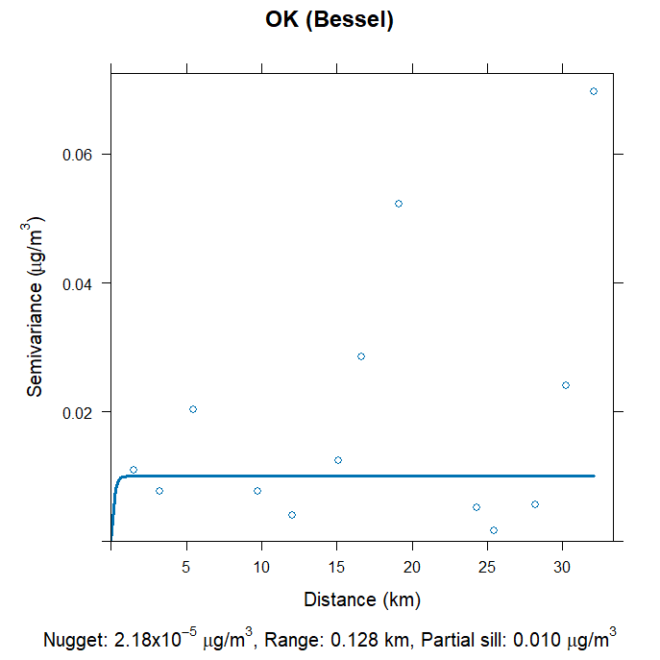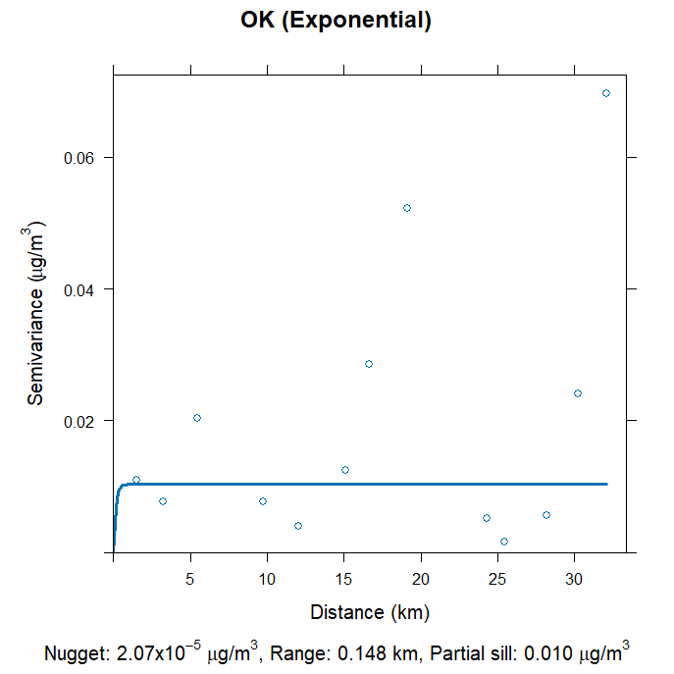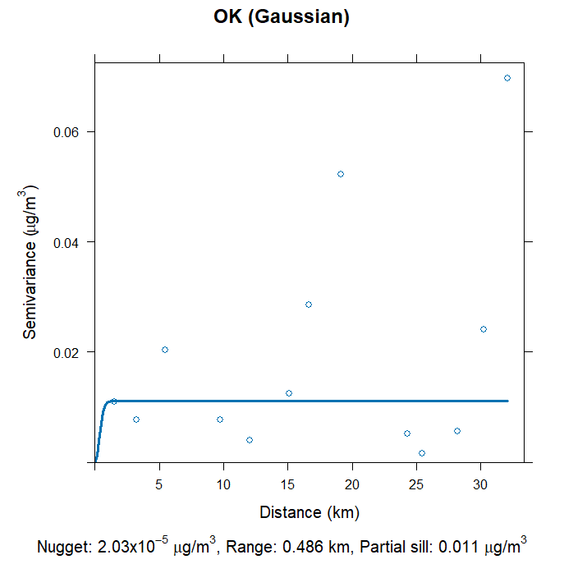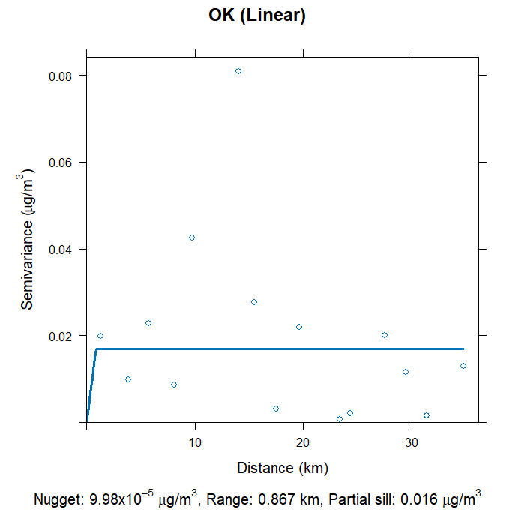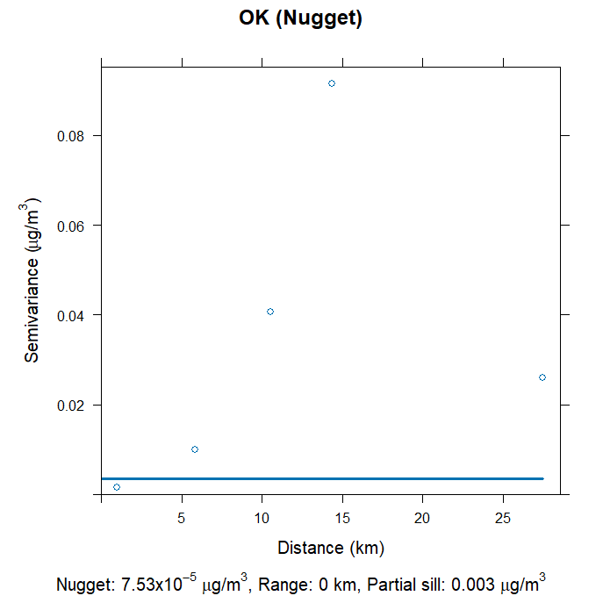
Figure S6. Variograms for OK models by fit. Select days (with high LOOCV R² and low LOOCV RMSE and MAE values) were chosen to represent models/fits.

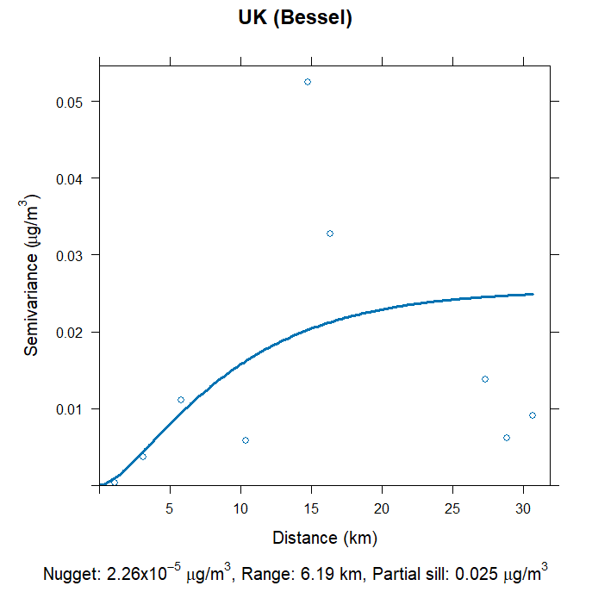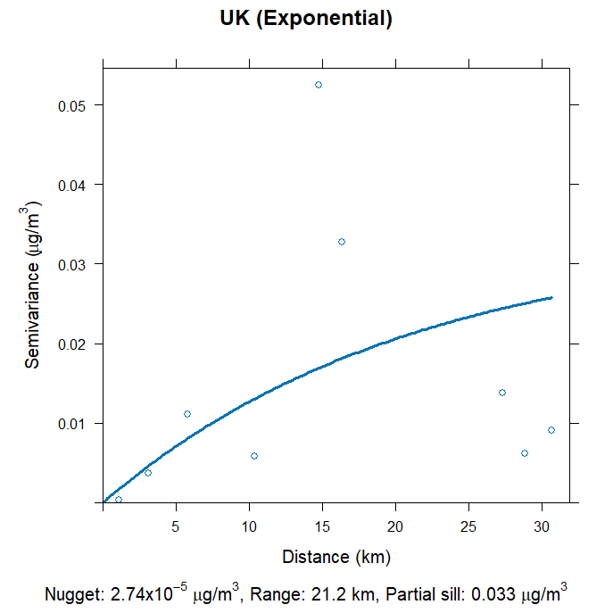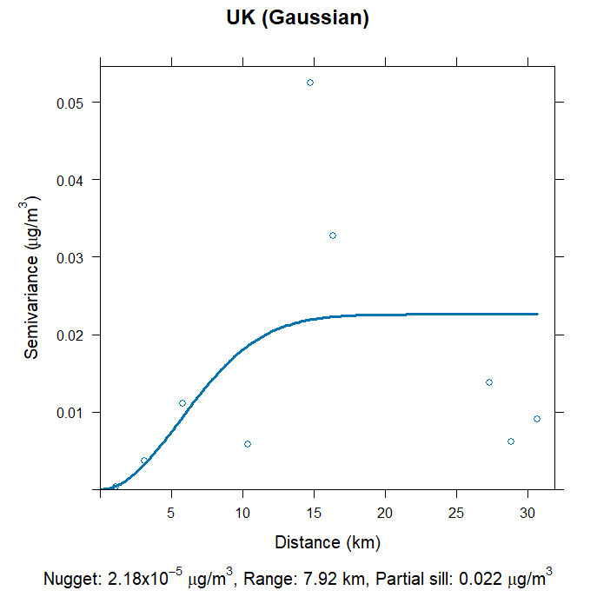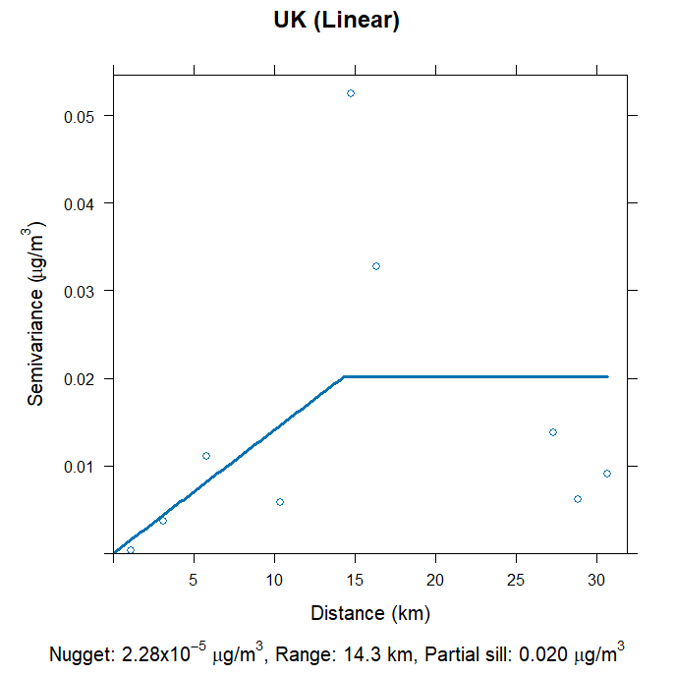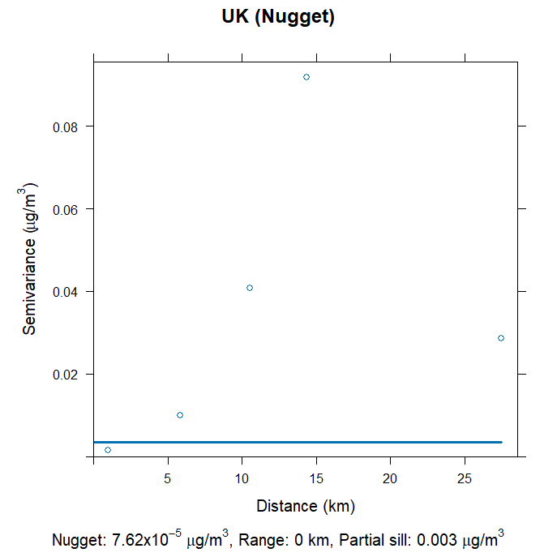
Figure S7. Variograms for UK models by fit. Select days (with high LOOCV R² and low LOOCV RMSE and MAE values) were chosen to represent models/fits.

Figure S8. Measured vs. predicted PM_{2.5} concentrations for the entire study period by model and fit with 95% confidence intervals. X- and Y- axes were scaled for readability and exclude values over 40 μg/m³.

Figure S9. Distributions of LOOCV R² values for IDW and OK models by fit function shown as density plots (in pink) and by date (below) for the entire measurement period with blue trendline.

Figure S10. Distributions of LOOCV R² values for IDW and UK models by fit function shown as density plots (in pink) and by date (below) for the entire measurement period with blue trendline.

