One-Step Electrodeposited Manganese-Copper Heterojunction Electrode for Efficient Electrochemical Nitrate Reduction to Ammonia
Shenghui Shi¹, Zihe Xu¹, Yundong Cai², Fengjiao Quan^{1,}*, Wenjuan Shen^{1,}*, Pengfei Xu¹, Jianfen Li¹, Yun He¹, Shunxi Zhang¹

- College of Chemical and Environmental Engineering, Wuhan Polytechnic University, Wuhan 430023, P. R. China.
- Wuhan Planning Institute, Wuhan 430014, P. R. China.
* Corresponding author. E-mail: fengjiaoquan@whpu.edu.cn (Fengjiao Quan); wenjuan_shen@whpu.edu.cn (Wenjuan Shen).

Supplementary Texts

Text S1. Synthesis of catalyst
Synthesis of Cu/NF and Mn-Cu/NF catalysts
Nickel foam (NF) with a dimension of 1×3 cm was subjected to ultrasonic treatment in 6 mol/L hydrochloric acid for 15 minutes to remove the surface oxide layer. Subsequently, the NF was ultrasonically cleaned in acetone and ethanol solution sequentially for 10 minutes each to remove residual contaminants, after which it was rinsed with deionized water and further ultrasonicated for 10 minutes. Finally, the treated NF was dried under nitrogen flow, sealed and stored for subsequent use. Mn-Cu/NF was synthesized via a facile one-step electrodeposition method. First, a electrolyte solution containing 0.05 mol/L CuSO₄·5H₂O. A certain amount of MnSO₄·7H₂O was added to the above electrolyte, such that the molar ratios of metallic manganese to copper in the electrolyte were controlled at 1:1, 1.5:1, 2:1, 2.5:1 and 3:1, respectively. A proper amount of C₆H₅Na₃O₇ was added to the solution under the monitoring of a pH meter, and the pH value was adjusted to 8 with sodium hydroxide solution. Pre-treated NF was used as the working electrode substrate, a platinum sheet as the counter electrode, and a saturated calomel electrode as the reference electrode. The electrodeposition was carried out via the galvanostatic method at a current density of –0.025 A/cm² for 40 minutes. After deposition, the product was rinsed thoroughly with deionized water, and finally dried immediately with nitrogen gas (N₂), followed by sealed storage.
Cu/NF was prepared in basically the same way as Mn-Cu/NF. The only difference lies in the fact that only CuSO₄·5H₂O is present in the electrolyte.

Text S2. Characterization of Catalyst
The X-ray diffraction (XRD) patterns of all samples were obtained on a Bruker D8 Advance diffractometer with monochromatized Cu Kα radiation (λ = 0.15418 nm), and the sweep rate was controlled at 6° min^{–1}. The scanning electron microscope (SEM) images were acquired through a JEOL 6700-F field-emission scanning electron microscope. TEM and high resolution TEM analysis were performed by using JEM 2010 FEF TEM operating at a voltage of 200 kV. X-ray photoelectron spectroscopy (XPS) (Thermo Scientific ESCLAB 250Xi) was used to analyze all samples' elemental compositions and valence states. All binding energies were calibrated using the contaminant carbon (C1s = 284.8 eV) as a reference. Electron spin resonance (ESR) analyses were conducted with the ESR-A300 spectrometer (Bruker Instruments) at – 0.44 V vs. RHE using 5,5′-dimethyl-1-pirroline-N-oxide (DMPO) as the spin-trapping agent.

Test S3. Electrochemical Measurement
All the electrochemical measurements were carried out in a conventional three-electrode system driven by CHI 650d electrochemical station (Shanghai Chenhua, China). A Hg/HgO electrode and a platinum plate were used as reference electrodes and counter electrodes. The working electrode (Mn/NF, Cu/NF, Mn-Cu/NF) was assembled in a classic H-type electrolytic cell for NO₃RR reaction and real-time detection of total power consumption. The measurements were carried out in a 0.1 mol L⁻¹ KOH aqueous cathode electrolyte (40 mL), where the initial concentration of NO₃– was 100 mg/L (measured in nitrogen). The anodic compartments were all filled with 40 mL of 0.1 mol L⁻¹ KOH electrolyte. Before the tests, high-purified Ar (>99.999%) gas was bubbled into the electrolyte for 30 minutes to achieve the saturation of Ar. Electrochemical characterization such as LSV was performed by loading individual catalysts (Mn/NF, Cu/NF, Mn-Cu/NF) onto Nickel rod electrodes of the same area (0.07 cm²). It was prepared by direct electrochemical deposition. Before the tests, high-purified Ar (> 99.999%) gas was bubbled into the electrolyte for 30 minutes to achieve the saturation of Ar. The linear sweep voltammetry (LSV) tests were measured in an Ar-saturated electrolyte (0.1 M KOH solution) with three electrodes in a single cell. The potentials in the study were reported versus RHE with the conversion equation: E(RHE) = E(Hg/HgO) + 0.098 + 0.0591*pH.
Text S4. Ultraviolet-visible spectrophotometer (UV-Vis) methods
Determination of NO₃–
First, dilute a known quantity of the sample to a final volume of 5 mL. Next, add 0.1 milliliter of 1 mole per liter hydrochloric acid and 0.01 milliliter of sulfamic acid solution (with a mass fraction of 0.8%) to the diluted sample. Allow the mixture to stand for 5 min before measuring its absorbance at wavelengths of 220 nm and 275 nm. The final absorbance value is determined using the following equation: A = A₂₂₀nm – 2A₂₇₅nm. Finally, the concentration of NO₃– was calculated according to the standard curve measured by the same method.
Determination of NH₄⁺
The concentration of NH₄⁺ was determined using the conventional Nessler's reagent method. The specific procedure is as follows: First, 16 g of sodium hydroxide (NaOH) was dissolved in 50 mL of deionized water. Next, 7 g of potassium iodide (KI) and 10 g of mercury(II) iodide (Hg₂I₂) were added to the solution, which was then diluted to a total volume of 100 mL to obtain Solution A. Separately, 50 g of potassium sodium tartrate was dissolved and diluted to 100 mL to prepare Solution B. A certain volume of the sample was diluted to 5 mL. Subsequently, 0.1 mL of Solution B was added to the diluted sample and mixed thoroughly, followed by the addition of 0.1 mL of Solution A. After allowing the mixture to stand for 20 minutes, the absorbance was measured at a wavelength of 420 nm. Finally, the concentration of NH₄⁺ in the sample was calculated based on a standard curve generated using the same method.
Text S5. Calculation of Faradaic efficiency and NO₃⁻ conversion rate
The equations for the quantitative calculation of Faraday efficiency, NO₃⁻ conversion rate and NH₃ yield rate are as follows.
$$FE\left(\%\right)=\frac{Detected products(mol NH_{3})\frac{8 mol e^{−}}{mol {NH}_{3}}}{\frac{Electrolysis charge}{96485\frac{C}{mol e^{−}}}}×100\% (1)$$
${{{\text{C}}_{ }\text{(NO}}_{\text{3}}}^{−}\text{) }\text{=}\frac{{{{\text{C}}_{\text{0}}\text{ (NO}}_{\text{3}}}^{\text{–}}\text{) -}{{{\text{ C}}_{\text{t}}\text{ (NO}}_{\text{3}}}^{−}\text{)}}{{{{\text{C}}_{\text{0 }}\text{(NO}}_{\text{3}}}^{−}\text{)}}\text{×100\%}$ (2)
NH₃ yield rate= C × V × M_{NH3}/ (M_{N} × t × S) (3)
Where V is the volume of electrolyte (40 mL), M_{N} is the molar mass of nitrogen (14 g mol⁻¹), M_{NH3} is the molar of NH₃ (17 g mol⁻¹), t is the time, and S is the electrode area.

Supplementary Figure
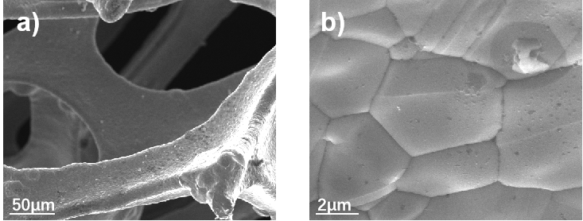
Fig.S1 (a, b) SEM images of NF.
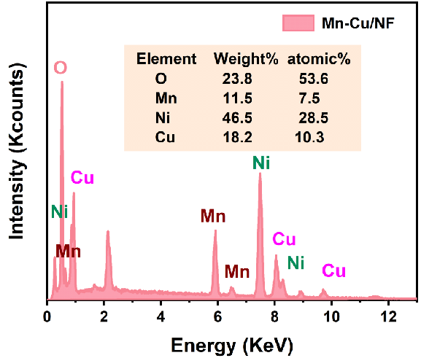
Fig. S2 EDS spectra of Mn-Cu/NF.
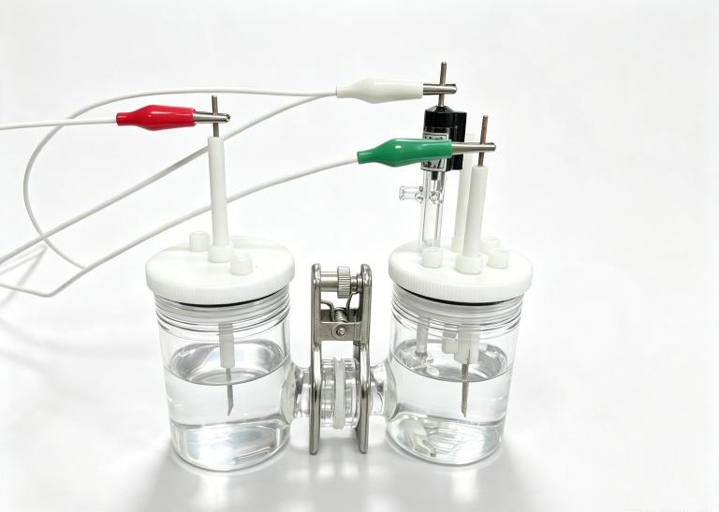
Fig. S3 The physical diagram of the reaction device for electrocatalytic reduction of NO₃RR using Mn-Cu/NF material. The digital marks on the picture correspond to the following components: Red is the counter electrode (platinum plate), Green represents the working electrode (Cu/NF, Mn/NF, and Mn-Cu/NF), White is the reference electrode (Hg/HgO), The diaphragm in the middle of the H-type reactor is the proton exchange membrane.
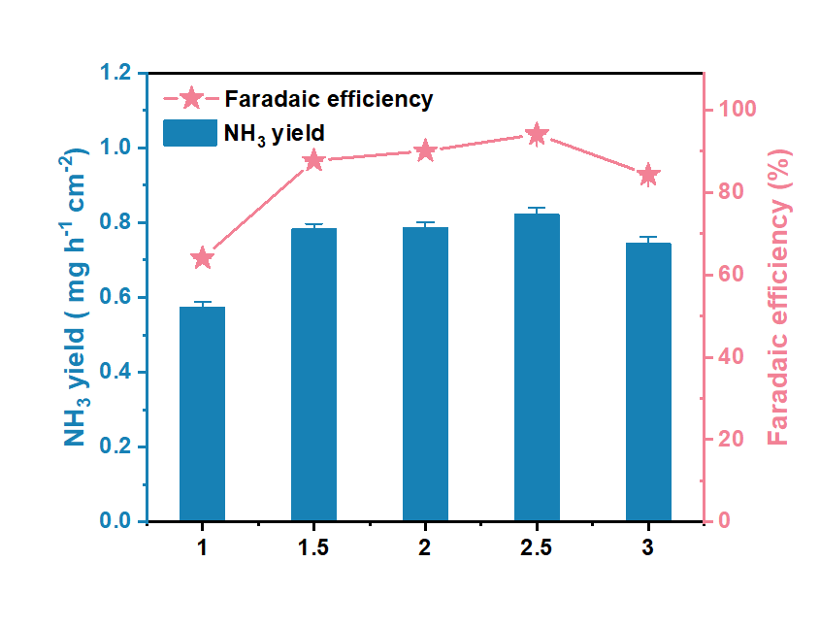
Fig. S4 Comparison of the activity of Mn-Cu/NF in different synthetic electrolytes (the ratio of metal Mn to Cu in the electrolyte was adjusted to 1:1, 1.5:1, 2:1, 2.5:1, and 3:1).
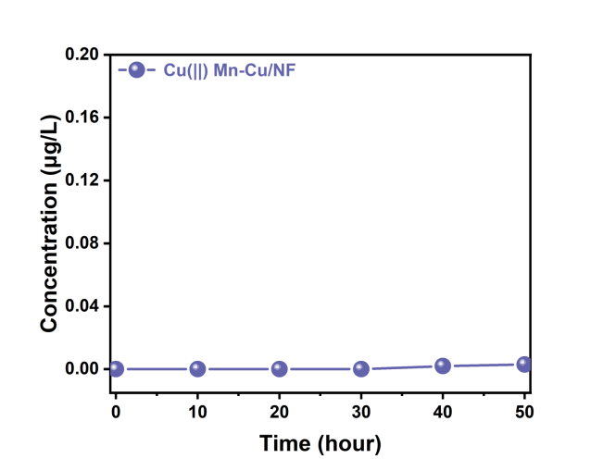
Fig. S5 The concentrations of Cu²⁺ during NO₃– removal in Mn-Cu/NF electrochemical system.
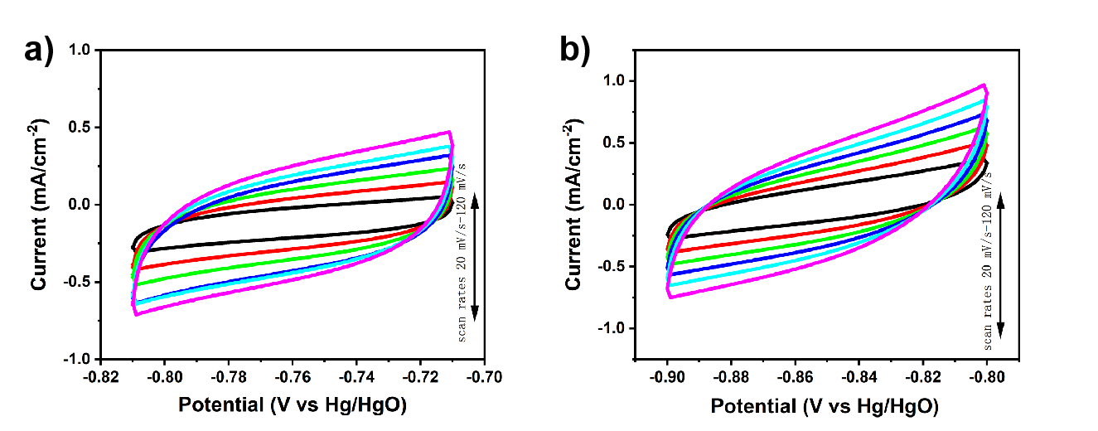
Fig. S6 Cu/NF (a) and Mn-Cu/NF (b) with different scan rates from 20 to 120 mV/s^{–1}.
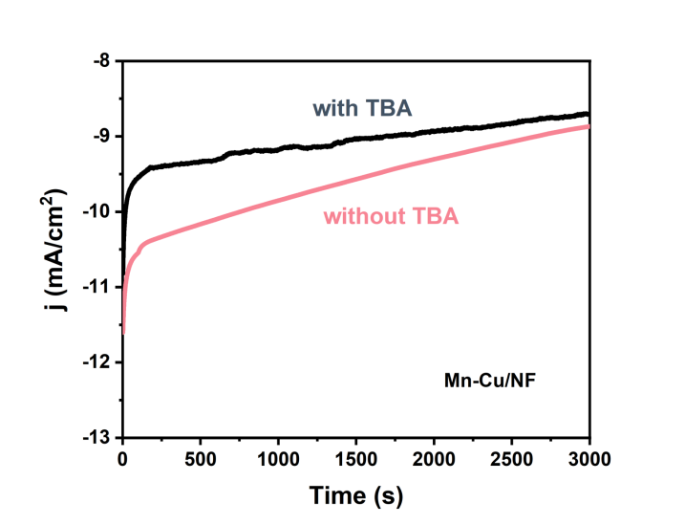
Fig. S7 Current curve (IT) of Mn-Cu/NF with or without TBA solution.

