Real-time repository-scale spectral search and global molecular networking with HNSW-MS

Supplemental Materials

Additional Computational Results for HNSW-MS on Smaller-Scale Datasets

M | efC | efS | Speedup | Avg. nodes visited | Recall@10 | Recall@1
16 | 200 | 64 | 53.75 | 663.98 | 0.95 | 0.96
16 | 200 | 512 | 25.62 | 1935.54 | 1.00 | 1.00
32 | 200 | 64 | 45.18 | 828.34 | 0.96 | 0.94
32 | 200 | 512 | 18.65 | 2863.48 | 1.00 | 1.00
Table S1. Spectrum matching performance (speedup and recall) on a benchmark dataset of 50,000 GC-EI spectra with different HNSW parameter combinations: in-library matching

M | efC | efS | Speedup | Avg. nodes visited | Recall@10 | Recall@1
16 | 200 | 128 | 104.90 | 1913.85 | 0.79 | 0.85
32 | 200 | 256 | 50.93 | 4370.23 | 0.85 | 0.88
32 | 400 | 256 | 51.45 | 4470.20 | 0.87 | 0.85
48 | 400 | 512 | 21.45 | 12522.10 | 0.90 | 0.94
Table S2. Spectrum matching performance (speedup and recall) on the dataset of 591,719 LC-MS/MS spectra (subset of global GNPS dataset) with different HNSW parameter combinations: in-library matching

M | efC | efS | Speedup | Avg. nodes visited | Recall@10 | Recall@1
16 | 200 | 128 | 401.21 | 1058.18 | 0.69 | 0.65
16 | 200 | 256 | 228.82 | 1722.87 | 0.76 | 0.72
16 | 200 | 512 | 118.7 | 3217.43 | 0.85 | 0.81
16 | 200 | 1024 | 72.52 | 5823.26 | 0.88 | 0.82
32 | 200 | 128 | 275.25 | 1655.56 | 0.78 | 0.71
32 | 200 | 256 | 163.73 | 2891.59 | 0.85 | 0.8
32 | 200 | 512 | 87.98 | 5542.14 | 0.91 | 0.82
32 | 200 | 1024 | 46.4 | 10302.9 | 0.94 | 0.88
32 | 400 | 128 | 295.83 | 1646.99 | 0.82 | 0.8
32 | 400 | 256 | 161.97 | 2896.03 | 0.84 | 0.82
32 | 400 | 512 | 84.02 | 5678.94 | 0.94 | 0.88
32 | 400 | 1024 | 43.19 | 10575.9 | 0.96 | 0.92
48 | 400 | 128 | 187.32 | 2404.7 | 0.86 | 0.83
48 | 400 | 256 | 108.45 | 4294.21 | 0.91 | 0.84
48 | 400 | 512 | 54.88 | 8187.23 | 0.95 | 0.87
48 | 400 | 1024 | 27.62 | 15421 | 0.97 | 0.87
Table S3. Spectrum matching performance (speedup and recall) on the dataset of 591,719 LC-MS/MS spectra (subset of global GNPS dataset) with different HNSW parameter combinations: out of library matching

M | efC | Build time (s) 50K
8 | 100 | 334.3
8 | 200 | 563.1
16 | 100 | 368.6
16 | 200 | 646.6
32 | 100 | 480.5
32 | 200 | 862.1
Table S4. Index construction time for a benchmark dataset of 50,000 GC-EI spectra

M | efC | Build time (min) 591K entities | Build time (min) 8.4M entities
16 | 200 | 37.65 | 732.46
32 | 200 | 57.83 | 953.39
32 | 400 | 105.7 | 1364.08
48 | 400 | 174.34 | 1693.24
Table S5. Index construction time for larger benchmark datasets

Proposed Structures of Novel Branch-Chain Acyls

m/z | Molecular Formula | SMILES | Proposed Structures
1118.5762 | C₄₈H₈₃N₁₁O₁₇S | CCCCCCCCCCCC(CC(NC(C(NC(C(NC(C(NC(C(NC(C(NC(C(NC(C(NC(C(N(C1)C)=O)CCCCN)=O)CO)=O)C(C)C)=O)=CC)=O)CN)=O)CO)=O)C(OC1=O)C)=O)CS(=O)(O)=O)=O)=O | 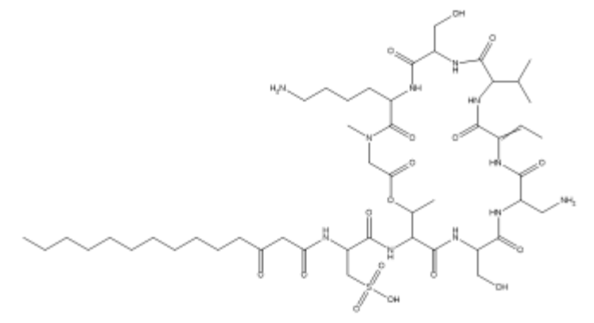
1118.5762 | C₄₈H₈₃N₁₁O₁₇S | CCCCCCCC(C)CC(CC(NC(C(NC(C(NC(C(NC(C(NC(C(NC(C(NC(C(NC(C(N(C1)C)=O)CCCCN)=O)CO)=O)C(C)C)=O)=CC)=O)CN)=O)CO)=O)C(OC1=O)C)=O)CS(=O)(O)=O)=O)=O | 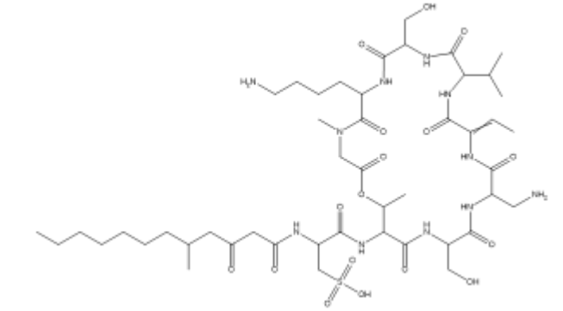
1146.6075 | C₅₀H₈₇N₁₁O₁₇S | O=C(CC(NC(C(NC(C(NC(C(NC(C(NC(C(NC(C(NC(C(NC(C(N(C1)C)=O)CCCCN)=O)CO)=O)C(C)C)=O)=CC)=O)CN)=O)CO)=O)C(OC1=O)C)=O)CS(=O)(O)=O)=O)CCCCCCCCCCCCC | 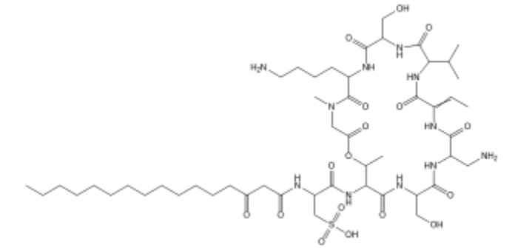
1146.6075 | C₅₀H₈₇N₁₁O₁₇S | O=C(CC(NC(C(NC(C(NC(C(NC(C(NC(C(NC(C(NC(C(NC(C(N(C1)C)=O)CCCCN)=O)CO)=O)C(C)C)=O)=CC)=O)CN)=O)CO)=O)C(OC1=O)C)=O)CS(=O)(O)=O)=O)CC(C)CCCCCCCCCC | 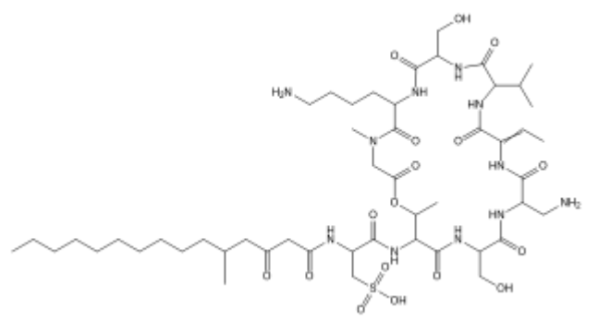
1146.6075 | C₅₀H₈₇N₁₁O₁₇S | CCCCCCCCC(CCCC(CC(NC(C(NC(C(NC(C(NC(C(NC(C(NC(C(NC(C(NC(C(N(C1)C)=O)CCCCN)=O)CO)=O)C(C)C)=O)=CC)=O)CN)=O)CO)=O)C(OC1=O)C)=O)CS(=O)(O)=O)=O)=O)C | 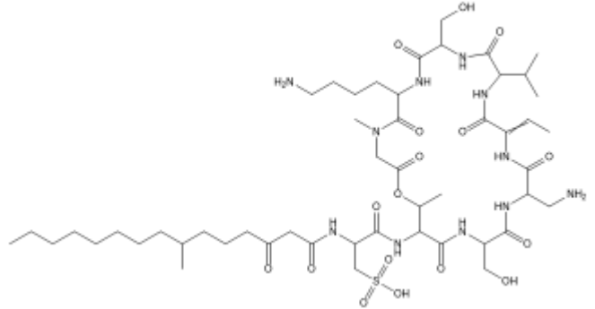
Table S6. Additional possible Stenothricin structures from the Stenothricin MCN.

CA-Gly-Phe Assignment

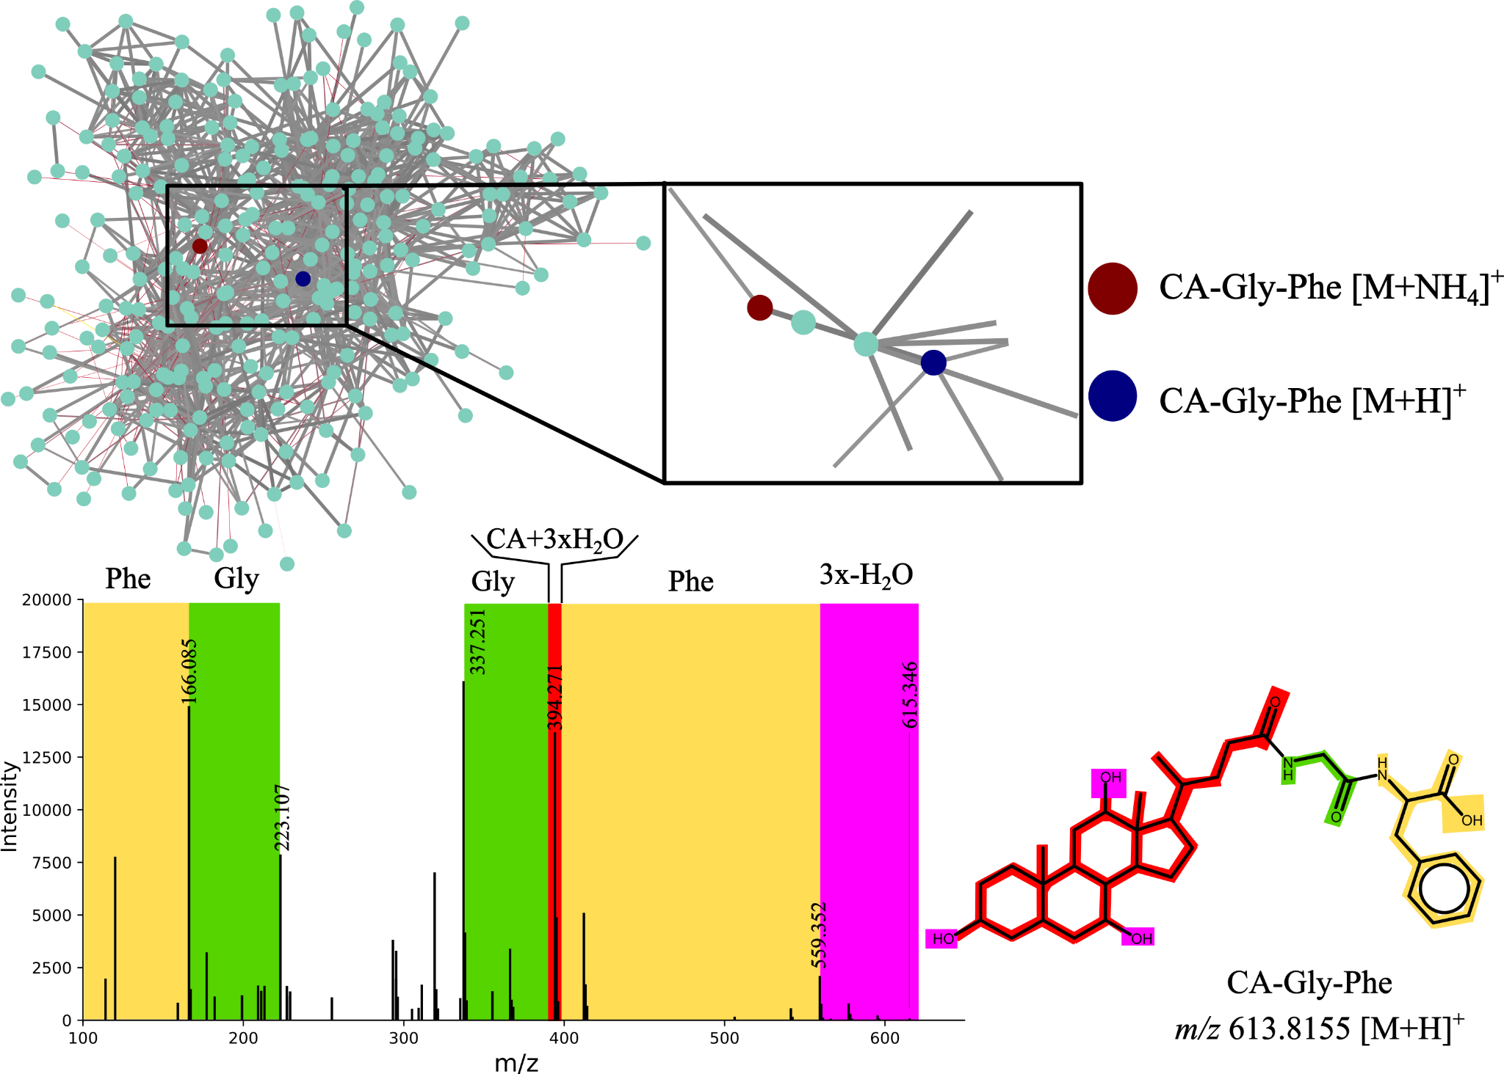
Figure S1. Bile acid connections in the molecular network and the proposed structure for unannotated nodes highlighted within the community with m/z 630.410 (red) and 613.384 (blue).

