Bacteria-engineered porous sponge for hemostasis and vascularization
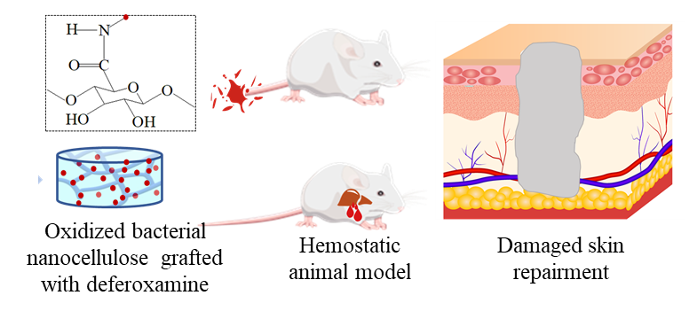
A hemostatic sponge was designed and developed derived from oxidized bacterial nanocellulose loading with DFO. The bacteria-engineered sponge with a high specific surface area and porosity has excellent water absorption and DFO release, and exhibits remarkable hemostatic properties and vascularization-promoting in vivo. Therefore, it could be used for the integrated treatment of hemostasis and post-repair of acute trauma.

