Supplementary Material
Sedentary Accumulation in Midlife and Subsequent SF-36 Physical Functioning and Pain Burden: A Longitudinal Analysis of the 1970 British Cohort Study

Contents
Supplementary Table S1. Variable definitions, coding, and conceptual roles
Supplementary Table S2. Missingness structure and outcome overlap
Supplementary Table S3. Multiple-imputation specification and diagnostics
Supplementary Table S4. Sequential and sensitivity-analysis estimates
Supplementary Table S5. Selection-weight and variance diagnostics
Supplementary Table S6. Stage-specific covariate balance
Supplementary Table S7. Outcome distributions, bounded models, and spline tests
Supplementary Table S8. Full model coefficients and influence diagnostics
Supplementary Table S9. Timing and device-quality-control analyses
Supplementary Figures S1–S5. Distributions, splines, imputation traces, covariate roles, and Stage-2 balance

Supplementary Table S1. Variable Definitions, Coding, and Conceptual Roles

Table A. Variable definitions, coding, and roles
Variable | Role | Definition | Unit or categories | Coding or missing-data treatment
Long-bout accumulation proportion | Primary ratio exposure / fixed-total-sitting contrast | Age-46 ratio of participant-average waking sitting/lying time in bouts lasting at least 30 min to participant-average total waking sitting/lying time, divided by 10 for modelling; at fixed total sitting/lying, a higher value reallocates time from <30-min to ≥30-min bouts | Per 10 percentage points | Continuous
Age-51 SF-36 Physical Functioning | Primary outcome | Age-51 SF-36 Physical Functioning | 0-100; higher is better | Official archive-derived score; outcome not imputed; archive permits scoring from ≥1 valid item
Age-51 pain burden (reverse-scored SF-36 Bodily Pain) | Key secondary outcome | 100 minus age-51 SF-36 Bodily Pain | 0-100; higher is worse | Official archive-derived score; outcome not imputed; archive permits scoring from ≥1 valid item
Age-46 SF-36 Physical Functioning | Baseline outcome | Age-46 SF-36 Physical Functioning | 0-100; higher is better | Continuous; imputed if missing
Age-46 pain burden (reverse-scored SF-36 Bodily Pain) | Baseline outcome | 100 minus age-46 SF-36 Bodily Pain | 0-100; higher is worse | Continuous; imputed if missing
Age at baseline | Covariate | Age at the age-46 interview | Years | Continuous
Sex | Covariate | Sex recorded at age 46 | Male; Female | Categorical
Follow-up time | Covariate | Time from plausible monitor/interview baseline to age-51 assessment | Years | Continuous; imputed among outcome respondents if missing
Waking activPAL wear time | Device-measurement covariate | Mean waking activPAL wear time | Hours/day | Continuous
Archive-defined valid days | Device-measurement covariate | Number of archive-defined valid activPAL days | Days | Continuous
Total waking sitting/lying time | Sedentary-volume covariate | Mean waking sitting/lying time | Hours/day | Continuous
Steps | Movement-volume covariate | Mean steps divided by 1,000 | 1,000 steps/day | Continuous
Educational attainment | Covariate | Age-46 educational attainment | Lower; Intermediate; Degree | Categorical; imputed if missing
Employment status | Covariate | Age-46 employment status | Employed; Unemployed/training; Sick/disabled; Other | Categorical; imputed if missing
Body mass index | Covariate | Nurse-measured BMI, supplemented by self-report when unavailable | kg/m² | Continuous; imputed if missing
Smoking status | Covariate | Age-46 smoking status | Never; Former; Current | Categorical; imputed if missing
Alcohol-use category | Covariate | Age-46 alcohol-risk group | Abstainer; Lower risk; Higher risk | Categorical; imputed if missing
Sleep duration | Covariate | Age-46 sleep duration | Hours/day | Continuous; imputed if missing
Malaise score | Covariate | Age-46 Malaise score | 0-9 points | Continuous; imputed if missing
Equality Act disability status | Covariate | Age-46 Equality Act disability status | No; Yes | Categorical; imputed if missing
Exercise frequency | Selection-model predictor | Age-46 exercise frequency | Days/week | Continuous; imputed if missing
Archive device selection | Selection stage 1 | Archive activPAL at least 3 valid days and non-missing primary exposure | No; Yes | Binary
Physical Functioning response | Selection stage 2 | Physical Functioning observed among device-selected participants | No; Yes | Binary
Pain-burden response | Selection stage 2 | Pain burden observed among device-selected participants | No; Yes | Binary
Official age-51 self-completion survey weight (bd11weight_psc) | Sensitivity weight | Official inverse-response weight for the paper self-completion; truncated by CLS at 20 and calibrated to self-completion respondents | Positive weight | Sensitivity only; calibration target differs from the willingness-question target
Long-bout sitting/lying time | Non-ratio exposure numerator | Participant-average hours/day in 30–60-min and >60-min sitting/lying bouts | Hours/day or per 30 min/day | Observed in device-selected participants
Shorter-bout sitting/lying time | Time-partition component | Total sitting/lying time minus long-bout time | Hours/day or per 30 min/day | Observed in device-selected participants
SF-36 reconstruction | Preprocessing quality control | Independent item recoding; Physical Functioning required ≥5/10 items and Bodily Pain ≥1/2 items | 0–100 | Diagnostic only; not substituted for archive scores
The 30-minute threshold is operational and archive-constrained, not a universal biological boundary. Figure S4 classifies variables by conceptual and temporal role; it is not asserted to be a fully identified causal DAG.

Table B. Correlations with the long-bout accumulation proportion
Comparison variable | N | Pearson r | Spearman ρ
Long-bout time (h/day) | 5,260 | 0.873 | 0.877
Shorter-bout sitting/lying (h/day) | 5,260 | −0.639 | −0.634
Total sitting/lying (h/day) | 5,260 | 0.439 | 0.433
Steps (1000/day) | 5,260 | −0.334 | −0.345
Waking wear (h/day) | 5,260 | 0.014 | 0.012
Valid days | 5,260 | −0.033 | −0.043
Correlations use the Stage-1 device-selected risk set. Participant counts are disclosure-rounded.

Supplementary Table S2. Missingness Structure and Outcome Overlap

Table A. Imputed-variable missingness in the willingness-question target
Variable | Eligible denominator | Missing n | Missing % | Imputed
pf46 | 7,440 | 430 | 5.8% | Yes
painburden46 | 7,440 | 360 | 4.8% | Yes
bmi | 7,440 | 40 | 0.6% | Yes
smoking3 | 7,440 | 0 | 0.0% | Yes
alcohol3 | 7,440 | 50 | 0.6% | Yes
sleep_h | 7,440 | <10 | — | Yes
malaise | 7,440 | 510 | 6.9% | Yes
disability | 7,440 | <10 | — | Yes
education3 | 7,440 | 100 | 1.4% | Yes
employment4 | 7,440 | 20 | 0.2% | Yes
exercise_days | 7,440 | 100 | 1.4% | Yes
Follow-up time | 3,820 | <10 | — | Yes

Table B. Structural nonavailability, scale-item availability, and outcome overlap
Category | n | Denominator | %
Age-51 main record unavailable among Stage-1 selected | 660 | 5,260 | 12.5%
Physical Functioning: no valid items among linked Stage-1 selected | 790 | 4,600 | 17.1%
Physical Functioning: 1-4 valid items (insufficient partial scale) | 0 | 4,600 | 0.0%
Pain: no valid items among linked Stage-1 selected | 790 | 4,600 | 17.1%
Pain: one valid item among linked Stage-1 selected | 0 | 4,600 | 0.0%
Both Age 51 outcomes observed | 3,810 | 5,260 | —
Physical Functioning only observed | <10 | 5,260 | —
Pain burden only observed | <10 | 5,260 | —
Neither Age 51 outcome observed among Stage 1 selected | 1,440 | 5,260 | —
An unavailable age-51 record is structurally distinct from a linked record with no valid scale items. Exact cells below 10 are not displayed, and complementary percentages are withheld when needed to avoid reconstruction.

Supplementary Table S3. Multiple-Imputation Specification and Diagnostics

Table A. Variable-specific methods
Variable | Type | Main method | Eligibility | Cycles | Donors
pf46 | Continuous/count | Chained bootstrap predictive mean matching | All missing values in the willingness-question target population | 10 | 5
painburden46 | Continuous/count | Chained bootstrap predictive mean matching | All missing values in the willingness-question target population | 10 | 5
bmi | Continuous/count | Chained bootstrap predictive mean matching | All missing values in the willingness-question target population | 10 | 5
smoking3 | Categorical coded with fixed allowed levels | Chained bootstrap predictive mean matching; observed donor category copied | All missing values in the willingness-question target population | 10 | 5
alcohol3 | Categorical coded with fixed allowed levels | Chained bootstrap predictive mean matching; observed donor category copied | All missing values in the willingness-question target population | 10 | 5
sleep_h | Continuous/count | Chained bootstrap predictive mean matching | All missing values in the willingness-question target population | 10 | 5
malaise | Continuous/count | Chained bootstrap predictive mean matching | All missing values in the willingness-question target population | 10 | 5
disability | Categorical coded with fixed allowed levels | Chained bootstrap predictive mean matching; observed donor category copied | All missing values in the willingness-question target population | 10 | 5
education3 | Categorical coded with fixed allowed levels | Chained bootstrap predictive mean matching; observed donor category copied | All missing values in the willingness-question target population | 10 | 5
employment4 | Categorical coded with fixed allowed levels | Chained bootstrap predictive mean matching; observed donor category copied | All missing values in the willingness-question target population | 10 | 5
exercise_days | Continuous/count | Chained bootstrap predictive mean matching | All missing values in the willingness-question target population | 10 | 5
followup_years | Continuous/count | Chained bootstrap predictive mean matching | Imputed only for participants with at least one observed Age-51 outcome | 10 | 5

Table B. Predictor-matrix specification
Imputation target group | Predictors | Handling of predictor missingness
Baseline covariate targets | Age, sex, every other baseline imputation variable, device-selection indicators, age-51 linkage, both outcome-response indicators, and observed age-51 Physical Functioning and pain burden | Missing continuous predictors median-filled; categorical predictors mode-filled; missingness indicator appended
Follow-up time | All baseline predictors plus age at follow-up, valid days, waking wear, total sitting/lying, long-bout proportion, and steps | Eligible only among participants with ≥1 observed age-51 outcome
Age-51 outcomes | Used only as auxiliary predictors when observed | Never imputed; missing values represented by fill plus missingness indicator in predictor design

Table C. Monte Carlo diagnostics and categorical-method sensitivity
Outcome | Imputation specification | m | Estimate | SE | FMI | MCSE/SE | Relative efficiency
Pain burden | Main donor-based PMM | 50 | −0.099 | 0.285 | 0.0043 | 0.009 | 0.99991
Physical Functioning | Main donor-based PMM | 50 | 0.426 | 0.266 | 0.0052 | 0.010 | 0.99990
Pain burden | Logistic/multinomial categorical sensitivity | 50 | −0.102 | 0.286 | 0.0042 | 0.009 | 0.99992
Physical Functioning | Logistic/multinomial categorical sensitivity | 50 | 0.423 | 0.266 | 0.0042 | 0.009 | 0.99992
Main seed=20260724; type-specific categorical sensitivity seed=20260813. Five diagnostic chains were evaluated over 10 cycles; Figure S3 displays traces for variables with material missingness. Cells based on fewer than 10 missing values are suppressed.

Supplementary Table S4. Sequential and Sensitivity-Analysis Estimates

Table A. Sequential adjustment models
Outcome | Model | m | N | Estimate | Robust SE | 95% CI | P | Holm P
Pain burden | Core | 50 | 3,820 | 0.115 | 0.290 | −0.453 to 0.684 | .691 | —
Pain burden | Sociodemographic | 50 | 3,820 | 0.033 | 0.286 | −0.527 to 0.593 | .908 | —
Pain burden | Fully adjusted | 50 | 3,820 | −0.099 | 0.285 | −0.658 to 0.461 | .729 | .729
Physical Functioning | Core | 50 | 3,820 | −0.288 | 0.301 | −0.878 to 0.302 | .338 | —
Physical Functioning | Sociodemographic | 50 | 3,820 | −0.069 | 0.284 | −0.625 to 0.488 | .808 | —
Physical Functioning | Fully adjusted | 50 | 3,820 | 0.426 | 0.266 | −0.096 to 0.948 | .109 | .219

Table B. Comparable share-exposure sensitivities
Analysis | Outcome | m | N | Estimate | 95% CI | P
Consented target: MI sequential IPSW (1st/99th percentile) | Pain burden | 50 | 3,790 | −0.090 | −0.650 to 0.471 | .754
Device-QC exposure: MI sequential IPSW (1st/99th percentile) | Pain burden | 50 | 3,820 | −0.095 | −0.653 to 0.464 | .740
MI covariates, unweighted | Pain burden | 50 | 3,820 | −0.025 | −0.541 to 0.490 | .923
MI device IPSW × official Age 51 PSC weight (1st/99th percentile) | Pain burden | 50 | 3,810 | −0.158 | −0.868 to 0.551 | .662
MI sequential IPSW (2.5th/97.5th percentile) | Pain burden | 50 | 3,820 | −0.094 | −0.648 to 0.460 | .740
MI sequential IPSW (untruncated) | Pain burden | 50 | 3,820 | −0.111 | −0.677 to 0.455 | .700
Consented target: MI sequential IPSW (1st/99th percentile) | Physical Functioning | 50 | 3,790 | 0.482 | −0.028 to 0.993 | .064
Device-QC exposure: MI sequential IPSW (1st/99th percentile) | Physical Functioning | 50 | 3,820 | 0.461 | −0.059 to 0.982 | .082
MI covariates, unweighted | Physical Functioning | 50 | 3,820 | 0.344 | −0.089 to 0.777 | .120
MI device IPSW × official Age 51 PSC weight (1st/99th percentile) | Physical Functioning | 50 | 3,810 | 0.504 | −0.180 to 1.187 | .148
MI sequential IPSW (2.5th/97.5th percentile) | Physical Functioning | 50 | 3,820 | 0.423 | −0.092 to 0.937 | .108
MI sequential IPSW (untruncated) | Physical Functioning | 50 | 3,820 | 0.428 | −0.097 to 0.953 | .110
Variable-type imputation: logistic/multinomial categorical models | Pain burden | 50 | 3,820 | −0.102 | −0.661 to 0.458 | .722
Variable-type imputation: logistic/multinomial categorical models | Physical Functioning | 50 | 3,820 | 0.423 | −0.099 to 0.944 | .112

Table C. Sensitivity and exploratory adjustment, timing, exposure-parameterization, and influence analyses
Analysis | Outcome | Exposure unit | N | Estimate | 95% CI | P
Absolute long-bout time conditional on total sitting/lying | Pain burden | long30_30min | 3,820 | −0.054 | −0.347 to 0.238 | .715
Absolute long-bout time conditional on total sitting/lying | Physical Functioning | long30_30min | 3,820 | 0.191 | −0.081 to 0.462 | .168
Age-46 interview month used as baseline for all participants | Pain burden | long30_10pp | 3,810 | −0.104 | −0.664 to 0.455 | .715
Age-46 interview month used as baseline for all participants | Physical Functioning | long30_10pp | 3,810 | 0.425 | −0.097 to 0.947 | .111
Candidate pre-exposure + device-measurement covariates | Pain burden | long30_10pp | 3,820 | −0.103 | −0.604 to 0.398 | .687
Candidate pre-exposure + device-measurement covariates | Physical Functioning | long30_10pp | 3,820 | 0.138 | −0.339 to 0.615 | .571
Candidate pre-exposure covariates only | Pain burden | long30_10pp | 3,820 | −0.100 | −0.600 to 0.401 | .696
Candidate pre-exposure covariates only | Physical Functioning | long30_10pp | 3,820 | 0.138 | −0.338 to 0.614 | .570
Conventional-threshold influence screen (Cook >4/n or |DFBETA| >2/sqrt(n) excluded) | Pain burden | long30_10pp | 3,520 | 0.202 | −0.209 to 0.613 | .336
Conventional-threshold influence screen (Cook >4/n or |DFBETA| >2/sqrt(n) excluded) | Physical Functioning | long30_10pp | 3,490 | 0.071 | −0.176 to 0.319 | .572
Time partition: long-bout time holding shorter-bout time constant | Pain burden | long30_30min | 3,820 | −0.286 | −0.520 to −0.052 | .017
Time partition: long-bout time holding shorter-bout time constant | Physical Functioning | long30_30min | 3,820 | 0.137 | −0.094 to 0.368 | .244
Top 1% of absolute exposure DFBETA excluded | Pain burden | long30_10pp | 3,780 | 0.079 | −0.418 to 0.577 | .754
Top 1% of absolute exposure DFBETA excluded | Physical Functioning | long30_10pp | 3,780 | 0.204 | −0.208 to 0.616 | .332
Adjusted R² is omitted because the arithmetic mean across imputed weighted models is not a Rubin-pooled fit statistic. P values from sensitivity and exploratory analyses were nominal and were not multiplicity-adjusted. The time-partition pain estimate addresses a different estimand and is exploratory.

Supplementary Table S5. Selection-Weight and Variance Diagnostics
Stage 1 formula: device selection ~ age + sex + baseline Physical Functioning + baseline pain burden + BMI + smoking + alcohol + sleep + Malaise + disability + education + employment + exercise. Stage 2 uses the same predictors plus the long-bout proportion, waking wear, valid days, total sitting/lying, and steps, within all device-selected participants. Reference groups: male, never smoker, alcohol abstainer, no disability, lower education, and employed.
Outcome | N | min p1 | min p2 | raw w p1 | raw w p99 | raw w max | final w p1 | final w p99 | final w max | ESS | % truncated
Pain burden | 3,820 | 0.302 | 0.308 | 1.371 | 4.161 | 7.688 | 0.706 | 2.140 | 2.144 | 3578.4 | 1.99
Physical Functioning | 3,820 | 0.302 | 0.310 | 1.370 | 4.128 | 7.596 | 0.706 | 2.123 | 2.127 | 3580.2 | 1.99

Table B. Fixed-weight versus propensity-coefficient uncertainty
Outcome | Estimate | Pooled SE | 95% CI | P | Mean fixed-weight variance | Mean added variance | Added/fixed
Pain burden | −0.099 | 0.286 | −0.6591 to 0.4616 | .730 | 0.081115 | 0.000276 | 0.34%
Physical Functioning | 0.426 | 0.267 | −0.0964 to 0.9493 | .110 | 0.070558 | 0.000233 | 0.33%
The primary HC3 covariance treats the realized estimated weights as fixed. The propensity-coefficient uncertainty sensitivity analysis used 200 paired multivariate-normal coefficient draws per imputation (seed=20260812), recomputed and retruncated weights for every draw, and added the between-draw exposure-coefficient variance before Rubin pooling. This is not a nonparametric participant bootstrap.

Supplementary Table S6. Stage-Specific Covariate Balance
Stage 1 compares device-selected participants with the willingness-question target before and after the Stage-1 weight. Stage 2 compares outcome responders with all device-selected participants before and after the outcome-specific response weight; all device variables are included. Overall maximum |SMD| values were 0.0738 before and 0.0047 after Stage 1, 0.0836 and 0.0040 for pain-burden Stage 2, and 0.0844 and 0.0041 for Physical-Functioning Stage 2. Across-imputation maximum |SMD| exceeded 0.05 for 6 of 24 Stage-1 levels and 7 of 29 levels in each Stage-2 analysis before weighting, and for none after weighting; no value exceeded 0.10. Figure S5 displays mean absolute Stage-2 SMDs.

Table A. Stage 1: device-selected participants versus willingness-question target
Variable or level | Mean SMD before | Max |SMD| before | Mean SMD after | Max |SMD| after
age46 | 0.0480 | 0.0480 | 0.0005 | 0.0009
alcohol3=0 | −0.0283 | 0.0302 | 0.0023 | 0.0029
alcohol3=1 | 0.0376 | 0.0392 | −0.0012 | 0.0019
alcohol3=2 | −0.0216 | 0.0233 | −0.0003 | 0.0006
bmi | −0.0718 | 0.0738 | −0.0021 | 0.0028
disability=0 | 0.0444 | 0.0444 | −0.0007 | 0.0012
disability=1 | −0.0444 | 0.0444 | 0.0007 | 0.0012
education3=0 | −0.0344 | 0.0364 | −0.0022 | 0.0025
education3=1 | 0.0127 | 0.0141 | 0.0020 | 0.0024
education3=2 | 0.0281 | 0.0295 | 0.0008 | 0.0011
employment4=0 | 0.0558 | 0.0571 | 0.0003 | 0.0007
employment4=1 | −0.0246 | 0.0255 | −0.0016 | 0.0024
employment4=2 | −0.0558 | 0.0568 | 0.0012 | 0.0021
employment4=3 | −0.0186 | 0.0195 | −0.0005 | 0.0008
exercise_days | 0.0155 | 0.0175 | 0.0010 | 0.0016
malaise | −0.0579 | 0.0631 | −0.0009 | 0.0023
painburden46 | −0.0420 | 0.0482 | 0.0036 | 0.0047
pf46 | 0.0671 | 0.0709 | −0.0013 | 0.0024
sex=1 | −0.0239 | 0.0239 | 0.0004 | 0.0008
sex=2 | 0.0239 | 0.0239 | −0.0004 | 0.0008
sleep_h | 0.0381 | 0.0386 | 0.0004 | 0.0010
smoking3=0 | 0.0299 | 0.0299 | −0.0019 | 0.0022
smoking3=1 | 0.0142 | 0.0142 | 0.0022 | 0.0026
smoking3=2 | −0.0551 | 0.0551 | −0.0002 | 0.0007

Table B. Stage 2: pain-burden responders versus device-selected participants
Variable or level | Mean SMD before | Max |SMD| before | Mean SMD after | Max |SMD| after
age46 | −0.0233 | 0.0233 | 0.0005 | 0.0008
alcohol3=0 | −0.0365 | 0.0388 | −0.0014 | 0.0021
alcohol3=1 | 0.0500 | 0.0519 | 0.0023 | 0.0028
alcohol3=2 | −0.0303 | 0.0319 | −0.0016 | 0.0022
bmi | −0.0259 | 0.0267 | 0.0033 | 0.0036
disability=0 | 0.0285 | 0.0290 | 0.0024 | 0.0027
disability=1 | −0.0285 | 0.0290 | −0.0024 | 0.0027
education3=0 | −0.0810 | 0.0836 | −0.0017 | 0.0020
education3=1 | 0.0222 | 0.0244 | 0.0023 | 0.0028
education3=2 | 0.0709 | 0.0726 | −0.0000 | 0.0004
employment4=0 | 0.0376 | 0.0388 | 0.0024 | 0.0031
employment4=1 | −0.0118 | 0.0133 | 0.0020 | 0.0028
employment4=2 | −0.0305 | 0.0316 | −0.0033 | 0.0040
employment4=3 | −0.0213 | 0.0220 | −0.0018 | 0.0024
exercise_days | −0.0205 | 0.0226 | 0.0013 | 0.0018
long30_10pp | 0.0024 | 0.0024 | −0.0008 | 0.0011
malaise | −0.0341 | 0.0402 | 0.0011 | 0.0019
painburden46 | −0.0433 | 0.0460 | −0.0004 | 0.0010
pf46 | 0.0665 | 0.0702 | −0.0005 | 0.0015
sex=1 | −0.0608 | 0.0608 | 0.0005 | 0.0008
sex=2 | 0.0608 | 0.0608 | −0.0005 | 0.0008
sitting_h | 0.0043 | 0.0043 | −0.0022 | 0.0026
sleep_h | 0.0291 | 0.0295 | −0.0023 | 0.0029
smoking3=0 | 0.0485 | 0.0485 | 0.0000 | 0.0003
smoking3=1 | 0.0052 | 0.0052 | −0.0020 | 0.0024
smoking3=2 | −0.0717 | 0.0717 | 0.0024 | 0.0030
steps_1000 | 0.0222 | 0.0222 | 0.0002 | 0.0005
valid_days | 0.0484 | 0.0484 | 0.0022 | 0.0027
wear_h | −0.0017 | 0.0017 | 0.0029 | 0.0032

Table C. Stage 2: Physical-Functioning responders versus device-selected participants
Variable or level | Mean SMD before | Max |SMD| before | Mean SMD after | Max |SMD| after
age46 | −0.0229 | 0.0229 | 0.0003 | 0.0007
alcohol3=0 | −0.0359 | 0.0378 | −0.0014 | 0.0020
alcohol3=1 | 0.0495 | 0.0511 | 0.0023 | 0.0028
alcohol3=2 | −0.0301 | 0.0317 | −0.0016 | 0.0023
bmi | −0.0255 | 0.0263 | 0.0032 | 0.0035
disability=0 | 0.0284 | 0.0289 | 0.0026 | 0.0029
disability=1 | −0.0284 | 0.0289 | −0.0026 | 0.0029
education3=0 | −0.0817 | 0.0844 | −0.0016 | 0.0019
education3=1 | 0.0223 | 0.0245 | 0.0023 | 0.0027
education3=2 | 0.0717 | 0.0734 | −0.0000 | 0.0004
employment4=0 | 0.0366 | 0.0378 | 0.0023 | 0.0029
employment4=1 | −0.0118 | 0.0132 | 0.0019 | 0.0027
employment4=2 | −0.0305 | 0.0316 | −0.0035 | 0.0041
employment4=3 | −0.0200 | 0.0208 | −0.0015 | 0.0021
exercise_days | −0.0218 | 0.0239 | 0.0011 | 0.0017
long30_10pp | 0.0019 | 0.0019 | −0.0011 | 0.0014
malaise | −0.0344 | 0.0404 | 0.0010 | 0.0018
painburden46 | −0.0427 | 0.0454 | −0.0006 | 0.0012
pf46 | 0.0648 | 0.0688 | −0.0004 | 0.0012
sex=1 | −0.0606 | 0.0606 | 0.0003 | 0.0006
sex=2 | 0.0606 | 0.0606 | −0.0003 | 0.0006
sitting_h | 0.0040 | 0.0040 | −0.0023 | 0.0028
sleep_h | 0.0283 | 0.0287 | −0.0021 | 0.0027
smoking3=0 | 0.0493 | 0.0493 | 0.0002 | 0.0004
smoking3=1 | 0.0042 | 0.0042 | −0.0020 | 0.0024
smoking3=2 | −0.0716 | 0.0716 | 0.0022 | 0.0028
steps_1000 | 0.0222 | 0.0222 | 0.0005 | 0.0008
valid_days | 0.0477 | 0.0477 | 0.0021 | 0.0025
wear_h | −0.0010 | 0.0010 | 0.0029 | 0.0032

Supplementary Table S7. Outcome Distributions, Bounded Models, and Spline Tests

Table A. Exposure and outcome distributions
Variable | Sample | N | Mean | SD | P25 | Median | P75 | Range
Long-bout accumulation proportion (%) | Stage-1 device-selected risk set | 5,260 | 48.91 | 13.00 | 39.93 | 49.15 | 58.21 | 3.12–87.23
Long-bout accumulation proportion (%) | Physical Functioning response sample | 3,820 | 48.94 | 12.80 | 39.91 | 49.17 | 58.11 | 3.12–85.99
Long-bout accumulation proportion (%) | Pain-burden response sample | 3,820 | 48.95 | 12.80 | 39.91 | 49.17 | 58.11 | 3.12–85.99
Long-bout accumulation time (h/day) | Stage-1 device-selected risk set | 5,260 | 4.64 | 1.85 | 3.26 | 4.47 | 5.82 | 0.13–13.72
Total waking sitting/lying time (h/day) | Stage-1 device-selected risk set | 5,260 | 9.26 | 1.93 | 7.96 | 9.31 | 10.61 | 1.74–17.40
Age-51 SF-36 Physical Functioning | Physical Functioning response sample | 3,820 | 89.66 | 18.79 | 90.00 | 95.00 | 100.00 | 0.00–100.00
Age-51 pain burden | Pain-burden response sample | 3,820 | 21.59 | 22.12 | 10.00 | 10.00 | 32.00 | 0.00–100.00

Table B. Boundary mass
Category | n | Denominator | %
Physical Functioning floor (score = 0) | 20 | 3,820 | 0.55%
Physical Functioning ceiling (score = 100) | 1,810 | 3,820 | 47.30%
Pain-burden floor (score = 0; no pain burden) | 940 | 3,820 | 24.65%
Pain-burden ceiling (score = 100) | 40 | 3,820 | 1.15%

Table C. Bounded-score and boundary-probability models
Analysis | Outcome | Marginal contrast | Estimate | 95% CI | P
Fractional-logit bounded pain-burden score | Pain burden | Average marginal score difference | −0.079 | −0.623 to 0.465 | .777
Fractional-logit bounded Physical Functioning score | Physical Functioning | Average marginal score difference | 0.407 | −0.073 to 0.887 | .096
Probability of any pain burden (score >0) | Pain burden | Average marginal risk difference, percentage points | 0.645 | −0.524 to 1.814 | .279
Probability of any Physical Functioning limitation (score <100) | Physical Functioning | Average marginal risk difference, percentage points | −0.281 | −1.617 to 1.056 | .681

Table D. Restricted cubic spline tests
Outcome | Test | df | Wald statistic | P | Knots (%); reference median
Physical Functioning | Overall exposure-response association | 3 | 3.354 | .340 | 26.91, 43.98, 54.28, 69.55; 49.15
Physical Functioning | Departure from linearity | 2 | 0.485 | .785 | 26.91, 43.98, 54.28, 69.55; 49.15
Pain burden | Overall exposure-response association | 3 | 1.932 | .587 | 26.91, 43.98, 54.28, 69.55; 49.15
Pain burden | Departure from linearity | 2 | 1.806 | .405 | 26.91, 43.98, 54.28, 69.55; 49.15

Supplementary Table S8. Full Model Coefficients and Influence Diagnostics

Table A. Fully adjusted pooled coefficients
Outcome | Model term | Estimate | Robust SE | 95% CI | P
Pain burden | (Intercept) | −42.728 | 36.562 | −114.389 to 28.933 | .243
Pain burden | age46 | 1.199 | 0.719 | −0.211 to 2.608 | .096
Pain burden | alcohol3Higher_risk | 0.676 | 1.414 | −2.095 to 3.447 | .633
Pain burden | alcohol3Lower_risk | −1.139 | 1.249 | −3.587 to 1.308 | .362
Pain burden | bmi | 0.238 | 0.067 | 0.108 to 0.369 | <.001
Pain burden | disabilityYes | 7.494 | 1.254 | 5.037 to 9.951 | <.001
Pain burden | education3Degree | −3.635 | 0.661 | −4.930 to −2.341 | <.001
Pain burden | education3Intermediate | −2.952 | 0.859 | −4.636 to −1.269 | <.001
Pain burden | employment4Other | 3.233 | 1.560 | 0.175 to 6.292 | .038
Pain burden | employment4Sick_disabled | 8.935 | 2.617 | 3.806 to 14.065 | <.001
Pain burden | employment4Unemployed_or_training | −3.441 | 3.261 | −9.833 to 2.951 | .291
Pain burden | followup_years | 1.226 | 0.535 | 0.177 to 2.274 | .022
Pain burden | long30_10pp | −0.099 | 0.285 | −0.658 to 0.461 | .729
Pain burden | malaise | 0.908 | 0.211 | 0.494 to 1.322 | <.001
Pain burden | painburden46 | 0.432 | 0.022 | 0.388 to 0.476 | <.001
Pain burden | sexFemale | 1.876 | 0.678 | 0.546 to 3.205 | .006
Pain burden | sitting_h | −0.516 | 0.240 | −0.986 to −0.046 | .031
Pain burden | sleep_h | −1.220 | 0.333 | −1.872 to −0.567 | <.001
Pain burden | smoking3Current | 1.495 | 0.989 | −0.444 to 3.434 | .131
Pain burden | smoking3Former | 1.689 | 0.691 | 0.336 to 3.043 | .014
Pain burden | steps_1000 | −0.385 | 0.112 | −0.604 to −0.166 | <.001
Pain burden | valid_days | 0.324 | 0.298 | −0.259 to 0.908 | .276
Pain burden | wear_h | −0.056 | 0.343 | −0.728 to 0.616 | .871
Physical Functioning | (Intercept) | 109.739 | 32.909 | 45.238 to 174.239 | <.001
Physical Functioning | age46 | −0.787 | 0.640 | −2.041 to 0.467 | .219
Physical Functioning | alcohol3Higher_risk | 2.233 | 1.393 | −0.498 to 4.964 | .109
Physical Functioning | alcohol3Lower_risk | 2.261 | 1.257 | −0.203 to 4.725 | .072
Physical Functioning | bmi | −0.463 | 0.064 | −0.587 to −0.338 | <.001
Physical Functioning | disabilityYes | −9.947 | 1.186 | −12.271 to −7.624 | <.001
Physical Functioning | education3Degree | 1.861 | 0.543 | 0.797 to 2.925 | <.001
Physical Functioning | education3Intermediate | 2.330 | 0.710 | 0.938 to 3.721 | .001
Physical Functioning | employment4Other | −5.859 | 1.592 | −8.980 to −2.739 | <.001
Physical Functioning | employment4Sick_disabled | −17.627 | 3.024 | −23.553 to −11.701 | <.001
Physical Functioning | employment4Unemployed_or_training | −1.731 | 3.174 | −7.952 to 4.490 | .585
Physical Functioning | followup_years | −0.681 | 0.471 | −1.605 to 0.243 | .149
Physical Functioning | long30_10pp | 0.426 | 0.266 | −0.096 to 0.948 | .109
Physical Functioning | malaise | −0.664 | 0.185 | −1.026 to −0.302 | <.001
Physical Functioning | pf46 | 0.342 | 0.031 | 0.280 to 0.403 | <.001
Physical Functioning | sexFemale | −2.264 | 0.620 | −3.480 to −1.049 | <.001
Physical Functioning | sitting_h | 0.059 | 0.233 | −0.398 to 0.516 | .800
Physical Functioning | sleep_h | 0.416 | 0.331 | −0.233 to 1.066 | .209
Physical Functioning | smoking3Current | −1.265 | 0.913 | −3.055 to 0.525 | .166
Physical Functioning | smoking3Former | −0.637 | 0.630 | −1.871 to 0.598 | .312
Physical Functioning | steps_1000 | 0.397 | 0.107 | 0.187 to 0.607 | <.001
Physical Functioning | valid_days | −0.003 | 0.286 | −0.563 to 0.557 | .992
Physical Functioning | wear_h | −0.280 | 0.352 | −0.970 to 0.410 | .426

Table B. Influence diagnostics across 50 imputations
Outcome | m | N | Flagged n, mean | Flagged n, min | Flagged n, max | Flagged %, mean | Top-1% |DFBETA| n | Top-1% threshold | Max Cook's D | Max |DFBETA| | Max leverage
Pain burden | 50.0000 | 3,820 | 290 | 290 | 300 | 7.7233 | 40 | 0.0194 | 0.0342 | 0.0451 | 0.0552
Physical Functioning | 50.0000 | 3,820 | 320 | 320 | 330 | 8.4444 | 40 | 0.0206 | 0.0480 | 0.0519 | 0.0591
Conventional screening used Cook's distance>4/n or |exposure DFBETA|>2/√n. Counts are disclosure-rounded/suppressed. The union screen removed approximately 8% and was intentionally treated as aggressive; the targeted top-1% DFBETA refit is reported in Table S4.

Supplementary Table S9. Timing and Device-Quality-Control Analyses

Table A. Timing sources and interval distributions
Category |  |  | n |  |  | Denominator |  |  | %
Baseline date source: accepted_monitor_month |  |  | 5,260 |  |  | 5,260 |  |  | —
Baseline date source: age46_interview_monitor_outside_window |  |  | <10 |  |  | 5,260 |  |  | —
Follow-up time source: exact_month_midpoints |  |  | 3,820 |  |  | 3,820 |  |  | —
Follow-up time source: unavailable |  |  | <10 |  |  | 3,820 |  |  | —
Interval | Sample | N |  | Mean | SD |  | P25 | Median |  | P75 | Range
Monitor month minus age-46 interview month (days; accepted monitor months) | Stage-1 device-selected risk set with accepted monitor month | 5,260 |  | 0.897 | 5.261 |  | 0.000 | 0.000 |  | 0.000 | −30.000–31.000
Exact follow-up interval (years) | Either-outcome response sample | 3,820 |  | 4.931 | 0.881 |  | 4.252 | 4.914 |  | 5.503 | 2.084–7.666
Analysis follow-up interval (years) | Either-outcome response sample | 3,820 |  | 4.931 | 0.881 |  | 4.252 | 4.914 |  | 5.503 | 2.084–7.666
Interview-month follow-up interval (years) | Either-outcome response sample | 3,820 |  | 4.933 | 0.881 |  | 4.252 | 4.914 |  | 5.580 | 2.084–7.666

Table B. Device-quality-control impact
Metric | Value | Unit
Participants with both original and QC exposure | 5,260 | participants
Paired participants with absolute QC-minus-original exposure difference >1e-10 percentage points | 5,150 | participants
Pearson correlation, original versus QC exposure | 0.99924 | correlation
Spearman correlation, original versus QC exposure | 0.99918 | correlation
Mean QC-minus-original exposure difference | −0.031 | percentage points
SD QC-minus-original exposure difference | 0.507 | percentage points
Median absolute exposure difference | 0.037 | percentage points
Maximum absolute exposure difference | 15.857 | percentage points
Participants with any >24-h archived day | 70 | participants
Archived days with waking wear >24 h | 79 | days
Participants losing Stage-1 eligibility after QC | <10 | participants
Participants gaining Stage-1 eligibility after QC | 0 | participants
The all-interview-month timing estimates and device-QC outcome-model estimates are included in Table S4. The numeric-change count uses |QC−original|>1×10⁻¹⁰ percentage points and primarily reflects comparison of day-level recalculation with rounded archive averages.

Supplementary Figure S1
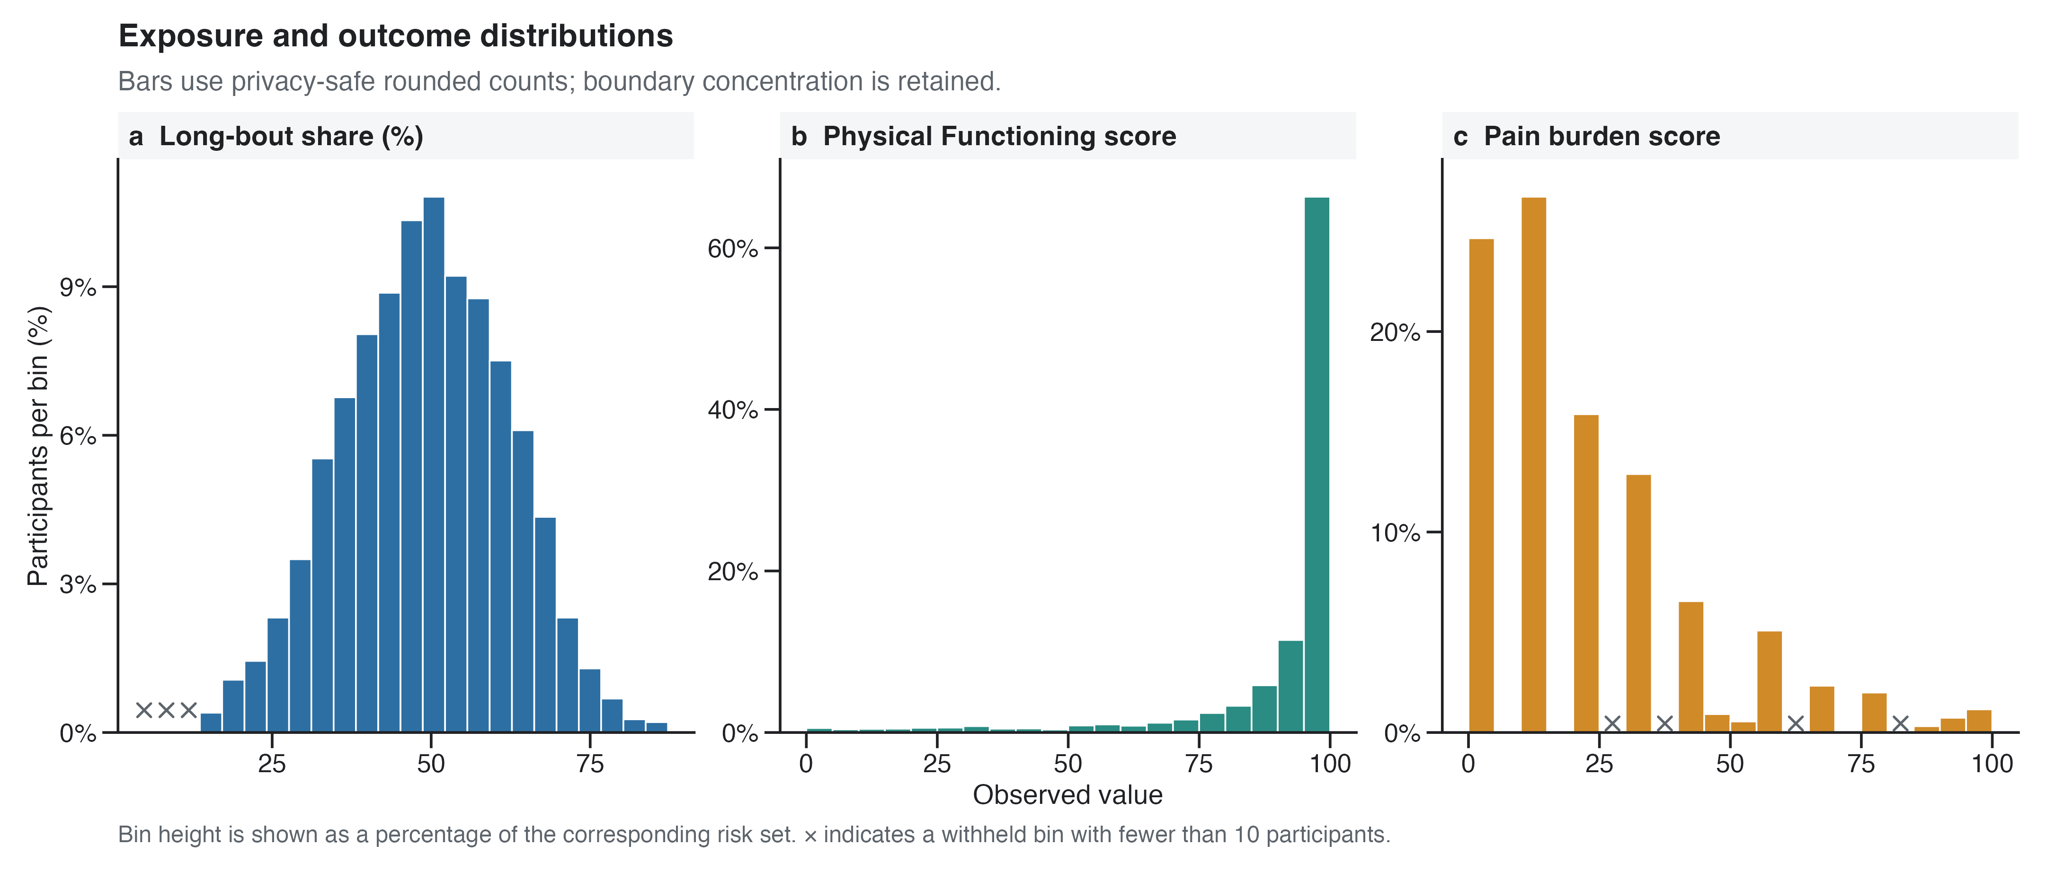
Supplementary Figure S1. Distributions of the long-bout proportion and age-51 outcomes.

Supplementary Figure S2
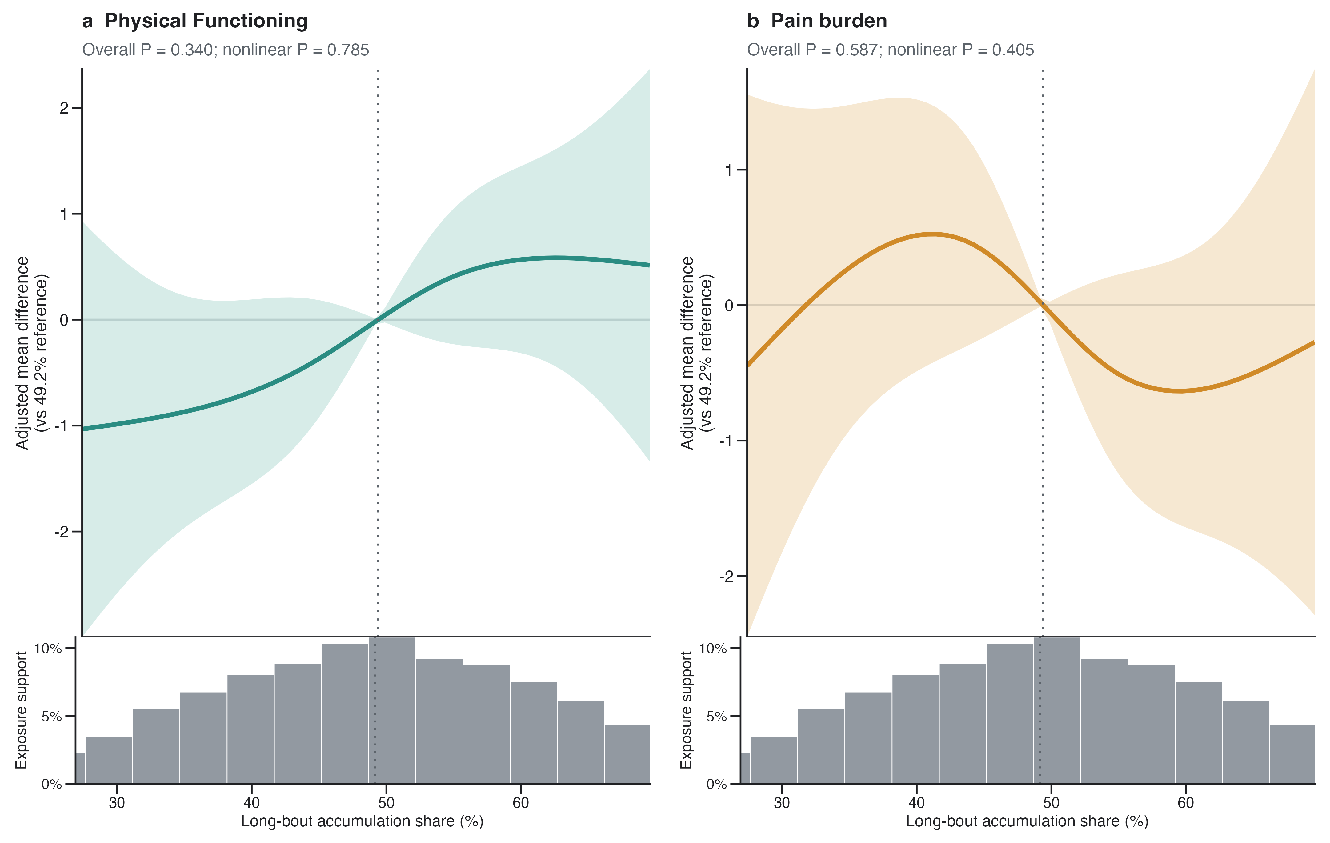
Supplementary Figure S2. Adjusted restricted cubic spline contrasts over the 5th–95th percentile exposure range, with observed exposure support.

Supplementary Figure S3
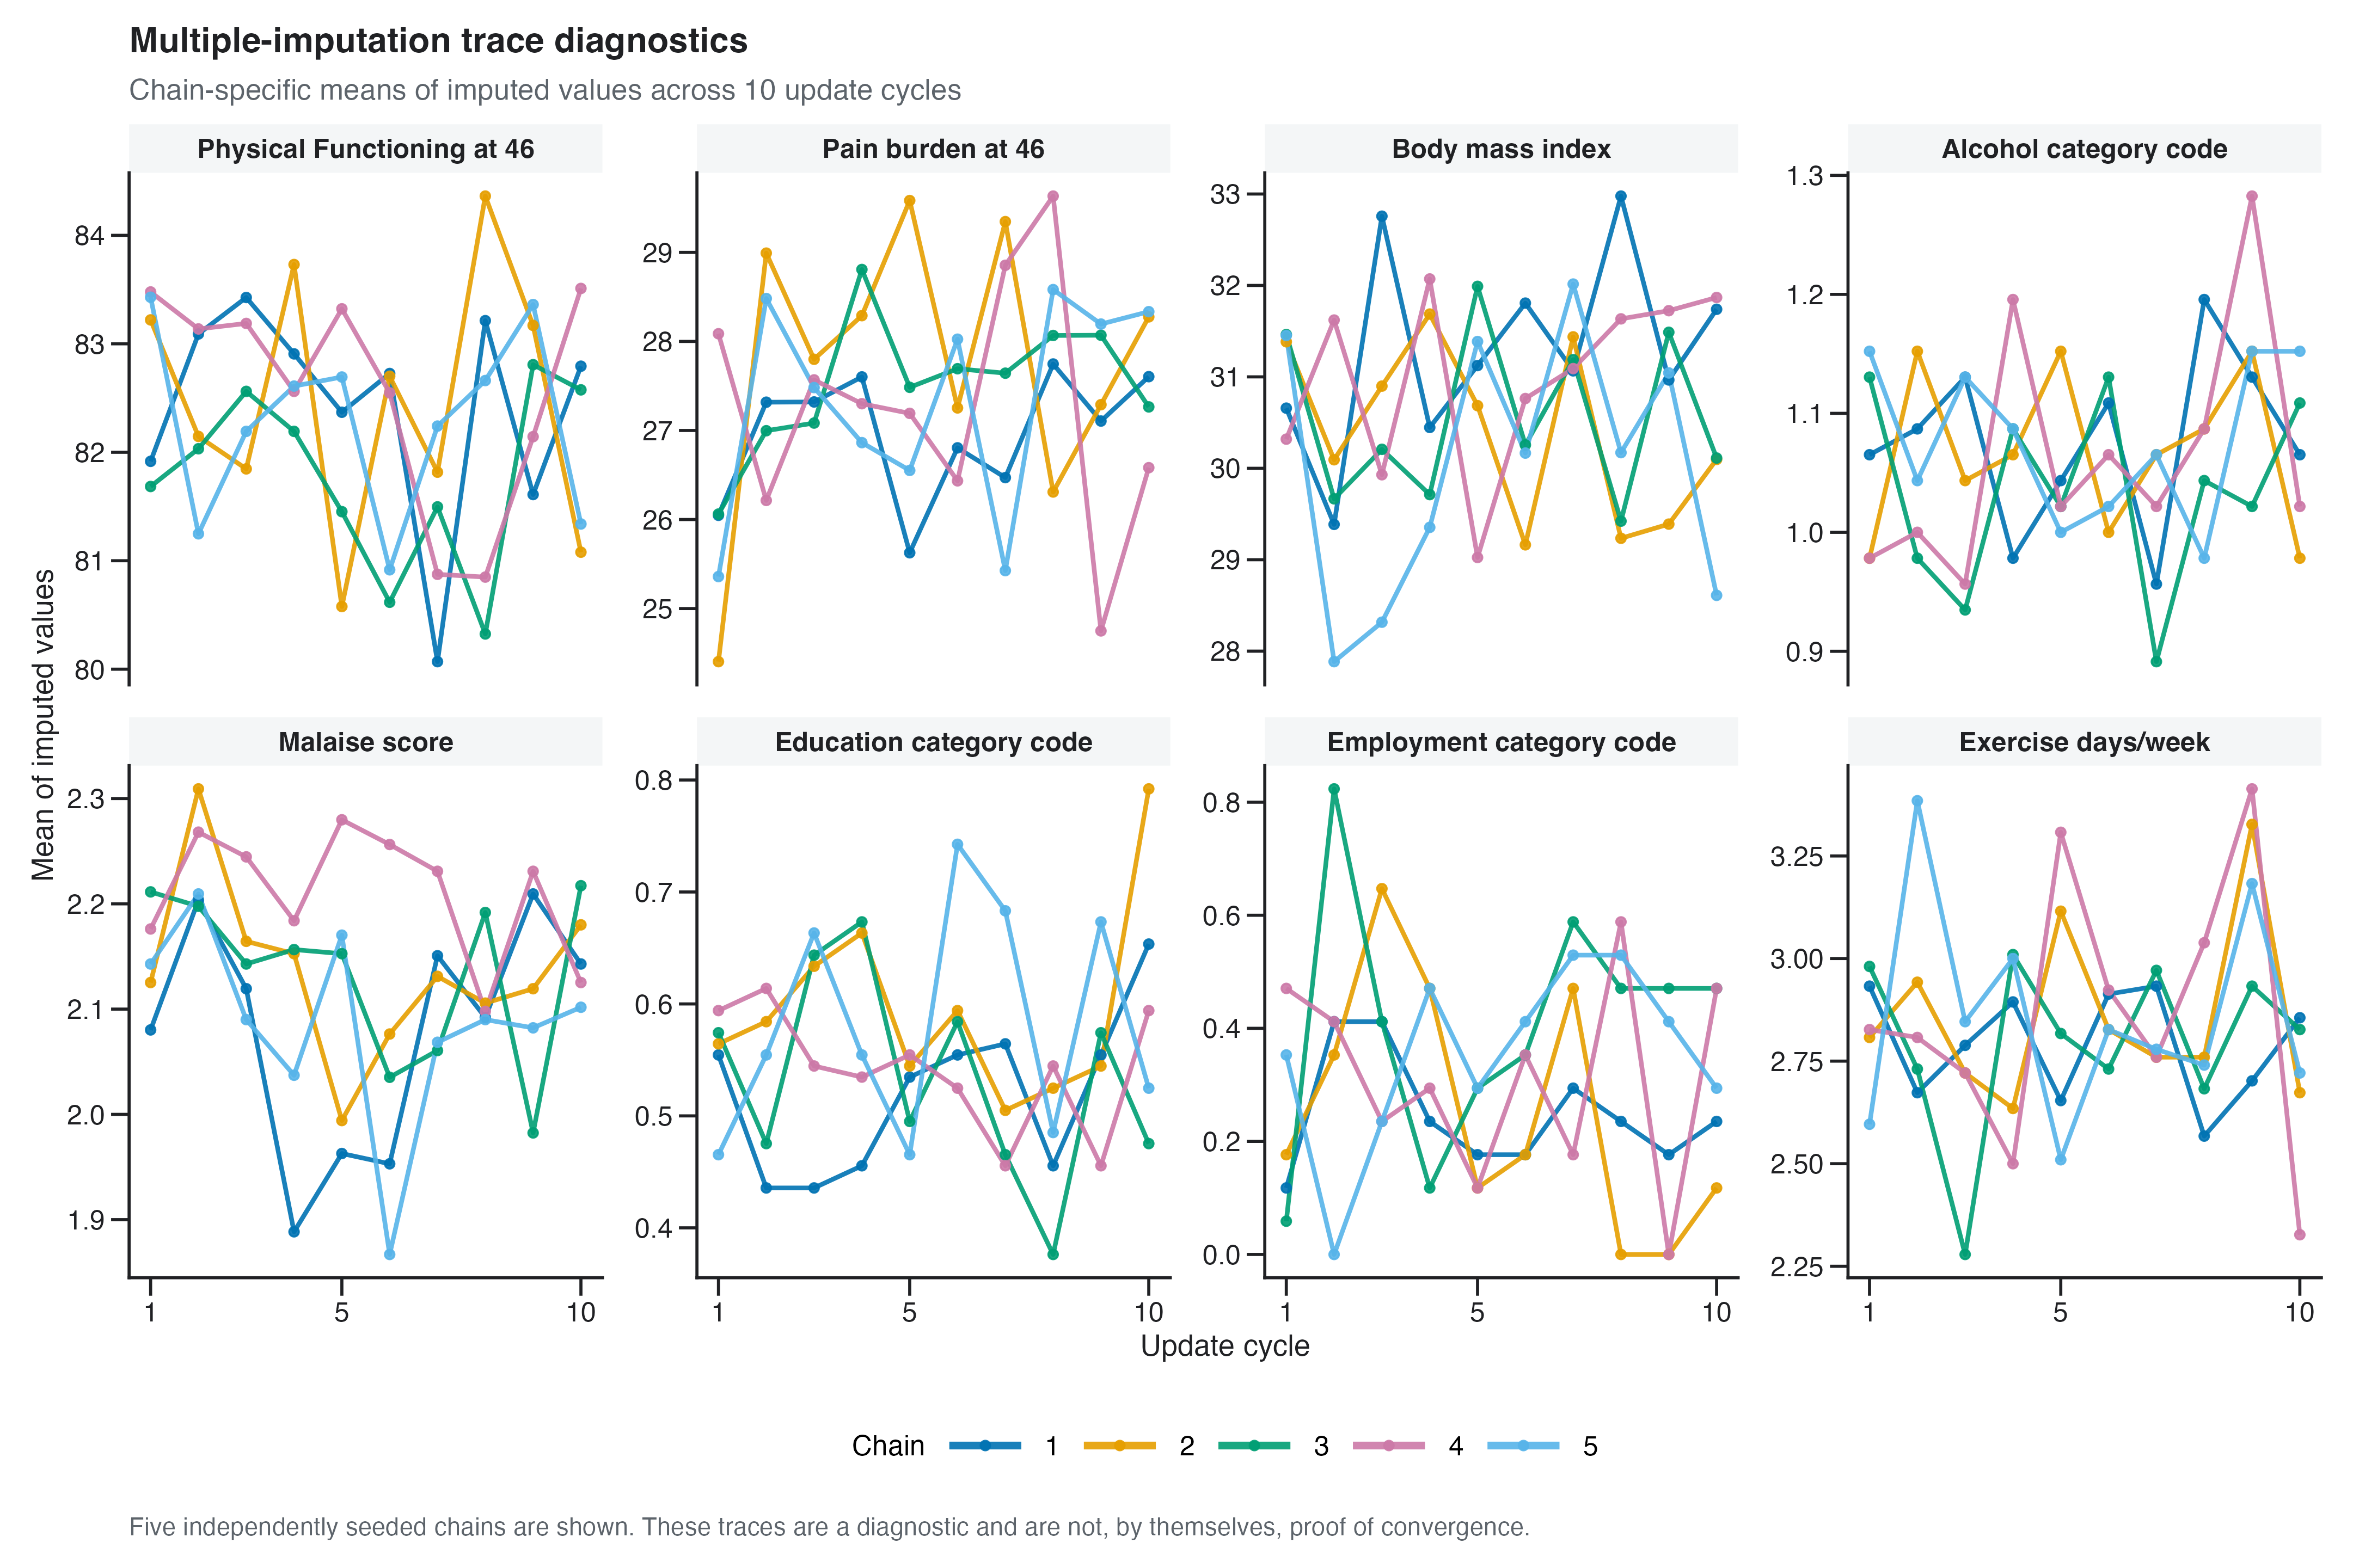
Supplementary Figure S3. Multiple-imputation chain traces for variables with material missingness.

Supplementary Figure S4
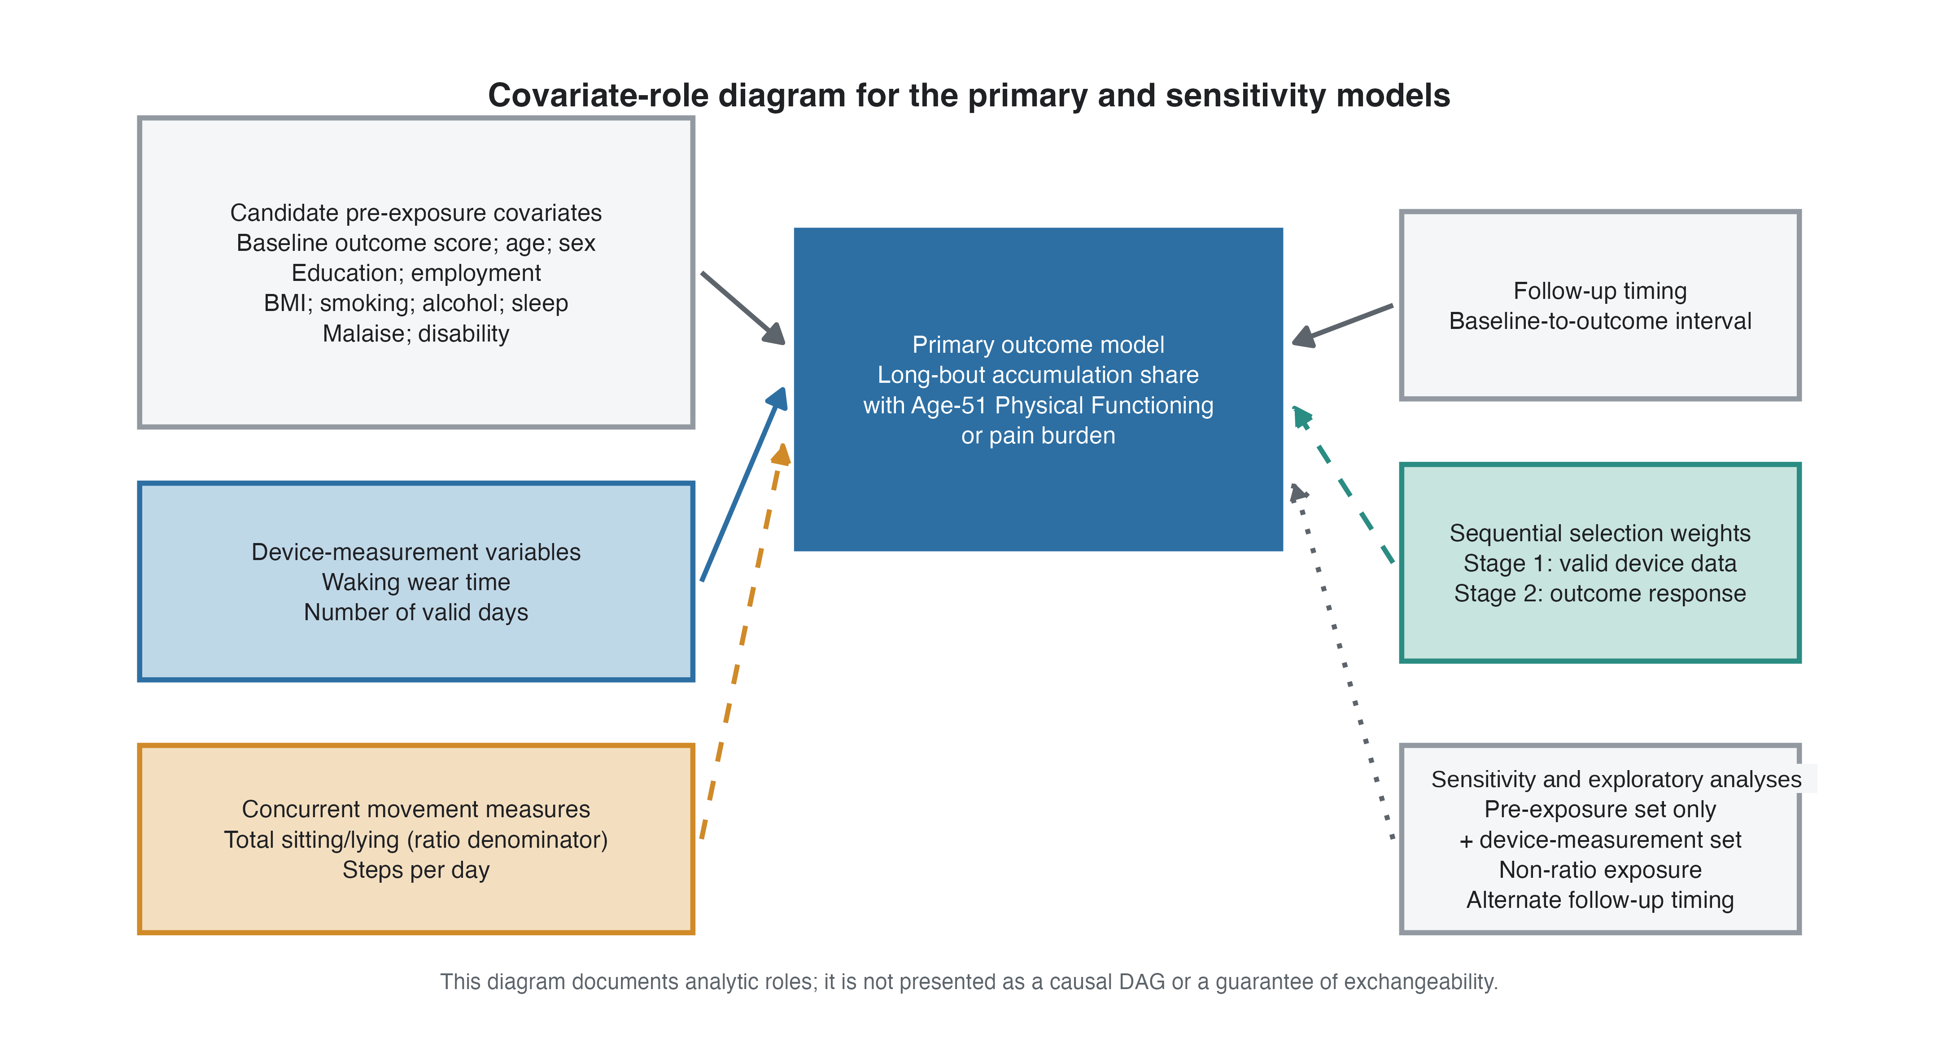
Supplementary Figure S4. Conceptual and temporal roles of analysis variables.

Supplementary Figure S5
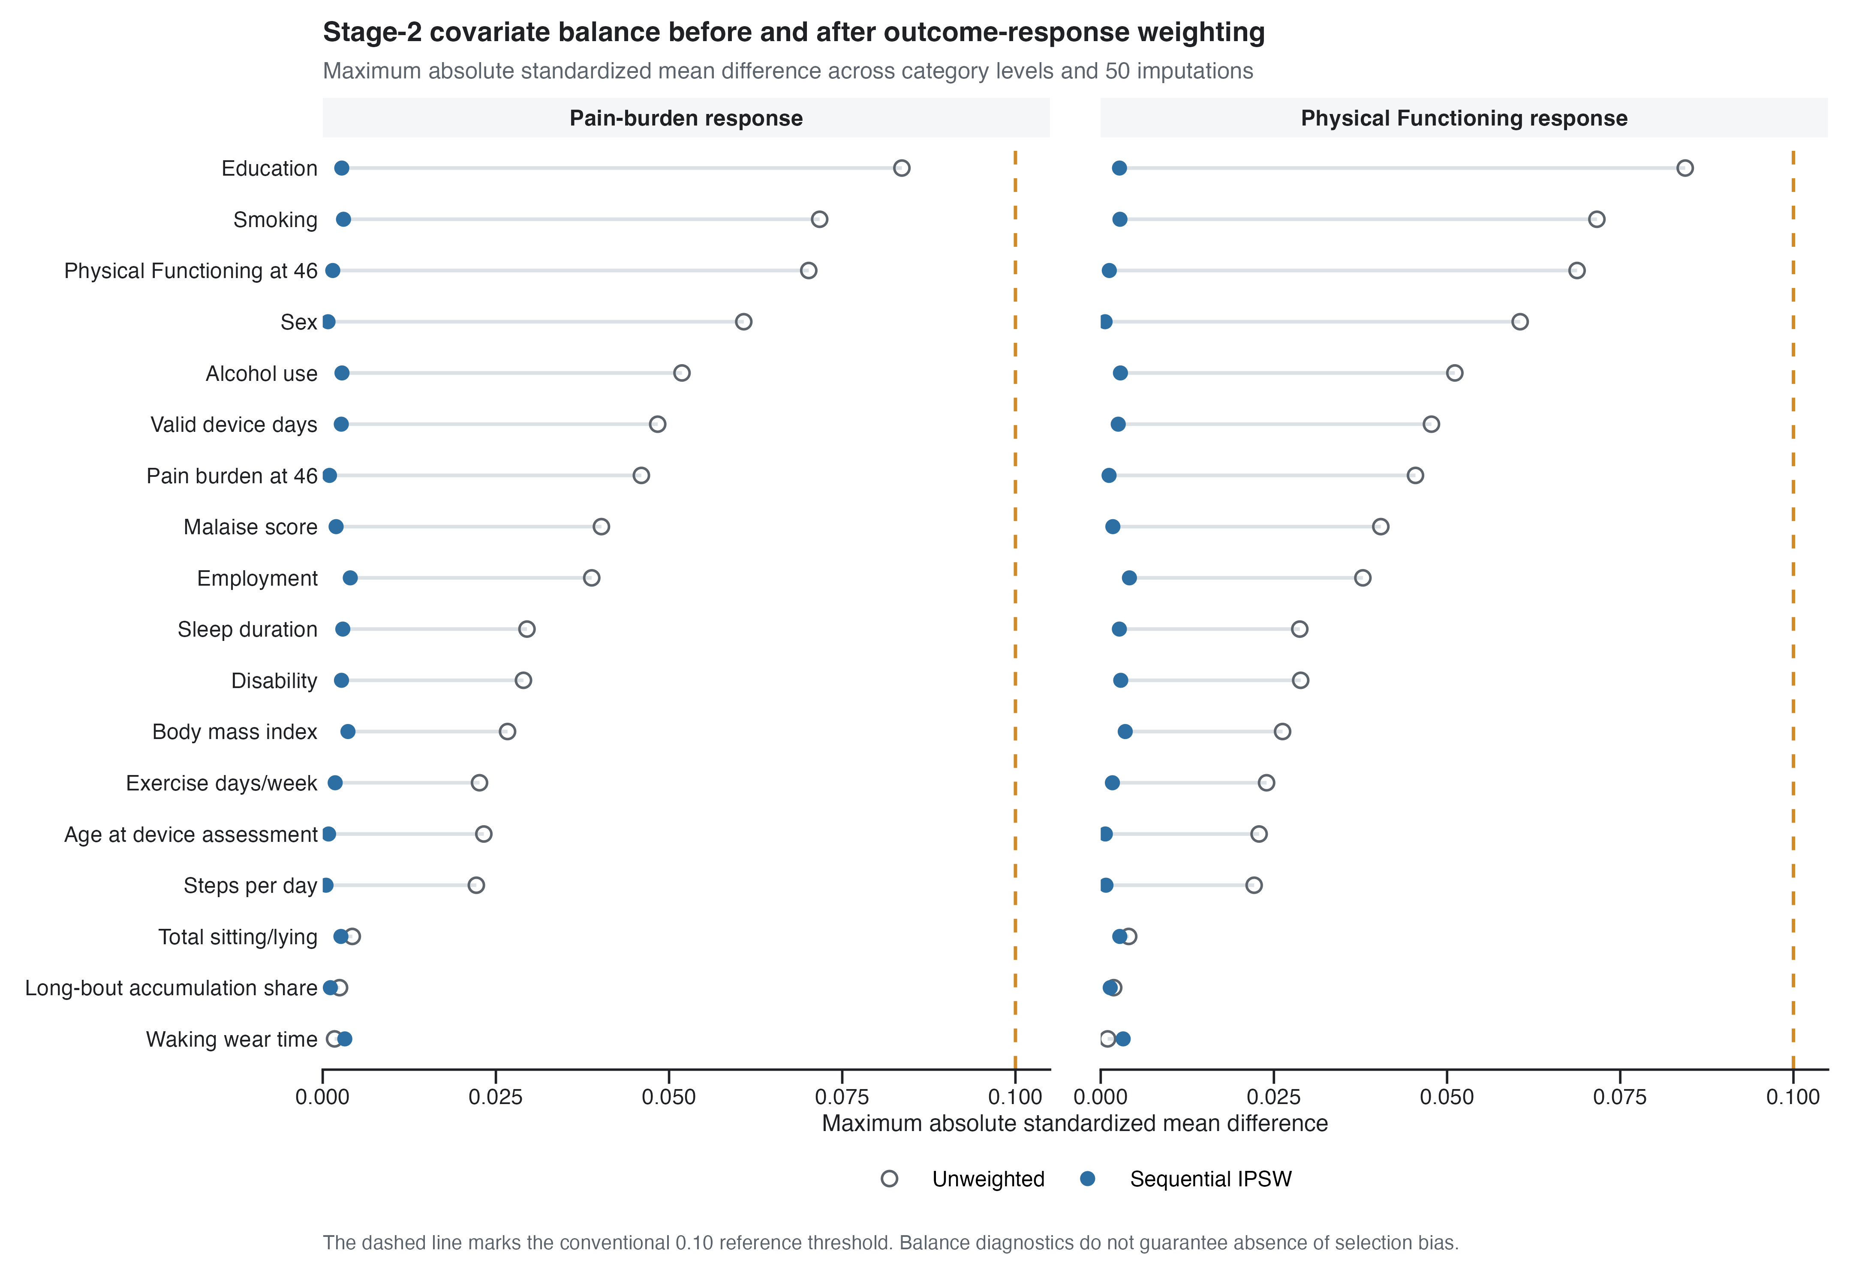
Supplementary Figure S5. Stage-2 standardized mean differences before and after outcome-response weighting.

