Supporting Information
Effects of oxide supports and Pt loading on the interfacial structure and catalytic performance of SANIs-inspired catalysts for dry reforming of methane
Chao Hu^{1*}, Hongye Chen¹, Ziwen Zhao¹, Yue Zhang¹, Rui Zhou¹, Shenqiao Song¹, Nai Rong¹, Xiaokang Wan¹
¹: School of Environment and Energy Engineering, Anhui Jianzhu University, Hefei 230601, China
*Corresponding author: Chao Hu Tel.: +86 551 63828252
E-mail: chaohu@mail.ustc.edu.cn
Submitted to: Korean Journal of Chemical Engineering

Table S1. Detailed preparation parameters of catalysts modified by different metal oxides.
Catalysts | Metal precursor (mg) | IEP(PH)
Pt/AlO_{x}-SiO₂ | 150.0 | 4.01
Pt/CrO_{x}-SiO₂ | 160.0 | 6.93
Pt/ZnO_{x}-SiO₂ | 93.2 | 8.15
Pt/NiO_{x}-SiO₂ | 127.0 | 7.85
Pt/CoO_{x}-SiO₂ | 116.4 | 9.90

Table S2. Precursor solution compositions for catalyst preparation.
Catalysts | H₂PtCl₆·6H₂O amount (μmol) | HCl solution volume (ml) | HCl solution PH
Pt/AlO_{x}-SiO₂ | 60 | 50.00 | 5.4
Pt/CrO_{x}-SiO₂ | 60 | 50.00 | 4.3
Pt/ZnO_{x}-SiO₂ | 60 | 50.00 | 6.4
Pt/CoO_{x}-SiO₂ | 60 | 50.00 | 6.4
0.37wt% Pt/NiO_{x}-SiO₂ | 10 | 8.33 | 5.3
0.74wt% Pt/NiO_{x}-SiO₂ | 20 | 16.67 | 5.3
2.1wt% Pt/NiO_{x}-SiO₂ | 60 | 50.00 | 5.3
4.2wt% Pt/NiO_{x}-SiO₂ | 120 | 100.00 | 5.3
6.3wt% Pt/NiO_{x}-SiO₂ | 180 | 150.00 | 5.3

Table S3. Preparation parameters of Pt/NiO_{x}–SiO₂ catalysts with different Pt loadings.
Catalysts | Substrate mass(mg) | IEP (PH)
Pt/AlO_{x}-SiO₂ | 291.6 | 5.4
Pt/CrO_{x}-SiO₂ | 381.6 | 4.3
Pt/ZnO_{x}-SiO₂ | 290.0 | 6.4
Pt/CoO_{x}-SiO₂ | 300.0 | 6.4
Pt/NiO_{x}-SiO₂ | 378.0 | 5.3

Table S4. Fitted XPS parameters of Ni 2p spectra for Pt/NiO_{x}–SiO₂ catalysts.
Catalysts | Binding Energy |  | Relative Peak Area
Catalysts | Ni²⁺2p_{3/2} (ev) | Ni²⁺2p_{1/2}(ev) | Ni²⁺2p_{3/2} (a.u.) | Ni²⁺2p_{1/2}(a.u.)
0.37wt% Pt/NiO_{x}-SiO₂ | 873.9 | 856.1 | 240.6 | 499.9
2.1wt% Pt/NiO_{x}-SiO₂ | 872.8 | 855.0 | 250.0 | 500.3
4.2wt% Pt/NiO_{x}-SiO₂ | 872.7 | 855.2 | 210.3 | 410.8
5.2wt% Pt/NiO_{x}-SiO₂ | 872.3 | 855.1 | 192.5 | 375.9
6.3wt% Pt/NiO_{x}-SiO₂ | 871.9 | 854.8 | 179.9 | 369.6

Table S5. Fitted XPS parameters of Pt 4f spectra for Pt/NiO_{x}–SiO₂ catalysts.
Catalysts | Binding Energy |  | Relative Peak Area
Catalysts | Pt²⁺4f_{7/2} (ev) | Pt²⁺4f_{5/2} (ev) | Pt²⁺4f_{7/2} (a.u.) | Pt²⁺4f_{5/2} (a.u.)
0.37wt% Pt/NiO_{x}-SiO₂ | 72.31 | 75.73 | 23.65 | 17.95
2.1wt% Pt/NiO_{x}-SiO₂ | 72.46 | 75.78 | 33.09 | 24.37
4.2wt% Pt/NiO_{x}-SiO₂ | 72.58 | 75.93 | 48.50 | 36.54
5.2wt% Pt/NiO_{x}-SiO₂ | 72.62 | 75.87 | 61.33 | 47.78
6.3wt% Pt/NiO_{x}-SiO₂ | 72.74 | 75.93 | 80.61 | 60.16

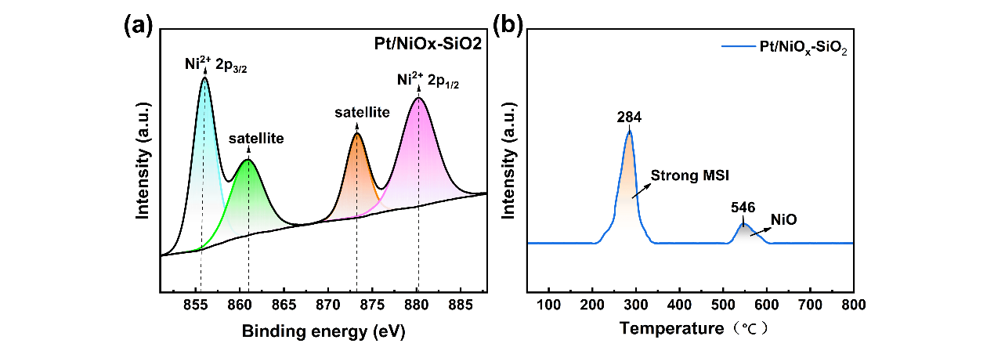
Figure. S1 XPS Analysis and H₂-TPR profiles of Pt/NiO_{x}-SiO₂. XPS spectra of (a) Ni 2p, H₂-TPR profiles of (b) Pt/NiO_{x}-SiO₂
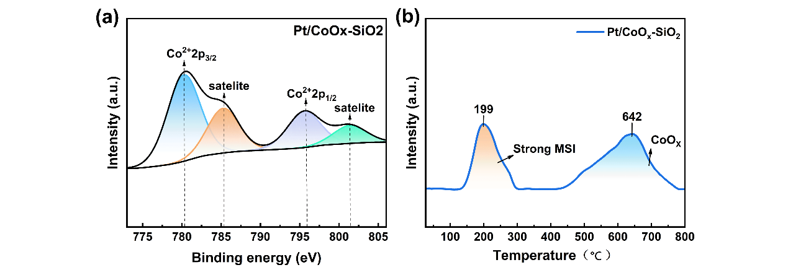
Figure. S2 XPS Analysis and H₂-TPR profiles of Pt/CoO_{x}-SiO₂. XPS spectra of (a) Co 2p, H₂-TPR profiles of (b) Pt/CoO_{x}-SiO₂
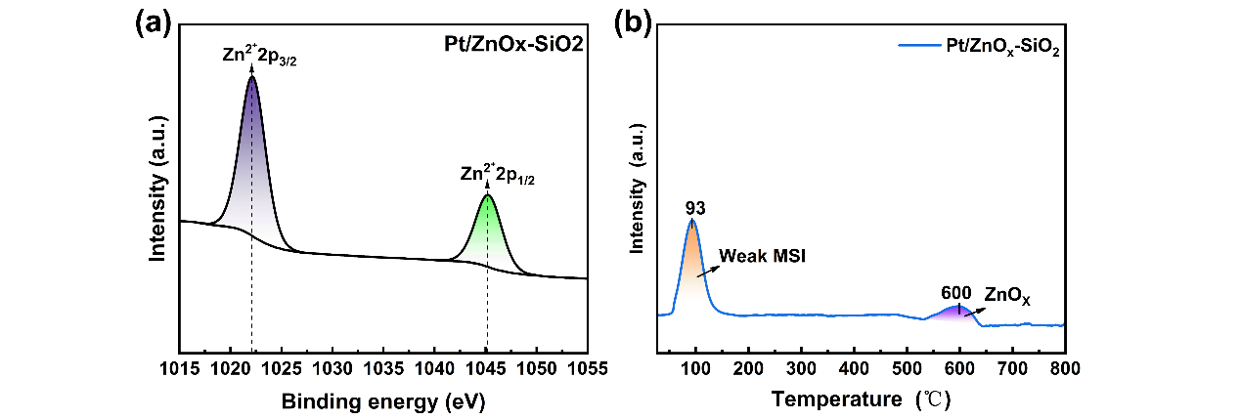
Figure. S3 XPS Analysis and H₂-TPR profiles of Pt/ZnO_{x}-SiO₂. XPS spectra of (a) Zn 2p, H₂-TPR profiles of (b) Pt/ZnO_{x}-SiO₂
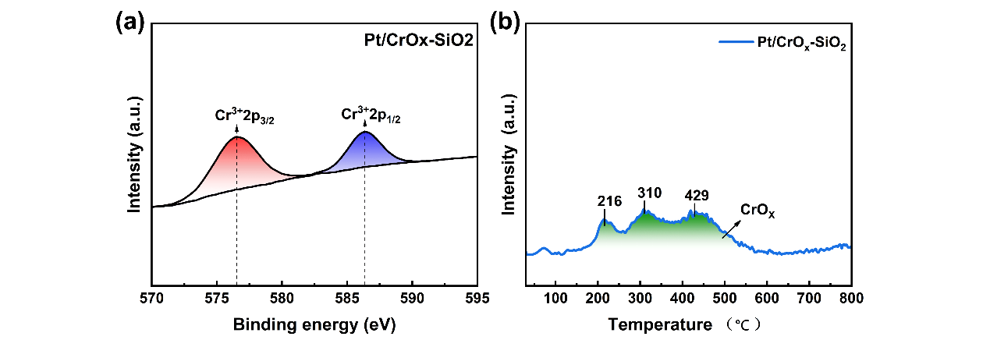
Figure. S4 XPS Analysis and H₂-TPR profiles of Pt/CrO_{x}-SiO₂. XPS spectra of (a) Cr 2p, H₂-TPR profiles of (b) Pt/CrO_{x}-SiO₂
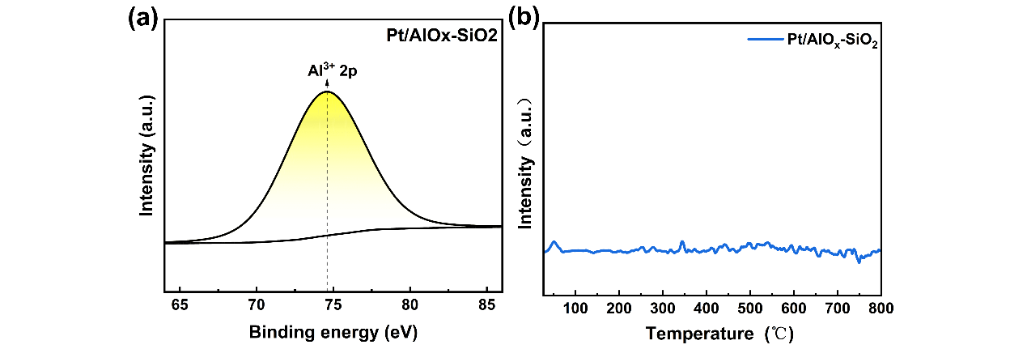
Figure. S5 XPS Analysis and H₂-TPR profiles of Pt/AlO_{x}-SiO₂. XPS spectra of (a) Al 2p, H₂-TPR profiles of (b) Pt/AlO_{x}-SiO₂
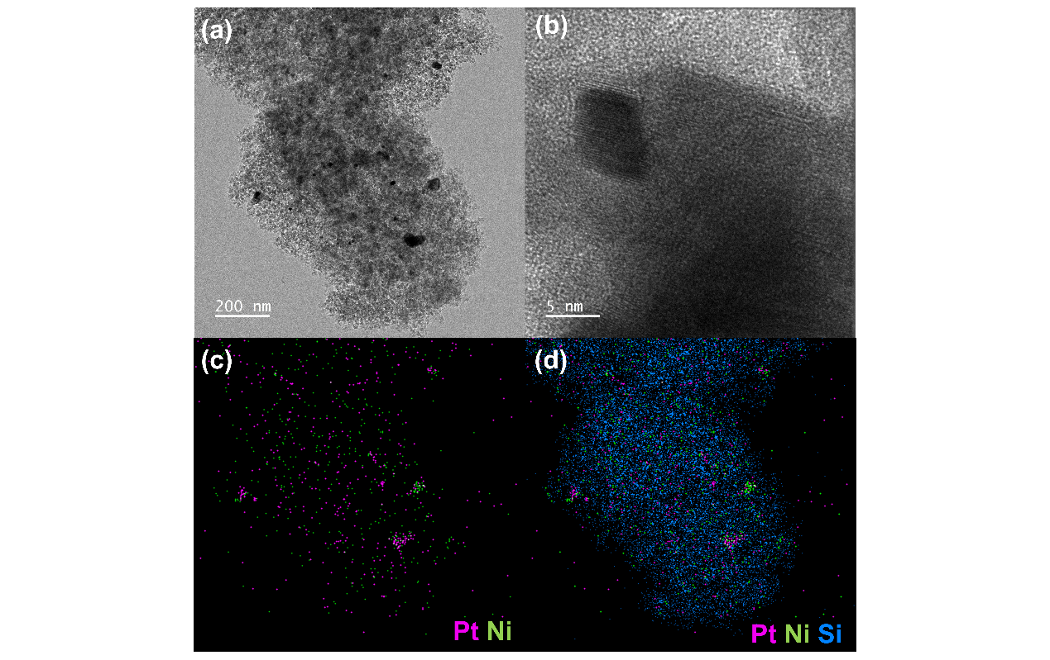
Figure. S6 TEM, HAADF-STEM images, and corresponding STEM-EDS elemental mappings of 0.37wt% Pt/NiO_{x}-SiO₂. (a) TEM image; (b); HRTEM image; (c); Overlay elemental mapping of Ni and Pt (d); Overlay elemental mapping of Ni, Pt, and Si
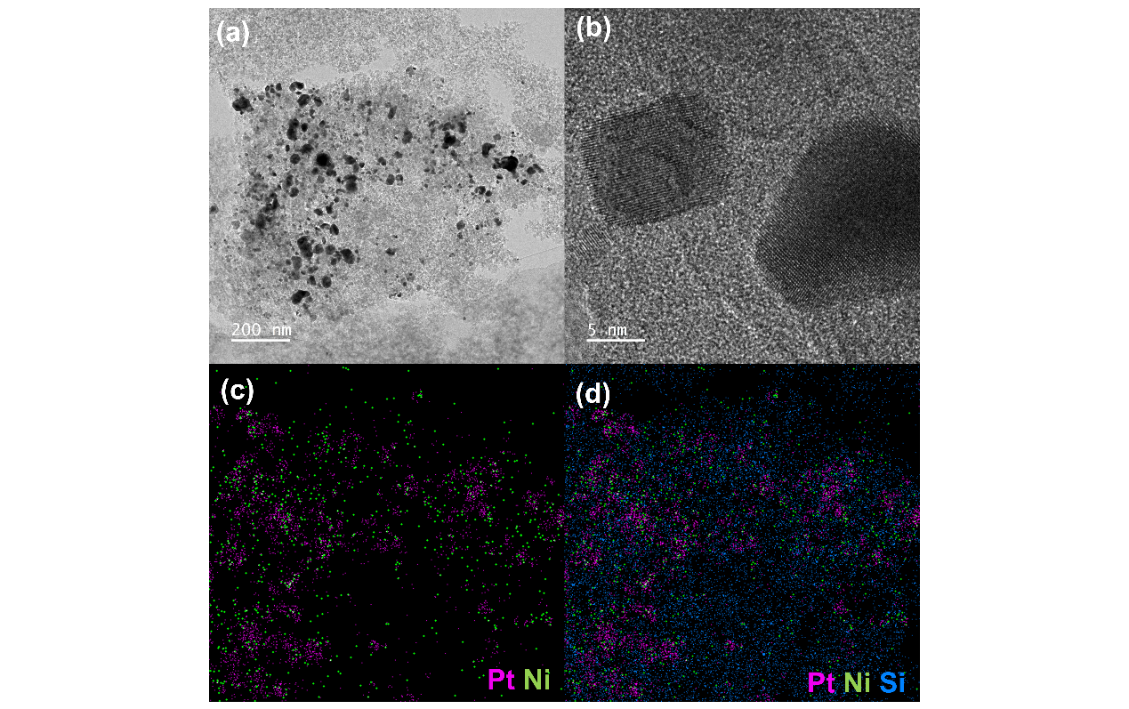
Figure. S7 TEM, HAADF-STEM images, and corresponding STEM-EDS elemental mappings of 4.2wt% Pt/NiO_{x}-SiO₂. (a) TEM image; (b); HRTEM image; (c); Overlay elemental mapping of Ni and Pt (d); Overlay elemental mapping of Ni, Pt, and Si
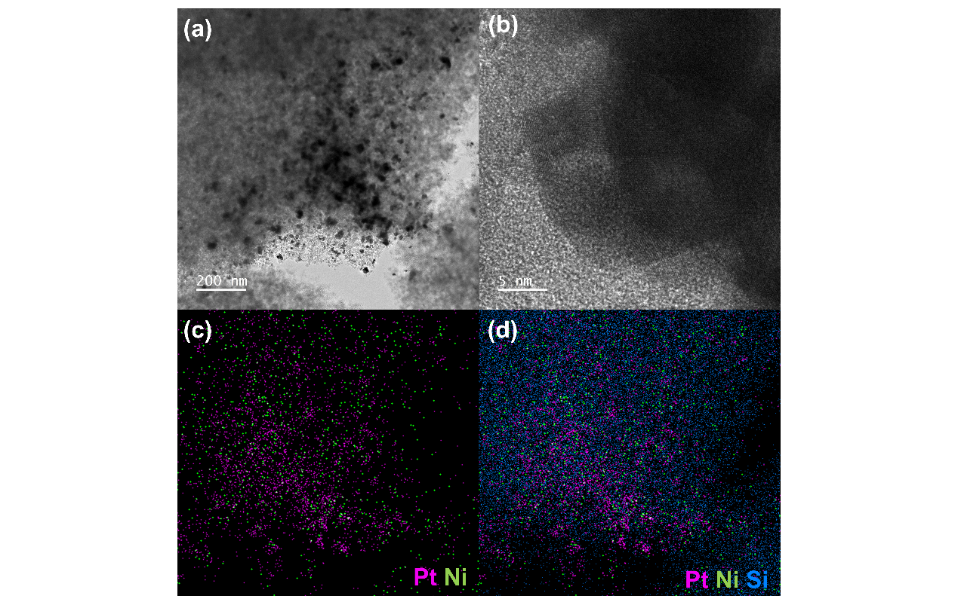
Figure. S8 TEM, HAADF-STEM images, and corresponding STEM-EDS elemental mappings of 6.3wt% Pt/NiO_{x}-SiO₂. (a) TEM image; (b); HRTEM image; (c); Overlay elemental mapping of Ni and Pt (d); Overlay elemental mapping of Ni, Pt, and Si

