Supporting Information

Intrinsically Disordered Regions in CAHS Proteins Govern Self-assembly and Enzyme Stabilization Against Multiple Stresses
Manuel Pérez-Soto^{1,2}, Giacomo Fabrini¹, Marcos Gil-Garcia¹, Paolo Arosio¹, Ana I. Benítez-Mateos^{1,2}*

¹ Department of Chemistry and Applied Biosciences, Institute for Chemical and Bioengineering, ETH Zurich, 8093, Zurich, Switzerland.
² Center for Functional Protein Assemblies & Department of Bioscience, TUM School of Natural Sciences, Technical University of Munich (TUM) 85748, Garching, Germany.

*Corresponding author: ana.benitez-mateos@tum.de

Table S1: Protein nomenclature and properties. The number of residues and the molecular weight (MW) of the proteins and enzymes are calculated including the (6x)Histag.
Protein | Gene name/code Uniprot | Organism of origin | Number residues | MW (kDa)
NOX | LPE-02581 | Lactobacillus pentosus | 470 | 51.65
FDH | FDH1 | Candida boidinii | 390 | 43.31
ADH | ADH3_GEOSE | Geobacillus stearothermophilus | 365 | 39.28
CAHS1 | CAHS 107838 | Paramacrobiotus richtersi | 252 | 29.01
CAHS2 | CAHS 106094 | Paramacrobiotus richtersi | 250 | 29.23
CAHS3 | BV898_02951 | Hypsibius exemplaris | 260 | 28.79
CAHS4 | BV898_10309 | Hypsibius exemplaris | 250 | 27.95
CAHS5 | CAHS 89226 | Hypsibius exemplaris | 437 | 47.98
CAHS6 | RvY_16824-1 | Ramazzottius varieornatus | 436 | 47.07
CAHS7 | RvY_00868-1 | Ramazzottius varieornatus | 247 | 28.49
CAHS8 | RvY_00945-1 | Ramazzottius varieornatus | 284 | 31.59
CAHS9 | RvY_07296-1 | Ramazzottius varieornatus | 331 | 37.53

a
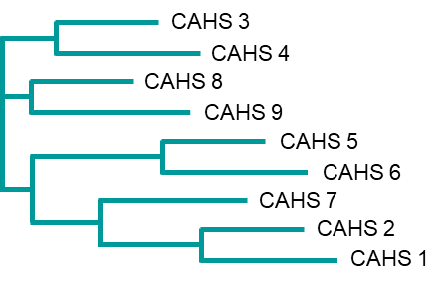
b
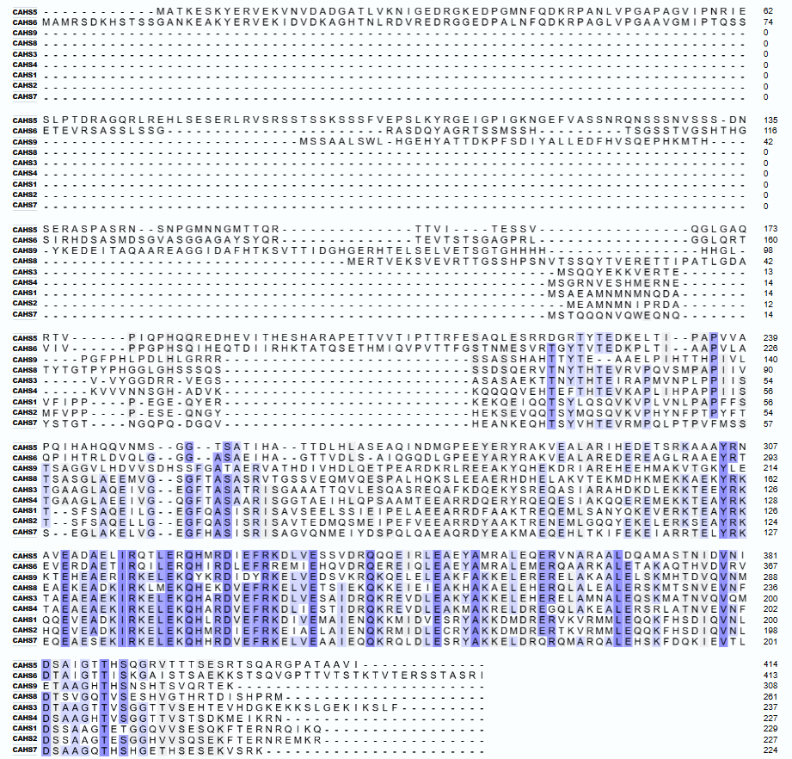
Figure S1. a) Phylogenetic tree analysis of CAHS proteins. b) Multiple sequence alignment of CAHS proteins. Conserved residues are highlighted in purple. Gaps introduced for optimal alignment are indicated by dots. Residue numbers are indicated on the right.
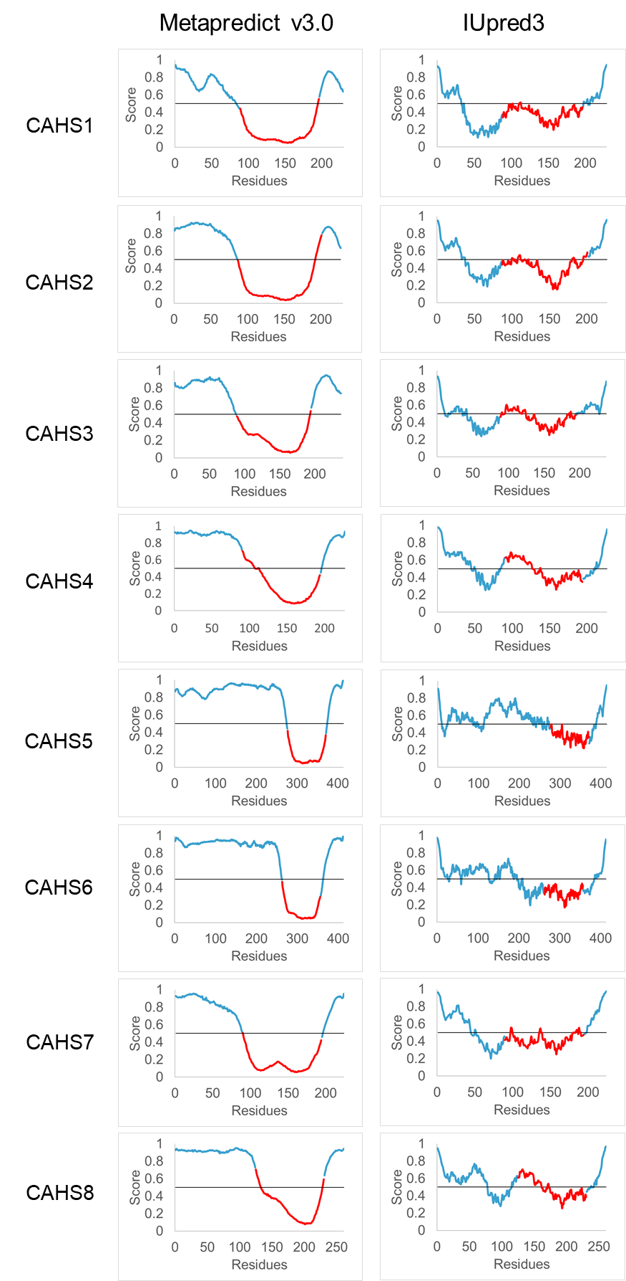
Figure S2. AI-guided simulations of CAHS protein structures. On the left column: Metapredict v3.0, and on the right column: IUPred3 predictions^{1,2}. For both, values >0.5 indicate disordered regions, whereas values <0.5 are indicative of ordered regions. The α-helix predicted by AlphaFold is highlighted in red.
a
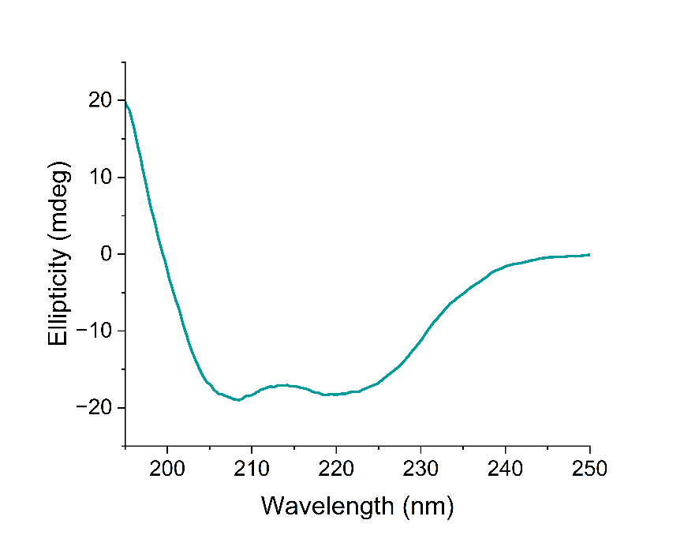

b c
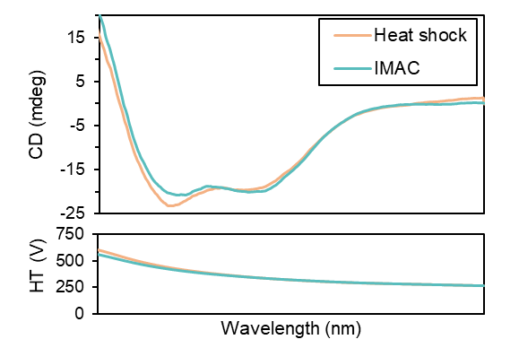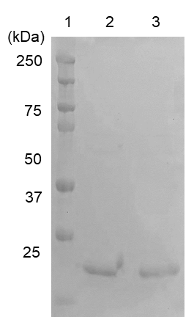
Figure S3. Comparison of CAHS protein purified by heat-shock or IMAC. a) Circular dichroism spectrum of CAHS2. It resembles the typical alpha-helix profile with 2 minima at 208 nm and 222 nm. b) Circular dichroism analysis of purified CAHS2. c) SDS-PAGE analysis. Lane 1: Pre-stained protein marker; lane 2: CAHS2 purified by IMAC; lane 3: CAHS2 purified by heat-shock.

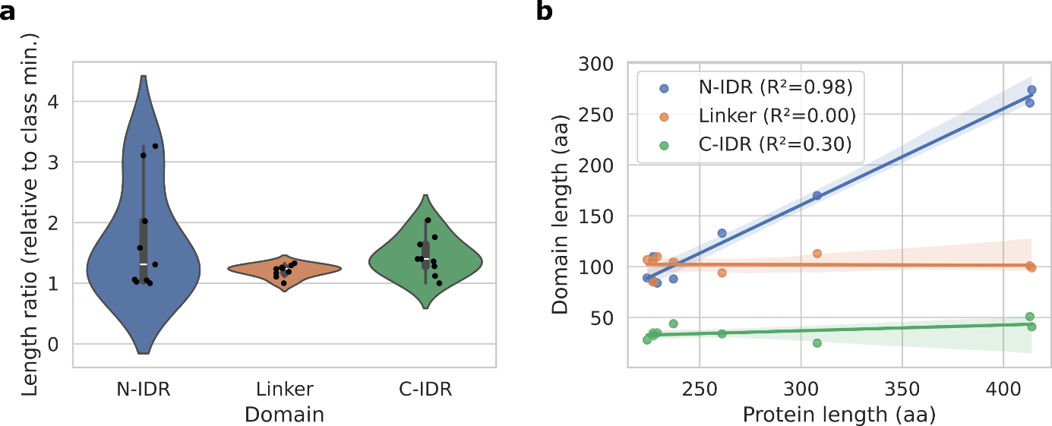
Figure S4. N-terminal IDR length is highly variable in CAHS proteins and increases with increasing CAHS protein length. a) Violin plot of CAHS domain (N-terminal IDR – N-IDR; Linker; C-terminal IDR – C-IDR) length ratio compared to the minimum (min.) in each domain class. N-terminal IDRs display the largest degree of variability, followed by C-terminal IDRs and finally by the most conserved domain, i.e. the Linker. Markers within violins show individual datapoints/proteins. b) Domain length (N-IDR, Linker, C-IDR) vs overall CAHS protein length and associated linear fits (shaded regions report 95% confidence intervals). Overall, the larger the CAHS protein, the longer the N-terminal IDR, as highlighted by the high R² values (legend). Conversely, this linear trend is dramatically reduced in the C-IDRs and absent in Linkers.

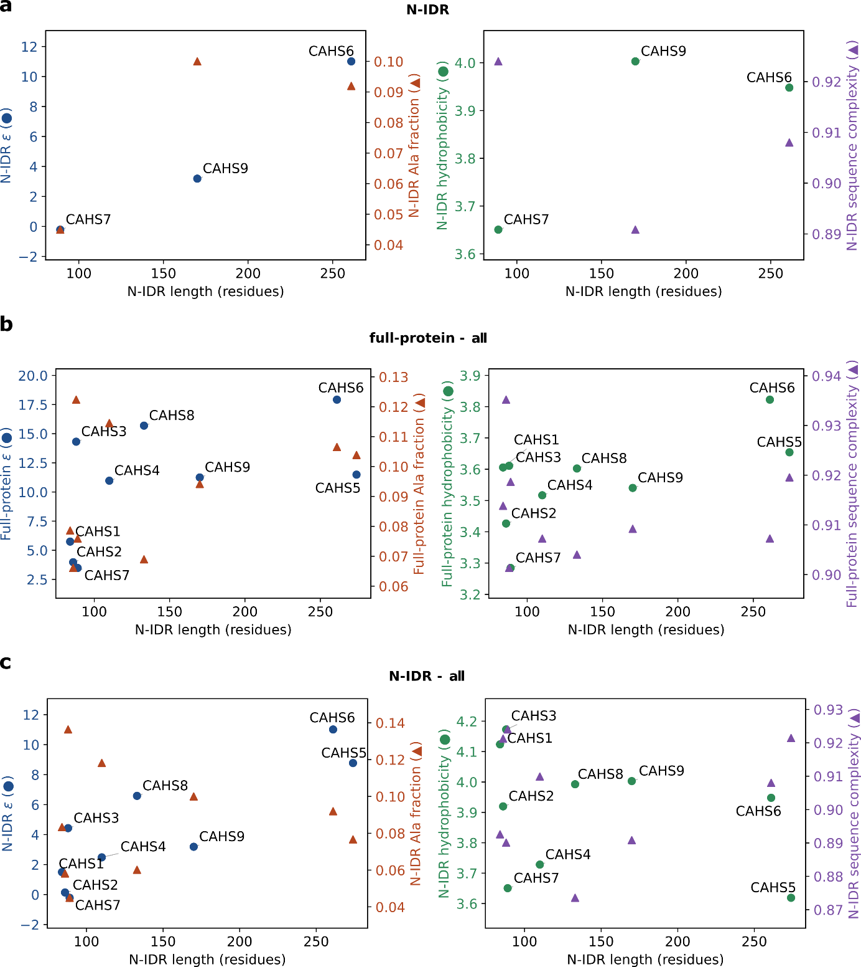
Figure S5. N-terminal IDR and full sequence descriptors. a) Descriptors computed from N-terminal IDRs (N-IDR) vs N-terminal IDR length for CAHS 6/7/9, directly complementing Figure 2 (which reports full sequence descriptors instead). Left: mean homotypic interaction strength ($ϵ$) on left y-axis (circles) and alanine fraction on right y-axis (triangles). Right: hydrophobicity on left y-axis (circles) and sequence complexity on right y-axis (triangles). b-c) Descriptors computed from the full protein sequences (b) and the N-terminal IDR sequences (c) of the entire CAHS1-9 set vs the N-terminal IDR lengths, with the same layout of (a). While the trends hold perfectly for CAHS6/7/9 full-sequence descriptors (see Figure 2), N-IDR descriptors (a) show poorer correlation, and extension to the full CAHS1-9 set (b-c) is not trivial, particularly when proteins display very similar N-IDR length (e.g., CAHS1-3).

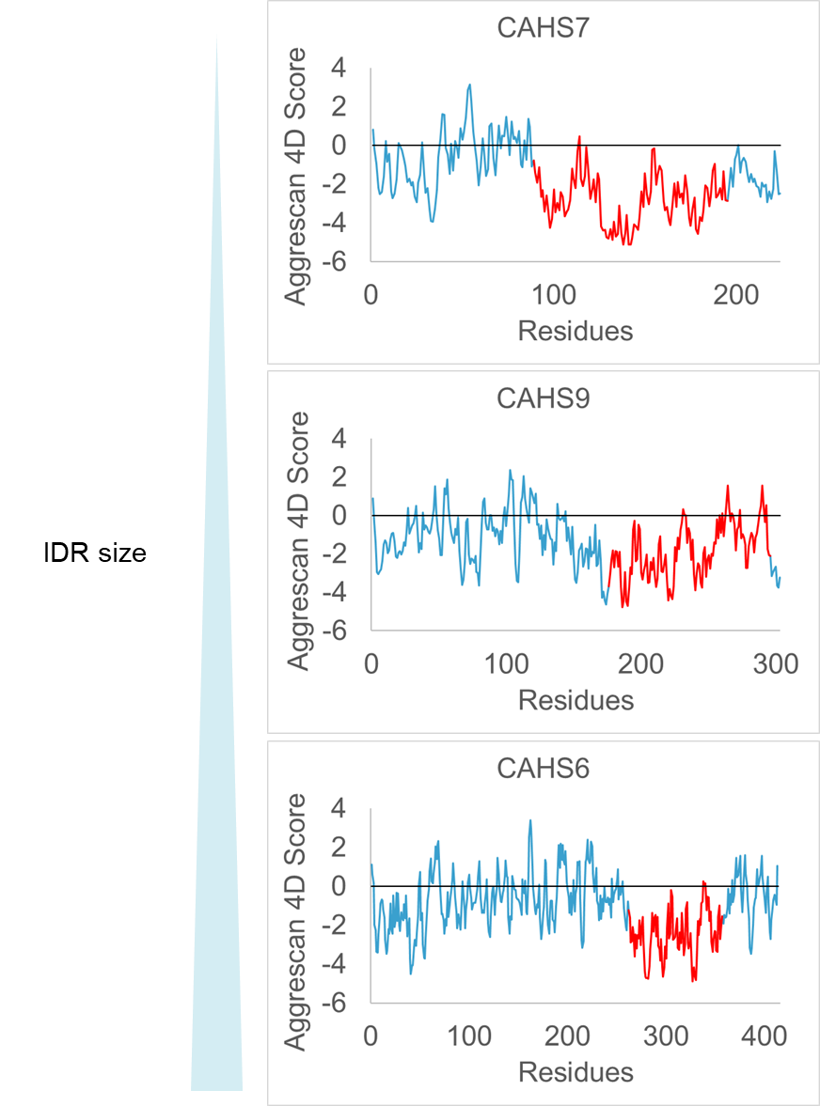
Figure S6. Protein aggregation prediction of CAHS6, CAHS7 and CAHS9 by Aggrescan4D. Positive values indicate aggregation prone regions, and negative values indicate soluble regions. The α-helix predicted by AlphaFold is highlighted in red.

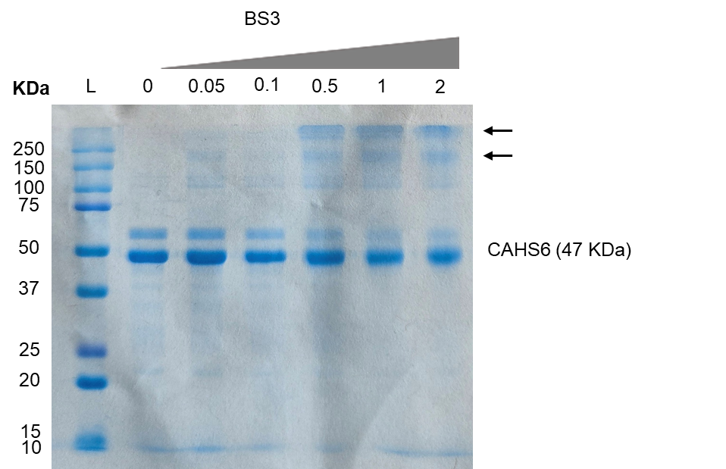
Figure S7. SDS-PAGE analysis of CAHS6 crosslinked with BS3. SDS-PAGE gel of 1 mg mL⁻¹ CAHS6 incubated with increasing concentrations of BS3 amine ester crosslinker to assess the oligomer formation. Lane 1: molecular weight marker; lane 2: untreated CAHS6 showing the monomeric state; lanes 3-7: crosslinked CAHS6 with increasing concentration of BS3 (0.05 to 2 mM) showing the progressive formation of oligomers (indicated by arrow).

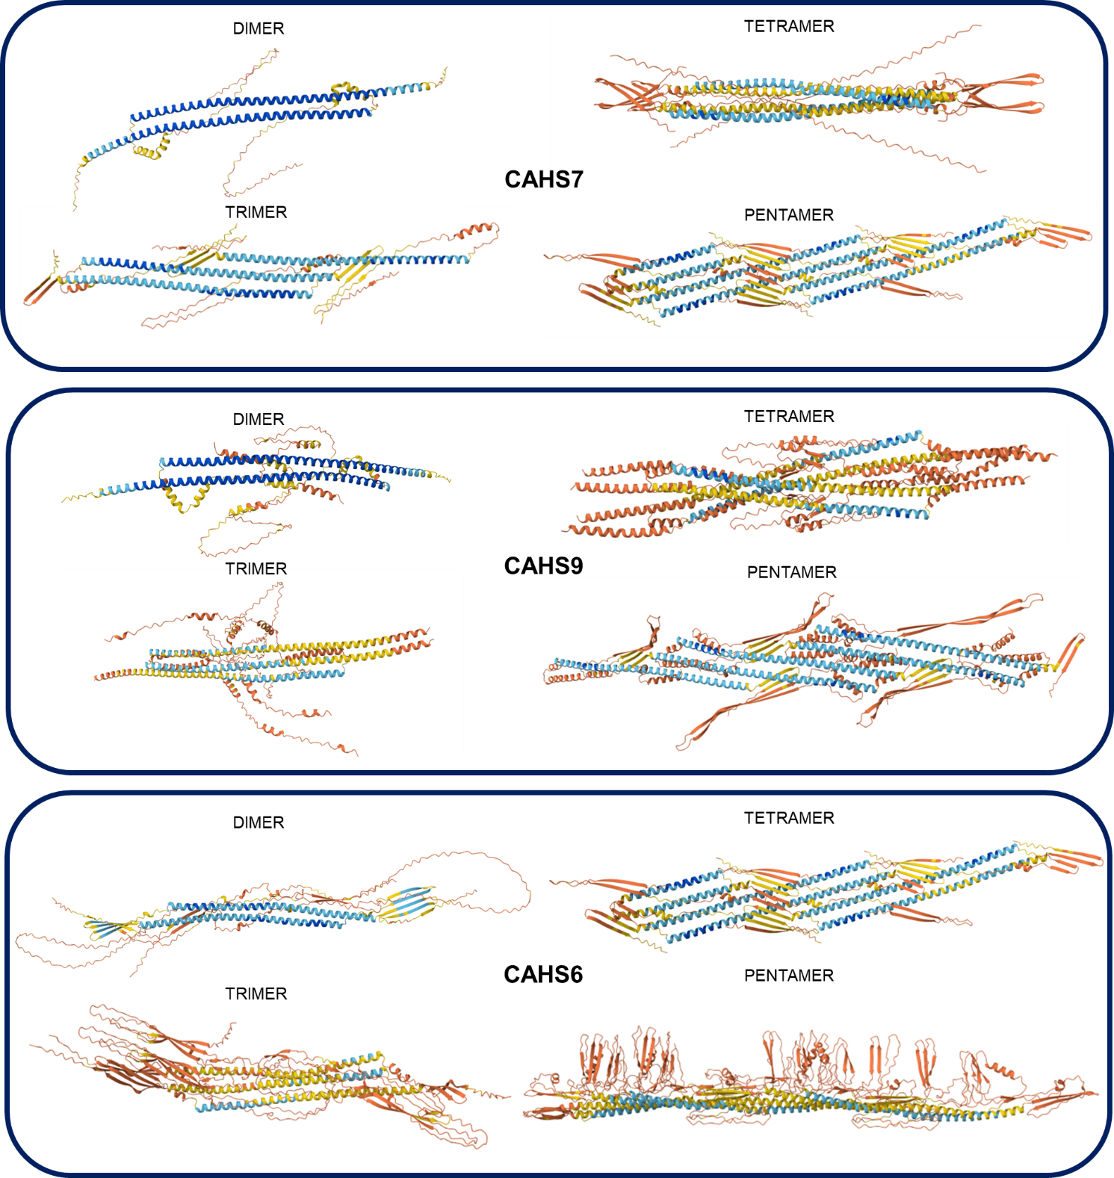
Figure S8. AlphaFold Multimer predictions of CAHS7, CAHS9, and CAHS6 aggregation assemblies. AI-guided structural models generated by the AlphaFold Server (Multimer mode) illustrate the predicted aggregation architectures of the different CAHS proteins.

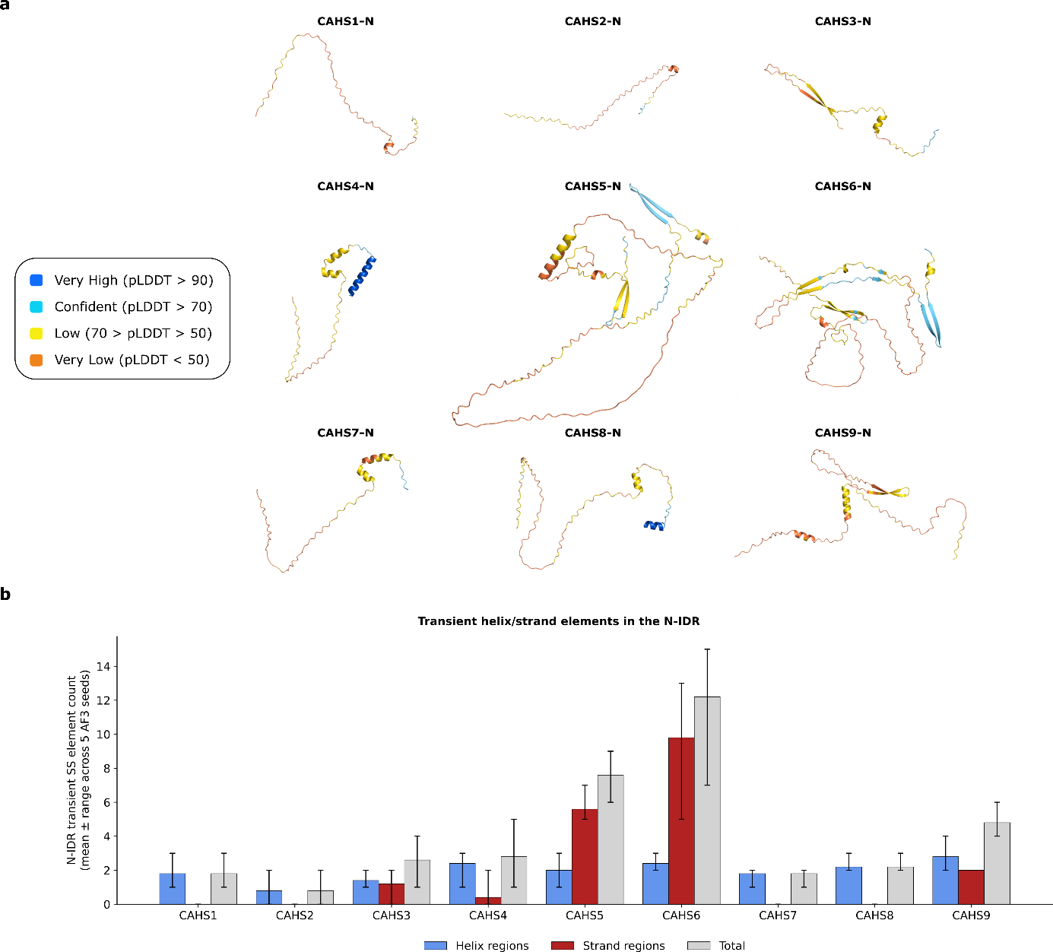
Figure S9. CAHS N-terminal IDRs contain transient secondary structure elements. a) AlphaFold 3⁵ (AF3) structures of the N-terminal IDRs (-N) of all investigated CAHS proteins, highlighting the presence of numerous (likely transient) secondary structure (SS) elements, some predicted with high confidence. b) Grouped bar plot displaying the number of SS elements in AF3 predicted structures in (a) according to DSSP (as implemented in MDAnalysis⁶), divided in $α$-helix, $β$-strand (implicated in higher-order assembly⁷) and total (sum). Data are reported as mean (bar) and min-max range (error bar) across the five AF3 diffusion samples.

Table S2: Cluster prediction by CapiPy. Clusters of negative (red) and hydrophobic (blue) residues within a 10 Å distance are highlighted. The table distinguishes between the total number of clusters and those located within the intrinsically disordered region^{8,9}.
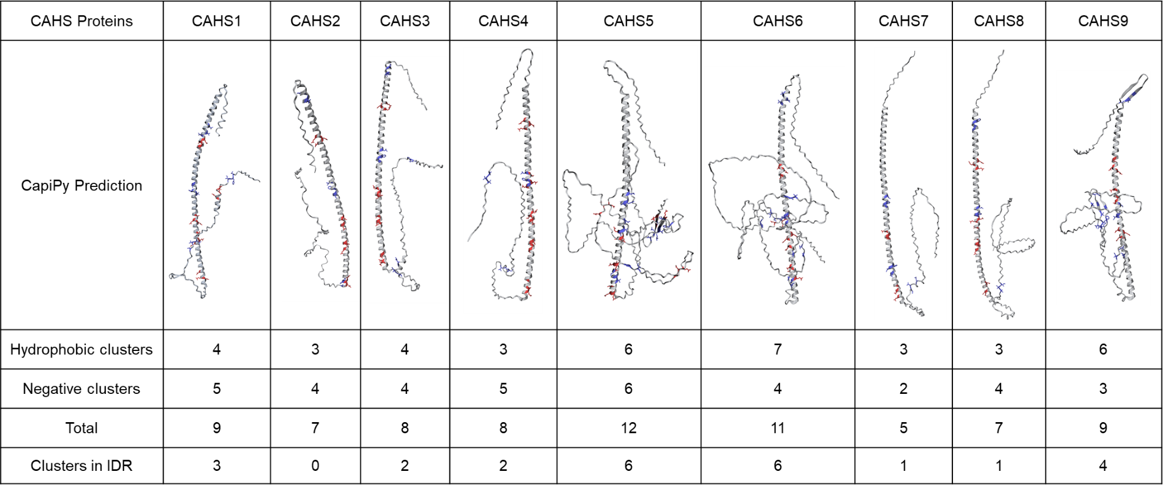

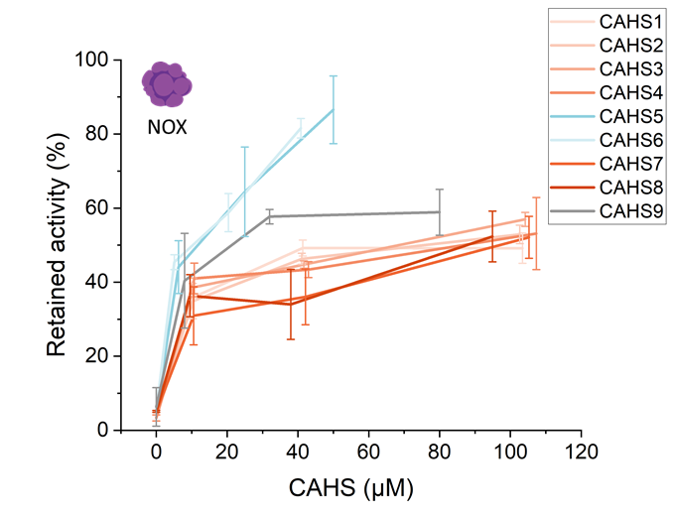

Figure S10. Stabilizing effect of CAHS proteins on NOX upon desiccation. NOX (0.03 mg mL⁻¹) was desiccated with CAHS proteins at concentrations ranging from 0 to 110 µM. Data represent mean values from at least three independent replicates.

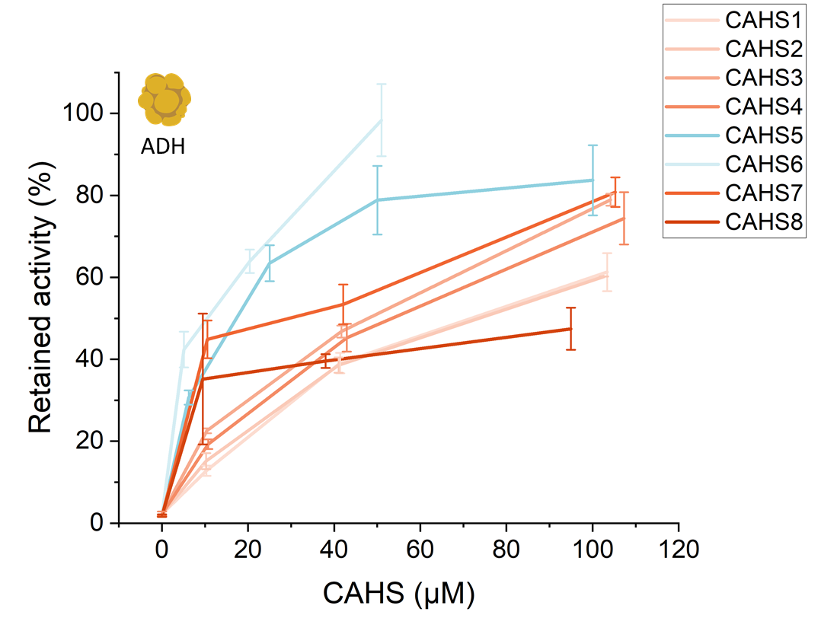
Figure S11. Effect of CAHS proteins on ADH desiccation tolerance. ADH (0.03 mg mL⁻¹) was desiccated with CAHS proteins at concentrations ranging from 0 to 110 µM. Data represent mean values from at least three independent replicates.

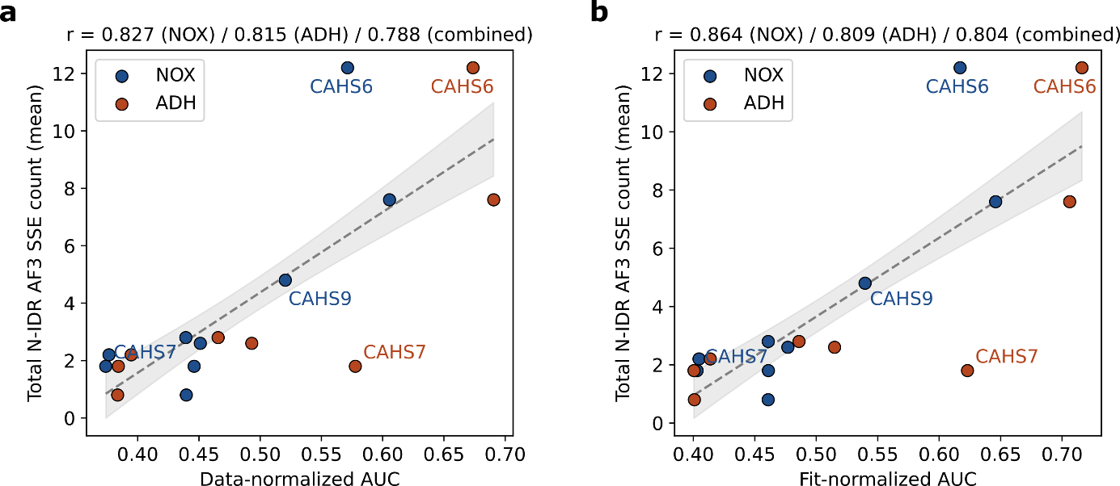
Figure S12. The higher number of secondary structure elements predicted in longer N-terminal IDRs strongly correlates with desiccation-protection performance. a) Total number of DSSP-counted secondary structure elements (SSE) within AlphaFold 3⁵ (AF3) predicted structures of N-terminal IDRs vs normalized and rescaled (see Methods) Area Under the Curve (AUC) from enzyme stability assays in Figures S10 (NOX) and S11 (ADH). Data is shown as mean total number of SSE across 5 AF3 diffusion samples. Dashed lines are linear fits, with shaded regions being the Standard Error (SE) around the regression mean. Longer IDRs contain a higher overall number of SSEs (see Figure S9) and exhibit a higher AUC, as shown by the strong correlation (Pearson’s r, reported in the title for NOX/ADH/combined assays). A higher AUC is indicative of higher protective performance from desiccation. b) Same as (a) but using the fit-derived normalized AUC (see Methods).

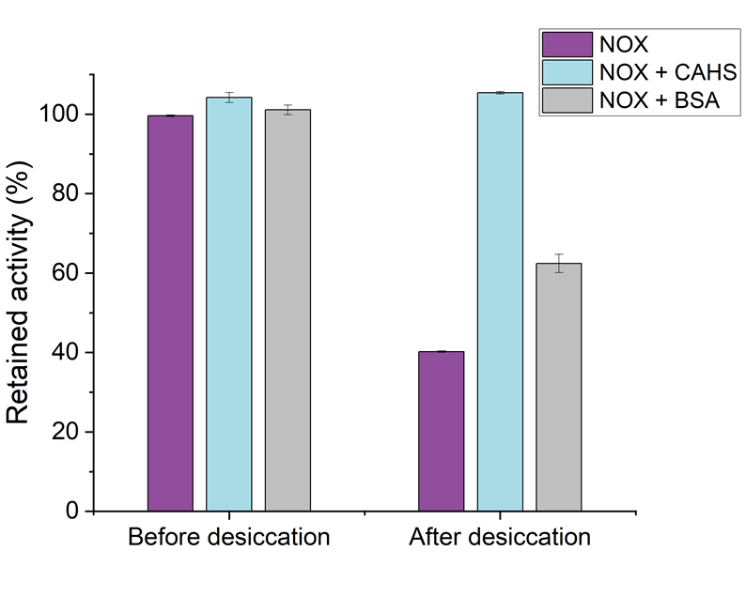
Figure S13. Comparison of BSA and CAHS proteins as stabilizers of NOX activity. NOX (0.1 mg mL⁻¹) was desiccated for 3 h in the absence of any additional protein and in the presence of CAHS4 and BSA (1 mg mL⁻¹) before rehydration and activity assay. Retained activity is defined as the percentage of enzymatic activity remaining after exposure to the indicated abiotic stresses, normalized to the initial activity of the enzyme. Data represent mean values from at least three independent replicates.

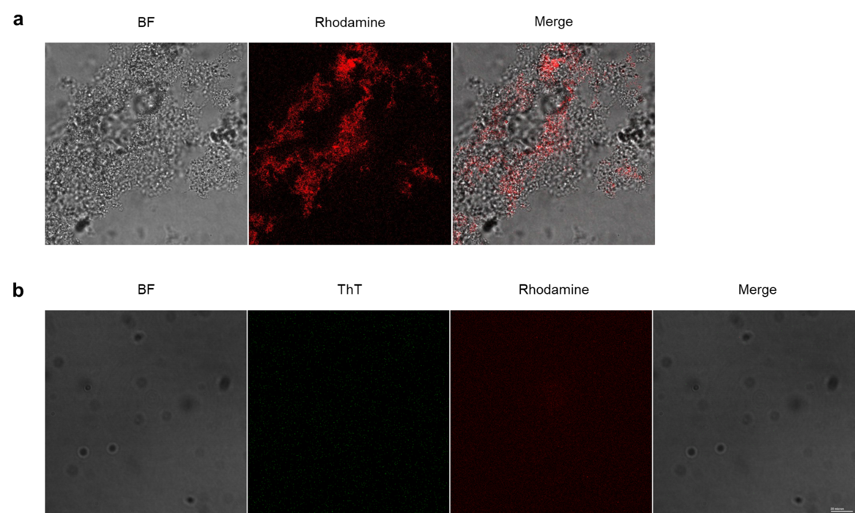
Figure S14. Negative controls for confocal microscopy. a) CAHS6 (60 µM) incubated for 10 min with NOX-Rhodamine. From left to right: bright field (BF), rhodamine, and merged images. b) Sample containing both ThT and NOX-Rhodamine but lacking CAHS6 incubated for 1 hour. From left to right: (BF), ThT, rhodamine, and merged images. Both samples were imaged using a 60× oil immersion objective. Laser excitation settings and detector ranges were kept constant across all samples.

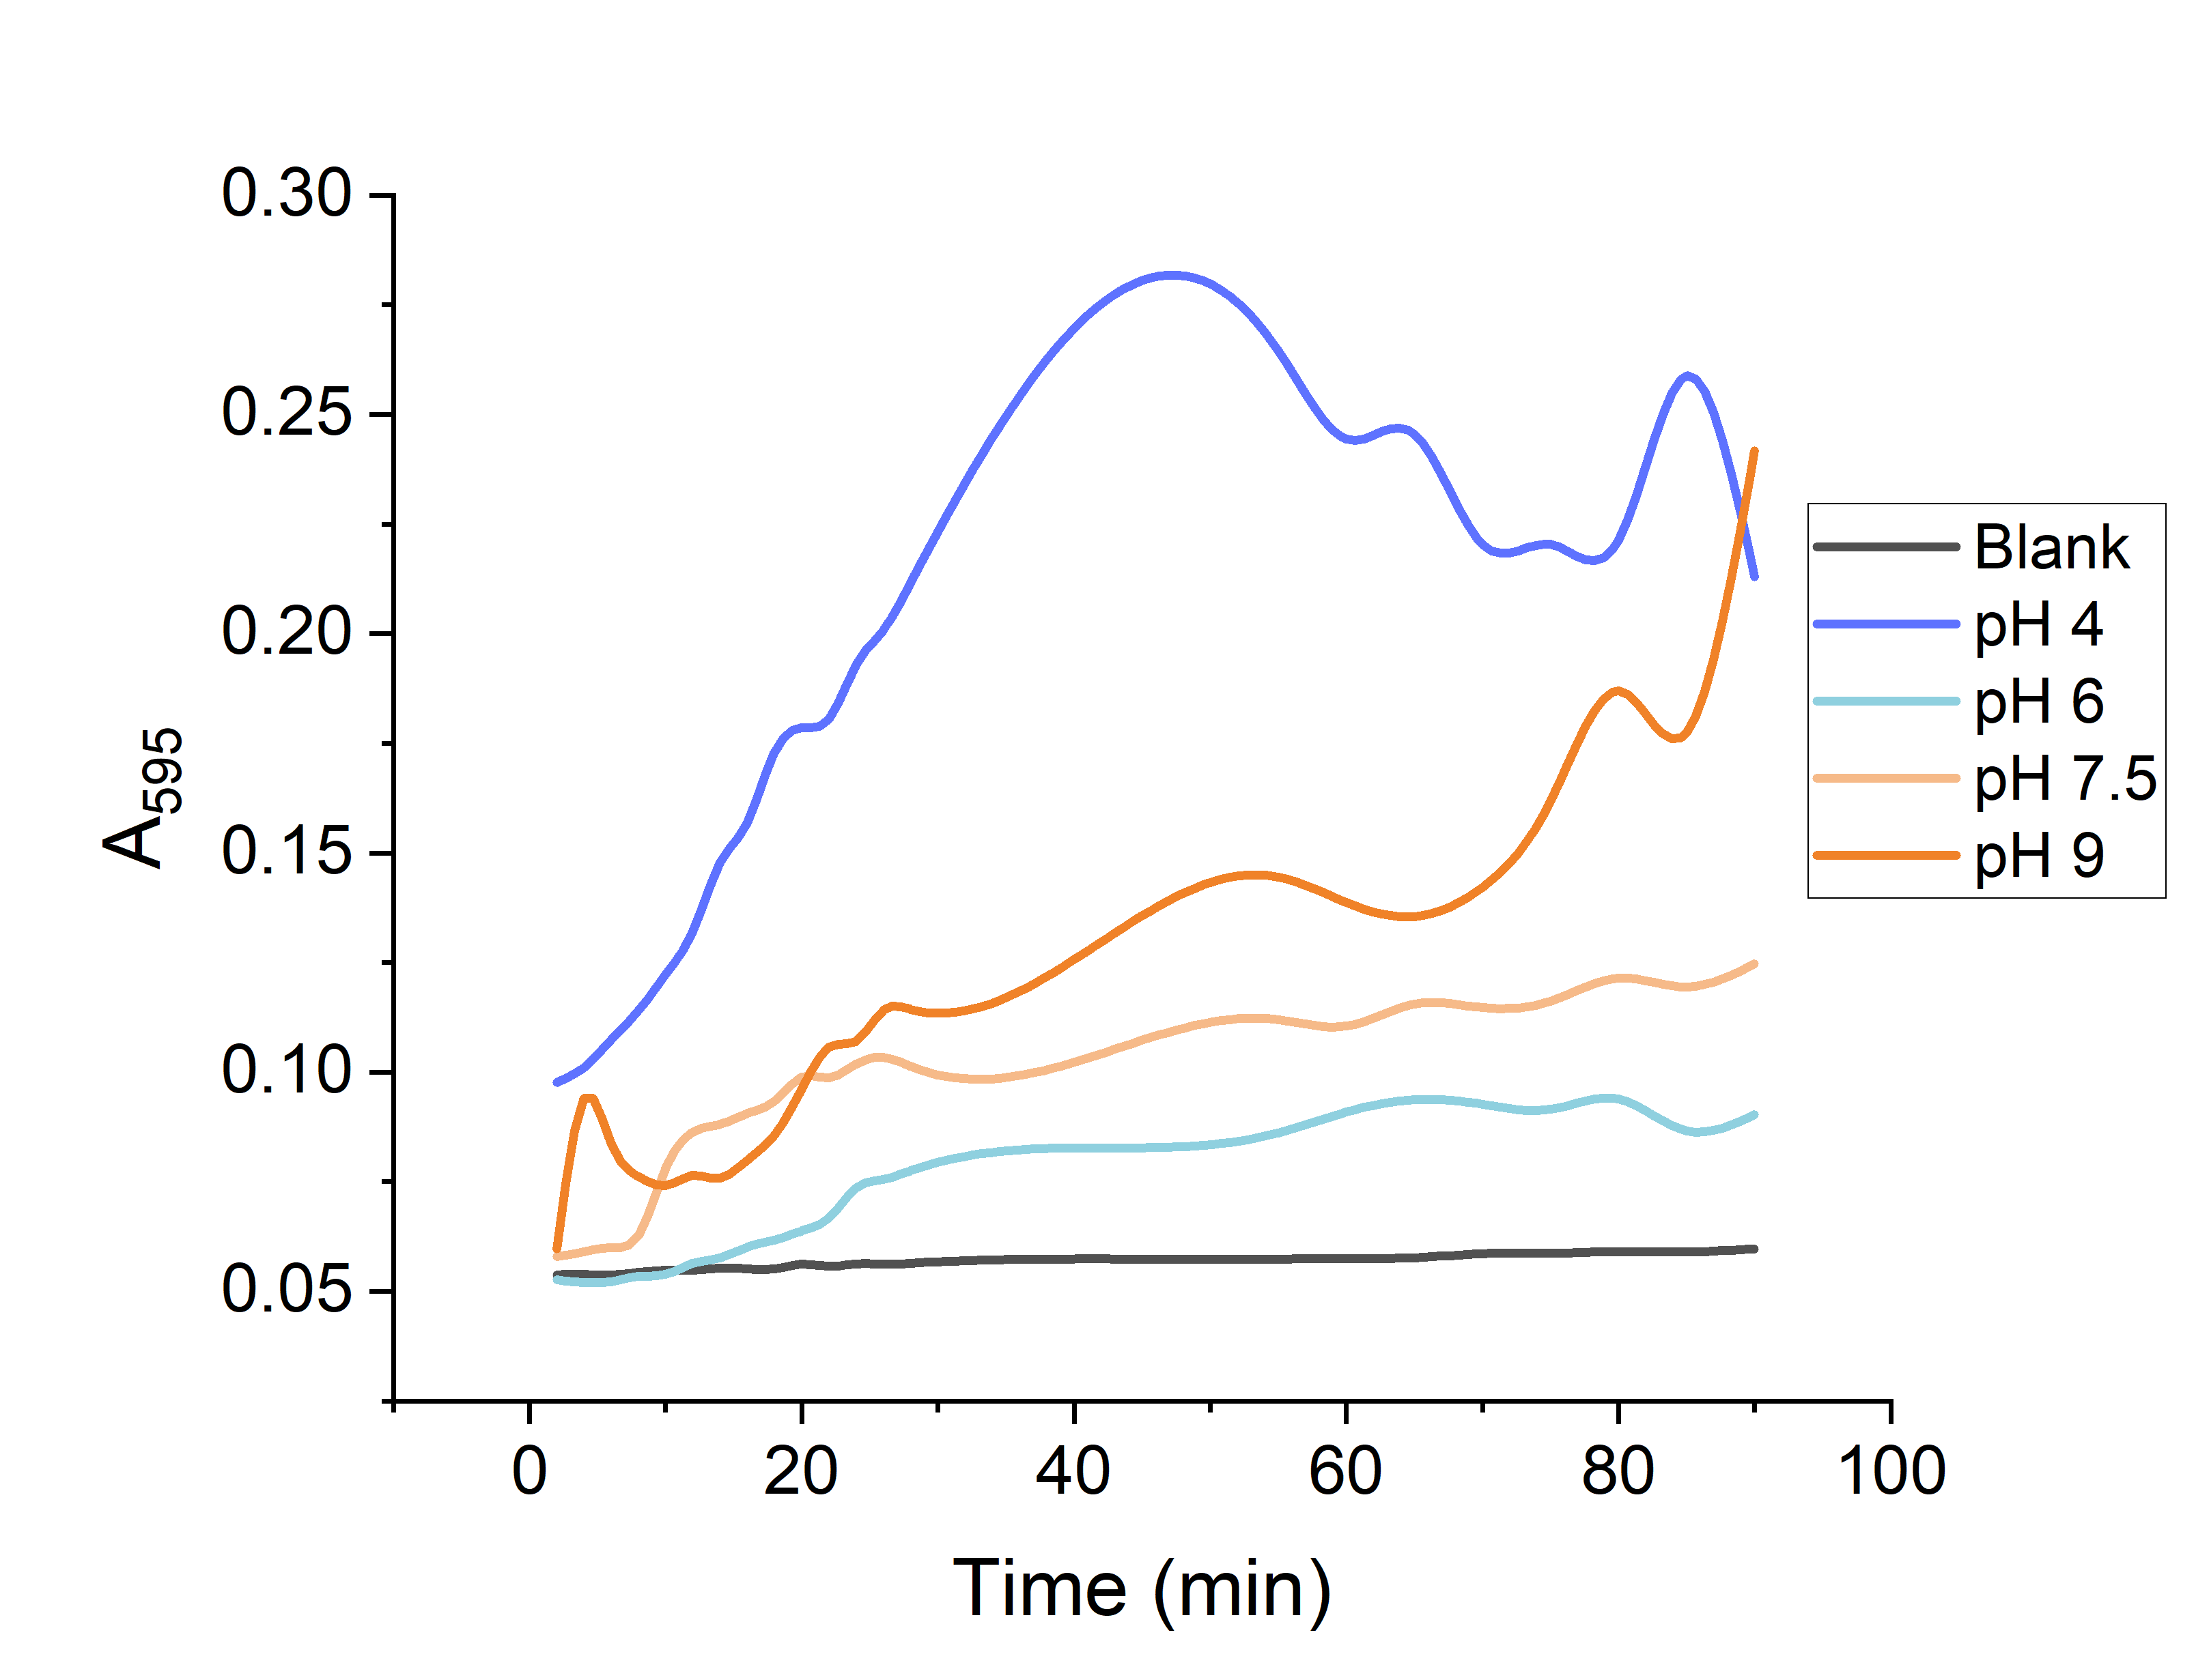
Figure S15. Effect of pH in structural stability of NOX. Time-dependent changes in absorbance at 595 nm of NOX (0.5 mg mL⁻¹) incubated at pH 4, 6, 7.5 and 9 at 25 ºC. Data represent mean values from at least three independent replicates.

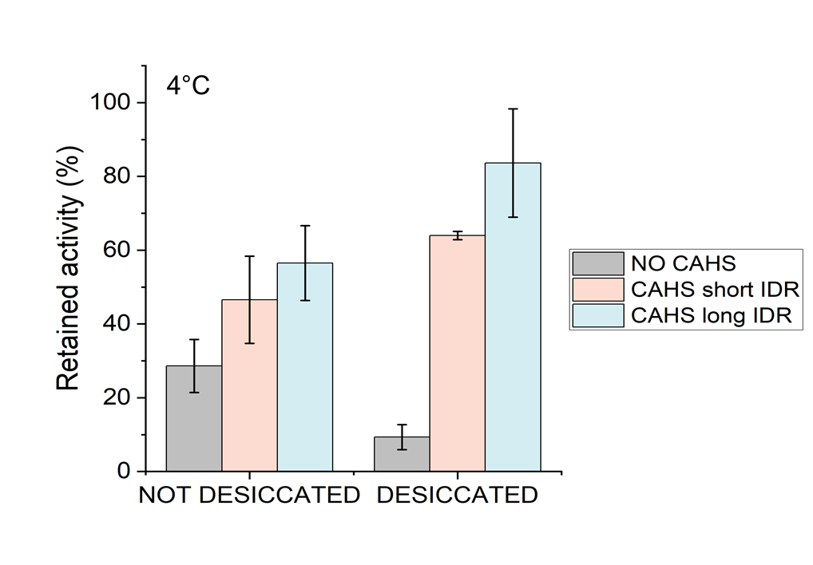
Figure S16. Stabilization of NOX by CAHS proteins at low temperature. Storage of NOX at 4 ºC in the presence or absence of CAHS, before and after a desiccation-rehydration cycle. Retained activity was calculated relative to the initial activity measured at time zero. Data represent mean values from at least three independent replicates.

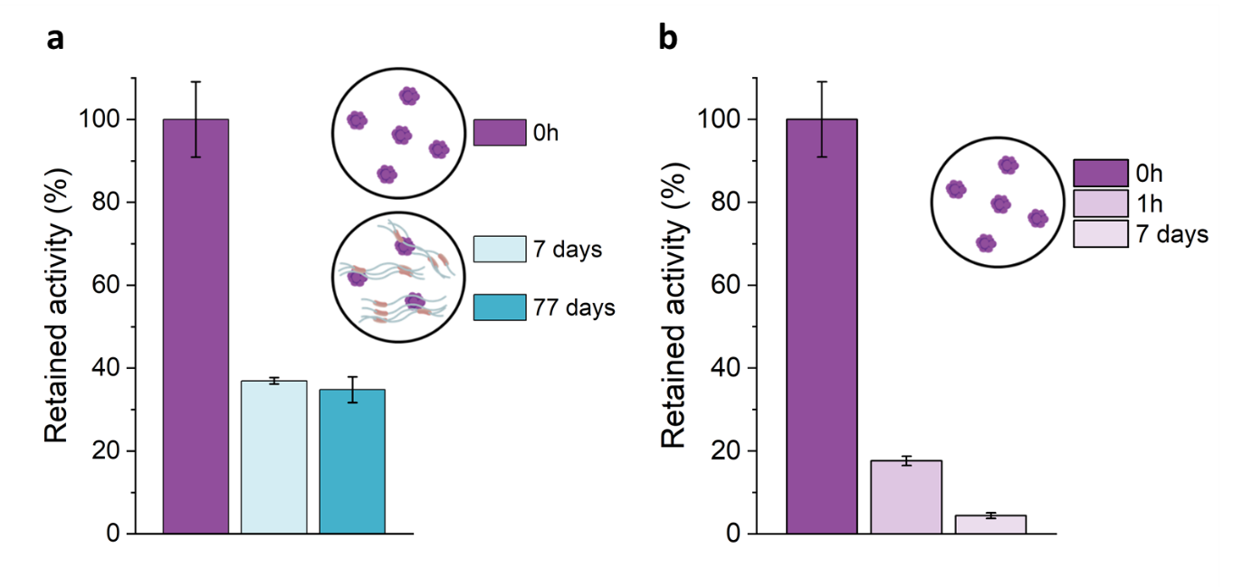
Figure S17. Storage stability of NOX at room temperature with/without addition of CAHS proteins. Retained NOX activity following a desiccation-rehydration cycle after a) supplementation with CAHS6 and storage for 7 or 77 days prior to rehydration, and after b) no CAHS supplementation and 1 h incubation at room temperature. Data represent mean values from at least three independent replicates.

a
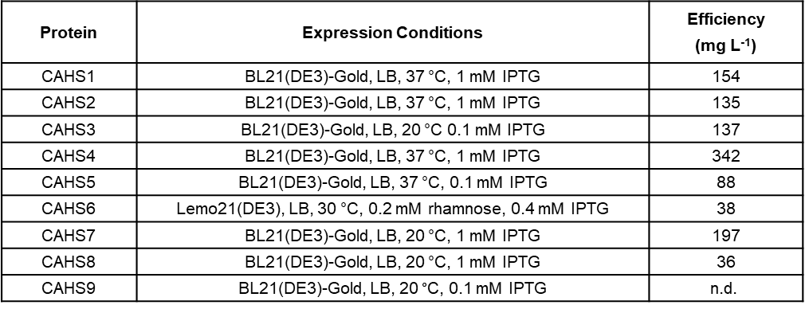
b

Figure S18. Expression of CAHS proteins. a) Overview of expression conditions. Columns indicate the E. coli strain, culture medium, incubation temperature, and inductor concentration. Kanamycin was used for antibiotic selection. Protein yield is reported as mg of purified protein per liter of culture (results were calculated as extrapolation from cultures of 100 mL). b) SDS-PAGE analysis of CAHS proteins (1 mg mL⁻¹). Lane 1: molecular weight marker; lanes 2-9: purified CAHS proteins by heat-lysis.

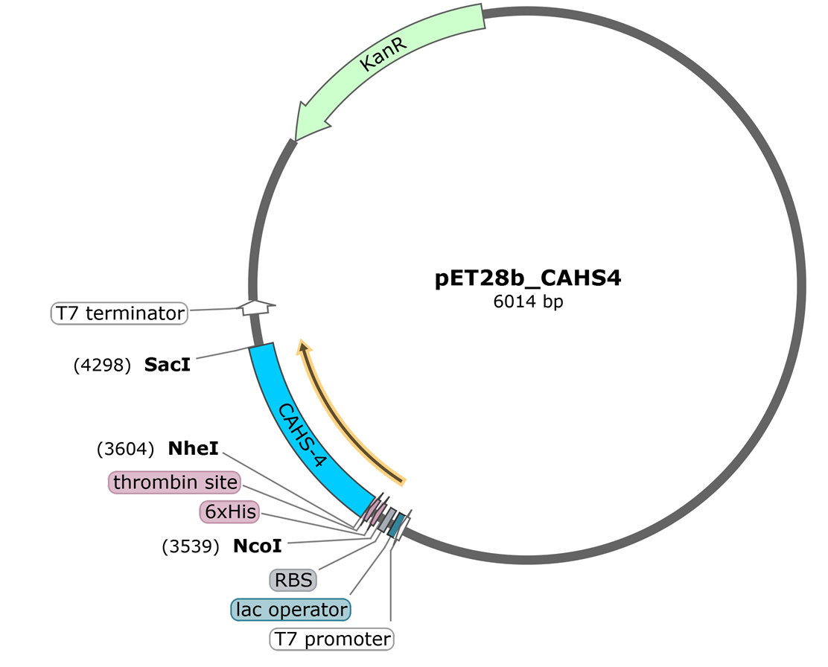

Figure S19. Plasmid map of pET-28b-CAHS4. The construct was synthesized by GenScript Biotech Corporation (Piscataway, NJ), and the map was generated using SnapGene. The same plasmid design was followed for the expression of all CAHS proteins.

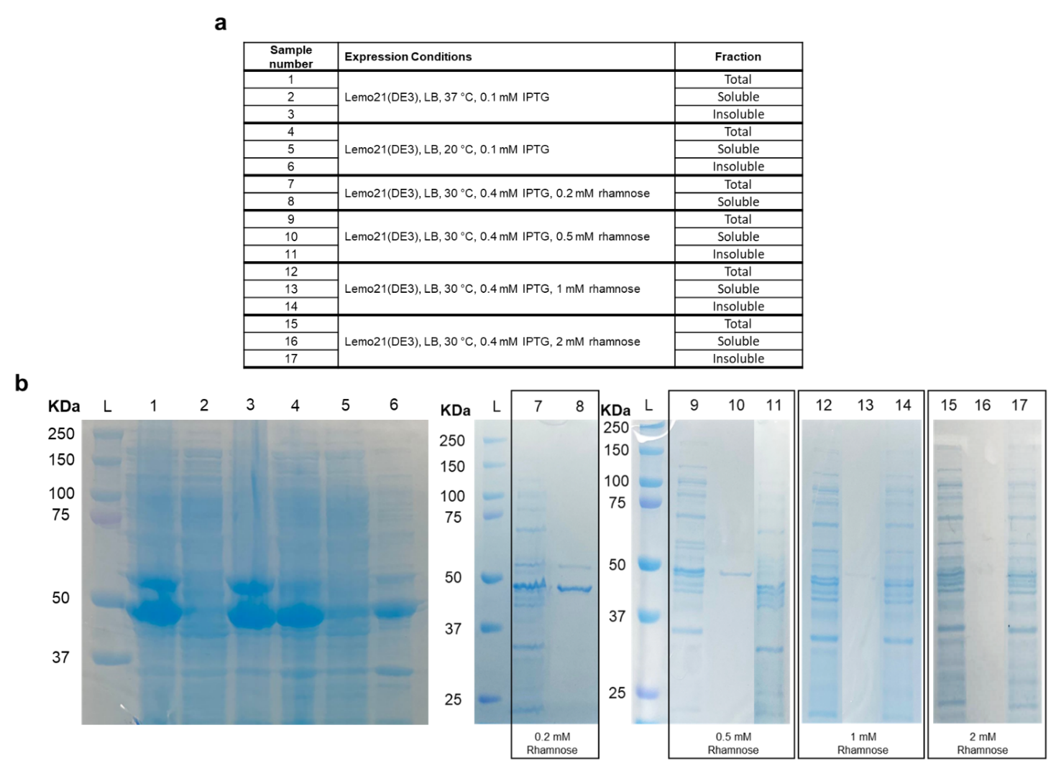
Figure S20. Optimization of expression conditions for CAHS6. a) Overview of expression conditions. Columns indicate the E. coli strain, culture medium, incubation temperature, and inducer/s concentration. Kanamycin was used for antibiotic selection. The third column indicates the different fractions after sonication and centrifugation. b) SDS-PAGE analysis of the different CAHS6 expression conditions. L: molecular weight ladder.

Table S3: IMAC purification buffers.
Protein | Buffer name | Composition
General | Loading buffer | 50 mM KPO₄, 30 mM Imidazole, pH 7.5
General | Elution buffer | 50 mM KPO₄, 300 mM Imidazole, pH 7.5
NOX | NOX Loading buffer | 0.001 mM FAD, 50 mM KPO₄, 30 mM Imidazole, pH 7.5
NOX | NOX Elution buffer | 0.001 mM FAD, 50 mM KPO₄, 300 mM Imidazole, pH 7.5
CAHS | Urea Loading buffer | 8 M Urea, 50 mM KPO₄, 30 mM Imidazole, pH 7.5
CAHS | Urea Elution buffer | 2 M Urea, 50 mM KPO₄, 300 mM Imidazole, pH 7.5

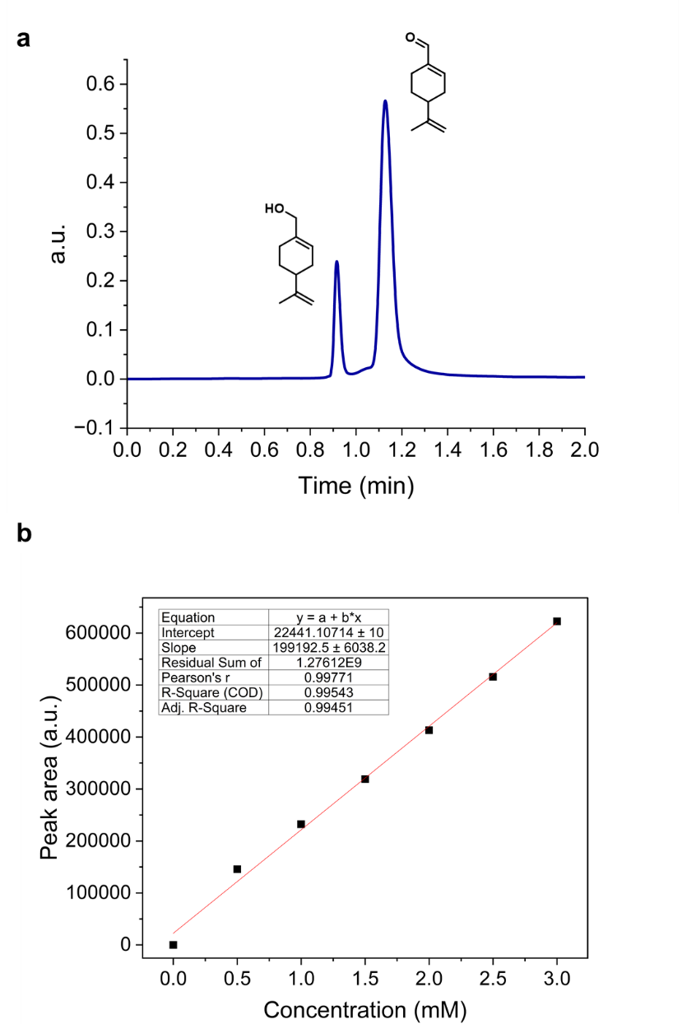
Figure S21. HPLC Analysis. a) HPLC chromatogram of the substrate (retention time = 0.91 min) and the resulting product (retention time = 1.13 min) from the biotransformation. b) Calibration curve for quantification of the biotransformation product (perillaldehyde).

Supporting References

1. Lotthammer, J. M. et al. Metapredict enables accurate disorder prediction across the Tree of Life. 2024.11.05.622168 Preprint at https://doi.org/10.1101/2024.11.05.622168 (2024).
2. Erdős, G., Pajkos, M. & Dosztányi, Z. IUPred3: prediction of protein disorder enhanced with unambiguous experimental annotation and visualization of evolutionary conservation. Nucleic Acids Res. 49, W297–W303 (2021).
3. Hunter, K. et al. Rational design of disordered proteins for sequence–function investigation. Nature 1–10 (2026) doi:10.1038/s41586-026-10849-1.
4. Abramson, J. et al. Accurate structure prediction of biomolecular interactions with AlphaFold 3. Nature 630, 493–500 (2024).
5. Gowers, R. J. et al. MDAnalysis: A Python Package for the Rapid Analysis of Molecular Dynamics Simulations. SciPy 2016 https://doi.org/10.25080/Majora-629e541a-00e (2016) doi:10.25080/Majora-629e541a-00e.
6. Sanchez-Martinez, S. et al. Labile assembly of a tardigrade protein induces biostasis. Protein Sci. 33, e4941 (2024).
7. Roura Padrosa, D., Marchini, V. & Paradisi, F. CapiPy: python-based GUI-application to assist in protein immobilization. Bioinformatics 37, 2761–2762 (2021).
8. CapiPy by inSEIT | Protein Surface Analysis. https://capipy.inseit.ch.

