Supplementary Material

Supplementary Tables

Supplementary Table 1 Comparison of associations of five composite indices with incident CMM in CHARLS and ELSA
Indicator | CHARLS |  |  |  | ELSA
Indicator | Q2 vs Q1 | Q3 vs Q1 | Q4 vs Q1 | P for trend | Q2 vs Q1 | Q3 vs Q1 | Q4 vs Q1 | P for trend
TyG-WHtR | 1.30 (1.09–1.57) | 1.84 (1.54–2.18) | 3.18 (2.70–3.74) | <0.001 | 1.03 (0.78–1.36) | 1.18 (0.89–1.55) | 1.49 (1.14–1.95) | 0.001
TyG-BRI | 1.34 (1.12–1.61) | 1.78 (1.49–2.11) | 3.06 (2.60–3.61) | <0.001 | 1.05 (0.79–1.39) | 1.19 (0.91–1.57) | 1.42 (1.08–1.86) | 0.006
AIP-WHtR | 1.04 (0.88–1.23) | 1.47 (1.26–1.72) | 2.10 (1.81–2.44) | <0.001 | 1.11 (0.85–1.45) | 1.16 (0.89–1.52) | 1.41 (1.08–1.84) | 0.012
AIP-BRI | 1.09 (0.92–1.30) | 1.55 (1.32–1.81) | 2.35 (2.02–2.74) | <0.001 | 0.94 (0.72–1.22) | 0.99 (0.76–1.30) | 1.25 (0.97–1.61) | 0.077
ICMRS | 1.20 (1.01–1.43) | 1.75 (1.48–2.06) | 2.57 (2.20–3.00) | <0.001 | 0.97 (0.73–1.29) | 1.33 (1.02–1.73) | 1.52 (1.17–1.98) | <0.001
Notes: Results are from fully adjusted Cox proportional hazards models (Model 3). Model 3 was adjusted for age, sex, education, marital status, smoking, drinking, hypertension, history of cancer, systolic blood pressure, diastolic blood pressure, total cholesterol, HDL-C, and LDL-C.

Supplementary Table 2 Interaction between cohort and composite indices for incident CMM in the pooled CHARLS and ELSA analysis
Indicator | CHARLS HR (95% CI) per 1 SD | ELSA HR (95% CI) per 1 SD | P for interaction
TyG-WHtR | 1.22 (1.18–1.26) | 1.09 (1.04–1.14) | <0.001
TyG-BRI | 1.08 (1.06–1.11) | 1.04 (0.99–1.09) | 0.101
AIP-WHtR | 1.33 (1.27–1.40) | 1.12 (1.02–1.22) | <0.001
AIP-BRI | 1.13 (1.11–1.16) | 1.02 (0.93–1.12) | 0.001
ICMRS | 1.28 (1.24–1.32) | 1.13 (1.06–1.20) | <0.001
Abbreviations: HR, hazard ratio; CI, confidence interval; CMM, cardiometabolic multimorbidity. Hazard ratios were estimated using Cox proportional hazards models (Model 3). Model 3 was adjusted for age, sex, education, marital status, smoking, drinking, hypertension, history of cancer, systolic blood pressure, diastolic blood pressure, total cholesterol, HDL-C, and LDL-C. P for interaction was obtained by testing the interaction between each standardized composite index and cohort indicator in the pooled dataset.

Supplementary Table S3. Sensitivity analyses of the associations between five composite indices and incident cardiometabolic multimorbidity in CHARLS
Sensitivity analysis | Indicator | Q2 vs Q1 HR | Q3 vs Q1 HR | Q4 vs Q1 HR
Sensitivity analysis | Indicator | (95%CI) | (95%CI) | (95%CI)
Hypertension included in CMM definition | TyG-WHtR | 1.35 (1.15–1.58) | 1.85 (1.58–2.16) | 3.07 (2.65–3.55)
 | TyG-BRI | 1.42 (1.21–1.66) | 1.79 (1.53–2.09) | 3.03 (2.61–3.51)
 | AIP-WHtR | 1.09 (0.94–1.27) | 1.52 (1.32–1.76) | 2.13 (1.86–2.44)
 | AIP-BRI | 1.15 (0.99–1.34) | 1.59 (1.38–1.84) | 2.38 (2.07–2.73)
 | ICMRS | 1.20 (1.02–1.40) | 1.79 (1.55–2.08) | 2.52 (2.19–2.90)
Excluding early events | TyG-WHtR | 1.36 (1.00–1.84) | 2.02 (1.52–2.69) | 2.89 (2.19–3.81)
 | TyG-BRI | 1.39 (1.03–1.89) | 2.10 (1.58–2.79) | 2.84 (2.14–3.75)
 | AIP-WHtR | 1.02 (0.77–1.35) | 1.33 (1.02–1.72) | 1.86 (1.45–2.39)
 | AIP-BRI | 1.07 (0.81–1.43) | 1.40 (1.07–1.83) | 2.08 (1.62–2.68)
 | ICMRS | 1.24 (0.93–1.66) | 1.52 (1.15–2.00) | 2.34 (1.81–3.04)
Complete-case analysis | TyG-WHtR | 1.31 (1.09–1.57) | 1.83 (1.54–2.18) | 3.18 (2.70–3.74)
 | TyG-BRI | 1.35 (1.13–1.62) | 1.78 (1.50–2.12) | 3.07 (2.61–3.62)
 | AIP-WHtR | 1.04 (0.88–1.23) | 1.47 (1.26–1.72) | 2.10 (1.81–2.44)
 | AIP-BRI | 1.08 (0.91–1.29) | 1.54 (1.31–1.81) | 2.34 (2.02–2.73)
 | ICMRS | 1.20 (1.01–1.44) | 1.75 (1.48–2.06) | 2.57 (2.20–3.00)
Abbreviations: HR, hazard ratio; CI, confidence interval; CMM, cardiometabolic multimorbidity; TyG, triglyceride-glucose index; WHtR, waist-to-height ratio; BRI, body roundness index; AIP, atherogenic index of plasma; ICMRS, integrated cardiometabolic risk score.
Notes: Fully adjusted Cox proportional hazards models were used. Models were adjusted for age, sex, education, marital status, smoking, and drinking. In the sensitivity analysis including stroke, CMM was redefined as the presence of at least two of the following conditions: hypertension, diabetes, heart disease, and stroke. In the analysis excluding early incident cases, participants who developed incident CMM at the earliest follow-up wave were excluded. Complete-case analysis was restricted to participants with complete covariate information.

Supplementary Table S4.Sensitivity analyses of the associations between five composite indices and incident cardiometabolic multimorbidity in ELSA
Sensitivity analysis | Indicator | Q2 vs Q1 HR | Q3 vs Q1 HR | Q4 vs Q1 HR
Sensitivity analysis | Indicator | (95%CI) | (95%CI) | (95%CI)
Excluding early events | TyG-WHtR | 1.03 (0.78–1.36) | 1.18 (0.89–1.55) | 1.49 (1.14–1.95)
 | TyG-BRI | 1.05 (0.79–1.39) | 1.19 (0.91–1.57) | 1.42 (1.08–1.86)
 | AIP-WHtR | 1.11 (0.85–1.45) | 1.16 (0.89–1.52) | 1.41 (1.08–1.84)
 | AIP-BRI | 0.94 (0.72–1.22) | 0.99 (0.76–1.30) | 1.25 (0.97–1.61)
 | ICMRS | 0.97 (0.73–1.29) | 1.33 (1.02–1.73) | 1.52 (1.17–1.98)
Complete-case analysis | TyG-WHtR | 1.03 (0.78–1.36) | 1.18 (0.89–1.55) | 1.49 (1.14–1.95)
 | TyG-BRI | 1.05 (0.79–1.39) | 1.19 (0.91–1.57) | 1.42 (1.08–1.86)
 | AIP-WHtR | 1.11 (0.85–1.45) | 1.16 (0.89–1.52) | 1.41 (1.08–1.84)
 | AIP-BRI | 0.94 (0.72–1.22) | 0.99 (0.76–1.30) | 1.25 (0.97–1.61)
 | ICMRS | 0.97 (0.73–1.29) | 1.33 (1.02–1.73) | 1.52 (1.17–1.98)
Abbreviations: HR, hazard ratio; CI, confidence interval; CMM, cardiometabolic multimorbidity; TyG, triglyceride-glucose index; WHtR, waist-to-height ratio; BRI, body roundness index; AIP, atherogenic index of plasma; ICMRS, integrated cardiometabolic risk score.
Notes: Fully adjusted Cox proportional hazards models were used. Models were adjusted for age, sex, education, marital status, smoking, and drinking. In ELSA, excluding early incident cases did not materially change the analytic sample, and complete-case analysis yielded results essentially identical to the primary analysis,

Supplementary Figures

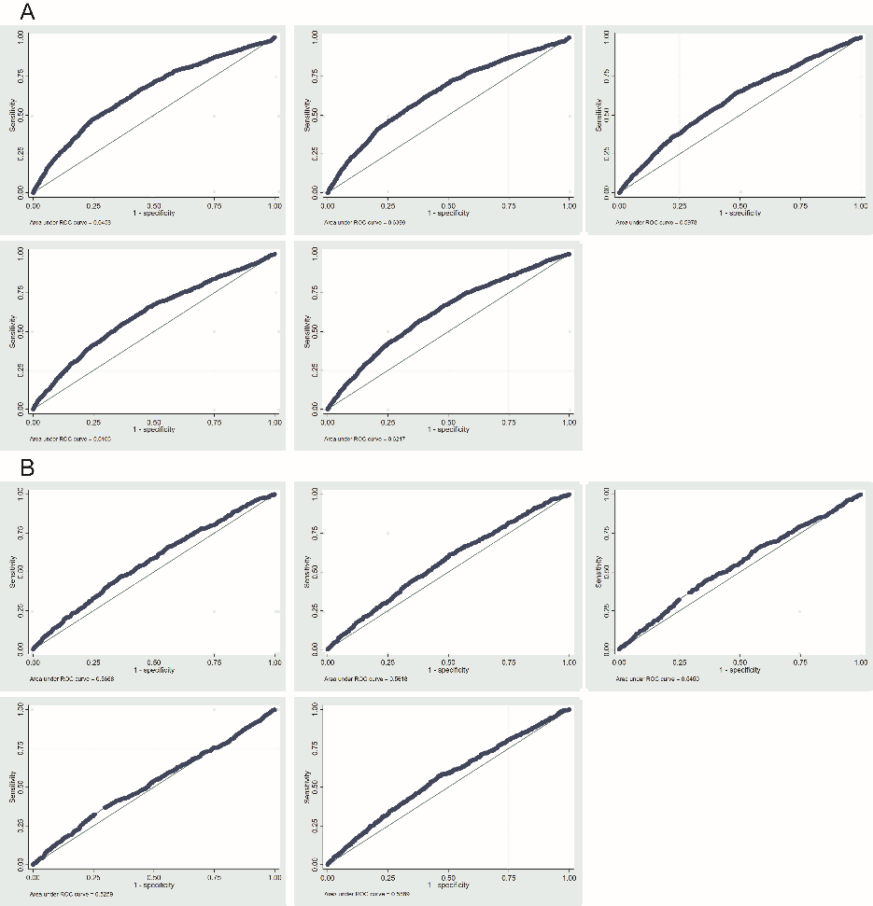

Supplementary Figure S1 ROC curves of five composite indices for incident CMM in CHARLS and ELS. A The ROC curves in the CHARLS cohort. B The ROC curves in the ELSA cohort.

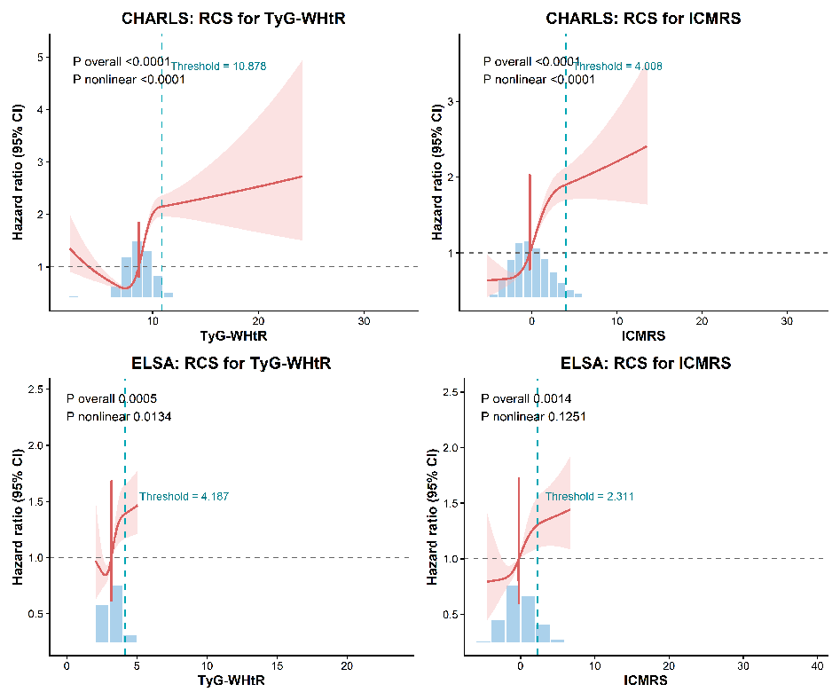

Supplementary Figure S2 Threshold effect analysis of TyG-WHtR and ICMRS for incident CMM.
Restricted cubic spline curves show the associations of TyG-WHtR and ICMRS with the risk of incident cardiometabolic multimorbidity (CMM) in the CHARLS and ELSA cohorts. The red solid line represents the adjusted hazard ratio, and the shaded area indicates the 95% confidence interval. The grey dashed horizontal line indicates HR = 1. The blue-green dashed vertical line indicates the threshold identified by two-piecewise Cox regression. Histograms at the bottom show the distribution of each exposure.

