Greenspace availability or greenspace usability, which matters on PM_{2.5}-related premature deaths: evidence from 360 cities in China

Table of Contents
Supplementary Figures ……………………………………………………………...3
Supplementary Fig. 1 3
Supplementary Fig. 2 4
Supplementary Fig. 3 5
Supplementary Fig. 4 6
Supplementary Fig. 5 7
Supplementary Fig. 6 8
Supplementary Tables 9
Supplementary Table 1 9
Supplementary Table 2 10
Supplementary Table 3 11
Supplementary Table 4 13
Supplementary References 14

Supplementary Figures
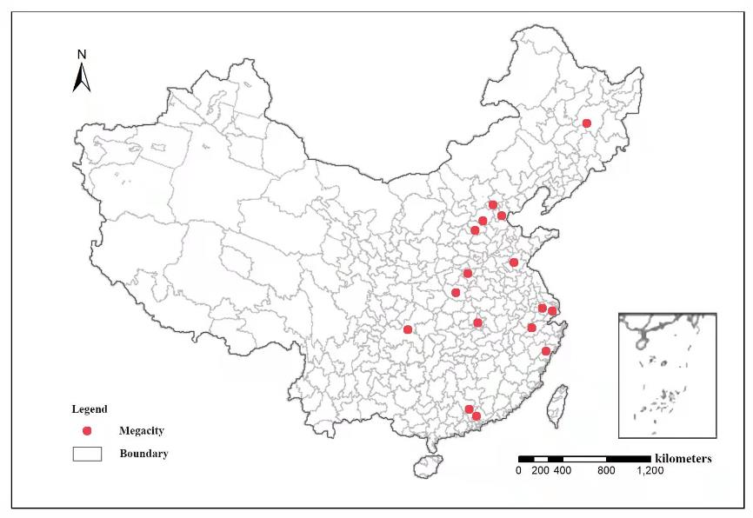
Supplementary Fig. 1 Administrative divisions of 360 cities in China.

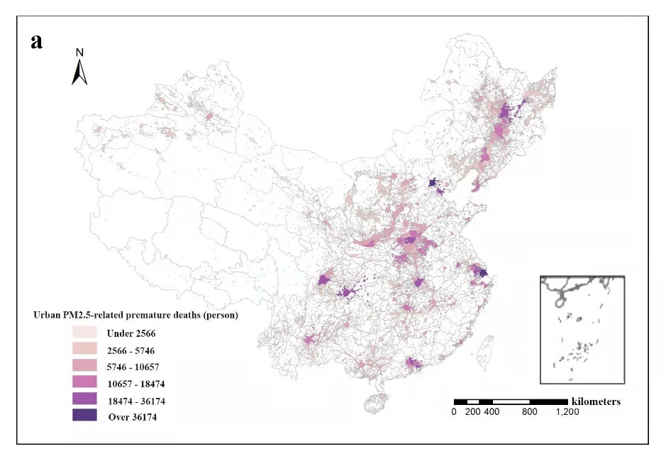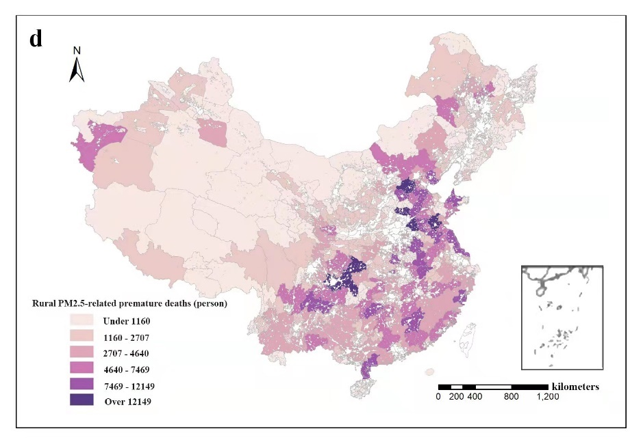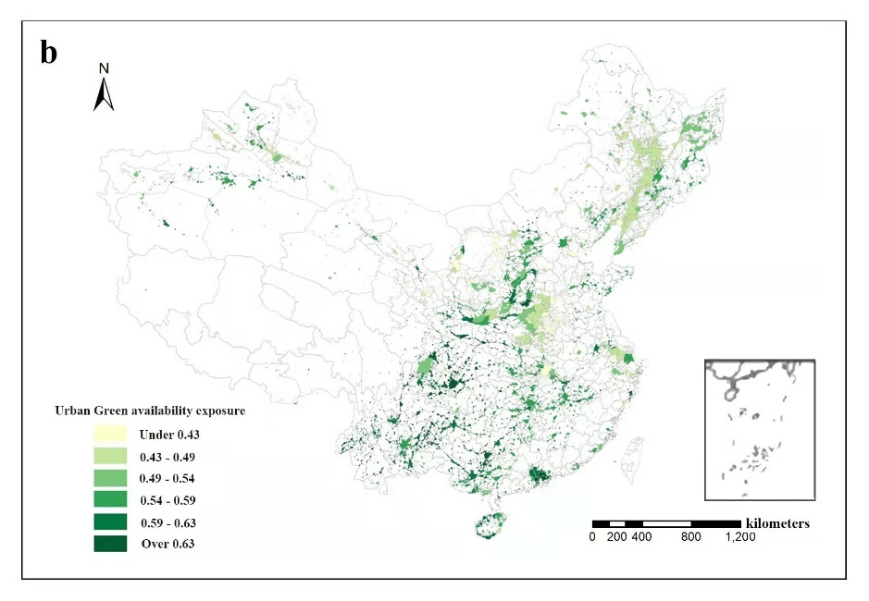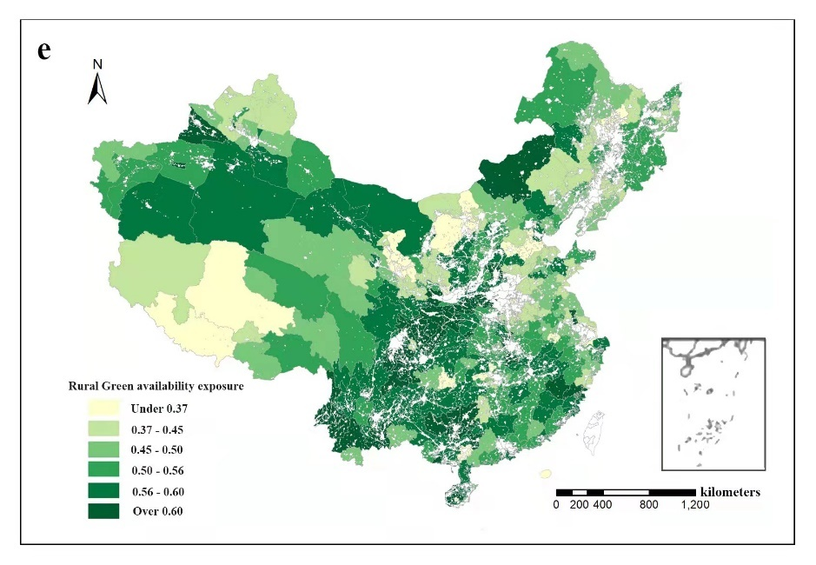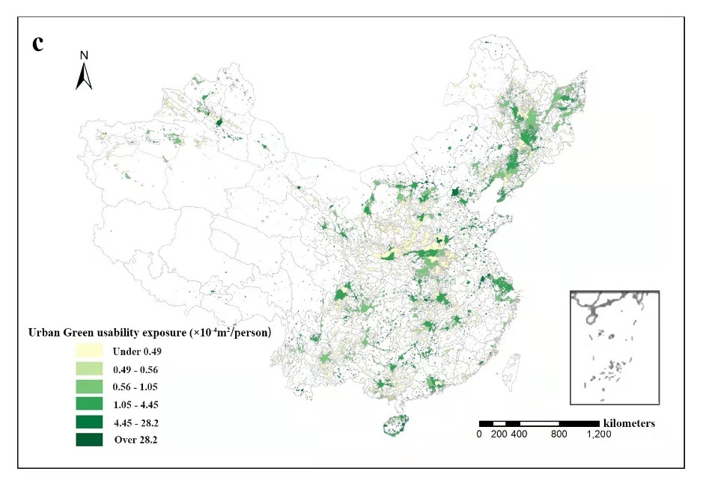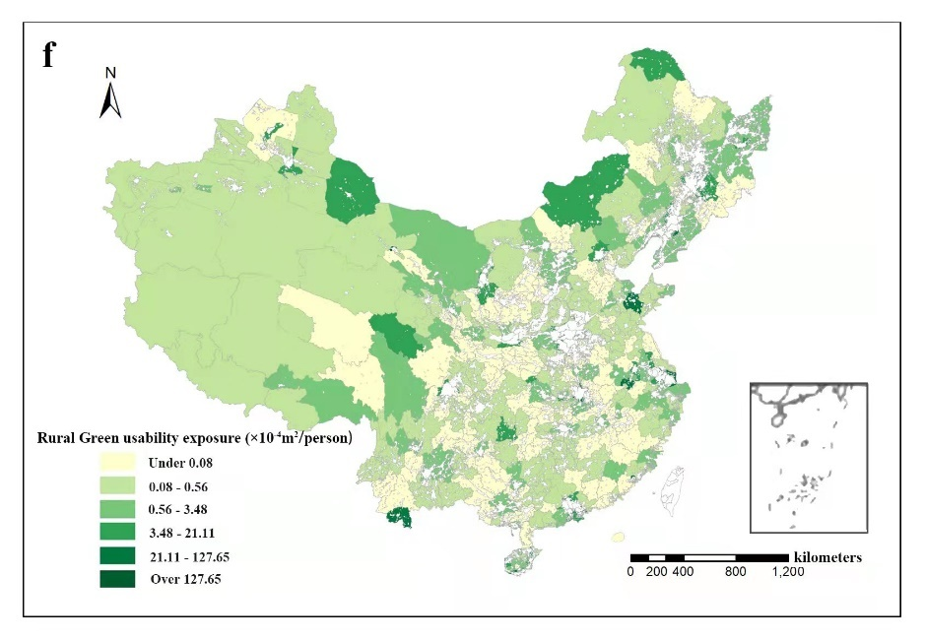
Supplementary Fig. 2 Urban PM2.5-related premature deaths (a), urban greenspace availability exposure (b), urban greenspace usability exposure (c) and rural PM2.5-related premature deaths (d), rural greenspace availability exposure (e), urban greenspace usability exposure (f) for 360 China cities in 2017^{1, 2, 3}. Source data were provided as a Source Data file.

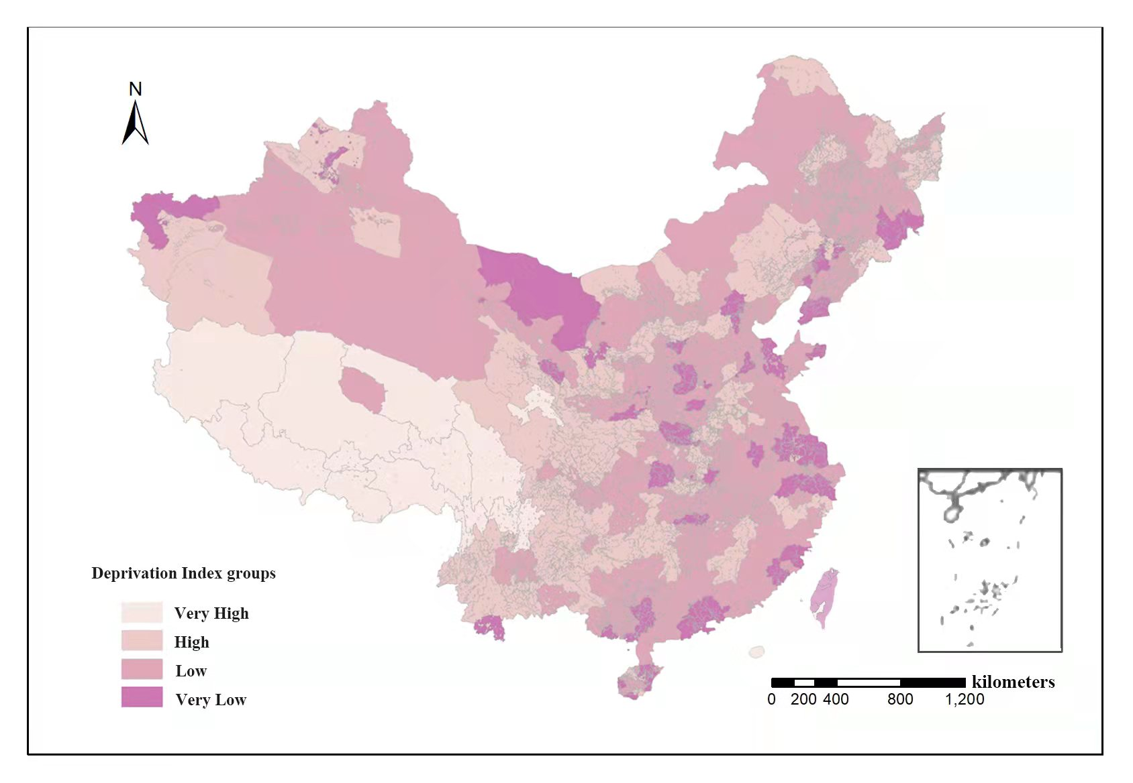
Supplementary Fig. 3 Deprivation level of 360 China cities in 2017. Source data of Deprivation Index were provided as a Source Data file.

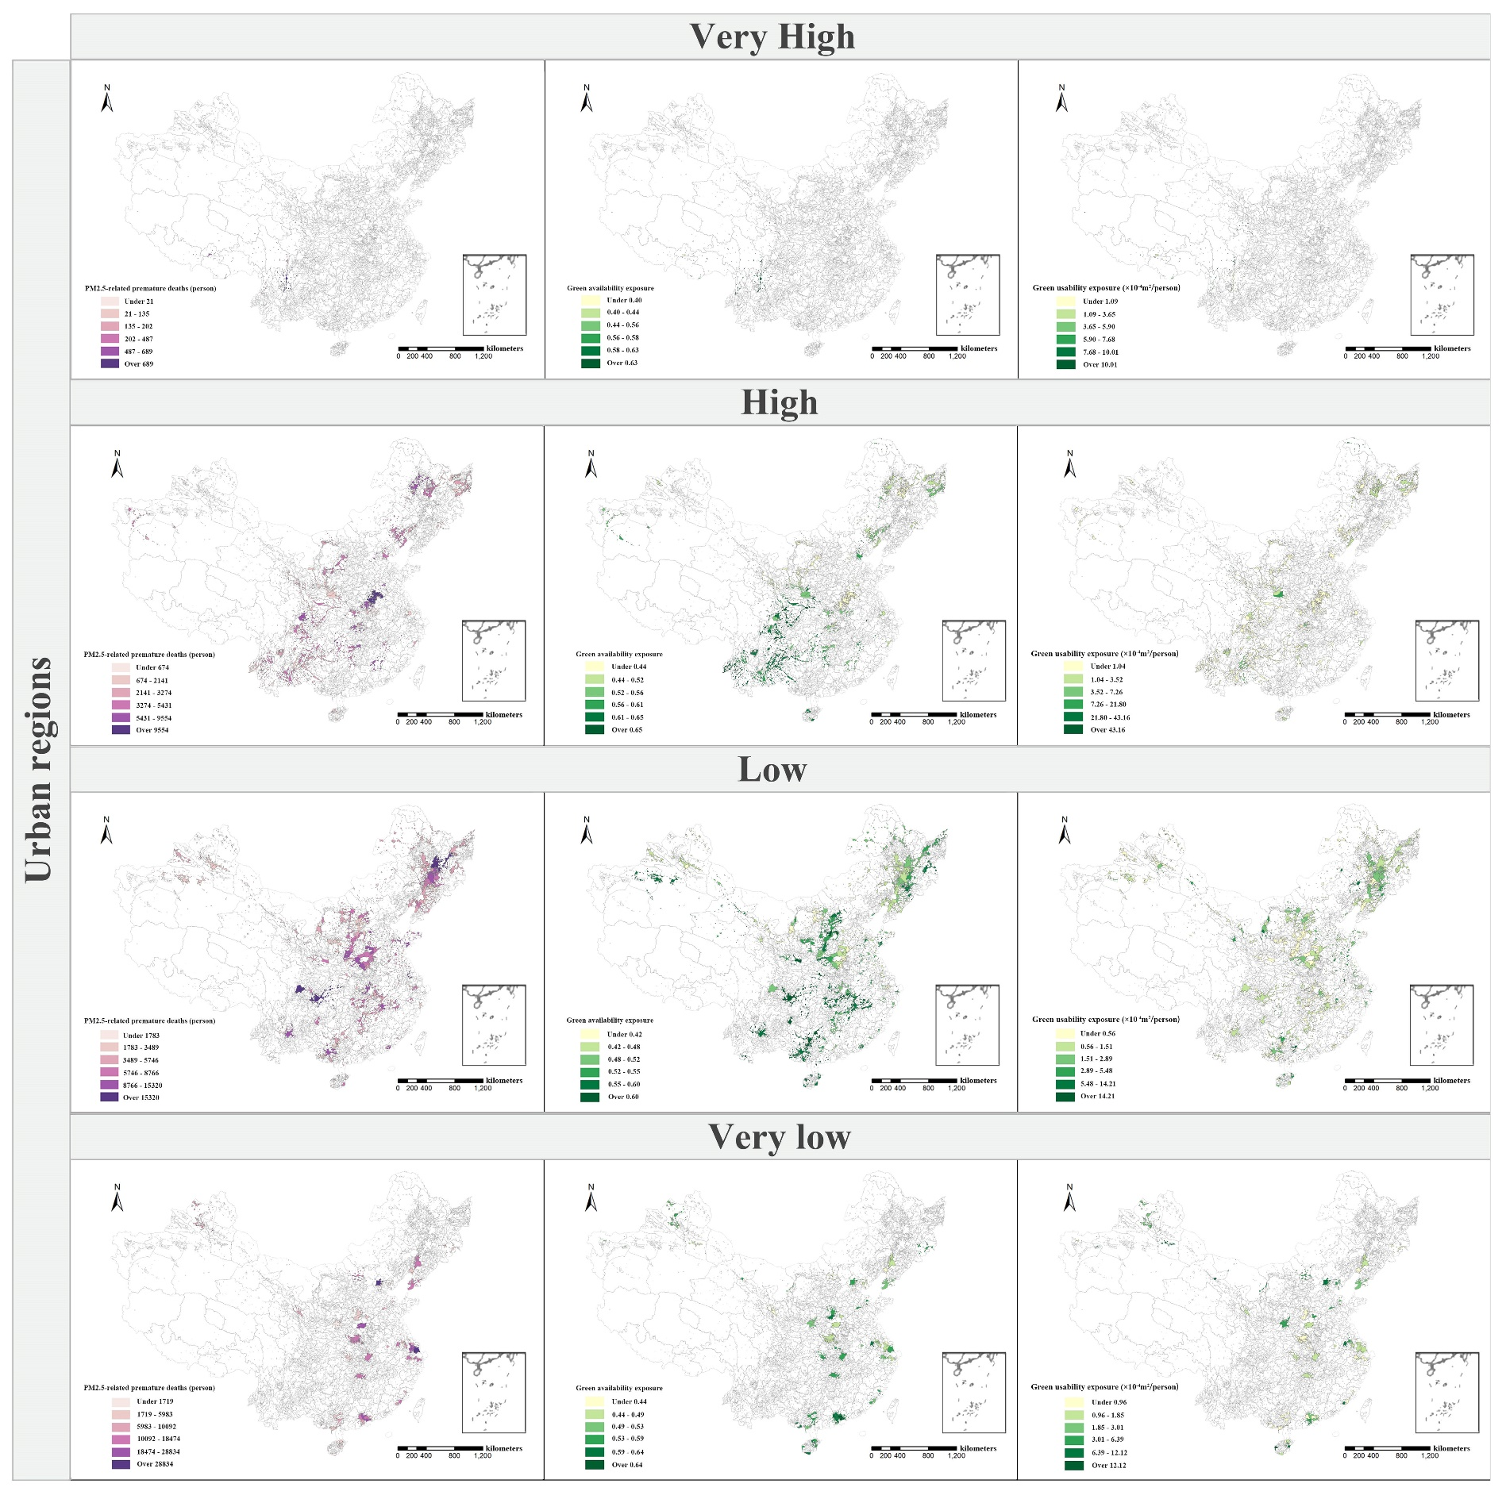
Supplementary Fig. 4 Greenspace availability exposure, Greenspace usability exposure and PM_{2.5}-related premature deaths in 360 China cities’ urban regions of four DI groups in 2017. Source data were provided as a Source Data file.

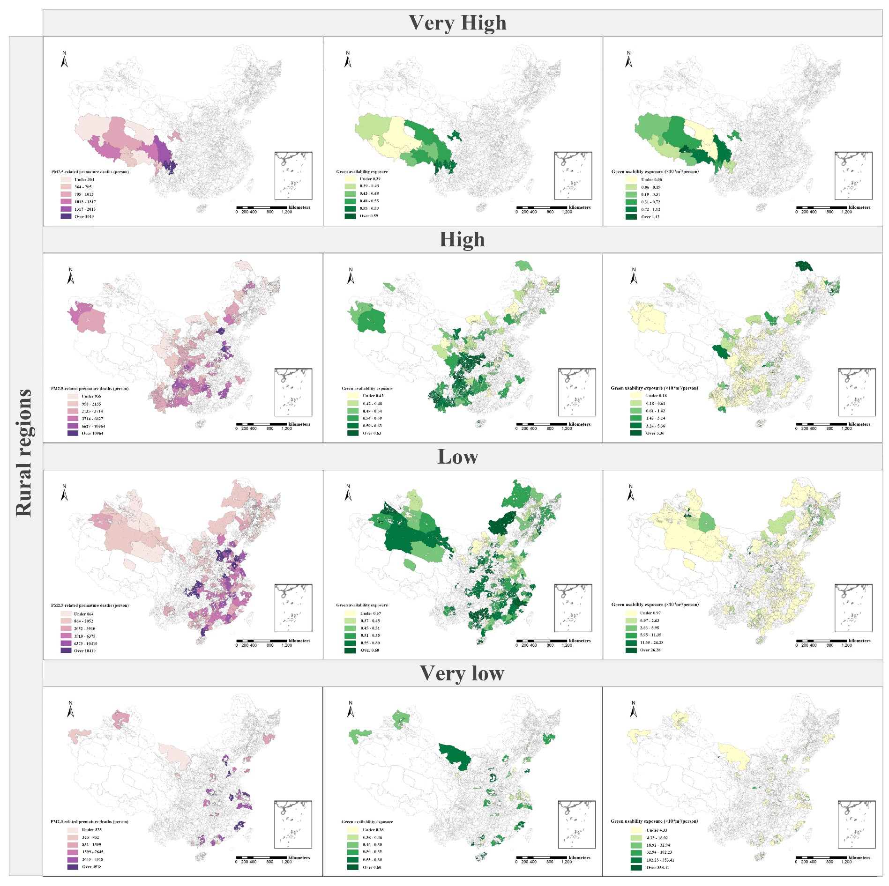
Supplementary Fig. 5 Greenspace availability exposure, Greenspace usability exposure and PM_{2.5}-related premature deaths in 360 China cities’ rural regions of four DI groups in 2017. Source data were provided as a Source Data file.

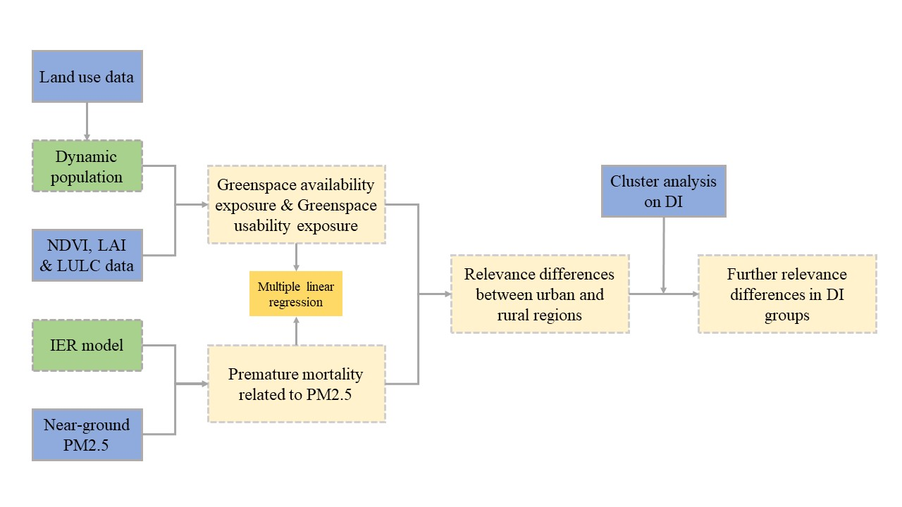
Supplementary Fig. 6 Schematic of the methodology used in this study.

Supplementary Tables
Supplementary Table 1. Greenspace availability exposure, greenspace usability exposure and PM2.5-related deaths in 17 megacities.
Megacities | Urban |  |  | Rural |  |  | Population⁴
Megacities | GAVE | GUE | M_{PM2.5} | GAVE | GUE | M_{PM2.5} | Population⁴
Shanghai | 0.56 | 1.69 | 56068 | 0.36 | 21.36 | 1308 | 28541227
Chongqing | 0.65 | 0.73 | 36174 | 0.59 | 0.31 | 20604 | 28244132
Beijing | 0.55 | 9.36 | 46274 | 0.54 | 12.52 | 3557 | 24788031
Chengdu | 0.49 | 1.37 | 31956 | 0.57 | 7.74 | 895 | 16341505
Tianjin | 0.43 | 1.87 | 25090 | 0.44 | 1.96 | 5958 | 15444378
Guangzhou | 0.62 | 2.43 | 28834 | 0.53 | 16.69 | 1599 | 15138749
Shenzhen | 0.74 | 2.63 | 26387 | 0.64 | 51.69 | 212 | 13231473
Suzhou | 0.49 | 1.85 | 23329 | 0.45 | 10.63 | 632 | 11919121
Baoding | 0.43 | 0.82 | 6900 | 0.44 | 0.05 | 16794 | 11786370
Harbin | 0.48 | 0.83 | 20986 | 0.51 | 2.23 | 2052 | 11573554
Wuhan | 0.39 | 1.82 | 21525 | 0.48 | 17.20 | 478 | 10945088
Shijiazhuang | 0.46 | 2.56 | 10332 | 0.33 | 0.32 | 11595 | 10907794
Nanyang | 0.48 | 0.61 | 17297 | 0.55 | 0.50 | 4518 | 10851428
Wenzhou | 0.45 | 0.67 | 14954 | 0.49 | 0.24 | 5831 | 10339703
Linyi | 0.49 | 2.78 | 6601 | 0.48 | 0.13 | 14002 | 10248557
Zhengzhou | 0.46 | 1.45 | 20433 | 0.57 | 53.58 | 130 | 10228763
Hangzhou | 0.52 | 0.87 | 16227 | 0.54 | 0.58 | 4145 | 10134066
Note: The units of GUE, M_{PM2.5} and Population were 10⁻⁴m²/person, person and person. GAVE was dimensionless.

Supplementary Table 2. K-means Cluster analysis on Deprivation Index (DI)⁵ groups (p＜0.001) .
Clusters | Cases in each cluster |  |  | Initial cluster center |  | Final cluster center
Very high |  | 13 | 1.0000 |  | 0.8733
High |  | 108 | 0.7009 |  | 0.5879
Low |  | 176 | 0.3502 |  | 0.4460
Very low |  | 63 | 0.0000 |  | 0.3018

Supplementary Table 3. Deprivation Index (DI) groups details.
DI groups | Cities included in each groups
Very High  (n=13) | Ali, Changdu, Diqing, Gannan Tibetan Autonomous Prefecture, Ganzi Tibetan Autonomous Prefecture, Lhasa, Liangshan Yi Autonomous Prefecture, Linzhi, Nagqu, Nujiang, Shigatse, Shannan, Yushu Tibetan Autonomous Prefecture
High  (n=108) | Aba Tibetan & Qiang Autonomous Prefecture, Ankang, Anshun, Bayannur, Bazhong, Baishan, Baise, Baoding, Baoshan, Baoting, Bijie, Haozhou, Bortala Mongolian Autonomous Prefecture, Chaoyang, Chengde, Chifeng, Dazhou, Dali, Daxinganling, Danzhou, Dehong, Deyang, Dingxi, Fuzhou, Fuxin, Ganzhou, Guyuan, Guangan, Guangyuan, Guoluo Tibetan Autonomous Prefecture, Haibei Tibetan Autonomous Prefecture, Haidong, Hainan Tibetan Autonomous Prefecture, Hanzhong, Hetian, Heze, Hegang, Honghe, Hulu island, Huaihua, Huangnan Tibetan Autonomous Prefecture, Jixi, Jining, Jingzhou, Kashi, Leshan, Lijiang, Lishui, Liaocheng, Lincang, Linxia Hui Autonomous Prefecture, Lingshui Li Autonomous County, Liupanshui, Longnan, Loudi, Luzhou, Meishan, Mianyang, Nanchong, Neijiang, Panzhihua, Pingliang, Puer, Qitaihe, Qiqihaer, Qianjiang, Miao & and Dong in Southeast Guizhou, Buyi in South Guizhou, Buyi in Southwest Guizhou, Qingyang, Qujing, Quzhou, Shangluo, Shangqiu, Shaoyang, Shennongjia Forest, Shuangyashan, Suzhou, Suihua, Tianjin, Tianmen, Tongchuan, Tongling, Wenzhou, Wenshan, Wuxi, Wuzhishan, Xi an, Xianyang, Xiangtan, Xiangxi Tujia & Miao Autonomous Prefecture, Xiangyang, Xinyang, Xinganmeng, Yaan, Yichun, Yibing, Yongzhou, Yulin, Yuxi, Zhangjiajie, Zhaotong, Zhongwei, Zhoukou, Zhumadian, Ziyang, Zigong, Zunyi
Low  (n=176) | Aksu, Alar, Altay, Anqing, Anyang, Anshan, Bayingoleng Mongolian Autonomous Prefecture, Baicheng, Baisha Li Autonomous County, Baiyin, Bengbu, Baotou, Baoji, Benxi, Binzhou, Cangzhou, Changji Hui Autonomous Prefecture, Changjiang Li Autonomous County, Changde, Chaozhou, Chenzhou, Chengdu, Chizhou, Chongzuo, Chuzhou, Chuxiong, Daqing, Datong, Dandong, Dezhou, Ordos, Ezhou, Enshi Tujia & Miao Autonomous Prefecture, Fushun, Fuyang, Guiyang, Guilin, Harbin, Hami, Haixi Mongolian & Tibetan Autonomous Prefecture, Handan, Hechi, Heyuan, Hezhou, Heihe, Hengshui, Hengyang, Hohhot, Hulunbeir, Huzhou, Huaian, Huaibei, Huainan, Huanggang, Huangshan, Huangshi, Jian, Jilin, Jiamusi, Jiaxing, Jiaozuo, Jieyang, Jinchang, Jinhua, Jinzhou, Jinzhong, Jingmen, Jingdezhen, Jiujiang, Jiuquan, Kaifeng, Kunming, Laibin, Laiwu, Ledong Li Autonomous County, Lianyungang, Liaoyang, Liaoyuan, Linfen, Lingao, Linyi, Liuzhou, Liuan, Longyan, Luoyang, Luohe, Lvliang, Maanshan, Maoming, Meizhou, Mudanjiang, Nanchang, Nanning, Nanping, Ningde, Pingdingshan, Pingxiang, Putian, Puyang, Qinzhou, Qinhuangdao, Qingdao, Qingyuan, Qiongzhong Li & Miao Autonomous County, Rizhao, Sanmenxia, Sanming, Shantou, Shanwei, Shangrao, Shaoguan, Shiyan, Shijiazhuang, Shizuishan, Shuozhou, Siping, Songyuan, Suqian, Suining, Taizhou, Taiyuan, Taian, Taizhou, Tianshui, Tieling, Tonghua, Tongliao,Tongren, Wanning, Weihai, Weifang, Wenchang, Wuhai, Urumqi, Wuhu, Wuzhong, Wuzhou, Wuwei, Xining, Xishuangbanna, Xilin Gol League, Xiantao, Xianning, Xiaogan, Xinzhou, Xinxiang, Xinyu, Xingtai, Xuzhou, Xuchang, Xuancheng, Yantai, Yanan, Yancheng, Yangjiang, Yangquan, Yili Kazakh Autonomous Prefecture, Yichun, Yiyang, Yinchuan, Yingtan, Yingkou, Yueyang, Yunfu, Yuncheng, Zaozhuang, Zhanjiang, Zhangjiangkou, Zhangye, Zhangzhou, Changchun, Zhaoqing, Chongqing, Zhoushan, Zhuzhou, Zibo
Very low  (n=63) | Alxa League, Beihai, Beijing, Changzhou, Chengmai, Dalian, Anding, Donfang, Dongguan, Dongying, Fangchenggang, Foshan, Fuzhou, Guangzhou, Guigang, Haikou, Hangzhou, Hefei, Hebi, Huizhou, Jinan, Jiayuguan, Jiangmen, Jincheng, Karamay, Kizilsu Kirgiz Autonomous, Lanzhou, Lanfang, Nanjing, Nantong, Nanyang, Ningbo, Panjin, Qionghai, Quanzhou, Sanya, Xiamen, Shanghai, Shaoxing, Shenzhen, Shenyang, Shihezi, Suzhou, Suizhou, Tacheng, Tangshan, Tumxuk, Turpan, Tunchang, Weinan, Wulanchabu, Wujiaqu, Wuhan, Yanbian Korean Autonomous Prefecture, Yangzhou, Yichang, Yulin, Changsha, Changzhi, Zhenjiang, Zhengzhou, Zhongshan, Zhuhai
Supplementary Table 4. Parameters, counterfactual concentration and baseline incidences used in IER model.
Parameters | IHD | Stroke | COPD | LC | Source
a₁ | 0.843 | 1.01 | 18.3 | 159 | Lee et al., 2015⁶
a₂ | 0.07240 | 0.01640 | 0.00093 | 0.00012 | Lee et al., 2015
a₃ | 0.544 | 1.140 | 0.682 | 0.735 | Lee et al., 2015
C₀ | 6.96 | 8.38 | 7.17 | 7.24 | Lee et al., 2015
B_{C} | 0.000707 | 0.00129 | 0.000696 | 0.000383 | Zhao et al., 2019⁷

Supplementary References
1. Rose AN, McKee JJ, Urban ML, Bright EA. LandScan 2017.). 2017 edn. Oak Ridge National Laboratory (2018).

2. MODND1T China 500M NDVI Ten-day Synthetic Product. Geospatial Data Cloud, (2018).

3. LANDSAT series data, Landsat 8 OLI_TIRS satellite digital product. Geospatial Data Cloud, (2018).

4. Tatem, A. J. WorldPop, open data for spatial demography. Sci. Data 4, 170004 (2018).

5. CSA. 2018 China Statistical Yearbook. (China Statistics Authority, China, 2018).

6. Lee CJ, Martin RV, Henze DK, Brauer M, Cohen A, van Donkelaar A. Response of Global Particulate-Matter-Related Mortality to Changes in Local Precursor Emissions. Environmental Science & Technology 49, 4335-4344 (2015).

7. Zhao H, et al. Inequality of household consumption and air pollution-related deaths in China. Nature communications 10, 4337 (2019).

