Supplemental Information
Electrolyte-in-Gas Architecture: A Platform for Atmospheric Open and Rechargeable Metal–Air Batteries

Yoon Jeong Yoo^{1,†}, Hongjun Chang^{2,†}, Yeji Lim¹, Joon Hyun Baik¹, Janghyuk Moon^{2, *},Won-Hee Ryu ^{3, *}
¹ Department of Chemical and Biological Engineering, Sookmyung Women’s University, 100 Cheongpa-ro 47-gil, Yongsan-gu, Seoul, 04310, Republic of Korea
² School of Energy Systems Engineering, Chung-Ang University, 84 Heukseok-ro, Dongjak-gu, Seoul, Republic of Korea
³ Department of Battery Engineering, Yonsei University, 50 Yonsei-ro, Seodaemun-gu, Seoul, 03722 Republic of Korea

E-mail: jhmoon84@cau.ac.kr (Prof. Janghyuk Moon); wonheeryu@yonsei.ac.kr (Prof. Won-Hee Ryu)
†These authors contributed equally.

Supplementary Data

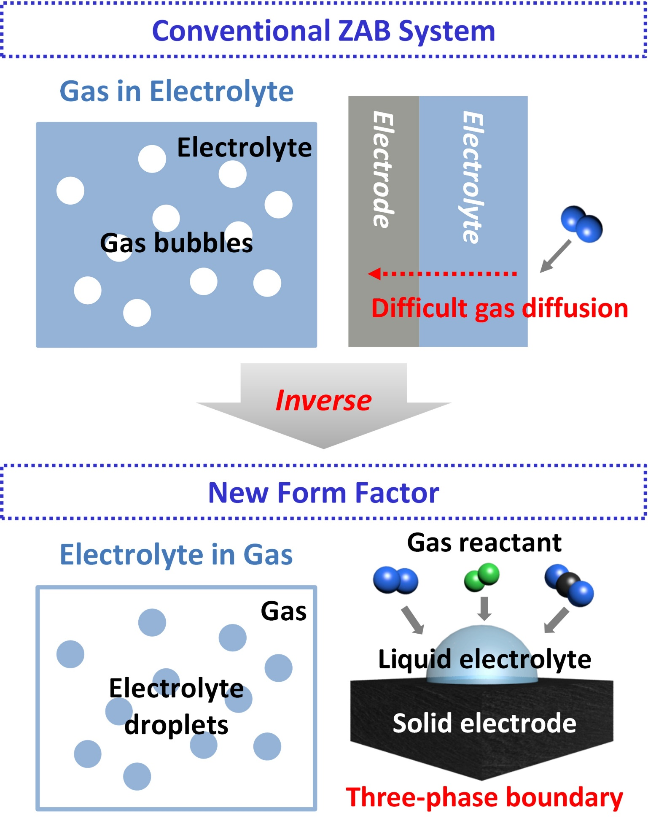

Supplementary Fig. 1 | Schematic comparison of conventional and aeroelectrolyte-based Zn–air battery systems.

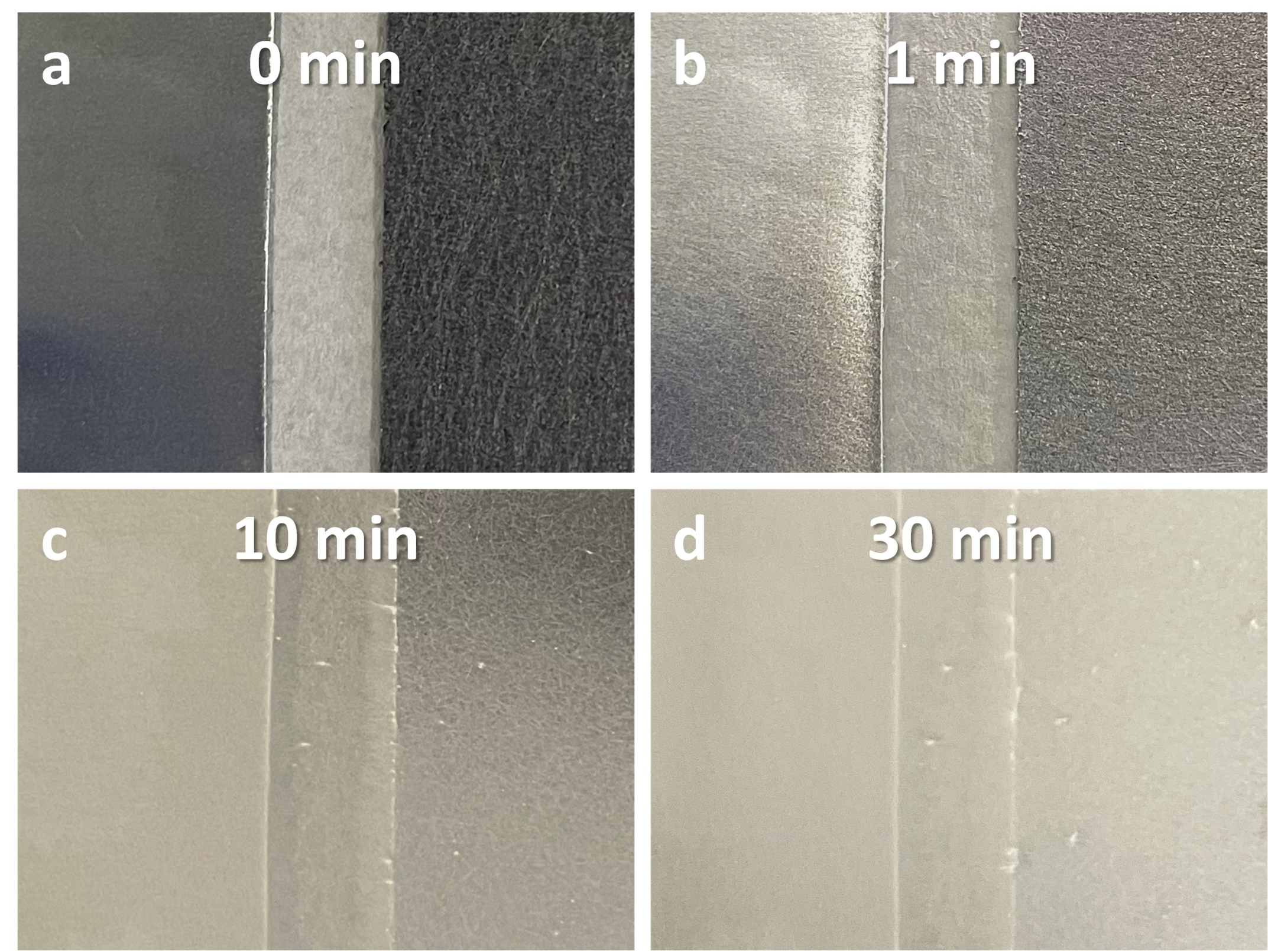

Supplementary Fig. 2 | Photographic images of salt-bridge-coated electrodes at various electrospinning times. a–d, Electrodes after electrospinning for (a) 0, (b) 1, (c) 10, and (d) 30 min.

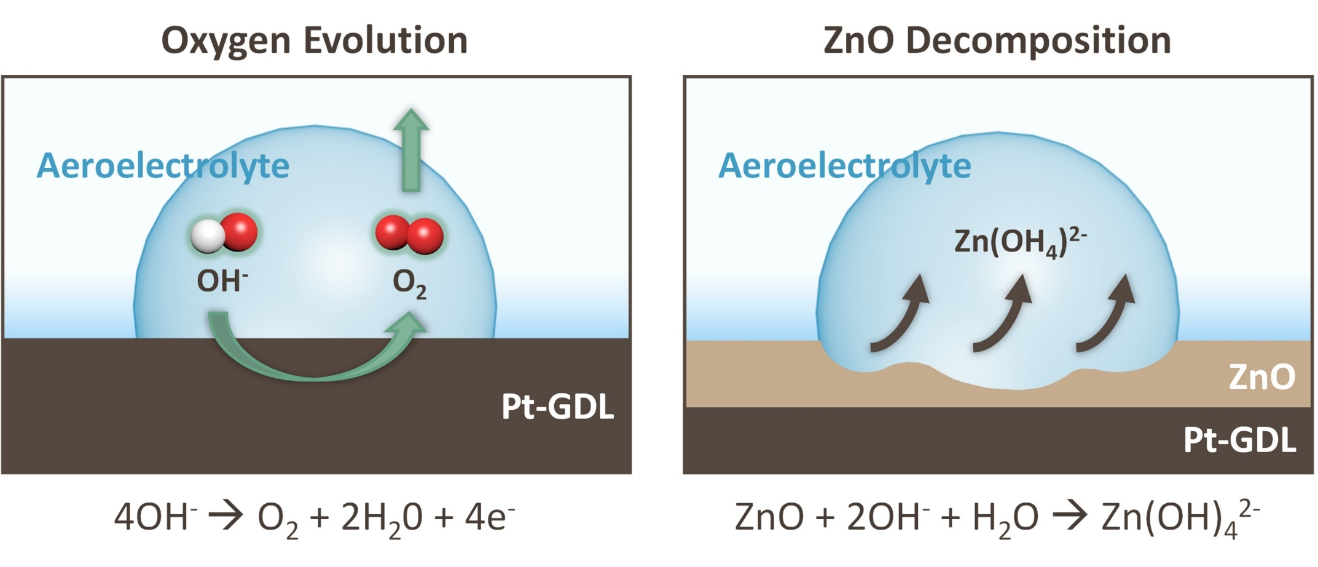

Supplementary Fig. 3 | Schematic illustration of the charging mechanism in an alkaline Zn–air battery.

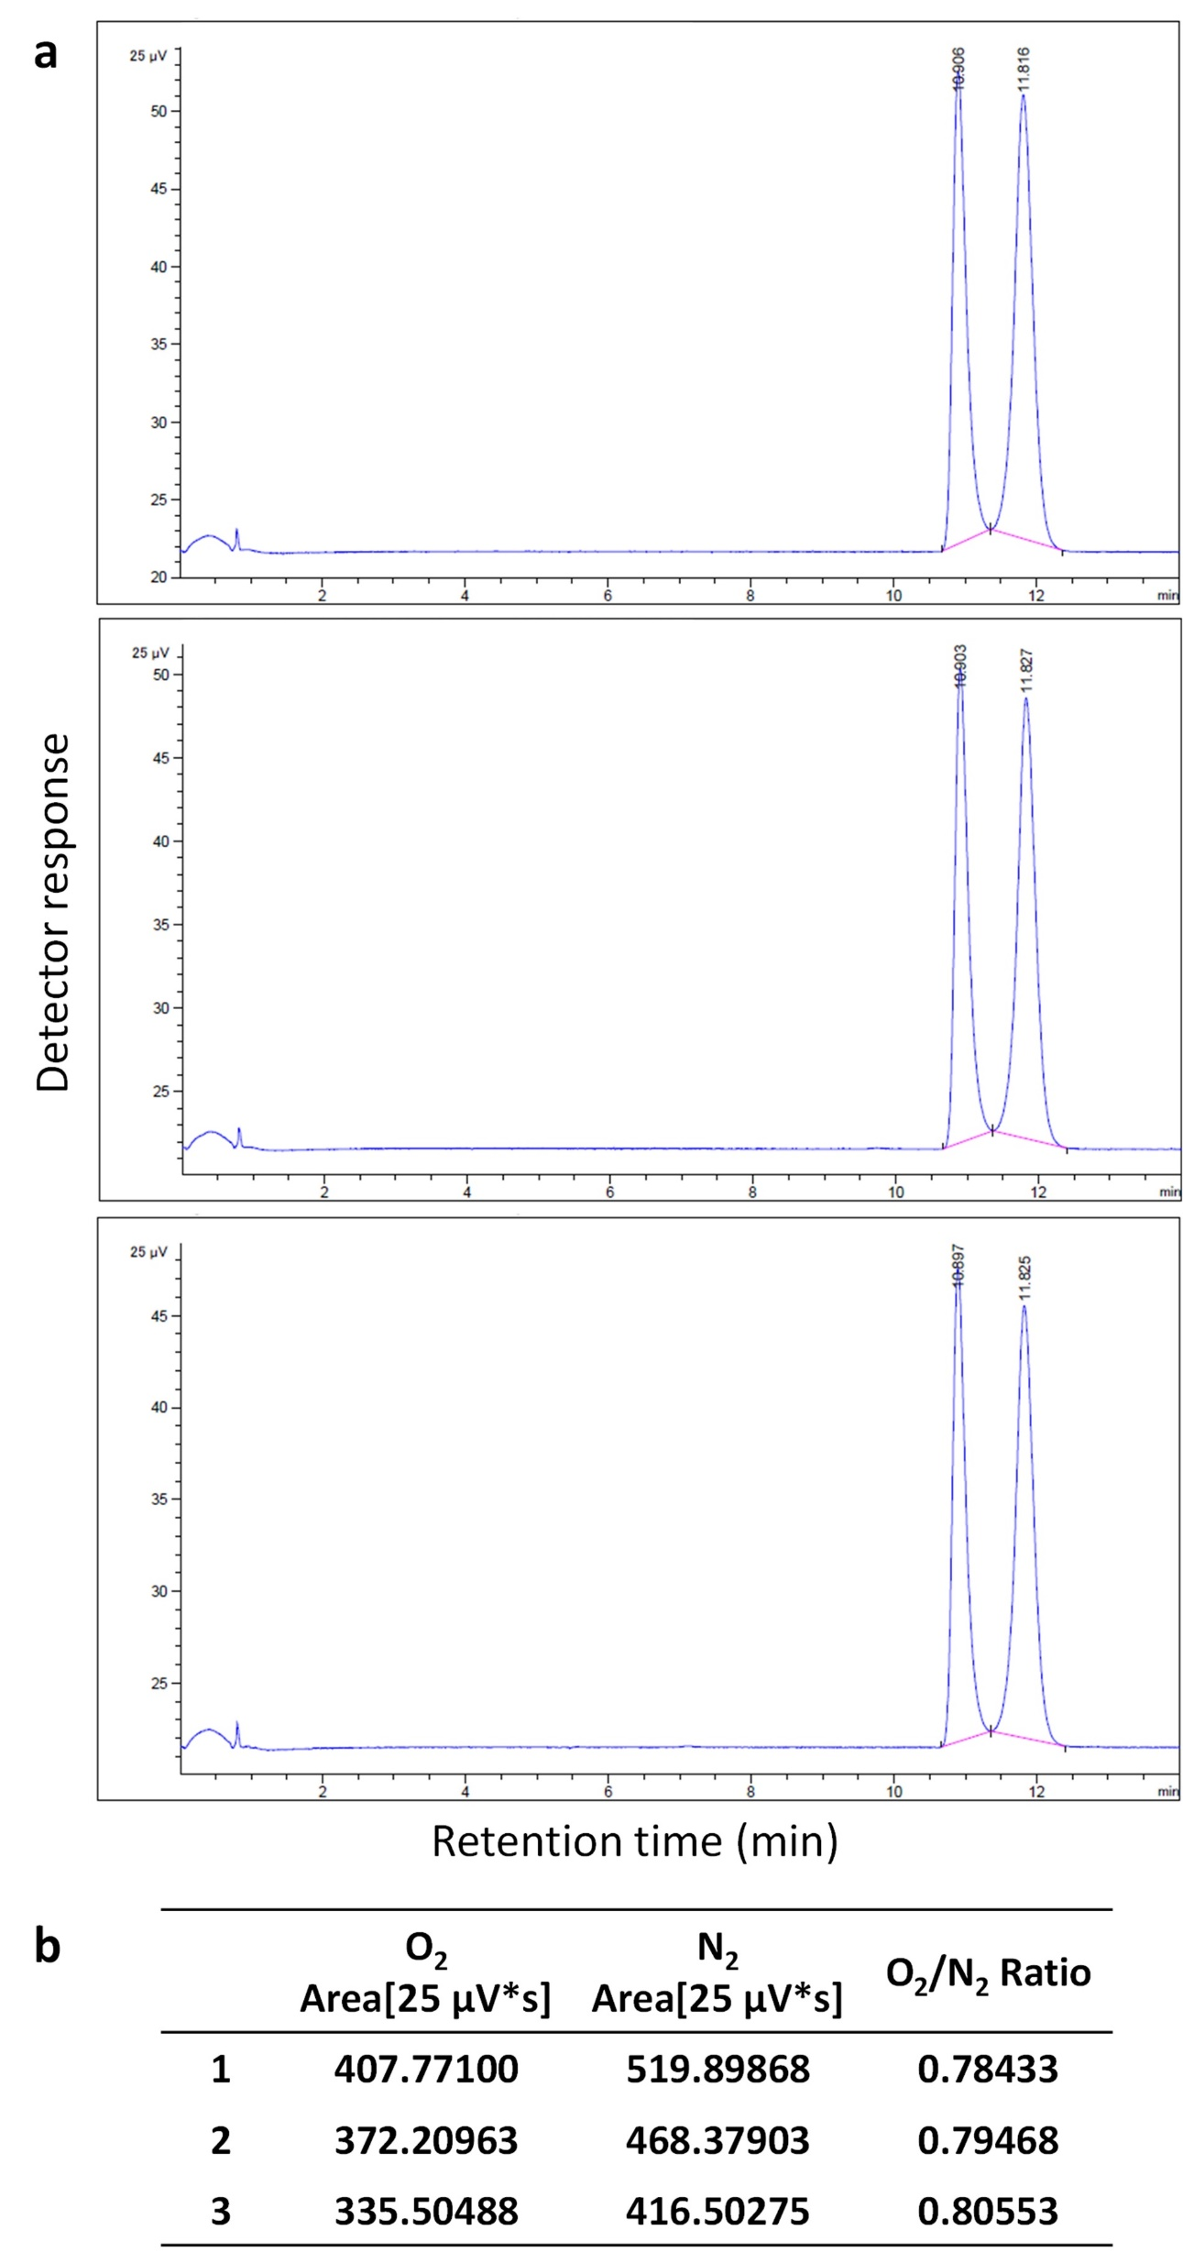

Supplementary Fig. 4 | Gas chromatography (GC) analysis in the pristine state. a, GC spectra from three repliacte measurements under resting conditions. b, Summary of O₂ peak area, N₂ peak area, and O₂/N₂ ratio for each measurement.

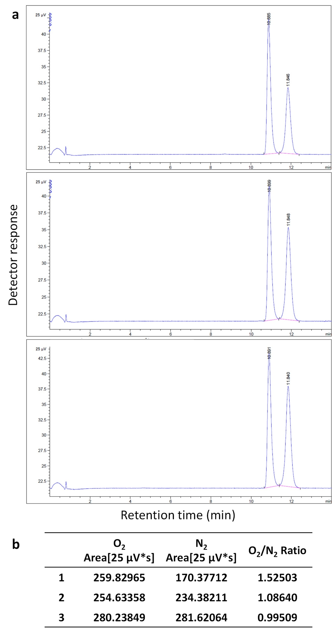

Supplementary Fig. 5 | Gas chromatography (GC) analysis in the charged state. a, GC spectra from three replicate measurements during charging. b, Summary of O₂ peak area, N₂ peak area, and O₂/N₂ ratio for each measurement.

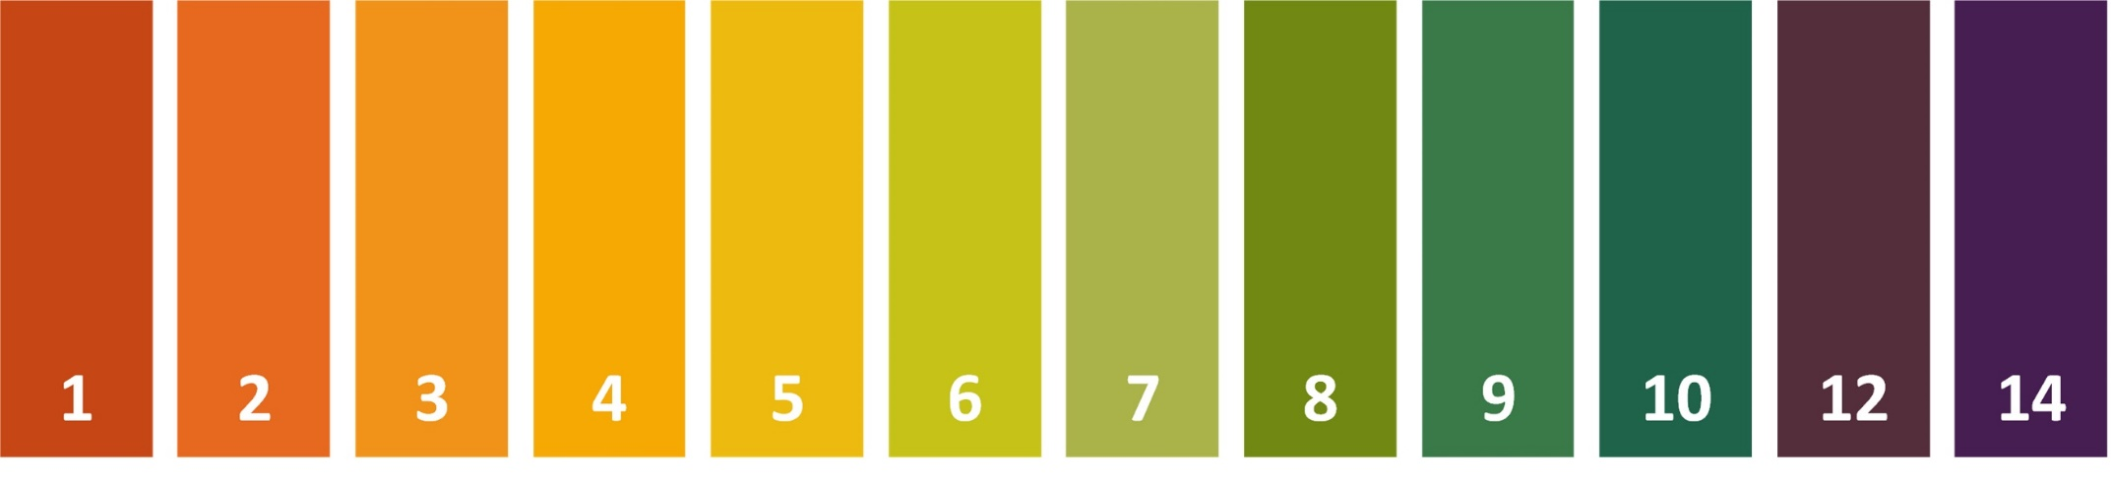

Supplementary Fig. 6 | Colorimetric pH scale of the indicator paper.

Supplementary Videos

Supplementary Video 1 | Diffusion characteristics of the aeroelectrolyte. High-speed camera video of the aeroelectrolyte generated at 0.25 MPa using 3 M ZnC1₂ electrolyte purged with O₂.

Supplementary Videos 2-5 | Dynamic simulations at different aerosol-generation pressures. Aeroelectrolyte transport simulated at (2) 0.1, (3) 0.15, (4) 0.2, and (5) 0.25 MPa using 3 M ZnC1₂ electrolyte.

Supplementary Videos 6-9 | Dynamic simulations at different ZnCl₂ concentrations. Aeroelectrolyte transport simulated using (6) 0.1, (7) 1, (8) 3, and (9) 5 M ZnC1₂ electrolytes at an aerosol-generation pressure of 0.25 MPa.

