Supporting Information

Docked ions: vertical-aligned tubular arrays for highly efficient capacitive deionization

Zhi-Yong Luo⁺, Dong Wang⁺, Lingqi Huang, Xiangyang Liu, Qi Zhang, He Zhu *, and Shiping Zhu*

Dr. Z. Y. Luo, Prof. D. Wang, Dr. L. Huang, X. Liu, Prof. Q. Zhang, Prof. H. Zhu and Prof. S. Zhu
School of Science and Engineering, The Chinese University of Hong Kong, Shenzhen, Shenzhen, Guangdong, 518172, P.R. China.
Email: zhuhe@cuhk.edu.cn, shipingzhu@cuhk.edu.cn

Dr. Z. Y. Luo, Dr. L. Huang
University of Science and Technology of China, Hefei, Anhui, 230026, P.R.China.

[+] These authors contributed equally: Zhi-Yong Luo, Dong Wang.

*Correspondence and requests for materials should be addressed to H. Z. (email: zhuhe@cuhk.edu.cn) and S. Z. (email: shipingzhu@cuhk.edu.cn)

Experimental section

Chemicals:
Ammonium fluoride (NH₄F, 98%) and ethylene glycol (C₂H₆O₂, 98%) were purchased from Aladdin. Diammonium hydrogen phosphate ((NH₄)₂HPO₄, 99%) was purchased from Rhawn. Sodium chloride (NaCl, 99.5%) was purchased from Sinopharm Chemical Reagent (Shanghai) Co. Ltd. Ion-exchange membranes were purchased from Lvhe Environmental Protection Technology (Hangzhou) Co. Ltd. The Milli-Q water (Milli-Q System, Direct-Q3) was used in all experiments. All chemicals were used as received without any further purification.

Preparation of as-prepared TiO₂ nanotubes:
A Ti foil (purity ≥ 99.9%, size 2.5 cm × 4 cm, thickness: 0.1 mm) was cleaned by acetone, ethanol and deionized water via ultrasonic cleaner for 10 min in order. After that, the as-prepared TiO₂ nanotubes with highly ordered morphology were obtained via a two-step anodization under 80 V in a two-electrode electrochemical cell by using the Ti foil and carbon paper as the anode and cathode, respectively. In the first step, the Ti foil was anodized in an electrolyte containing 0.25 wt% NH₄F, 3 wt% H₂O and 96.75 wt% ethylene glycol for 2 hours, the Ti template was obtained by stripping the TiO₂ nanotubes. In the second step, the Ti template was anodized in an electrolyte containing 0.25 wt% NH₄F, 6 wt% H₂O and 93.75 wt% ethylene glycol for 30 minutes to prepare the as-prepared TiO₂ nanotubes. All the experiments were carried out in a water bath at 25 ℃ and the distance between two electrodes was 2 cm.

Preparation of phosphated TiO₂ (P-TiO₂) and anatase TiO₂ (A-TiO₂) nanotubes:
The as-prepared TiO₂ nanotubes were calcined at 450 ℃ for 2 hours in a N₂ atmosphere containing 0.1 g (NH₄)₂HPO₄ to obtained the P-TiO₂ with a vertical-aligned nanotubular structure. As a comparison, the A-TiO₂ was prepared at 450 ℃ for 2 hours in a N₂ atmosphere without (NH₄)₂HPO₄.

CDI experiments:
The CDI prototype was assembled from a CDI cell, electrodes, a cation exchange membrane, an anion exchange membrane, and a separator (PMMA, thickness: 1mm) (Figure S4). 40 ml NaCl solution (~0.01 mol L⁻¹) was cycled in the CDI system (Figure S5) and the flow velocity was fixed at 30 mL min⁻¹. The NaCl concentration in CDI cell was in-situ analyzed via a conductivity meter interfaced to a computer.

The gravimetric NaCl adsorption capacity (Q, mg g⁻¹) was calculated based on the equation (1)¹:

Qg = (C₀ - C_{e} ) ×V/m (1)

where C₀ and C_{e} (mg L⁻¹) are the initial and equilibrium concentration of NaCl solution, respectively. V (L) is the volume of the NaCl solution in the CDI cell, and m (g) is the mass loading of the active material.

Characterization:
SEM images and EDX data were obtained via a field-emission scanning electron microscope (TESCAN Mira3). XRD patterns were obtained via a Bruker D8 diffractometer using Cu Kα radiation (λ= 1.5406 Å). The XPS data were collected with a Theta Probe electron spectrometer (VG ESCALab 220i-XL, Thermo Scientiﬁc). The electrochemical analysis was carried out on an electrochemical workstation (CHI 760E) by using TiO₂-based electrode, Pt wire and saturated calomel electrode as the working electrode, counter electrode and reference electrode, respectively. The NaCl concentration was measured via a conductivity meter (DDSJ-308A).

Simulation:
In order to model the process of how ions escape from the nanotube, we mainly consider the effect of the transportation of fluid flow and the effect from the unequal distribution of ions in the space. Instead of using classical microscopic models (i.e., using techniques of molecular dynamics methods²), we propose to use a macroscopic model to approximate the process effectively.

In this part, we assume the fluid flow is steady, incompressible and in the regime of low Reynolds numbers. Thus, we use the Stokes equation and divergence free condition to describe the velocity field of the fluid flow. We also assume the fluid velocity field is independent of the change of distribution of ions. However, the fluid velocity field does have effects on the transportation of ions. Hence, as for modelling the change of the distribution of ions, we consider a diffusion-convection equation where the convection speed is induced by the velocity field from the Stokes equation.

To be more specific, we denote $Ω=Ω_{1}∪Ω_{2}$ the computational domain which is the lower half of the tube with rough bottoms (the rough part can be periodic triangles or periodic nano-tubulars, see Figure S9 for a diagram), $∂Ω=∂Ω_{D_{1}}∪∂Ω_{D_{2}}∪∂Ω_{N}$ the boundary of the computational domain, $u\left(x\right)$ the velocity field for any $x∈Ω$, $p\left(x\right)$ the pressure, and $h\left(x,t\right)$ the density of ions at any point $x∈Ω$ and any time $t$. Here, $Ω_{1}$ is a thin layer on the bottom of the computational domain to represent the initial distribution of density of ions (the magenta region in Figure S9), and $Ω_{2}$ is the region where the initial density of ions is 0, $∂Ω_{D_{1}}$ is the left and right boundary of the computational domain where we impose the inflow and outflow boundary condition of the fluid flow, $∂Ω_{N}$ is the top boundary of the computational domain where we impose the Neumann boundary condition of the fluid velocity, and $∂Ω_{D_{2}}$ is the bottom boundary of the computational domain where we set the fluid velocity as 0. In addition, without loss of generality, we consider the dimensionless equation with all coefficients set to be 1.

We then arrive at the following coupled system of partial differential equations³:

- System of equations: $\left\{\begin{matrix}∆u+p∙∇u=0 & in & Ω \\ ∇∙u=0 & in & Ω \\ h_{t}+u∙∇h=∆h & in & Ω\end{matrix}\right.$ ;

- Boundary conditions for $u$: $\left\{\begin{matrix}u =u_{g} & on & ∂Ω_{D_{1}} \\ u=0 & on & ∂Ω_{D_{2}} \\ ∂u/∂n = 0 & on & ∂Ω_{N} \end{matrix}\right.$ ;

- Initial and boundary conditions for $h$: $\left\{\begin{matrix}∂h/∂n = 0 & on & ∂Ω_{D_{2}} \\ ∂h/∂n+αh= 0 & on & ∂Ω_{D_{1}}∪∂Ω_{N} \\ h\left(x,t\right)=χ_{Ω_{1}} & at & t=0 \end{matrix}\right.$.

Here $∆$ is the Laplace operator, $∙$ is the inner product, $∇$ is the gradient operator, $∇∙$ is the divergence operator, $∂∙/∂n$ is the directional derivative along the outer normal direction of the boundary, $α$ is a fixed parameter to control the diffusivity of $h$ on the boundary, and

$$χ_{Ω_{1}}(x)=\left\{\begin{matrix}1 & if x∈Ω_{1} \\ 0 & otherwise\end{matrix}\right.$$

is the indicator function of the region $Ω_{1}$. As for $u_{g}$ in the boundary conditions for $u$ on $∂Ω_{D_{1}}$, we set the vertical velocity to be 0 and the horizontal velocity to be changing as a parabolic profile along the vertical direction with 0 at the bottom and maximum at the top.

For above system, because the Stokes equation with divergence free condition is independent of $h$, we first solve it by the finite element method. Then the solved velocity field $u$ is used to solve the diffusion-reaction equation for $h$ with the initial condition and boundary condition. Here, we simply use the standard finite element method to solve the weak formulation of above system with corresponding boundary conditions. The details of the weak form and the discretization is out of the scope of this article, we refer the details to literature⁴ and the references therein.

Figure S1. The electrochemical analysis of as-prepared TiO₂ and P-TiO₂. (a)-(b) Cyclic voltammetry (CV) analysis and (c) alternating-current (AC) impedance analysis. (d) The electrochemical durability of P-TiO₂.
The P-TiO₂ displayed enhanced capacitance and electrical conductivity. The electrochemical durability of P-TiO₂ was also remarkable even after 1,000 cycles.

Table S1. The comparison of electrochemical capacitance of our work and previous works.
No. | Material | Areal capacitance/specific capacitance (mF cm⁻²) | Scan rate/discharge rate
1 | Pristine TiO₂⁵ | 2.4 | 50 mV s⁻¹
2 | H-TiO₂⁶ | 3.24 | 100 mV s⁻¹
3 | Plasma treated TiO₂⁷ | 7.22 | 0.05 mA cm⁻²
4 | C-axis TiO₂⁸ | 8.21 | 100 mV s⁻¹
5 | Black TiO₂⁹ | 15.6 | 100 mV s⁻¹
6 | Electrochemical reduced TiO₂¹⁰ | 20.08 | 0.05 mA cm⁻²
7 | P-TiO₂ (This work) | 22.6 | 100 mV s⁻¹

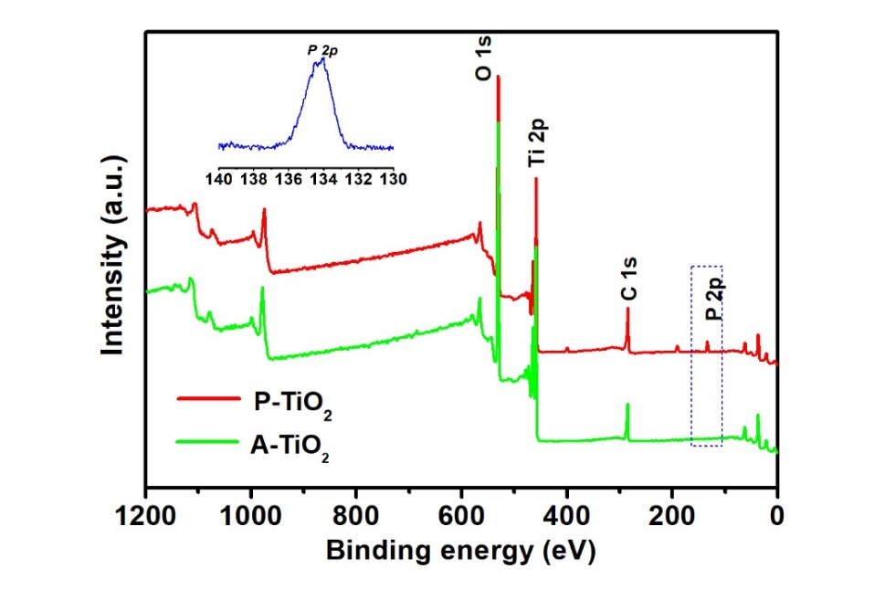
Figure S2. XPS full spectra of P-TiO₂ and A-TiO₂. The insert is the P 2p peak of P-TiO_{2.}
After calcining in the presence of (NH₄)₂HPO₄ at 450 ℃, the P was doped in the lattice of TiO₂ in the form of Ti-O-P and O-P (Figure 1g).

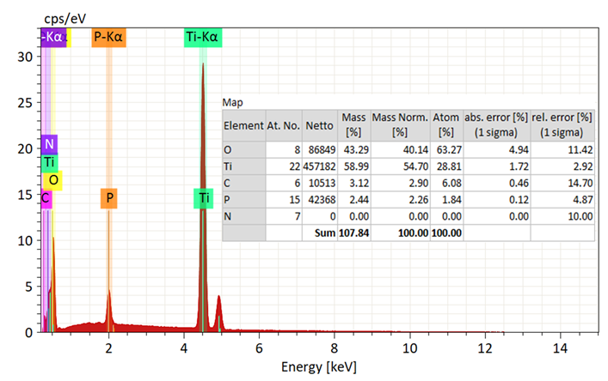
Figure S3. EDX analysis of P-TiO₂.
From the EDX analysis, the content of P was 1.84 %.

Figure S4. The demonstration of CDI prototype in detail.
The CDI prototype was assembled from a CDI cell, electrodes, a cation exchange membrane, an anion exchange membrane and a separator. It should be noted that there was a pore in both the cation exchange membrane and the anion exchange membrane to allow the solution to pass through. At the same time, the electrodes were separated from the bulk solution by the ion exchange membranes.

Figure S5. The CDI system.
The CDI system was composed of a CDI cell, a pump that drove the circulation of NaCl solution, a conductivity meter interfaced to a computer to measure the NaCl concentration in-situ, and a DC power.

Figure S6. The schematic structures of the three electrodes.

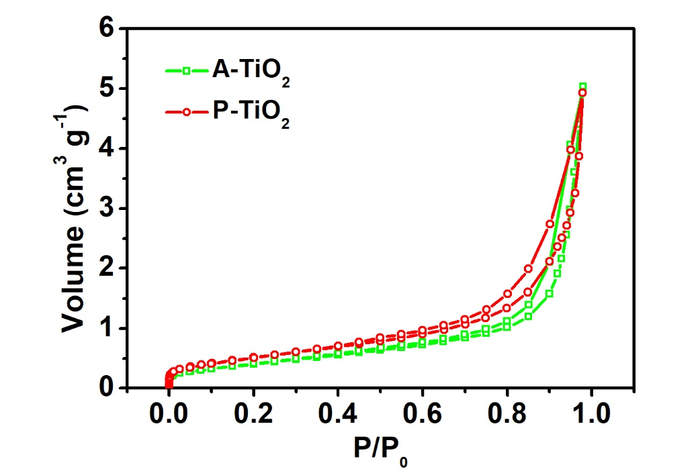
Figure S7. The nitrogen adsorption-desorption analysis of vertical-aligned nanotubular arrays.
The A-TiO₂ and P-TiO₂ vertical-aligned nanotubular arrays displayed low specific surface areas of ~20 m² g⁻¹ and ~23 m² g⁻¹.

Figure S8. The ion adsorption-desorption curves of the vertical-aligned nanotubular P-TiO₂ arrays, where the adsorption time was controlled at 10 minutes and 20 minutes, respectively.
We changed the ion adsorption time to demonstrate that the IDE always existed in the CDI device based on the vertical-aligned nanotubular P-TiO₂ arrays.

Figure S9. The diagrams of computational domain for (a) rough structure and (b) vertical-aligned nanotubular structure.

References
1. Bao, W., Tang, X., Guo, X., Choi, S., Wang, C., Gogotsi, Y., Wang, G. Porous cryo-dried mxene for efficient capacitive deionization. Joule 2, 778-787 (2018).
2. Griebel M., Knapek S., Zumbusch G. Numerical simulation in molecular dynamics. Berlin, Heidelberg: Springer, ISBN: 978-3-540-68094-9 (2007).
3. Evans, L. C. Partial differential equations. Graduate studies in mathematics, 2, 19 (1998).
4. Reddy, J. N. An introduction to the finite element method (Third ed.), McGraw-Hill, ISBN: 9780071267618 (2006).
5. Kim M. S., Lee T. W., and Park J. H. J. Electrochem. Soc. 156, A584 (2009).
6. Lu X., Wang G., Zhai T., Yu M., Gan J., Tong Y., and Li Y. Nano lett. 12, 1690 (2012).
7. Wu H., Xu C., Xu J., Lu L., Fan Z., Chen X., Song Y., and Li D. Nanotech. 24, 455401 (2013).
8. Pan D., Huang H., Wang X., Wang L., Liao H., Li Z., and Wu M. J. Mater. Chem. A 2, 11454 (2014).
9. Kim C., Kim S., Lee J., Kim J., and Yoon J. ACS Appl. Mater. Interfaces 7, 7486 (2015).
10. Wu H., Li D., Zhu X., Yang C., Liu D., Chen X., Song Y., and Lu L. Electrochimica Acta 116, 129 (2014).
11. Yin H., Zhao S., Wan J., Tang H., Chang L., He L., Zhao H., Gao Y., Tang Z. Adv. Mater. 25, 6270 (2013); Zhao C., Liu G., Sun N., Zhang X., Wang G., Zhang Y., Zhang H., Zhao H. Chem. Eng. J. 334, 1270 (2018).

