Supplementary Table 1. (Poly)phenol intake in the study population, measured using KP-Food Frequency Questionnaire and 24 h dietary recalls (mg/day)

 |  | KP-FFQ |  | 24 hours diet recalls
 | N | Mean ± SD | N | Mean ± SD
Total (Poly)phenols (mg) | 256 | 1164.3 ± 762.7 | 300 | 800.2 ± 757.0
Flavonoids (mg) | 256 | 553.3 ± 366.7 | 300 | 384.6 ± 397.3
Anthocyanins (mg) | 256 | 38.4 ± 30.8 | 300 | 21.9 ± 40.3
Dihydroflavonols (mg) | 256 | 0.2 ± 0.4 | 300 | 0.1 ± 0.6
Flavan-3-ols (mg) | 256 | 398.6 ± 323.3 | 300 | 307.8 ± 365.0
Proanthocyanidins (mg) | 256 | 229.3 ± 147.1 | 300 | 144.4 ± 217.1
Flavanones (mg) | 256 | 45.8 ± 43.7 | 300 | 12.2 ± 34.1
Flavones (mg) | 256 | 8.4 ± 7.2 | 300 | 6.4 ± 12.7
Flavonols (mg) | 256 | 50.9 ± 30.1 | 300 | 31.3 ± 35.5
Isoflavonoids (mg) | 256 | 8.7 ± 12.9 | 300 | 4.0 ± 8.4
Lignans (mg) | 256 | 5.6 ± 9.3 | 300 | 4.1 ± 12.0
Tyrosols (mg) | 256 | 6.3 ± 6.0 | 300 | 2.8 ± 7.7
Phenolic acids (mg) | 256 | 541.9 ± 517.0 | 300 | 388.4 ± 589.6
Hydroxybenzoic acids (mg) | 256 | 47.4 ± 40.8 | 300 | 32.6 ± 38.6
Hydroxycinnamic acids (mg) | 256 | 494.4 ± 506.8 | 300 | 355.6 ± 586.1
Hydroxyphenylacetic acids (mg) | 256 | 0.0 ± 0.1 | 300 | 0.2 ± 0.8
Stilbenes (mg) | 256 | 0.0 ± 0.0 | 300 | 0.2 ± 0.5
Sum other polyphenols (mg) | 256 | 0.3 ± 0.3 | 300 | 36.9 ± 36.5

Supplementary Table 2. Food sources of the (poly)phenol subclasses estimated from KP-FFQ and 24 hours diet recalls.

(Poly)phenols | Estimated (poly)phenol food sources (% to total)​
 | KP-FFQ | 24 hours diet recalls
Total (poly)phenols | Coffee (58.8%), Tea (23.1%), Chocolate drinks (7.1%), Red apples (5.6%), Cloves (5.3%) | Coffee (51%), Tea (33.9%), Apple (5.8%), Chocolates (4.9%), Blueberries (4.3%)​
Total flavonoids​ | Tea (57.6%), Chocolate drinks (16.0%), Red apples (11.1%), Dark chocolates (8.3%), Blueberries (7.0%)​ | Tea (63.5%), Apple (9.5%), Chocolates (15.5%), Chocolate drinks (6.2%), Blueberries (5.3%)​
Anthocyanins​ | Blueberries (24.2%), Purple cabbages (23.5%), Cherries (19.3%), Aubergine (16.8%), Red cabbages (16.3%) | Blueberries (38.1%), Aubergine (23%), Strawberries (15.9%), Red grapes (15.3%), Mixed berries (7.8%)​
Total flavan-3-ol​ | Tea (58.9%), Chocolate drinks (16.8%), Red apples (10.9%), Dark chocolates (8.6%), Green apples (4.9%) | Tea (64.4%), Chocolates (18.6%), Apple (8.1%), Chocolate drinks (5.7%), Blueberries (3.1%)​
Flavanones​ | Orange (43.3%), Orange juice (30.8%), Lemons (15.3%), Mint (7.7%), Grapefruit (3.0%) | Orange juice (46.6%), Orange (45.6%), Grapefruit (3.6%), Tomatoes (3%), Lemon (1.2%)​
Flavones​ | Wholemeal bread (45.1%), Parsley (21.1%), Mint (14.8%), Orange juice (12.1%), Oranges (6.9%) | Soup (41.5%), Gnocchi (15.9%), Pizza (15.7%), Orange juice (15.7%), Brown bread (11.2%)​
Flavonols​ | Tomatoes (38.8%), Spinach (36.2%), Tomato ketchup (10.2%), Tomato soup (8.6%), Broccoli (6.3%) | Tomatoes (62.3%), Spinach (14.6%), Tea (17.1%), Blueberries (3.1%), Vegetables soup (2.8%)​
Isoflavonoids​ | Soya milk (35.7%), Edamame beans (23.0%), Tofu (22.2%), Soya yoghurt (9.8%), Beansprouts (9.3%)​ | Tofu (53.8%), Soya beans (12.1%), Soya milk (16.5%), Chia seeds (11.9%), Beansprouts (5.7%)​
Total Phenolic acids​ | Coffee (89.0%), White rice (4.8%), Chestnuts (2.4%), Blueberries (2.2%), Tea (1.6%) | Coffee (89.9%), Tea (3.5%), White basmati (2.9%), Blueberries (2.1%), Brown rice (1.6%)​
Hydroxybenzoic acids​ | Tea (47.5%), Chestnuts (29.3%), Strawberries (9.6%), Garlic (8.7%), White rice (4.9%) | Tea (77.8%), Raspberries (7.1%), Strawberries (6.8%), Chestnuts (5.1%), White basmati (3.1%)​
Hydroxycinnamic acids​ | Coffee (90.6%), White rice (4.5%), Blueberries (2.2%), Sunflower seeds (1.5%), Cherries (1.2%) | Coffee (93.1%), Blueberries (2.6%), Brown rice (2.1%), Apple (1.5%), Sunflower oil (0.7%)​
Hydroxyphenylacetic acids​ | Beer (46.8%), Red wine (21.3%), Olive oil (18.5%), White wine (11.5%), Green pesto (1.9%) | Olives (62.4%), Salad (22.9%), Mushrooms (4.2%), Lager (7.7%), White wine (2.9%)​
Stilbenes​ | Red wine (43.9%), Oranges (22.6%), Lemons (15.0%), Strawberries (11.7%), White wine (6.8%) | Red wine (60.7%), Dry white wine (22.3%), Strawberries (9.4%), Red grapes (4.5%), Red wine sauce (3.1%)​
Lignans​ | Flaxseeds (57.4%),Sesame seeds (16.8%), Bread seeded (11.1%),Potatoes (8.6%), Brocolli (6.0%) | Sesame seeds (30%), Flaxseeds (22.1%), Noodles (35.1%), Brazil nuts (8.4%), Sauerkraut (4.3%)​
Tyrosols​ | Olive oil (85.4%), Green pesto (8.7%), Pesto pizza (2.6%), Red wine (2.3%)​, Vinegar (1.0%) | Olive oil (53%), Olives (25.7%), Green pesto (12%), Salad dressing (5.1%), Red wine (4.2%)​

Supplementary Table 3. Association between individual levels (poly)phenol intake diversity and quantity and mental health outcomes, measured using KP-FFQ
 | Polyphenol intake diversity or quantity, β (95% CI)
 | Tertile 1 | Tertile 2 | Tertile 3 | Continuous variable
Diversity (Hill’s effective numbers at the individual level)
Anxiety score
Crude model | 0.00 | 0.19 (-1.07, 1.44) | -1.01 (-2.28, 0.25) | -0.06 (-0.14, 0.02)
Model 1 | 0.00 | -0.16 (-1.44, 1.13) | -1.06 (-2.38, 0.25) | -0.07 (-0.16, 0.01)
Model 2 | 0.00 | -0.29 (-1.59, 1.02) | -1.25 (-2.60, 0.10) | -0.09 (-0.18, -0.01) *
Depression score
Crude model | 0.00 | -0.31 (-1.36, 0.75) | -0.86 (-1.92, 0.20) | -0.06 (-0.13, 0.01)
Model 1 | 0.00 | -0.35 (-1.42, 0.72) | -0.62 (-1.71, 0.47) | -0.05 (-0.12, 0.02)
Model 2 | 0.00 | -0.49 (-1.57, 0.59) | -0.82 (-1.94, 0.29) | -0.06 (-0.13, 0.01)
Stress score
Crude model | 0.00 | -0.54 (-2.73, 1.64) | -2.36 (-4.56, -0.16) * | -0.13 (-0.27, 0.01)
Model 1 | 0.00 | -1.18 (-3.38, 1.01) | -2.38 (-4.62, -0.13) * | -0.15 (-0.29, -0.01) *
Model 2 | 0.00 | -1.58 (-3.79, 0.63) | -2.95 (-5.23, -0.66) * | -0.19 (-0.34, -0.04) *
Mood disturbance score
Crude model | 0.00 | -1.35 (-5.18, 2.49) | -4.03 (-7.90, -0.16) * | -0.22 (-0.46, 0.03)
Model 1 | 0.00 | -2.55 (-6.43, 1.32) | -4.23 (-8.21, -0.24) * | -0.26 (-0.52, -0.01) *
Model 2 | 0.00 | -3.43 (-7.32, 0.46) | -5.45 (-9.49, -1.40) ** | -0.36 (-0.62, -0.09) **
Cortisol level
Crude model | 0.00 | 32.84 (-131.83, 197.51) | -142.50 (-307.17, 22.17) | -8.94 (-19.22, 1.34)
Model 1 | 0.00 | 29.26 (-134.80, 193.32) | -144.16 (-311.63, 23.32) | -9.95 (-20.50, -0.60)
Model 2 | 0.00 | 35.54 (-131.08, 202.17) | -134.36 (-307.43, 38.70) | -9.51 (-20.57, 1.54)
Quantity (100 mg)
Anxiety score
Crude model | 0.00 | -0.76 (-2.03, 0.50) | 0.10 (-1.16, 1.36) | 0.01 (-0.06, 0.08)
Model 1 | 0.00 | -1.40 (-2.75, -0.05) * | -0.84 (-2.43, 0.74) | -0.03 (-0.12, 0.05)
Model 2 | 0.00 | -1.71 (-3.13, -0.29) * | -1.39 (-3.15, 0.37) | -0.06 (-0.16, 0.03)
Depression score
Crude model | 0.00 | -1.05 (-2.11, 0.01) | -1.04 (-2.09, 0.01) | -0.05 (-0.11, -0.01) *
Model 1 | 0.00 | -1.08 (-2.20, 0.04) | -0.69 (-2.01, 0.62) | -0.05 (-0.11, 0.02)
Model 2 | 0.00 | -1.37 (-2.54, -0.19) * | -1.20 (-2.66, 0.26) | -0.08 (-0.16, 0.01)
Stress score
Crude model | 0.00 | -0.09 (-2.31, 2.12) | -0.14 (-2.36, 2.07) | -0.02 (-0.15, 0.09)
Model 1 | 0.00 | -1.31 (-3.64, 1.02) | -1.73 (-4.46, 1.00) | -0.12 (-0.26, 0.03)
Model 2 | 0.00 | -1.97 (-4.41, 0.47) | -2.87 (-5.90, 0.16) | -0.19 (-0.35, -0.03) *
Mood disturbance score
Crude model | 0.00 | -2.47 (-6.32, 1.38) | -2.60 (-6.48, 1.29) | -0.18 (-0.38, 0.02)
Model 1 | 0.00 | -3.88 (-7.94, 0.19) | -3.46 (-8.23, 1.32) | -0.25 (-0.50, -0.01) *
Model 2 | 0.00 | -4.30 (-8.60, -0.01) * | -4.19 (-9.52, 1.14) | -0.31 (-0.60, -0.03) *
Cortisol level
Crude model | 0.00 | -70.36 (-96.23, 236.96) | 113.85 (-52.74, 280.44) | 6.51 (-2.42, 15.45)
Model 1 | 0.00 | 51.92 (-120.50, 224.34) | 65.58 (-137.45, 268.62) | 4.41 (-6.60, 15.43)
Model 2 | 0.00 | 41.64 (-139.59, 222.87) | 45.67 (-183.68, 275.02) | 3.54 (-9.14, 16.22)
CI, confidence interval; Model 1, adjusted for sex, age, ethnicity, education, physical activity, smoking status, alcohol use, body mass index, and daily energy intake; Model 2, additionally adjusted for (poly)phenol intake diversity in quantity analysis, and (poly)phenol intake quantity in diversity analysis.*P<0.05, **P<0.01, ***P<0.001.

Supplementary Table 4. Association between individual levels (poly)phenol intake diversity and quantity and mental health outcomes, measured using 24-hour dietary recalls
 | Polyphenol intake diversity or quantity, β (95% CI)
 | Tertile 1 | Tertile 2 | Tertile 3 | Continuous variable
Diversity (Hill’s effective numbers at the individual level)
Anxiety score
Crude model | 0.00 | 0.24 (-0.10, 1.48) | -0.54 (-1.78, 0.69) | -0.02 (-0.10, 0.06)
Model 1 | 0.00 | -0.16 (-1.43, 1.10) | -0.54 (-1.83, 0.75) | -0.02 (-0.11, 0.06)
Model 2 | 0.00 | -0.17 (-1.43, 1.10) | -0.54 (-1.84, 0.76) | -0.02 (-0.11, 0.06)
Depression score
Crude model | 0.00 | -0.01 (-1.01, 1.00) | -1.01 (-2.02, -0.01) * | -0.05 (-0.12, 0.01)
Model 1 | 0.00 | 0.09 (-0.93, 1.11) | -0.51 (-1.55, 0.53) | -0.03 (-0.10, 0.04)
Model 2 | 0.00 | 0.10 (-0.91, 1.12) | -0.51 (-1.55, 0.52) | -0.03 (-0.10, 0.04)
Stress score
Crude model | 0.00 | 0.56 (-1.54, 2.66) | -2.27 (-4.38, -0.16) * | -0.13 (-0.27, 0.01)
Model 1 | 0.00 | -0.18 (-2.33, 1.96) | -2.12 (-4.31, 0.07) | -0.12 (-0.26, 0.03)
Model 2 | 0.00 | -0.17 (-2.31, 1.98) | -2.13 (-4.32, 0.06) | -0.12 (-0.26, 0.02)
Mood disturbance score
Crude model | 0.00 | 1.95 (-1.68, 5.58) | -2.17 (-5.78, 1.44) | -0.16 (-0.39, 0.08)
Model 1 | 0.00 | 1.09 (-2.59, 4.78) | -1.69 (-5.44, 2.05) | -0.13 (-0.37, 0.12)
Model 2 | 0.00 | 1.11 (-2.58, 4.80) | -1.71 (-5.46, 2.04) | -0.13 (-0.38, 0.11)
Cortisol level
Crude model | 0.00 | -137.72 (-289.01, 13.57) | -173.06 (-323.84, -22.27) * | -12.02 (-21.90, -2.13) *
Model 1 | 0.00 | -158.23 (-315.96, -0.50) * | -150.38 (-308.13, 7.37) | -10.03 (-20.35, 0.29)
Model 2 | 0.00 | -159.16 (-316.36, -1.96) * | -143.80 (-301.23, 13.64) | -9.51 (-19.83, 0.80)
Quantity (100 mg)
Anxiety score
Crude model | 0.00 | -0.10 (-1.30, 1.11) | 0.72 (-0.48, 1.93) | 0.03 (-0.03, 0.09)
Model 1 | 0.00 | -0.01 (-1.25, 1.24) | 0.51 (-0.89, 1.91) | 0.02 (-0.05, 0.09)
Model 2 | 0.00 | -0.30 (-1.59, 0.98) | -0.02 (-1.54, 1.49) | -0.01 (-0.08, 0.07)
Depression score
Crude model | 0.00 | -0.94 (-1.91, 0.04) | -0.79 (-1.77, 0.19) | -0.06 (-0.11, -0.01) *
Model 1 | 0.00 | -0.81 (-1.80, 0.19) | -0.41 (-1.53, 0.71) | -0.04 (-0.10, 0.01)
Model 2 | 0.00 | -0.95 (-1.99, 0.08) | -0.67 (-1.89, 0.55) | -0.06 (-0.12, 0.01)
Stress score
Crude model | 0.00 | 0.10 (-1.99, 2.18) | -0.03 (-2.12, 2.05) | -0.05 (-0.16, 0.06)
Model 1 | 0.00 | 0.02 (-2.11, 2.15) | -0.46 (-2.86, 1.93) | -0.07 (-0.19, 0.05)
Model 2 | 0.00 | -0.59 (-2.78, 1.60) | -1.55 (-4.13, 1.04) | -0.13 (-0.26, -0.01) *
Mood disturbance score
Crude model | 0.00 | -2.28 (-5.85, 1.29) | -0.62 (-4.20, 2.95) | -0.10 (-0.29, 0.09)
Model 1 | 0.00 | -1.83 (-5.46, 1.80) | -0.34 (-4.43, 3.74) | -0.11 (-0.31, 0.10)
Model 2 | 0.00 | -2.13 (-5.90, 1.64) | -0.88 (-5.33, 3.57) | -0.14 (-0.36, 0.08)
Cortisol level
Crude model | 0.00 | -124.28 (-272.37, 23.82) | -123.71 (-271.81, 24.38) | 1.87 (-5.78, 9.51)
Model 1 | 0.00 | -84.31 (-237.06, 68.44) | -52.62 (-224.36, 119.11) | 6.19 (-2.06, 14.45)
Model 2 | 0.00 | -115.50 (-275.03, 44.03) | -104.56 (-292.91, 83.79) | 5.59 (-3.31, 14.49)
CI, confidence interval; Model 1, adjusted for sex, age, ethnicity, education, physical activity, smoking status, alcohol use, body mass index, and daily energy intake; Model 2, additionally adjusted for (poly)phenol intake diversity in quantity analysis, and (poly)phenol intake quantity in diversity analysis.*P<0.05, **P<0.01, ***P<0.001.

Supplementary Table 5. Association between individual subclass levels (poly)phenol intake and mental health outcomes measured, using KP-FFQ

 | (Poly)phenol intake, β (95%CI)
 | Tertile 1 | Tertile 2 | Tertile 3 | Continuous variable
Depression score
Total (poly)phenol
Intake range level, mg, (SD) | 399.04-1592.06(336.09) | 1602.26-2970.14 (347.07) | 2973.86-10493.51 (1458.61)
Crude Model | 0.00 | -0.92 (-1.92,0.09) | -1.01 (-2.02,-0.01)* | 0.00 (-0.00,0.00)*
Model 1 | 0.00 | -0.76 (-1.76,0.24) | -0.50 (-1.55,0.54) | 0.00 (0.00,0.00)
Model 2 | 0.00 | -0.77 (-0.83,0.29) | -0.40 (-1.69,0.88) | 0.00 (0.00,0.00)
Flavonoids
Intake range level, mg, (SD) | 71.69-343.44 (72.57) | 343.79-619.73 (82.03) | 630.88-2605.92 (352.99)
Crude Model | 0.00 | -0.83 (-1.83,0.16) | -1.35 (-2.35,-0.35)** | -0.00 (-0.00,0.00)*
Model 1 | 0.00 | -0.75 (-1.73,0.23) | -0.90 (-1.92,0.11) | -0.00 (-0.00,0.00)
Model 2 | 0.00 | -0.66 (-0.68,0.35) | -0.72 (-1.89,0.46) | 0.00 (-0.00,0.00)
Anthocyanins
Intake range level, mg, (SD) | 0.23-21.47 (6.27) | 21.581-41.323 (5.954) | 41.593-164.507 (29.726)
Crude Model | 0.00 | -0.165 (-1.164,0.835) | -1.200 (-2.200,-0.200)** | -0.02 (-0.03,-0.00)**
Model 1 | 0.00 | -0.055 (-1.037,0.926) | -0.764 (-1.770,0.241) | -0.01 (-0.02,0.01)
Model 2 | 0.00 | 0.069 (-0.928,1.066) | -0.345 (-1.492,0.803) | -0.00 (-0.02,0.01)
Flavan-3-ols
Intake range level, mg, (SD) | 17.59-210.94 (49.71) | 214.807-434.106 (65.028) | 441.947-2474.658 (338.020)
Crude Model | 0.00 | -0.484 (-1.481,0.514) | -1.243 (-2.247,-0.239)** | -0.001 (-0.003,0.000)
Model 1 | 0.00 | -0.431 (-1.434,0.572) | -0.807 (-1.832,0.218) | -0.001 (-0.002,0.001)
Model 2 | 0.00 | -0.387 (-0.416,0.642) | -0.584 (-1.774,0.606) | -0.001 (-0.002,0.001)
Proanthocyanidins
Intake range level, mg, (SD) | 11.85-140.92 (31.48) | 141.563-256.217 (32.945) | 258.575-700.766 (118.277)
Crude Model | 0.00 | -0.035 (-1.036,0.965) | -1.118 (-2.118,-0.117)* | -0.003 (-0.006,-0.001)**
Model 1 | 0.00 | 0.021 (-0.966,1.009) | -0.650 (-1.666,0.366) | -0.002 (-0.004,0.001)
Model 2 | 0.00 | 0.168 (-0.890,1.225) | -0.304 (-1.486,0.878) | 0.000 (-0.004,0.003)
Flavanones
Intake range level, mg, (SD) | 0.0-21.337 (6.284) | 21.782-49.578 (7.856) | 50.027-290.255 (44.590)
Crude Model | 0.00 | -0.894 (-1.900,0.112) | -0.153 (-1.159,0.853) | -0.003 (-0.012,0.007)
Model 1 | 0.00 | -1.008 (-1.994,-0.023)* | 0.089 (-0.900,1.078) | 0.000 (-0.009,0.010)
Model 2 | 0.00 | -0.923 (-0.898,0.053) | 0.264 (-0.773,1.302) | 0.000 (-0.009,0.010)
Flavonols
Intake range level, mg, (SD) | 2.336-35.348 (7.413) | 35.420-56.407 (6.458) | 56.849-214.978 (27.797)
Crude Model | 0.00 | -1.082 (-2.086,-0.079)* | -0.671 (-1.674,0.333) | -0.012 (-0.025,0.002)
Model 1 | 0.00 | -0.803 (-1.787,0.180) | -0.187 (-1.198,0.825) | -0.007 (-0.021,0.007)
Model 2 | 0.00 | -0.597 (-1.609,0.415) | 0.563 (-0.717,1.843) | 0.001 (-0.018,0.019)
Tyrosols
Intake range level, mg, (SD) | 0.0-2.185 (0.628) | 2.211-7.373 (1.405) | 7.438-32.203 (5.242)
Crude Model | 0.00 | -1.424 (-2.415,-0.432)** | -1.494 (-2.485,-0.503)** | -0.105 (-0.172,-0.037)**
Model 1 | 0.00 | -1.069 (-2.095,-0.042)* | -0.898 (-1.932,0.136) | -0.071 (-0.139,-0.002)*
Model 2 | 0.00 | -0.851 (-1.917,0.214) | -0.627 (-1.780,0.526) | -0.060 (-0.135,0.016)
Hydroxycinnamic acids
Intake range level, mg, (SD) | 23.890-182.698 (39.494) | 185.825-560.845 (107.170) | 561.521-3186.008 (554.784)
Crude Model | 0.00 | -0.876 (-1.879,0.126) | -1.102 (-2.107,-0.097)* | -0.001 (-0.001,0.000)
Model 1 | 0.00 | -0.761 (-1.755,0.234) | -0.729 (-1.786,0.328) | 0.000 (-0.001,0.001)
Model 2 | 0.00 | -0.771 (-0.778,0.235) | -0.767 (-1.909,0.376) | 0.000 (-0.001,0.001)
Mood disturbance score
Anthocyanins
Intake range level, mg, (SD) | 0.226-21.469 (6.265) | 21.581-41.323 (5.954) | 41.593-164.507 (29.726)
Crude Model | 0.00 | -1.575 (-5.261,2.111) | -3.744 (-7.409,-0.080)* | -0.056 (-0.105,-0.008)*
Model 1 | 0.00 | -1.095 (-4.739,2.549) | -2.762 (-6.483,0.960) | -0.042 (-0.092,0.008)
Model 2 | 0.00 | -0.713 (-4.344,2.917) | -1.443 (-5.616,2.730) | -0.037 (-0.098,0.024)
Tyrosols
Intake range level, mg, (SD) | 0.0-2.185 (0.628) | 2.211-7.373 (1.405) | 7.438-32.203 (5.242)
Crude Model | 0.00 | -3.905 (-7.572,-0.237)* | -3.333 (-7.001,0.334) | -0.246 (-0.497,0.005)
Model 1 | 0.00 | -3.415 (-7.229,0.400) | -2.379 (-6.215,1.457) | -0.181 (-0.438,0.075)
Model 2 | 0.00 | -3.166 (-7.033,0.700) | -1.988 (-6.166,2.190) | -0.157 (-0.434,0.120)
Hydroxybenzoic acids
Intake range level, mg, (SD) | 3.350-25.968 (5.727) | 26.232-49.773 (6.912) | 50.451-256.866 (46.225)
Crude Model | 0.00 | -2.679 (-6.344,0.987) | -4.343 (-8.019,-0.667)* | -0.034 (-0.070,0.003)
Model 1 | 0.00 | -2.544 (-6.174,1.087) | -4.175 (-7.883,-0.466) | -0.029 (-0.065,0.008)
Model 2 | 0.00 | -3.018 (-6.576,0.540) | -5.414 (-9.418,-1.410)** | -0.031 (-0.070,0.008)
Model 1, adjusted by age, sex, education levels and ethnicity ;Model 2, model 1 additionally adjusted for physical activity, BMI, alcohol intake, smoking, energy and fibre intake​ *P<0.05, **P<0.01, ***P<0.001

Supplementary Table 6. Association between individual subclass levels (poly)phenol intake and mental health outcomes measured, using 24-hour dietary recalls

 | (Poly)phenol intake, β (95%CI)
 | Tertile 1 | Tertile 2 | Tertile 3 | Continuous variable
Anxiety score
Anthocyanins
Intake range level, mg, (SD) | 0.0-0.24 (0.07) | 0.26-16.12 (4.81) | 16.46-367.31 (51.77)
Crude Model | 0.00 | -1.531 (-2.66, -0.40) ** | -0.57 (-1.70, 0.56) | -0.003 (-0.015,0.008)
Model 1 | 0.00 | -1.403 (-2.54, -0.26) * | -0.54 (-1.71, 0.63) | -0.003 (-0.014,0.009)
Model 2 | 0.00 | -1.510 (-2.70, -0.32) ** | -0.69 (-1.94, 0.56) | -0.003 (-0.015,0.009)
Flavonols
Intake range level, mg, (SD) | 0.03-11.99 (3.29) | 12.00-33.05 (5.91) | 33.17-298.77 (41.49)
Crude Model | 0.00 | -0.57 (-1.71, 0.56) | -1.22 (-2.36, -0.09) * | -0.012 (-0.025,0.001)
Model 1 | 0.00 | -0.42 (-1.56, 0.73) | -1.15 (-2.30, -0.001) * | -0.010 (-0.024,0.003)
Model 2 | 0.00 | -0.54 (-1.71, 0.62) | -1.50 (-2.77, -0.24) * | -0.014 (-0.028,0.001)
Tyrosols
Intake range level, mg, (SD) | 0.0-0.0 (0) | 0.003-0.60 (0.18) | 0.61-78.89 (11.45)
Crude Model | 0.00 | -0.32 (-1.67, 1.03) | -1.38 (-2.41, -0.35) ** | -0.049 (-0.110,0.012)
Model 1 | 0.00 | -0.27 (-1.61, 1.06) | -1.51 (-2.64, -0.37) ** | -0.038 (-0.102,0.026)
Model 2 | 0.00 | -0.31 (-1.68, 1.05) | -1.59 (-2.72, -0.45) ** | -0.039 (-0.103,0.025)
Depression score
Anthocyanins
Intake range level, mg, (SD) | 0.0-0.24 (0.07) | 0.26-16.12 (4.81) | 16.46-367.31 (51.77)
Crude Model | 0.00 | -1.19 (-2.13, -0.25) ** | -0.92 (-1.86, 0.02) | -0.005 (-0.014,0.005)
Model 1 | 0.00 | -0.80 (-1.74, 0.13) | -0.32 (-1.27, 0.64) | -0.001 (-0.010,0.008)
Model 2 | 0.00 | -0.76 (-1.74, 0.21) | -0.34 (-1.37, 0.68) | -0.001 (-0.011,0.008)
Flavanones
Intake range level, mg, (SD) | 0.0-0.4 (0.124) | 0.42-1.96 (0.42) | 2.10-291.71 (51.85)
Crude Model | 0.00 | -1.02 (-1.96, -0.08) * | -0.72 (-1.66, 0.23) | 0.003 (-0.009,0.014)
Model 1 | 0.00 | -0.70 (-1.62, 0.23) | -0.13 (-1.08, 0.81) | 0.004 (-0.007,0.015)
Model 2 | 0.00 | -0.95 (-1.90, -0.001) * | -0.27 (-1.27, 0.73) | 0.005 (-0.006,0.016)
Flavonols
Intake range level, mg, (SD) | 0.03-11.99 (3.29) | 12.00-33.05 (5.91) | 33.17-298.77 (41.49)
Crude Model | 0.00 | -0.59 (-1.53, 0.35) | -1.36 (-2.30, -0.42) ** | -0.012 (-0.023,-0.001)*
Model 1 | 0.00 | -0.20 (-1.13, 0.73) | -0.87 (-1.81, 0.06) | -0.008 (-0.018,0.003)
Model 2 | 0.00 | -0.21 (-1.17, 0.74) | -1.04 (-2.07, -0.01) * | -0.009 (-0.021,0.003)
Tyrosols
Intake range level, mg, (SD) | 0.0-0.0 (0) | 0.003-0.60 (0.18) | 0.61-78.89 (11.45)
Crude Model | 0.00 | -0.53 (-1.62, 0.57) | -1.96 (-2.79, -1.12) *** | -0.056 (-0.106,-0.006)*
Model 1 | 0.00 | -0.42 (-1.51, 0.66) | -1.40 (-2.32, -0.48) ** | -0.021 (-0.073,0.031)
Model 2 | 0.00 | -0.64 (-1.73, 0.47) | -1.55 (-2.47, -0.63) *** | -0.023 (-0.075,0.030)
Stress score
Anthocyanins
Intake range level, mg, (SD) | 0.0-0.24 (0.07) | 0.26-16.12 (4.81) | 16.46-367.31 (51.77)
Crude Model | 0.00 | -2.85 (-4.81, -0.90) ** | -2.34 (-4.29, -0.39) * | -0.021 (-0.041,-0.001)*
Model 1 | 0.00 | -2.51 (-4.49, -0.53) ** | -1.86 (-3.89, 0.17) | -0.016 (-0.037,0.004)
Model 2 | 0.00 | -2.48 (-4.52, -0.44) * | -2.11 (-4.25, 0.03) | -0.019 (-0.039,0.002)
Flavonols
Intake range level, mg, (SD) | 0.03-11.99 (3.29) | 12.00-33.05 (5.91) | 33.17-298.77 (41.49)
Crude Model | 0.00 | -1.27 (-3.24, 0.70) | -2.43 (-4.40, -0.46) * | -0.027 (-0.050,-0.004)*
Model 1 | 0.00 | -0.72 (-2.72, 1.27) | -1.84 (-3.84, 0.16) | -0.022 (-0.045,0.001)
Model 2 | 0.00 | -0.71 (-2.71, 1.29) | -2.24 (-4.41, -0.08) * | -0.027 (-0.052,-0.003)*
Tyrosols
Intake range level, mg, (SD) | 0.0-0.0 (0) | 0.003-0.60 (0.18) | 0.61-78.89 (11.45)
Crude Model | 0.00 | 0.08 (-2.25, 2.41) | -2.94 (-4.70, -1.17) *** | -0.058 (-0.164,0.047)
Model 1 | 0.00 | 0.03 (-2.29, 2.36) | -2.56 (-4.53, -0.59) ** | -0.003 (-0.115,0.108)
Model 2 | 0.00 | -0.42 (-2.75, 1.90) | -2.91 (-4.85, -0.97) ** | -0.005 (-0.115,0.105)
Mood disturbance score
Anthocyanins
Intake range level, mg, (SD) | 0.0-0.24 (0.07) | 0.26-16.12 (4.81) | 16.46-367.31 (51.77)
Crude Model | 0.00 | -4.66 (-8.06, -1.25) ** | -1.20 (-4.59, 2.20) | 0.008 (-0.027,0.043)
Model 1 | 0.00 | -3.58 (-6.99, -0.16) * | 0.28 (-3.23, 3.79) | 0.020 (-0.015,0.055)
Model 2 | 0.00 | -3.31 (-6.82, 0.21) | 0.06 (-3.65, 3.76) | 0.020 (-0.016,0.055)
Flavanones
Intake range level, mg, (SD) | 0.0-0.4 (0.124) | 0.42-1.96 (0.42) | 2.10-291.71 (51.85)
Crude Model | 0.00 | -2.87 (-6.30, 0.55) | -1.38 (-4.82, 2.05) | 0.040 (-0.001,0.081)
Model 1 | 0.00 | -2.34 (-5.77, 1.08) | -0.24 (-3.73, 3.26) | 0.043 (0.002,0.083)*
Model 2 | 0.00 | -3.64 (-7.09, -0.19) * | -1.15 (-4.77, 2.48) | 0.047 (0.007,0.087)*
Flavonols
Intake range level, mg, (SD) | 0.03-11.99 (3.29) | 12.00-33.05 (5.91) | 33.17-298.77 (41.49)
Crude Model | 0.00 | -1.54 (-4.96, 1.89) | -3.60 (-7.01, -0.18) * | -0.036 (-0.075,0.004)
Model 1 | 0.00 | -0.11 (-3.57, 3.35) | -2.29 (-5.76, 1.17) | -0.025 (-0.064,0.014)
Model 2 | 0.00 | -0.21 (-3.67, 3.24) | -3.23 (-6.96, 0.50) | -0.034 (-0.076,0.008)
Tyrosols
Intake range level, mg, (SD) | 0.0-0.0 (0) | 0.003-0.60 (0.18) | 0.61-78.89 (11.45)
Crude Model | 0.00 | 0.59 (-3.45, 4.63) | -5.87 (-8.91, -2.84) *** | -0.226 (-0.407,-0.044)*
Model 1 | 0.00 | 0.64 (-3.37, 4.64) | -5.30 (-8.67, -1.93) ** | -0.136 (-0.328,0.055)
Model 2 | 0.00 | 0.45 (-3.54, 4.44) | -5.95 (-9.26, -2.64) *** | -0.137 (-0.325,0.052)
Cortisol levels
Flavonoids
Intake level, mg, (SD) | 0.05-162.91 (48.66) | 163.79-426.59 (73.11) | 429.33-2207.87 (427.25)
Crude Model | 0.00 | -9.01 (-151.42, 133.41) | -144.27 (-285.06, -3.47) * | -0.129 (-0.276,0.019)
Model 1 | 0.00 | -1.83 (-143.40, 139.74) | -121.99 (-265.41, 21.43) | -0.119 (-0.269,0.032)
Model 2 | 0.00 | 19.84 (-128.26, 167.93) | -91.15 (-248.16, 65.86) | -0.090 (-0.258,0.077)
Flavan-3-ols
Intake level, mg, (SD) | 0.0-100.91 (32.55) | 101.52-333.54 (69.83) | 335.22-2093.46 (399.35)
Crude Model | 0.00 | -66.41 (-208.29, 75.47) | -189.72 (-329.12, -50.33) ** | -0.126 (-0.287,0.035)
Model 1 | 0.00 | -64.52 (-205.80, 76.76) | -171.94 (-315.72, -28.17) | -0.115 (-0.278,0.048)
Model 2 | 0.00 | -54.84 (-199.78, 90.09) | -151.92 (-304.00, 0.17) * | -0.080 (-0.258,0.098)
Isoflavonoids
Intake level, mg, (SD) | 0.0-1.46 (0.03) | 0.09-1.46 (0.330) | 1.476-52.436 (11.027)
Crude Model | 0.00 | -154.80 (-295.46, -14.13) * | -135.23 (-276.73, 6.27) | -1.533 (-8.615,5.549)
Model 1 | 0.00 | -124.99 (-265.81, 15.83) | -99.55 (-244.70, 45.61) | 0.446 (-6.612,7.503)
Model 2 | 0.00 | -104.77 (-250.24, 40.69) | -91.74 (-241.90, 58.43) | 0.497 (-6.903,7.897)
Lignans
Intake level, mg, (SD) | 0.0-0.43 (0.12) | 0.44-1.64 (0.33) | 1.65-130.03 (18.89)
Crude Model | 0.00 | -147.90 (-291.15, -4.65) * | -80.08 (-219.53, 59.37) | 1.213 (-3.597,6.023)
Model 1 | 0.00 | -116.55 (-260.03, 26.92) | -33.72 (-179.46, 112.01) | 2.440 (-2.304,7.185)
Model 2 | 0.00 | -102.91 (-250.26, 44.45) | 8.65 (-147.79, 165.10) | 3.005 (-1.831,7.840)
Hydroxybenzoic acids
Intake level, mg, (SD) | 0.0-9.56 (2.41) | 9.71-32.82 (6.46) | 32.96-330.65 (43.72)
Crude Model | 0.00 | -79.31 (-220.23, 61.62) | -177.09 (-318.43, -35.76) ** | -2.015 (-3.694,-0.336)*
Model 1 | 0.00 | -68.84 (-212.08, 74.39) | -143.84 (-289.70, 2.02) | -1.651 (-3.380,0.078)
Model 2 | 0.00 | -51.12 (-198.45, 96.21) | -122.87 (-278.11, 32.37) | -1.395 (-3.254,0.465)
Model 1, adjusted by age, sex, education levels and ethnicity ;Model 2, model 1 additionally adjusted for physical activity, BMI, alcohol intake, smoking, energy and fibre intake​ *P<0.05, **P<0.01, ***P<0.001

Supplementary Table 7. Associations of (poly)phenol intake quantity or diversity with alpha diversity

 | Alpha diversity, β (95% CI)
 | Crude model | Model 1 | Model 2
(Poly)phenol intake quantity, 100 mg
Observed features | 4.47 (-3.24, 12.17) | 3.93 (-0.82, 8.68) | 4.27 (-1.47, 10.01)
Shannon index | 0.01 (-0.01, 0.02) | 0.01 (0.003, 0.02) ** | 0.01 (0.002, 0.02) *
Inverse Simpson index | 0.58 (0.07, 1.08) * | 0.55 (0.17, 0.92) ** | 0.62 (0.18, 1.05) **
(Poly)phenol intake diversity
Observed features | 2.23 (-7.07, 11.53) | 2.93 (-2.81, 8.67) | 1.91 (-3.87, 7.69)
Shannon index | 0.001 (-0.01, 0.02) | 0.003 (-0.01, 0.01) | 0.002 (-0.01, 0.01)
Inverse Simpson index | 0.17 (-0.44, 0.78) | 0.21 (-0.25, 0.67) | 0.15 (-0.30, 0.61)
CI, confidence interval; Model 1: adjusted for batch effect; Model 2: additionally adjusted for sex, age, education, ethnicity, smoking status, alcohol use, physical activity, body mass index, and daily energy intake.* P<0.05, ** P<0.01, *** P<0.001.

Supplementary Table 8. Gut microbial genera associated with (poly)phenol intake quantity and diversity selected by elastic net regression, measured using KP-FFQ
Gut microbial genera | Coefficient in elastic net regression
(Poly)phenol intake quantity
Bifidobacterium | 3.4600
Segatella | 14.7680
Dorea | 27.1249
Phascolarctobacterium | -29.4492
Lachnospiraceae ND3007 group | -36.8414
UCG-002 | 8.6232
Intestinibacter | -25.8359
CAG-56 | -7.9172
[Ruminococcus] gauvreauii group | 26.944
Escherichia-Shigella | -5.5247
UCG-005 | 8.93404
Dialister | 5.2673
UCG-003 | -33.1116
Christensenellaceae R-7 group | 33.8786
[Eubacterium] siraeum group | 2.3250
Barnesiella | 20.2626
Terrisporobacter | -13.3982
Turicibacter | -21.5816
Butyribacter | 3.9702
Haemophilus | -12.5870
Intestinimonas | 50.1071
Eggerthella | 39.9816
Butyricimonas | -19.5060
Veillonella | 3.7034
Adlercreutzia | 24.4258
Schaalia | -14.5447
(Poly)phenol intake diversity
Subdoligranulum | <0.0001

Supplementary Table 9. Associations of selected microbial genera with (poly)phenol intake quantity or diversity, measured using KP-FFQ
Gut microbial genera | Adjusted β (95% CI) #
(Poly)phenol intake quantity
Bifidobacterium | 8.91 (-38.55, 56.37)
Segatella | 24.36 (-0.85, 49.58)
Dorea | 67.83 (-7.34, 142.99)
Phascolarctobacterium | -42.43 (-69.17, -15.69) **
Lachnospiraceae ND3007 group | -59.68 (-122.50, 3.15)
UCG-002 | 54.93 (8.82, 101.03) **
Intestinibacter | -58.73 (-105.49, -11.97) **
CAG-56 | -23.72 (-60.33, 12.88)
[Ruminococcus] gauvreauii group | 44.75 (8.24, 81.26) **
Escherichia-Shigella | -13.86 (-54.21, 26.49)
UCG-005 | 65.35 (20.00, 110.71) **
Dialister | 39.62 (10.06, 69.17) **
UCG-003 | -21.12 (-70.59, 28.35)
Christensenellaceae R-7 group | 62.26 (20.60, 103.92) **
[Eubacterium] siraeum group | 30.88 (-4.60, 66.36)
Barnesiella | 27.19 (-6.38, 60.76)
Terrisporobacter | -39.61 (-81.75, 2.53)
Turicibacter | -57.27 (-100.94, -13.60) **
Butyribacter | 20.45 (-16.09, 56.99)
Haemophilus | -66.27 (-113.56, -18.97) **
Intestinimonas | 82.01 (24.97, 139.05) **
Eggerthella | 10.58 (-30.55, 51.71)
Butyricimonas | -21.90 (-57.91, 14.11)
Veillonella | -12.10 (-57.87, 33.66)
Adlercreutzia | 52.82 (-2.97, 108.60)
Schaalia | -57.44 (-132.10, 17.22)
(Poly)phenol intake diversity
Subdoligranulum | -0.82 (-1.34, -0.31) **
CI,confidence interval. # βs (95% CIs) were adjusted for sex, age, ethnicity, education, smoking status, alcohol use, physical activity, body mass index, and daily energy intake.* P<0.05; ** P<0.05 and FDR-adjusted P<0.20.

Supplementary Table 10. Significant metabolites of mental health outcomes and cortisol levels selected by elastic net regression

 | Metabolite | Weight
Anxiety | 4-Feruloylquinic acid | 0.031
 | Isoferulic acid | -0.021
 | m-Coumaric acid | -0.206
 | Procyanidin A2 | 0.076
 | Daidzein | 0.026
 | 5-(phenyl)-y-VL-3'-glucuronide | 0.050
 | 4-Hydroxyphenylpropionic acid | -0.028
Depression | 2,5-Dihydroxybenzoic acid | -0.113
 | m-Coumaric acid | -0.109
 | Procyanidin A2 | 0.001
 | Equol Sulfate | -0.101
 | Daidzein | 0.031
Stress | Procyanidin A2 | <0.001
AUCG_CAR | Tyrosol | 0.931
AUCG_D | 2-hydroxybenzoic acid | 3.760
 | Tyrosol | 26.373
 | (-)-Epicatechin-3’-methylether | -0.865
AUCI_CAR | Isourolithin A | <0.001
AUCG_CAR, area under the curve with respect to ground-cortisol awakening response; AUCG_D, area under the curve with respect to ground-daytime; AUCI_CAR, area under the curve with respect to increase-cortisol awakening response; AUCI_D, area under the curve with respect to increase-daytime.

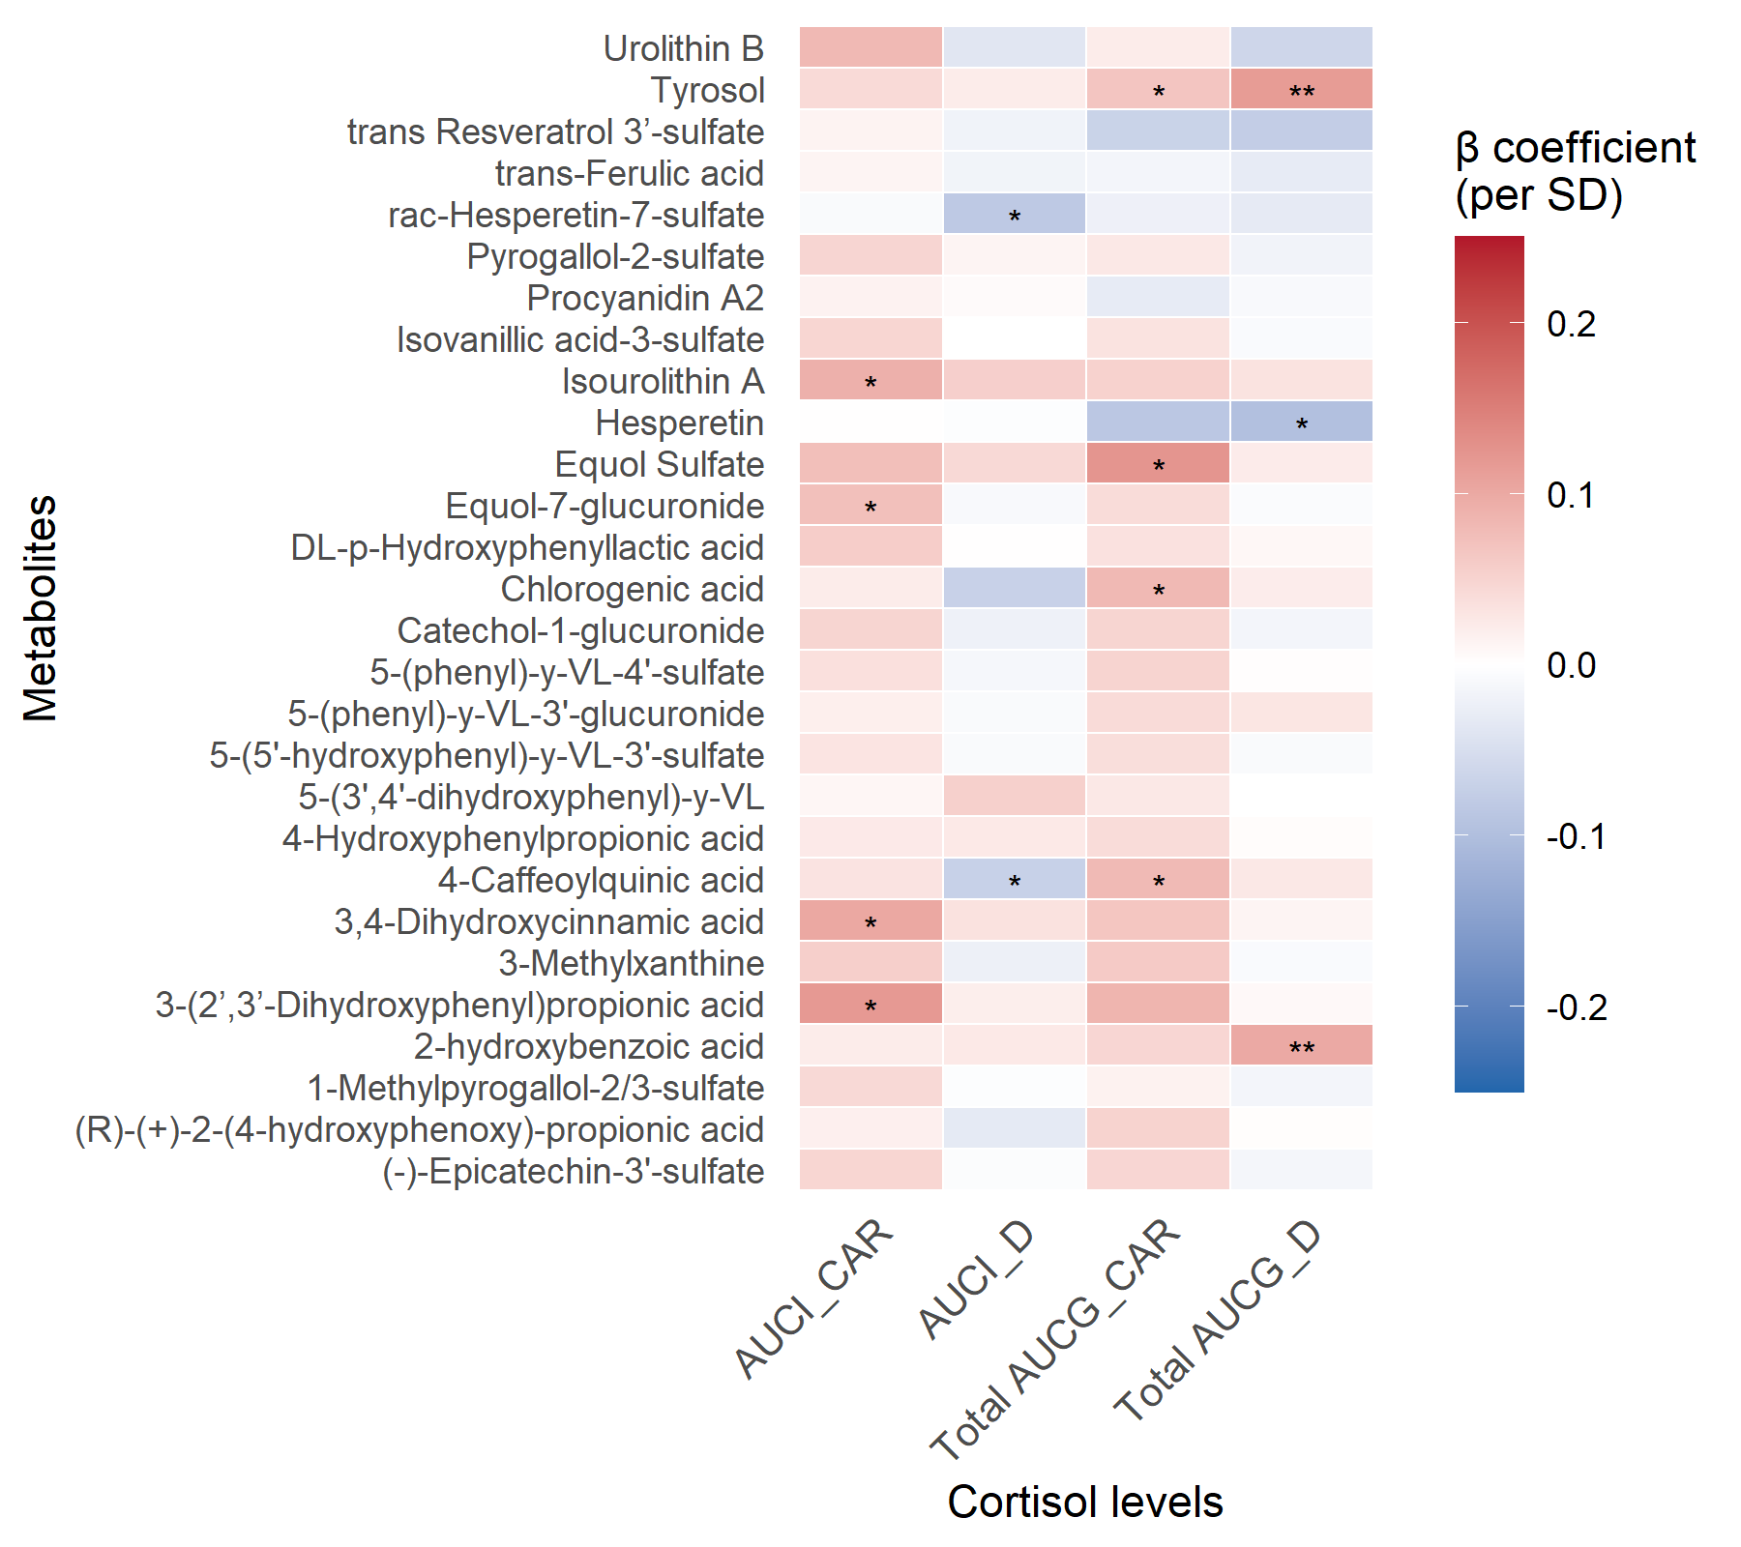

Supplementary Figure 1. Associations of the selected metabolites using elastic net regression with cortisol levels (Crude model)
Model 1, adjusted by age, sex, education levels and ethnicity ;Model 2, model 1 additionally adjusted for physical activity, BMI, alcohol intake, smoking, energy and fibre intake. Colors indicate the direction (red for positive and blue for inverse) and strength (darker color for stronger effect size) of the associations; asterisks denote significance. Total AUCG_CAR,total area under the curve with respect to ground-cortisol awakening response; Total AUCG_D, total area under the curve with respect to ground-daytime; AUCI_CAR, area under the curve with respect to increase-cortisol awakening response; AUCI_D, area under the curve with respect to increase-daytime.* P<0.05; ** False Discovery Rate (FDR) adjusted P<0.05.

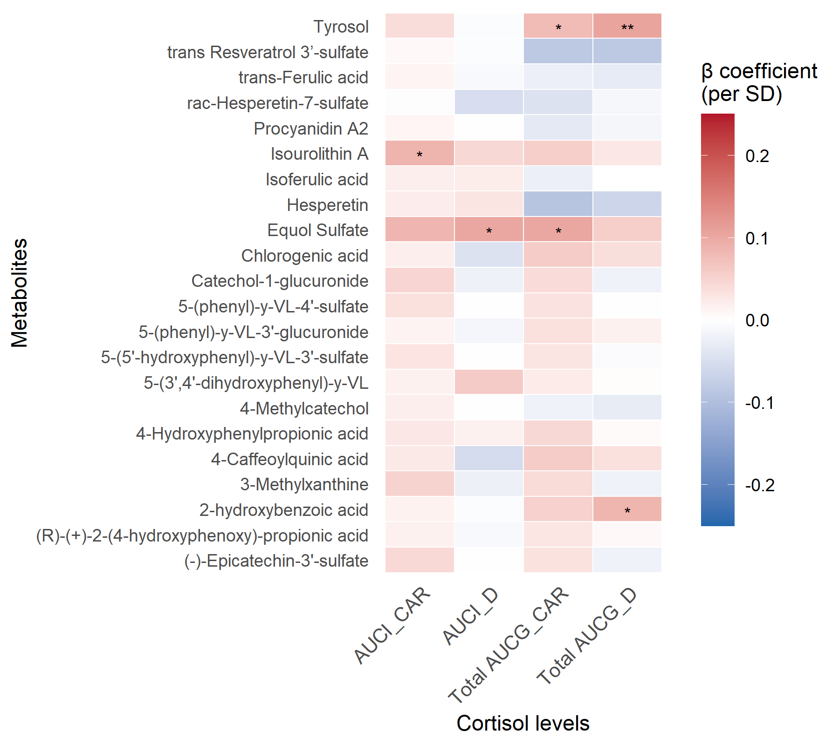

Supplementary Figure 2. Associations of the selected metabolites using elastic net regression with cortisol levels (Model 1)

Model 1, adjusted by age, sex, education levels and ethnicity ;Model 2, model 1 additionally adjusted for physical activity, BMI, alcohol intake, smoking, energy and fibre intake. Colors indicate the direction (red for positive and blue for inverse) and strength (darker color for stronger effect size) of the associations; asterisks denote significance. Total AUCG_CAR,total area under the curve with respect to ground-cortisol awakening response; Total AUCG_D, total area under the curve with respect to ground-daytime; AUCI_CAR, area under the curve with respect to increase-cortisol awakening response; AUCI_D, area under the curve with respect to increase-daytime.* P<0.05; ** False Discovery Rate (FDR) adjusted P<0.05.

