Supplementary material
Phosphoflow protocol
- Surface labelling
- Put 100 μL of whole blood into a Falcon tube
- Add the following antibodies to each tube : 1 μL CD14 PerCp-Vio700 + 2.5 μL CD16 BV605 + 2.5 μL CD3 AF700 + 0.5 μL CD19 BV421
- Incubate 30 minutes at 4°C in a dark environment
- Add 2 mL of BD lysis. Incubate for 5 minutes at 4°C protected from light
- Add 2 mL of PBS. Centrifuge for 5 minutes at 4°C 1500 rpm. Remove the supernatant by inverting
- Permeabilization
- Add 250 μl of Cytofix/Cytoperm solution. Vortex briefly
- Incubate 20 min, at 4°C, protected from light
- Add 1mL of 1:10 diluted BD Perm/Wash™ solution. Centrifuge during 5 min at 4°C, 1500 rpm and remove the supernatant by inverting
- Intracellular labelling
- Dilute the pSHP-1^{S591}AF647 antibody to 1:20
- Add the antibodies directly to the cell pellet after removal of the supernatant: 2 μL pSHP-1^{S591}AF647 + 0.5 μL pSyk^{Y525}AF488 + 2.5 μL pPLC-G2^{Y759}PE-Vio770
- Incubate 30 minutes at 4°C, protected from light
- Add 1 mL of BD Perm/Wash™ diluted 1:10. Centrifuge during 5 minutes at 4°C, 1500 rpm. Remove the supernatant by inverting
- Add 1 mL of PBS. Centrifuge during 5 minutes at 4°C, 1500 rpm. Remove supernatant by inverting
- Re-suspend the cells in 350 μl of PBS
- Scan with flow cytometer

Supplementary Table 1: Comparison of the six T1/T0 phosphoprotein ratios according to norepinephrine requirement on postoperative day 1
T1/T0 ratio | Median without NOR on POD 1 | Median with NOR on POD 1 | Unadjusted p | Bonferroni-adjusted p | Benjamini-Hochberg adjusted p
SHP-1 ratio, neutrophils | 0.50 | 0.33 | 1.00 | 1.00 | 1.00
Syk ratio, neutrophils | 1.16 | 1.30 | 0.39 | 1.00 | 0.79
PLC-G ratio, neutrophils | 0.46 | 0.34 | 1.00 | 1.00 | 1.00
SHP-1 ratio, monocytes | 0.79 | 1.33 | 0.24 | 1.00 | 0.73
Syk ratio, monocytes | 0.22 | 0.64 | 0.032 | 0.19 | 0.19
PLC-G ratio, monocytes | 0.74 | 0.70 | 1.00 | 1.00 | 1.00
Ratios were compared using the Mann-Whitney U test. Adjustment for multiple comparisons was applied across the six ratios. Numbers of patients were 19 without NOR and 4 with NOR on POD 1, except for SHP-1 ratios (17 and 3, respectively).
NOR: norepinephrine; PLC-G: phospholipase C gamma; POD: postoperative day; SHP-1: Src homology 2 domain-containing phosphatase 1; Syk: spleen tyrosine kinase

Supplementary Figure 1: Correlation matrix of the proteins of interest and CPB duration

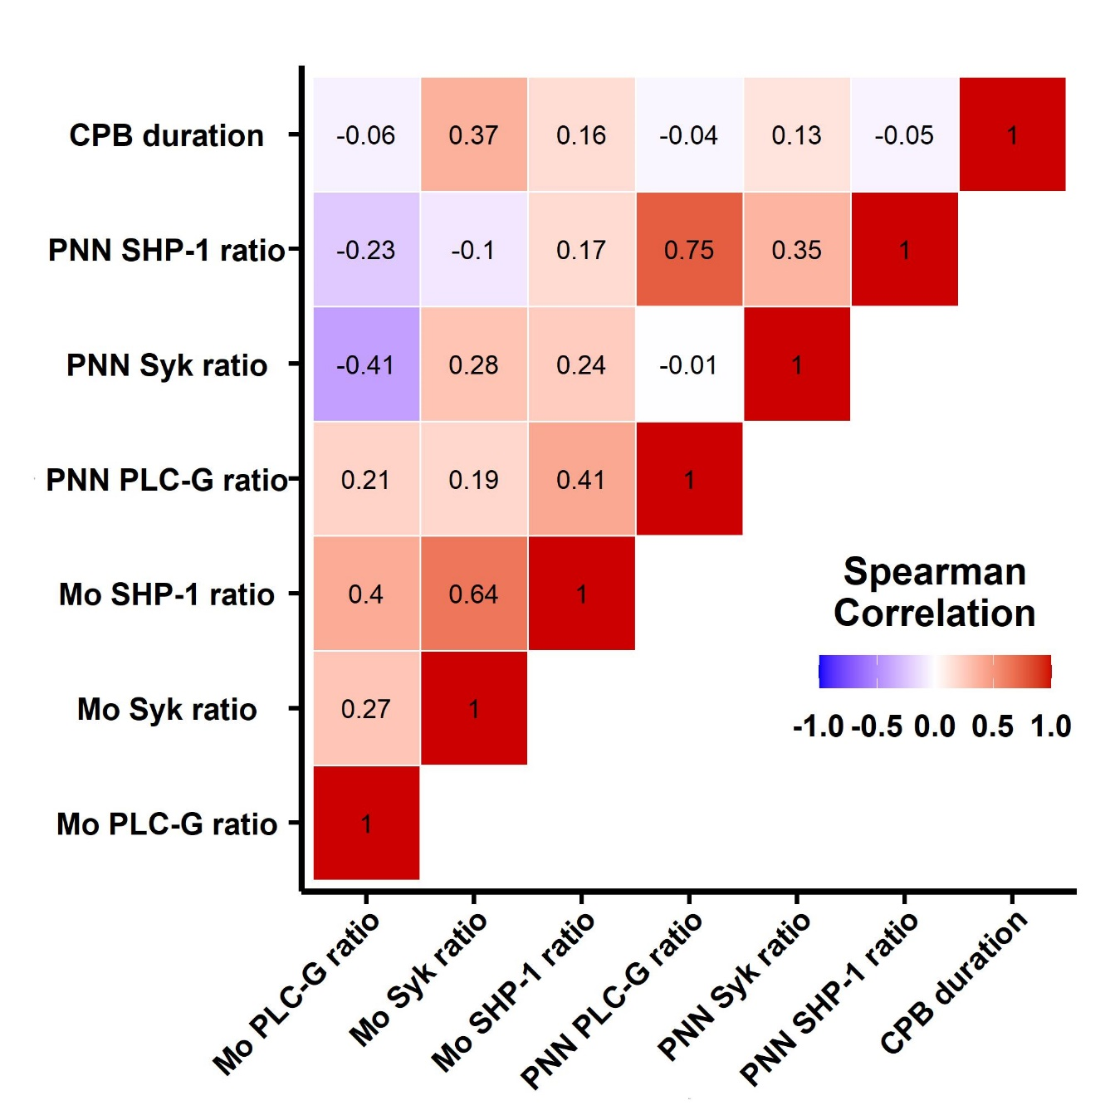
CPB: cardiopulmonary bypass; Mo: monocyte; PLC-G: phospholipase C gamma; PNN: polynuclear neutrophil; SHP-1: Src homology 2 domain-containing phosphatase 1; Syk: spleen tyrosine kinase

