Supplementary Materials
Supplementary 1. General functioning of the REAplan®.
With the distal effector of the REAplan® (AXINESIS, Wavre, Belgium) robot, the subjects are able to realize displacements in the horizontal plane through movement of the shoulder (flexion/extension and /adduction/abduction) and the elbow (flexion/extension), by interacting with the robot through a handle mounted on a forearm rest gutter. The height of the table (i.e., the horizontal plane), is adjusted to the subject’s morphology in order to provide a comfortable sitting position.
A large immersive screen is positioned in front of the subject, on which the instructions, tasks and feedbacks are displayed. By using a connected keyboard and a side-monitor, the therapist can configure the exercises, start and stop trials, and monitor the progression of the subject’s performances.
The distal effectors (handles and forearms gutters) are positioned in front of each shoulder of the subject during the calibration phase. For the current experiment, depending on the randomization, each UL controlled the cursor’s displacement along a single axis, either left-right or front-back (i.e., lateral X-axis or sagittal Y-axis).

Supplementary Fig. 1. Formula of the biCO for the REACHING task.
$$biCO=\frac{min⁡(\left|V_{x}\right|,\left|V_{y}\right|*0.41)}{\sqrt{{\left(V_{x}\right)}^{2}+(0.41*V_{y})²}}$$

Because in the ± 22.5° targets (from the Y-axis), the ideal coordination does not happen when V_{x} = V_{y} but when V_{x} is 0.41 x V_{y} (i.e. tan 22.5° = V_{x}/V_{y} = 0.41). Finally, as 0° REACHING was actually “unimanual”, biCO was not calculated.

Supplementary Fig. 2. Simplified CONSORT flow diagram for the chronic stroke patients.

Enroll

ment
Assessed for eligibility (n=70)
Analysed (n=11)
♦ Excluded from analysis (give reasons) (n=0)
Analysed (n=13)
♦ Excluded from analysis (give reasons) (n=0)

Lost to follow-up (give reasons) (n= 0)
Discontinued intervention (give reasons) (n= 0)
Lost to follow-up (give reasons) (n=0)
Discontinued intervention (give reasons) (n= 0)
Allocated to intervention: Left-UpDown. (n=13)
♦ Received allocated intervention (n=13)
♦ Did not receive allocated intervention (give reasons) (n=0)
Allocated to intervention Right-UpDown (n= 11)
♦ Received allocated intervention (n=11)
♦ Did not receive allocated intervention (give reasons) (n= 0)

Allocation

Follow-Up
Excluded (n= 46)
♦ Not meeting inclusion criteria (n=7)
♦ Declined to participate (n= 2)
♦ Other reasons (n= 37)
- Others diseases (n= 8)
- Not disponible 3 days (n= 17)
- Do not wish (n=12)
Randomized (n= 24)

Analysis

Supplementary Table 1. Speed and Error on the CIRCUIT task.

 | Speed (cm/s)  Mean ± SD |  |  |  | Error (cm)  Mean ± SD
 | HIs | Group 1 | Group 2 |  | HIs | Group 1 | Group 2
D1 start | 5 ± 3 | 8 ± 5 | 6 ± 3 |  | 0.86 ± 0.18 | 1.04 ± 0.37 | 1.24 ± 0.52
D1 end | 10 ± 7 | 16 ± 9 | 9 ± 4 |  | 0.66 ± 0.11 | 0.97 ± 0.54 | 1.16 ± 0.51
D2 start | 7 ± 4 | 10 ± 6 | 7 ± 4 |  | 0.94 ± 0.27 | 1.11 ± 0.47 | 1.22 ± 0.54
D2 end | 18 ± 7 | 19 ± 8 | 12 ± 6 |  | 0.81 ± 0.28 | 0.94 ± 0.48 | 1.11 ± 0.50
D3 start | 15 ± 5 | 14 ± 7 | 11 ± 6 |  | 0.91 ± 0.30 | 1.07 ± 0.53 | 1.28 ± 0.54
D3 end | 24 ± 9 | 23 ± 13 | 17 ± 12 |  | 0.87 ± 0.26 | 0.97 ± 0.48 | 1.06 ± 0.40
NC start | 16 ± 4 | 13 ± 6 | 12 ± 7 |  | 0.89 ± 0.18 | 1.00 ± 0.44 | 1.27 ± 0.47
NC end | 20 ± 7 | 17 ± 9 | 14 ± 9 |  | 0.89 ± 0.28 | 1.04 ± 0.54 | 1.13 ± 0.41
R1 | 17 ± 12 | 15 ± 11 | 9 ± 5 |  | 0.90 ± 0.19 | 1.03 ± 0.45 | 1.32 ± 0.72
R2 | 49 ± 18 | 14 ± 9 | 18 ± 12 |  | 0.85 ± 0.17 | 0.77 ± 0.31 | 1.08 ± 0.45
Supplementary Table 1. D1: day 1, D2: day 2, D3: day 3, NC: New Circuit layout for assessed the generalization, R1: reaching on D1, R2: reaching on D2), HIs: healthy ndividuals, 1: Group 1 (i.e., patients with FMA-UE =66), 2: Group 2 (i.e., patients with FMA-UE <66).

Supplementary Fig. 3. Evolution of velocity on the CIRCUIT task.
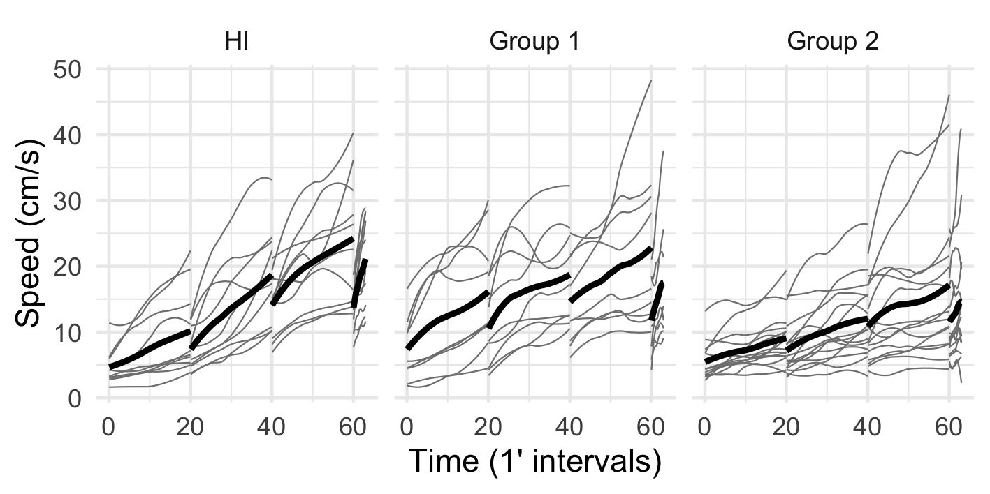

Velocity measured in cm/s over the three days of training on the CIRCUIT task. The thick black lines correspond to the group means, and the thin gray lines correspond to the healthy individuals (HIs), patients with stroke with FMA-UE = 66 (Group 1), and patients with stroke with FMA-UE < 66 (Group 2) respectively. D1: blocks 1-20, D2: blocks 21-40, D3: blocks 41-60, NC (generalisation on D3): blocks 61-63.

Supplementary Fig. 4. Evolution of error on the CIRCUIT task.
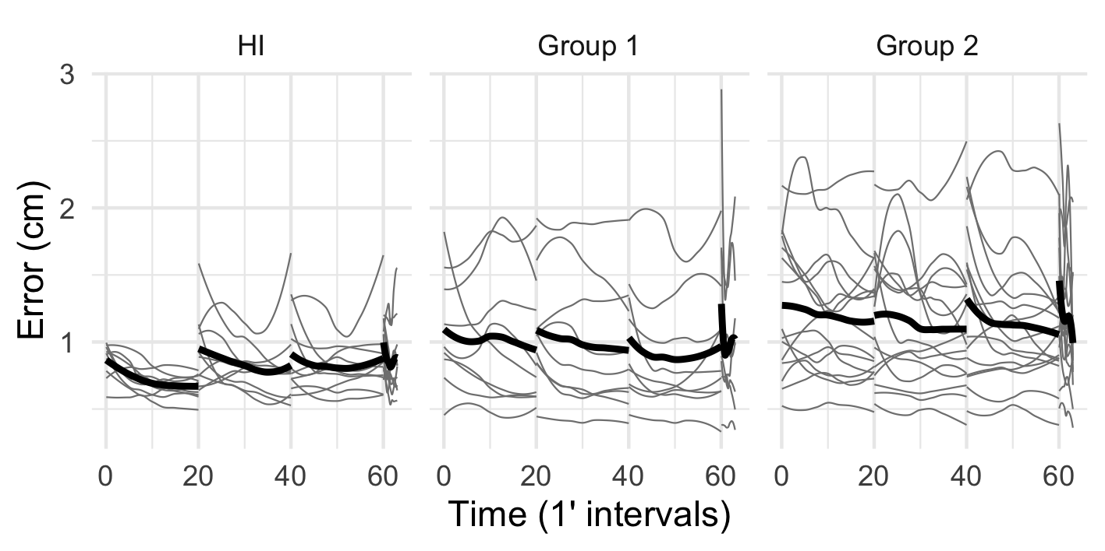
Error (distance between the cursor trajectory and the ideal path, defined as the centre of the track, in cm. Same conventions as for Supplementary Figure 3.

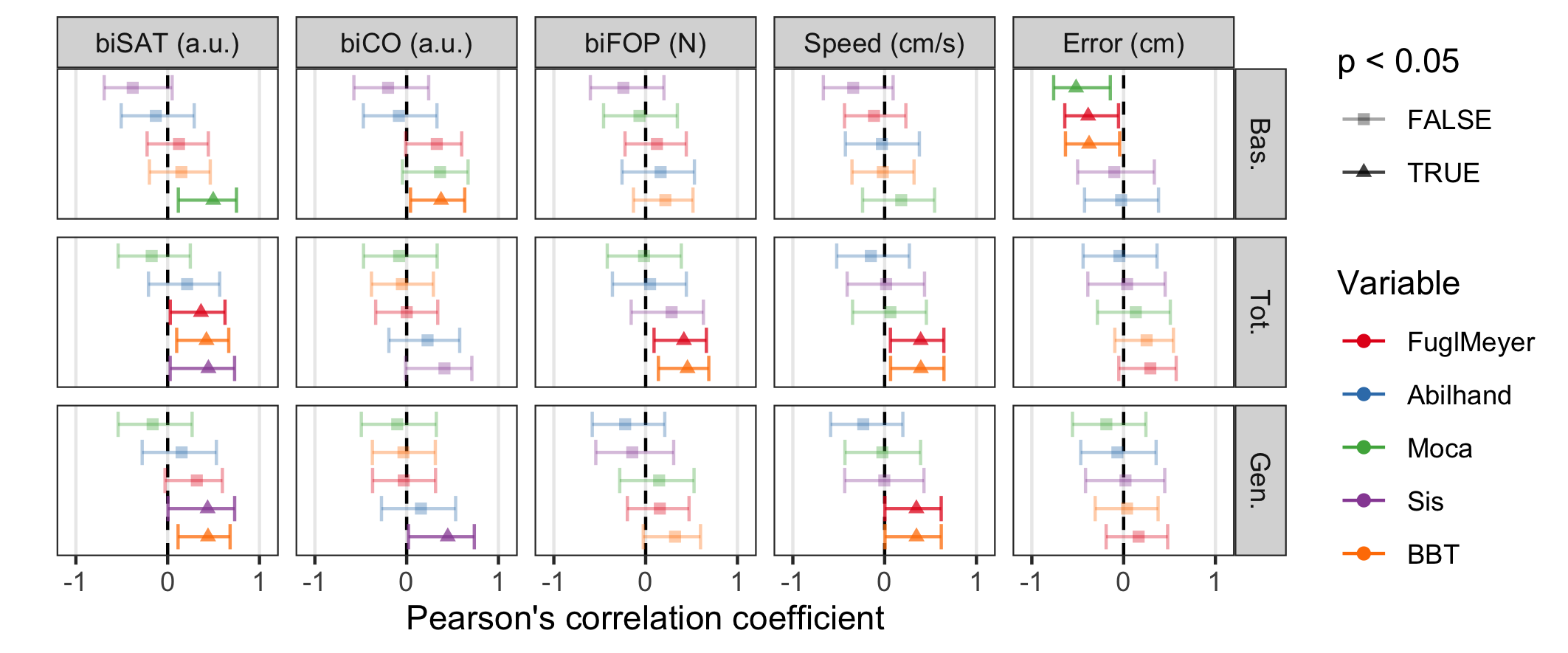
Supplementary Fig. 5. Correlations between robotic ouctomes and baseline clinical scales.

Supplementary Fig. 5. Pearson’s correlation coefficient for each pair of
variables of the 95% confidence interval (CI). biSAT/biCO/biFOP: variables
representing the progressions on the robot, Bas: baseline (i.e., first CIRCUIT training block on the first day, Tot: overall progression, Gen: generalization (i.e., task on a new CIRCUIT (NC) layout), Fugl-Meyer Upper Extremity (FMA-UE), ABILHAND: measure of manual ability for patients with chronic stroke in activities of daily living, MoCA: Montreal Cognitive Assessment, Stroke Impact Scale (SIS) and Box and Blocks Test (BBT). The dots correspond to the effect sizes and the bars to the CI. The dashed line represents the value 0.

