Supplementary Material for
Original article
Quercetin inhibits the growth of triple-negative breast cancer via the AKT1 pathway
Supplementary S1 Synthetic route of compound QUE-Biotin. Reagents and conditions: (a) 6-(5-((3aS,4S,6aR)-2-oxohexahydro-1H-thieno[3,4-d]imidazol-4-yl)pentanamido)hexanoic acid, EDC, DMAP, THF, RT, 2 h.
Simplyput,6-(5-((3aS,4S,6aR)-2-oxohexahydro-1H-thieno[3,4-d]imidazol-4-yl)pentanamido)hexanoic acid was dissolved in 5 mL of THF.The solution was stirred bath as DMAP (2 mg, 0.014 mmol) and EDC (11 mg, 0.07 mmol) were added over 30min,Then QUE (21 mg, 0.07 mmol) was added, While the mixture was stirred at room temperaturefor 1 h. Finally,The resulting solution was washed successively with 0.5mol/L HCl and 20 mL water ,then dried over Na₂SO4, filteredand concentrated in vacuo. The crude produce was purified by flash chromatography to afford the probe compound (4.5 mg, Yield: 10%)as a yellow solid. 1H NMR (500 MHz, DMSO-d6) δ 7.93 (s, 1H), 7.85 (s, 1H), 7.80 (d, J = 6.3 Hz, 1H), 7.74 (s, 1H), 7.67 (s, 1H), 7.57 (d, J = 6.3 Hz, 1H), 7.29 (s, 1H), 6.68 (s, 1H), 6.46 (s, 1H), 6.41 (s, 1H), 6.34 (s, 1H), 6.19 (s, 1H), 4.32 – 4.25 (t, J = 4.5 Hz, 1H), 4.12 (t, J = 4.3 Hz, 1H), 3.81 – 3.72 (m, 2H), 3.05 (d, J = 6.2 Hz, 2H), 2.81 (dd, J = 12.4, 5.0 Hz, 1H), 2.59 (d, J = 7.1 Hz, 2H), 2.40 (s, 1H), 2.10 – 2.05 (m, 2H), 1.98 (d, J = 5.9 Hz, 1H), 1.87 (s, 1H), 1.69 – 1.62 (m, 2H), 1.45 (m, 3H), 1.33 – 1.28 (m, 3H), 1.23 (s, 1H). LC-MS (ESI-TOF): m/z 642.2118 [M + H]+.
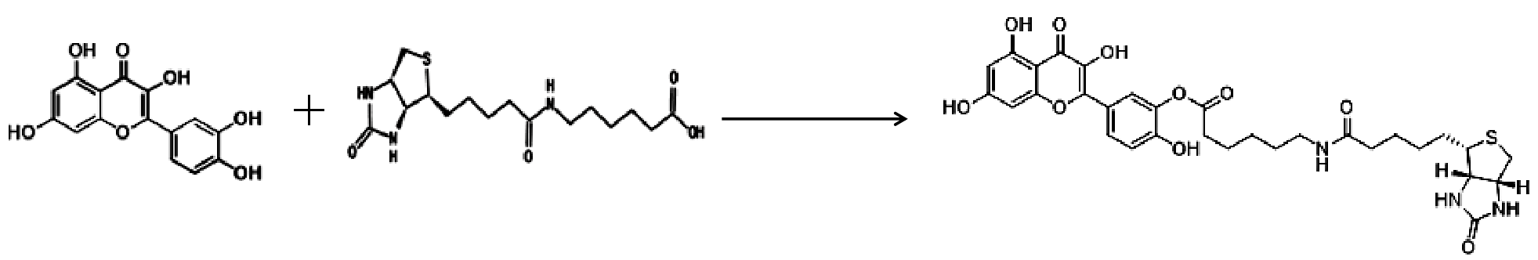
QUE-Biotin
N-Biotinylcaproic Acid
Quercetin, QUE
RT,2h
EDC,DMAP,THF

All solvents and reagents were used as obtained. 1H NMR spectra were recorded with a Bruker 500 MHz NMR spectrometer (Karlsruhe, Germany) and referenced to deuterium dimethyl sulfoxide (DMSO-d6). Chemical shifts are expressed in ppm. Chemical shifts are expressed in ppm. In the NMR tabulation, s indicates singlet; d, doublet; t, triplet; q, quartet; m, multiplet; and br, broad peak. LC/MS experiments were performed on an Agilent 6224 TOF (Santa Clara, CA, USA) using an ESI source coupled to an Agilent 1260 Infinity HPLC system operating in reverse mode with an Agilent Eclipse Plus C18 1.8 μm, 3.0 mm×50 mm column. Purification of the final compounds were performed with an Isco CombiFlash Rf+ system (Lincoln, NE, USA) (silica flash column 4 g) using a gradient of 0%–10% MeOH in DCM over 20 min at a flow rate of 18 mL/min. QUE-Biotin were isolated by flash chromatography and turned out to be a mixture of 3′ - and 4′ -substituted quercetins, 3′ as the major esterification site. The two isomers would be expected to have very similar properties.

Fig. S1 1H-NMR of QUE-Biotin
Table S1 List of the sequences of siRNA used in cell transfection.
 | Forward primer (5′-3′) | Reverse primer (3′-5′)
si-AKT1#1 | CUCCUCAAGAAUGAUGGCATT | UGCCAUCAUUCUUGAGGAGTT
si-AKT2#2 | AGCGACGUGGCUAUUGUGATT | UCACAAUAGCCACGUCGCUTT
si-AKT1#3 | CUGACCAAGAUGACAGCAUTT | AUGCUGUCAUCUUGGUCAGTT
si-AKT1#4 | CCCUGAAGUACUCUUUCCATT | UGGAAAGAGUACUUCAGGGTT
si-NC | UUCUCCGAACGUGUCACGUTT | TTAAGAGGCUUGCACAGUGCA

Fig. S2 The knockdown efficiency of AKT1 in MDA-MB-231 cells was verified by qPCR assay(A) and western blotting assay (B).

