Supplementary information
Alpine plant thermophilisation is driven by shrubs, snow and microclimates
This document contains:
Fig. S1 | GLORIA mountain sites and summit setup
Fig. S2 | Schematic overview of our hypotheses
Fig. S3 | Additional density plots for mean and maximum soil temperatures as well as freezing and thawing degree days
Fig. S4 | Density plots for macroclimate debts
Fig. S5 | Model estimates for macroclimate debts
Fig. S6 | Model estimates for thermophilization rates with annual mean soil temperature as predictor
Fig. S7 | Model estimates for macro- and microclimate debts with annual mean soil temperature as predictor
Fig. S8 | Model estimates for thermophilization rates with annual maximum soil temperature as predictor
Fig. S9 | Model estimates for macro- and microclimate debts with annual maximum soil temperature as predictor
Fig. S10 | Model estimates for thermophilization rates with soil freezing degree days as predictor
Fig. S11 | Model estimates for macro- and microclimate debts with soil freezing degree days as predictor
Fig. S12 | Model estimates for thermophilization rates with soil thawing degree days as predictor
Fig. S13 | Model estimates for macro- and microclimate debts soil thawing degree days as predictor
Fig. S14 | Density plots for thermophilization rates and microclimate debts based on community-weighted mean thermal indices
Fig. S15 | Model estimates for thermophilization rates and microclimate debts based on community-weighted mean thermal indices
Fig. S16 | Model estimates for thermophilization rates and microclimate debts with deciduous shrub cover as predictor
Fig. S17 | Model estimates for thermophilization rates and microclimate debts with evergreen shrub cover as predictor
Table S1 | Overview of the mountain sites and summits including geographical positioning and elevations
Table S2 | Summary table with model estimates for the rate of shrub cover change
Table S3 | Summary table with model estimates for the rate of change in snow duration
Table S4 | Summary table with model estimates for the rate of annual minimum soil temperature change
Table S5 | Summary table with model estimates for thermophilization rates in the herbaceous vegetation
Table S6 | Summary table with model estimates for microclimate debts in the herbaceous vegetation
Table S7 | Summary table with model estimates for macroclimate debs in the herbaceous vegetation

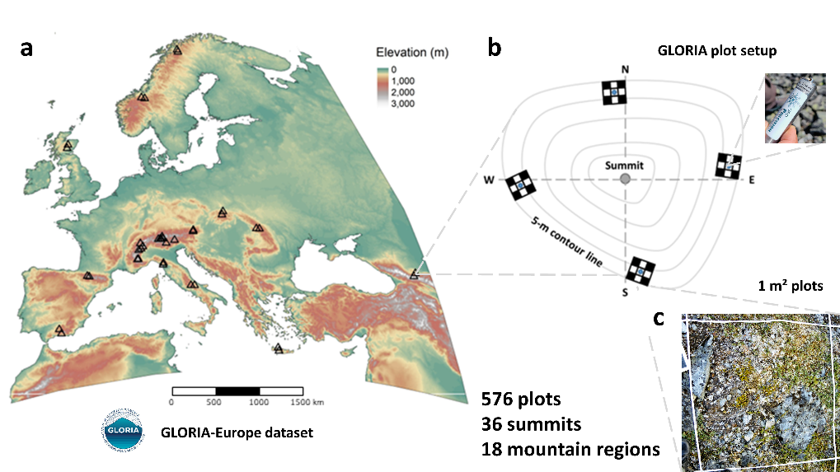
Fig. S1. Geographical distribution of the mountain summit sites across Europe (a) including the setup of the 1-m² permanent plot network (b), and the vegetation surveys and microclimate loggers (c). Pictures by Thomas Vanneste.
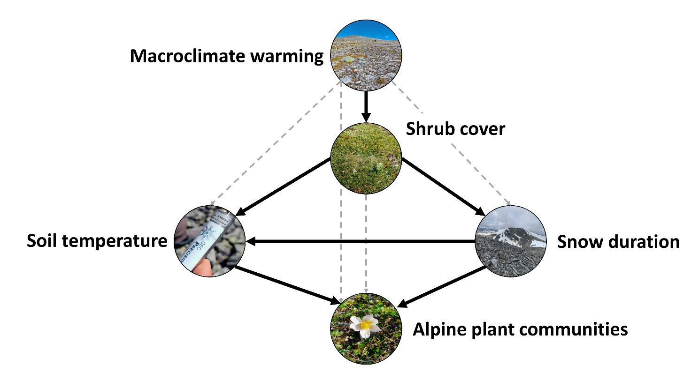
Fig. S2. Schematic overview of our four main hypotheses (black arrows) as well as additionally expected pathways (grey dashed lines). Pictures by Thomas Vanneste.

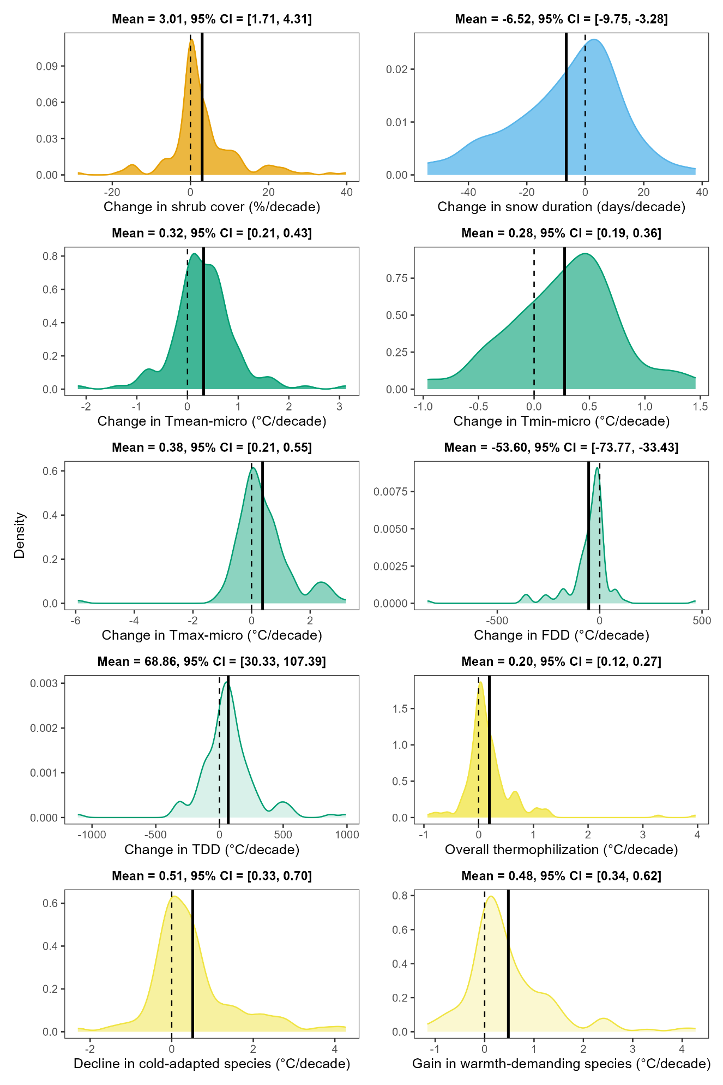
Fig. S3. Density plots showing the distribution for the rate of shrub cover change, change in snow cover duration, annual minimum, mean and maximum soil temperature, freezing degree days (FDD, i.e., thermal sums below 0 °C) thawing degree days (TDD, i.e., thermal sums above 0 °C), and thermophilization rates in the herbaceous vegetation in the 1-m² plots across the European alpine summits. The y-axis in the density plots represents the estimated probability density with the area under each curve summing to 1. At any point, the height of the curve reflects the relative likelihood of the respective variables taking that value. The dashed line shows the zero-change line, whereas the solid black line depicts the average rate of change for each focal variable.

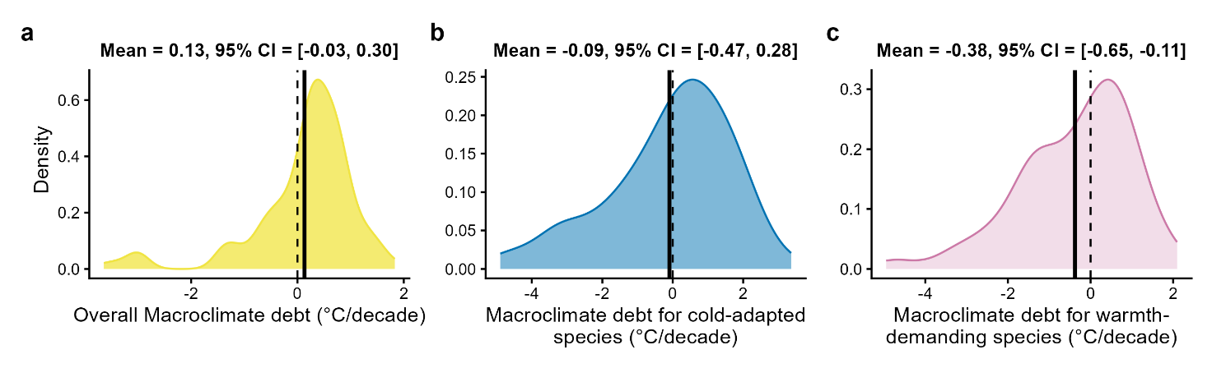
Fig. S4. Density plots showing the distribution for the macroclimate debts in the herbaceous vegetation in the 1-m² plots across the European alpine summits. Macroclimate debts (in °C per decade) were calculated as the difference between the rate of gridded air (i.e., annual minimum) temperature change, on the one hand, and the thermophilization rates of the herbaceous vegetation (i.e., mean, 5th percentile and 95th percentile of CTI), on the other hand. The y-axis in the density plots represents the estimated probability density with the area under each curve summing to 1. At any point, the height of the curve reflects the relative likelihood of the respective variables taking that value. The dashed line shows the zero-change line, whereas the solid black line depicts the average rate of change for each focal variable. This graph complements Fig. 2 in the main text.
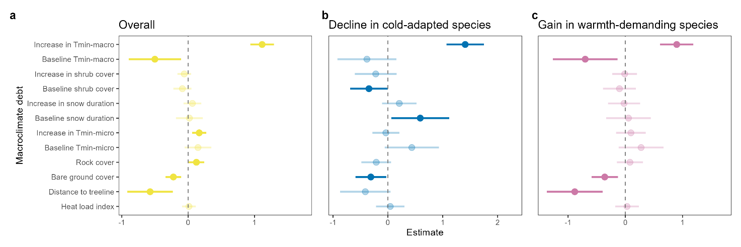
Fig. S5. Macroclimate debts in the herbaceous plant communities on the European alpine summits modelled as function of macroclimate change, shrub cover change, change in snow duration and soil microclimate change. Macroclimate debts (in °C per decade) were calculated as the difference between the rate of soil (i.e., annual minimum) temperature change, on the one hand, and the thermophilization rates of the herbaceous vegetation, on the other hand. Thermophilization was quantified as the rate of change in mean community temperature index (CTI, i.e., overall thermophilization; a), the 5th percentile of the community temperature index (i.e., decline in cold-adapted species; b) and the 95th percentile of the community temperature index (i.e., gain in warmth-demanding species; c). Main predictor variables in the linear-mixed effect models were: the rate of shrub cover change, the rate of change in snow duration and the rate of soil temperature change. For each model, the baseline conditions (e.g., baseline shrub cover, baseline snow cover duration, etc.) were used as additional predictors to account for regression toward the mean. All models also included plot-level rock cover (i.e., proxy for topographical complexity), plot-level bare ground cover (i.e., amount of colonization space), distance of summit to the treeline (i.e., proximity to colonization source of more warmth-demanding species), and heat load index (HLI, i.e., proxy for the amount of radiation a mountain slope receives and calculated based on latitude, aspect and steepness) as covariates. Dots depict mean model estimates and error bars the 95% confidence intervals (CIs) of linear mixed-effect models. Bright colours indicate statistically clear effects (i.e., 95% CIs not including zero), while faded colours depict the absence of statistically clear effects. The dashed line shows the zero-effect line. This graph complements Fig. 3 in the main text.

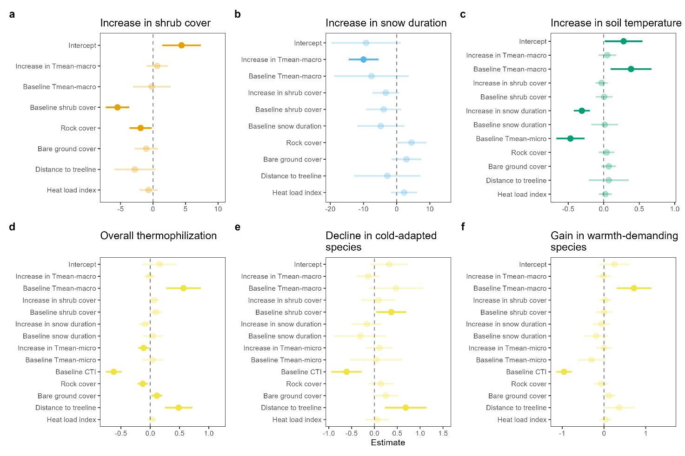
Fig. S6. Rate of change in shrub cover, snow cover duration and soil microclimate as well as thermophilization rates of the herbaceous vegetation on the alpine summits between 2001 and 2022. The first model (a) predicts the rate of shrub cover change in the 1-m² plots based on the rate of change in the annual mean air temperature (i.e., macroclimate), the second model (b) predicts the rate of change in snow cover duration based on the rate of change in shrub cover and mean macroclimate temperature and, the third model (c) predicts the rate of change in mean soil temperature (i.e., microclimate) based on the rate of shrub cover, mean macroclimate temperature and snow cover duration, and the fourth model predicts the thermophilization rates of the herbaceous vegetation as function of based on the rate of shrub cover, mean macroclimate temperature, snow cover duration and mean soil temperature (i.e., microclimate). Thermophilization was quantified as the rate of change in mean community temperature index (CTI, i.e., overall thermophilization; d), the 5th percentile of the community temperature index (i.e., decline in cold-adapted species; e) and the 95th percentile of the community temperature index (i.e., gain in warmth-demanding species; f). All models also included plot-level rock cover (i.e., proxy for topographical complexity), plot-level bare ground cover (i.e., amount of colonization space), distance of summit to the treeline (i.e., proximity to colonization source of more warmth-demanding species), and heat load index (HLI, i.e., proxy for the amount of radiation a mountain slope receives and calculated based on latitude, aspect and steepness) as covariates. Dots depict mean model estimates and error bars the 95% confidence intervals (CIs) of linear mixed-effect models. Bright colours indicate statistically clear effects (i.e., 95% CIs not including zero), while faded colours depict the absence of statistically clear effects. The dashed line shows the zero-effect line. Positive effect sizes indicate an increase in shrub cover, snow duration and soil temperature, and vice versa.
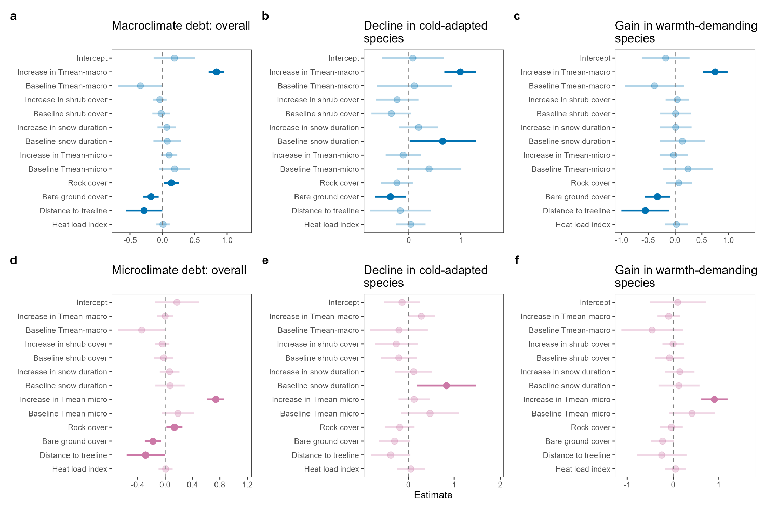
Fig. S7. Macro- and microclimate debts in the herbaceous plant communities on the European alpine summits modelled as function of macroclimate change, shrub cover change, change in snow duration and soil microclimate change. Macro- and microclimate debts (in °C per decade) were calculated as the difference between respectively the rate of gridded air and soil (i.e., annual mean) temperature change, on the one hand, and the thermophilization rates of the herbaceous vegetation, on the other hand. Thermophilization was quantified as the rate of change in mean community temperature index (CTI, i.e., overall thermophilization; a, d), the 5th percentile of the community temperature index (i.e., decline in cold-adapted species; b, e) and the 95th percentile of the community temperature index (i.e., gain in warmth-demanding species; c, f). Main predictor variables in the linear-mixed effect models were: the rate of shrub cover change, the rate of change in snow duration and the rate of soil (i.e., annual mean) temperature change. For each model, the baseline conditions (e.g., baseline shrub cover, baseline snow cover duration, etc.) were used as additional predictors to account for regression toward the mean. All models also included plot-level rock cover (i.e., proxy for topographical complexity), plot-level bare ground cover (i.e., amount of colonization space), distance of summit to the treeline (i.e., proximity to colonization source of more warmth-demanding species), and heat load index (HLI, i.e., proxy for the amount of radiation a mountain slope receives and calculated based on latitude, aspect and steepness) as covariates. Dots depict mean model estimates and error bars the 95% confidence intervals (CIs) of linear mixed-effect models. Bright colours indicate statistically clear effects (i.e., 95% CIs not including zero), while faded colours depict the absence of statistically clear effects. The dashed line shows the zero-effect line.
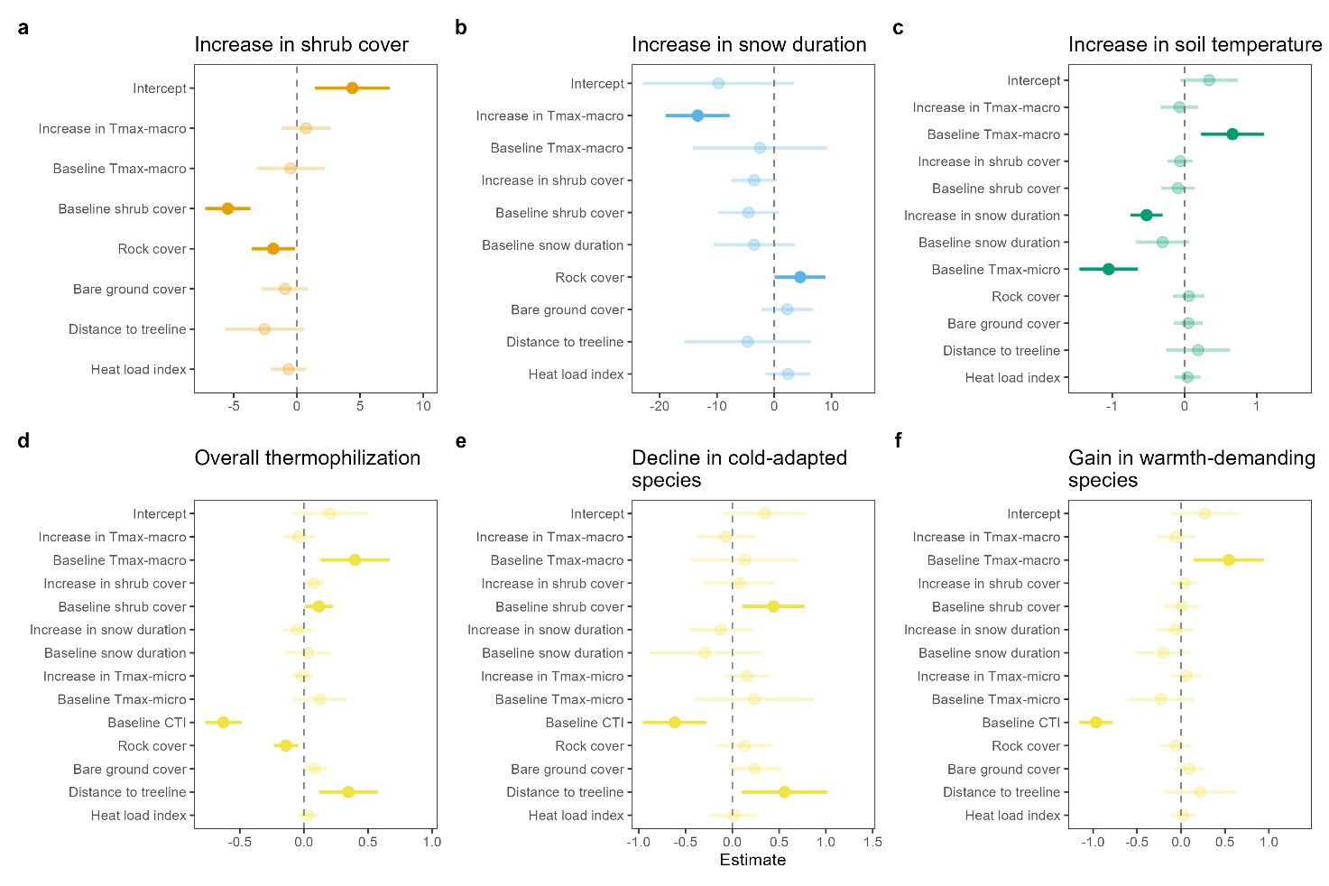
Fig. S8. Rate of change in shrub cover, snow cover duration and soil microclimate as well as thermophilization rates of the herbaceous vegetation on the alpine summits between 2001 and 2022. The first model (a) predicts the rate of shrub cover change in the 1-m² plots based on the rate of change in the annual maximum air temperature (i.e., macroclimate), the second model (b) predicts the rate of change in snow cover duration based on the rate of change in shrub cover and maximum macroclimate temperature and, the third model (c) predicts the rate of change in maximum soil temperature (i.e., microclimate) based on the rate of shrub cover, maximum macroclimate temperature and snow cover duration, and the fourth model predicts the thermophilization rates of the herbaceous vegetation as function of based on the rate of shrub cover, maximum macroclimate temperature, snow cover duration and maximum soil temperature (i.e., microclimate). Thermophilization was quantified as the rate of change in mean community temperature index (CTI, i.e., overall thermophilization; d), the 5th percentile of the community temperature index (i.e., decline in cold-adapted species; e) and the 95th percentile of the community temperature index (i.e., gain in warmth-demanding species; f). All models also included plot-level rock cover (i.e., proxy for topographical complexity), plot-level bare ground cover (i.e., amount of colonization space), distance of summit to the treeline (i.e., proximity to colonization source of more warmth-demanding species), and heat load index (HLI, i.e., proxy for the amount of radiation a mountain slope receives and calculated based on latitude, aspect and steepness) as covariates. Dots depict mean model estimates and error bars the 95% confidence intervals (CIs) of linear mixed-effect models. Bright colours indicate statistically clear effects (i.e., 95% CIs not including zero), while faded colours depict the absence of statistically clear effects. The dashed line shows the zero-effect line. Positive effect sizes indicate an increase in shrub cover, snow duration and soil temperature, and vice versa.
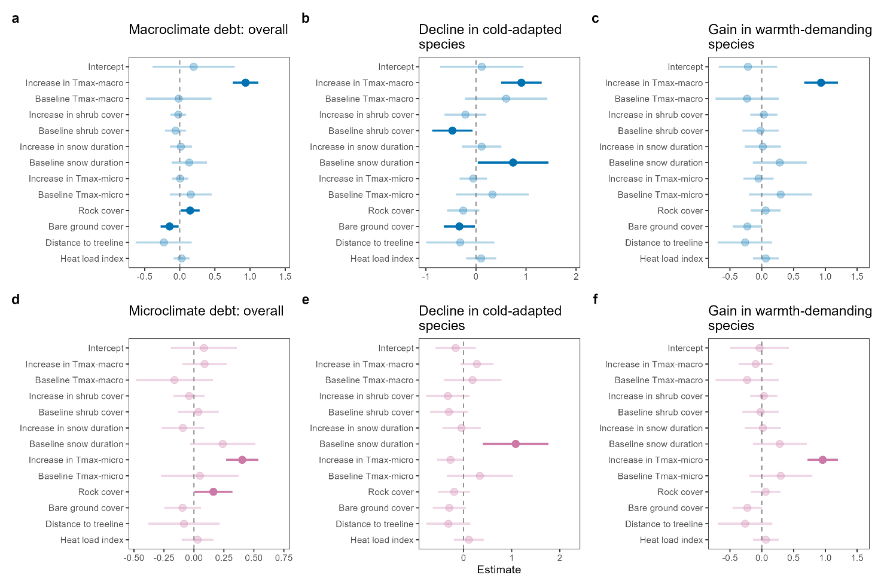
Fig. S9. Macro- and microclimate debts in the herbaceous plant communities on the European alpine summits modelled as function of macroclimate change, shrub cover change, change in snow duration and soil microclimate change. Macro- and microclimate debts (in °C per decade) were calculated as the difference between respectively the rate of gridded air and soil (i.e., annual maximum) temperature change, on the one hand, and the thermophilization rates of the herbaceous vegetation, on the other hand. Thermophilization was quantified as the rate of change in mean community temperature index (CTI, i.e., overall thermophilization; a, d), the 5th percentile of the community temperature index (i.e., decline in cold-adapted species; b, e) and the 95th percentile of the community temperature index (i.e., gain in warmth-demanding species; c, f). Main predictor variables in the linear-mixed effect models were: the rate of shrub cover change, the rate of change in snow duration and the rate of soil (i.e., annual maximum) temperature change. For each model, the baseline conditions (e.g., baseline shrub cover, baseline snow cover duration, etc.) were used as additional predictors to account for regression toward the mean. All models also included plot-level rock cover (i.e., proxy for topographical complexity), plot-level bare ground cover (i.e., amount of colonization space), distance of summit to the treeline (i.e., proximity to colonization source of more warmth-demanding species), and heat load index (HLI, i.e., proxy for the amount of radiation a mountain slope receives and calculated based on latitude, aspect and steepness) as covariates. Dots depict mean model estimates and error bars the 95% confidence intervals (CIs) of linear mixed-effect models. Bright colours indicate statistically clear effects (i.e., 95% CIs not including zero), while faded colours depict the absence of statistically clear effects. The dashed line shows the zero-effect line.
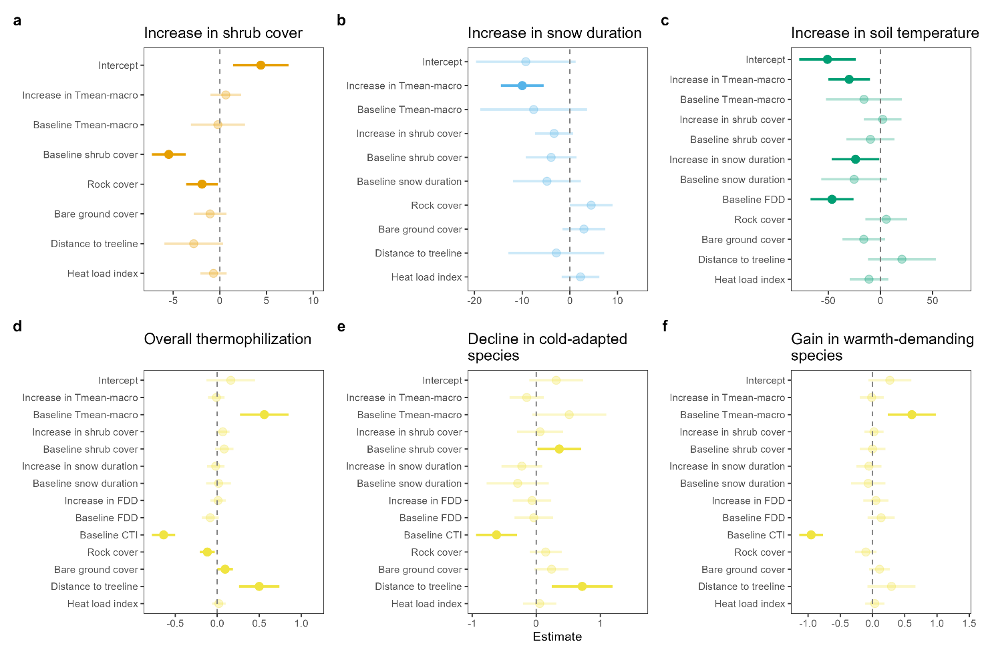
Fig. S10. Rate of change in shrub cover, snow cover duration and soil microclimate as well as thermophilization rates of the herbaceous vegetation on the alpine summits between 2001 and 2022. The first model (a) predicts the rate of shrub cover change in the 1-m² plots based on the rate of change in the annual mean air temperature (i.e., macroclimate), the second model (b) predicts the rate of change in snow cover duration based on the rate of change in shrub cover and mean macroclimate temperature and, the third model (c) predicts the rate of change in freezing degree days (i.e., thermal sums below 0 °C; microclimate) based on the rate of shrub cover, mean macroclimate temperature and snow cover duration, and the fourth model predicts the thermophilization rates of the herbaceous vegetation as function of based on the rate of shrub cover, mean macroclimate temperature, snow cover duration and freezing degree days (i.e., microclimate). Thermophilization was quantified as the rate of change in mean community temperature index (CTI, i.e., overall thermophilization; d), the 5th percentile of the community temperature index (i.e., decline in cold-adapted species; e) and the 95th percentile of the community temperature index (i.e., gain in warmth-demanding species; f). All models also included plot-level rock cover (i.e., proxy for topographical complexity), plot-level bare ground cover (i.e., amount of colonization space), distance of summit to the treeline (i.e., proximity to colonization source of more warmth-demanding species), and heat load index (HLI, i.e., proxy for the amount of radiation a mountain slope receives and calculated based on latitude, aspect and steepness) as covariates. Dots depict mean model estimates and error bars the 95% confidence intervals (CIs) of linear mixed-effect models. Bright colours indicate statistically clear effects (i.e., 95% CIs not including zero), while faded colours depict the absence of statistically clear effects. The dashed line shows the zero-effect line. Positive effect sizes indicate an increase in shrub cover, snow duration and soil temperature, and vice versa.
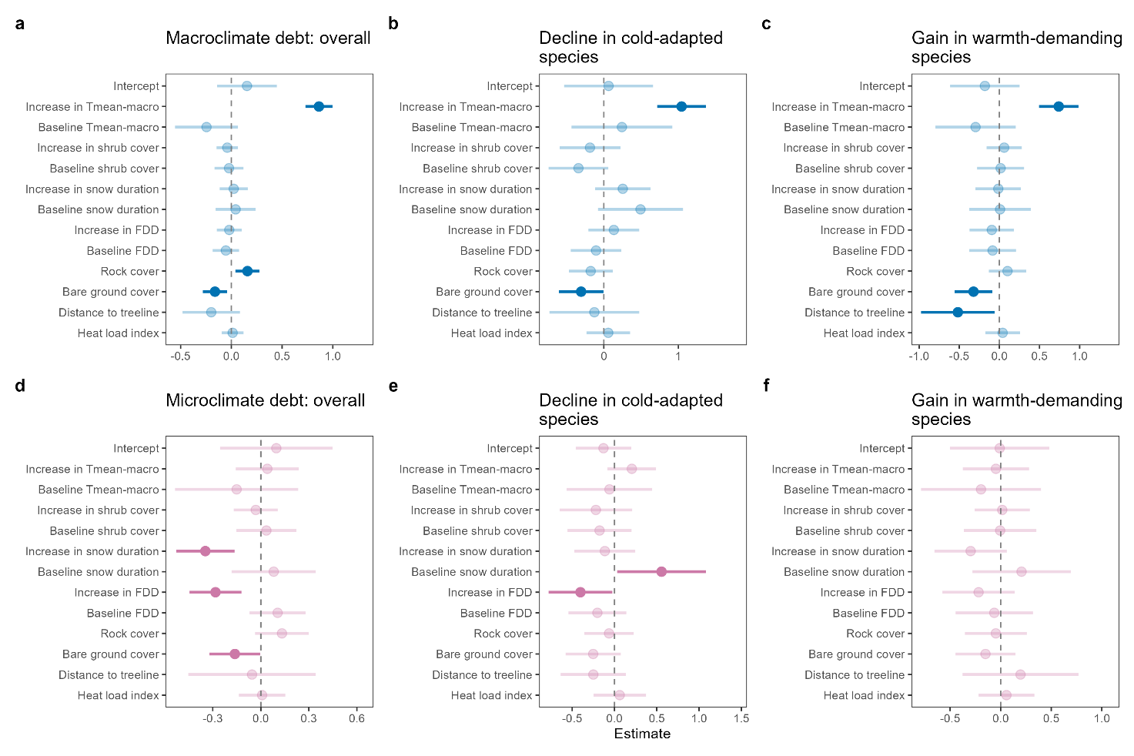
Fig. S11. Macro- and microclimate debts in the herbaceous plant communities on the European alpine summits modelled as function of macroclimate change, shrub cover change, change in snow duration and soil microclimate change. Macro- and microclimate debts (in °C per decade) were calculated as the difference between respectively the rate of gridded air and soil (i.e., annual mean) temperature change, on the one hand, and the thermophilization rates of the herbaceous vegetation, on the other hand. Thermophilization was quantified as the rate of change in mean community temperature index (CTI, i.e., overall thermophilization; a, d), the 5th percentile of the community temperature index (i.e., decline in cold-adapted species; b, e) and the 95th percentile of the community temperature index (i.e., gain in warmth-demanding species; c, f). Main predictor variables in the linear-mixed effect models were: the rate of shrub cover change, the rate of change in snow duration and the rate of change in soil freezing degree days (thermal sums below 0 °C; microclimate). For each model, the baseline conditions (e.g., baseline shrub cover, baseline snow cover duration, etc.) were used as additional predictors to account for regression toward the mean. All models also included plot-level rock cover (i.e., proxy for topographical complexity), plot-level bare ground cover (i.e., amount of colonization space), distance of summit to the treeline (i.e., proximity to colonization source of more warmth-demanding species), and heat load index (HLI, i.e., proxy for the amount of radiation a mountain slope receives and calculated based on latitude, aspect and steepness) as covariates. Dots depict mean model estimates and error bars the 95% confidence intervals (CIs) of linear mixed-effect models. Bright colours indicate statistically clear effects (i.e., 95% CIs not including zero), while faded colours depict the absence of statistically clear effects. The dashed line shows the zero-effect line.
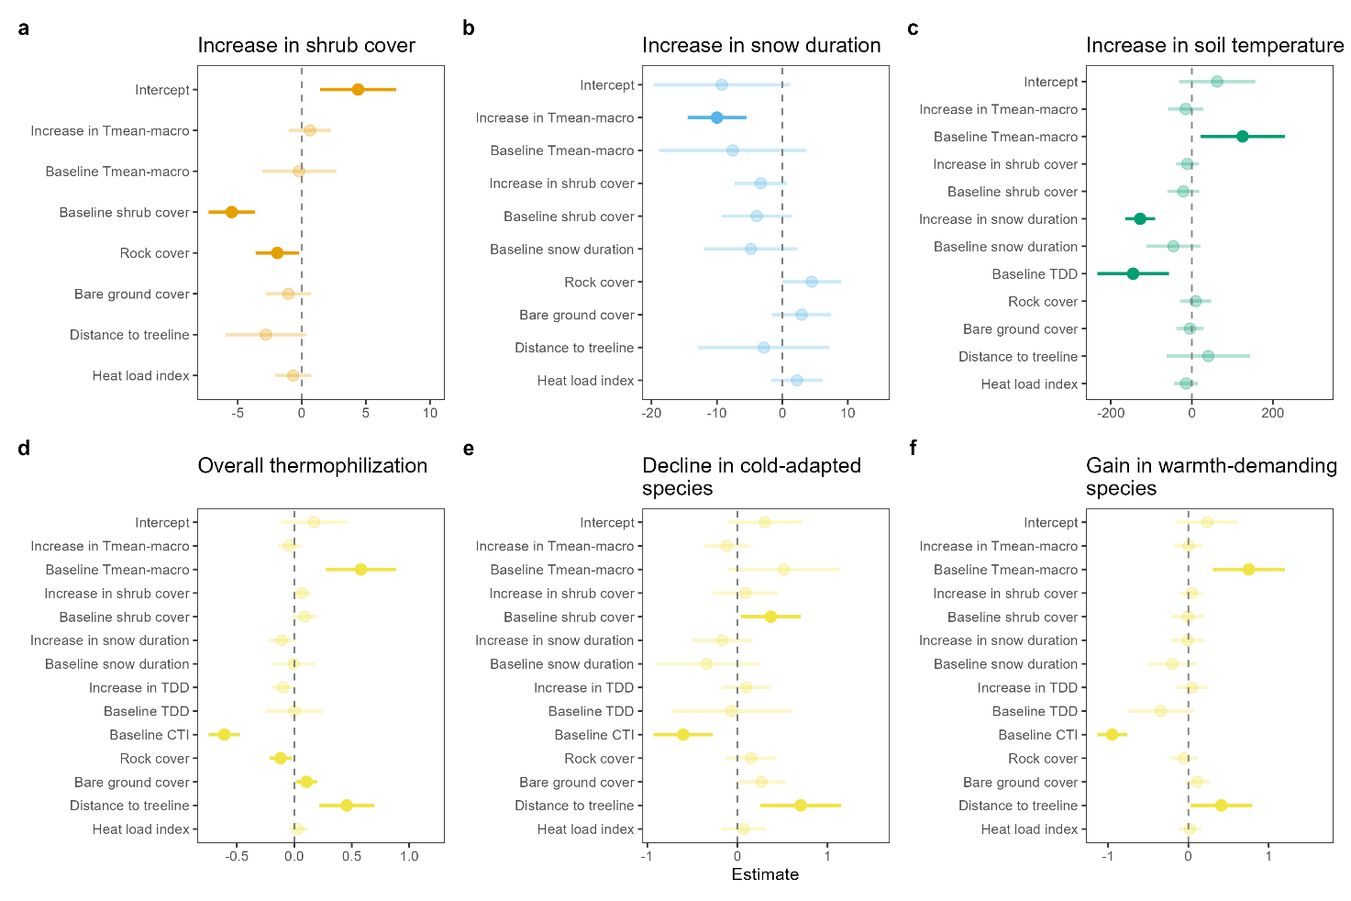
Fig. S12. Rate of change in shrub cover, snow cover duration and soil microclimate as well as thermophilization rates of the herbaceous vegetation on the alpine summits between 2001 and 2022. The first model (a) predicts the rate of shrub cover change in the 1-m² plots based on the rate of change in the annual mean air temperature (i.e., macroclimate), the second model (b) predicts the rate of change in snow cover duration based on the rate of change in shrub cover and mean macroclimate temperature and, the third model (c) predicts the rate of change in thawing degree days (i.e., thermal sums above 0 °C; microclimate) based on the rate of shrub cover, mean macroclimate temperature and snow cover duration, and the fourth model predicts the thermophilization rates of the herbaceous vegetation as function of based on the rate of shrub cover, mean macroclimate temperature, snow cover duration and thawing degree days (i.e., microclimate). Thermophilization was quantified as the rate of change in mean community temperature index (CTI, i.e., overall thermophilization; d), the 5th percentile of the community temperature index (i.e., decline in cold-adapted species; e) and the 95th percentile of the community temperature index (i.e., gain in warmth-demanding species; f). All models also included plot-level rock cover (i.e., proxy for topographical complexity), plot-level bare ground cover (i.e., amount of colonization space), distance of summit to the treeline (i.e., proximity to colonization source of more warmth-demanding species), and heat load index (HLI, i.e., proxy for the amount of radiation a mountain slope receives and calculated based on latitude, aspect and steepness) as covariates. Dots depict mean model estimates and error bars the 95% confidence intervals (CIs) of linear mixed-effect models. Bright colours indicate statistically clear effects (i.e., 95% CIs not including zero), while faded colours depict the absence of statistically clear effects. The dashed line shows the zero-effect line. Positive effect sizes indicate an increase in shrub cover, snow duration and soil temperature, and vice versa.
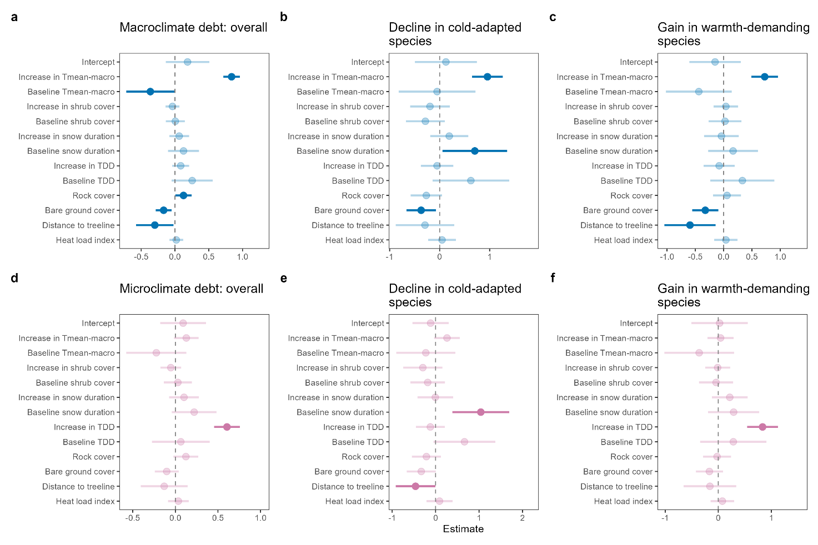
Fig. S13. Macro- and microclimate debts in the herbaceous plant communities on the European alpine summits modelled as function of macroclimate change, shrub cover change, change in snow duration and soil microclimate change. Macro- and microclimate debts (in °C per decade) were calculated as the difference between respectively the rate of gridded air and soil (i.e., annual mean) temperature change, on the one hand, and the thermophilization rates of the herbaceous vegetation, on the other hand. Thermophilization was quantified as the rate of change in mean community temperature index (CTI, i.e., overall thermophilization; a, d), the 5th percentile of the community temperature index (i.e., decline in cold-adapted species; b, e) and the 95th percentile of the community temperature index (i.e., gain in warmth-demanding species; c, f). Main predictor variables in the linear-mixed effect models were: the rate of shrub cover change, the rate of change in snow duration and the rate of change in soil thawing degree days (thermal sums above 0 °C; microclimate). For each model, the baseline conditions (e.g., baseline shrub cover, baseline snow cover duration, etc.) were used as additional predictors to account for regression toward the mean. All models also included plot-level rock cover (i.e., proxy for topographical complexity), plot-level bare ground cover (i.e., amount of colonization space), distance of summit to the treeline (i.e., proximity to colonization source of more warmth-demanding species), and heat load index (HLI, i.e., proxy for the amount of radiation a mountain slope receives and calculated based on latitude, aspect and steepness) as covariates. Dots depict mean model estimates and error bars the 95% confidence intervals (CIs) of linear mixed-effect models. Bright colours indicate statistically clear effects (i.e., 95% CIs not including zero), while faded colours depict the absence of statistically clear effects. The dashed line shows the zero-effect line.

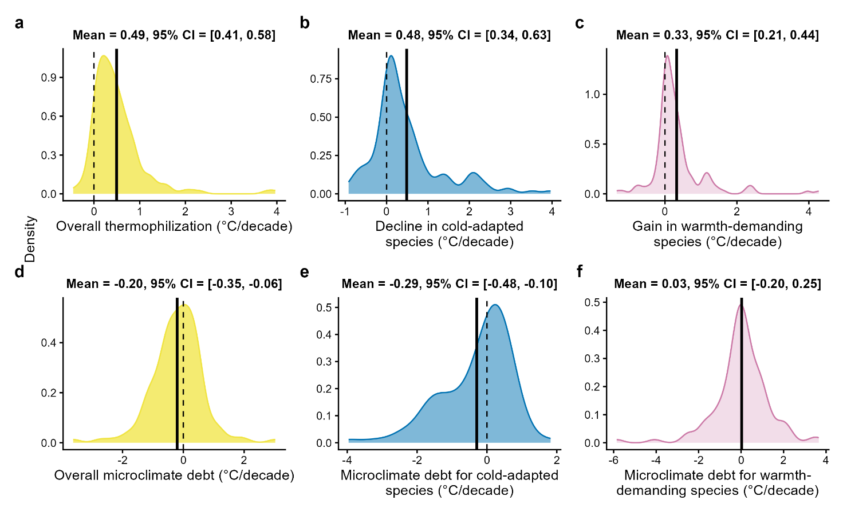
Fig. S14. Density plots for the thermophilization rates and microclimate debts in the herbaceous vegetation across the European alpine summits. Thermophilization rates (in °C per decade) were quantified as the rate of change in community-weighted mean temperature index (CTI, i.e., overall thermophilization; a), the 5th percentile of the CTI (i.e., decline in cold-adapted species; b) and the 95th percentile of the CTI (i.e., gain in warmth-demanding species; c) for the herbaceous vegetation per 1-m² plot. CTI values latter was calculated as the average temperature niche of all species per plot. Species temperature niches were extracted from Yue et al. (2026) and are based on a combination of the species’ geographical distributions and gridded climate data. Microclimate debts (in °C per decade) were calculated as the difference between the rate of soil (i.e., annual minimum) temperature change, on the one hand, and the thermophilization rates of the herbaceous vegetation (i.e., mean, 5th percentile and 95th percentile of CTI), on the other hand. The y-axis in the density plots represents the estimated probability density with the area under each curve summing to 1. At any point, the height of the curve reflects the relative likelihood of the respective variables taking that value. The dashed lines show the zero-change line, whereas the solid black lines depict the average rate of change for each focal variable.
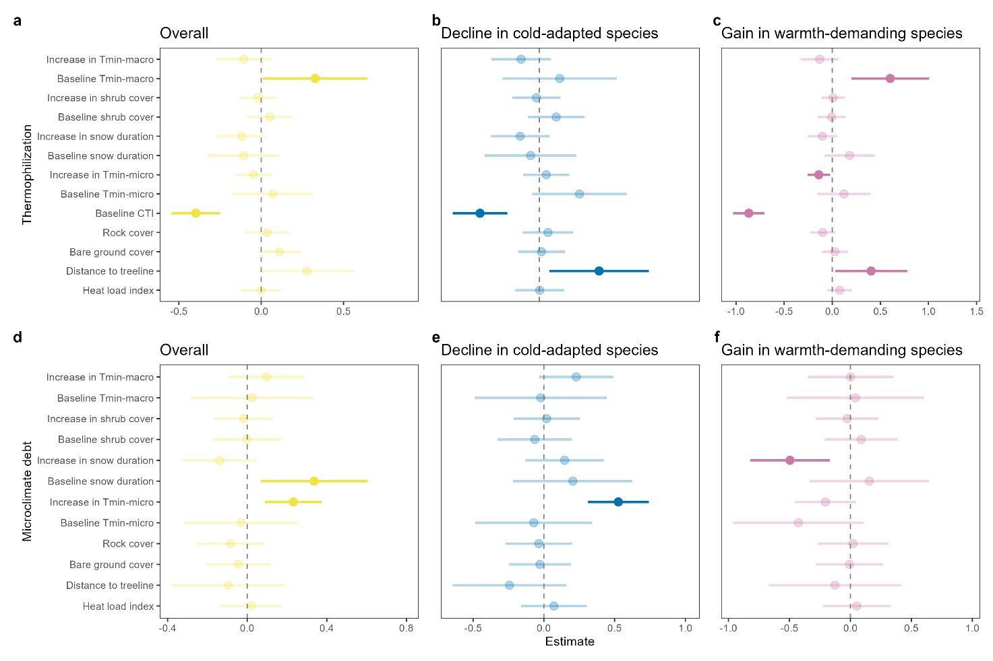
Fig. S15. Thermophilization rates and microclimate debts in the herbaceous plant communities on the European alpine summits modelled as function of macroclimate change, shrub cover change, change in snow duration and soil microclimate change. Thermophilization was quantified as the rate of change in community-weighted mean temperature index (CTI, i.e., overall thermophilization; a), the 5th percentile of the community temperature index (i.e., decline in cold-adapted species; b) and the 95th percentile of the community temperature index (i.e., gain in warmth-demanding species; c). (d-f) Microclimate debts (in °C per decade) were calculated as the difference between the rate of soil (i.e., annual minimum) temperature change, on the one hand, and the thermophilization rates of the herbaceous vegetation, on the other hand. Main predictor variables in the linear-mixed effect models were: the rate of shrub cover change, the rate of change in snow duration and the rate of soil temperature change. For each model, the baseline conditions (e.g., baseline shrub cover, baseline snow cover duration, etc.) were used as additional predictors to account for regression toward the mean. All models also included plot-level rock cover (i.e., proxy for topographical complexity), plot-level bare ground cover (i.e., amount of colonization space), distance of summit to the treeline (i.e., proximity to colonization source of more warmth-demanding species), and heat load index (HLI, i.e., proxy for the amount of radiation a mountain slope receives and calculated based on latitude, aspect and steepness) as covariates. Dots depict mean model estimates and error bars the 95% confidence intervals (CIs) of linear mixed-effect models. Bright colours indicate statistically clear effects (i.e., 95% CIs not including zero), while faded colours depict the absence of statistically clear effects. The dashed line shows the zero-effect line.

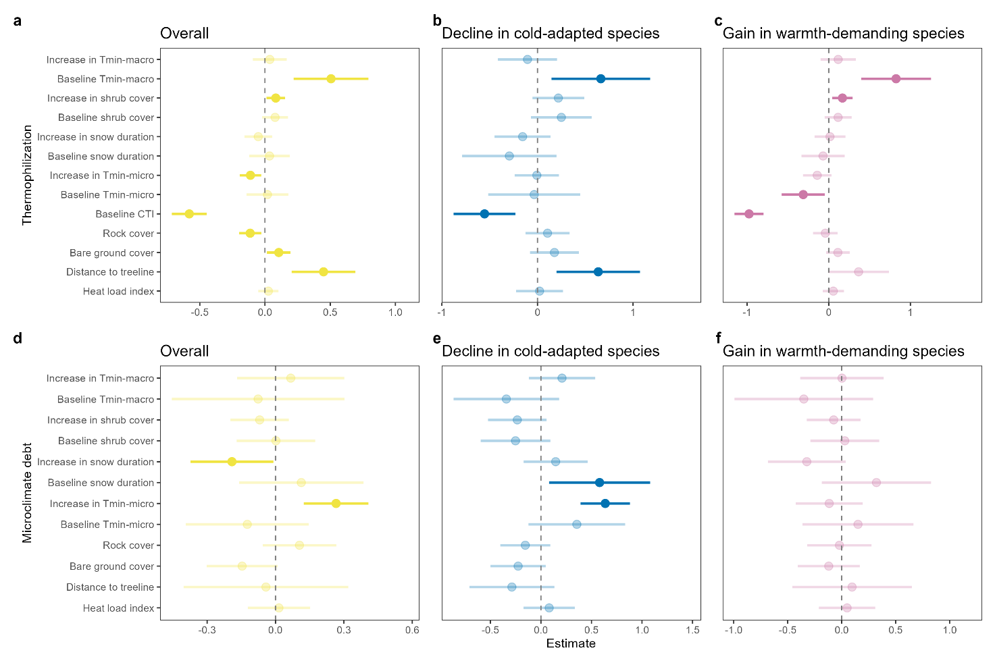
Fig. S16. Thermophilization rates and microclimate debts in the herbaceous plant communities on the European alpine summits modelled as function of macroclimate change, deciduous shrub cover change, change in snow duration and soil microclimate change. Thermophilization was quantified as the rate of change in mean community temperature index (CTI, i.e., overall thermophilization; a), the 5th percentile of the community temperature index (i.e., decline in cold-adapted species; b) and the 95th percentile of the community temperature index (i.e., gain in warmth-demanding species; c). (d-f) Microclimate debts (in °C per decade) were calculated as the difference between the rate of soil (i.e., annual minimum) temperature change, on the one hand, and the thermophilization rates of the herbaceous vegetation, on the other hand. Main predictor variables in the linear-mixed effect models were: the rate of shrub cover change, the rate of change in snow duration and the rate of soil temperature change. For each model, the baseline conditions (e.g., baseline shrub cover, baseline snow cover duration, etc.) were used as additional predictors to account for regression toward the mean. All models also included plot-level rock cover (i.e., proxy for topographical complexity), plot-level bare ground cover (i.e., amount of colonization space), distance of summit to the treeline (i.e., proximity to colonization source of more warmth-demanding species), and heat load index (HLI, i.e., proxy for the amount of radiation a mountain slope receives and calculated based on latitude, aspect and steepness) as covariates. Dots depict mean model estimates and error bars the 95% confidence intervals (CIs) of linear mixed-effect models. Bright colours indicate statistically clear effects (i.e., 95% CIs not including zero), while faded colours depict the absence of statistically clear effects. The dashed line shows the zero-effect line.

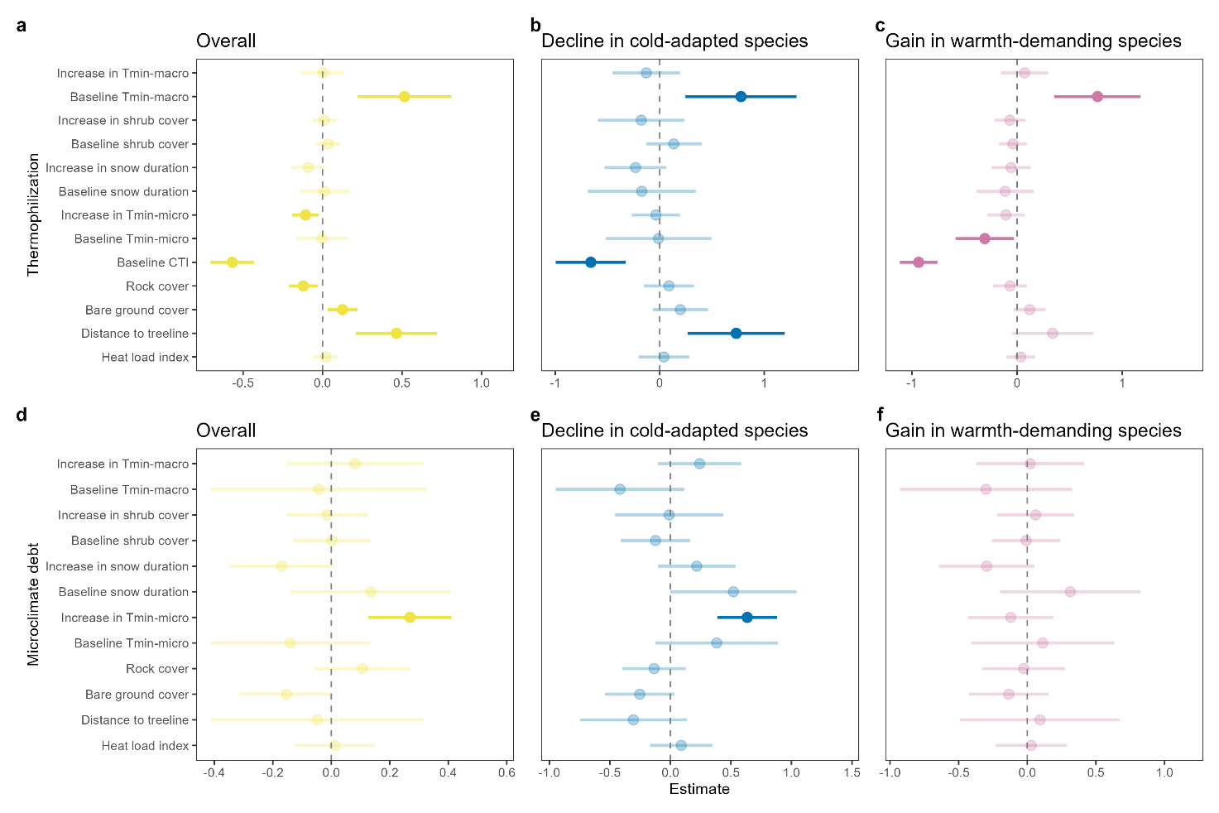
Fig. S17. Thermophilization rates and microclimate debts in the herbaceous plant communities on the European alpine summits modelled as function of macroclimate change, evergreen shrub cover change, change in snow duration and soil microclimate change. Thermophilization was quantified as the rate of change in mean community temperature index (CTI, i.e., overall thermophilization; a), the 5th percentile of the community temperature index (i.e., decline in cold-adapted species; b) and the 95th percentile of the community temperature index (i.e., gain in warmth-demanding species; c). (d-f) Microclimate debts (in °C per decade) were calculated as the difference between the rate of soil (i.e., annual minimum) temperature change, on the one hand, and the thermophilization rates of the herbaceous vegetation, on the other hand. Main predictor variables in the linear-mixed effect models were: the rate of shrub cover change, the rate of change in snow duration and the rate of soil temperature change. For each model, the baseline conditions (e.g., baseline shrub cover, baseline snow cover duration, etc.) were used as additional predictors to account for regression toward the mean. All models also included plot-level rock cover (i.e., proxy for topographical complexity), plot-level bare ground cover (i.e., amount of colonization space), distance of summit to the treeline (i.e., proximity to colonization source of more warmth-demanding species), and heat load index (HLI, i.e., proxy for the amount of radiation a mountain slope receives and calculated based on latitude, aspect and steepness) as covariates. Dots depict mean model estimates and error bars the 95% confidence intervals (CIs) of linear mixed-effect models. Bright colours indicate statistically clear effects (i.e., 95% CIs not including zero), while faded colours depict the absence of statistically clear effects. The dashed line shows the zero-effect line.

Table S1. List of GLORIA mountain sites and summits located in the alpine vegetation belt. For each summit, the full name, elevation (above sea level), geographical positioning and the year of the baseline and final resurvey is included.
Region ID | Summit ID | Summit name | Elevation (m) | Latitude (°N) | Longitude (°E) | Baseline survey | Last resurvey
ADO | GRM | Grasmugl | 2199 | 46.331 | 11.562 | 2001 | 2022
ADO | PNL | Do Peniola | 2463 | 46.383 | 11.605 | 2001 | 2022
AME | CFE | Cîme du Fer | 2700 | 44.325 | 6.938 | 2001 | 2022
AME | LAU | Butte des Laussets | 2508 | 44.332 | 6.907 | 2001 | 2022
CAI | CAM | Camp Cairn | 904 | 57.090 | -3.843 | 2001 | 2022
CAI | MIG | Creag Mhigeachaidh | 742 | 57.099 | -3.861 | 2002 | 2022
CAK | CP1 | Cross Pass 1 | 2240 | 42.539 | 44.493 | 2001 | 2022
CAK | CP2 | Cross Pass 2 | 2477 | 42.499 | 44.456 | 2001 | 2022
CAM | FEM | Femmina Morta | 2405 | 42.033 | 14.099 | 2001 | 2022
CPY | ACU | Punta Acuta | 2242 | 42.638 | -0.062 | 2001 | 2022
CPY | CUS | Punta Custodia | 2519 | 42.650 | 0.033 | 2001 | 2022
CRO | GOL | Golgota | 2116 | 47.600 | 24.625 | 2001 | 2022
CRO | GRO | Gorpile | 2063 | 47.573 | 24.618 | 2001 | 2022
CTA | KRI | Krížna | 1919 | 49.181 | 19.950 | 2001 | 2022
CTA | VEK | Velká kopa | 2052 | 49.201 | 19.974 | 2001 | 2022
DOV | VAR | Vesle Armodshokollen | 1161 | 62.262 | 9.666 | 2001 | 2022
DOV | VKO | Veslekolla | 1418 | 62.307 | 9.457 | 2001 | 2022
HSW | WEK | Weihbrunnkogel | 2065 | 47.625 | 15.163 | 2001 | 2022
HSW | ZIK | Zinken-NW-summit | 1910 | 47.598 | 15.092 | 2001 | 2022
LAT | KVA | Karsavage | 1000 | 68.342 | 18.503 | 2001 | 2019
LAT | RVA | Rakkasvare | 492 | 68.431 | 18.596 | 2002 | 2019
LEO | CHO | Chorafas | 1965 | 35.273 | 24.081 | 2001 | 2022
LEO | LOW | Low summit | 1664 | 35.269 | 24.087 | 2001 | 2022
MAV | SU1 | Colle Lago Bianco | 2340 | 45.646 | 7.595 | 2002 | 2022
MAV | SU2 | Lago Balena | 2584 | 45.640 | 7.552 | 2002 | 2022
NAP | FOG | Cima di Foce a Giovo | 1722 | 44.118 | 10.611 | 2001 | 2022
NAP | PCA | Cima di Pian Cavallaro | 1815 | 44.202 | 10.693 | 2001 | 2022
SN1 | MBU | Munt Buffalora | 2438 | 46.639 | 10.244 | 2003 | 2022
SN1 | MCH | Munt Chavagl | 2542 | 46.644 | 10.234 | 2002 | 2022
SN2 | MCS | Mot sper Chamana Sesvenna | 2424 | 46.736 | 10.429 | 2003 | 2022
SN2 | MIN | Minschuns | 2519 | 46.645 | 10.338 | 2002 | 2022
SN3 | MAC | Macun Chavagliet | 2642 | 46.733 | 10.132 | 2017 | 2022
SNE | CUP | Cúpula | 2968 | 37.046 | -3.352 | 2001 | 2022
SNE | PUL | Pulpitito | 2778 | 37.037 | -3.345 | 2001 | 2022
VAL | BRU | Mont Brûlé | 2550 | 46.021 | 7.201 | 2001 | 2022
VAL | LAL | La Ly | 2360 | 46.031 | 7.249 | 2001 | 2022

Table S2. Model estimates (± 95% confidence interval) for the rate of shrub cover change as function of the rate of macroclimate change, the baseline macroclimate and the baseline shrub cover. The model also includes four covariates; i.e., rock cover, bare ground cover, distance to the treeline and heat load index, as well as a random intercept of summit ID nested within mountain site ID.
AIC = 889.08, BIC = 920.62
Pseudo-R² (fixed effects) = 0.26
Pseudo-R² (total) = 0.52
 | Estimate | CI-5% | CI-95%
Intercept | 4.49 | 1.94 | 7.05
Increase in Tmacro-min | 1.04 | -0.69 | 2.77
Baseline Tmacro-min | -0.51 | -3.05 | 2.04
Baseline shrub cover | -5.55 | -7.04 | -4.05
Rock cover | -1.91 | -3.32 | -0.51
Bare ground cover | -1.10 | -2.56 | 0.37
Distance to treeline | -3.14 | -5.90 | -0.38
Heat Load Index | -0.68 | -1.87 | 0.50

Table S3. Model estimates (± 95% confidence interval) for the rate of change in snow duration as function of the rate of macroclimate change, the baseline macroclimate, the rate of shrub cover change, the baseline shrub cover and the baseline snow duration. The model also includes four covariates; i.e., rock cover, bare ground cover, distance to the treeline and heat load index, as well as a random intercept of summit ID nested within mountain site ID.
AIC = 1112.79, BIC = 1150.07
Pseudo-R² (fixed effects) = 0.26
Pseudo-R² (total) = 0.66
 | Estimate | CI-5% | CI-95% | t value
Intercept | -9.43 | -18.41 | -0.46 | -1.73
Increase in Tmacro-min | -13.36 | -18.19 | -8.52 | -4.54
Baseline Tmacro-min | -7.11 | -16.57 | 2.36 | -1.23
Increase shrub cover | -3.20 | -6.54 | 0.14 | -1.57
Baseline shrub cover | -3.26 | -7.68 | 1.17 | -1.21
Baseline snow duration | -5.30 | -11.13 | 0.53 | -1.5
Rock cover | 4.71 | 1.03 | 8.38 | 2.11
Bare ground cover | 3.39 | -0.35 | 7.13 | 1.49
Distance to treeline | -1.17 | -9.79 | 7.45 | -0.22
Heat Load Index | 2.01 | -1.29 | 5.31 | 1.00

Table S4. Model estimates (± 95% confidence interval) for the rate of microclimate (i.e., annual minimum soil) temperature as function of the rate of macroclimate change, the baseline macroclimate, the rate of shrub cover change, the baseline shrub cover, the rate of change in snow duration, the baseline snow duration and the baseline microclimate temperature. The model also includes four covariates; i.e., rock cover, bare ground cover, distance to the treeline and heat load index, as well as a random intercept of summit ID nested within mountain site ID.
AIC = 281.37, BIC = 324.38
Pseudo-R² (fixed effects) = 0.15
Pseudo-R² (total) = 0.63
 | Estimate | CI-5% | CI-95% | t value
Intercept | 0.22 | -0.05 | 0.50 | 1.36
Increase in Tmacro-min | 0.09 | -0.08 | 0.25 | 0.87
Baseline Tmacro-min | 0.21 | -0.1 | 0.51 | 1.11
Increase shrub cover | 0.00 | -0.1 | 0.11 | 0.06
Baseline shrub cover | 0.06 | -0.08 | 0.19 | 0.71
Increase in snow duration | -0.23 | -0.35 | -0.10 | -2.91
Baseline snow duration | 0.14 | -0.06 | 0.34 | 1.18
Baseline Tmicro-min | -0.32 | -0.51 | -0.12 | -2.70
Rock cover | 0.11 | 0.00 | 0.23 | 1.59
Bare ground cover | 0.13 | 0.02 | 0.25 | 1.90
Distance to treeline | -0.11 | -0.39 | 0.16 | -0.69
Heat Load Index | 0.06 | -0.04 | 0.16 | 0.94

Table S5. Model estimates (± 95% confidence interval) for the thermophilization rates of the herbaceous vegetation as function of the rate of macroclimate change, the baseline macroclimate, the rate of shrub cover change, the baseline shrub cover, the rate of change in snow duration, the baseline snow duration, the rate of microclimate (i.e., annual minimum soil) temperature change, the baseline microclimate temperature and the baseline community thermal index (CTI). The model also includes four covariates; i.e., rock cover, bare ground cover, distance to the treeline and heat load index, as well as a random intercept of summit ID nested within mountain site ID.
Overall thermophilization  AIC = 190.82, BIC = 239.57  Pseudo-R² (fixed effects) = 0.37  Pseudo-R² (total) = 0.84 |  |  |  |  | Decline cold-adapted species  AIC = 278.05, BIC = 318.97  Pseudo-R² (fixed effects) = 0.31  Pseudo-R² (total) = 0.47 |  |  |  | Gain warmth-demanding species  AIC = 282.77, BIC = 326.89  Pseudo-R² (fixed effects) = 0.37  Pseudo-R² (total) = 0.60
 | Est | CI-5% | CI-95% | t value | Est | CI-5% | CI-95% | t value |  | Est | CI-5% | CI-95% | t value
Intercept | 0.14 | -0.12 | 0.40 | 0.9 | 0.25 | -0.08 | 0.59 | 1.25 |  | 0.23 | -0.10 | 0.55 | 1.15
Increase in Tmacro-min | 0.03 | -0.07 | 0.14 | 0.5 | -0.14 | -0.42 | 0.13 | -0.88 |  | 0.05 | -0.13 | 0.24 | 0.48
Baseline Tmacro-min | 0.49 | 0.25 | 0.74 | 3.32 | 0.73 | 0.27 | 1.18 | 2.62 |  | 0.81 | 0.45 | 1.17 | 3.72
Increase shrub cover | 0.08 | 0.01 | 0.15 | 2.00 | 0.08 | -0.22 | 0.38 | 0.45 |  | 0.06 | -0.07 | 0.18 | 0.74
Baseline shrub cover | 0.11 | 0.02 | 0.20 | 2.10 | 0.39 | 0.12 | 0.65 | 2.39 |  | 0.04 | -0.12 | 0.21 | 0.44
Increase in snow duration | -0.07 | -0.15 | 0.02 | -1.28 | -0.22 | -0.47 | 0.02 | -1.5 |  | -0.06 | -0.22 | 0.10 | -0.6
Baseline snow duration | 0.01 | -0.12 | 0.14 | 0.16 | -0.25 | -0.69 | 0.19 | -0.94 |  | -0.13 | -0.35 | 0.10 | -0.93
Increase in Tmicro-min | -0.11 | -0.18 | -0.04 | -2.73 | -0.06 | -0.26 | 0.13 | -0.54 |  | -0.12 | -0.27 | 0.03 | -1.27
Baseline Tmicro-min | -0.01 | -0.14 | 0.12 | -0.12 | -0.08 | -0.49 | 0.34 | -0.31 |  | -0.33 | -0.56 | -0.10 | -2.38
Baseline CTI | -0.58 | -0.7 | -0.47 | -8.55 | -0.62 | -0.9 | -0.35 | -3.71 |  | -0.95 | -1.11 | -0.80 | -10.3
Rock cover | -0.11 | -0.18 | -0.03 | -2.38 | 0.16 | -0.05 | 0.37 | 1.28 |  | -0.06 | -0.19 | 0.08 | -0.67
Bare ground cover | 0.13 | 0.06 | 0.21 | 2.89 | 0.27 | 0.05 | 0.48 | 2.01 |  | 0.13 | 0.00 | 0.26 | 1.7
Distance to treeline | 0.49 | 0.28 | 0.70 | 3.89 | 0.85 | 0.43 | 1.26 | 3.38 |  | 0.39 | 0.07 | 0.72 | 1.98
Heat Load Index | 0.03 | -0.03 | 0.10 | 0.86 | 0.08 | -0.13 | 0.29 | 0.64 |  | 0.04 | -0.08 | 0.16 | 0.56

Table S6. Model estimates (± 95% confidence interval) for the macroclimate debts in the herbaceous vegetation as function of the rate of macroclimate change, the baseline macroclimate, the rate of shrub cover change, the baseline shrub cover, the rate of change in snow duration, the baseline snow duration, the rate of microclimate (i.e., annual minimum soil) temperature change and the baseline microclimate temperature. The model also includes four covariates; i.e., rock cover, bare ground cover, distance to the treeline and heat load index, as well as a random intercept of summit ID nested within mountain site ID.
Overall macroclimate debt  AIC = 249.11, BIC = 294.99  Pseudo-R² (fixed effects) = 0.65  Pseudo-R² (total) = 0.91 |  |  |  |  | Decline cold-adapted species  AIC = 305.34, BIC = 346.87  Pseudo-R² (fixed effects) = 0.49  Pseudo-R² (total) = 0.76 |  |  |  | Gain warmth-demanding species  AIC = 279.28, BIC = 317.79  Pseudo-R² (fixed effects) = 0.62  Pseudo-R² (total) = 0.70
 | Est | CI-5% | CI-95% | t value | Est | CI-5% | CI-95% | t value | Est | CI-5% | CI-95% | t value
Intercept | 0.29 | -0.05 | 0.62 | 1.39 | -0.04 | -0.46 | 0.38 | -0.17 | 0.12 | -0.21 | 0.46 | 0.60
Increase in Tmacro-min | 1.12 | 0.97 | 1.27 | 12.27 | 0.90 | 0.66 | 1.14 | 6.06 | 1.41 | 1.12 | 1.70 | 8.09
Baseline Tmacro-min | -0.5 | -0.83 | -0.17 | -2.49 | -0.70 | -1.17 | -0.23 | -2.43 | -0.38 | -0.83 | 0.07 | -1.39
Increase shrub cover | -0.06 | -0.15 | 0.03 | -1.13 | -0.01 | -0.19 | 0.17 | -0.09 | -0.22 | -0.54 | 0.1 | -1.14
Baseline shrub cover | -0.09 | -0.20 | 0.03 | -1.25 | -0.1 | -0.34 | 0.14 | -0.69 | -0.34 | -0.63 | -0.06 | -1.97
Increase in snow duration | 0.06 | -0.05 | 0.18 | 0.94 | -0.02 | -0.26 | 0.21 | -0.15 | 0.21 | -0.06 | 0.47 | 1.30
Baseline snow duration | 0.02 | -0.15 | 0.19 | 0.18 | 0.06 | -0.27 | 0.38 | 0.28 | 0.59 | 0.15 | 1.03 | 2.19
Increase in Tmicro-min | 0.17 | 0.08 | 0.26 | 3.07 | 0.10 | -0.12 | 0.32 | 0.74 | -0.04 | -0.24 | 0.17 | -0.29
Baseline Tmicro-min | 0.15 | -0.02 | 0.32 | 1.45 | 0.28 | -0.05 | 0.61 | 1.38 | 0.44 | 0.02 | 0.85 | 1.73
Rock cover | 0.12 | 0.03 | 0.22 | 2.07 | 0.08 | -0.11 | 0.27 | 0.7 | -0.21 | -0.44 | 0.02 | -1.53
Bare ground cover | -0.22 | -0.32 | -0.12 | -3.71 | -0.36 | -0.55 | -0.17 | -3.05 | -0.31 | -0.54 | -0.07 | -2.16
Distance to treeline | -0.57 | -0.86 | -0.29 | -3.28 | -0.88 | -1.29 | -0.47 | -3.54 | -0.41 | -0.8 | -0.02 | -1.75
Heat Load Index | 0.01 | -0.07 | 0.1 | 0.24 | 0.03 | -0.14 | 0.2 | 0.28 | 0.04 | -0.17 | 0.26 | 0.33

Table S7. Model estimates (± 95% confidence interval) for the microclimate debts in the herbaceous vegetation as function of the rate of macroclimate change, the baseline macroclimate, the rate of shrub cover change, the baseline shrub cover, the rate of change in snow duration, the baseline snow duration, the rate of microclimate (i.e., annual minimum soil) temperature change and the baseline microclimate temperature. The model also includes four covariates; i.e., rock cover, bare ground cover, distance to the treeline and heat load index, as well as a random intercept of summit ID nested within mountain site ID.
Overall microclimate debt  AIC = 316.42, BIC = 362.30  Pseudo-R² (fixed effects) = 0.25  Pseudo-R² (total) = 0.63 |  |  |  |  | Decline cold-adapted species  AIC = 279.28, BIC = 317.79  Pseudo-R² (fixed effects) = 0.46  Pseudo-R² (total) = 0.58 |  |  |  | Gain warmth-demanding species  AIC = 346.03, BIC = 387.56  Pseudo-R² (fixed effects) = 0.16  Pseudo-R² (total) = 0.51
 | Est | CI-5% | CI-95% | t value | Est | CI-5% | CI-95% | t value | Est | CI-5% | CI-95% | t value
Intercept | 0.10 | -0.16 | 0.36 | 0.66 | -0.01 | -0.35 | 0.32 | -0.06 | 0.00 | -0.41 | 0.41 | 0.01
Increase in Tmacro-min | 0.08 | -0.12 | 0.27 | 0.65 | 0.24 | -0.05 | 0.53 | 1.38 | 0.02 | -0.3 | 0.34 | 0.10
Baseline Tmacro-min | -0.06 | -0.37 | 0.25 | -0.32 | -0.38 | -0.83 | 0.07 | -1.39 | -0.30 | -0.84 | 0.23 | -0.94
Increase shrub cover | -0.05 | -0.17 | 0.06 | -0.76 | -0.22 | -0.54 | 0.1 | -1.14 | 0.00 | -0.23 | 0.23 | -0.02
Baseline shrub cover | 0.00 | -0.16 | 0.15 | -0.03 | -0.34 | -0.63 | -0.06 | -1.97 | 0.00 | -0.29 | 0.3 | 0.01
Increase in snow duration | -0.18 | -0.32 | -0.03 | -1.95 | 0.21 | -0.06 | 0.47 | 1.3 | -0.29 | -0.58 | 0.00 | -1.62
Baseline snow duration | 0.14 | -0.09 | 0.36 | 0.98 | 0.59 | 0.15 | 1.03 | 2.19 | 0.34 | -0.08 | 0.77 | 1.32
Increase in Tmicro-min | 0.27 | 0.15 | 0.39 | 3.71 | 0.66 | 0.46 | 0.87 | 5.31 | -0.11 | -0.38 | 0.15 | -0.71
Baseline Tmicro-min | -0.12 | -0.35 | 0.10 | -0.9 | 0.44 | 0.02 | 0.85 | 1.73 | 0.13 | -0.30 | 0.57 | 0.50
Rock cover | 0.11 | -0.03 | 0.25 | 1.25 | -0.21 | -0.44 | 0.02 | -1.53 | -0.02 | -0.28 | 0.24 | -0.11
Bare ground cover | -0.15 | -0.29 | -0.02 | -1.89 | -0.31 | -0.54 | -0.07 | -2.16 | -0.13 | -0.38 | 0.11 | -0.88
Distance to treeline | -0.06 | -0.36 | 0.25 | -0.31 | -0.41 | -0.8 | -0.02 | -1.75 | 0.07 | -0.42 | 0.56 | 0.23
Heat Load Index | 0.01 | -0.11 | 0.13 | 0.19 | 0.04 | -0.17 | 0.26 | 0.33 | 0.04 | -0.18 | 0.27 | 0.30

