SUPPLEMENTARY MATERIAL
Reduced brain connectivity in clinical and dimensional autism phenotypes beyond familial confounding – a twin study
Neufeld, Janina, PhD¹, Maier, Simon, PhD², Revers, Mirian, MD¹, Reisert, Marco, PhD², Kuja-Halkola, Ralf, PhD³, Tebartz van Elst. Ludger, Prof.², & Bölte, Sven, Prof.^{1,4,5}
¹Center of Neurodevelopmental Disorders (KIND), Centre for Psychiatry Research; Department of Women’s and Children’s Health, Karolinska Institutet & Stockholm Health Care Services, Region Stockholm, Stockholm, Sweden.
²Section for Experimental Neuropsychiatry, Department for Psychiatry & Psychotherapy, University Medical Center Freiburg, Freiburg, Germany
³Department of Medical Epidemiology and Biostatistics, Karolinska Institutet, Stockholm, Sweden
⁴Child and Adolescent Psychiatry, Stockholm Health Care Services, Region Stockholm, Stockholm, Sweden.
⁵Curtin Autism Research Group, Curtin School of Allied Health, Curtin University, Perth, Western Australia.

Table of contents
Methodological clarifications……………………………………………………………………...2
Supplementary results……………………………………………………………………………...3
Supplementary Table 1: The 56 LPBA40 atlas regions………………………………………….7
Supplementary Fig. 1: Z-map of all 903 included connections in association with clinical autism…………………………………………………………………………………………………..8
Supplementary Fig. 2: Z-map of all 903 included connections in association with dimensional autism…………………………………………………………………………………………………..9
Supplementary Fig. 3: Z-map the interaction between clinical autism and age on structural connectivity…………………………………………………………………………………………...10
Supplementary Fig. 4: Z-map the interaction between dimensional autism and age on structural connectivity..……………………………………………………………………………...11

Methodological clarifications

Psychometrics of the SRS-2
In this study, we used the Swedish translation of the second version of the Social Responsiveness Scale, SRS-2 (1). The SRS-2 consists of 65 items rated by a caregiver on a Likert scale (0-3), focusing on the individual’s behavior during the past six months, with higher scores indicating higher autistic traits. The maximum score is 195 and individuals diagnosed with clinical autism typically score between 60 and 165 (2). The SRS has demonstrated good to excellent psychometric properties for test-retest reliability (.80-.97), interrater reliability (.75-.95), and satisfactory convergent validity (.35-.58) with the ADOS and ADI-R (2,3).

References for this section:
(1) Constantino J.N., Gruber C.P. [Swedish version by Zander E, Bölte S] (2019). Skattningsskala för social responsivitet, andra upplagan (SRS-2). [Original English title: Social responsiveness scale: SRS-2.] Göttingen, Stockholm. Hogrefe.
(2) Constantino, J.N., Davis, S.A., Todd, R.D., Schindler, M.K., Gross, M.M., Brophy, S.L., Metzger, L.M., Shoushtari, C.S., Splinter, R. and Reich, W. (2003). Validation of a brief quantitative measure of autistic traits: comparison of the social responsiveness scale with the autism diagnostic interview-revised. Journal of Autism and Developmental Disorders, 33(4), 427–433.
(3) Bölte, S., Poustka, F., & Constantino, J. N. (2008). Assessing autistic traits: cross‐cultural validation of the social responsiveness scale (SRS). Autism Research, 1(6), 354-363.

Supplementary results

Group differences in dimensional autism and IQ
For descriptive analysis, we divided the sample into individuals diagnosed with clinical autism (n = 25), NT individuals (n = 87) and individuals diagnosed with other NDD or psychiatric conditions (n = 58). Individuals diagnosed with clinical autism had on average a higher degree of dimensional autism (elevated autistic traits) compared to both NT individuals (t(31.87) = 10.72, p = 4.3e⁻¹²) and individuals with other NDD or psychiatric diagnoses (t(39.00) = 8.29, p = 3.9e⁻¹⁰). Further, individuals with other NDD or psychiatric diagnoses had on average higher autistic traits than NT individuals (t(111.96) = -3.083, p = .003). The proportion of females was 52% in the clinical autism sample, 64% in the NT sample, and 38% in individuals with other NDD or psychiatric diagnoses. Still, the gender distribution did not differ significantly between these three groups (Kruskal-Wallis χ²(3) = 2.93, p = .403). There were also no significant group differences in test age (clinical autism vs NT: t(42.43) = -1.89, p = .066; clinical autism vs other diagnoses: t(53.33) = -1.30, p = .198; other diagnoses vs NT: t(116.95) = .56, p = .578) or IQ (clinical autism vs NT: t(31.23) = .09, p = .927; clinical autism vs other diagnoses: t(34.43) = .86, p = .398; other diagnoses vs NT: t(123.77) = 1.42, p = .159).

Within-pair differences in dimensional autism and IQ
Twins differed from each other by an average of 20.13 points (SD=22.74) on the SRS-2. 76 twin pairs (38 MZ, 36 DZ and 2 where zygosity was undetermined) differed by at least one point in the SRS-2, while 52 pairs (23 MZ, 27 DZ and 2 where zygosity was undetermined) differed at least 7 points, which is above the standard error of measurement (6.6) in clinical samples (see reference 23 in the main article). Therefore, there were similar numbers of MZ and DZ pairs that were discordant for dimensional autism (>1 point or >6.6 points), which contributed to the association between dimensional autism and brain connectivity. Twins from 22 pairs (4 MZ, 18 DZ and 2 where zygosity was undetermined) differed by more than one sample standard deviation (>28.37) on the SRS-2. In the sub-sample of 17 twin pairs discordant for clinical autism (six pairs were MZ and 11 pairs DZ), the mean difference in the SRS-2 score was greater (mean = 48.65, SD = 29.70) compared to the 64 pairs in which no twin was diagnosed with clinical autism (t(17.66) = 4.933, p < .001).
The mean IQ differences between twins were rather small, both in the whole sample (mean = 10.39; SD = 8.63) and in the 17 pairs discordant for clinical autism (mean = 14.41, SD = 11.52). Within-pair differences of autism-discordant pairs and twin pairs where no individuals was diagnosed with clinical autism did not differ significantly (t(19.75)= 1.614, p-value = .122).

Within-twin pair effects of covariates on structural connectivity
None of the covariates were significantly associated with any of the connections that were found to be associated with clinical or dimensional autism after FDR correction. Taking all 903 connections into account, having an NDD diagnosis other than clinical autism (as comorbid condition or as main diagnosis) was negatively associated with connectivity strength, both in models where dimensional autism was the main independent variable and where clinical autism was the main independent variable. These connections were between the left superior central gyrus and the left precentral gyrus (Model with dimensional autism: β (95% CI) = -1.059 (-1.446, -.672), SE = .198, Z = -5.357, p corr. = 6.7e⁻⁵, model with clinical autism: β (95% CI) = -1.085 (-1.437, -.733), SE = .180, Z = -6.041, corrected p = 1.4e⁻⁶) and between the right cingulate gyrus and the left angular gyrus (Model with dimensional autism: β (95% CI) = -1.435 (-2.031, -.839), SE = .304, Z = -4.721, p corr. = .002; model with clinical autism: β (95% CI) = -1.475 (-2.044, -.906), SE = 0.290, Z = -5.080, corrected p = 3.4e⁻⁴).
In the model with clinical autism, two additional negative associations survived the correction. These were between the left supramarginal gyrus and the left precentral gyrus (β (95% CI) = -.910 (-1.293, -.526), SE = .196, Z = -4.650, corrected p = .003) and between the fusiform gyrus and the left precuneus (β (95% CI) = -.904 (-1.341, -.467), SE = .223, Z = -4.058, corrected p = .045).
Non-NDD psychiatric diagnoses did not predict brain connectivity within twin pairs after FDR correction, nor did IQ.

Z-maps of all assessed associations (uncorrected)
The uncorrected Z-maps of the associations between connectivity strength as the outcome predicted by clinical autism (Supplementary Fig. 1) and dimensional autism (Supplementary Fig. 2), respectively, revealed quite similar patterns of increases and decreases in connectivity. Associations with clinical and dimensional autism predictors differed in which Z-values were most extreme (i.e. which associations survived the corrections for multiple comparisons), rather than leading to fundamentally different patterns of altered connectivity. Those associations surviving the correction for one measure had also quite extreme Z-values in the same direction for the other, albeit below the significance threshold.
Further, it is apparent that both, clinical and dimensional autism were also associated with extended patterns of (non-significant) increases in connectivity rather than uniformly being associated with reduced connectivity – especially of occipital and occipito-temporal brain regions to temporal and parietal regions and of cerebellum and brain stem to frontal brain regions.

Across cohort associations of clinical and dimensional autism with brain connectivity
In order to complement our within-pair analysis, we also performed linear regressions across the cohort using the same statistical framework, treating twins as individuals but adjusting standard errors for twin clustering. The latter model is more similar to regression analyses in non-twin samples and hence more comparable to the majority of previous studies, but these results do not directly reflect associations in the general population (due to the sampling bias). Across the cohort, we adjusted additionally for sex and age (these variables are implicitly controlled in the within-pair analysis). None of the associations with clinical or dimensional autism that were found within twin pairs survived the correction for multiple comparisons across the cohort.
However, other associations were found. More specifically, both clinical and dimensional autism were associated with connectivity strength between the left caudate nucleus and the left inferior frontal gyrus (clinical autism: -.750 (-1.075, -.424), SE = .166, Z = -4.517, corrected p = .006; dimensional autism: β (95% CI) = -.319 (-.462, -.175), SE = .073, Z = -4.353, corrected p = .012;). Clinical autism was additionally negatively associated with connectivity strength between the right postcentral gyrus and the right lateral orbitofrontal gyrus (β (95% CI) = -.605 (-.882, -.327), SE = .142, Z = -4.274, corrected p = .017), between the left superior parietal gyrus and the left superior frontal gyrus (β (95% CI) = -.729 (-1.032, -.426), SE = .155 Z = -4.715, corrected p = .002) and between the left superior parietal gyrus and the left lateral orbitofrontal gyrus (β (95% CI) = -.652 (-.955, -.350), SE = .154, Z = -4.230, corrected p = .021).
Since these associations were only found across the cohort, we suggest that these connectivity alterations are influenced by familial factors, such as genetics or upbringing. This means that co-twins of twins with clinical autism who themselves do not fulfil diagnostic criteria might nevertheless share the connectivity alterations between these regions to some extent.

Supplementary Tables

Supplementary Table 1: The 56 LPBA40 atlas regions
numeric label  __________ | Name label  ____________________ | numeric label  __________ | Name label  _____________________
21 | L superior frontal gyrus | 65 | L inferior occipital gyrus
22 | R superior frontal gyrus | 66 | R inferior occipital gyrus
23 | L middle frontal gyrus | 67 | L cuneus
24 | R middle frontal gyrus | 68 | R cuneus
25 | L inferior frontal gyrus | 81 | L superior temporal gyrus
26 | R inferior frontal gyrus | 82 | R superior temporal gyrus
27 | L precentral gyrus | 83 | L middle temporal gyrus
28 | R precentral gyrus | 84 | R middle temporal gyrus
29 | L middle orbitofrontal gyrus | 85 | L inferior temporal gyrus
30 | R middle frontal gyrus | 86 | R inferior temporal gyrus
31 | L lateral orbitofrontal gyrus | 87 | L parahippocampal gyrus
32 | R lateral orbitofrontal gyrus | 88 | R parahippocampal gyrus
33 | L gyrus rectus | 89 | L lingual gyrus
34 | R gyrus rectus | 90 | R lingual gyrus
41 | L postcentral gyrus | 91 | L fusiform gyrus
42 | R postcentral gyrus | 92 | R fusiform gyrus
43 | L superior parietal gyrus | 101 | L insular cortex
44 | R superior parietal gyrus | 102 | R insular cortex
45 | L supramarginal gyrus | 121 | L cingulate gyrus
46 | R supramarginal gyrus | 122 | R cingulate gyrus
47 | L angular gyrus | 161 | L caudate
48 | R angular grus | 162 | R caudate
49 | L precuneus | 163 | L putamen
50 | R precuneus | 164 | R putamen
61 | L superior occipital gyrus | 165 | L hippocampus
62 | R superior occipital gyrus | 166 | R hippocampus
63 | L middle occipital gyrus | 181 | cerebellum
64 | R middle occipital gyrus | 182 | brainstem
Note. R = right and L = left hemisphere

Supplementary Figures

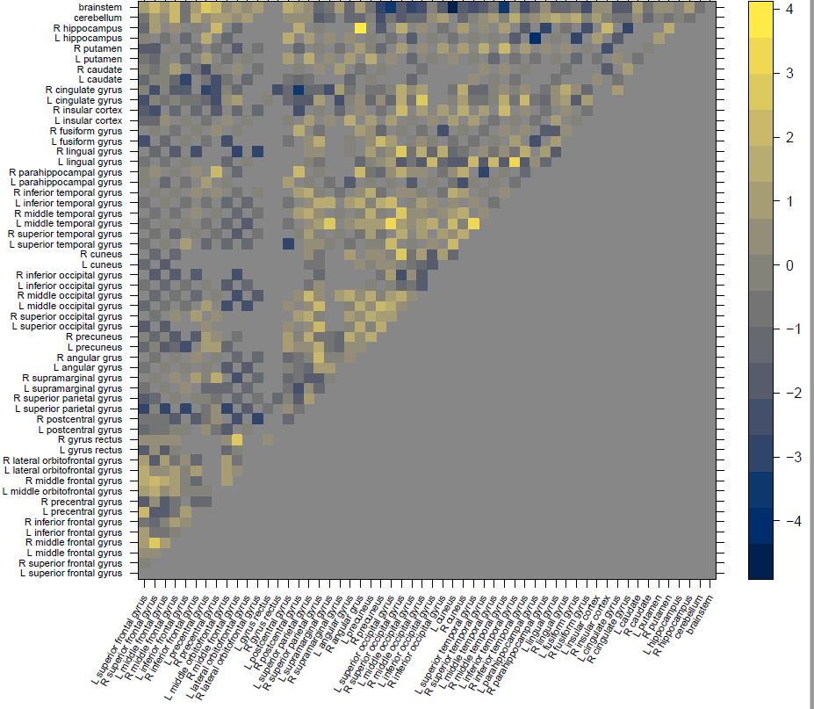
Supplementary Fig. 1: Z-map of all 903 included connections in association with clinical autism. The legend shows the color range of Z-values (-4 to +4) and yellow squares depict positive and blue squares negative within-pair associations between clinical autism and connectivity while adjusting for IQ and other neurodevelopmental and psychiatric diagnosis.

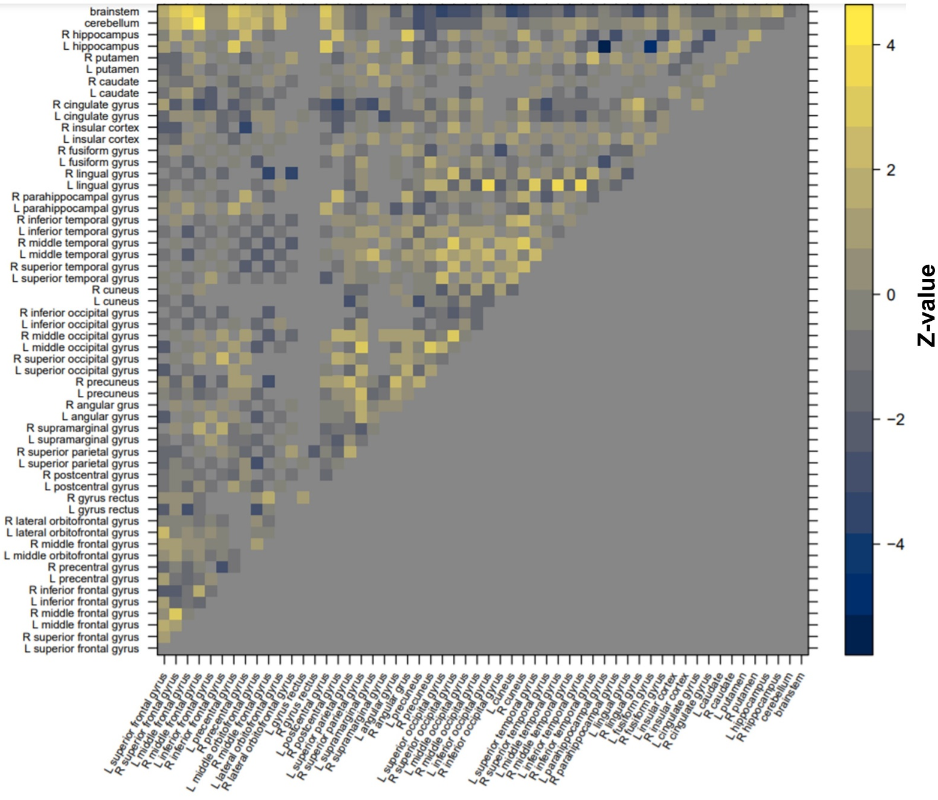

Supplementary Fig. 2: Z-map of all 903 included connections in association with dimensional autism. The legend shows the color range of Z-values (-4 to +4) and yellow squares depict positive and blue squares negative within-pair associations between dimensional autism and connectivity while adjusting for IQ and other neurodevelopmental and psychiatric diagnosis.

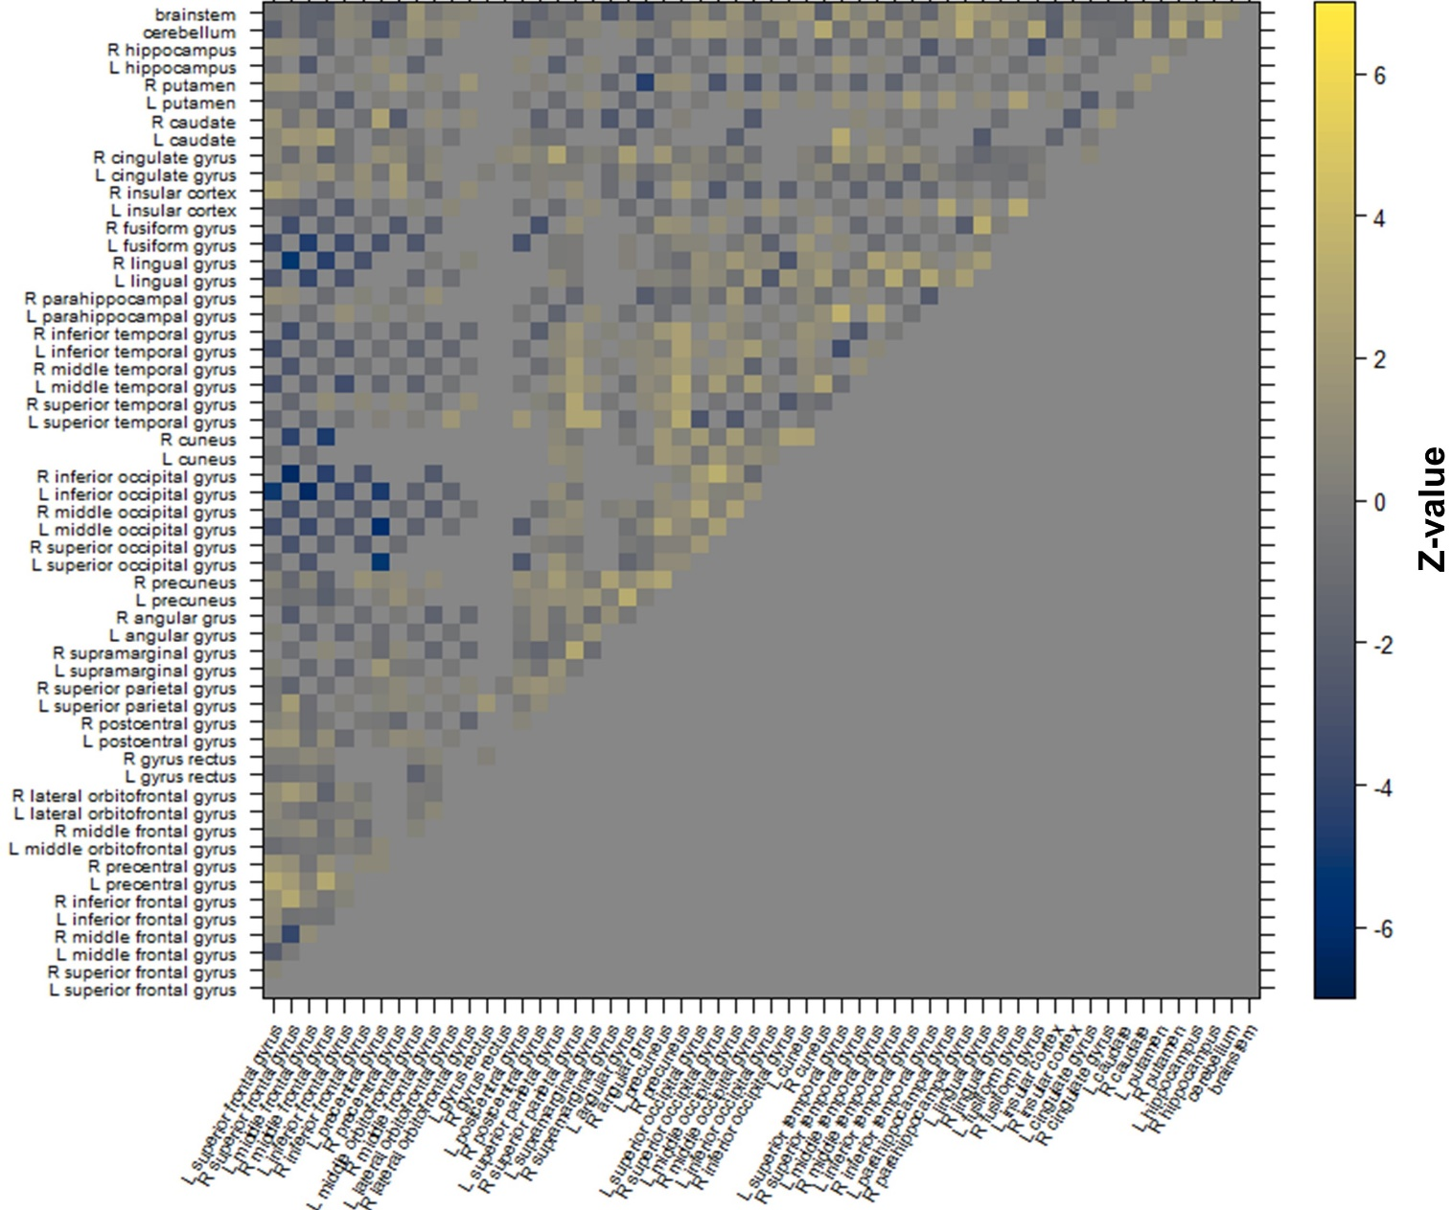

Supplementary Fig. 3: Z-map the interaction between clinical autism and age on structural connectivity. Z-values ranged from -6.253 to 3.576 and yellow squares depict positive and blue squares negative within-pair interaction effects.

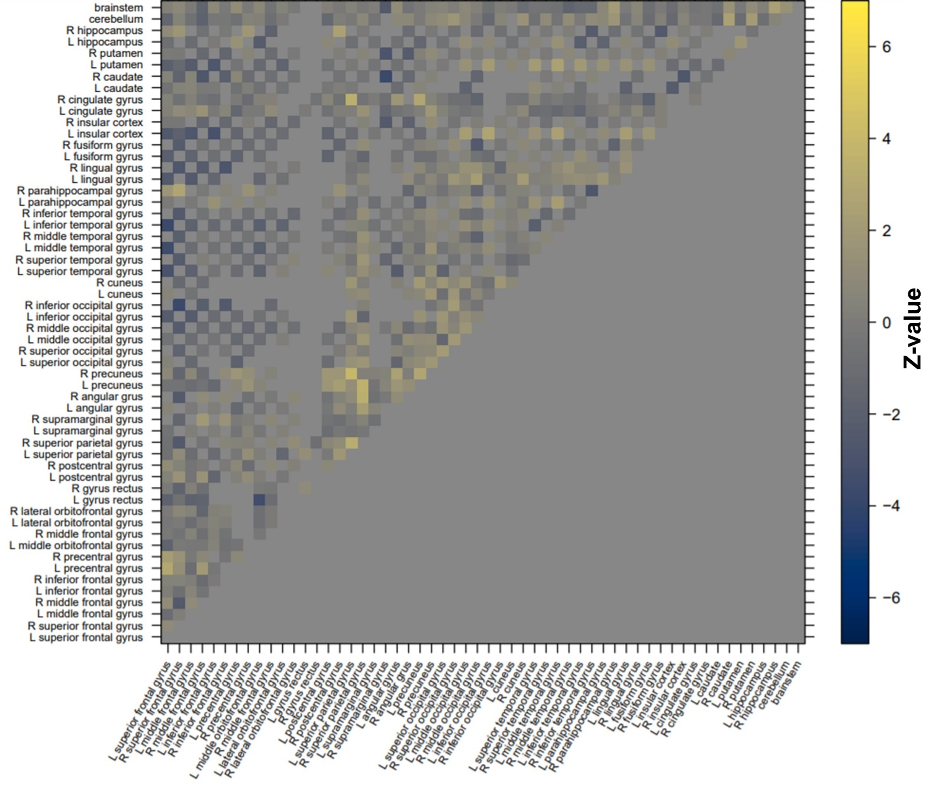

Supplementary Fig. 4: Z-map the interaction between dimensional autism and age on structural connectivity. Z-values ranged from -3.740 to 3.947 and yellow squares depict positive and blue squares negative within-pair interaction effects. The legend was set to range from -6.5 to 6.5 in order to match the legend of Supplementary Fig. 3.

