Online-Only Supplements:
eFigure 1. Treatment components and structure
eFigure 2. Acceptability rating scale
eFigure 3. Acceptability rating scale. Perceived reduction in suicidal ideation

eFigure 1. Treatment components and structure

BASELINE | TREATMENT |  |  |  |  |  |  |  | POST-  TREATMENT
 | TAU
 | SAMIT
Blood sample  Questionnaires  HADS  BHS  BIS-11  SSI  PSE | V1 | V2 | V3 | V4 | V5 | V6 | V7 | V8 | Blood sample  Questionnaires  HADS  BHS  BIS-11  SSI  PSE
Blood sample  Questionnaires  HADS  BHS  BIS-11  SSI  PSE | Narrative interview  patients are asked to explain the event and how they reached the point of SA | MBT psychoeducational  introductory concepts of the MBT are explained | Emotions  from MBT framework | Functional analysis  of the SA is performed by the MBT | Emotional regulation  and techniques from DBT | Attachment and relationships  related specifically to the SA and loss of mentalization capacity | Conceptualization  of suicide, attachment and mentalization from MBT | Crisis plan  from MBT | Blood sample  Questionnaires  HADS  BHS  BIS-11  SSI  PSE

Abbreviations: SAMIT, Suicide Attempt Multi-Component Intervention Treatment; NT, narrative therapy; MBT, mentalization based therapy; DBT, dialectical behaviour therapy; HADS, Hospital Anxiety and depression Scale; BHS, Beck hopelessness scale; BIS-11, Barratt impulsiveness scale; SSI, scale for suicide ideation; PSE, psychache scale

eFigure 2. Acceptability rating scale.

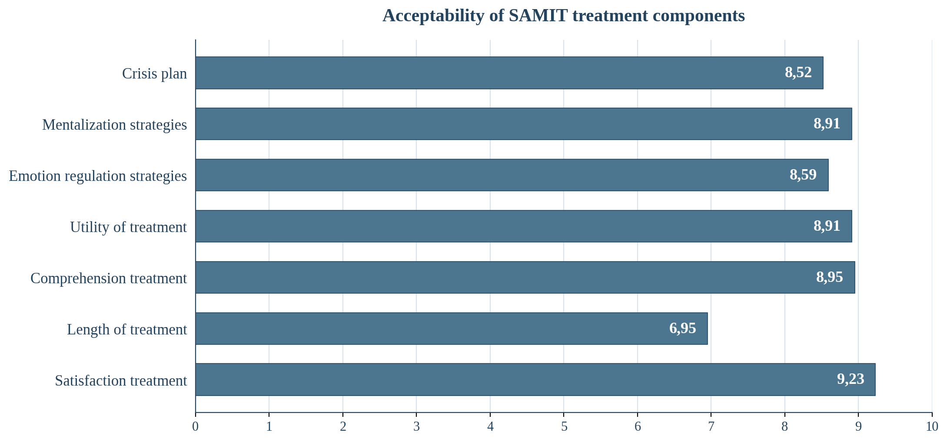

eFigure 3. Acceptability rating scale. Perceived reduction in suicidal ideation

